Supplementary Information

Ultra-dilute electrolytes for suppressing metal anode corrosion during calendar aging and cycling
Haoyang Wu,^{#1} Bo Liu,^{#1} Dongfang Cheng,¹ Keyue Liang,¹ Xintong Yuan,¹ Min-Ho Kim,¹ Kaiyan Liang,¹ Dingyi Zhao,¹ Jung Tae Kim,¹ Jiayi Yu,¹ Kaixi Chen,¹ Tian-Yu Wang,¹ Philippe Sautet,¹ and Yuzhang Li^{*1, 2}

#Contributed equally
¹Department of Chemical and Biomolecular Engineering, University of California, Los Angeles, CA 90095, United States
²California NanoSystems Institute (CNSI), University of California, Los Angeles, CA 90095, United States
*Corresponding author: yuzhangli@ucla.edu

Supplementary Notes
Supplementary Note 1: Crystal Orbital Hamilton Population (COHP) Analysis of O–H Bonding Free and Solvated Water
To better understand the activity of proton donors in free water and solvated water, and their role in the hydrogen evolution reaction (HER), we performed density functional theory (DFT) calculations. The Zn(002) surface was used as a model, as confirmed by experimental TEM results. Two layers of water were incorporated to represent the local solvent environment. To investigate the effect of Zn ions on proton donor activity, a Zn ion was introduced into the solvent layer. Constant-potential DFT structural optimizations were then performed at –0.8 V vs. standard hydrogen electrode (SHE) to simulate the potential at which HER typically occurs. The calculations show that the Zn ion becomes solvated by four surrounding water molecules, forming Zn–O bonds.
The ability of water molecules to donate protons is directly linked to the strength of their O–H bonds where weaker bonds facilitate bond cleavage and proton transfer. To quantitatively analyze differences in O–H bond strength, we performed COHP analysis (Supplementary Fig. 1A-B), a method that decomposes the electronic structure into bonding, non-bonding, and anti-bonding contributions, on the O–H bonds in both free and solvated water. The integrated COHP (–ICOHP) values provide a quantitative measure of bond strength, with more negative –ICOHP values corresponding to stronger bonds. Our results indicate that the O–H bond in free water (denoted as O–H@H₂O) exhibits substantial bonding character (Supplementary Fig. 1C). In contrast, the O–H bond in solvated water (O–H@Zn(H₂O)) shows reduced bonding contributions and a pronounced anti-bonding feature near the Fermi level (Supplementary Fig. 1D). This anti-bonding character significantly decreases the –ICOHP value, indicating a much weaker bond in solvated water compared to free water. As a result, the O–H bond in solvated water is more prone to cleavage, enhancing its proton-donating ability. These electronic structure results demonstrate that Zn ions modulate O–H bond strength via anti-bonding interactions, thereby facilitating proton transfer in HER.

Supplementary Note 2: Energy Barrier Calculations for Proton Donation
To quantify the proton-donating abilities of free and solvated water, we calculated the minimum-energy reaction pathway for the Volmer step, which is widely recognized as the rate-determining step in HER. In the case of free water, proton transfer typically involves migration between adjacent water molecules, ultimately forming a hydroxide ion. Although this OH⁻ is partially stabilized by hydrogen bonding, the overall process requires substantial O–H bond cleavage and proton migration. Consequently, the reaction barrier is relatively high (~1.2 eV), and the overall reaction energy is about 0.6 eV (Figure 2A),¹ primarily due to the limited stabilization of the OH⁻ ion in solution.
In contrast, when Zn ions are present, we examined two scenarios involving proton donation from solvated water: (1) direct proton donation from a 1st shell water molecule, and (2) donation from a 2nd shell water molecule, assisted by a Zn-coordinated water molecule. In the first scenario, the resulting OH⁻ binds strongly to the Zn ion, forming a Zn²⁺(H₂O)₃OH⁻ complex (Figure 2B). This stabilization of both the transition and final states significantly lowers the reaction barrier and energy by ~0.6 eV and ~0.4 eV, respectively, compared to the free water case (Figure 2A). In the second scenario, proton donation occurs from a 2nd shell solvated water via a Grotthuss-like mechanism, in which the proton transfer is mediated by a Zn-coordinated water molecule . This forms a transition state represented as Zn²⁺–OH–H–OH, further stabilized by the Zn ion (Figure 2B). The final state in both scenarios involves the OH⁻ directly coordinated to Zn²⁺ (Figure 2B). Overall, our explicit reaction path modeling demonstrates that Zn ions substantially facilitate proton donation by stabilizing both the transition and final states through strong Zn–OH interactions. This stabilization lowers the energy required for O–H bond cleavage in solvated water, making the proton transfer process more favorable and enhancing the HER kinetics.
Supplementary Figures
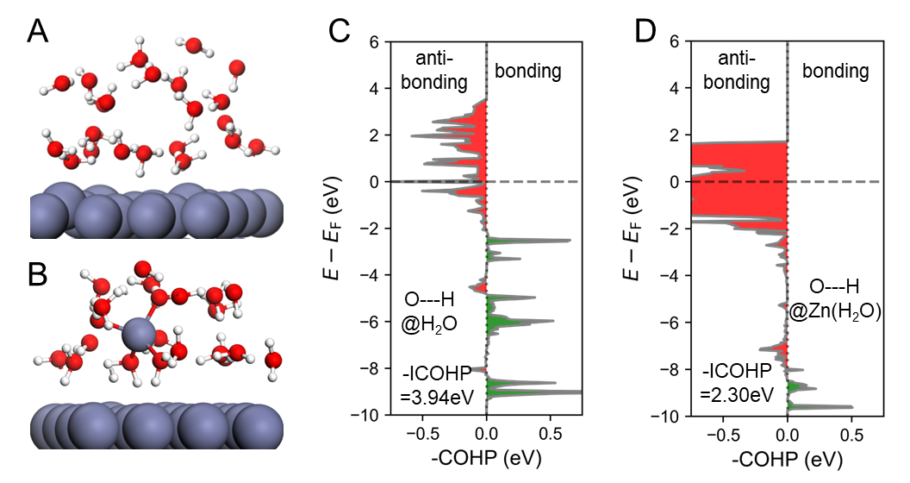
Supplementary Fig. 1. Simulation of bonding energy difference between free water molecules and solvated water molecules. The atomic structure of (A) Zn (002)-water interface and (B) Zn (002)-water-Zn²⁺ interface. The Crystal Orbital Hamilton Population (COHP) analysis of O-H bond in (C) pure water molecule and (D) water molecule which binds to Zn²⁺.

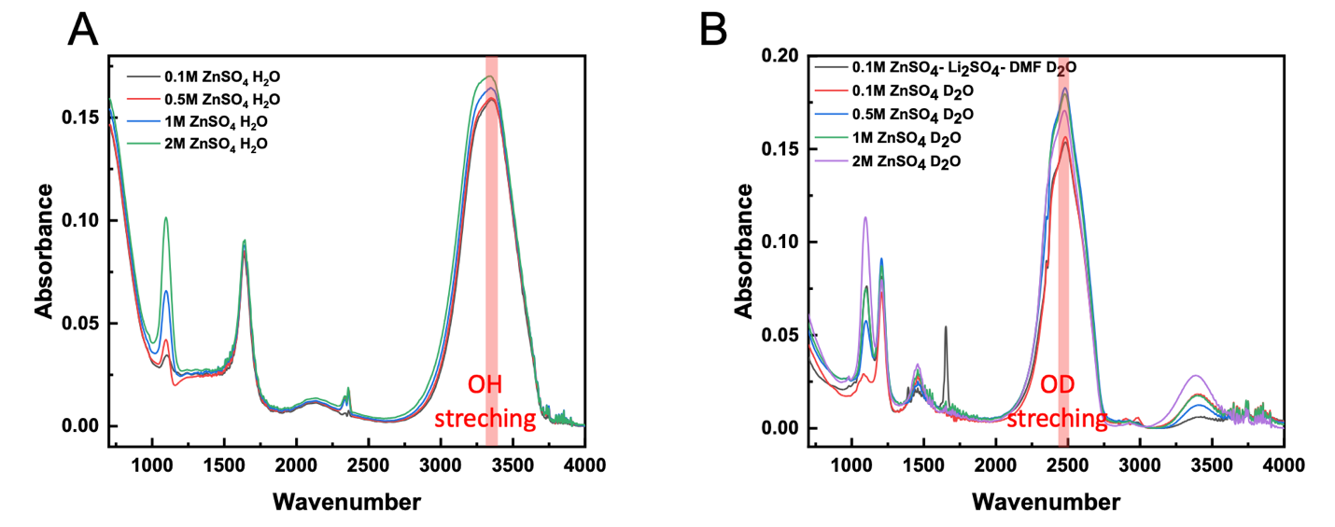Supplementary Fig. 2. The effect of Zn²⁺ concentration on the water reactivity. Fourier Transform Infrared Spectroscopy (FTIR) spectra between 700 and 4,000 cm⁻¹ with different salt concentrations in (A) H₂O-based electrolyte and (B) D₂O-based electrolyte.²
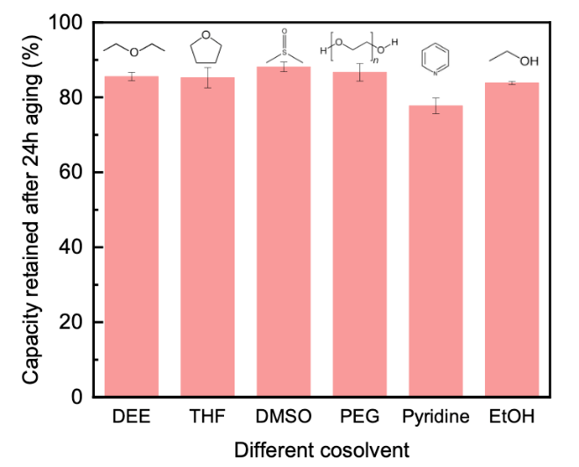
Supplementary Fig. 3. Calendar aging performance using cosolvent electrolyte –– 1 M ZnSO₄ in H₂O/cosolvent mixture (with volume ratio 8:2). CE after 24 h aging using various organice cosolvent including Diethyle ether (DEE), Tetrahydrofuran (THF), Dimethyl sulfoxide (DMSO), Polyethylene glycol (PEG 400), Pyridine, Ethanol (EtOH) (with a Zn deposition capacity of 1 mAh·cm⁻² at 25 °C under 1mA·cm⁻² current density, using graphite paper as substrate).

Supplementary Fig. 4. Tafel analysis. (A-B) Tafel plot of different electrolytes derived by LSV measurements. (C) Representative LSV data.

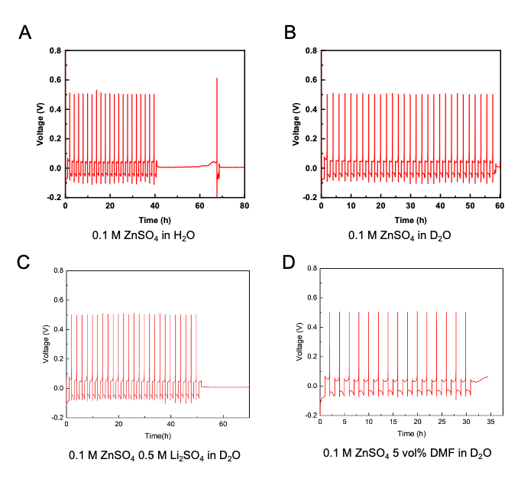
Supplementary Fig. 5. Long-term stability in electrolytes with ultralow Zn²⁺ concentration. Voltage profiles of Zn stripping and plating in (A) 0.1 M ZnSO₄ in H₂O, (B) 0.1 M ZnSO₄ in D₂O, (C) 0.1 M ZnSO₄ + 0.5 M Li₂SO₄ in D₂O, and (D) 0.1 M ZnSO₄ + 5 vol% DMF in D₂O at 1 mA cm⁻² and 1 mAh cm⁻².
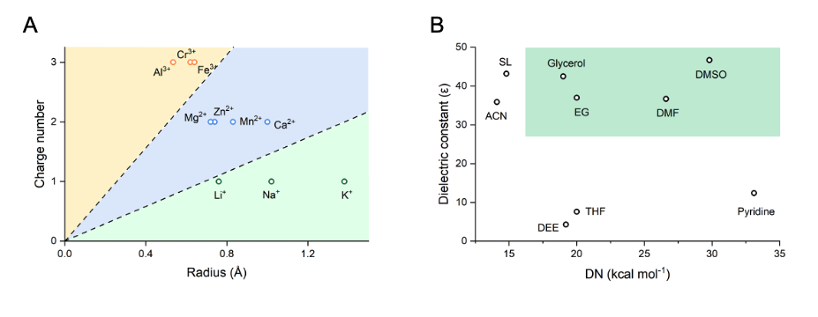
Supplementary Fig. 6. Selection of cations and organic additives. (A) Different cations with their ionic potentials. (B) Organic molecules with different dielectric constant and DN.

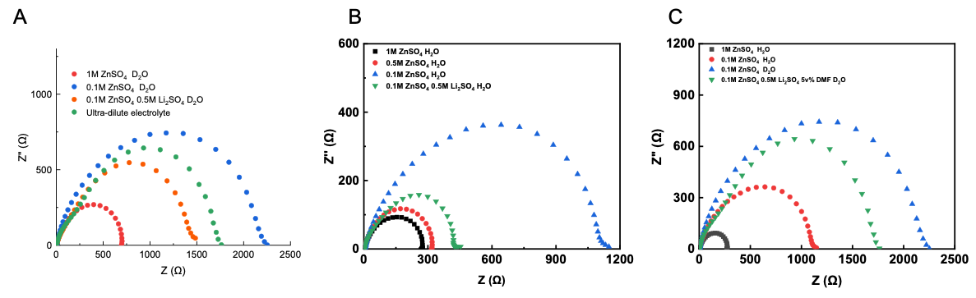
Supplementary Fig. 7. Cation concentration effects on electrolyte ionic conductivity. (A) Comparison of D₂O-based electrolyte ion-transport resistance with decreasing Zn²⁺ concentration. (B) Water-based electrolyte with different Zn²⁺ concentrations and the presence of Li⁺ supporting salt. (C) Comparison between H₂O and D₂O as solvents, with and without additive and supporting salt.

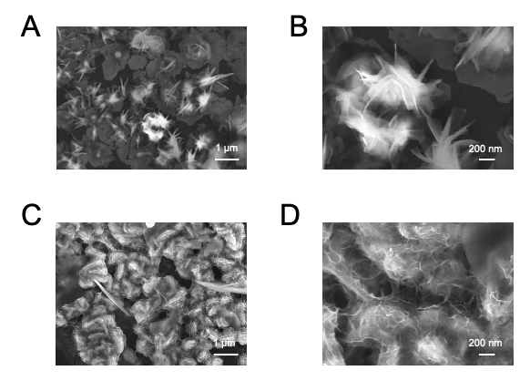
Supplementary Fig. 8. Zn deposition morphology at 1 mA cm⁻² and 1 mAh cm⁻². (A and B) 2 M ZnSO₄ in H₂O and (C and D) 0.1 M ZnSO₄+0.5 M Li₂SO₄+5 vol% DMF in D₂O electrolyte.

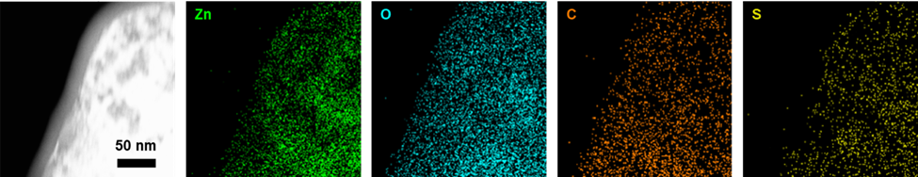
Supplementary Fig. 9. Incorporating DMF to facilitate stable SEI formation. TEM-EDS images displaying Zn, O, C, and S distributions.

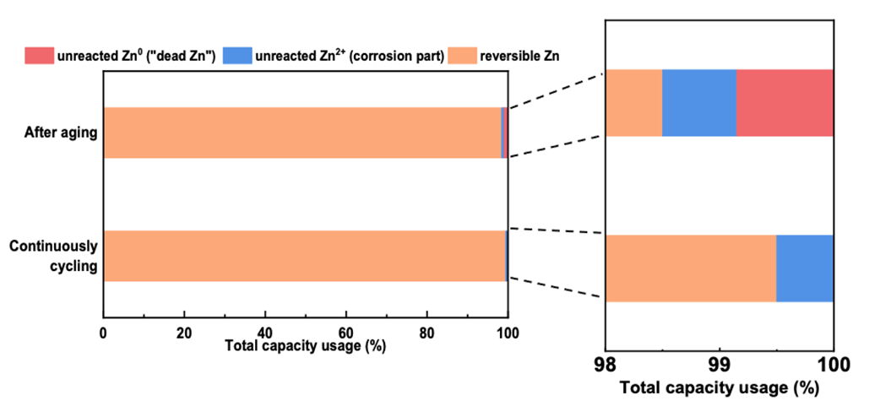
Supplementary Fig. 10. TGC Quantification of inactive Zn species left after stripping by the TGC method with ultra-dilute concentration electrolyte (0.1 M ZnSO₄ + 0.5 M Li₂SO₄ + 5 vol% DMF) under 1 mA cm⁻² and 1 mAh cm⁻² on graphite paper substrate. The percentage of unreacted Zn⁰, unreacted Zn²⁺, and reversible Zn.
The aging sample was collected after undergoing one cycle followed by a 24-hour aging protocol. The continuously cycled sample was obtained after completing two consecutive cycles.
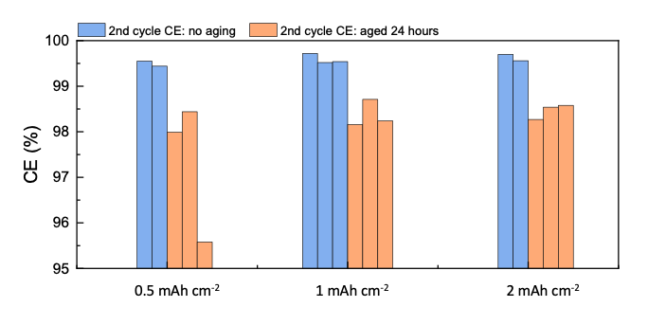
Supplementary Fig. 11. Comprehensive analysis of calendar aging performance. CE without aging (blue bar) and CE after 24 h aging (orange bar) under varying Zn deposition capacities.

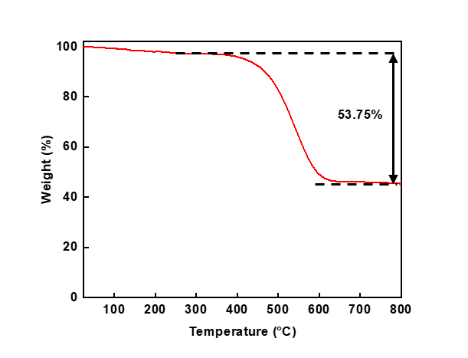
Supplementary Fig. 12. Characterizations of the as-prepared ZMO/C cathode material.
TG analysis.

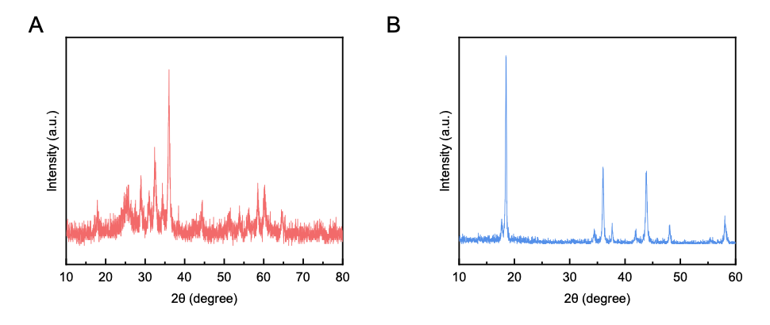
Supplementary Fig. 13. XRD patterns of different cathode materials. (A) ZnMn₂O₄ (ZMO). (B) LiMn₂O₄ (LMO).

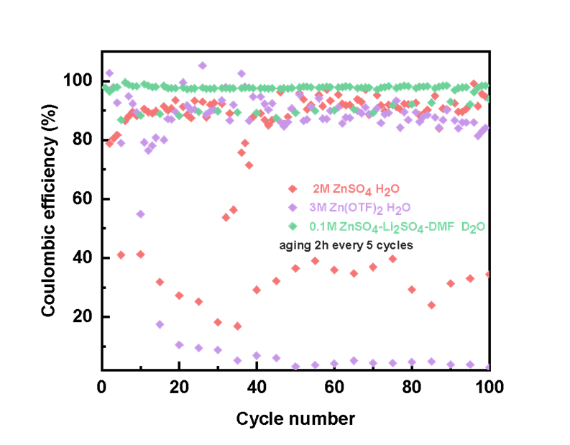
Supplementary Fig. 14. CE of Graphite paper|ZMO anode-free cell in various electrolytes.

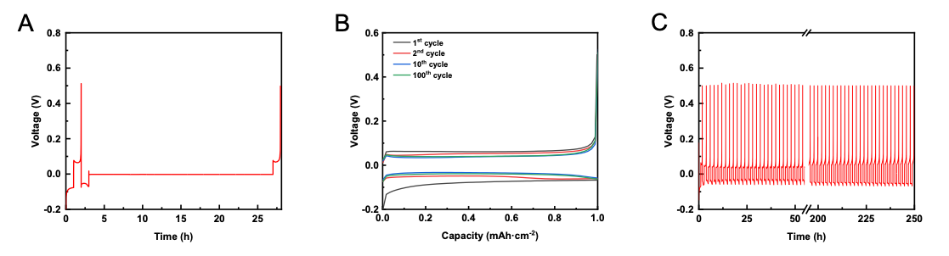Supplementary Fig. 15. Voltage profiles of 1 mAh cm⁻² plated Zn metal on graphite paper substrate. (A) Voltage profile with 24 h calendar aging. (B) Voltage profile without calendar aging. (C) Overall voltage profile.

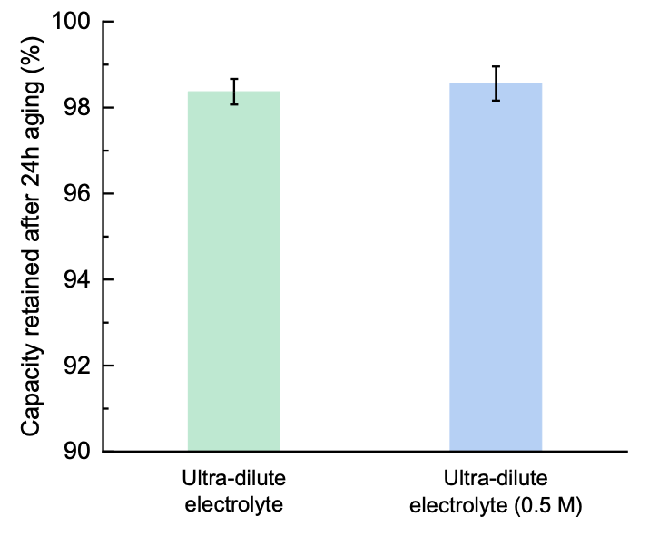
Supplementary Fig. 16. Capacity retained comparison after 24 h calendar aging with ultra-dilute electrolyte, where 0.5 M ZnSO₄ + 0.5 M Li₂SO₄ + 5 vol% DMF is denoted as ultra-dilute electrolyte (0.5 M).
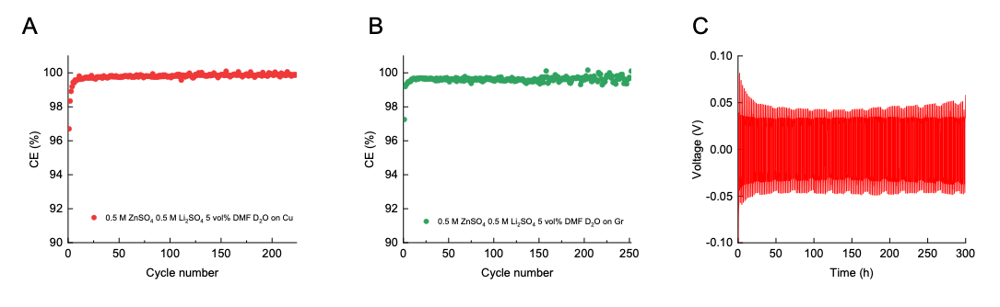
Supplementary Fig. 17. Comprehensive analysis of ultra-dilute electrolyte (0.5 M ZnSO₄). (A) CE performance at 1 mA cm⁻² and 1 mAh cm⁻² using Cu foil as substrate. (B) CE performance at 1 mA cm⁻² and 1 mAh cm⁻² using graphite paper as substrate. (C) Zn anode stability test at 1 mA cm⁻² and 1 mAh cm⁻².

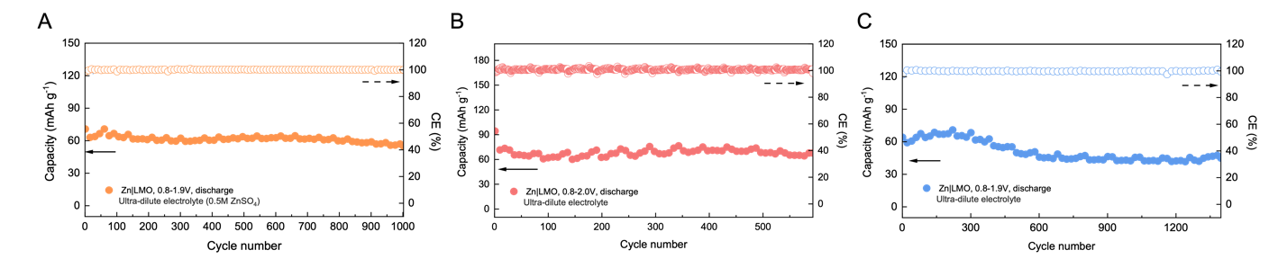
Supplementary Fig. 18. Zn|LMO hybrid cell cycling performance under different conditions. (A) Cycling performance of the Zn|LMO full cell using ultra-dilute electrolyte (0.5 M) with cut-off voltage 0.8-1.9 V at a 2 C charge/discharge rate. (B) Cycling performance of the Zn|LMO full cell using ultra-dilute electrolyte with cut-off voltage 0.8-2.0 V at a 2.8 C charge/discharge rate. (C) Cycling performance of the Zn|LMO full cell using with cut-off voltage 0.8-1.9 V at a 4 C charge/discharge rate.
Supplementary Tables
Supplementary Table 1. Free energy of complexes in water solvent relative to Zn(H₂O)₆ and Li(H₂O)₄ respectively.³
Complex | ∆G (kcal/mol)
Zn(H₂O)₆ | 0
Zn(H₂O)₅(H₂O) | -0.724
Li(H₂O)₄ | 0
Li(H₂O)₃(H₂O) | -0.543

References
1. Liu, E. et al. Unifying the Hydrogen Evolution and Oxidation Reactions Kinetics in Base by Identifying the Catalytic Roles of Hydroxyl-Water-Cation Adducts. J. Am. Chem. Soc. 141, 3232-3239 (2019).
2. Belhadj, H., Melchers, S., Robertson, P.K.J. & Bahnemann, D.W. Pathways of the photocatalytic reaction of acetate in H2O and D2O: A combined EPR and ATR-FTIR study. J. Catal. 344, 831-840 (2016).
3. Wang, F. et al. Highly reversible zinc metal anode for aqueous batteries. Nat Mater 17, 543-549 (2018).

