Using distribution and movement of invasive channel catfish Ictalurus punctatus in the San Juan River to inform removal efforts

Biological Invasions

Keegan C. Epping^{1*} (0009-0003-3522-8451), Keith Gido¹ (0000-0002-4342-161X), Rachel E. Grey², Stephani L. Clark Barkalow^{3,4} (0000-0002-1456-3563), Sophia M. Bonjour^{1,5} (0000-0003-3614-7023), John Cleveland^{1,6}(0009-0005-0742-5508), Justin Furby⁷, Casey A. Pennock⁷(0000-0002-3547-6477), Matthew Bogaard^{1,8} (0000-0002-3054-5314), Tracy A. Diver^{2,9} (0000-0001-9730-223X)

¹Kansas State University, Division of Biology, 116 Ackert Hall, 1717 Claflin Rd, Manhattan, KS 66506, United States

²U.S. Fish and Wildlife Service, New Mexico Fish and Wildlife Conservation Office, 3800 Commons Ave, NE, Albuquerque, NM 87109, United States

³American Southwest Ichthyological Researchers, 800 Encino Pl NE, Albuquerque, NM 87102, United States

⁴U.S. Fish and Wildlife Service, San Juan River Basin Recovery Implementation Program, 2105 Osuna Road NE, Albuquerque, NM 87113, United States

⁵U.S. Geological Survey, Columbia Environmental Research Center, 4200 New Haven Rd, Columbia, MO 65201, United States

⁶Maryland Department of Natural Resources, 301 Marine Academy Drive, Stevensville, Maryland 21666, United States

⁷The Ohio State University, Department of Evolution, Ecology, and Organismal Biology and Aquatic Ecology Laboratory, 1314 Kinnear Road, Columbus, OH 43212, United States

⁸Washington Department of Fish and Wildlife, Intergovernmental Salmon Management Unit, 1111 Washington St SE, Olympia, WA, 98502, United States

⁹U.S. Fish and Wildlife Service, Southwestern Native Aquatic Resources and Recovery Center, 7116 Hatchery Rd, Dexter, New Mexico 88230, United States

Corresponding author email: keegan.epping@gmail.com

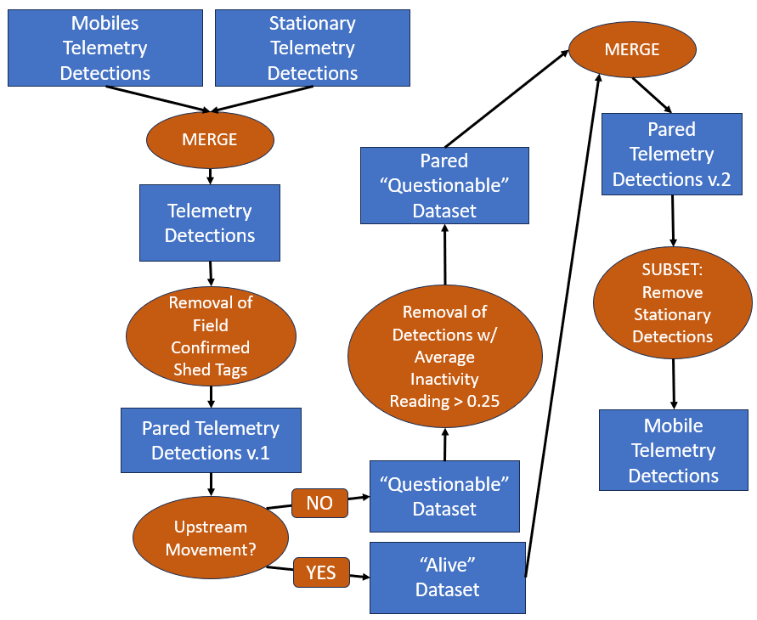
Online Resource 1. Flow chart used to filter all telemetry detections from channel catfish Ictalurus punctatus from the San Juan River. All detections were filtered to remove observations suspected to be associated with shed tags. Filtering of detections consisted of 1) removing detections that occurred following field confirmation of a shed tag, 2) creating a “questionable” dataset of the detections obtained since the last occurrence of upstream movement (as we assumed upstream movement to indicate a live-tagged fish), and 3) removing detections from the “questionable” dataset using average inactivity readings obtained from radio transmitters. Inactivity readings obtained from all detections of a transmitter are registered as a 0, 1, or 2 (0: active within 4 hours; 1: no activity from previous 4 hours; 2: no activity from previous 8 hours). A threshold of 0.25 was used to remove suspected shed tags based on comparisons between average activity reading and transmitters with a known fate.

