Supplementary Information
Figures
Supplementary Figure 1: Changing correlation between coverage of skilled birth attendants and maternal mortality ratio, neonatal mortality ratio 2
Supplementary Figure 2: Prevalence of skilled birth attendance in Nepal, Senegal, and Zambia, compared to the average skilled birth attendance level in their region 8
Supplementary Figure 3: Methods diagram 11
Supplementary Figure 4: Bivariate correlations between ENMR and individual indicators 12
Tables
Supplementary Table 1: Full list of proposed indicators 14
Supplementary Table 2: Data sources for 39 included indicators by country 18
Supplementary Table 3A: Description of sensitivity analyses 25
Supplementary Table 3B: List and number of types of sensitivity analyses across three categories 25
Supplementary Table 4A: Ranks of indicators across 16 sensitivity analyses 27
Supplementary Table 4B: Average, standard deviation, range, and count of indicators across 16 sensitivity analyses, sorted by average rank across sensitivity analyses 29

Supplementary Figure 1: Changing correlation between coverage of skilled birth attendants and maternal mortality ratio, neonatal mortality ratio
Published model estimates (references in manuscript) were used to demonstrate the changing correlation between coverage of skilled birth attendants (SBA) and maternal or neonatal mortality (MMR or NMR). In many low- and middle-income countries (61 LMICs for MMR, 50 LMICs for NMR), we observed that the correlation between these variables was strongly negative in earlier years, but less so in more recent years. In other words, as SBA coverage increases, the corresponding decrease in MMR and NMR has been declining over time in many countries.
The below figures and tables demonstrate this trend for MMR and NMR respectively. In the figures, only select countries are displayed. In the tables, columns 2-4 display estimates of SBA coverage in 2000, 2010 and 2021 respectively, columns 5-7 display estimates of MMR or NMR in 2000, 2010 and 2021 respectively, column 8 displays an ordinary least squares coefficient (regression slope) between SBA and MMR or NMR between 2000 and 2010 (inclusive of estimates for all years in between, not displayed), column 9 displays the same coefficient for the period 2011 to 2021. Both tables display all LMICs in which the regression slope was more negative in the earlier time frame than the later time frame.
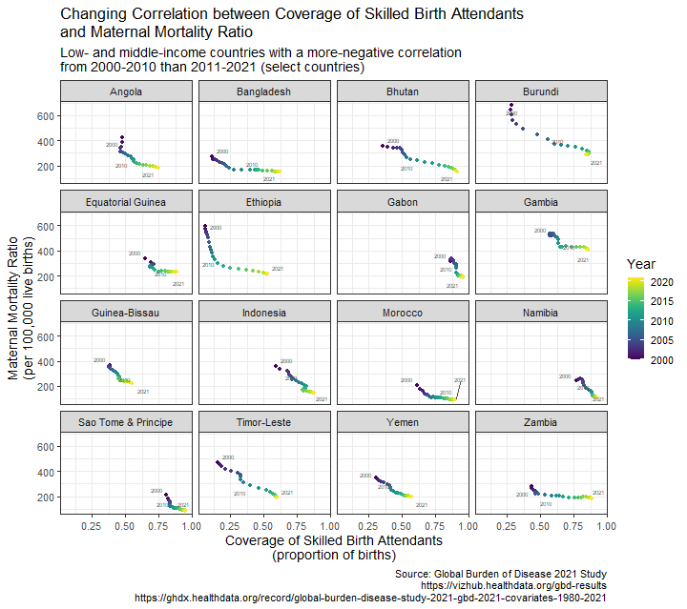
Country | SBA Coverage 2000 (proportion) | SBA Coverage 2010 (proportion) | SBA Coverage 2021 (proportion) | MMR 2000 (per 100,000 live births) | MMR 2010 (per 100,000 live births) | MMR 2021 (per 100,000 live births) | Regression Slope, 2000-2010 | Regression Slope, 2011-2021
Algeria | 0.92 | 0.96 | 0.98 | 136 | 89 | 64 | -1098 | -1042
Angola | 0.48 | 0.55 | 0.75 | 427 | 260 | 184 | -973 | -279
Armenia | 0.98 | 1.00 | 1.00 | 24 | 12 | 11 | -321 | 2319
Bangladesh | 0.11 | 0.34 | 0.62 | 271 | 166 | 148 | -481 | -82
Belarus | 0.99 | 1.00 | 0.99 | 20 | 14 | 9 | -2657 | 820
Bhutan | 0.36 | 0.61 | 0.91 | 353 | 238 | 154 | -508 | -300
Bolivia | 0.62 | 0.78 | 0.81 | 298 | 236 | 202 | -331 | -71
Brazil | 0.97 | 0.99 | 0.99 | 62 | 61 | 60 | 29 | 74
Bulgaria | 0.99 | 0.99 | 1.00 | 21 | 12 | 7 | -2129 | -732
Burundi | 0.28 | 0.71 | 0.84 | 684 | 353 | 285 | -656 | -495
Cambodia | 0.36 | 0.81 | 0.93 | 389 | 187 | 139 | -433 | -296
Chad | 0.14 | 0.20 | 0.32 | 605 | 545 | 452 | -794 | -722
Colombia | 0.88 | 0.96 | 0.98 | 71 | 56 | 65 | -142 | 470
Comoros | 0.70 | 0.85 | 0.90 | 273 | 151 | 190 | -804 | 548
Costa Rica | 0.98 | 0.99 | 0.99 | 41 | 37 | 27 | -2043 | -34
Cuba | 0.99 | 0.99 | 1.00 | 52 | 44 | 46 | -744 | 1095
Djibouti | 0.91 | 0.93 | 0.96 | 726 | 623 | 502 | -3484 | -3361
Dominica | 0.98 | 0.98 | 0.99 | 42 | 68 | 90 | -192 | 2921
Dominican Republic | 0.98 | 0.98 | 0.99 | 71 | 96 | 97 | -1899 | 1146
Egypt | 0.67 | 0.89 | 0.96 | 68 | 41 | 34 | -128 | -103
El Salvador | 0.99 | 0.99 | 1.00 | 43 | 58 | 43 | -5590 | -998
Equatorial Guinea | 0.65 | 0.68 | 0.88 | 342 | 278 | 232 | -445 | -165
Eritrea | 0.31 | 0.34 | 0.56 | 599 | 544 | 425 | -769 | -507
Ethiopia | 0.06 | 0.12 | 0.53 | 599 | 354 | 218 | -4106 | -224
Fiji | 0.98 | 0.99 | 0.99 | 138 | 106 | 99 | -2793 | 546
Gabon | 0.86 | 0.90 | 0.96 | 318 | 227 | 186 | -1421 | -583
Gambia | 0.58 | 0.63 | 0.86 | 521 | 486 | 407 | -502 | -119
Ghana | 0.48 | 0.64 | 0.85 | 201 | 187 | 177 | -85 | 13
Guatemala | 0.50 | 0.62 | 0.77 | 192 | 118 | 158 | -510 | 211
Guinea-Bissau | 0.38 | 0.44 | 0.55 | 366 | 298 | 223 | -1002 | -465
Honduras | 0.59 | 0.82 | 0.80 | 180 | 151 | 114 | -115 | 310
Indonesia | 0.59 | 0.79 | 0.88 | 359 | 220 | 145 | -780 | -458
Jamaica | 0.98 | 0.99 | 0.99 | 62 | 56 | 74 | -818 | 1656
Kiribati | 0.82 | 0.80 | 0.91 | 202 | 192 | 181 | -100 | -86
Korea (DPR) | 0.97 | 1.00 | 1.00 | 82 | 78 | 58 | -94 | 5140
Lao PDR | 0.32 | 0.40 | 0.65 | 449 | 261 | 153 | -522 | -413
Lebanon | 0.98 | 0.99 | 1.00 | 22 | 16 | 15 | -453 | -393
Malaysia | 0.94 | 0.99 | 0.99 | 77 | 64 | 66 | -266 | 2462
Marshall Islands | 0.94 | 0.87 | 0.95 | 112 | 132 | 123 | -157 | -99
Mexico | 0.90 | 0.98 | 0.99 | 62 | 47 | 46 | -152 | 206
Mongolia | 0.98 | 0.99 | 1.00 | 118 | 58 | 39 | -8469 | -1172
Morocco | 0.61 | 0.75 | 0.90 | 208 | 112 | 92 | -738 | -133
Namibia | 0.77 | 0.88 | 0.92 | 242 | 156 | 111 | -992 | -683
Palau | 1.00 | 1.00 | 1.00 | 254 | 311 | 319 | -4272538 | -379424
Paraguay | 0.79 | 0.93 | 0.94 | 116 | 102 | 97 | -118 | -89
Peru | 0.63 | 0.88 | 0.95 | 153 | 103 | 91 | -222 | -22
Philippines | 0.60 | 0.64 | 0.91 | 88 | 87 | 82 | -90 | -8
Russian Federation | 0.99 | 1.00 | 1.00 | 43 | 20 | 11 | -4283 | -2071
Saint Vincent and the Grenadines | 0.99 | 0.99 | 0.99 | 58 | 71 | 94 | 2183 | 2854
Samoa | 0.78 | 0.82 | 0.88 | 35 | 26 | 27 | -349 | 10
Sao Tome & Principe | 0.81 | 0.85 | 0.95 | 209 | 115 | 87 | -2416 | -288
Syrian Arab Republic | 0.76 | 0.94 | 0.92 | 60 | 27 | 34 | -136 | -67
Tajikistan | 0.87 | 0.88 | 0.96 | 45 | 28 | 25 | -199 | -38
Timor-Leste | 0.16 | 0.40 | 0.60 | 472 | 285 | 190 | -703 | -578
Turkiye | 0.83 | 0.97 | 0.99 | 75 | 22 | 26 | -310 | 527
Vanuatu | 0.87 | 0.79 | 0.91 | 85 | 85 | 80 | -59 | -45
Venezuela | 0.98 | 0.97 | 0.97 | 65 | 70 | 104 | 622 | 7838
Viet Nam | 0.85 | 0.93 | 0.97 | 25 | 18 | 17 | -96 | -26
Yemen | 0.30 | 0.44 | 0.57 | 346 | 239 | 195 | -721 | -292
Zambia | 0.44 | 0.62 | 0.88 | 282 | 201 | 182 | -338 | -45
Zimbabwe | 0.72 | 0.66 | 0.86 | 229 | 362 | 288 | -1789 | -249

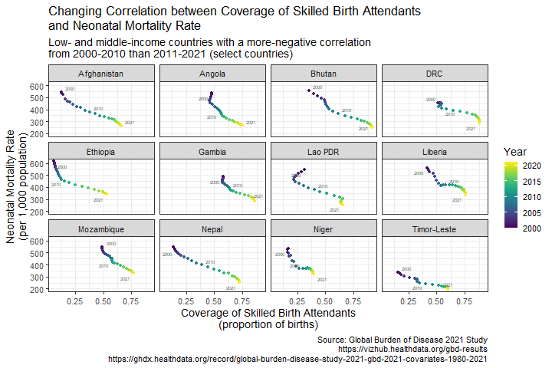
Country | SBA Coverage 2000 (proportion) | SBA Coverage 2010 (proportion) | SBA Coverage 2021 (proportion) | NMR 2000 (per 100,000 population) | NMR 2010 (per 100,000 population) | NMR 2021 (per 100,000 population) | Regression Slope, 2000-2010 | Regression Slope, 2011-2021
Afghanistan | 0.13 | 0.38 | 0.66 | 54328 | 37667 | 26416 | -13592 | -8295
Angola | 0.48 | 0.55 | 0.75 | 53897 | 38298 | 26731 | -30964 | -10380
Bangladesh | 0.11 | 0.34 | 0.62 | 57011 | 43092 | 25220 | -10660 | -7843
Belarus | 0.99 | 1.00 | 0.99 | 11918 | 5494 | 2602 | -322060 | 42015
Belize | 0.93 | 0.96 | 0.98 | 19099 | 14284 | 11429 | -30958 | -18328
Bhutan | 0.36 | 0.61 | 0.91 | 55895 | 36638 | 24779 | -11833 | -4806
Bolivia | 0.62 | 0.78 | 0.81 | 34899 | 25761 | 18229 | -10895 | -9434
Bulgaria | 0.99 | 0.99 | 1.00 | 10217 | 7166 | 4187 | -142545 | -107674
Cameroon | 0.57 | 0.66 | 0.77 | 42201 | 37324 | 30205 | -11298 | -9424
Chad | 0.14 | 0.20 | 0.32 | 55357 | 49122 | 44272 | -21027 | -11080
Costa Rica | 0.98 | 0.99 | 0.99 | 9738 | 8996 | 7891 | -31773 | -6875
Cuba | 0.99 | 0.99 | 1.00 | 5436 | 3491 | 2500 | -70201 | -10533
DRC | 0.53 | 0.54 | 0.88 | 45738 | 41098 | 28840 | -21575 | -8147
Djibouti | 0.91 | 0.93 | 0.96 | 36971 | 31022 | 21272 | -54020 | -51785
Dominica | 0.98 | 0.98 | 0.99 | 14726 | 18174 | 21173 | 12559 | 44433
Ecuador | 0.94 | 0.99 | 0.99 | 20501 | 14971 | 9585 | -22077 | 120152
Equatorial Guinea | 0.65 | 0.68 | 0.88 | 44798 | 30533 | 23507 | -5862 | -5695
Ethiopia | 0.06 | 0.12 | 0.53 | 61401 | 47745 | 33895 | -51937 | -4569
Gambia | 0.58 | 0.63 | 0.86 | 48826 | 39004 | 28620 | -19630 | -4957
Grenada | 0.99 | 0.99 | 0.99 | 12736 | 11725 | 10555 | -57995 | -53406
Guatemala | 0.50 | 0.62 | 0.77 | 21810 | 14683 | 11543 | -7899 | -3572
Guinea-Bissau | 0.38 | 0.44 | 0.55 | 65778 | 52664 | 36823 | -41083 | -15312
Honduras | 0.59 | 0.82 | 0.80 | 22198 | 18170 | 11441 | -3332 | 9289
Korea (DPR) | 0.97 | 1.00 | 1.00 | 16496 | 14018 | 6895 | -248313 | 177518
Lao PDR | 0.32 | 0.40 | 0.65 | 54366 | 37860 | 25482 | -10387 | -9260
Lesotho | 0.59 | 0.70 | 0.87 | 46023 | 43472 | 39762 | -5502 | -5059
Liberia | 0.42 | 0.58 | 0.76 | 56152 | 41986 | 33808 | -31354 | -11242
Libya | 0.92 | 0.99 | 1.00 | 16853 | 12941 | 13355 | -5909 | 93323
Mauritius | 0.99 | 1.00 | 1.00 | 15010 | 11621 | 10515 | -26029 | 37305
Mongolia | 0.98 | 0.99 | 1.00 | 24591 | 18519 | 10998 | -232529 | -66222
Montenegro | 0.99 | 0.99 | 0.99 | 10778 | 5942 | 3190 | -9823 | 18106
Morocco | 0.61 | 0.75 | 0.90 | 35522 | 24066 | 12251 | -13654 | -8898
Mozambique | 0.49 | 0.58 | 0.77 | 54864 | 43870 | 32824 | -31649 | -12510
Nepal | 0.13 | 0.39 | 0.72 | 54503 | 39834 | 25302 | -8728 | -5472
Niger | 0.17 | 0.30 | 0.39 | 53575 | 36648 | 32558 | -29723 | -17263
Philippines | 0.60 | 0.64 | 0.91 | 20312 | 18165 | 13990 | -7913 | -1852
Russian Federation | 0.99 | 1.00 | 1.00 | 13528 | 6864 | 3819 | -166695 | -146140
Samoa | 0.78 | 0.82 | 0.88 | 11489 | 9164 | 7745 | -6151 | -3291
Sao Tome & Principe | 0.81 | 0.85 | 0.95 | 29845 | 22092 | 11922 | -50264 | -18917
Serbia | 0.99 | 0.99 | 1.00 | 13354 | 6078 | 4367 | -141968 | -44432
South Sudan | 0.22 | 0.43 | 0.32 | 56380 | 55147 | 55354 | -4287 | -3079
Suriname | 0.85 | 0.94 | 0.99 | 29214 | 23562 | 19513 | -9735 | -5248
Tajikistan | 0.87 | 0.88 | 0.96 | 29920 | 25758 | 20687 | -8571 | -5973
Tanzania | 0.43 | 0.56 | 0.75 | 43332 | 37996 | 29690 | -24894 | -11105
Timor-Leste | 0.16 | 0.40 | 0.60 | 33976 | 24128 | 19531 | -9816 | -4781
Uganda | 0.39 | 0.62 | 0.82 | 43854 | 39019 | 30035 | -10076 | -9092
Venezuela | 0.98 | 0.97 | 0.97 | 15534 | 14391 | 15336 | 19535 | 43395
Yemen | 0.30 | 0.44 | 0.57 | 47557 | 36095 | 26023 | -18480 | -11832
Zambia | 0.44 | 0.62 | 0.88 | 40789 | 36834 | 25927 | -15444 | -8358
Zimbabwe | 0.72 | 0.66 | 0.86 | 27046 | 34588 | 30868 | -8046 | -7478

Supplementary Figure 2: Prevalence of skilled birth attendance in Nepal, Senegal, and Zambia, compared to the average skilled birth attendance level in their region

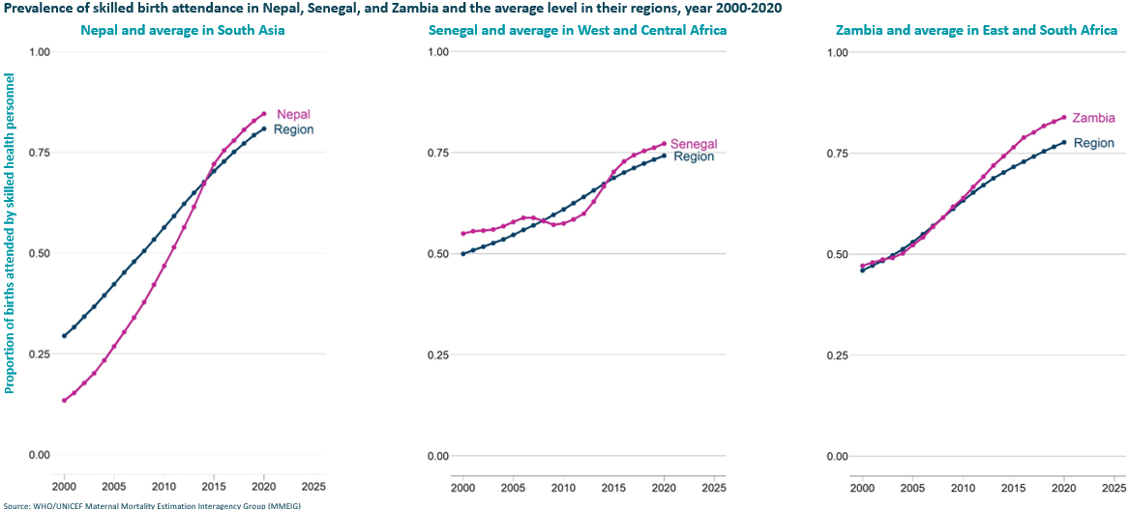
Please note that the dip in SBA in Senegal is likely linked to national political shifts, irregular data reporting, and health worker strikes during this time period.

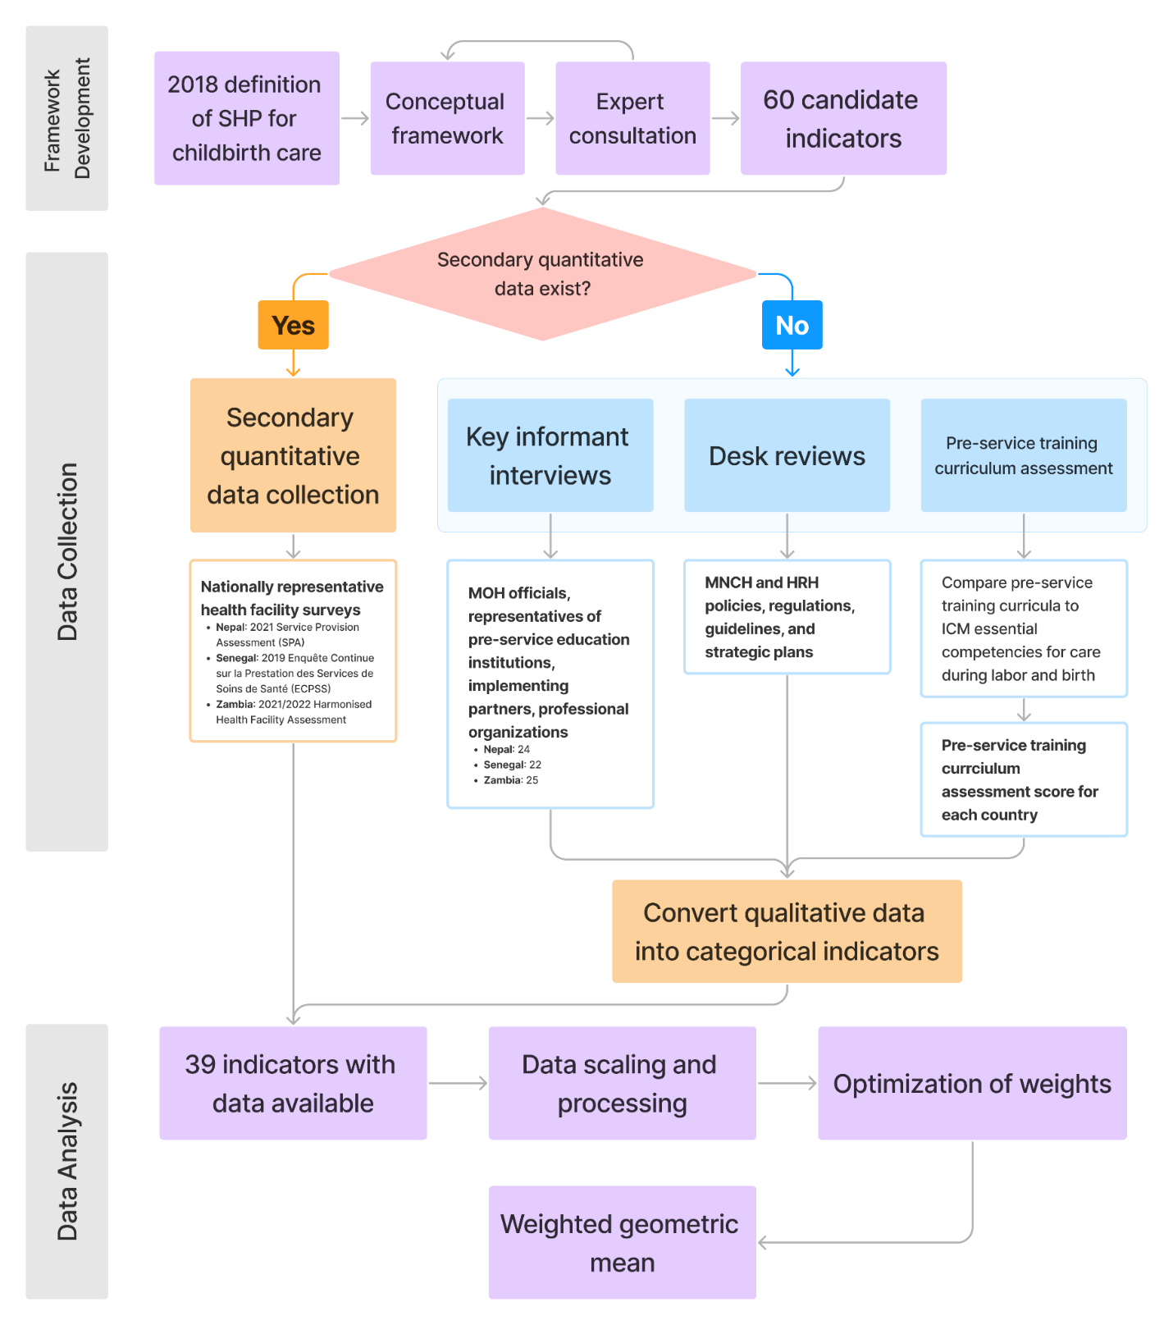
Supplementary Figure 3:
Methods diagram

Supplementary Figure 4: Bivariate correlations between ENMR and individual indicators
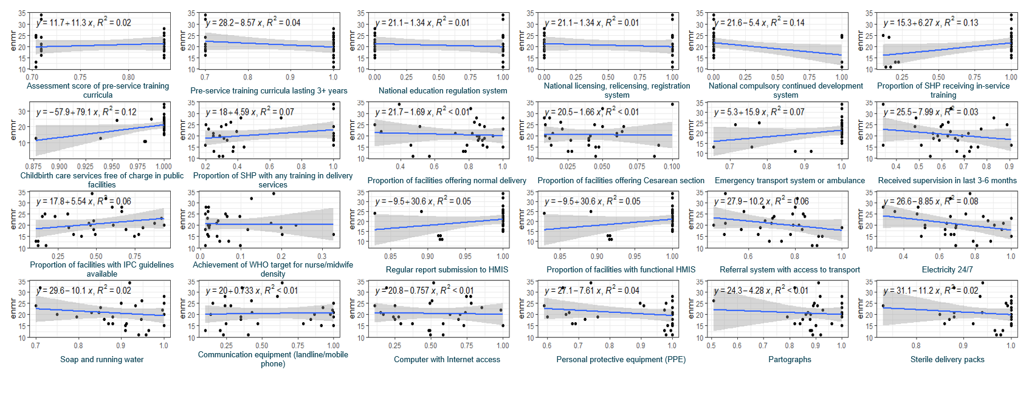
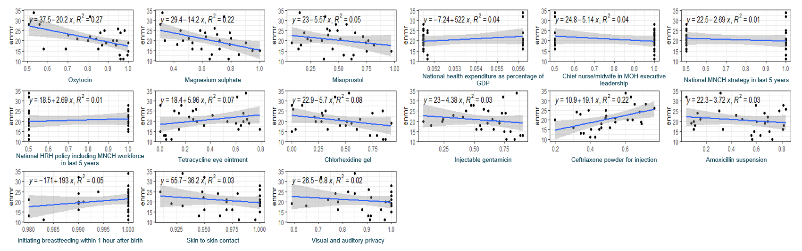

Supplementary Table 1: Full list of proposed indicators
Indicator Number | Category | Indicator name
1 | Education/training | Intrapartum care providers are educated to national and international standards of practice (%)
2 | Education/training | Pre-service training curriculum mapping score (%)
3 | Education/training | Pre-service training programs that are at least 3 years long (%)
4 | Regulation | Intrapartum care providers fulfil the registration, licensing and relicensing as required at national level (%)
5 | Regulation | Functioning national education regulation system(s) is/are in place
6 | Regulation | Formal process for licensing and relicensing are in place
7 | Continuing professional development (training) | The provision of opportunities for continuing education and training to maintain and upgrade intrapartum care competencies (e.g., in-service training) (%)
8 | Continuing professional development (training) | Does a system of compulsory continued professional development exist? (Yes/No)
9 | Continuing professional development (training) | Do (or did) MOH offer any in-service training related to intrapartum care? (e.g., in the last 5 or 10 years)
10 | Continuing professional development (training) | Who are responsible for in-service training?
11 | Continuing professional development (training) | Are any policy documents available which outline in-service requirements?
12 | Service delivery | Childbirth care is provided free of charge in public facilities (part of UHC) (%)
13 | Service delivery | Staff trained in delivery service
14 | Service delivery | Facilities offering normal delivery service (%)
15 | Service delivery | Facilities offering C-section (%)
16 | Service delivery | Intrapartum guidelines are implemented
17 | Service delivery | A referral system is in place with access to transportation
18 | Service delivery | Which intrapartum care providers are considered part of an “integrated team of MNH professionals”
19 | Service delivery | percent of facilities offering normal delivery with guidelines for childbirth care
20 | Service delivery | Number of maternity beds per 1000 pregnant women
21 | Health workforce | Nurses/midwives per 10 000 population
22 | Health workforce | Density of nurse/ midwives against national target
23 | Health workforce | Midwives per 10,000 population
24 | Health workforce | Midwives per 1,500 women of reproductive age
25 | Health workforce | Obstetricians per 10,000 population
26 | Health workforce | Doctors per 10 000 population (specialist medical practitioner ISCO 2212)
27 | Health workforce | Rural/urban and public/private distribution of intrapartum care providers per 10 000 population
28 | Information systems | Number of district MPDSR hospitals
29 | Information systems | Number of hospitals with MPDSR
30 | Information systems | National and/or sub-national MPSDR systems in place
31 | Information systems | Facilities with regular HMIS reporting
32 | Information systems | Number of public facilities
33 | Information systems | Functional Health Management Information Systems (HMIS)
34 | Medical products, vaccines and technologies | Transport system in place (ambulance services) including emergency transport in all facilities (%)
35 | Medical products, vaccines and technologies | Electricity service is available 24/7 in all facilities (%)
36 | Medical products, vaccines and technologies | Running water and soap available in all facilities (%)
37 | Medical products, vaccines and technologies | Communication equipment (landline/mobile phone) in all facilities (%)
38 | Medical products, vaccines and technologies | Computer with Internet access in all facilities (%)
39 | Medical products, vaccines and technologies | PPE available (medical masks, gloves, eye protection, gowns) in all facilities (%)
40 | Medical products, vaccines and technologies | Partographs available in all facilities (%)
41 | Medical products, vaccines and technologies | Sterile delivery pack available in all facilities (%)
42 | Medical products, vaccines and technologies | Essential drugs in stock: oxytocin in all facilities (%)
43 | Medical products, vaccines and technologies | Essential drugs in stock: magnesium sulphate in all facilities (%)
44 | Medical products, vaccines and technologies | Essential drugs in stock: misoprostol in all facilities (%)
45 | Medical products, vaccines and technologies | Blood sufficiency
46 | Medical products, vaccines and technologies | Essential drugs in stock: Tetracycline eye ointment in all facilities (%)
47 | Medical products, vaccines and technologies | Essential drugs in stock: 4% chlorhexidine gel in all facilities (%)
48 | Medical products, vaccines and technologies | Essential drugs in stock: Injectable gentamicin in all facilities (%)
49 | Medical products, vaccines and technologies | Essential drugs in stock: Ceftriaxone powder for injection in all facilities (%)
50 | Medical products, vaccines and technologies | Essential drugs in stock: Amoxicillin suspension in all facilities (%)
51 | Financing | Intrapartum care providers are paid regularly (e.g., monthly) (%)
52 | Financing | Current health expenditure (CHE) as percentage of gross domestic product (GDP) (%)
53 | Leadership and governance | Full time government Chief Nurse/Midwife Officer in MoH (yes, no, other)
54 | Leadership and governance | Was a national strategy for MNCH issued in the last 5 years?
55 | Leadership and governance | Was a national human resources strategy issued in the last 5 years that includes MNCH workforce planning?
56 | Realization of behaviors illustrating quality of care | Initiate breastfeeding within 1 hour (%)
57 | Realization of behaviors illustrating quality of care | Skin to skin contact (%)
58 | Realization of behaviors illustrating quality of care | Visual and auditory privacy (%)
59 | Realization of behaviors illustrating quality of care | Recent supervision of staff (%)

Supplementary Table 2: Data sources for 39 included indicators by country
Construct |  |  | Indicator Full Name |  |  | Indicator Short Name |  |  |  |  |  |  | Indicator Type |  |  |  |  | Country |  |  |  |  | Data Source |  | Source Year
Education |  |  | Scores from the assessment of pre-service training curricula against ICM criteria |  |  | preservice_score_pct |  |  |  |  |  |  | Proportional |  |  |  |  | Nepal |  |  |  |  | Assessment conducted by study team members |  | 2023
 |  |  |  |  |  |  |  |  |  |  |  |  |  |  |  |  |  | Senegal |  |  |  |  | Assessment conducted by study team members |  | 2023
 |  |  |  |  |  |  |  |  |  |  |  |  |  |  |  |  |  | Zambia |  |  |  |  | Assessment conducted by study team members |  | 2023
Education |  |  | Proportion of pre-service training curricula that last at least 3 years |  |  | preservice_3yrs_pct |  |  |  |  |  |  | Proportional |  |  |  |  | Nepal |  |  |  |  | Assessment conducted by study team members |  | 2023
 |  |  |  |  |  |  |  |  |  |  |  |  |  |  |  |  |  | Senegal |  |  |  |  | Assessment conducted by study team members |  | 2023
 |  |  |  |  |  |  |  |  |  |  |  |  |  |  |  |  |  | Zambia |  |  |  |  | Assessment conducted by study team members |  | 2023
Continuing Professional Development |  |  | Presence of a compulsory continued professional development program or system for SHP for childbirth care |  |  | compulsory_continued_education |  |  |  |  |  |  | Binary |  |  |  |  | Nepal |  |  |  |  | Key informant interviews (KIIs) conducted by study team members - Credit points system for continuing professional development [CPD] (both NMC and NNC) |  | 2020
 |  |  |  |  |  |  |  |  |  |  |  |  |  |  |  |  |  | Senegal |  |  |  |  | KIIs conducted by study team members |  | 2023
 |  |  |  |  |  |  |  |  |  |  |  |  |  |  |  |  |  | Zambia |  |  |  |  | KIIs conducted by study team members |  | 2023
Continuing Professional Development |  |  | Proportion of SHP for childbirth care who received in-service training related to intrapartum care from MOH in the last 5 years |  |  | in_service_training_pct |  |  |  |  |  |  | Proportional |  |  |  |  | Nepal |  |  |  |  | Service Provision Assessments (SPA) |  | 2021
 |  |  |  |  |  |  |  |  |  |  |  |  |  |  |  |  |  | Senegal |  |  |  |  | SPA |  | 2019
 |  |  |  |  |  |  |  |  |  |  |  |  |  |  |  |  |  | Zambia |  |  |  |  | (Not provided) |  | -
Regulation |  |  | Presence of a national education regulation system for SHP for childbirth care |  |  | education_system |  |  |  |  |  |  | Binary |  |  |  |  | Nepal |  |  |  |  | KIIs conducted by study team members |  | 2023
 |  |  |  |  |  |  |  |  |  |  |  |  |  |  |  |  |  | Senegal |  |  |  |  | Desk review conducted by study team members |  | 2023
 |  |  |  |  |  |  |  |  |  |  |  |  |  |  |  |  |  | Zambia |  |  |  |  | Desk review conducted by study team members |  | 2023
Regulation |  |  | Presence of a formal process for licensing, relicensing, and registration for SHP for childbirth care |  |  | licensing_process |  |  |  |  |  |  | Binary |  |  |  |  | Nepal |  |  |  |  | KIIs conducted by study team members |  | 2023
 |  |  |  |  |  |  |  |  |  |  |  |  |  |  |  |  |  | Senegal |  |  |  |  | Desk review conducted by study team members |  | 2023
 |  |  |  |  |  |  |  |  |  |  |  |  |  |  |  |  |  | Zambia |  |  |  |  | Desk review conducted by study team members |  | 2023
Service Delivery | Proportion of childbirth care services provided free of charge in public health facilities as part of universal health coverage |  |  |  |  |  |  |  | ipc_free_pct | Proportional (mixed format) |  |  |  |  | Nepal |  |  |  |  | - 2020 NHSSP III. Review of the Aama program and Free Delivery Incentive in Nepal  - 2019 FWD NHSSP.Rapid Assessment of Aama  - Service Tracking Survey 2013  - SMNH-ROAD MAP 2030-SGOP, pg219 |  |  |  |  | Various
 |  |  |  |  |  |  |  |  |  |  |  |  |  |  | Senegal |  |  |  |  | Reproductive Health Standards and Procedures Policy Document |  |  |  |  | 2018
 |  |  |  |  |  |  |  |  |  |  |  |  |  |  | Zambia |  |  |  |  | Desk review conducted by study team members |  |  |  |  | 2023
Service Delivery | Proportion of staff trained in birth delivery services |  |  |  |  |  |  |  | staff_trained_pct | Proportional (mixed format) |  |  |  |  | Nepal |  |  |  |  | SPA |  |  |  |  | 2021
 |  |  |  |  |  |  |  |  |  |  |  |  |  |  | Senegal |  |  |  |  | SPA |  |  |  |  | 2019
 |  |  |  |  |  |  |  |  |  |  |  |  |  |  | Zambia |  |  |  |  | Harmonised Health Facility Assessment (HHFA) |  |  |  |  | 2022
Service Delivery | Proportion of facilities offering normal delivery services |  |  |  |  |  |  |  | delivery_facilities_pct | Proportional |  |  |  |  | Nepal |  |  |  |  | SPA |  |  |  |  | 2021
 |  |  |  |  |  |  |  |  |  |  |  |  |  |  | Senegal |  |  |  |  | SPA |  |  |  |  | 2019
 |  |  |  |  |  |  |  |  |  |  |  |  |  |  | Zambia |  |  |  |  | Harmonised Health Facility Assessment (HHFA) |  |  |  |  | 2022
Service Delivery | Proportion of facilities offering Cesarean section services |  |  |  |  |  |  |  | csection_facilities_pct | Proportional |  |  |  |  | Nepal |  |  |  |  | SPA |  |  |  |  | 2021
 |  |  |  |  |  |  |  |  |  |  |  |  |  |  | Senegal |  |  |  |  | SPA |  |  |  |  | 2019
 |  |  |  |  |  |  |  |  |  |  |  |  |  |  | Zambia |  |  |  |  | Harmonised Health Facility Assessment (HHFA) |  |  |  |  | 2022
Service Delivery | Proportion of facilities having a referral system with access to transportation |  |  |  |  |  |  |  | referral_system_pct | Proportional (mixed format) |  |  |  |  | Nepal |  |  |  |  | NHSSP |  |  |  |  | 2022
 |  |  |  |  |  |  |  |  |  |  |  |  |  |  | Senegal |  |  |  |  | KIIs conducted by study team members |  |  |  |  | 2023
 |  |  |  |  |  |  |  |  |  |  |  |  |  |  | Zambia |  |  |  |  | KIIs conducted by study team members |  |  |  |  | 2023
Service Delivery |  |  |  | Proportion of facilities offering normal delivery that have intrapartum care guidelines available | guidelines_facilities_pct |  |  |  |  |  |  |  |  | Proportional |  |  |  |  | Nepal |  |  |  |  | SPA | 2021
 |  |  |  |  |  |  |  |  |  |  |  |  |  |  |  |  |  |  | Senegal |  |  |  |  | SPA | 2019
 |  |  |  |  |  |  |  |  |  |  |  |  |  |  |  |  |  |  | Zambia |  |  |  |  | Harmonised Health Facility Assessment (HHFA) | 2022
Health Workforce |  |  |  | Percent achievement of WHO target for nurse/midwife density | nurse_midwife_density_pct |  |  |  |  |  |  |  |  | Proportional |  |  |  |  | Nepal |  |  |  |  | Desk review conducted by study team members | 2023
 |  |  |  |  |  |  |  |  |  |  |  |  |  |  |  |  |  |  | Senegal |  |  |  |  | MoH/ Human Resources Directorate/Human Resources Statistical Directory | 2022
 |  |  |  |  |  |  |  |  |  |  |  |  |  |  |  |  |  |  | Zambia |  |  |  |  | Desk review conducted by study team members | 2023
Medical Products, Vaccines, and Technologies |  |  |  | Proportion of facilities with:  - An emergency transport system or ambulance services in place  - Electricity available 24/7  - Running water and soap  - Communication equipment (landline/mobile phone)  - Computer with Internet access  - Personal protective equipment (PPE) available  - Partographs available  - Sterile delivery pack available  - Essential drugs in stock: oxytocin  - Essential drugs in stock: magnesium sulphate  - Essential drugs in stock: misoprostol  - Essential drugs in stock: Tetracycline eye ointment  - Essential drugs in stock: 4% chlorhexidine gel  - Essential drugs in stock: injectable gentamicin  - Essential drugs in stock: ceftriaxone powder  - Essential drugs in stock: amoxicillin suspension | - transport_pct  - electricity_pct  - soap_water_pct  - comms_equipment_pct  - computer_internet_pct  - ppe_pct  - partographs_pct  - sterile_pack_pct  - oxytocin_pct  - magnesium_sulphate_pct  - misoprostol_pct  - tetracycline_pct  - chlorhexidine_pct  - gentamicin_pct  - ceftriaxone_pct  - amoxicillin_pct |  |  |  |  |  |  |  |  | Proportional |  |  |  |  | Nepal |  |  |  |  | SPA | 2021
 |  |  |  |  |  |  |  |  |  |  |  |  |  |  |  |  |  |  | Senegal |  |  |  |  | SPA | 2019
 |  |  |  |  |  |  |  |  |  |  |  |  |  |  |  |  |  |  | Zambia |  |  |  |  | Harmonised Health Facility Assessment (HHFA) | 2022
Financing |  | Current national health expenditure as percentage of GDP |  |  |  |  | che_as_pct_gdp |  |  |  |  | Proportional |  |  |  |  | Nepal |  |  |  |  | World Health Organization Global Health Observatory |  |  | 2021
 |  |  |  |  |  |  |  |  |  |  |  |  |  |  |  |  | Senegal |  |  |  |  | MOH Health Account Report |  |  | 2022
 |  |  |  |  |  |  |  |  |  |  |  |  |  |  |  |  | Zambia |  |  |  |  | World Health Organization Global Health Observatory |  |  | 2021
Information, Monitoring, and Evaluation Systems |  | Proportion of facilities submitting reports regularly on Health Management Information System (HMIS) |  |  |  |  | regular_hmis_reports_pct |  |  |  |  | Proportional (mixed format) |  |  |  |  | Nepal |  |  |  |  | SPA |  |  | 2021
 |  |  |  |  |  |  |  |  |  |  |  |  |  |  |  |  | Senegal |  |  |  |  | KIIs conducted by study team members |  |  | 2023
 |  |  |  |  |  |  |  |  |  |  |  |  |  |  |  |  | Zambia |  |  |  |  | KIIs conducted by study team members |  |  | 2023
Information, Monitoring, and Evaluation Systems |  | Proportion of facilities with functional HMIS |  |  |  |  | hmis_functional_pct |  |  |  |  | Proportional (mixed format) |  |  |  |  | Nepal |  |  |  |  | SPA |  |  | 2021
 |  |  |  |  |  |  |  |  |  |  |  |  |  |  |  |  | Senegal |  |  |  |  | KIIs conducted by study team members |  |  | 2023
 |  |  |  |  |  |  |  |  |  |  |  |  |  |  |  |  | Zambia |  |  |  |  | KIIs conducted by study team members |  |  | 2023
Leadership and Governance |  | Presence of a chief nurse/midwife in the executive leadership team of the MOH |  |  |  |  | chief_nurse_in_moh |  |  |  |  | Binary |  |  |  |  | Nepal |  |  |  |  | Ministry of Health and Population, Organization Structure and Department of Health Services Staff Profile |  |  | 2024
 |  |  |  |  |  |  |  |  |  |  |  |  |  |  |  |  | Senegal |  |  |  |  | SPA |  |  | 2019
 |  |  |  |  |  |  |  |  |  |  |  |  |  |  |  |  | Zambia |  |  |  |  | Harmonised Health Facility Assessment (HHFA) |  |  | 2022
Leadership and Governance |  | Presence of a national maternal, newborn, and child health (MNCH) strategy document that is no more than 5 years old |  |  |  |  | MNCH_strategy |  |  |  |  | Binary |  |  |  |  | Nepal |  |  |  |  | Nepal Safe Motherhood and Newborn Health Road Map 2030 |  |  | 2019
 |  |  |  |  |  |  |  |  |  |  |  |  |  |  |  |  | Senegal |  |  |  |  | Politique, Normes & Protocoles des Services de Sante de la Reproduction et Survie de l’Enfant |  |  | 2018
 |  |  |  |  |  |  |  |  |  |  |  |  |  |  |  |  | Zambia |  |  |  |  | KIIs conducted by study team members |  |  | 2023
Leadership and Governance |  | Presence of a national human resources for health policy where MNCH workforce is included, and the policy is no more than 5 years old |  |  |  |  | HR_MNCH_strategy |  |  |  |  | Binary |  |  |  |  | Nepal |  |  |  |  | NHSSP Human Resources for Health Nepal Country Profile |  |  | 2013
 |  |  |  |  |  |  |  |  |  |  |  |  |  |  |  |  | Senegal |  |  |  |  | Annuaire Statistique des Ressources Humaines |  |  | 2022
 |  |  |  |  |  |  |  |  |  |  |  |  |  |  |  |  | Zambia |  |  |  |  | KIIs conducted by study team members |  |  | 2023
Realization of behaviors illustrating quality of care | Proportion of facilities that received supervision in the recent 3-6 months regarding childbirth care |  |  |  |  |  |  | recent_supervision_pct |  |  | Proportional |  |  |  |  | Nepal |  |  |  |  | SPA |  |  |  | 2021
 |  |  |  |  |  |  |  |  |  |  |  |  |  |  |  | Senegal |  |  |  |  | SPA |  |  |  | 2019
 |  |  |  |  |  |  |  |  |  |  |  |  |  |  |  | Zambia |  |  |  |  | Harmonised Health Facility Assessment (HHFA) |  |  |  | 2022
Realization of behaviors illustrating quality of care | Proportion of facilities initiating breastfeeding for newborns within 1 hour after birth |  |  |  |  |  |  | breastfeed1_pct |  |  | Proportional |  |  |  |  | Nepal |  |  |  |  | SPA |  |  |  | 2021
 |  |  |  |  |  |  |  |  |  |  |  |  |  |  |  | Senegal |  |  |  |  | SPA |  |  |  | 2019
 |  |  |  |  |  |  |  |  |  |  |  |  |  |  |  | Zambia |  |  |  |  | Harmonised Health Facility Assessment (HHFA) |  |  |  | 2022
Realization of behaviors illustrating quality of care | Proportion of facilities offering skin to skin contact for newborns after birth |  |  |  |  |  |  | skin_pct |  |  | Proportional |  |  |  |  | Nepal |  |  |  |  | SPA |  |  |  | 2021
 |  |  |  |  |  |  |  |  |  |  |  |  |  |  |  | Senegal |  |  |  |  | SPA |  |  |  | 2019
 |  |  |  |  |  |  |  |  |  |  |  |  |  |  |  | Zambia |  |  |  |  | Harmonised Health Facility Assessment (HHFA) |  |  |  | 2022
Realization of behaviors illustrating quality of care | Proportion of facilities offering visual and auditory privacy |  |  |  |  |  |  | privacy_pct |  |  | Proportional |  |  |  |  | Nepal |  |  |  |  | SPA |  |  |  | 2021
 |  |  |  |  |  |  |  |  |  |  |  |  |  |  |  | Senegal |  |  |  |  | SPA |  |  |  | 2019
 |  |  |  |  |  |  |  |  |  |  |  |  |  |  |  | Zambia |  |  |  |  | Harmonised Health Facility Assessment (HHFA) |  |  |  | 2022

Supplementary Table 3A: Description of sensitivity analyses
 | SENSITIVITY ANALYSIS 1:  Managing zero values | SENSITIVITY ANALYSIS 2: Managing uniform binary variables | SENSITIVITY ANALYSIS 3:  Managing mixed format data (e.g. binary and proportion)
Problem | Zero (converted from “No” in binary indicators) will make the geometric mean 0. We need to convert 0 to 0.01 or 0.001, but which one is more appropriate? | Uniform binary indicators are the six indicators that had "Yes" from all subnational regions in all three countries. They offer little predictive power as all values are the same, but we would like to consider how we can include this data. | Seven indicators with different formats of values between countries – Nepal had proportions, but Senegal and Zambia had “Yes” for all provinces. What is the best way to include these mixed format indicators?
Approach | Test conversion to 0.01 and compare to conversion to 0.001 | Test inclusion of indicators as is, compared to introducing small amount of random variance to uniform variables, compared to exclusion of indicators | Test inclusion of mixed format indicators via keeping Nepal’s proportions, or by converting Nepal’s values to “Yes”/1
Findings | Out of the 26 indicators that went into the analysis, about 8 moved places noticeably (moved 5+ ranks) in the weight ranking after changing from 0.01 to 0.001.​  Most values of the SHP indices decreased; the decrease was more obvious for Senegal and Zambia which had more “No”/zeros.​ | After adding the indicators as is, 10 of the previous 26 indicators changed ranking noticeably. Values of the SHP index increased slightly, especially in Senegal and Zambia.​  After changing the values to have random variance, we do not see much change in the ranking of the indicators or SHP indices.​ | After converting only YES to 100%, 13 of the previous 32 indicators changed ranking noticeably. All SHP indices increased, especially for Senegal and Zambia.​  After converting all values to 100%, the ranking of the indicators changed again. SHP indices decreased slightly compared to the standard scenario, especially for Senegal and Zambia.​
Decision | 0.001 was used in the model | Uniform indicators were not included in the model | Mixed format variables were included with Nepal’s original proportions

Supplementary Table 3B: List and number of types of sensitivity analyses across three categories
Type of sensitivity analysis | Number | List of types of sensitivity analysis
SENSITIVITY ANALYSIS 1 – MANAGING ZERO VALUES | 1 | Non-linear optimization (geometric mean with 0)
SENSITIVITY ANALYSIS 1 – MANAGING ZERO VALUES | 2 | Non-linear optimization (geometric mean with 0.01)
SENSITIVITY ANALYSIS 1 – MANAGING ZERO VALUES | 3 | Non-linear optimization (geometric mean with 0.001)
SENSITIVITY ANALYSIS 1 – MANAGING ZERO VALUES | 4 | Non-linear optimization (geometric mean with 0.0001)
SENSITIVITY ANALYSIS 2 - MANAGING UNIFORM BINARY VARIABLES | 1 | Removed uniform variables
SENSITIVITY ANALYSIS 2 - MANAGING UNIFORM BINARY VARIABLES | 2 | Include uniform variables as they are
SENSITIVITY ANALYSIS 2 - MANAGING UNIFORM BINARY VARIABLES | 3 | Include uniform variables after introducing random variance to the values
SENSITIVITY ANALYSIS 2 - MANAGING UNIFORM BINARY VARIABLES | 4 | Introduced random noise to uniform variables
SENSITIVITY ANALYSIS 2 - MANAGING UNIFORM BINARY VARIABLES | 5 | Introduced random noise at 0.5 intensity
SENSITIVITY ANALYSIS 2 - MANAGING UNIFORM BINARY VARIABLES | 6 | Introduced random noise at 1 intensity
SENSITIVITY ANALYSIS 2 - MANAGING UNIFORM BINARY VARIABLES | 7 | Dropping all uniform variables
SENSITIVITY ANALYSIS 2 - MANAGING UNIFORM BINARY VARIABLES | 8 | Introduced random noise that mimics other variable's variance
SENSITIVITY ANALYSIS 3 - MANAGING MIXED FORMAT DATA  (E.G. BINARY AND PROPORTION) | 1 | Excluded variables with differential format of values
 | 2 | Included variables with differential format of values after converting YES to 100%
 | 3 | Included variables with differential format of values after converting all non-zero responses to 100%
 | 4 | Refined a few uniform indicators, eliminated those that remained uniform

Supplementary Table 4A: Ranks of indicators across 16 sensitivity analyses
Full indicator names are included in Supplementary Figure 3. Lower ranking represents higher weighting; higher ranking represents lower weighting.
 | SENSITIVITY ANALYSIS 1 |  |  |  | SENSITIVITY ANALYSIS 2 |  |  |  |  |  |  |  | SENSITIVITY ANALYSIS 3
Analysis number | 1 | 2 | 3 | 4 | 1 | 2 | 3 | 4 | 5 | 6 | 7 | 8 | 1 | 2 | 3 | 4
Indicator Name
amoxicillin | 3 | 12 | 26 | 10 | 26 | 7 | 7 | 23 | 13 | 27 | 17 | 28 | 7 | 9 | 9 | 4
breastfeed | 18 | 7 | 17 | 7 | 17 | 29 | 29 | 13 | 16 | 14 | 24 | 14 | 29 | 22 | 36 | 16
ceftriaxone | 16 | 22 | 23 | 24 | 23 | 28 | 28 | 37 | 37 | 37 | 29 | 8 | 28 | 25 | 25 | 27
che_as_pct_gdp | 13 | 14 | 16 | 13 | 16 | 13 | 13 | 40 | 41 | 12 | 13 | 16 | 13 | 17 | 4 | 20
chief_nurse_in_moh |  |  |  |  |  | 22 | 22 | 28 | 34 | 6 |  | 6 | 22 | 30 | 30 | 25
chlorhexidine | 1 | 6 | 5 | 25 | 5 | 6 | 6 | 17 | 21 | 28 | 36 | 25 | 6 | 7 | 7 | 7
comms_equipment_pct | 6 | 5 | 12 | 18 | 12 | 19 | 19 | 35 | 35 | 38 | 27 | 36 | 19 | 28 | 21 | 32
compulsory_continued_education | 15 | 2 | 1 | 1 | 1 | 4 | 4 | 4 | 4 | 1 | 1 | 1 | 4 | 1 | 1 | 1
computer_internet_pct | 2 | 26 | 7 | 23 | 7 | 10 | 10 | 33 | 33 | 32 | 30 | 44 | 10 | 18 | 15 | 19
csection_facilities_pct | 19 | 9 | 13 | 5 | 13 | 5 | 5 | 8 | 9 | 9 | 32 | 11 | 5 | 5 | 6 | 11
delivery_facilities_pct | 8 | 18 | 24 | 3 | 24 | 21 | 21 | 9 | 10 | 43 | 7 | 12 | 21 | 26 | 14 | 5
education_system | 21 | 4 | 4 | 4 | 4 | 3 | 3 | 2 | 2 | 4 | 23 | 4 | 3 | 3 | 2 | 2
electricity_pct | 12 | 8 | 3 | 20 | 3 | 25 | 25 | 10 | 11 | 15 | 9 | 35 | 25 | 14 | 13 | 3
gentamicin | 17 | 16 | 8 | 16 | 8 | 11 | 11 | 43 | 43 | 5 | 8 | 43 | 11 | 35 | 34 | 9
guidelines_facilities_pct |  |  |  |  |  |  |  | 32 | 31 | 40 | 33 | 40
hmis_functional |  |  |  |  |  |  |  | 41 | 29 | 31 | 34 | 32 |  | 11 | 35 | 31
HR_MNCH_strategy |  |  |  |  |  |  |  | 29 | 40 | 22 |  | 37 |  |  |  | 24
in_service_documents |  |  |  |  |  | 12 | 26 | 25 | 28 | 44 |  | 33 | 12 | 6 | 31
in_service_training |  |  |  |  |  |  |  | 42 | 42 | 25 | 18 | 27 |  | 36 | 12 | 34
ipc_free |  |  |  |  |  |  |  | 39 | 27 | 30 | 11 | 31 |  | 15 | 29 | 37
ipc_guidelines_implemented |  |  |  |  |  | 20 | 20 | 19 | 19 | 29 |  | 39 | 20 | 4 | 38 | 35
ipc_providers_paid |  |  |  |  |  | 2 | 12 | 24 | 23 | 19 |  | 10 | 2 | 34 | 32
licensing_process | 20 | 1 | 2 | 2 | 2 | 1 | 1 | 1 | 1 | 3 | 2 | 2 | 1 | 2 | 5 | 6
magnesium_sulphate_pct | 7 | 17 | 10 | 19 | 10 | 14 | 14 | 6 | 7 | 39 | 3 | 5 | 14 | 24 | 17 | 8
misoprostol_pct | 22 | 25 | 21 | 11 | 21 | 31 | 31 | 14 | 14 | 35 | 5 | 22 | 31 | 20 | 39 | 22
MNCH_strategy |  |  |  |  |  |  |  | 12 | 6 | 10 |  | 20 |  |  |  | 36
nurse_midwife_density_pct | 10 | 11 | 9 | 22 | 9 | 9 | 9 | 11 | 22 | 21 | 28 | 17 | 9 | 10 | 10 | 26
oxytocin_pct | 4 | 10 | 6 | 6 | 6 | 8 | 8 | 7 | 8 | 8 | 10 | 9 | 8 | 37 | 11 | 10
partographs_pct | 5 | 15 | 11 | 14 | 11 | 18 | 18 | 20 | 3 | 23 | 4 | 24 | 18 | 32 | 24 | 18
ppe_pct | 23 | 20 | 18 | 8 | 18 | 24 | 24 | 16 | 20 | 18 | 25 | 23 | 24 | 8 | 16 | 29
preservice_3yrs_pct |  |  |  |  |  |  |  | 22 | 18 | 17 | 21 | 21 |  |  |  | 28
preservice_score | 24 | 23 | 22 | 12 | 22 | 23 | 23 | 27 | 38 | 26 | 15 | 30 | 23 | 19 | 33 | 21
privacy | 14 | 13 | 20 | 21 | 20 | 27 | 27 | 30 | 25 | 41 | 16 | 41 | 27 | 27 | 28 | 12
providers_educated |  |  |  |  |  | 30 | 17 | 3 | 32 | 7 |  | 7 | 30 | 12 | 22
providers_licensed |  |  |  |  |  | 17 | 2 | 38 | 39 | 36 |  | 26 | 17 | 13 | 23
recent_supervision_pct |  |  |  |  |  |  |  | 18 | 17 | 16 | 31 | 19
referral_system |  |  |  |  |  |  |  | 34 | 5 | 34 | 14 | 29 |  | 39 | 18 | 33
regular_hmis_reports |  |  |  |  |  |  |  | 5 | 26 | 20 | 26 | 34 |  | 21 | 8 | 30
skin-to-skin | 11 | 19 | 14 | 15 | 14 | 26 | 30 | 21 | 12 | 2 | 19 | 3 | 26 | 38 | 20 | 14
soap_water_pct | 9 | 3 | 19 | 17 | 19 | 16 | 16 | 15 | 15 | 13 | 20 | 15 | 16 | 23 | 26 | 15
staff_trained |  |  |  |  |  |  |  | 36 | 36 | 33 | 22 | 38 |  | 33 | 27 | 38
sterile_pack_pct |  |  |  |  |  |  |  | 26 | 24 | 24 | 12 | 18 |  |  |  | 13
supportive_supervision |  |  |  |  |  |  |  |  |  |  |  |  |  | 31 | 3 | 17
tetracycline | 26 | 24 | 15 | 26 | 15 | 32 | 32 | 44 | 44 | 42 | 35 | 42 | 32 | 29 | 37 | 39
transport_pct | 25 | 21 | 25 | 9 | 25 | 15 | 15 | 31 | 30 | 11 | 6 | 13 | 15 | 16 | 19 | 23

Supplementary Table 4B: Average, standard deviation, range, and count of indicators across 16 sensitivity analyses, sorted by average rank across sensitivity analyses
Indicator | Average Rank | Standard Deviation of Rank | Range of Ranks | Total Count of Indicator in Analyses | Rank in primary analysis
compulsory_continued_education | 2.9 | 3.5 | 14.0 | 16 | 1
licensing_process | 3.3 | 4.7 | 19.0 | 16 | 2
education_system | 5.5 | 6.5 | 21.0 | 16 | 3
chlorhexidine | 7.4 | 10.6 | 35.0 | 16 | 17
oxytocin_pct | 9.8 | 7.5 | 33.0 | 16 | 14
csection_facilities_pct | 10.3 | 7.0 | 27.0 | 16 | 10
magnesium_sulphate_pct | 13.4 | 8.9 | 36.0 | 16 | 9
amoxicillin | 14.3 | 8.9 | 25.0 | 16 | 5
electricity_pct | 14.4 | 9.3 | 32.0 | 16 | 4
nurse_midwife_density_pct | 14.6 | 6.9 | 19.0 | 16 | 27
soap_water_pct | 16.1 | 5.3 | 23.0 | 16 | 18
partographs_pct | 16.1 | 8.0 | 29.0 | 16 | 8
delivery_facilities_pct | 16.6 | 10.2 | 40.0 | 16 | 6
MNCH_strategy | 16.8 | 11.9 | 30.0 | 5 | 36
supportive_supervision | 17.0 | 14.0 | 28.0 | 3 | Not included
che_as_pct_gdp | 17.1 | 9.7 | 37.0 | 16 | 12
ipc_providers_paid | 17.6 | 11.9 | 32.0 | 9 | Not included
skin-to-skin | 17.8 | 9.3 | 36.0 | 16 | 19
providers_educated | 17.8 | 11.2 | 29.0 | 9 | Not included
transport_pct | 18.7 | 7.4 | 25.0 | 16 | 35
breastfeed | 19.3 | 8.3 | 29.0 | 16 | 20
sterile_pack_pct | 19.5 | 6.1 | 14.0 | 6 | 15
ppe_pct | 19.6 | 5.8 | 21.0 | 16 | 29
gentamicin | 19.9 | 14.3 | 38.0 | 16 | 11
computer_internet_pct | 19.9 | 12.1 | 42.0 | 16 | 13
recent_supervision_pct | 20.2 |  | 15.0 | 5 | 23
preservice_3yrs_pct | 21.2 | 3.9 | 11.0 | 6 | 28
regular_hmis_reports | 21.3 | 10.2 | 29.0 | 8 | 31
chief_nurse_in_moh | 22.5 | 9.6 | 28.0 | 10 | 26
comms_equipment_pct | 22.6 | 10.8 | 33.0 | 16 | 30
misoprostol_pct | 22.8 | 9.1 | 34.0 | 16 | 25
providers_licensed | 23.4 | 12.6 | 37.0 | 9 | Not included
preservice_score | 23.8 | 6.3 | 26.0 | 16 | 7
in_service_documents | 24.1 | 12.1 | 38.0 | 9 | Not included
ipc_guidelines_implemented | 24.3 | 10.9 | 35.0 | 10 | Not included
privacy | 24.3 | 8.7 | 29.0 | 16 | 16
referral_system | 25.8 | 12.0 | 34.0 | 8 | 22
ceftriaxone | 26.1 | 7.5 | 29.0 | 16 | 24
ipc_free | 27.4 | 9.8 | 28.0 | 8 | 38
in_service_training | 29.5 | 11.0 | 30.0 | 8 | 34
HR_MNCH_strategy | 30.4 | 7.9 | 18.0 | 5 | 21
hmis_functional | 30.5 | 8.7 | 30.0 | 8 | 32
tetracycline | 32.1 | 9.3 | 29.0 | 16 | 37
staff_trained | 32.9 | 5.7 | 16.0 | 8 | 39
guidelines_facilities_pct | 35.2 | 4.4 | 9.0 | 5 | 33

