Supplementary Materials
Solid-state optical properties of self-assembling amyloid-like peptides with different charged states at the terminal ends
Chiara Schiattarella,^{‡a} Carlo Diaferia^{‡b,} Enrico Gallo,^{c} Bartolomeo Della Ventura,^{d} Giancarlo Morelli,^{b} Luigi Vitagliano,^{e} Raffaele Velotta*^{d} and Antonella Accardo*^{b}

ªInstitute of Applied Sciences and Intelligent Systems, CNR, Via P. Castellino 111, Naples, 80131, Italy.
^{b}Department of Pharmacy and Research Centre on Bioactive Peptides (CIRPeB), University of Naples “Federico II”, Via Mezzocannone 16, Naples, 80134, Italy.
Email: antonella.accardo@unina.it
^{c}IRCCS SDN, Via Gianturco 113, Naples, 80143, Italy;
^{d}Department of Physics “Ettore Pancini”, University of Naples “Federico II”, Via Cintia 26, Naples, 80125, Italy. Email:rvelotta@unina.it
^{e}Institute of Biostructures and Bioimaging (IBB), CNR, Via Mezzocannone 16, 80134, Naples, Italy.

Figure S1: Fluorescence microscopy images of: a) H⁺-F6-O⁻, b) Ac-F6-O⁻, c) H⁺-F6-Amide and d) Ac-F6-Amide. All the samples are prepared by deposition of peptide solution (5.0 mg·mL⁻¹) in HFIP on a clean coverslip glass and slowly dried at room temperature. On the left, images in the bright field, in the center and on the right PL images in the DAPI (4’,6-diamidino-2-phenylindole; λ_{exc} = 359 nm, λ_{em} = 461 nm) and GFP (Green Fluorescent protein λ_{exc} = 488 nm, λ_{em} = 507 nm) spectral regions. The scale bar = 50 μm.

Figure S2: Normalized fluorescence spectra of peptide films H⁺-F6-O⁻ (a), Ac-F6-O⁻ (b) and H⁺-F6-Am (c) versus the excitation wavelength in the range between 330 and 430 nm

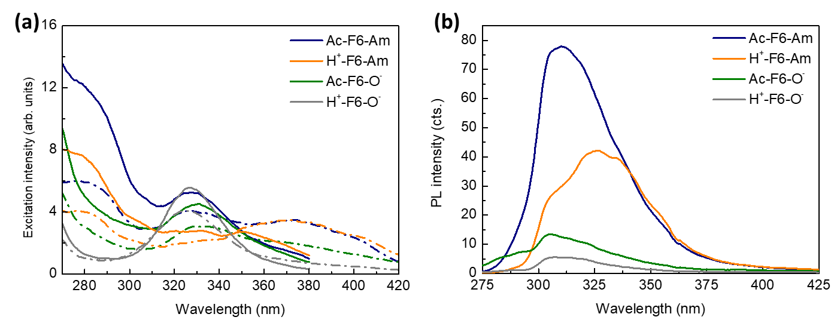
Figure S3: (a) Excitation spectra of the F6 setting λ_{em}= 400 nm (solid lines) and λ_{em} = 450 nm (dash-dotted lines) at 100 mg/mL concentration. (b) Fluorescence spectra of the F6 at λ_{exc} = 257 nm.

Figure S4: a) Schematic representation of the Aβ-peptide variants with charged/uncharged termini. b) Selected micrograph acquired on the Aβ-peptide solution (5 mg/mL) deposited on stub and air-dried (scale bar 100 μm). c) Fluorescence emission spectra of ThT, Aβ-peptide and the mix of ThT and the peptide.

