Supplementary Material for

“Memory deficits in hypertensive ApoE4 mice reversed by P2Y12 inhibition via different mechanisms in males and perimenopausal females”

Authors: Lianne J. Trigiani¹, Nicole E. Chernavsky¹, Rachel Kim¹, Nuri Hong¹, Robert F. Hawkins¹, Emily L. Le¹, Zahra Bahninameh¹, Keri Yamaguchi¹, Jonah Bernard¹, Amanda Huang¹, Daniel A. Rivera¹, Nathaniel H. Allan-Rahill¹, Michael Lamont¹, Roberta Marongiu^{2,3,4}, Costantino Iadecola², Nozomi Nishimura^{1,2}, & Chris B. Schaffer^{1,2}

Affiliations:
1. Nancy E. and Peter C. Meinig School of Biomedical Engineering, Cornell University, Ithaca, NY, USA
2. Feil Family Brain and Mind Research Institute, Weill Cornell Medicine, New York, NY, USA
3. Department of Neurological Surgery, Weill Cornell Medical College, Cornell University, New York, NY, USA
4. Department of Genetic Medicine, Weill Cornell Medical College, Cornell University, New York, NY, USA
Supplementary Materials and Methods

Mouse Treatments
VCD-induced accelerated ovarian failure
In order to study female mice during the transition to a menopause-like state (induced perimenopause), we used a model of accelerated ovarian failure (AOF). Female mice were injected i.p. with 4-vinylcyclohexene dioxide (VCD, AstaTech #39333, 160 mg/kg/day in sesame oil) for ten days over a two-week period (i.e. no injections on weekends) to cause selective loss of both primordial and primary follicles in the ovary (henceforth called VCD-female mice)^{39,104}. A perimenopausal-like state (peri-AOF), characterized by ovarian shrinkage and degeneration of ovarian follicles without an increase in follicular stimulating hormone (FSH), is typically achieved about 45 days after the VCD injections in this model and persists for about 90 days³⁹.

Subcutaneous osmotic minipump implantation for inducing hypertension
To induce hypertension, mice were implanted subcutaneously with an Alzet osmotic minipump (model 1004, 28 days, 0.11 μL/h, incubated for 24 hours prior to implantation) three weeks after cranial window implant, and one day after any baseline imaging and behavior experiments. Briefly, mice were anesthetized (1.5% isoflurane) and a ~1 cm square over the right shoulder was shaved and sterilized with alternating swabs of povidone and 70% ethanol. A small incision was made, and a subcutaneous pocket was created with a blunt hemostat to enable insertion of the minipump, which contained AngII (Sigma Aldrich #A9525, 500 ng/kg/min) dissolved in 0.9% sterile saline. In intact female mice used as controls for peri-AOF, minipumps that only contained 0.9% saline were implanted. Wound clips were used to close the incision. In a subset of mice, noninvasive blood pressure measurements were recorded at baseline and after two weeks of AngII infusion using a CODA® tail cuff monitoring system (Kent Scientific), after the mice had been habituated to the restraint and tail cuffs for 1-2 days. Another subset of mice received noninvasive blood pressure measurements at baseline, after two weeks of AngII, and again after a week of prasugrel treatment (with continued AngII infusion).

Prasugrel treatment
In cohort two, following two weeks of AngII infusion, mice were treated with prasugrel in one of two ways. Some mice were treated acutely via oral gavage at a dose of 10 mg/kg diluted in drinking water (APExBIO #B1283, 10 mM in 1 mL DMSO), with in vivo imaging outcome measures assessed 30 min following oral gavage and behavioral outcome measures assessed 48 hours after the gavage. The remaining mice were treated chronically for seven days via prasugrel dissolved in drinking water (~10 mg/kg/day assuming ~5 mL/day of water consumption, Aurobindo Pharma NDC 65862-830-30), with outcome measures assessed on the seventh day. The water was prepared daily by pulverizing prasugrel tablets using a mortar and pestle, making a paste with drinking water and allowing this to stir for at least 30 min. In both cases mice were continuously being infused with 500 ng/kg/min AngII.

Platelet depletion
In cohort three, we depleted circulating platelets by administering an antibody against mouse CD42b, which results in irreversible Fc-independent platelet depletion within 60 minutes (Emfret #R300; 2 mg/kg dissolved in 0.9% sterile saline; r.o.). In this cohort, mice served as their own controls in that isotype control antibodies (Emfret #C301) were injected for the timepoints at baseline and after two weeks of AngII infusion. Two days later, the same mice were administered antibodies for platelet depletion and re-assessed 24 hours later.

Microglia depletion
In cohort four, we depleted microglia by administering the colony-stimulating factor 1 receptor inhibitor PLX5622 (MedKoo Bioscience #555604, prepared by Reach Diets, Inc. at 1,200 ppm in chow (D19101002)). Mice were assessed after two weeks of AngII and again after seven days on the PLX5622 diet to achieve ~90% microglia depletion^{105,106}.

Cranial window surgery
Three weeks prior to in vivo imaging mice (4.5 - 5.5 months in age; 45 days after the first VCD injection in females) were implanted with a cranial window centered over the sagittal sinus using sterile technique, following procedures analogous to those we have previously published.³³ Briefly, mice were anesthetized with 3% isoflurane mixed with 100% O₂, injected with glycopyrrolate (0.5 mg/100g i.m.), 200 µL glucose (5% in 0.9% saline, s.c.), ketoprofen (0.5 mg/100g, s.c.), and dexamethasone (0.025 mg/100g, s.c.); the latter two were administered daily for an additional two days after surgery. During the procedure mice were maintained on 1.5-2% isoflurane. The skull was shaved, and six alternating swabs of povidone and 70% ethanol were used to create a sterile field prior to providing a local anesthetic (bupivacaine 0.125%, 100 µL, s.c.), after which an incision was made to expose the skull, and meninges and skin pushed to the edges. Vetbond® was applied to adhere and hold open the incision site. An ~6-mm craniotomy was performed using a manual dental drill (0.5 mm drill bit). Once the skull fragment was removed using forceps, a piece of surgifoam was applied to stop any bleeding prior to placing an 8-mm diameter round glass coverslip (0.16-0.19 mm thickness, Electron Microscopy Sciences #72296-08), which was affixed to the remaining skull using cyanoacrylate (Loctite 406). The coverslip was allowed to adhere for 6 minutes before surrounding it with dental cement (mixture of TEETS cold cure denture material, A-M Systems product numbers: 525000 and 526000) to cover any remaining exposed skull and create a small well for water immersion objectives during in vivo imaging.

In vivo two-photon excited fluorescence (2PEF) microscopy
During 2PEF imaging sessions mice were kept under 1-1.5% isoflurane mixed with medical air (21% O₂, 78% N₂), placed on a custom-made stereotactic frame, and injected with glycopyrrolate (0.5 mg/100 g i.m.) and 5% glucose (100 µL/h of imaging, s.c.). Breathing rate was monitored with a custom-built piezoelectric based physiology monitoring system¹⁰⁷ and small adjustments to the isoflurane level were made to maintain a ~1-Hz respiratory rate. Body temperature was monitored and maintained at 37°C throughout imaging sessions with a feedback-controlled heating blanket (40–90-8D DC, FHC). For most imaging experiments we used a combination of three labels of blood and blood cells: 50 µL of 2.5% 70-kDa Texas red dextran to label the blood plasma, 100 µL rhodamine 6G (1 mg/mL) to label mitochondria in white blood cells and platelets¹⁰⁸, and 50 µL (4.8 mg/mL) Hoescht-33342 to label white blood cell nuclei, all diluted in 0.9% saline and injected retro-orbitally just prior to imaging. We imaged these dyes on a custom-built 2PEF microscope using a Ti:Sapphire oscillator (Chameleon, Coherent) at a wavelength of 830 nm for excitation. Emitted fluorescence was detected on a three-channel detection system with dichroics at 520 nm and 593 nm and band-pass filters (center wavelength/bandwidth) for each channel: Texas red (630/92), rhodamine 6G (538/40), and Hoescht (439/154). For experiments analyzing microglia behavior (e.g. Fig. 4N-P), an additional label (GFP) was used. The same 830-nm excitation wavelength was used for excitation and a fourth detection channel was added. For detection, we used dichroics at 488, 526 and 593 nm together with bandpass filters for Hoescht (447/60), GFP (510/42), rhodamine 6G (560/25), and Texas red (630/92). For experiments imaging the glycocalyx (e.g. Supplementary fig. 10), thirty minutes prior to imaging, 6.25 mg/kg of Alexa-488 WGA-lectin was injected r.o. (1 mg/mL, W11261, Thermo Fischer). Immediately prior to imaging, we made another r.o. injection of 50 µL of 2.5% 10 kDa cascade blue dextran (Thermo Fisher) to label blood plasma. 2PEF imaging was performed using 800-nm excitation, a dichroic at 488, and bandpass filters for blood plasma labeled with cascade blue (451/106) and WGA-lectin labeling of the glycocalyx (540/80). Laser scanning and data acquisition was controlled by ScanImage software through MATLAB to acquire six 360 x 360 µm z-stacks, spaced axially by 1 µm and 300-500 µm in depth to quantify capillary stalling. To measure blood flow speed in 8-12 individual penetrating arterioles or capillary branches, we acquired line scans along the centerline of the vessel segment (0.5 ms/line for 30 s). For microglia and glycocalyx 2PEF imaging, z-stacks were spaced axially by 0.5 µm. For microglia motility analysis, 50-µm thick stacks in four different locations within the top 150 µm of the cortex were acquired every 5 minutes for 20 minutes in each mouse. Images were acquired by galvanometric scanning (1 ms/line, 1024x1024 pixels, 1.06 fps) using a water immersion objective (Olympus 25x, 1.05 NA, collar correction set for 0.17 mm thick cover glass).

Analysis of capillary stalling and blood flow speed
Capillary stalls were identified based on manual assessment of the motion of unlabeled red blood cells (RBCs) inside vessels with fluorescently labeled blood plasma. Potentially-stalled vessels were first flagged by creating running 30-µm thick z-projections through each image stack. With Texas red labeling of blood plasma, potentially-stalled vessels exhibited a dark or dimmed region, approximately cell sized. With rhodamine 6G labeling, we also looked for non-moving, bright, cell-sized objects inside the vessel lumen. In either case, vessel segments flagged as potentially stalled in this screen were examined by stepping up and down through the individual frames of the z-stack to verify whether blood cells were moving or not. Line scan data was analyzed with custom MATLAB code that determines the angle of streaks created by the plasma and RBC interface using a Radon-transform based approach; this angle is inversely proportional red blood cell velocity¹⁰⁹.

Focal constriction analysis
To assess whether there were focal constrictions in vessel diameter associated with capillary stalls, we analyzed lumen diameter using WGA-lectin labeling. Image stacks of stalled vessel segments were average intensity projected from just above to just below the vessel segment. We manually drew five adjacent lines perpendicular to the vessel axis at the narrowest point in the vessel segment on top of or immediately adjacent to an arrested blood cell in the capillary stall. Another five lines were drawn in the same vessel segment, but more distant from any arrested blood cell. Intensity profiles were fit to a gaussian curve for each line and the full width at half-maximum was determined. We then calculated the percent difference between the average diameter across the five measurements at these two locations.

Microglia motility analysis
Stacks from Cx3Cr1-ApoE3-TR and Cx3Cr1-ApoE4-TR mice were acquired every 5 minutes for 20 minutes, were average intensity projected, and concatenated to make a time series to analyze process motility. The background for each projection was removed by subtracting a Gaussian blurred (radius of 25 pixels) version of the projection from itself. A custom MATLAB script was written to binarize the microglia channel using Phansalkar’s local thresholding method¹¹⁰ (k = 0.5, neighborhood = 10 pixels, p = 0.5, q = 100) followed by five successive rounds of median filtering (1 pixel radius). To calculate microglia process movement between successive timepoints, each projected image was subtracted from the following projection, following the approach outlined by Mendes et al.¹¹¹ Briefly, pixels present at a timepoint, but not at the previous timepoint were considered extended pixels, while pixels that were initially present, but absent at a subsequent timepoint were considered retracted pixels. Pixels present in successive timepoints were considered stable pixels. Between each successive timepoint, motility indices were calculated as follows:
$$Motility index= \frac{extended pixels+retracted pixels}{stable pixels}$$

$$Extension index= \frac{extended pixels}{stable pixels}$$

$$Retraction index= \frac{retracted pixels}{stable pixels}$$

$$Stability index= \frac{extended pixels at t_{1} that stabilized at t_{2}}{total number of extended pixels}$$

$$Instability index= \frac{stable pixels at t_{1} that retracted at t_{2}}{total number of stable pixels}$$

Mean indices were calculated by averaging the values across the four image pairs from 0 to 20 minutes (i.e. 0 to 5 min, 5 to 10 min, 10 to 15 min, and 15 to 20 min).

Microglia branch analyses
The first image stack from each location/timepoint acquired for the motility analysis was also used to quantify microglia branching morphology. Images were segmented using the DiAna segmentation plugin¹¹² in FIJI using the classic method, median filtering set to a radius of two pixels (0.7 µm), excluding objects on XY edges, and with minimum object pixel size set to 10,000 pixels. Segmented images were then maximum intensity z-projected, binarized, and skeletonized. We then manually removed skeletons from microglia that were not fully within the 50-µm thick image stack. The lowest intensity voxel method was used for pruning to remove any loops that were present in the skeletons before running the analyze skeleton plugin¹¹³ in FIJI. From the skeletons, we extracted the number of branches, junctions, endpoints, and branch lengths for each microglia.

In vivo three-photon excited fluorescence (3PEF) and third harmonic generation (THG) imaging in the sub-cortical white matter
Mice were anesthetized and monitored under the same conditions during 3PEF microscopy as during 2PEF imaging sessions, except only blood plasma was labeled with 100 µL 5% 70 kDa FITC-dextran (ThermoFisher, D1823), injected retro-orbitally. Myelin and blood vessels were visualized by THG and 3PEF, respectively, driven by 1320-nm wavelength laser light from an optical parametric amplifier (Opera-F, Coherent) seeded by a diode-pumped femtosecond laser (40 μJ/pulse at 1 MHz; Monaco, Coherent). Laser control and image acquisition was performed using the same ScanImage software as 2PEF imaging. We acquired two emission channels, separated with a dichroic at 473 nm, with band-pass filters for each channel: THG (447/60) and FITC (540/80). The same water-immersion objective (Olympus 25x, 1.05 NA) was used, equipped with an objective heater set to 37°C (Bioscience Tools, MTC-HLS-025). THG images of sub-cortical myelin were acquired according to the protocol described previously.⁴⁰ Briefly, two 230 x 230 µm z-stacks, spaced axially by 2 µm at ~700 to 900 µm depth from the cortical surface and 1-2 mm laterally from the sagittal sinus were acquired with 3-5 frames at each z-position to allow for necessary frame-averaging to ensure sufficient image quality for myelin morphology analysis. Additionally, two 115 x 115 µm z-stacks (10-30 µm), spaced axially by 1 µm, were acquired at the same depth with 5-8 frames averaged at each z-position to capture the top layer of the sub-cortical white matter at higher resolution. Blood flow speed was measured with line scans from either the FITC or THG channel¹¹⁴ from 8-12 white matter capillaries per mouse.
Quantification of sub-cortical white matter changes
We evaluated changes in the morphology of the sub-cortical myelin using approaches developed in our lab previously⁴⁰. Putative nodes of Ranvier were manually identified and the intranodal distance was measured from the THG intensity profile across the node using a custom MATLAB script. The researcher making these measurements was blinded to the genotype and treatment condition. Analysis code and additional details on the intranodal distance can be found here: https://github.com/sn-lab/THG.

Multi-exposure speckle contrast imaging
In a subset of mice, we further assessed cortical perfusion using multi-exposure speckle contrast imaging using a custom-built setup and analysis code¹¹⁵. Mice were anesthetized with isoflurane and injected with 0.5 mg/100 g glycopyrrolate (i.m.) and 100 µL 5% glucose (s.c.) and allowed 15 min to stabilize while being placed in a stereotactic frame. To reduce variability in blood flow due to anesthesia, we monitored respiration rate and heart rate using our locally designed piezoelectric sensor system,¹⁰⁷ and we adjusted isoflurane levels to maintain a steady, ~1-Hz respiration rate. For imaging, a low magnification (4x 0.20 NA Nikon Plan Apochromat objective) reflectance image of the surface vasculature was first acquired using illumination with a green LED (Thorlabs, M530L4). For speckle contrast imaging, three series of laser speckle images, spaced 5 min apart, were acquired on a CMOS camera (Basler, aca2040-90umNIR) equipped with a 792/64 bandpass filter and linear polarizer, using a 785-nm laser diode (Thorlabs, LD785-SEV300) for illumination. Thirty image sequences were taken for each series, with each sequence consisting of 15 different exposure times (50 µs to 80 ms). Speckle contrast was computed for each image by dividing the standard deviation by the average pixel intensity within a 7x7 pixel moving window. Speckle contrast images were averaged together for each exposure and timepoint. The contrast images at 5 ms were used to draw five ROIs over the parenchyma. Pixels within the ROI were fit to Eq. 12 in Rivera and Schaffer¹¹⁵ using linear least-squares regression with initial conditions estimated from the whole image using the rapid estimation of multi-exposure imaging (REMI) procedure from that paper. Average perfusion was taken to be proportional to the average inverse correlation time of all pixels within each ROI.

Behavior (Y-maze and novel object recognition)
Prior to any behavioral testing, all mice were allowed to acclimate to the testing room for 30 min. We performed behavioral experiments in dim light, out of view from the experimenter, and captured with a FLIR Firefly S camera (Teledyne, FFY-U3-16S2C-CS) fit with a 6-mm focal length microlens (KVR, BW60BLF) and recorded with SpinView software set to capture 30 frames/s. Testing apparatuses and objects were cleaned with a 50% ethanol solution and allowed to dry between each mouse. To assess working spatial memory, a spontaneous alternation Y-maze assay was performed where mice were placed at the end of a maze arm and allowed to freely explore the three arms for six minutes (arms: 34.5-cm long, 6.5-cm wide, and 12-cm high). A mouse was considered to have entered an arm when the base of the tail crossed a point 4.0 cm beyond the entry into the arm. Arm re-entries were only counted if the mouse exited to the center of the maze before returning. Three consecutive alternations (triad) were scored as a correct choice and percent alternation was calculated as the number of correct triads over the total number of triads. To assess short term object memory, we used a novel object recognition task. Mice were habituated (10 min) to the testing arena, a red corrugated plastic box (45 x 45 x 45 cm) one day prior to testing. The following day, mice underwent both the familiarization and test phases separated by 2 hours. During familiarization, each mouse was given 5 min to explore two identical objects placed in opposite corners of the arena, equidistant from the center. Two hours after familiarization, one object was replaced with a novel object, and another 5 min of exploration were recorded. ODLog software was used to evaluate time spent exploring each object and the investigation ratio was calculated by dividing the time spent with the novel object by the total time investigating both objects during the test phase.

Tissue Histology and Immunostaining
For immunohistochemical analysis, mice were intracardially perfused immediately after their last imaging session with 15 mL of ice-cold 0.1-M phosphate buffered saline (PBS) followed by 40 mL of 4% ice-cold paraformaldehyde (PFA) in PBS. Brains were then post-fixed in 4% PFA in PBS overnight then cryoprotected in 30% sucrose in PBS, all at 4°C. Prior to sectioning, brains were frozen in Tissue-Tek O.C.T compound at -20°C, and coronal sections were cut on a cryostat (25 µm thickness), keeping sections between bregma coordinates -1.43 and -1.91 mm for staining. Sections were washed in 0.1-M PBS (3x5 min) prior to 1 h incubation in either 10% goat or donkey serum and then incubated overnight at 4°C in primary antibodies against the following proteins: ionized calcium-binding protein 1 (Iba-1, 1:500, Wako #019-19741), glial fibrillary acidic protein (GFAP, 1:500, Rockland, #200-901-D60), glucose transporter 1 (GLUT1, 1:200, Abcam #ab15309), occludin (1:100, Abcam #ab31721), and matrix metalloproteinase-9 (MMP-9, 1:100, Abcam #ab38898). All antibodies were evaluated within the top 500 µm of the cortex, where all in vivo cortical CBF measurements were acquired. Slides were rinsed in 0.1 M PBS (3x5min) prior to incubation with appropriate secondary antibodies conjugated with Alexa-488 or Alexa-594 (1:200 for 30min), and coverslipped in Mowiol 4-88® (Sigma-Aldrich, CAS #9002-89-5). Sections were imaged with a z-step size of 4.4 µm with a confocal microscope (LSM-710, Zeiss, Inc.) equipped with a 10x water immersion objective (NA 0.55). Automated optimization of laser power, PMT gain settings, pinhole diameter, and scan rate were used (Zeiss “Zen Smart Setup”), keeping the master gain constant for each fluorophore across each image for that marker. For analysis in FIJI, images were average intensity z-projected, the polygon tool was used to delineate the cortex and image thresholding was performed with the triangle method, with manual background subtraction. For Iba-1 and GFAP, we then measured the area of pixels above the threshold over the entire delineated area. Because of their localization to the endothelium, for occludin and MMP-9 we normalized the area above threshold to the area of GLUT1 that was above threshold.

As an assessment of blood brain barrier (BBB) dysfunction in tissue sections, 30 minutes prior to brain extraction, mice were anesthetized with isoflurane and injected retro-orbitally with 200 µL per sinus of horseradish peroxidase type II (HRP, Sigma Aldrich #P8250-50SKU, 0.5mg/g dissolved in 400 µL of 0.9% saline). Brains were fixed overnight in 4% PFA and sectioned coronally (50-µm thick) the following day with a Leica vibratome (VT1000S), with speed set to 0.21 mm/s and frequency to 60 Hz. Four consecutive sections between bregma -0.59 and -0.83 mm (for paraventricular nucleus) and four between -1.43 and -1.91 mm (for somatosensory cortex) were counterstained with DAB (Vector Laboratories SK-4100) for 35 min. Sections were then dehydrated in increasing concentrations of ethanol and coverslipped with Permount®, and imaged under a bright field microscope for evidence of HRP diffusion into the parenchyma. To quantify HRP extravasation, the polygon tool in FIJI was used to manually delineate areas in the parenchyma that contained HRP (excluding vessels), which was then shown as a percentage of the area of cortex imaged.

To assess gross anatomical changes to ovaries from female mice that were injected with VCD, ovaries were removed following perfusion and placed in 70% ethanol. Ovaries were placed in histology cassettes with a mesh insert (CellSafe, CW7777) and processed by Cornell’s core Histology Laboratory, where 9 consecutive mid-level ovary sections were collected (10-µm thick) and stained with hematoxylin and eosin.

ELISAs and 62-Cytokine Assay
A separate group of mice that were not used for imaging or behavior were used for these experiments. Mice were deeply anesthetized with 3% isoflurane, the chest cavity was opened, and 500 µL of blood was drawn using a left ventricle cardiac puncture with a 23G needle. Collected blood was added to anti-coagulant tubes containing 3.2% sodium citrate (SAI infusion technologies, PMTP-C-0.5). Prior to spinning down for 10 min at 2,000 g to collect plasma, 20 µL of whole blood was extracted for fluorescent activated cell sorting experiments (see below). During centrifugation brains were dissected on ice to obtain cortex samples that were immediately flash frozen using liquid nitrogen and stored at -80°C until protein extraction. After centrifugation, 5 µL of plasma was kept for the von Willebrand factor (vWF) ELISA (Abcam, ab314372) and 200 µL kept for the 62-mouse cytokine assay (Abcam, ab133995). After diluting plasma samples 1:2000, manufacturer protocol was followed for the vWF ELISA, using a 12 min incubation time in TMB development solution. Endpoint absorbance was read in duplicate samples at 450 nm on a SpectraMax iD5 plate reader (Molecular Devices) to quantify vWF levels⁵¹.

For the 62-cytokine assay kit, we first extracted proteins from flash frozen cortical samples using a 2-mL Dounce homogenizer with the cell lysis buffer provided in the cytokine assay kit and a broad-spectrum cOmpleteTM protease inhibitor cocktail (Millipore Sigma #04693116001). Protein concentration was measured using a PierceTM BCA protein assay kit (Thermo Fischer #23225). For cortical samples, 250 µg of total protein was added per sample and diluted in 1x blocking buffer. Plasma samples were diluted 1:5 and incubated overnight (20 h at 4°C), after which the manufacturer instructions were followed using 2 h incubation times at room temperature for the biotinylated antibody cocktail and HRP-conjugated streptavidin. Chemiluminescence was detected using ChemiDoc Touch Imaging system (BioRad #1708370) with membranes read after 10 s and then every 30 s over a 10 min period. Blots were background subtracted (radius of 25 pixels) and a dot blot analyzer plugin in FIJI¹¹⁶ was used to quantify cytokine expression relative to the average value of positive controls printed on the membranes.

In a subset of females, we measured follicular stimulating hormone (FSH) in plasma from blood collected by cardiac puncture just prior to perfusion to ensure females had not yet entered a menopause-like state by the study’s endpoint. Samples of 250 µL whole blood were collected in EDTA coated tubes (SAI infusion technologies, M500-E) and spun down at 1,000 g for 15 min. Plasma was aliquoted and frozen (-80°C) until use. A mouse FSH ELISA kit was used according to manufacturer instructions (Antibodies-Online, ABIN6955956) and read at 450 nm on a SpectraMax iD5 plate reader (Molecular Devices).

Fluorescent activated cell sorting of whole blood
Whole blood and lysed blood cell suspensions were labeled with a constitutive platelet membrane marker CD41 [fibrinogen receptor glycoprotein IIb (GPIIb)], a neutrophil marker (Ly6G), and two platelet activation markers CD62P (P selectin) and JON/A (active fibrinogen receptor conformation). Whole blood suspensions were analyzed to measure the fraction of the CD41 positive events that also expressed the platelet activation markers, and lysed blood suspensions were analyzed to determine the fraction of neutrophils that had formed platelet/neutrophil aggregates. Citrate whole blood samples (20 µL) were combined with 2 volumes of HEPES/EDTA saline buffer, combined with an equal volume of 1:50 Fc Block (BD Pharminogen; diluted in 2.5 mM calcium buffer, Annexin binding buffer, BD Pharmingen), and then incubated for 5 min at 4°C. Samples (40 µL) were then labeled with fluorescent antibodies (10 µL each antibody) diluted in Annexin binding buffer as follows: CD41 (1:50, CD41-BUV661, clone MWReg30, BD Biosciences), Ly6G-PE-Cy7 (1:25, clone IA8, BD Biosciences), and CD62P-FITC and JON/A-PE (1:2, clones Wug.E9 and JON/A, Emfret Analytics). Labeling reactions were performed in duplicate and a third reaction per individual was used for fluorescence minus one (FMO) labeling to establish threshold boundaries for positive cells. After 15 min incubation in the dark, a 5 µL aliquot of labeled suspension was quench-diluted in 250 µL PBS. The remaining suspension was fixed in 3 volumes of Cytofix (BD Biosciences) for 30 min at room temperature, then treated twice with 4 volumes of lysis buffer (5 Prime GMBH) for 5 min at 37°C, and centrifuged at 1,000 g x 1 min, followed by resuspension in 150 µL PBS. The labeling reactions were analyzed using a BD Accuri C6+ cytometer (BD Biosciences) set to obtain 10,000 events in a platelet gate (whole blood reactions) or 2,500 events in leukocyte gates (lysed blood reactions) defined by forward vs. side scatter (FSC/SSC) properties. Data analyses (FlowJo, Treestar) of whole blood reactions were performed to determine the percentage of CD41 positive events within the platelet gate, and the mean fluorescence intensity and percentage of CD62P and JON/A positive events within that population. The lysed blood reactions were analyzed to determine the number of LY6G positive events and the percentage of dual-labeled LY6G/CD41 positive events, representing platelet-neutrophil aggregates.
Supplementary Tables
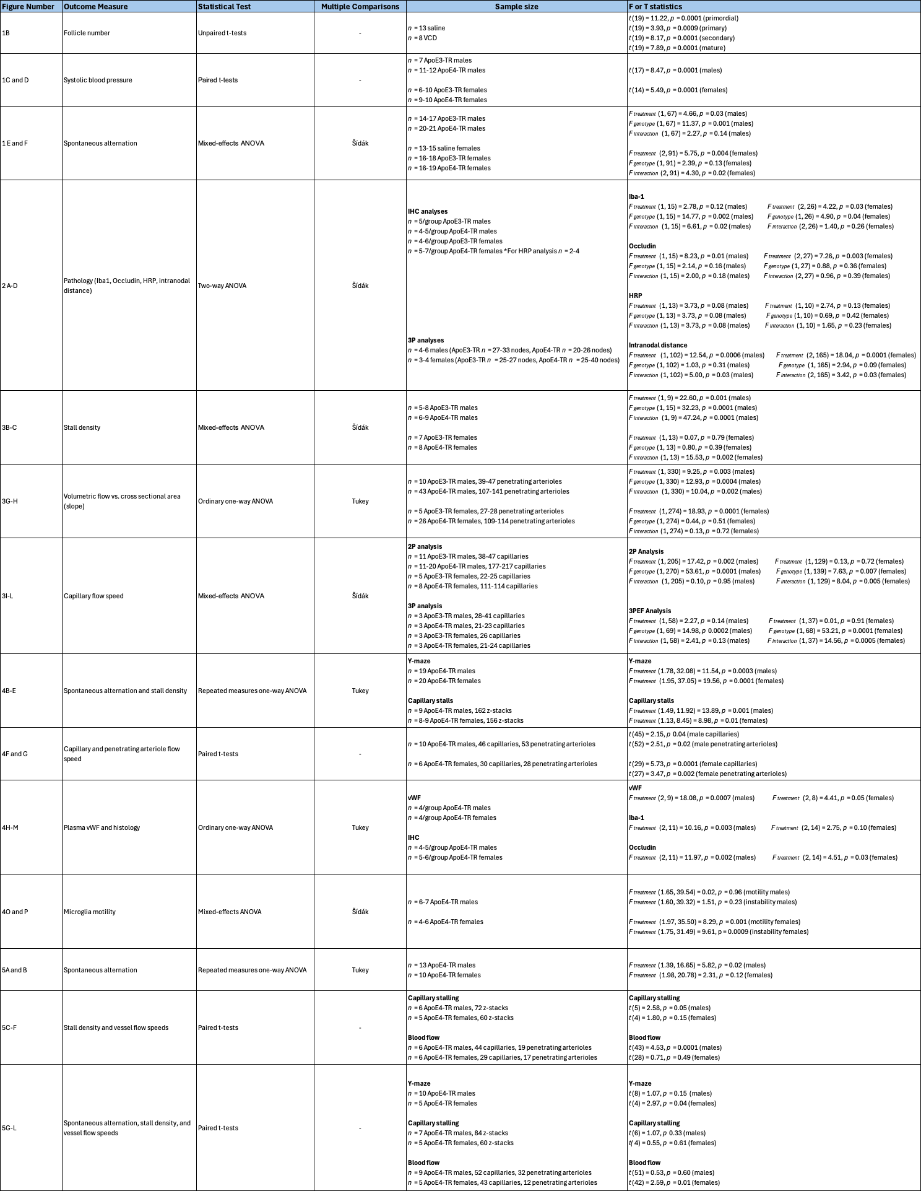Supplementary Table 1. Detailed statistical tests and sample sizes for main figures 1-5.
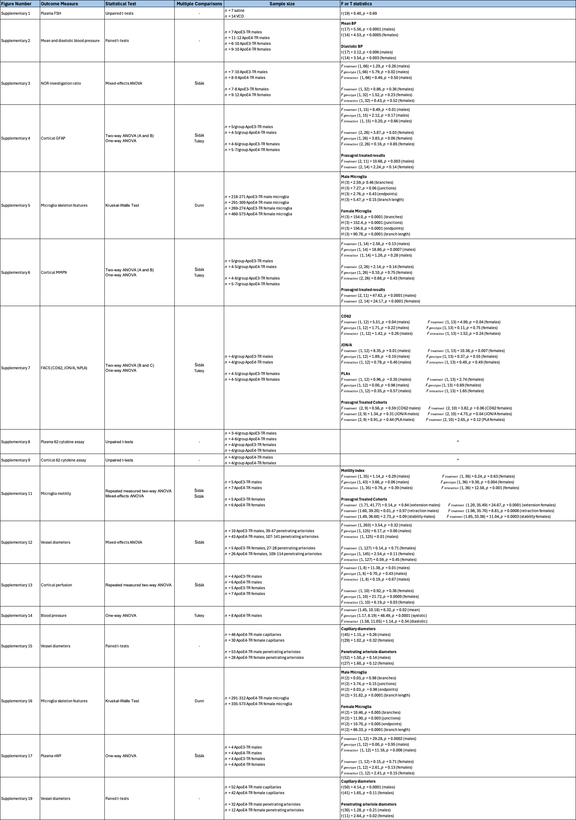
Supplementary Table 2. Detailed statistical tests and sample sizes for supplementary figures. *Note we did not list individual unpaired t-tests for the 62-cytokine assay.
Supplementary Figures

Supplementary Figure 1. Plasma follicular stimulating hormone ELISA assay in VCD-treated females. Post-mortem samples of plasma FSH revealed no differences between mice treated with VCD collected at study endpoint, as compared to age-matched mice that had intact ovaries and infused with saline minipumps instead of AngII. This implies that the VCD-female mice in our studies remained within a perimenopausal-like phase and had not yet entered a menopause-like state by the study end point.

Supplementary Figure 2. Mean and diastolic blood pressure measurements from tail cuff method. Mean and diastolic blood pressure significantly increased following two weeks of subcutaneous angiotensin II (AngII) infusion (500 ng/kg/min), as compared to baseline, in males (A) and VCD–females (B). Each point represents an individual mouse – ApoE3-TR mice are shown in shades of purple and ApoE4-TR mice in shades of green.

Supplementary Figure 3. Novel objection recognition investigation ratio scores. While both male (A) and female (B) ApoE4-TR mice trended towards impaired performance on the novel object recognition task as measured by investigation ratio (time with novel object over time investigating both objects), there was no worsening with induced hypertension.
Supplementary Figure 4. Cortical glial fibrillary acidic protein quantification. Representative immunohistochemistry images of GFAP-positive cortical reactive astrocytes from males (left). Fraction of area that was GFAP-positive in males (A and C), and females (B and D). Panels C and D include only ApoE4 mice. GFAP tended to increase across both genotypes with induced hypertension and decreased with chronic prasugrel treatment.
Supplementary Figure 5. Microglia 2D skeleton branch analysis from 2PEF images in ApoE3- and ApoE4-TR mice. Example of image processing from raw average z-projected 2PEF stack to individual skeletons for branch analysis (left). Violin plots contain results from individual microglia skeleton characteristics (number of branches, junctions, and endpoints) from male (A) microglia; and VCD-female (B) microglia. Only one genotype difference after hypertension was found in males such that hypertensive ApoE4-TR mice had less junctions than ApoE3-TR. Meanwhile, female microglia show significant baseline differences between perimenopausal ApoE3 and ApoE4-TR microglia. After hypertension, female ApoE4-TR microglia had an increase in average branch length compared to baseline (VCD).

Supplementary Figure 6. Cortical vascular matrix metalloprotease-9 quantification. Representative immunohistochemistry images of MMP9 and GLUT1 showing blood vessels from cortex of males (left). MMP9 area was normalized to GLUT1-positive area in male mice (A and C) and female mice (B and D). Panels C and D include only ApoE4 mice. Relative to hypertensive ApoE3-TR males, MMP9 levels were increased in hypertensive ApoE4-TR males, whereas VCD treatment in ApoE4-TR females tended to increase MMP9 but was not worsened by hypertension. Regardless of sex, MMP9 levels decreased after chronic treatment with prasugrel.
Supplementary Figure 7. Whole blood fluorescent activated cell sorting for platelet activation and platelet-leukocyte aggregation. (A) Gating strategies to isolate platelets (using anti-CD41) from peripheral whole blood samples to label receptors that indicate platelet activation (anti-CD62P and anti-JON/A) with histograms showing percent-positive signal of fluorophores, and gating strategy to identify platelet-leukocyte aggregates (PLAs) with the addition of anti-Ly6G to label neutrophils. Quantification of CD62P, JON/A, and PLAs in ApoE3- and ApoE4-TR males (B) and VCD-females (C) indicated that platelets were in a more activated state after two weeks of AngII infusion regardless of genotype, and that VCD-females generally had more PLAs compared to males at baseline. Since prasugrel can only prevent platelet aggregation or prevent their activation (not reverse already activated platelets), treatment with prasugrel (7 days through drinking water) did not significantly reduce platelet activation status in ApoE4-TR males (D) or ApoE4-TR VCD-females (E).
Supplementary Figure 8. Blood plasma 62-cytokine assay heat maps and quantification. Heat maps for plasma cytokine averages in blue for males and purple for VCD-females (top) calculated as a ratio of relative expression from positive controls provided on the cytokine array. Results from individual unpaired t-test comparisons for each cytokine between male groups (A, C, and E) and VCD-females (B, D, and F). Comparisons between ApoE3-TR and ApoE4-TR hypertensive groups (A and B) revealed no differences in any cytokines amongst males (A), and only two cytokines reduced in ApoE4-TR VCD-females compared to ApoE3-TR mice (B, fractalkine and MCP-1). When comparing plasma cytokines from baseline and hypertension in ApoE4-TR mice more differences were uncovered in VCD-female plasma (D) relative to males (C) but with both sexes showing similar decreases in eotaxin-2 and increases in leptin R and IGFBP-3 due to hypertension. Changes between hypertension and prasugrel treatment (E and F) were assessed in both sexes: Prasugrel led to increased plasma levels of eotaxin-2, M-CSF, MIP-1gamma, P-selectin, TCA-1, sTNF RI, sTNF RII, and VCAM-1. Some interesting sex differences to note here were opposite but significant changes in leptin R, and changes in IGFBP-3 and PF-4 that were only significant in males. Principal component analysis performed on square root-transformed cytokine data that was converted to z-scores to compare all conditions in (G) shows clustering between baseline and hypertension is independent of genotype and reveals a slightly better separation in males treated with prasugrel from other clusters. Darker color shades and outlines represent males, while lighter shades represent females. ApoE4 mice have solid circles, while ApoE3 mice have just outlines. Colors represent baseline, hypertensive, and prasugrel treated conditions.

Supplementary Figure 9. Cortical 62-cytokine assay heat maps and quantification. Heat maps for cortical cytokine averages in blue for males and purple for VCD-females only in ApoE4-TR mice (top), all calculated as a ratio of relative expression from positive controls provided on the cytokine array. Comparisons were made for individual cytokines using unpaired samples t-tests comparing cytokine levels at baseline and after hypertension in (A) ApoE4-TR males and (B) VCD-females. There were more changes in cytokine levels after hypertension in VCD-females relative to males, however many similar changes between sexes were observed such that Axl, IGFBP-5, IL-6, IL-10, IL-13, and Leptin decreased after hypertension and cortical IL-1α significantly increased. Comparisons between hypertension and prasugrel treatment in (C) males and (D) VCD-females. All 7 of the previously listed cytokines were reversed by prasugrel such that Axl, IGFBP-5, IL-6, IL-10, and IL-13 increased but IL-1α decreased. Additionally, fas ligand, IL-1, and IL-5 increased and eotaxin-2, IGFBP-3, M-CSF, PF-4, P-selectin, TCA-3, and VCAM-1 decreased. (E) Principal component analysis performed on square root transformed cytokine data that was converted to z-scores to compare all conditions in males and VCD-females revealed three distinct clusters regardless of sex. Darker color shades represent ApoE4-TR males and lighter shades are reserved for females.

Supplementary Figure 10. Quantification of focal constrictions at capillary stall locations. To test the possibility of capillary stalls being caused by focal capillary constrictions, as can be caused by pericytes, we used WGA-lectin Alexa-488 and a 10 kDa cascade blue conjugated dextran to be able to visualize the glycocalyx so that such constrictions could be seen. Images show 2PEF average projections of a stall without (left) and with (center) a focal constriction. In a subset of n = 5 hypertensive ApoE4-TR males we found 90 capillary stalls, of which only 27% were classified as having a focal constriction (average 23% decrease in capillary diameter) immediately adjacent to the arrested blood cell. The remaining capillary stalls exhibited a somewhat increased capillary diameter at the location of the stall.

Supplementary Figure 11. Penetrating arteriole diameters from ApoE3- and ApoE4-TR mice. Violin plots of penetrating arteriole diameters for all vessels plotted in Fig. 3G from ApoE3- and ApoE4-TR males (left) and in Fig. 3H from ApoE3- and ApoE4-TR VCD-female vessels (right). There was a baseline difference in male vessels that were measured such that the randomly selected ApoE4-TR penetrating arterioles were smaller than ApoE3-TR males.
Supplementary Figure 12. Laser speckle contrast imaging quantification of cortical perfusion in ApoE3- and ApoE4-TR mice. Processed multi-exposure laser speckle contrast images (left) from the same two ApoE3- and ApoE4-TR males imaged at baseline and after two weeks of AngII infusion with five parenchymal regions of interest (ROI) outlined in red where cortical perfusion was measured. Average perfusion was taken as proportional to the average inverse correlation time of all pixels within each ROI, and all five regions were averaged together for each mouse. Quantification is shown on the right for males and VCD-females, where a significant decrease in perfusion with hypertension was found exclusively in ApoE4-TR mice.

Supplementary Figure 13. Prasugrel treatment does not have blood pressure-altering effects in male ApoE4-TR mice. Systolic blood pressure significantly increased following two weeks of subcutaneous angiotensin II (AngII) infusion (500 ng/kg/min) compared to baseline and remained elevated after an additional week of AngII infusion while being treated orally with 10 mg/kg prasugrel through the drinking water. Diastolic and mean blood pressure follows similar, but not statistically significant, trends. Each point represents an individual mouse measured at all three timepoints.

Supplementary Figure 14. Vessel diameter, quantified as a fraction of baseline diameter, in male and VCD-female ApoE4-TR mice from prasugrel cohort. No changes in capillary diameter (left) nor penetrating arteriole diameter (right) were observed after treatment with prasugrel in either males (A) or VCD-females (B). Diameters here were exclusively from the same vessels measured at three timepoints (baseline, hypertension, and prasugrel) and are plotted as a fraction of baseline diameter.

Supplementary Figure 15. Microglia process dynamics extracted from microglia timelapse 2PEF imaging. Microglia process motility was measured in the same locations in each mouse. (A) In males, the motility index was not impacted by hypertension or genotype, while in (B)
VCD-females, microglia process motility was lower in ApoE4 mice, as compared to ApoE3 mice, at baseline, with an increase due to hypertension in ApoE4 mice. In the prasugrel-treated ApoE4 cohort, additional metrics were also extracted from microglia process movements including process extension, retraction, and stability indices from the same four locations per mouse measured at three timepoints in males and (C) VCD-females (D). In females, the observed increase in motility with hypertension was due to increases in both process extension and retraction, both of which were decreased by prasugrel. An increase in extended process stability was also observed in hypertensive ApoE4-TR VCD-females. No changes in microglia process motility were observed after hypertension, nor with prasugrel treatment in males.

Supplementary Figure 16. Microglia 2D skeleton branch analysis from 2PEF images. Violin plots contain results from individual microglia skeleton characteristics (number and average length of branches, junctions, and endpoints) from males (A) and VCD-treated females (B). More morphological changes were observed in female microglia between hypertension (VCD+AngII) and prasugrel treatment, as compared to males (where only an increase in branch length was observed after prasugrel treatment). In contrast, VCD-female microglia branch length decreased slightly after prasugrel, as did the number of branches, junctions, and endpoints.

Supplementary Figure 17. Plasma von Willebrand factor ELISA quantification. ApoE3- and ApoE4-TR plasma vWF comparisons in males (A) and VCD-females (B) shows that the increase in vWF after hypertension (AngII) was unique to ApoE4-TR males (p < 0.001).

Supplementary Figure 18. 2PEF cortical imaging of microglia depletion. Example images acquired from the same mouse at the same cortical location 100-200 µm from the surface before (Day 0) and during (Days 1, 3, and 7) microglia depletion with a 1,200 ppm PLX5622 diet. We observed significant loss of microglia cells in the same field of view. Images are 100-frame average z-projections with a 50-pixel rolling ball background subtraction applied. Blood vessels are labeled by 70kDa Texas red-conjugated dextran (magenta) and microglia (green) by CX3CR1-GFP labeling.

Supplementary Figure 19. Vessel diameters in male and VCD-female ApoE4-TR mice from PLX5622 cohort. Capillary and penetrating arteriole diameters were measured at the hypertension timepoint (AngII) and after 7 days on the 1,200 ppm PLX5622 diet to deplete microglia in ApoE4-TR males (top) and VCD-females (bottom). In males there was a significant increase in capillary diameter after microglia depletion, but not in penetrating arterioles. While in VCD-females, no change in capillary diameter was observed but there was an increase in penetrating arteriole diameter with microglia depletion.

