Supplementary Information

Sunlight-Catalysed Green Synthesis of Copper Nanoparticles Using Green Tea Extract

UV–Vis Spectroscopy Raw Data (Absorbance vs Wavelength)

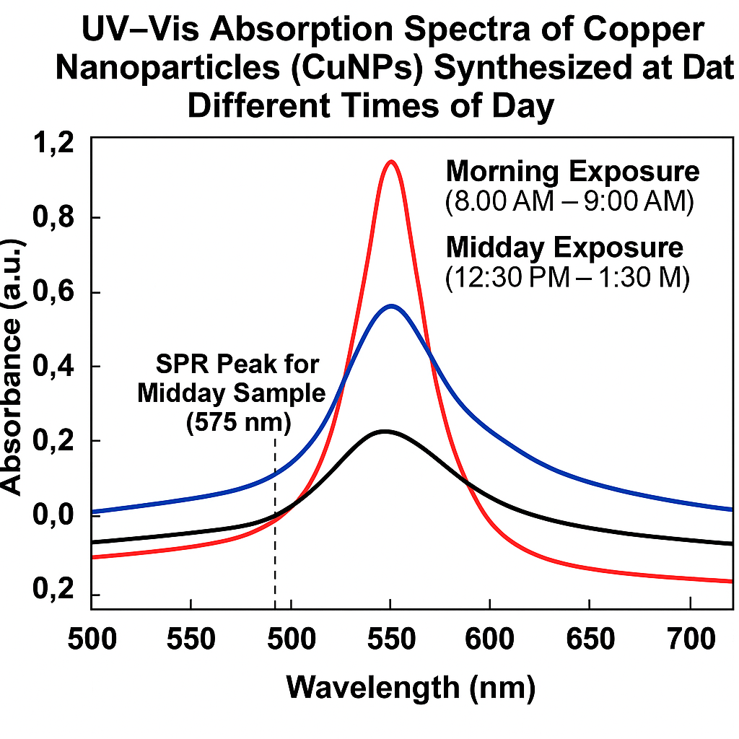

FTIR Spectroscopy Raw Data (Wavenumber vs Intensity)

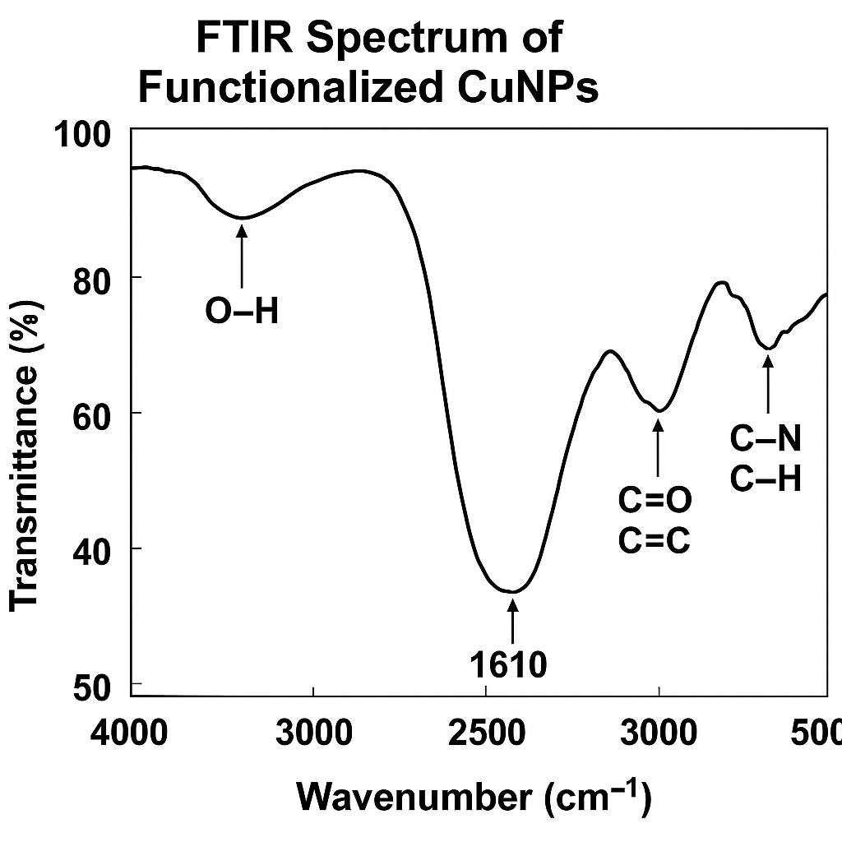

XRD Patterns (2θ vs Intensity)

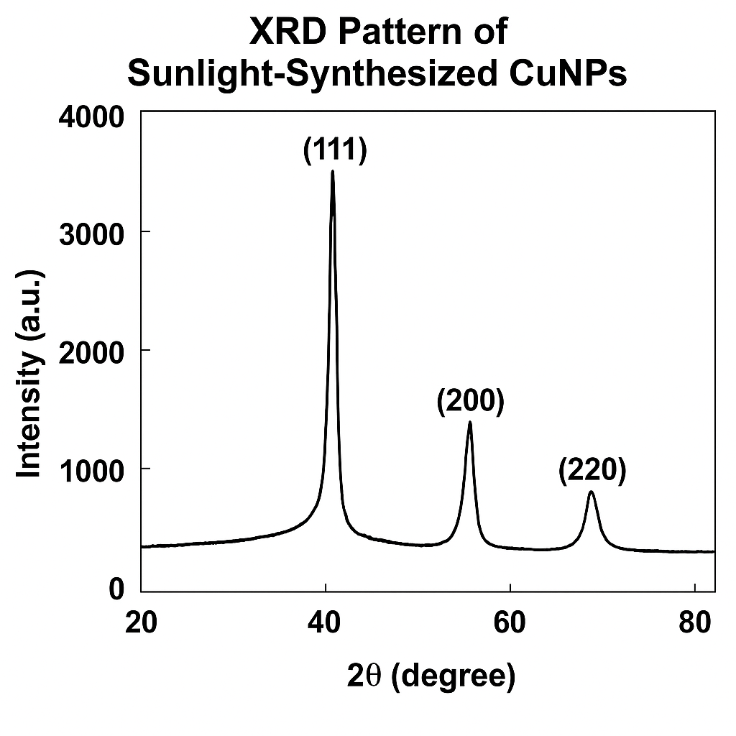

SEM Micrographs (Representative Images)
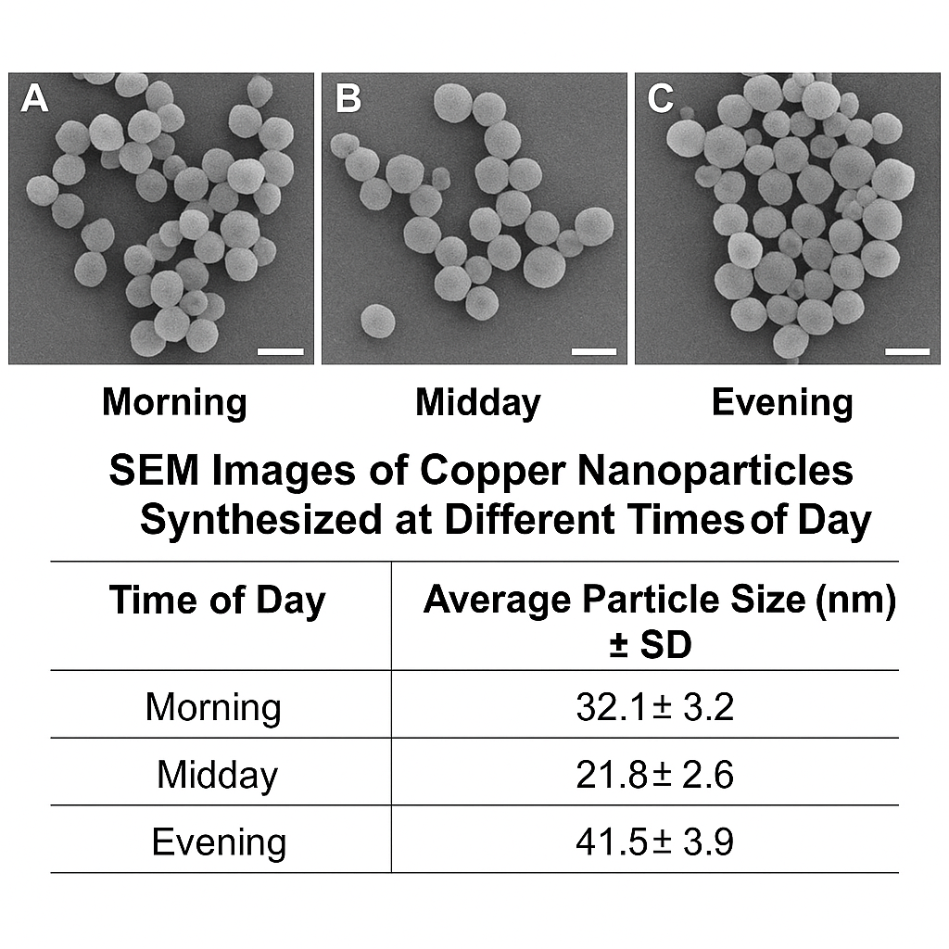

Zeta Potential Measurements

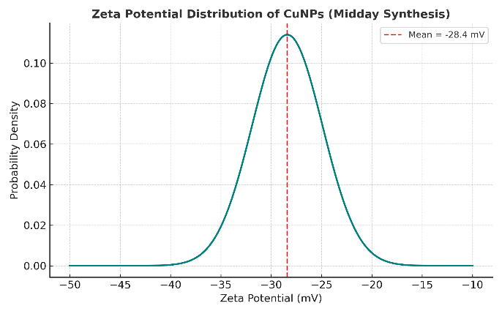

Antimicrobial Assay Results (Zone of Inhibition, mm)

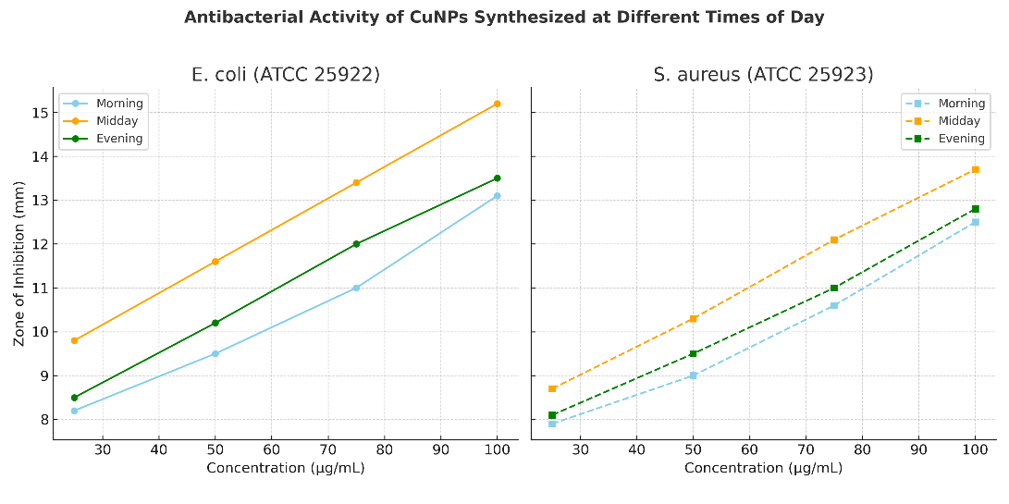

Antimicrobial Assay Data Table:

Concentration (µg/mL) | E. coli (mm) | S. aureus (mm)
25 | - | -
50 | - | -
100 | 15.2 | 13.7

