Synthesis of functionalized Fe₃O₄/zeolite-HY based on dendrimer-like nitrogen-containing compounds and investigating their application in removing Nickel and Lead as a new absorbent
Alireza Orashzadª, and Kaveh Khosravi*^{a,b}
ªDepartment of Chemistry, Faculty of Science, Arak University, Arak 38156-88349, Iran.
^{b}Department of Chemistry, Faculty of Science, Arak University, Arak 38156-88349, Iran
E- mail: k-khosravi@araku.ac.ir; khosravi.kveh@gmail.com ; Alireza.orashzad@gmail.com

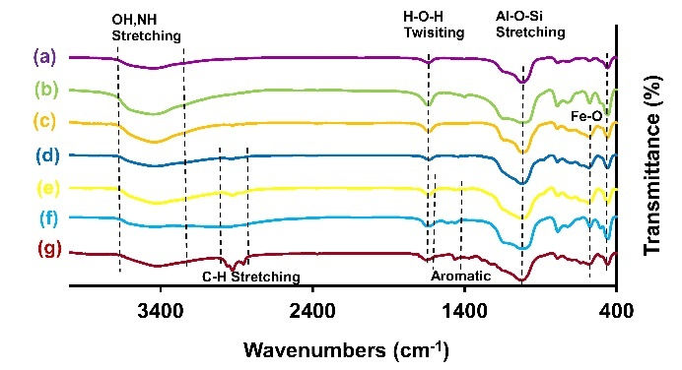
Fig 1: FT-IR spectra of a) NaY b) HYZ c) Fe₃O₄/ HYZ d) Fe₃O₄/HYZ@SiO₂ e) Fe₃O₄/HYZ@SiO₂-Tris f) Fe₃O₄/HYZ@SiO₂-Tris-TCT g) Fe₃O₄/HYZ@SiO₂-Tris-TCT-DAPT

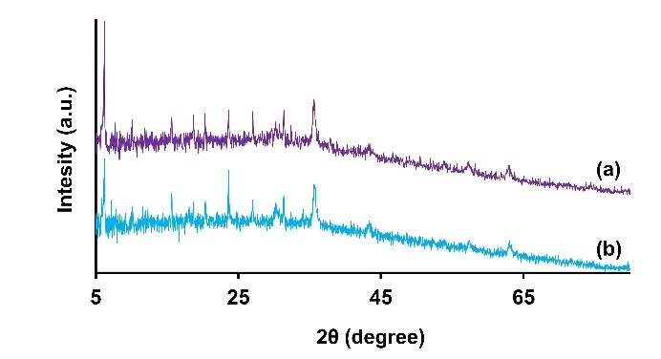
Fig 2: XRD patterns of a) Fe₃O₄/ HYZ and b) Fe₃O₄/HYZ@SiO₂-Tris-TCT-DAPT.
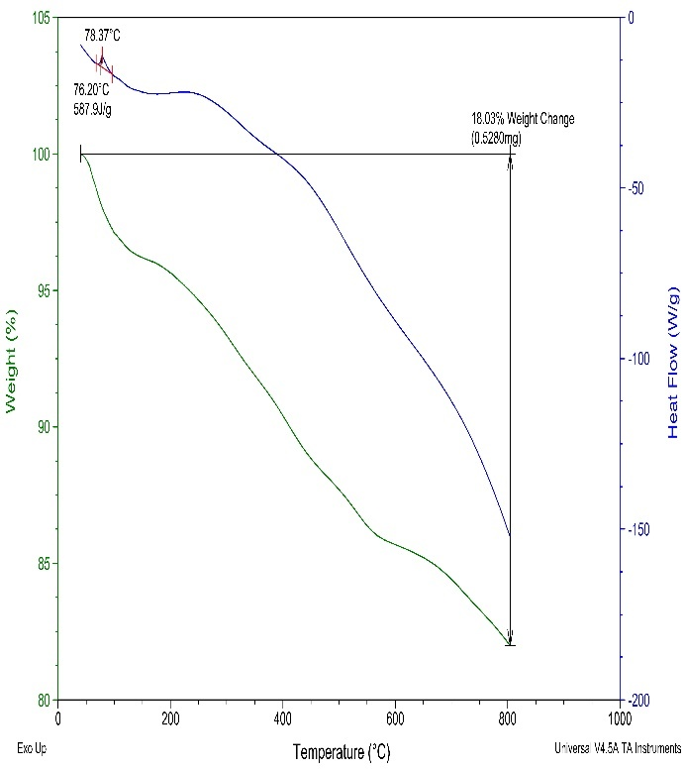
Fig 3: TGA-DSC curve of Fe₃O₄/HYZ@SiO₂-Tris-TCT-DAPT

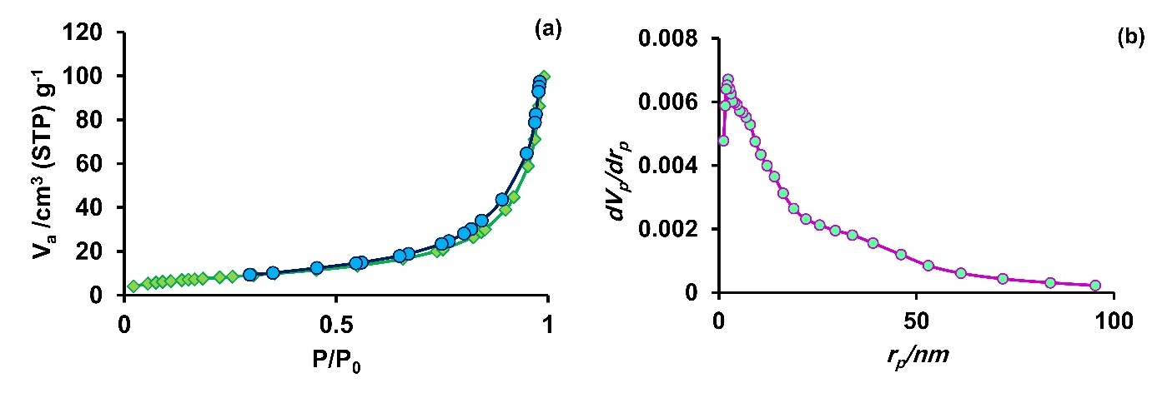
Fig 4: a) N₂ adsorption–desorption isotherm and b) pore size distribution of Fe₃O₄/HYZ@SiO₂-Tris-TCT-DAPT

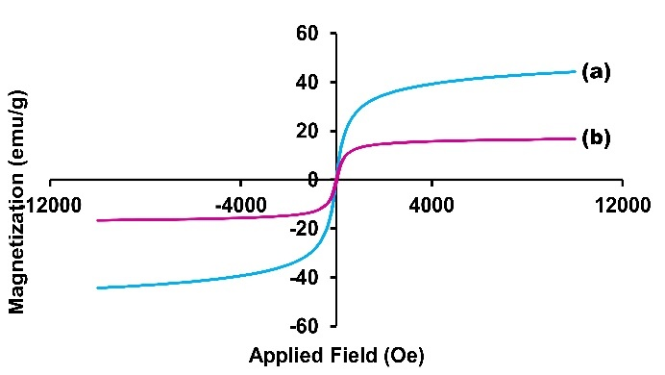
Fig 5: VSM spectra of a) Fe₃O₄ b) Fe₃O₄/HYZ@SiO₂-Tris-TCT-DAPT

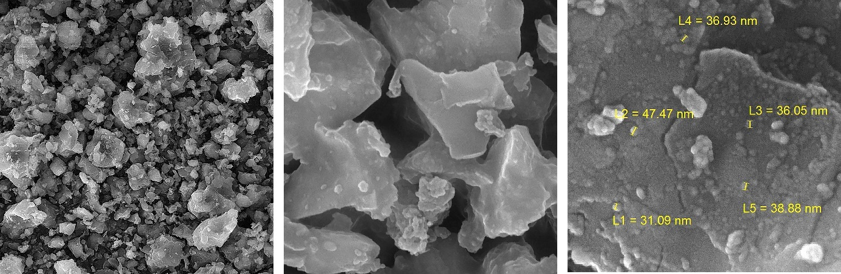
Fig 6: FE-SEM images of Fe₃O₄/HYZ@SiO₂-Tris-TCT-DAPT

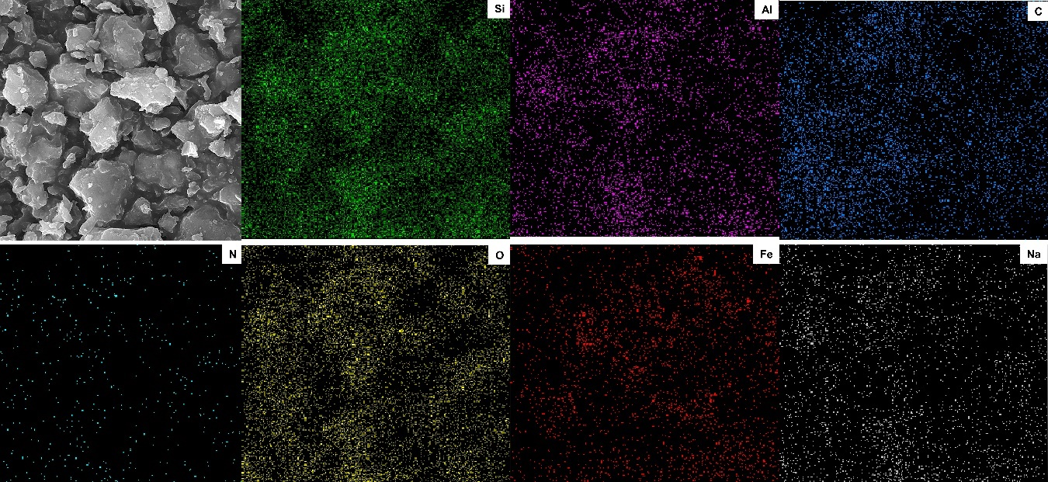
Fig 7: SEM image of Fe₃O₄/HYZ@SiO₂-Tris-TCT-DAPT and elemental mapping of Si, Al, C, N, O, Fe and Na

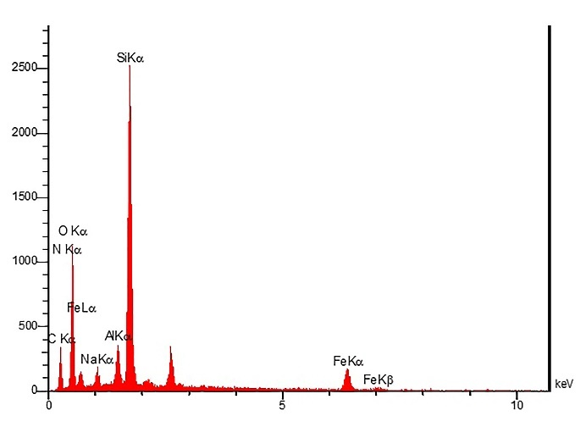
Fig 8: EDX spectrum of Fe₃O₄/HYZ@SiO₂-Tris-TCT-DAPT

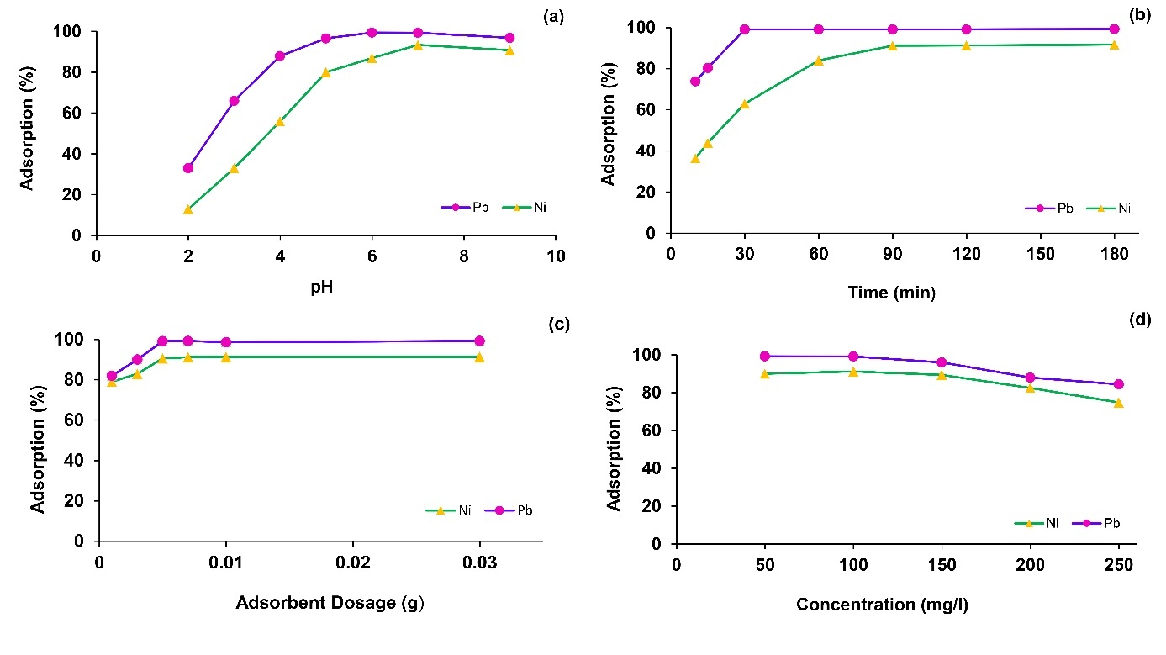
Fig 9: The effect of a) pH b) contact time c) adsorbent dosage d) metal ions concentration

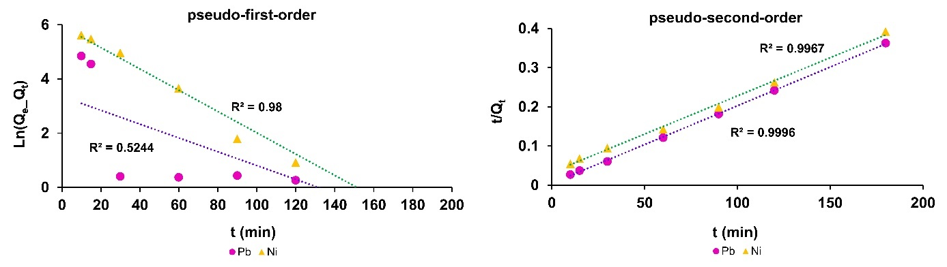
Fig 10: The kinetic models for Ni²⁺ and Pb²⁺ on Fe₃O₄/HYZ@SiO₂-Tris-TCT-DAPT

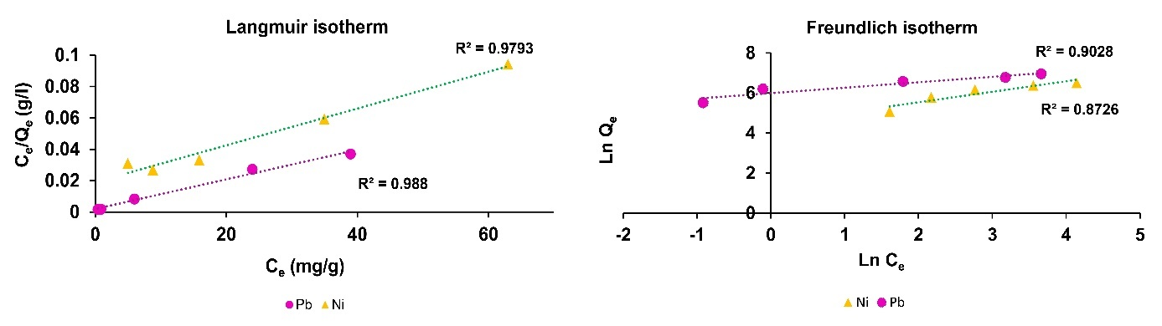
Fig 11: Pb²⁺ and Ni²⁺ adsorption isotherms

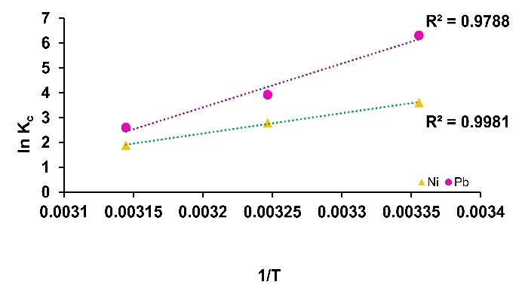
Fig 12. Determination of thermodynamic properties of adsorption of Pb²⁺ and Ni²⁺ by Fe₃O₄/HYZ@SiO₂-Tris-TCT-DAPT

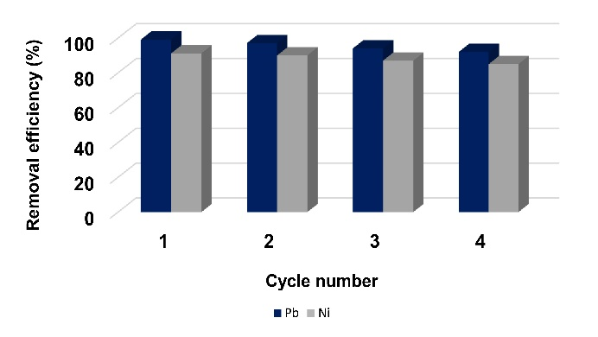
Fig 13. The reusability of Fe₃O₄/HYZ@SiO₂-Tris-TCT-DAPT for Pb²⁺ and Ni²⁺ removal in four consecutive cycles

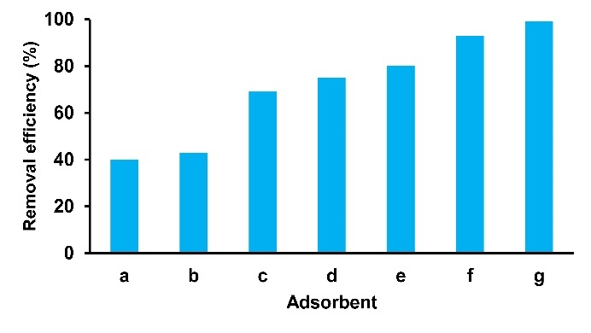
Fig 14. The effect of functionalization steps on the removal efficiency of Pb (II); 25 ml solution, concentration 100 mg/L, adsorbent dose 0.005 g, and contact time 30 min; a) NaY b) HYZ c) Fe₃O₄/ HYZ d) Fe₃O₄/HYZ@SiO₂ e) Fe₃O₄/HYZ@SiO₂-Tris f) Fe₃O₄/HYZ@SiO₂-Tris-TCT g) Fe₃O₄/HYZ@SiO₂-Tris-TCT-DAPT

