Figure 1: Local recurrence events across male and female patients in the adjuvant (a) and definitive (b) treatment setting between male and female patients.
a)
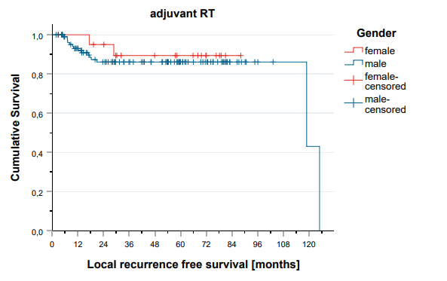

b)
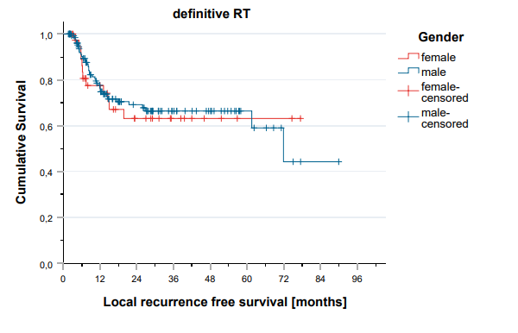

Figure 2: Overall survival events across male and female patients in the adjuvant (a) and definitive (b) treatment setting between male and female patients.
a)
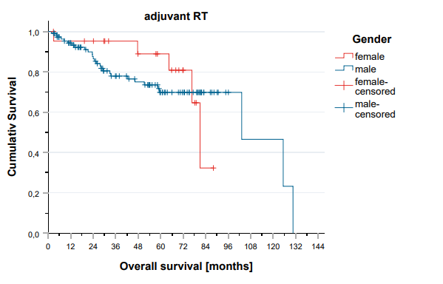
b)
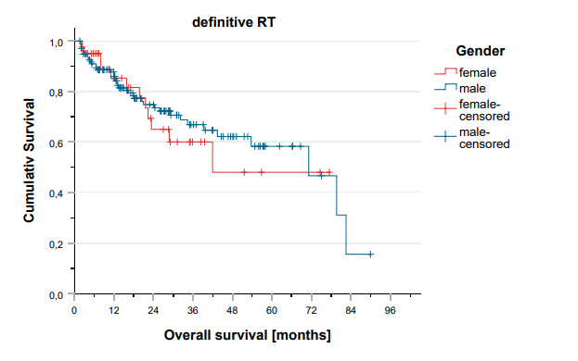

Figure 3: Progression free survival events across male and female patients in the adjuvant (a) and definitive (b) treatment setting between male and female patients.
a)
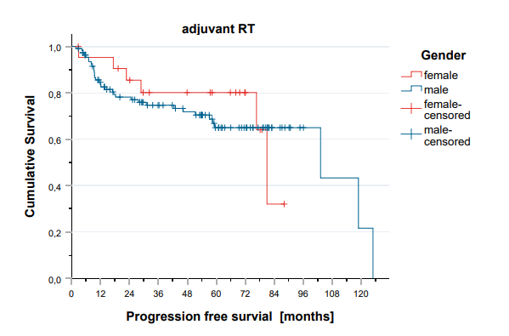
b)
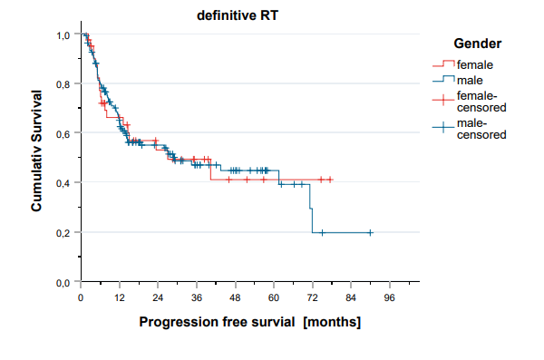

Figure 4: Metastases free survival Local recurrence events across male and female patients in the adjuvant (a) and definitive (b) treatment setting between male and female patients.
a)
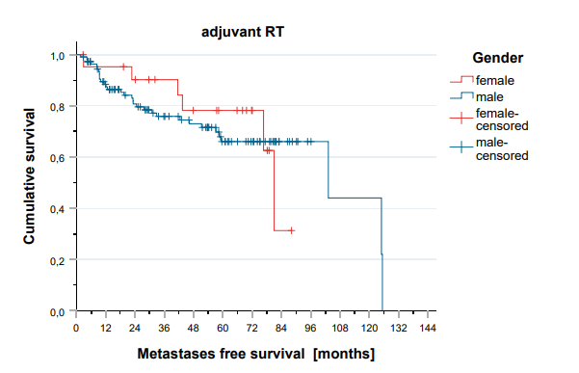
b)
