3.8 Correlation analysis
There was no significant correlation between serum concentration of CTX-II, IL-6 and OARSI score (r = 0.221, P = 0.242, and r = 0.227, P = 0.228, respectively), (Supplementary Figure 1A, B).
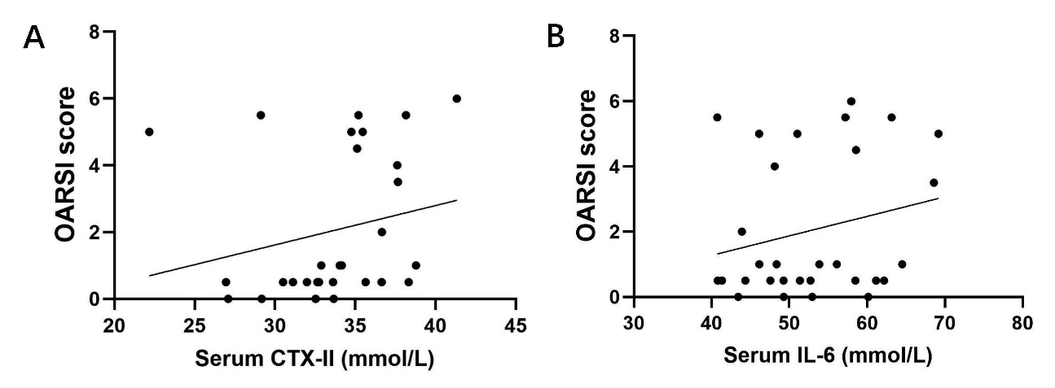

Supplementary Figure 1. Serum biomarker concentrations and Spearman's rank correlations. (A, B) Analysis of correlations between Serum concentrations of CTX-II, IL-6 and OARSI score. The regression line (solid) is shown. Data are expressed as mean ± standard deviation.

