SUPPLEMENTARY MATERIAL.
Supplementary table 1. Comparison of positivity and PCR CT-values for sponge sample types, feces origin and overall sponges and fecal samples, per molecular marker, sampling point and study site.
Pathogen marker | Value | O-sponge (n=90) | S-sponge (n=86) | STATISTICS RESULTS | Sampling points (sponges) | Wild boar feces (n=46) | Wild ruminant feces (n=93) | STATISTICAL RESULTS | Sponges (total; n=176) | Feces (total; n=139) | STATISTICAL RESULTS
uidA | Positivity (%) | 15.55 | 40.69 | χ²=12.61; p=0.0004 | 48.8 | 78.26 | 66.66 | χ²=1.47; p=0.23 | 27.84 | 70.5 | χ²=55.09; p=1.15e⁻¹³
uidA | PCR-CT (x̄±SD) | 37.28  ±2.32 | 35.37  ±2.92 | W=359.5; p=0.01 | 48.8 | 32.39  ±4.23 | 34.98  ±3.79 | W=711.5; p=0.003 | 35.92  ±2.87 | 34.03  ±4.14 | W=1800; p=0.01
stx1 | Positivity (%) | 0 | 1.16 | na | 3.3 | 13.04 | 6.45 | OR=0.38; p=0.18 | 1.70 | 7.91 | χ²=5.66; p=0.02
stx1 | PCR-CT (x̄±SD) |  | 35.88  ±2.77 | na | 3.3 | 37.46  ±4.09 | 31.87  ±3.87 | W=27; p=0.03 | 35.88  ±2.77 | 34.92  ±4.79 | W=13; p=0.66
stx2 | Positivity (%) | 1.11 | 2.32 | OR=4.31; p=0.2 | 5.55 | 13.04 | 7.52 | OR=0.55; p=0.36 | 2.84 | 9.35 | χ²=4.96; p=0.03
stx2 | PCR-CT (x̄±SD) | 35.16 | 31.71  ±1.47 | na | 5.55 | 34.87  ±2.48 | 33.48  ±2.30 | W=24; p=0.73 | 32.41  ±1.99 | 34.13  ±2.30 | W=47; p=0.17
eae | Positivity (%) | 0 | 0 | na | 0 | 13.04 | 3.22 | OR=0.22; p=0.05 | 0 | 6.47 | na
eae | PCR-CT (x̄±SD) | na | na | na | 0 | 31.66  ±4.40 | 31.95  ±0.64 | W=6; p=0.55 | na | 31.38  ±3.34 | na
IS6110 | Positivity (%) | 20 | 31.39 | χ²=2.43; p=0.12 | 42.22 | 6.52 | 4.30 | OR=0.65; p=0.68 | 25.57 | 5.04 | χ²=22.29; p=2.35e-06
IS6110 | PCR-CT (x̄±SD) | 38.02  ±1.47 | 36.54  ±1.99 | W=353; p=0.01 | 42.22 | 38.65  ±0.94 | 40.29  ±1.87 | W=3; p=0.40 | 37.14  ±1.93 | 39.58  ±1.67 | W=262.5; p=0.01
mpb70 | Positivity (%) | 3.33 | 2.32 | OR=0.69; p=1 | 4.44 | na | na | na | 2.84 | na | na
mpb70 | PCR-CT (x̄±SD) | 38.84  ±0.67 | 37.48  ±2.89 | W=4;  p=0.80 | 4.44 | na | na | na | 38.30  ±1.69 | na | na
invA | Positivity (%) | 0 | 2.32 | na | 2.22 | 4.34 | 0 | na | 1.14 | 1.44 | OR=0.79; p=1
invA | PCR-CT (x̄±SD) | na | 36.17  ±0.17 | na | 2.22 | 37.43  ±0.67 | na | na | 36.17  ±0.17 | 37.43  ±0.67 | W=4; p=0.33
IS1111 | Positivity (%) | 2.22 | 1.16 | OR=0.52; p=1 | 3.33 | 0 | 0 | na | 1.7 | 0 | na
IS1111 | PCR-CT (x̄±SD) | 39.03  ±0.68 | 35.35 | na | 3.33 | na | na | na | 37.80  ±2.18 | na | na
G. duodenalis | Positivity (%) | 5.55 | 3.48 | OR=0.61; p=0.72 | 8.89 | 6.52 | 7.53 | OR=1.16; p=1 | 4.55 | 7.19 | χ²=0.59; p=0.44
G. duodenalis | PCR-CT (x̄±SD) | 38.06  ±1.35 | 38.20  ±1.14 | W=7;  p=1 | 8.89 | 32.60  ±5.64 | 35.90  ±2.85 | W=6; p=0.36 | 38.11  ±1.19 | 34.92  ±3.88 | W=16.5; p=0.004
T. gondii | Positivity (%) | 10 | 2.22 | OR=0.21; p=0.05 | 12.22 | na | na | na | 6.25 | na | na
IS900 | Positivity (%) | na | na | na | na | 0 | 0 | na | na | 0 | na
Blastocystis sp. | Positivity (%) | na | na | na | na | 6.52 | 4.3 | OR=0.65; p=0.68 | na | 5.04 | na
B.coli | Positivity (%) | na | na | na | na | 8.69 | 0 | na | na | 2.88 | na
E.bieneusi | Positivity (%) | na | na | na | na | 2.17 | 0 | na | na | 0.72 | na
E.bieneusi | PCR-CT (x̄±SD) | na | na | na | na | 35 | na | na | na | 35 | na
E.cuniculi | Positivity (%) | na | na | na | na | 2.17 | 2.15 | OR=0.99; p=1 | na | 2.16 | na
E.cuniculi | PCR-CT (x̄±SD) | na | na | na | na | 36 | 37.60  ±0.28 | na | na | 37.07  ±0.95 | na
IS711 | Positivity (%) | na | na | na | na | 0 | 0 | na | na | 0 | na
Cryptosporidium spp. | Positivity (%) | 0 | 0 | na | 0 | 0 | 0 | na | 0 | 0 | na
—“OR”=odds ratio; “na”=no available; “χ²”=chi-square value; “SD”=standard deviation; “W”=Wilcoxon test parameter— Escherichia coli (uidA, stx1, stx2 and eae), Mycobacterium tuberculosis complex (IS6110 and mpb70), Salmonella spp. (invA), Coxiella burnetii (IS1111), Brucella spp. (IS711), M. avium subp. paratuberculosis (IS900), Balantioides coli, Blastocystis sp., Cryptosporidium spp, Encephalitozoon spp, Enterocytozoon bieneusi, Giardia duodenalis, and Toxoplasma gondii.

Supplementary table 2. Proportion of positive study sites (n=18) per pathogen marker.
Pathogen marker | Sponges (sites %) | Feces (sites %) | STATISTICAL RESULTS
uidA | 100 | 100 | χ²=0; p=1
stx1 | 11.11 | 22.22 | OR=0.17; p=0.06
stx2 | 16.67 | 44.44 | OR=0.26; p=0.15
eae | 0 | 44.44 | OR=0; p=0.003
IS6110 | 77.77 | 33.33 | χ²=5.5; p=0.02
invA | 11.11 | 11.11 | OR=1; p=1
IS1111 | 16.66 | 0 | OR=Inf; p=0.23
G. duodenalis | 33.30 | 22.22 | χ²=0.12; p=0.73
T. gondii | 50 | na | na
IS900 | na | 0 | na
Blastocystis sp. | na | 22.22 | na
B.coli | na | 11.11 | na
E.bieneusi | na | 5.56 | na
E.cuniculi | na | 16.66 | na
IS711 | na | 0 | na
C.parvum | 0 | 0 | na
mpb70 | 16.66 | na | na
—“OR”=odds ratio; “na”=no available; “χ²”=chi-square value— Escherichia coli (uidA, stx1, stx2 and eae), Mycobacterium tuberculosis complex (IS6110 and mpb70), Salmonella spp. (invA), Coxiella burnetii (IS1111), Brucella spp. (IS711), M. avium subp. paratuberculosis (IS900), Balantioides coli, Blastocystis sp., Cryptosporidium spp, Encephalitozoon spp, Enterocytozoon bieneusi, Giardia duodenalis, and Toxoplasma gondii.

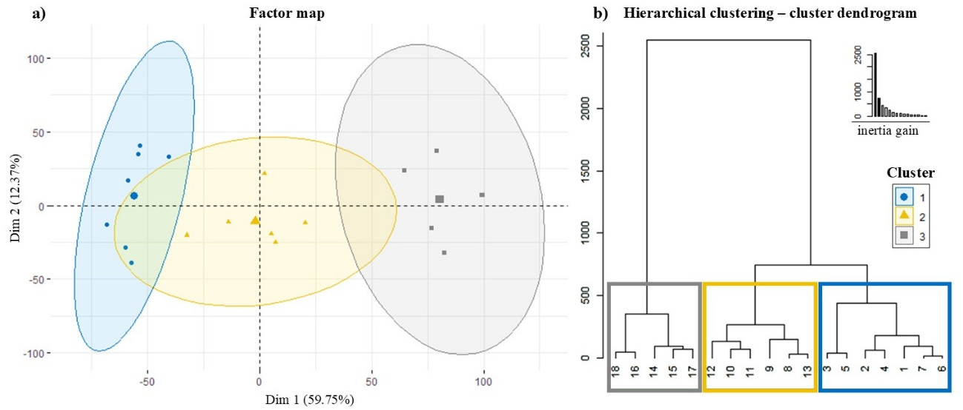
Supplementary figure 1. Factor map showing the proportion (%) of variance explained by both HCPC dimensions (a), and hierarchical clustering dendrogram (b).

Supplementary table 3. Clustering variables differences among established clusters.
VARIABLE GROUP | VARIABLE | CLUSTER 1 (x̄±SD) | CLUSTER 2 (x̄±SD) | CLUSTER 3 (x̄±SD) | χ²-value | p-value
Land cover | Urban use (%) | 0.02±0.06 | 0.14±0.23 | 0.53±0.75 | 3.11 | 0.21
Land cover | Forest coverage (%) | 34.31±30.26 | 32.23±22.72 | 55.36±19.79 | 2.39 | 0.30
Land cover | Grassland coverage (%) | 0.90±2.39 | 1.01±1.39 | 3.44±4.57 | 2.41 | 0.30
Land cover | Bare land (%) | 0.90±2.38 | 2.48±6.06 | 1.49±2.79 | 1.85 | 0.40
Land cover | Shrubland coverage (%) | 30.03±30.01 | 20.85±24.40 | 22.41±10.53 | 0.31 | 0.86
Climate | Precipitation during the driest quarter (mm) | 32.43±8.06 | 66.50±14.92 | 145.60±21.73 | 14.62 | 0.001
Climate | Maximum temperature during the warmest month (°C) | 32.75±1.07 | 29.50±3.40 | 25.38±2.82 | 10.40 | 0.006
Climate | Annual mean temperature (°C) | 15.55±1.45 | 11.92±1.46 | 11.64±2.31 | 9.76 | 0.008
Climate | Mean temperatures during the warmest quarter (°C) | 23.86±0.51 | 20.48±2.07 | 18.63±2.66 | 10.36 | 0.006
Climate | Mean temperatures during the coldest quarter (°C) | 8.32±2.24 | 4.65±1.35 | 5.53±2.16 | 8 | 0.02
Latitude |  | 38.45±0.88°N | 40.32±1.49°N | 42.50±0.67°N | 11.51 | 0.003
Mammal community | Red deer relative weight (%) | 61.72±16.31 | 16.55±20.07 | 6.45±14.35 | 11.62 | 0.003
Mammal community | Carnivore community relative weight (%) | 7.63±4.52 | 20.11±13.18 | 20.90±12.46 | 8.73 | 0.01
Mammal community | Grazing domestic ruminants relative weight (%) | 1.20±2.88 | 1.61±1.36 | 3.27±2.99 | 5.24 | 0.07
Mammal community | Wild boar relative weight (%) | 18.39±12.58 | 13.56±8.17 | 44.41±30.83 | 4.55 | 0.10
Health indicators | Co-exposure rate | 55.33±9.83 | 30.53±16.89 | 19.18±12.30 | 9.64 | 0.008
Surface ENAD | Marker diversity (H’) | 0.77±0.47 | 1.13±0.31 | 1.26±0.23 | 4.51 | 0.11
Surface ENAD | Marker richness | 2.57±1.27 | 3.50±1.05 | 4.20±1.30 | 4.78 | 0.09
—“χ²”=chi-square value; “SD”=standard deviation— Escherichia coli (uidA, stx1, stx2 and eae), Mycobacterium tuberculosis complex (IS6110 and mpb70), Salmonella spp. (invA), Coxiella burnetii (IS1111), Brucella spp. (IS711), M. avium subp. paratuberculosis (IS900), Balantioides coli, Blastocystis sp., Cryptosporidium spp, Encephalitozoon spp, Enterocytozoon bieneusi, Giardia duodenalis, and Toxoplasma gondii.

Supplementary table 4. Confusion matrix and statistics.
Confusion Matrix
 | Reference
Prediction | C1 | C2 | C3
C1 | 6 | 1 | 0
C2 | 1 | 5 | 0
C3 | 0 | 0 | 5
Overall Statistics
Accuracy |  | 0.89
95%CI |  | (0.65, 0.99)
No Information Rate |  | 0.39
P-Value [Acc>NIR] |  | 1.69e-05
Kappa |  | 0.83
Macro precision |  | 0.90
Macro recall |  | 0.90
Macro F1 score |  | 0.90
Weighted precision |  | 0.89
Weighted recall |  | 0.89
Weighted F1 score |  | 0.89
Statistics by Class
Class | C1 | C2 | C3
Sensitivity | 0.86 | 0.83 | 1
Specificity | 0.91 | 0.92 | 1
PosPredValue | 0.86 | 0.83 | 1
NegPredValue | 0.91 | 0.92 | 1
Prevalence | 0.39 | 0.33 | 0.28
DetectionRate | 0.33 | 0.28 | 0.28
DetectionPrevalence | 0.39 | 0.33 | 0.28
BalancedAccuracy | 0.88 | 0.88 | 1
—C1=Cluster 1; C2=Cluster 2; C3= Cluster 3—
Supplementary table 5. Prediction of the LOOCV using random forest method.
Study area | mtry | Predicted | Observed | Cluster 1 | Cluster 2 | Cluster 3 | Row index
1 | 10 | Cluster 1 | Cluster 1 | 0.85 | 0.14 | 0.01 | 1
2 | 10 | Cluster 1 | Cluster 1 | 0.93 | 0.07 | 0.00 | 4
3 | 10 | Cluster 1 | Cluster 1 | 0.90 | 0.09 | 0.004 | 3
4 | 10 | Cluster 1 | Cluster 1 | 0.95 | 0.04 | 0.01 | 2
5 | 10 | Cluster 1 | Cluster 1 | 0.89 | 0.11 | 0.01 | 5
6 | 10 | Cluster 3 | Cluster 3 | 0.38 | 0.11 | 0.50 | 14
7 | 10 | Cluster 2 | Cluster 2 | 0.17 | 0.80 | 0.03 | 10
8 | 10 | Cluster 1 | Cluster 1 | 0.76 | 0.23 | 0.01 | 6
9 | 10 | Cluster 3 | Cluster 3 | 0.03 | 0.48 | 0.49 | 15
10 | 10 | Cluster 2 | Cluster 2 | 0.01 | 0.88 | 0.12 | 11
11 | 10 | Cluster 2 | Cluster 1 | 0.36 | 0.59 | 0.05 | 7
12 | 10 | Cluster 3 | Cluster 3 | 0.07 | 0.26 | 0.67 | 16
13 | 10 | Cluster 2 | Cluster 2 | 0.10 | 0.74 | 0.16 | 12
14 | 10 | Cluster 1 | Cluster 2 | 0.98 | 0.02 | 0.00 | 8
15 | 10 | Cluster 3 | Cluster 3 | 0.02 | 0.22 | 0.76 | 17
16 | 10 | Cluster 2 | Cluster 2 | 0.01 | 0.76 | 0.23 | 13
17 | 10 | Cluster 2 | Cluster 2 | 0.34 | 0.46 | 0.19 | 9
18 | 10 | Cluster 3 | Cluster 3 | 0.01 | 0.26 | 0.74 | 18
—mtry parameter=number of variables randomly sampled as candidates at each split.—

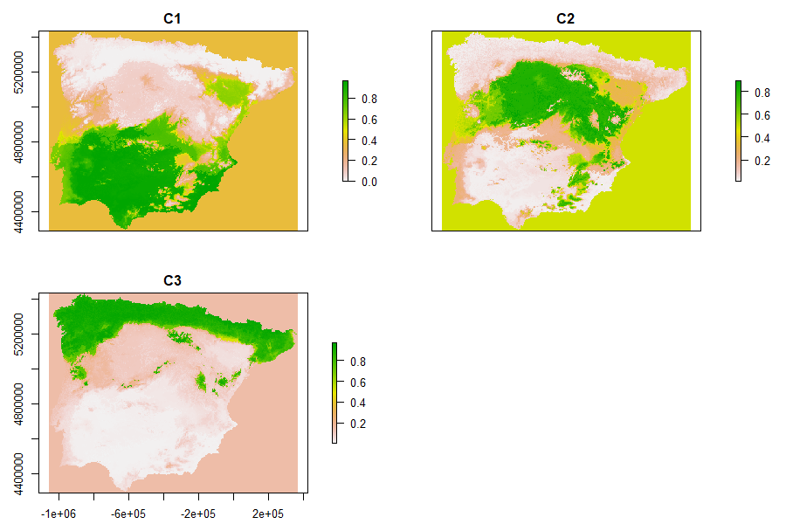
Supplementary figure 2. Probability of each map pixel belonging to a cluster. C1=Cluster 1; C2=Cluster 2; C3=Cluster 3.

SUPPLEMENTARY METHODS.
Detailed PCR protocols:
All the direct, semi-nested and nested PCR protocols described for parasites were conducted on a 2720 Thermal Cycler (Applied Biosystems). Reaction mixes always included 2.5 U of MyTAQ™ DNA polymerase (Bioline GmbH, Luckenwalde, Germany) and 5–10 μl 5× MyTAQ™ Reaction Buffer containing 5 mM deoxynucleotide triphosphates and 15 mM MgCl2. Negative and positive controls were included in every PCR run. PCR amplicons were visualized on 2% D5 agarose gels (Conda, Madrid, Spain) stained with Pronasafe (Conda nucleic acid staining solutions. A 100 bp DNA ladder (Boehringer Mannheim GmbH, Mannheim, Germany) was used for the sizing of the obtained amplicons.
Real-time PCR of bacteria molecular markers were conducted in a final volume of 25 µL, containing QuantiFast Pathogen + IC (Qiagen, Hilden, Germany) 400 mM primers, and 200 nM probes. PCR amplification conditions were the following: Tag DNA polymerase activation at 95ºC for 5 minutes followed by 45 cycles of denaturation at 95ºC for 15 seconds and annealing at 60 to 61ºC for 30 to 60 seconds. The analysis using the Foodproof STEC Screening Lyokit was performed according to the manufacturer’s instructions.

Mammal community characteristics parameters:
The parameters used to characterize the characteristics of the mammal community refer to the relative weight of the different species or groups of species within the community. This relative weight, as a proxy of a frequency-corrected relative abundance, has been obtained by multiplying the trapping rates (number of encounters per camera trap and day) by the detection frequency (% of cameras that detect that species), divided by the sum of these values ​​for all species detected at the study site (in %). From camera-trapping data, we defined “encounter” of a species as each independent photographic sequence within a time frame of 120 seconds. The formula for “relative weight” calculation is the following:
$${Relative weight (\%)}_{n}= \frac{{(trapping rate ×detection frequency)}_{n}}{\sum{{(trapping rate ×detection frequency)}_{m}}} ×100$$
where “n” is a species and “m” refers to all the species in each study site.
The photo-trapping data of the mammal community are taken from another related work by Perelló et al. at the same study sites.

