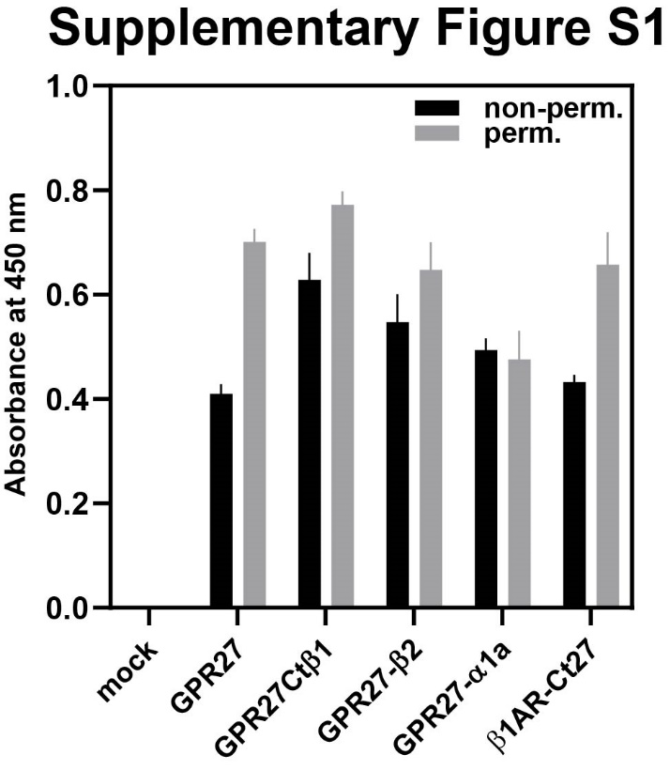
Suppl. Fig. S1
Whole-cell ELISA on HEK293T cells expressing the indicated receptors in non-permeabilized conditions (non-perm) to show plasma membrane localization or in permeabilized conditions (perm.) to determine the overall expression of the indicated receptors, using an anti-HA-HRP-conjugated antibody. Shown are mean values ± s.e.m., n = 3.

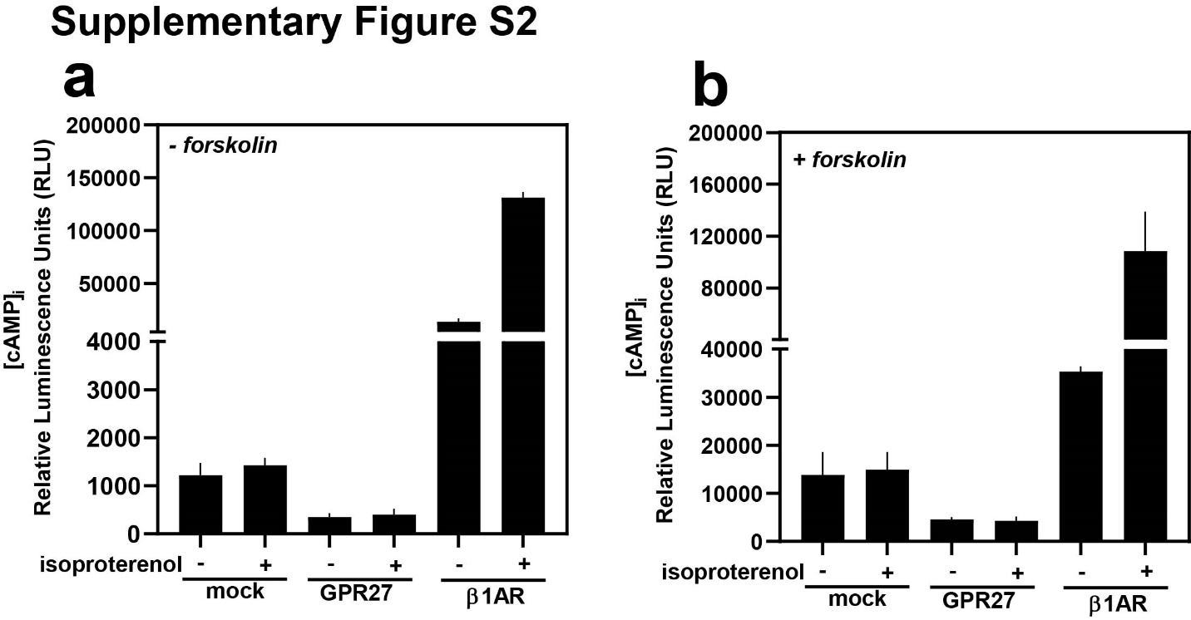
Suppl. Fig. S2
(a-b) Determination of intracellular cAMP levels in HEK293T cells expressing the indicated receptors together with the cAMP-sensitive probe after stimulation with 1 nM isoproterenol in the absence (a) or presence of 10 µM isoproterenol (b). Shown are mean values ± s.e.m., n = 4.

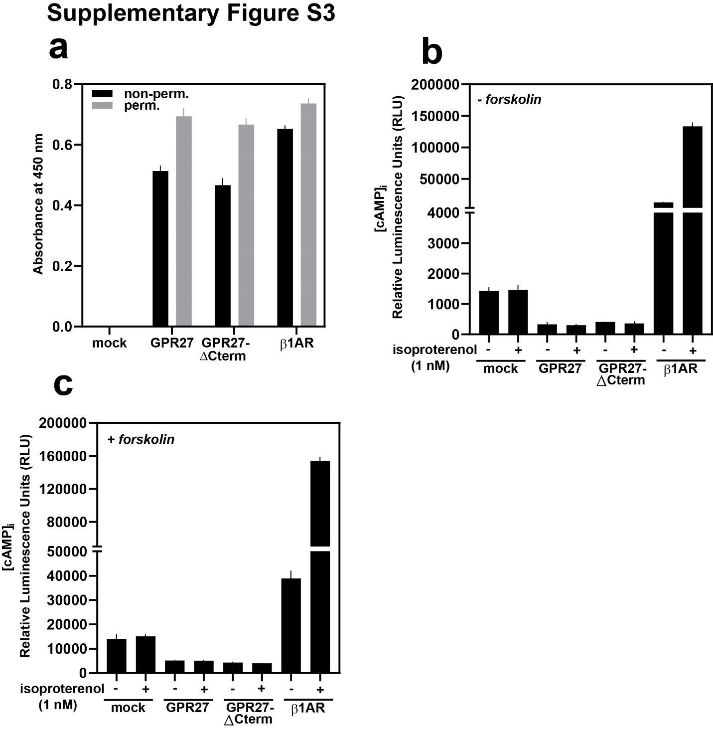

Suppl. Fig. S3
(a) Whole-cell ELISA on HEK293T cells expressing the indicated receptors to determine plasma membrane localization (non-perm.) and overall cellular expression (perm.). (b-c) Determination of intracellular levels of cAMP in HEK293T cells expressing the indicated receptors together with the cytosolic localized cAMP-sensitive probe after stimulation with 1 nM isoproterenol, in the presence (b) or absence (c) of forskolin (10 µM). Shown are mean values ± s.e.m., n = 3.

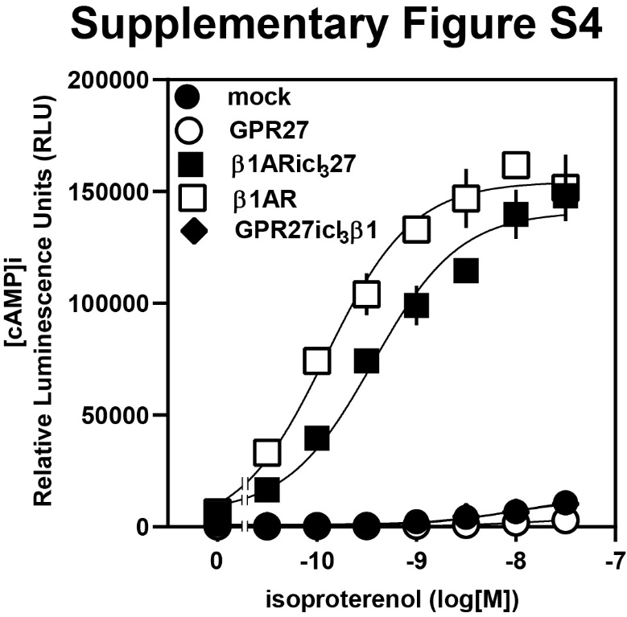
Suppl. Fig. S4
Effect of increasing concentrations of isoproterenol on intracellular levels of cAMP in HEK293T cells expressing the indicated receptors together with the cytosolic localized cAMP-sensitive probe. Shown are mean values ± s.e.m., n = 4.

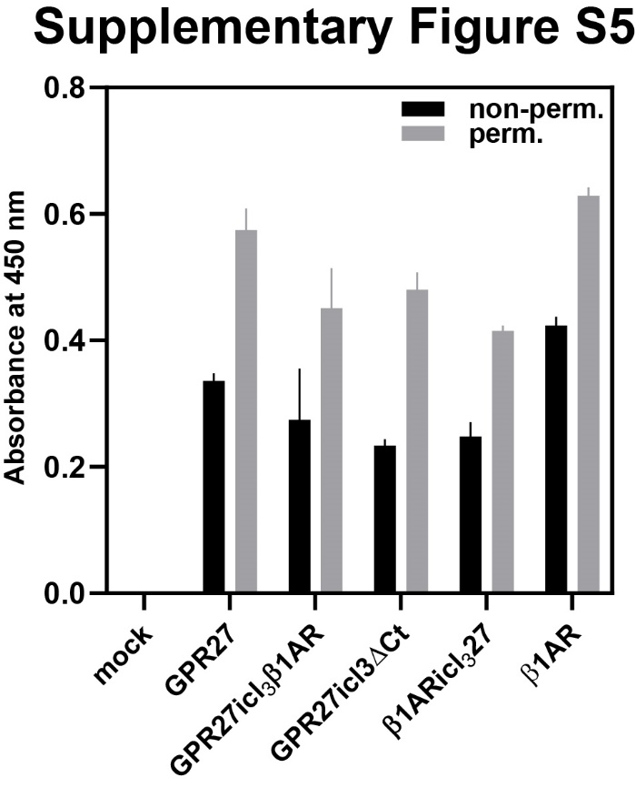
Suppl. Fig. S5
Whole-cell ELISA on HEK293T cells expressing the indicated receptors to evaluate plasma membrane localization (non-perm) and total cellular expression (perm.) using anti-HA-HRP conjugated antibody. Shown are mean values ± s.e.m., n = 3.

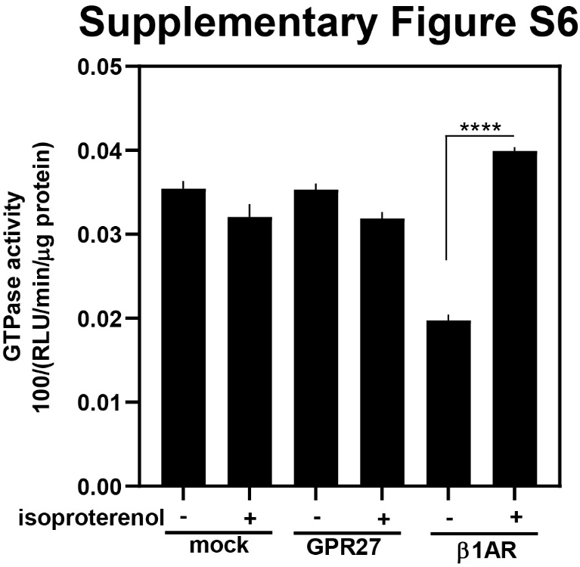
Suppl. Fig. S6
Total cellular GTPase activity assays in HEK293T cells expressing the indicated receptors were performed as described in Materials and Methods. For easier visualization, the raw results were divided by one hundred. Shown are mean values ± s.e.m., n = 3. ****P < 0.0001 (Student’s two-tailed t-test).

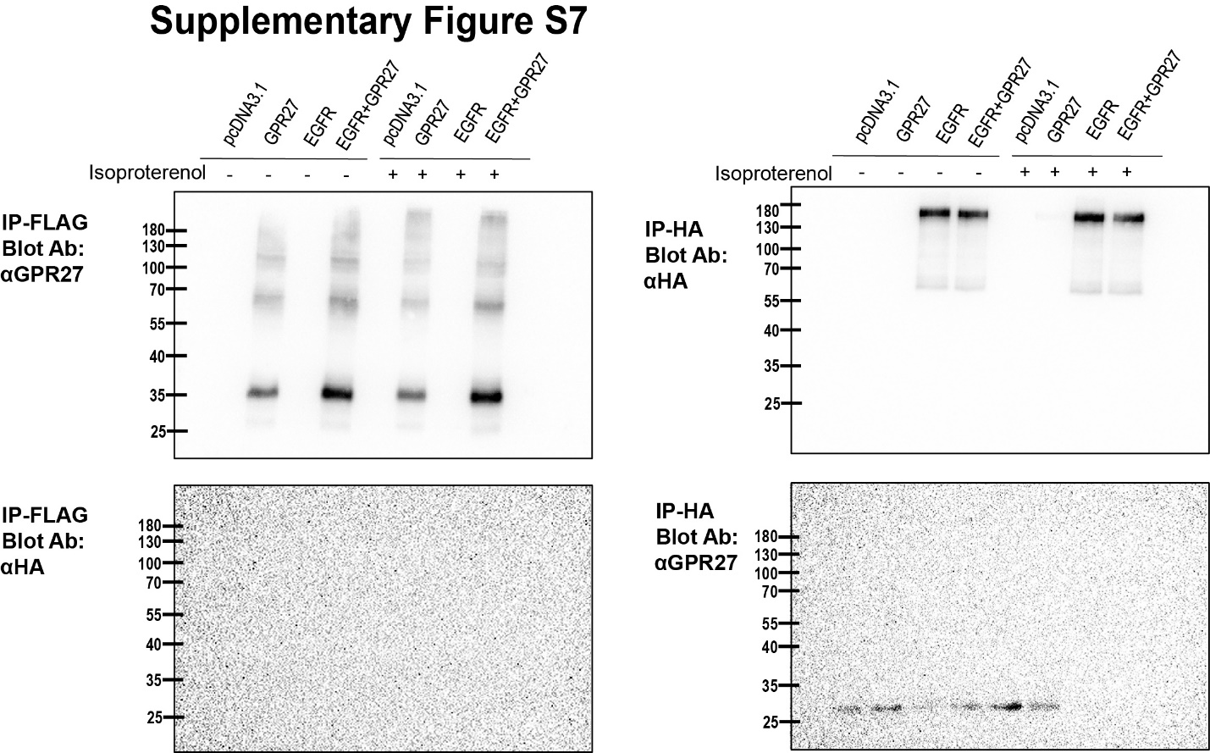
Suppl. Fig. S7
Immunoprecipitation followed by Western Blotting of cellular lysates (input: 300 µg total protein) from cells expressing N-terminally FLAG-tagged GPR27 and C-terminally HA-tagged EGFR. Where indicated, cells were exposed for 10 min to 1 µM isoproterenol. IP-FLAG, immunoprecipitation of total cellular lysates using anti-FLAG antibody; IP-HA, immunoprecipitation of total cellular lysates using anti-HA antibody. The assay was performed as presented in the Materials and Methods.

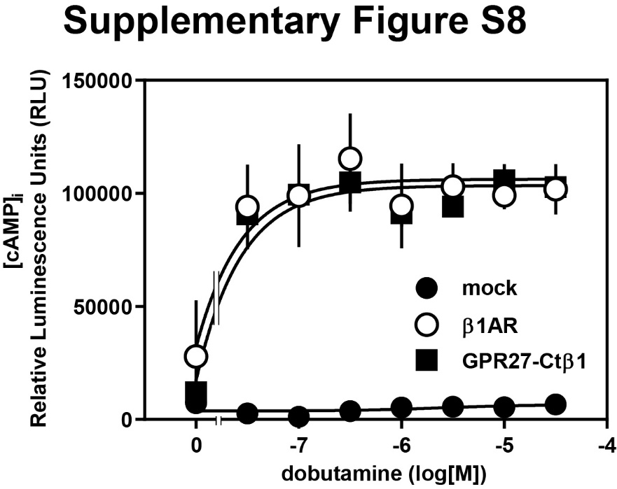
Suppl. Fig. S8
Effect of increasing concentrations of dobutamine on intracellular levels of cAMP in HEK293T cells expressing the indicated receptors together with the cytosolic localized cAMP-sensitive probe. Shown are mean values ± s.e.m., n = 4.

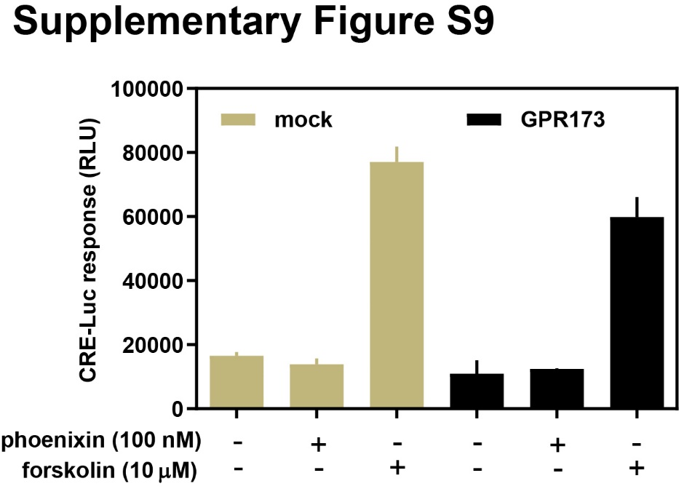
Suppl. Fig. S9
Effect of pheonixin and forskolin on HEK293T expressing empty vector (mock) and GPR173 toghether with a probe consisting of the firefly luciferase gene under the control of six cAMP response elements (CREs), CRE-Luc. Shown are mean values ± s.e.m,., n = 6.

