Supplementary Information for:

Emerging dominance of summer rainfall in driving High Arctic terrestrial-aquatic connectivity

Beel, C.R.^{1,2}, Heslop, J.K.^{1,3}, Orwin, J.F.^{1,4}, Pope, M.A.¹, Schevers, A.J.¹, Hung, J.K.Y.¹, Lafrenière, M.J.¹, Lamoureux, S.F.¹

¹Department of Geography and Planning, Queen’s University, Kingston, ON K7L 3N6 Canada
²Water Management and Monitoring, Environment and Natural Resources, Government of Northwest Territories, Yellowknife, NT X1A 2L9, Canada
³Section 3.7 Geomicrobiology, Helmholtz Centre Potsdam GFZ German Research Centre for Geosciences
⁴Resource Stewardship Division, Alberta Environment and Parks, Government of Alberta, Calgary, AB T2L 2K8, Canada

Introduction
Here we provide further information on the CBAWO site and our data record (Section 1) and detailed methods (Section 2; 37 references). This document contains an additional 17 supporting figures (Section 3) and 9 supporting tables (Section 4). All data presented in this study are available in the Supplementary Dataset.

- Site description
This research was conducted at the Cape Bounty Arctic Watershed Observatory (CBAWO), located on the south-central coast of Melville Island in the Canadian High Arctic (74º54’N, 109º35’W, Supplementary Fig. S1). This setting is characterized by a polar desert climate (Mean Annual Air Temperature (MAAT; ± 1σ: -14.8 ± 1.3 ºC) with limited annual precipitation and runoff (< 150 mm yr⁻¹) and is underlain by continuous permafrost (~500 m). Mean summer (Jun-Aug; JJA) air temperature is 2.7 ± 2.5 ºC (2003-2019, Supplementary Fig. S13). Extensive deposits of unconsolidated early Holocene marine and Late Glacial sediments drape the underlying sedimentary bedrock (Devonian sandstones and siltstones; Hodgson et al., 1984). Soils are typical cryosols (Soil Classification Working Group, 1998) with a thin organic layer (< 5 cm) and low OC content (1-3 %), developed from largely unaltered parent material (Grewer et al., 2016). Vegetation is characterized as prostrate dwarf-shrub tundra (Walker et al., 2005) with a heterogenous cover composed of wet (16.6 %), mesic (34.7 %), and polar desert (35.1 %) communities depending on slope drainage conditions (Hung and Treitz, 2020).

The CBAWO is comprised of paired watersheds (West and East, unofficial names; WR and ER, respectively); the West watershed is 8.0 km² and has instrumented headwater slope streams (PT: Ptarmigan and GS: Goose; both ~0.2 km² watershed area), and the East watershed is 11.6 km² (Supplementary Table S1). Both watersheds are non-glacial, and the streams have a seasonal snow-limited flow regime where channel runoff typically begins in early to mid-June, with flow cessation in late-August to early-September during freeze-up. Late season rainfall events punctuate baseflow runoff in headwater slope and mainstem streams, with pluvial responses largely controlled by the timing and magnitude of rainfall, as well as antecedent soil moisture conditions (Favaro and Lamoureux, 2015). V-cut notches eroded through a prominent bedrock ridge across both watersheds favour deep snow accumulation in winter (≥ 4 m) and snow dams during nival freshet (Lamoureux et al., 2006). Extensive wind redistribution of winter snow leads to further accumulation in gullies, channels, and concavities, especially in the West watershed (Lewis et al., 2012).

Both the West and East streams have second-order, low-sinuosity channels with short reaches of braided, riffle- and step-pool morphology along their lengths due to variability in channel slope. Surface runoff in the upper East watershed occurs as diffuse flow over vegetated water tracks, hydrologically connecting ponds along the terrestrial-aquatic continuum. Despite the similar relief in both watersheds, the West has more ridges, dissected slopes, and a higher proportion of steeper slopes (Lewis et al., 2012). Water tracks in the West watershed are limited to headwater slope inputs (e.g., GS; representative of runoff from ca. 50% of both watersheds area), with the majority of runoff in channelized colluvial streams. Mainstem channel bars are dominated by coarse material (55 % cobbles and boulders) draped with patches of fine sediment (45 % silt, clay, and sand) that provide material readily available for remobilization.

Both watersheds are impacted by varying degrees of documented permafrost disturbance. Deep thermal disturbance of the upper permafrost in July 2007, combined with multiple late-season rainfall events, resulted in the formation of 100+ localized active layer detachments (ALDs) that disturbed 2.7 % of the West and 1.2 % of the East watersheds (Lamoureux and Lafrenière, 2017; Supplementary Fig. S1). ALDs varied from small, hydrologically (dis)connected patches on slopes to long (> 100 m) linear features that directly coupled with mainstems (Supplementary Fig S1; Beel et al., 2020). Two periods of active massive-ice degradation in the channel (2008-2010; 2017-ongoing) were observed in a section of the upper West watershed but were absent along any section of the East channel. Analysis of satellite imagery between 1950 (first available image) and 2007 shows that prior to our observed ALDs in 2007-2008 there was no evidence for recent physical disturbance at the CBAWO (Lamoureux et al., 2014).

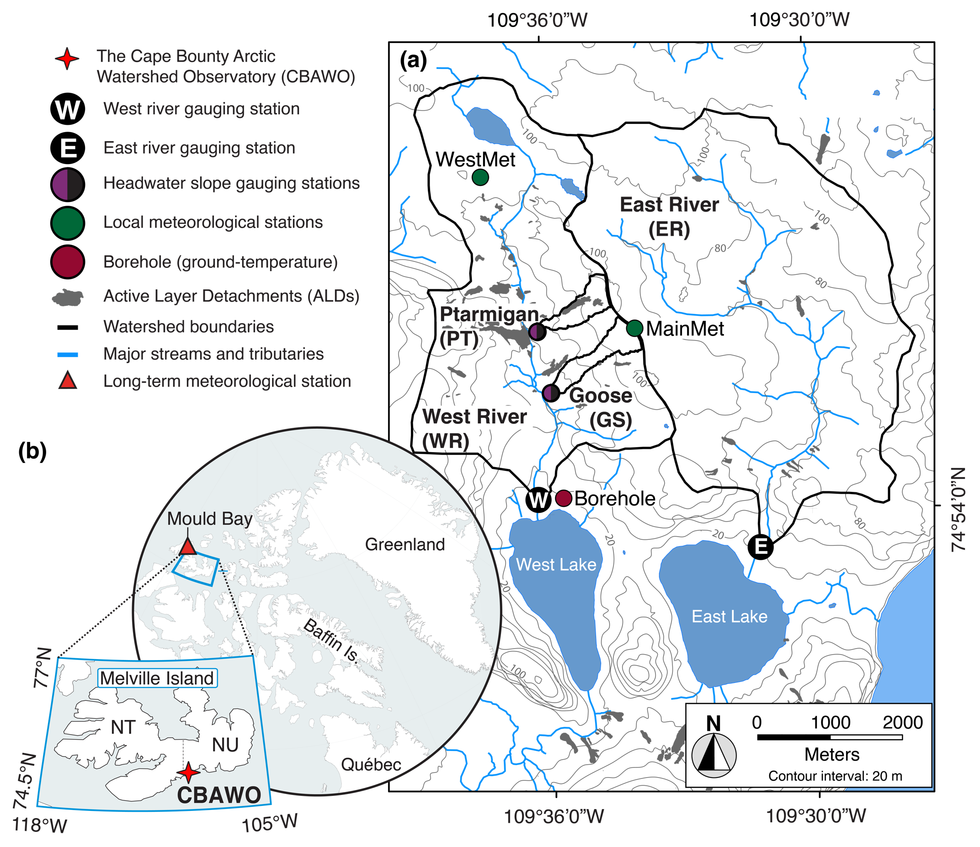

Fig. S1. The locations of (a) the Cape Bounty Arctic Watershed Observatory (CBAWO) and (b) Melville Island, Nunavut (NU) in the Canadian High Arctic. Boundaries of all studied watersheds are shown, with the locations of stream gauging stations and meteorological stations indicated. ALDs that formed in 2007-2008 are denoted as filled grey polygons that represent mapped disturbance extents on 1 August 2008 (Rudy et al., 2013). Basemaps prepared in ArcGIS version 10.5 from NTS 1:50 000 map 78F/15 (UTM, WGS 84). Inset map (b) shows the location of Mould Bay, the nearest long-term (1948-2019; 300 km to the west) Environment and Climate Change Canada meteorological site. Maps contain information licensed under the Open Government License – Canada.

Table S1. Watershed physiography at the CBAWO.
 | Watershed area (km²) | Mean channel slope | Areal extent of physical permafrost disturbance | Primary stream channel type
Main watersheds
West | 8.0 | 5.2° | 2.7 | Colluvual bed
East | 11.6 | 4.5° | 1.2 | Water track/Colluvial bed
Headwaters
PT | 0.21 | 3.9° | 10.8 | Colluvial bed
GS | 0.18 | 3.2° | 0 | Water track

- Methods
  - Data consistency and statistics
Instrumentation, datalogger, and analytical method specifications are documented in Supplementary Table S2. For coherence among records and to provide the finest temporal resolution across all years, we reprocessed all variables from raw data into daily means. We used propagation of uncertainty methods to: (1) account for the measurement error associated with instrumentation and analytical methods; and (2) determine how these uncertainties propagate through concentration and flux determinations using the sum of quadrature method (Taylor et al., 1982). To account for inter-annual variation in hydrometeorological and hydrological conditions, and since we capture the first day of flow in each year of record, we normalized data to the first day of flow instead of calendar dates for the full data set. All statistical analyses were conducted in Matlab version R2016a and 2020a software. Correlations were calculated using Pearson’s r linear correlation coefficients (Supplementary Tables S3-S6). Differences between variables: (a) between watersheds and (b) between hydrological periods were determined using a combination of ANOVA analyses (Supplementary Table S7) and two-samples T-tests (Supplementary Figs. S9-S10). Results from all statistical analyses were considered significant at the α = 0.05 level when p < 0.05.

  - Climatology
Climate data were obtained from local and regional meteorological stations proximal to the CBAWO. Local air temperature and rainfall data were collected hourly from the WestMet meteorological station, and barometric pressure data were collected at 10-min intervals at MainMet (Supplementary Fig. S1a). Event-scale rainfall data (2003-2019) from WestMet were used to construct a 72-hr intensity-duration-frequency (IDF) curve for the CBAWO (Gumbel EV1 distribution; Watt et al., 1989) to estimate the recurrence interval for each rainfall event (Supplementary Fig. S7; Beel et al., 2018). Additional monthly climate data for Mould Bay, NT (~ 300 km west of the CBAWO; Environment and Climate Change Canada; Supplementary Fig. S1b inset), the nearest long-term (1948-2019) station, were utilized to evaluate longer-term annual hydrometeorological changes. Given the relatively short duration of available snow and rainfall records at CBAWO and often incomplete records from Mould Bay, evaluation of any changes in the longer-term trend of precipitation beyond our measurement period at the CBAWO is outside the scope of these data.

  - Active layer depth and growing degree days
Daily JJA active layer depths (Fig. 3a) were estimated using ground temperature data collected between 2012-2018 from a 7-m borehole (Supplementary Fig. S1a). Daily active layer depth estimates were calculated using a linear regression of temperatures recorded at 0.3 m and 1.3 m depth, with the depth at which the temperature was 0 ºC being the assumed thaw boundary. This method assumed linear decreases in ground temperature within the 1.3 m depth range, and actual active layer depths may vary with local soil moisture and ice content conditions; however, values estimated using linear regression (0.0 to 1.20 m during JJA) were consistent with mean seasonal maximum active layer depths manually measured using a probe spatially across the CBAWO (0.7- 1.1 m; Lamoureux and Lafrenière, 2017).

Growing degree days (GDD) represent the cumulative amount of heat above a threshold temperature and was calculated as:

GDD=T_{max}+T_{min}2- T_{base} (Eq. S1)

where T_{max} and T_{min} are the daily maximum and minimum temperatures respectively and T_{base} is the base temperature representative of the threshold temperature above which plants are productive. Here, we use 5 °C after Carter (1998) and Weijers et al. (2013).

  - Hydrology
Stream stations located at the outlet of each watershed (WR, ER, PT, GS) measured water-level (stage) and water temperature at 10-min intervals (Supplementary Table S2; Beel et al., 2018). Stage measurements were corrected for barometric pressure and converted to discharge (Q) using site-specific annual rating curves developed from: (a) a minimum of 10 velocity-area gauging’s under different flow regimes to establish seasonal stage-Q relationships for each mainstem stream (r² = 0.71-0.99; Beel et al., 2018); and (b) using calibrated cut-throat flume ratings for headwater slope streams (Beel et al., 2020). Mean Q uncertainty was calculated to be ± 4-6 % for all streams. Seasonal hydrographs were partitioned into nival (snowmelt), baseflow (low flow), and pluvial (rainfall) hydrological periods based on subjective observed changes in the runoff regime (Singh, 1992; Beel et al., 2018) and compared to automated methods (Tang and Carey, 2017) with varying degrees of accuracy (60-80 % of pluvial responses captured); low-amplitude pluvial responses were often missed in headwater slope streams (0.2 km²). We report seasonal total Q in conventional watershed area-normalized depth (mm) units and instantaneous discharge in volume-time (m³ s⁻¹) units.

Stream power represents the rate of energy expenditure along a riverbed and banks and was calculated using Equation S2:
Ω = ρgQs (Eq. S2)

where stream power (Ω; Watts or kg m⁻² s⁻³) is the product of water density calculated from measured water temperatures (ρ; kg m⁻³), acceleration due to gravity (g; 9.8 m s⁻²), instantaneous discharge (Q; m³ s⁻¹), and channel slope (s) (Knighton, 1998). We applied a 5 m buffer on either side of the middle of the channel in ArcGIS® to represent the channel area, from which the watershed’s average channel slope was calculated (s; Supplementary Table S1).

e. Dissolved organic and inorganic fluvial measurements
Surface water samples for dissolved organic and inorganic variables were determined from filtered water samples collected between 2006 and 2017. Surface water samples were manually collected in 1 L high-density polyethylene bottles, which were tripled rinsed with stream water before sample collection. Samples were collected from WR, PT, and GS daily throughout the hydrological season at approximately daily low and high Q (0900 and 1800 h, respectively); at the ER, water samples were collected once every 3-5 days at approximately daily high Q. Samples for both dissolved organic carbon (DOC) and total dissolved nitrogen (TDN) were vacuum-filtered through pre-combusted (400 °C for 4 hours) 0.7-μm GF filters with a glass filtration apparatus. Filtered samples were stored in 45 ml amber EPA vials with Teflon-lined septa following previously published methods (Lewis et al., 2012; Fouche et al., 2017). Note that the pre-combusted 0.7-μm filters were not retained for POC analysis following filtration in the field (Beel et al., 2020). Samples for major ion determination were vacuum filtered through sterile 0.22-μm polyvinylidene difluoride (PVDF) membrane filters with a polysulfone filtration apparatus in the field laboratory and stored in 25 ml scintillation vials with no headspace. Filtered samples were refrigerated in the dark (< 4 °C) until analyses; samples were analyzed within 4-8 weeks of sample collection due to logistical limitations imposed by the remoteness of the CBAWO. We recognize that there was likely some DOC loss in our samples as a result of microbial processing during sample storage, but we are unable to quantify this effect.

DOC and TDN concentrations were measured simultaneously using high-temperature combustion on a Shimadzu TOC-VPCH/TNM system and concentrations of major ions were measured using a Dionex ICS 3000 ion chromatograph at Queen’s University, Kingston, Canada. Anions (Cl⁻, SO₄⁻, NO₃⁻) were measured with a gradient elution of 11-40 mM KOH, while cations (Na⁺, K⁺, Mg²⁺, Ca²⁺, NH₄⁺) were measured isocratically using 16 mM methane sulfonic acid (MSA) eluent. The detection limits, calculated as three times the standard deviation of the lowest level standard, were less than 0.010 mg L⁻¹ for all species, except Ca²⁺ and Mg²⁺, which had detection limits of 0.053 and 0.022 mg L⁻¹, respectively.

Major ion concentrations were calculated by summing all of the major anions and cations, and bicarbonate (HCO₃⁻) concentrations were estimated by charge balance (Lamhonwah et al., 2017). For the ER, daily DOC concentrations were estimated by applying a cubic spline function (spline) to the measurements using Matlab version R2020a (p < 0.05). Failure of refrigerators used to store water samples prior to analysis in 2014 resulted in the loss of a significant number of filtered water samples. As a result, we are unable to provide an estimate of the DOC_{flux} for ER in 2014. Daily mean major ion concentrations in the ER (2010-2017) were estimated using the relationship between measured major ion and continuous specific electrical conductivity measurements for all available years of data (Pearson r = 0.95, p < 0.05, n = 235) (Supplementary Fig. S15).

Daily fluxes (DOC_{flux}, TDN_{flux}, major ion_{flux}) were calculated as the product of total daily Q and daily mean concentrations of DOC, TDN and major ions and summed for each season. Average DOC and TDN uncertainty are calculated at ± 3-5 % (2006-2010) and ± 5-8 % (2012-2017). Average major ion uncertainty is calculated at ± 4-6 %. Total uncertainties for annual DOC_{flux} and TDN_{flux} were estimated to be ± 6-10 % (2006-2010) and ± 7-12 % (2012-2017). Total uncertainties for annual major ion_{flux} were estimated to be ± 5-9 %, respectively.

f. DOM optical measurements
Optical properties of chromophoric dissolved organic matter (CDOM) and fluorescent dissolved organic matter (FDOM) were determined using a Horiba Aqualog using DOC samples collected between 2012 and 2017. Both UV-visible absorbance (CDOM) and fluorescence (FDOM) were measured in a 1 cm quartz cuvette at room temperature. UV-visible absorbance was measured from 240 to 600 nm in 3 nm increments, then linearly interpolated to 1 nm increments. Excitation values were measured from 240 to 600 nm in 3 nm increments and corresponding emission wavelengths were measured from 214.16 to 621.03 nm at 3.15 nm intervals. CDOM measurements were referenced against DI water blanks and normalized using a 1 ppm quinine sulfate standard. FDOM excitation-emission matrix (EEM) files were: (1) corrected for blanks and inner filter effects (McKnight et al. 2001); (2) first- and second-order Rayleigh scatter effects were removed using the manufacturer’s correction procedure; and (3) normalized using a 1 ppm quinine sulfate standard.

CDOM data were used to calculate specific UV absorbance at 254 nm (SUVA₂₅₄), a parameter that is commonly used as an index of DOM aromaticity, by dividing the measured absorbance at a wavelength of 254 nm by the sample’s DOC concentration (L mgC⁻¹ m⁻¹; Weishaar et al., 2003). We then converted measured absorbance values (A) to Naperian units (α) using Equation S3:

α(λ) = 2.303A(λ)/l (Eq. S3)

where A(λ) is the measured absorbance at wavelength λ and l is the cell path length in meters (Green and Blough, 1994). We report absorption coefficients, in Naperian units, at wavelengths of 254 nm (α₂₅₄) and 350 nm (α₃₅₀). α₂₅₄ and α₃₅₀ have been previously shown to correlate with allochthonous-dominated DOM in riverine systems (Spencer et al., 2012). Further, α₃₅₀ has been previously shown to strongly correlate with lignin phenol concentrations (Spencer et al., 2010) and are indicative of terrigenous DOM in riverine systems (Mann et al., 2016; Spencer et al., 2012). Spectral slope was calculated between 275-295 nm and 350-400 nm by fitting Equation S4:
α_{g}(λ) = α_{g}(λ_{ref})e^{-S(λ- λref)} (Eq. S4)

where α_{g}(λ) is the Naparian absorption coefficient at wavelength λ, λ_{ref} is a reference wavelength, and S is the slope fitting parameter (Helms et al., 2008). Spectral slope ratio (S_{R}; S₂₇₅₋₂₉₅:S₃₅₀₋₄₀₀) have been shown to correlate with average DOM molecular weight (Helms et al., 2008).

Using the FDOM data, we calculated the Fluorescence index (FI), a measure of the relative contribution of terrestrial and microbial DOM sources, as the ratio of measured intensities at ex370/em470 and ex370/em520 (Cory et al., 2010). Humification index (HIX), an indicator of the degree of DOM humification, was calculated by dividing the area under ex254/em435-480 by the summed area under ex254/em300-345 and ex254/em435-480 (Ohno, 2002). We calculated the freshness index (β:α), an indicator of recently-produced DOM, as the ratio of intensity at ex310/em380 divided by the maximum intensity between ex310/em420-435 (Wilson and Xenopoulos, 2009). Additionally, the biological index (BIX), in indicator or autochthonous-origin DOM, was determined at the ratio of intensity at ex310/em380 divided by intensity at ex310/em430 (Huguet at al., 2009).

g. Particulate organic and inorganic fluvial measurements
Concentrations of suspended sediment (SSC) and particulate organic carbon (POC) were determined from water samples collected every 3-hr at mainstem stations (2003-2017) and concurrently with dissolved samples in headwater slope streams (2007-2017). All samples were volumetrically filtered through non-combusted, pre-weighed 1-μm glass fiber (GF) filters, folded to retain sediment on the filter and stored in individual polyethylene bags for SSC and POC quantification. Although pre-combusted 0.7-μm GF filters were not available for POC analysis in this study, extensive testing of non-combusted 1-μm GF filtration versus pre-combusted filters with 0.7-μm pore sizes showed negligible differences in concentrations of POC from these watersheds (Beel et al., 2020), similar to observations from the Mackenzie River (Emmerton et al., 2008; Gareis and Lesack, 2017).

In the laboratory, the GF filters were freeze-dried then weighed twice to determine SSCs. Average SSC uncertainty is ± 4 % (> 10 mg L⁻¹) and ± 10 % (< 10 mg L⁻¹). To determine POC concentrations, filters were acid-fumed with 50 ml of 6 % trace metal grade sulfurous acid (H₂SO₃) for 20-hr and oven-dried overnight at 50 °C (Kennedy et al., 2005; Komada et al., 2008). After fumigation, filters were sub-sampled into quarters, weighed individually, and pelletized in foil cups. Sample pellets were analyzed for organic carbon (OC) content using a LECO TruSpec CN elemental analyzer (Beel et al., 2020). Process blanks and LECO certified reference materials (LOT 1000: 10.8 ± 0.26 % C, 0.86 ± 0.03 % N) were run at the beginning and throughout every run to ensure consistency and determine instrument accuracy and stability (Beel et al., 2020). POC mass was calculated as the product of the sediment mass retained on the filter and the proportion of sediment composed of C (wt%), which was divided by filtered water volumes to determine POC concentrations.

SS and POC were strongly linearly correlated in both headwater slope (r² = 0.96-0.99; Beel et al., 2020) and mainstems (r² = 0.8-1.0; Supplementary Fig. S16). In mainstem streams, the proportion of POC in SS ranged from 0.9 to 3.5 %, with POC averaging 2.0 % and 1.8 % of the SS in the West and East, respectively (Supplementary Data).
The slopes of the correlation between SSC and POC varied between years suggesting the need for annual, site-specific relationships to be established (Supplementary Fig. S16). Average POC uncertainty was ± 6 % (POC > 10 mg L⁻¹) and ± 13 % (POC ≤ 10 mg L⁻¹). Daily fluxes (kg; SS_{flux}, POC_{flux}) were calculated with the product of total daily Q and daily mean SSC and POC and summed for each season. Total uncertainties for annual SS_{flux} and POC_{flux} were estimated to be ± 4.5-10 % and ± 8-15 %, respectively.

References

Beel, C.R., Lamoureux, S.F., Orwin, J.F. Fluvial response to a period of hydrometeorological change and landscape disturbance in the Canadian High Arctic. Geophys. Res. Lett., 45, https://doi.org/10.1029/2018GL079660 (2018).
Beel, C.R., et al. Differential impact of thermal and physical permafrost disturbance on High Arctic dissolved and particulate fluvial fluxes. Sci. Report., 10, 11836. https://doi.org/10.1038/s41598-020-68824-3 (2020).
Carter, T. Changes in the thermal growing season in Nordic countries during the past century and prospects for the future. Agricultural and Food Science in Finland, 7, 161–179. https://doi.org/10.23986/afsci.72857 (1998).
Cory, R.M., et al. Effect of instrument-specific response on the analysis of fulvic acid fluorescence spectra. Limnol. Oceanogr.-Meth. 8, 67-78 (2010).
Emmerton, C.A., Lesack, L.F.W., & Vincent, W.F. Mackenzie River nutrient delivery to the Arctic Ocean and effects of the Mackenzie Delta during open water conditions. Global Biogeochem. Cycles, 22, GB1024, https://doi.org/10.1029/2006GB002856 (2008).
Favaro, E.A., & Lamoureux, S.F. Antecedent controls on rainfall runoff response and sediment transport in a High Arctic catchment. Geogr. Ann. Phys. Geogr., 96(4), 433-446. https://doi.org/10.1111/geoa.12063 (2014).
Fouché, J., Lafrenière, M.J., Rutherford, K., & Lamoureux, S.F. Seasonal hydrology and permafrost disturbance impacts on dissolved organic matter composition in High Arctic headwater catchments. Arctic Sci., 3, 378-405, https://doi.org/10.1139/as-2016-0031 (2017).
Gareis, J.A.L., & Lesack, L.F.W. Fluxes of particulates and nutrients during hydrologically defined seasonal periods in an ice-affect great Arctic river, the Mackenzie. Water Resour. Res., 53, 6109-6132, https://doi.org/10.1002/2017WR020623 (2017).
Green, S.A. and Blough, N.V. Optical absorption and fluorescence properties of chromophoric dissolved organic matter in natural waters. Limn. Oceanogr. 39, 1903-1916 (1994).
Grewer, D.M., Lafrenière, M.J., Lamoureux, S.F., Simpson, M.J. Redistribution of soil organic matter by permafrost disturbance in the Canadian High Arctic. Biogeochemistry, 128(3), 397-415, https://doi.org/10.1007/s10533-016-0215-7 (2016).
Government of Canada – Environment and Natural Resources. Historical Climate Data (www.climat.meteo.gc.ca, 2019).
Helms, J.R., et al. Absorption spectral slopes and slope ratios as indicators of molecular weight, source, and photobleaching of chromophoric dissolved organic matter. Limnol. Oceanogr. 53, 955-969. https://doi.org/10.4319/lo.2008.53.3.0955 (2008).
Hodgson, D.A., Vincent, J.-S., Fyles, J.G. Quaternary geology of central Melville Island, Northwest Territories. Geological Survey of Canada, Paper 83-16, https://doi.org/10.4095/119784 (1984).
Huguet, A., et al. Properties of fluorescent dissolved organic matter in the Gironde Estuary. Org. Geochem., 40(6), 706-719. https://doi.org/10.1016/j.orggeochem.2009.03.002 (2009).
Hung, J.K.Y., Treitz, P. Environmental land-cover classification for integrated watershed studies: Cape Bounty, Melville Island, Nunavut. Arctic Sci., early version, 1-19. https://doi.org/10.1139/as-2019-0029 (2020).
Kennedy, P., Kennedy, H., & Papadimitriou, S. The effect of acidification on the determination of organic carbon, total nitrogen and their stable isotopic composition in algae and marine sediment. Rapid Commun. Mass Spectrom., 19, 1063-1068, https://doi.org/10.1002/rcm.1889 (2005).
Komada, T., Anderson, M.R., & Dorfmeier, C.L. Carbonate removal from coastal sediments for the determination of organic carbon and its isotopic signatures, d¹³C and D¹⁴C: comparison of fumigation and direct acidification by hydrochloric acid. Limnol. Oceanogr.: Methods, 6, 254-262, https://doi.org/10.4319/lom.2008.6.254 (2008).
Knighton, D. Fluvial forms & processes. (Hodder Arnold, 1998).
Lamhonwah, D., Lafrenière, M.J., Lamoureux, S.F., & Wolfe, B.B. Multi-year impacts of permafrost disturbance and thermal perturbation on High Arctic stream chemistry. Arctic Sci., 3, 254-276, https://doi.org/10.1139/as-2016-0024 (2017).
Lamoureux, S.F., et al., An incidence of multi-year sediment storage on channel snowpack in the Canadian High Arctic. Arctic, 59(4), 381-390, https://doi.org/10.14430/arctic287 (2006).
Lamoureux, S.F., Lafrenière, M.J. More than just snowmelt: integrated watershed science for changing climate and permafrost at the Cape Bounty Arctic Watershed Observatory. WIREs Water, 5(1), e1255, https://doi.org/10.1002/wat2.1255 (2017).
Lewis, T., Lafrenière, M.J., Lamoureux, S.F. Hydrochemical and sedimentary responses of paired High Arctic watersheds to unusual climate and permafrost change, Cape Bounty, Melville Island, Canada. Hydrol. Process., 26, 2003-2018, https://doi.org/10.1002/hyp.8335 (2012).
Mann, P.J., et al. Pan-Arctic trends in terrestrial dissolved organic matter from optical measurements. Front. Earth. Sci., 4:25. https://doi.org/10.3389/feart.2016.00025 (2016).
McKnight, D.M., et al., Spectrofluorometric characterization of dissolved organic matter for indication of precursor organic material and aromaticity. Limno. Ocean., 46(1), 38-48. https://doi.org/10.4319/lo.2001.46.1.0038 (2001).
Ohno, T., et al. Ultrahigh Resolution Mass Spectrometry and Indicator Species Analysis to Identify Marker Components of Soil- and Plant Biomass-Derived Organic Matter Fractions. Environmental Science & Technology 44, 8594–8600 (2010).
Rudy. A.C.A., Lamoureux, S.F., Treitz, P., Collingwood, A. Identifying permafrost slope disturbance using multi-temporal optical satellite images and change detection techniques. Cold Reg. Sci. Technol., 88, 37-49, https://doi.org/10.1016/j.coldregions.2012.12.008 (2013).
Singh, V. Elementary Hydrology. (Prentice Hall, 1992).
Soil Classification Working Group. The Canadian System of Soil Classification (3rd Ed.) Agriculture and Agri-Food Canada Publication, 1646 (Revised, 1998). http://sis.agr.gc.ca/cansis/publications/manuals/1998-cssc-ed3/index.html
Spencer, R.G.M., et al. Comparison of XAD with other dissolved lignin isolation techniques and a compilation of analytical improvements for the analysis of lignin in aquatic settings. Org. Geochem., 41, 445-453. https://doi.org/10.1016/j.orggeochem.2010.02.004 (2010).
Spencer, R.G.M., et al., Dissolved organic carbon and chromophoric dissolved organic matter properties of rivers in the USA. J. Geophys. Res., 117, G03001. https://doi.org/10.1029/2011JG001928 (2012).
Tang, W., Carey, S.K. HydRun: A MATLAB toolbox for rainfall-runoff analysis. Hydrological Processes. https://doi.org/10.1002/hyp.11185 (2017).
Taylor, J.R. An introduction to error analysis: the study of uncertainties in physical measurements. (University Science Books, 1982).
Walker, D.A. et al., The Circumpolar Arctic vegetation map. J. Veg. Sci., 16, 267-282. https://doi.org/10.1111/j.1654-1103.2005.tb02365.x (2005).
Watt, W.E., Lathem, K.W., Neill, C.R., Richards, T.L., & Rousselle, J. Hydrology of Floods in Canada: A Guide to Planning and Design (National Research Council of Canada, 1989).
Weijers, S., Wagner-Cremer, F., Sass-Klaassen, U., Broekman, R., Rozema, J. Reconstructing High Arctic growing season intensity from shoot length growth of a dwarf shrub. Holocene, 23(5), 721–731. https://doi.org/10.1177/0959683612470178 (2013).
Weishaar, JL, et al. Evaluation of specific ultraviolet absorbance as an indicator of the chemical composition and reactivity of dissolved organic carbon. Environ. Sci. Technol. 37, 4702-4708 (2003).
Wilson, H.F., Xenopoulos, M.A. Effects of agricultural land use on the composition of fluvial dissolved organic matter. Nat. Geosci., 2, 37– 41. https://doi.org/10.1038/NGEO391 (2009).

3. Supporting Figures
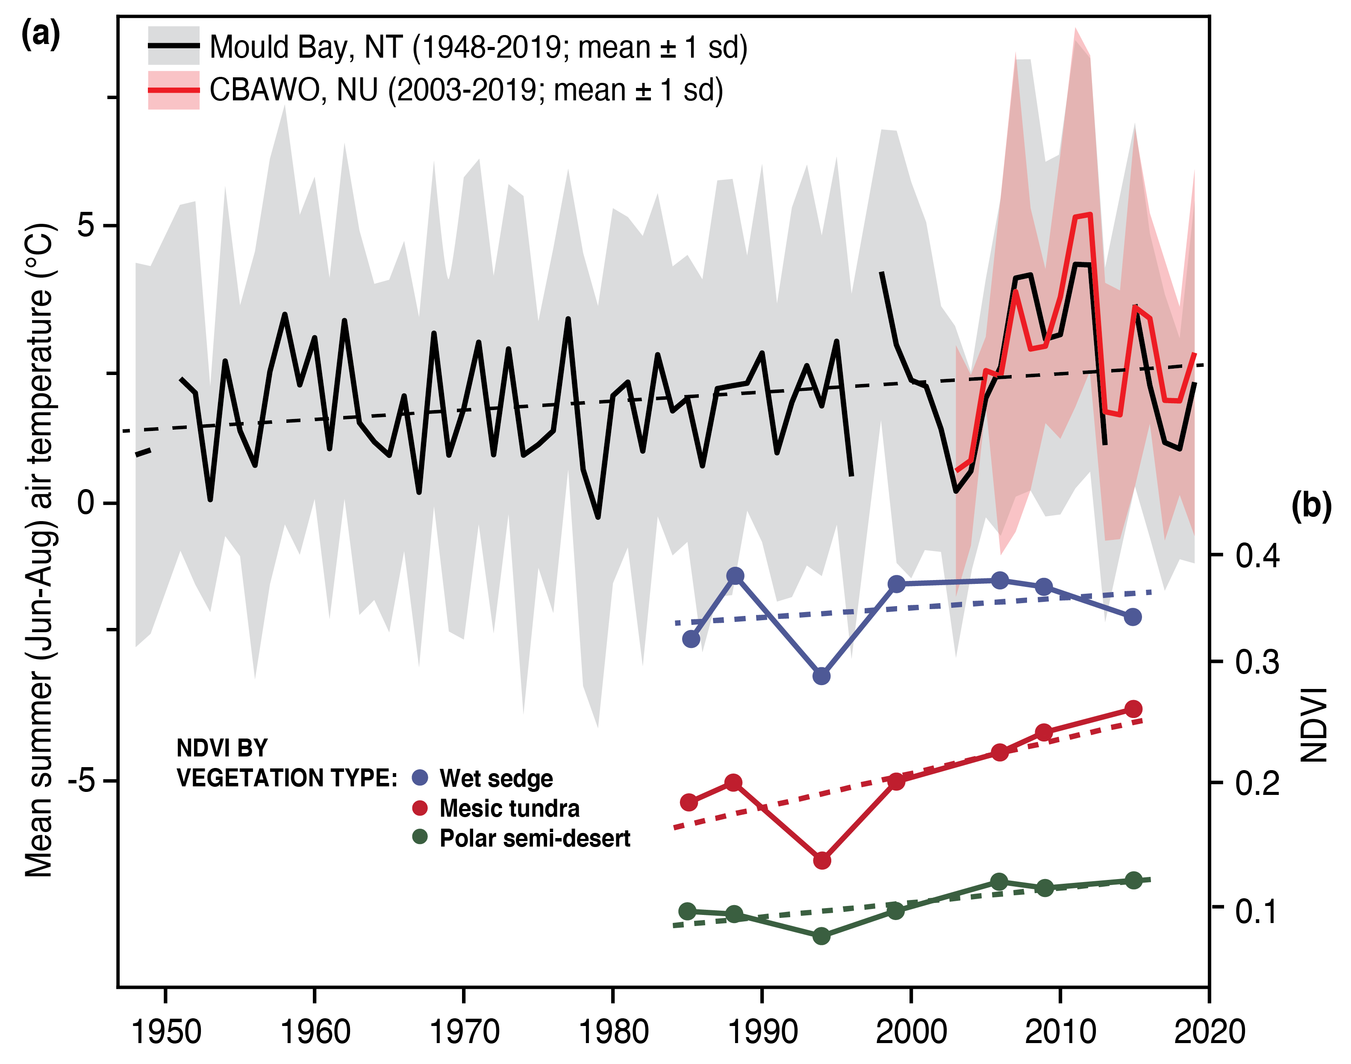
Fig. S2. (a) Local mean summer (June-August; JJA) air temperature for the CBAWO is significantly correlated (Pearson r = 0.99, p < 0.05; 2003-2019) with the long-term mean summer air temperature at Mould Bay (1948-2019; 300 km west of the CBAWO). (b) Normalized difference vegetation index (NVDI) by vegetation type (wet sedge, mesic tundra, polar semi-desert 1985-2015) at the CBAWO (modified from Edwards and Treitz, 2017). Regional climate has warmed on average 2 °C since 1948, leading to greening of all vegetation types at the CBAWO. Mould Bay (300 km to the west) is operated by Environment and Climate Change Canada. Mould Bay data are licensed under the Open Government License – Canada.

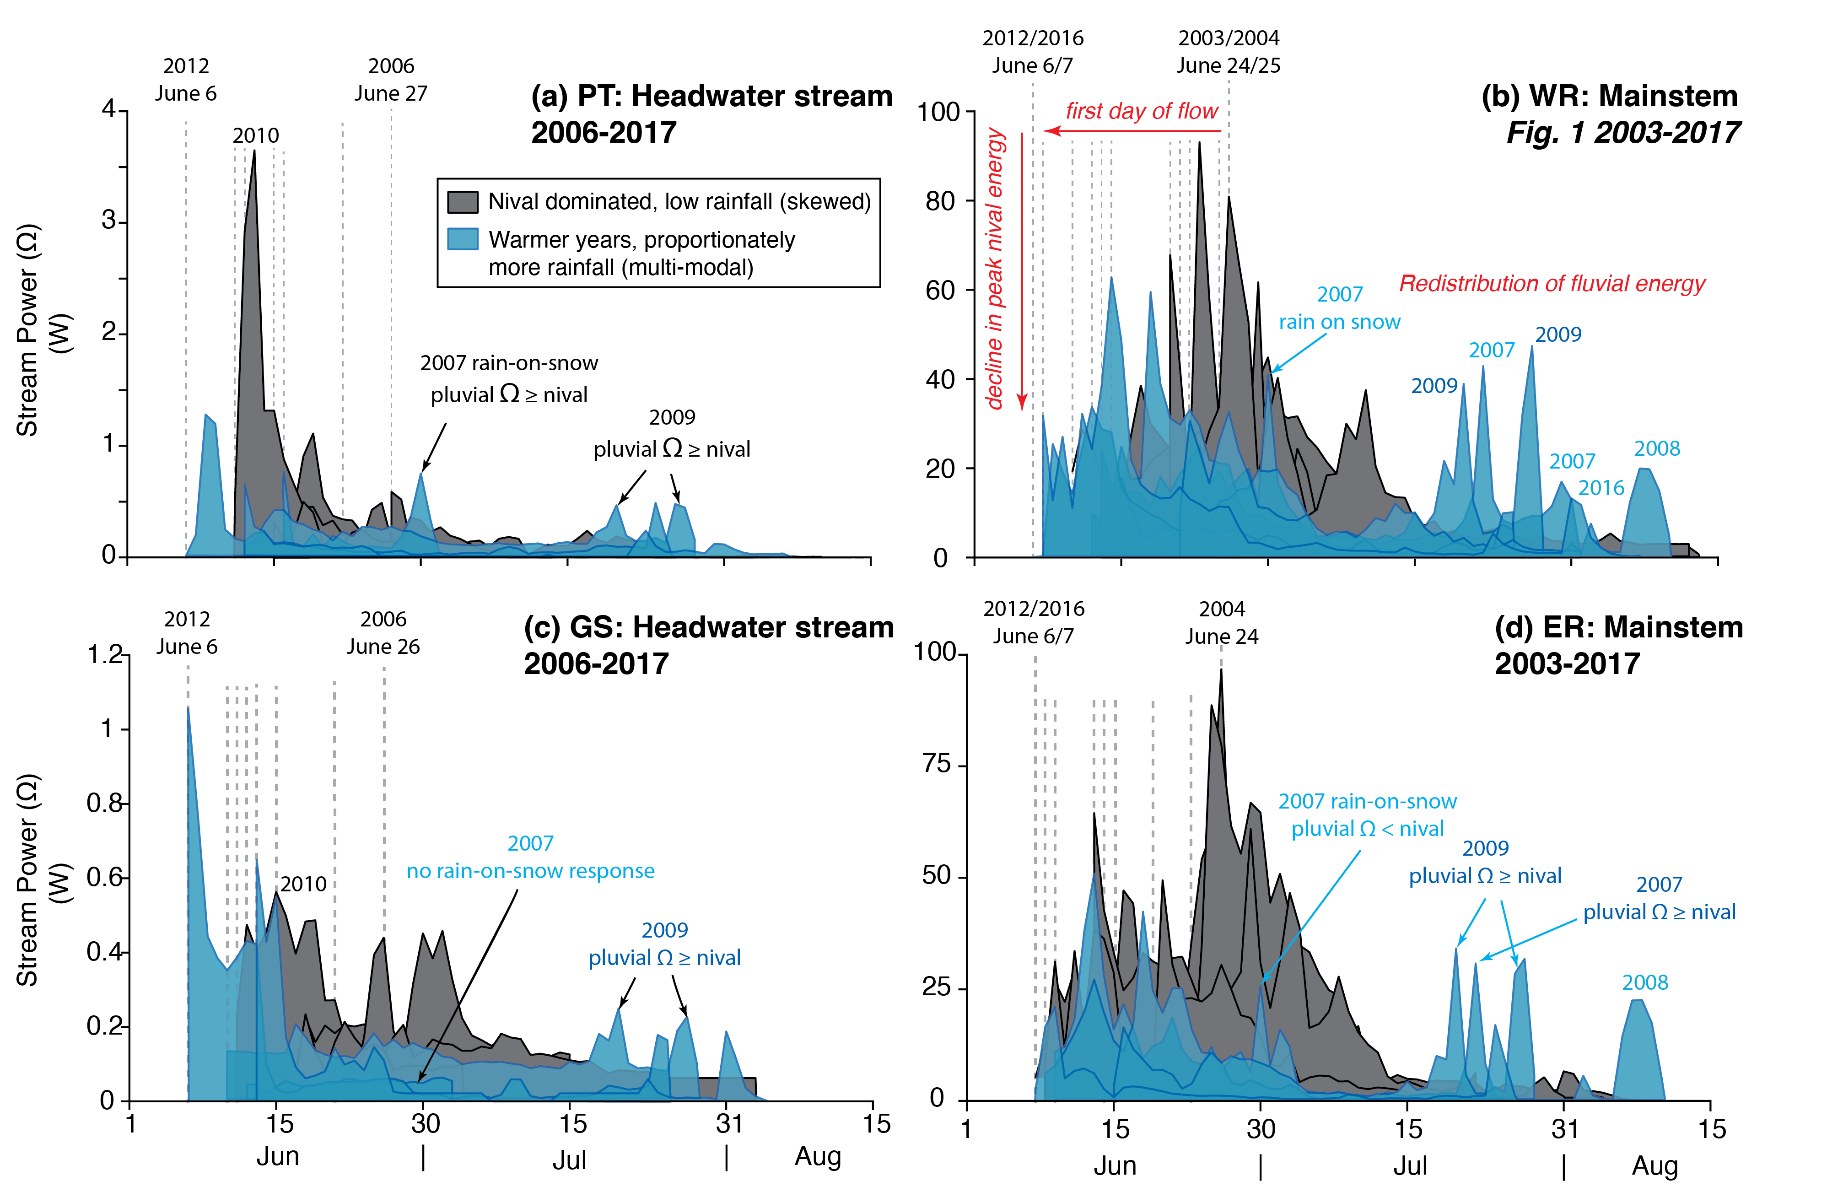
Fig. S3. Daily stream power records for the headwater slope streams (0.2 km²): (a) Ptarmigan (PT; 2006-2017) and (c) Goose (GS; 2006-2017); and main trunk streams (10 km²) at the CBAWO: (b) West river (WR; 2003-2017) and (d) East river (ER; 2003-2017). Note, at all watershed scales: (i) the first day of nival runoff advanced up to 20 days, (ii) peak nival stream power decreased, and (iii) proportionately more pluvial runoff changed the timing of seasonal stream power from a skewed (nival dominated) to a multi-modal (nival-pluvial) distribution. Data from this figure are in Fig 1.
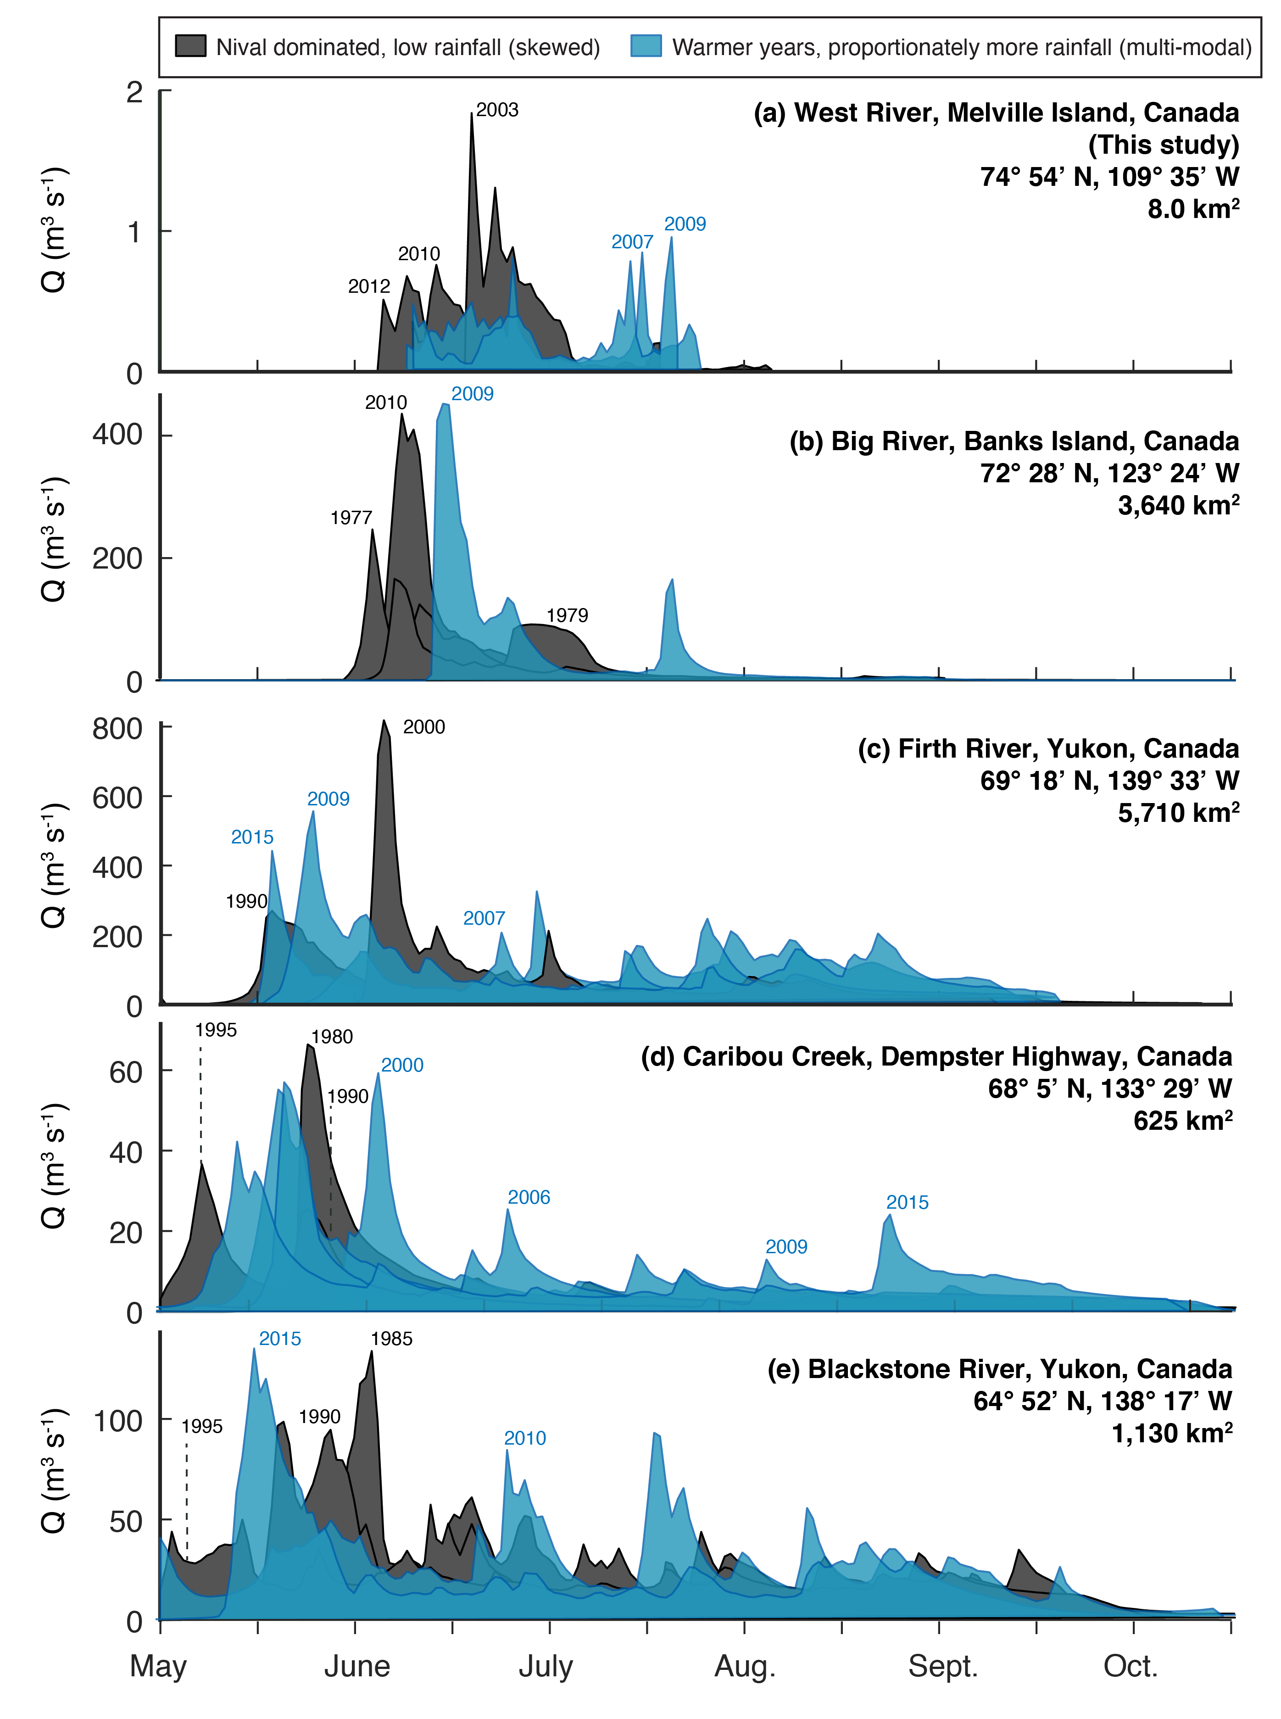
Fig. S4. Hydrographs from rivers of varying watershed size (8-5,710 km²) along a northern Canadian latitudinal gradient; from north to south: (a) West River, CBAWO (74 °N); (b) Big River, Banks Island NT (72 °N); (c) Firth River, YT (69 °N); (d) Caribou Creek, NT (68 °N); and (e) Blackstone Creek, YT (64 °N). Note that the observed changes at CBAWO are ubiquitous across the Canadian High and Low Arctic; though watersheds in the Low Arctic received proportionately more rainfall in general (e.g., Blackstone River).

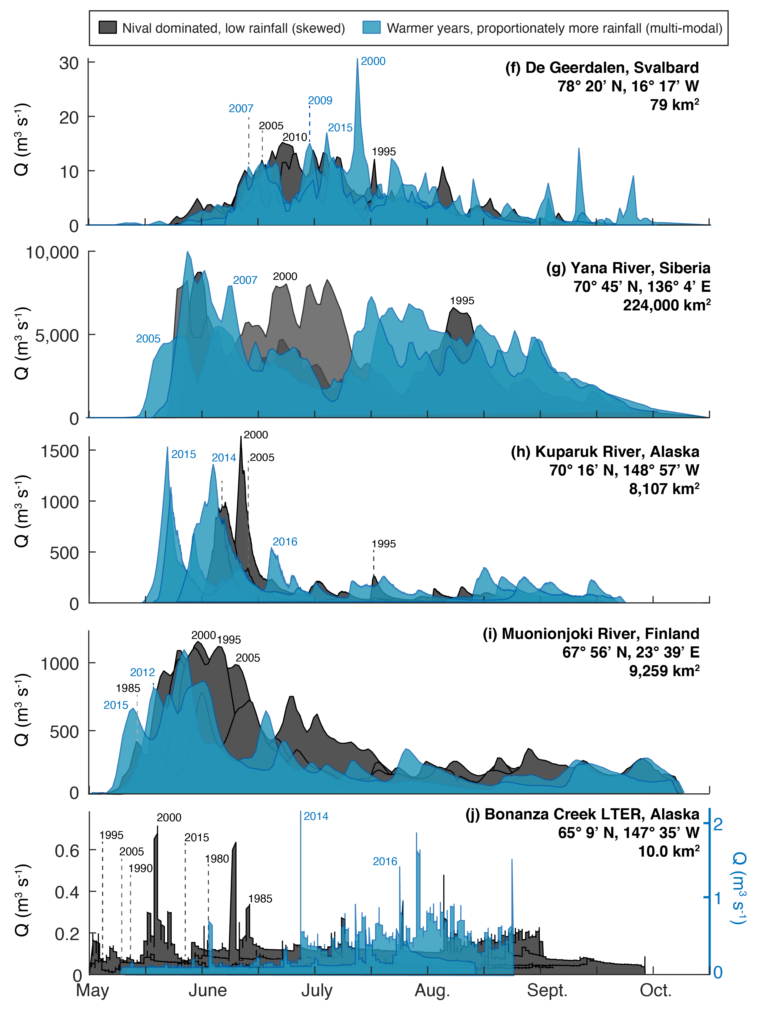
Fig. S4 continued. Hydrographs from circum-Arctic rivers of varying watershed size (10-224,000 km²): from north to south: (f) De Geerdalen, Svalbard (78 °N 16 °W); (g) Yana River, Siberia (70 °N 136 °E); (h) Kuparuk River, Alaska (70 °N 148 °W); (i) Muonionjoki River, Finland (67 °N 23 °E); and (j) Bonanza Creek LTER, Alaska (65 °N 147 °W). Note that the observed changes at CBAWO are ubiquitous across circum-Arctic; though watersheds in the Low Arctic received proportionately more rainfall in general.

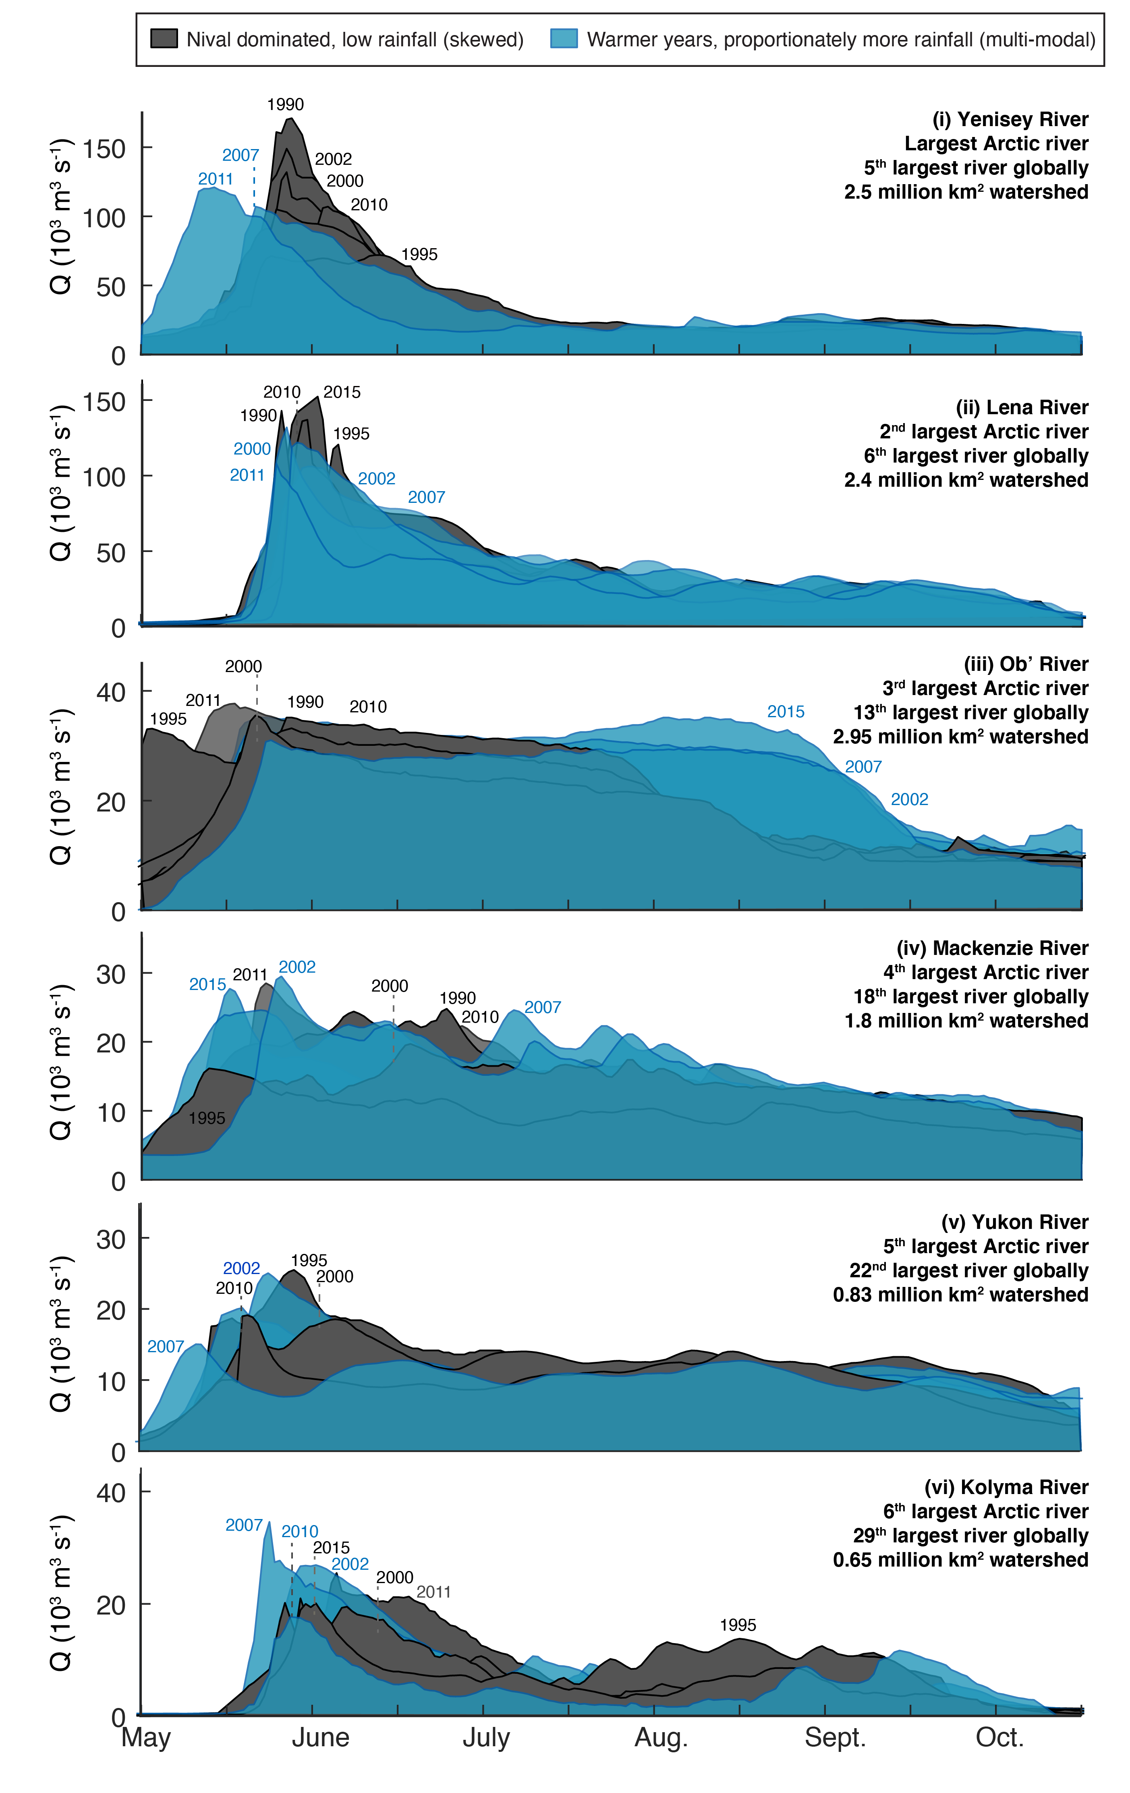
Fig. S5. Hydrographs from the six largest Arctic rivers (0.65-2.95 million km²): (i) Yenisey River; (ii) Lena River; (iii) Ob’ River; (iv) Mackenzie River; (v) Yukon River; and (vi) Kolyma River. Note that observed changes in small arctic watersheds (≤ 225,000 km²) are observed in the six largest Arctic rivers, though they received proportionately more rainfall in general.

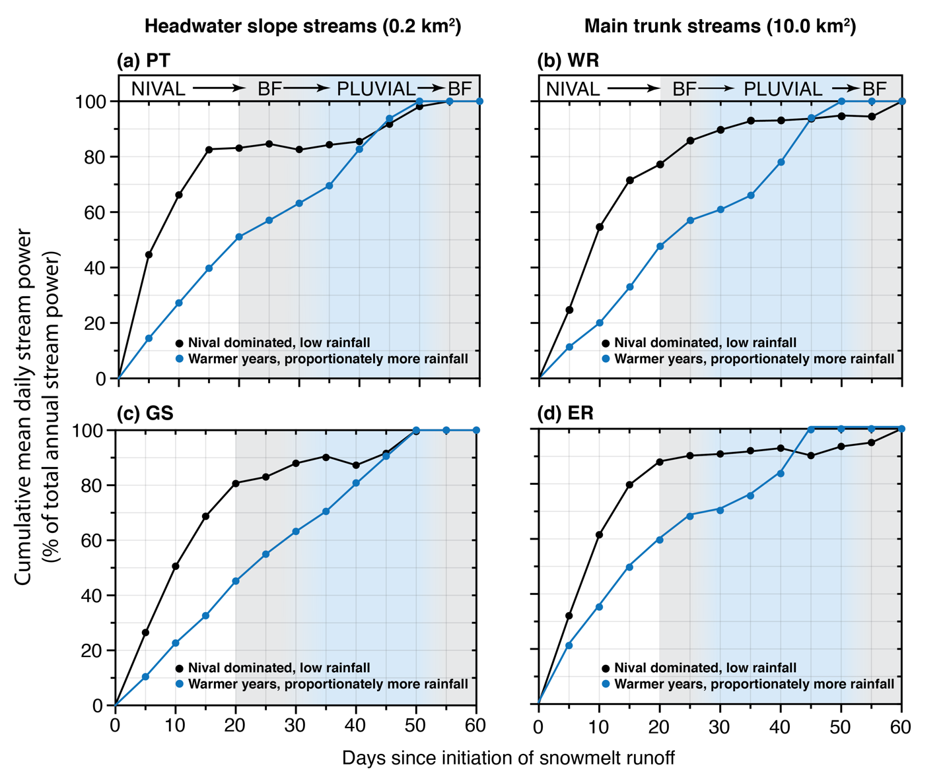
Fig. S6. Cumulative mean daily stream power for headwater slope streams (0.2 km²): (a) Ptarmigan (PT; 2006-2017) and (c) Goose (GS; 2006-2017); and main trunk streams (10 km²): (b) West river (WR; 2003-2017) and (d) East river (ER; 2003-2017). In nival dominated, low rainfall years (n = 10; black line), ≥ 50 % of the annual available stream power is expended within the first ten days of runoff and 80 ± 7 % of annual available stream power is expended during the full nival period (20 days). In warmer years with proportionately more rainfall (2007, 2009; blue line) 25-40 % of the annual available stream power is expended later in the thaw season. Low energy baseflow runoff expends < 5 % of the annual available stream power. Data from this figure are summarized in Fig. 3b.

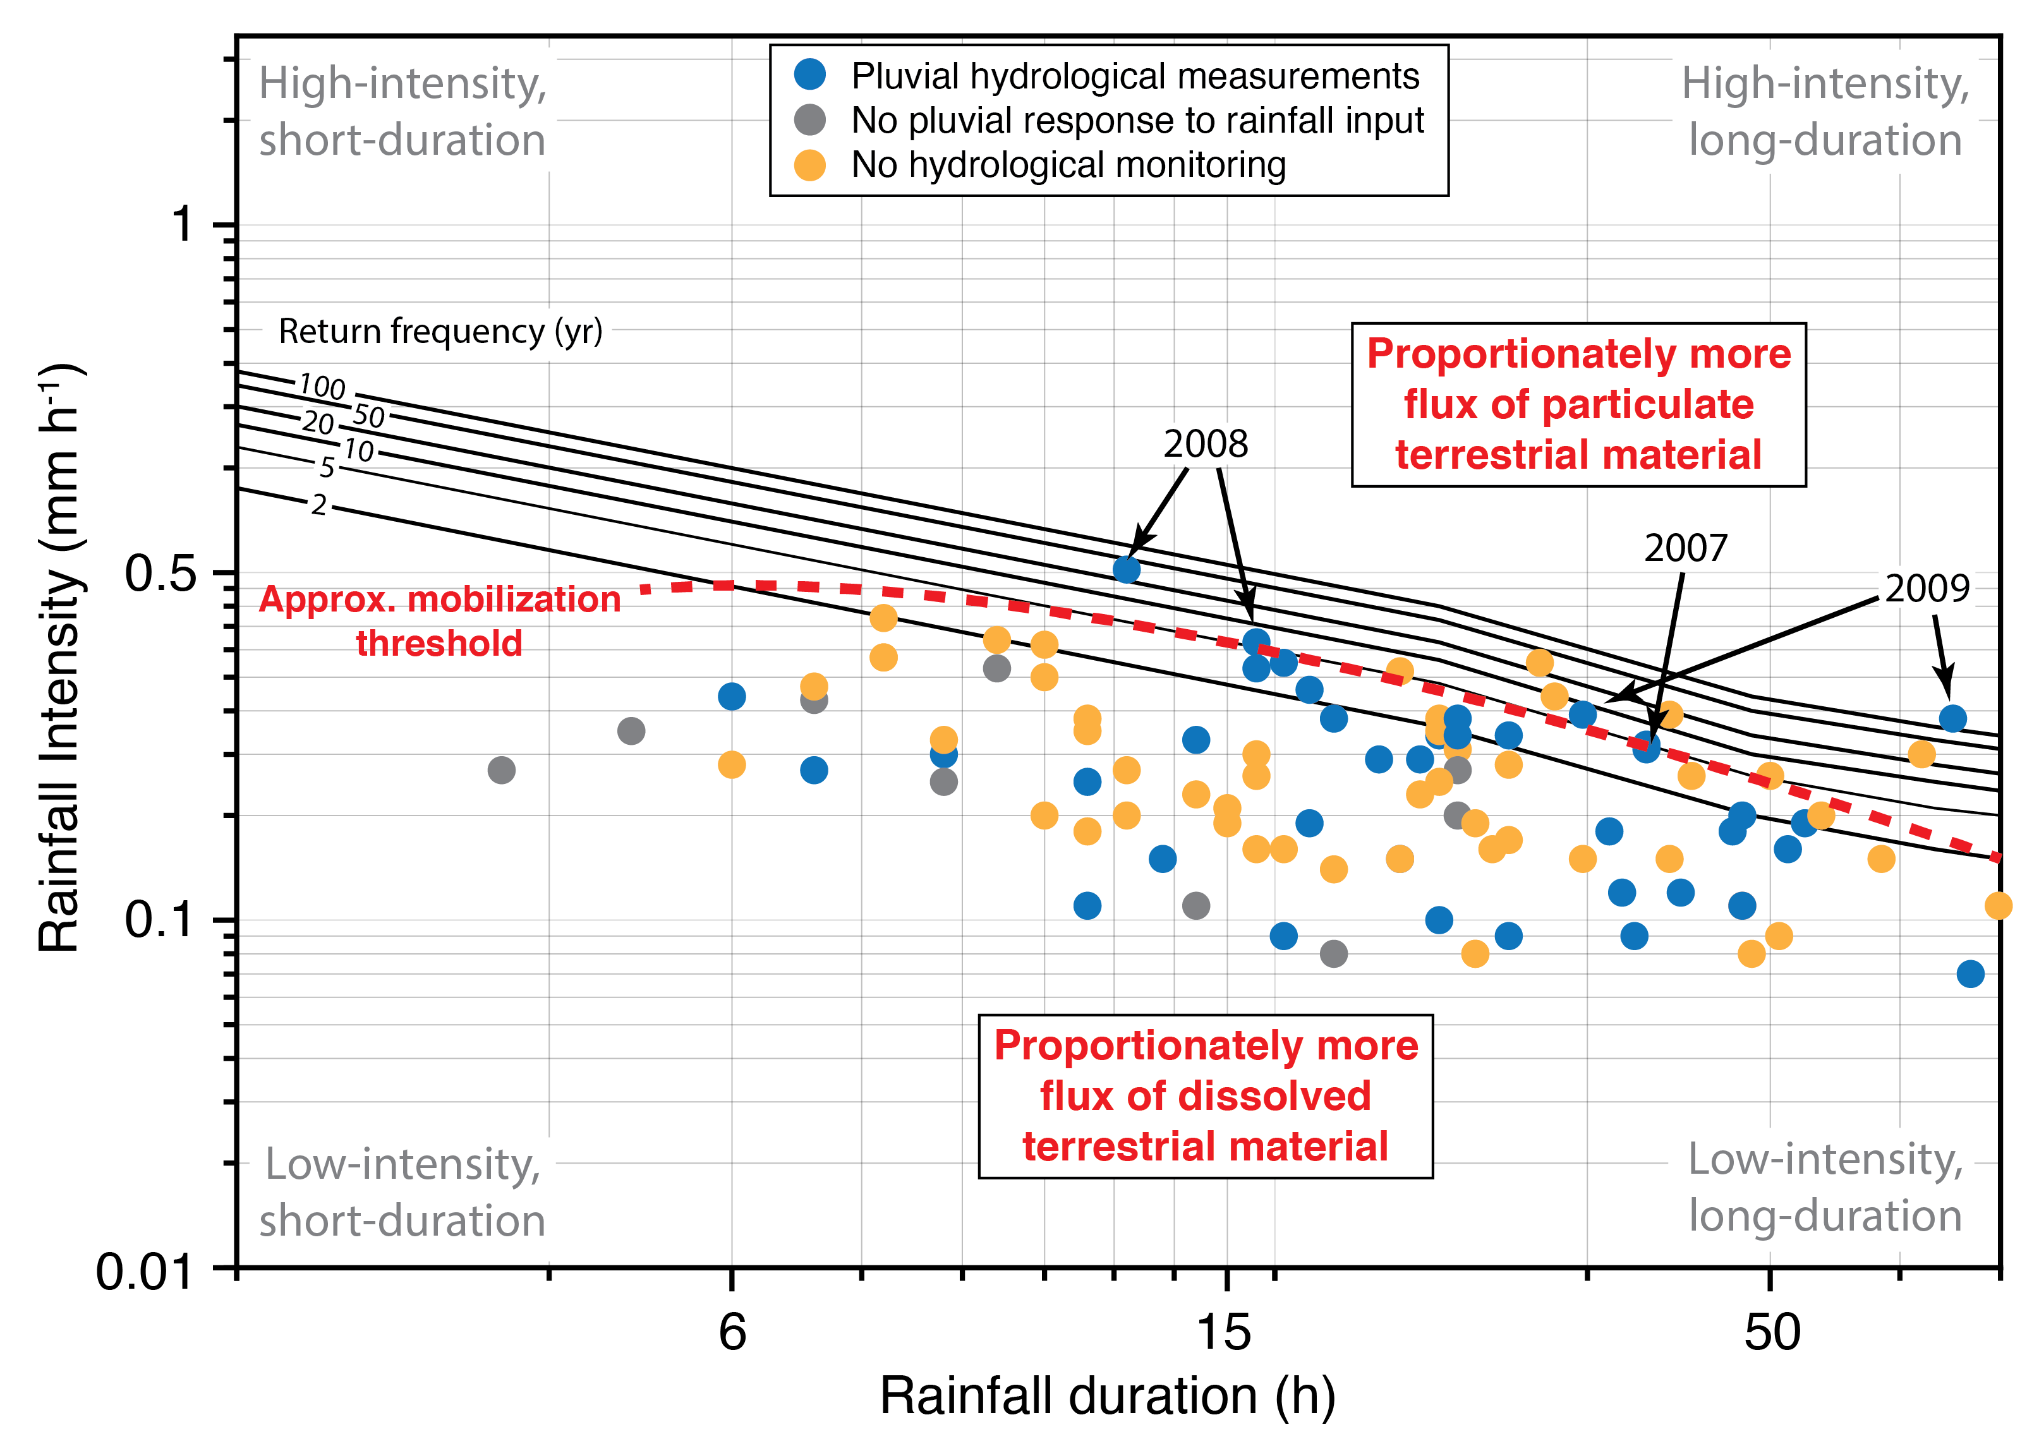
Fig. S7. The 72-h intensity-duration-frequency (IDF) curve for the CBAWO overlain with all measured rainfall events between 2003-2019 (n = 100). We have pluvial records for 39 of the 100 rainfall events (39 %; blue dots), including the highest magnitude rainfall event on record (2009; 100-year return frequency or 1% chance of exceedance in any given year). Maximum stream power during the 2007 and 2009 rainfall events exceeded that of the nival period. Although we captured significant High Arctic pluvial responses, our understanding remains limited by hydrological monitoring failing to capture the majority of late summer/fall (Aug-Sep) rainfall events (61 %; yellow dots). Note that not all rainfall events resulted in measurable pluvial responses at these watershed scales (grey dots), and high-intensity short-duration rainfall events in 2008 did not produce significant pluvial response due to antecedent conditions. The red dashed line indicates the approximate rainfall magnitude pluvial mobilization threshold: low-intensity rainfall events (below the line) produce enough energy to couple the watershed-scale terrestrial-to-aquatic cascade for dissolved material, while higher magnitude rainfall events (above the line) account for the majority of particulate flux and connectivity from hillslope sediment sources to watershed outlets.

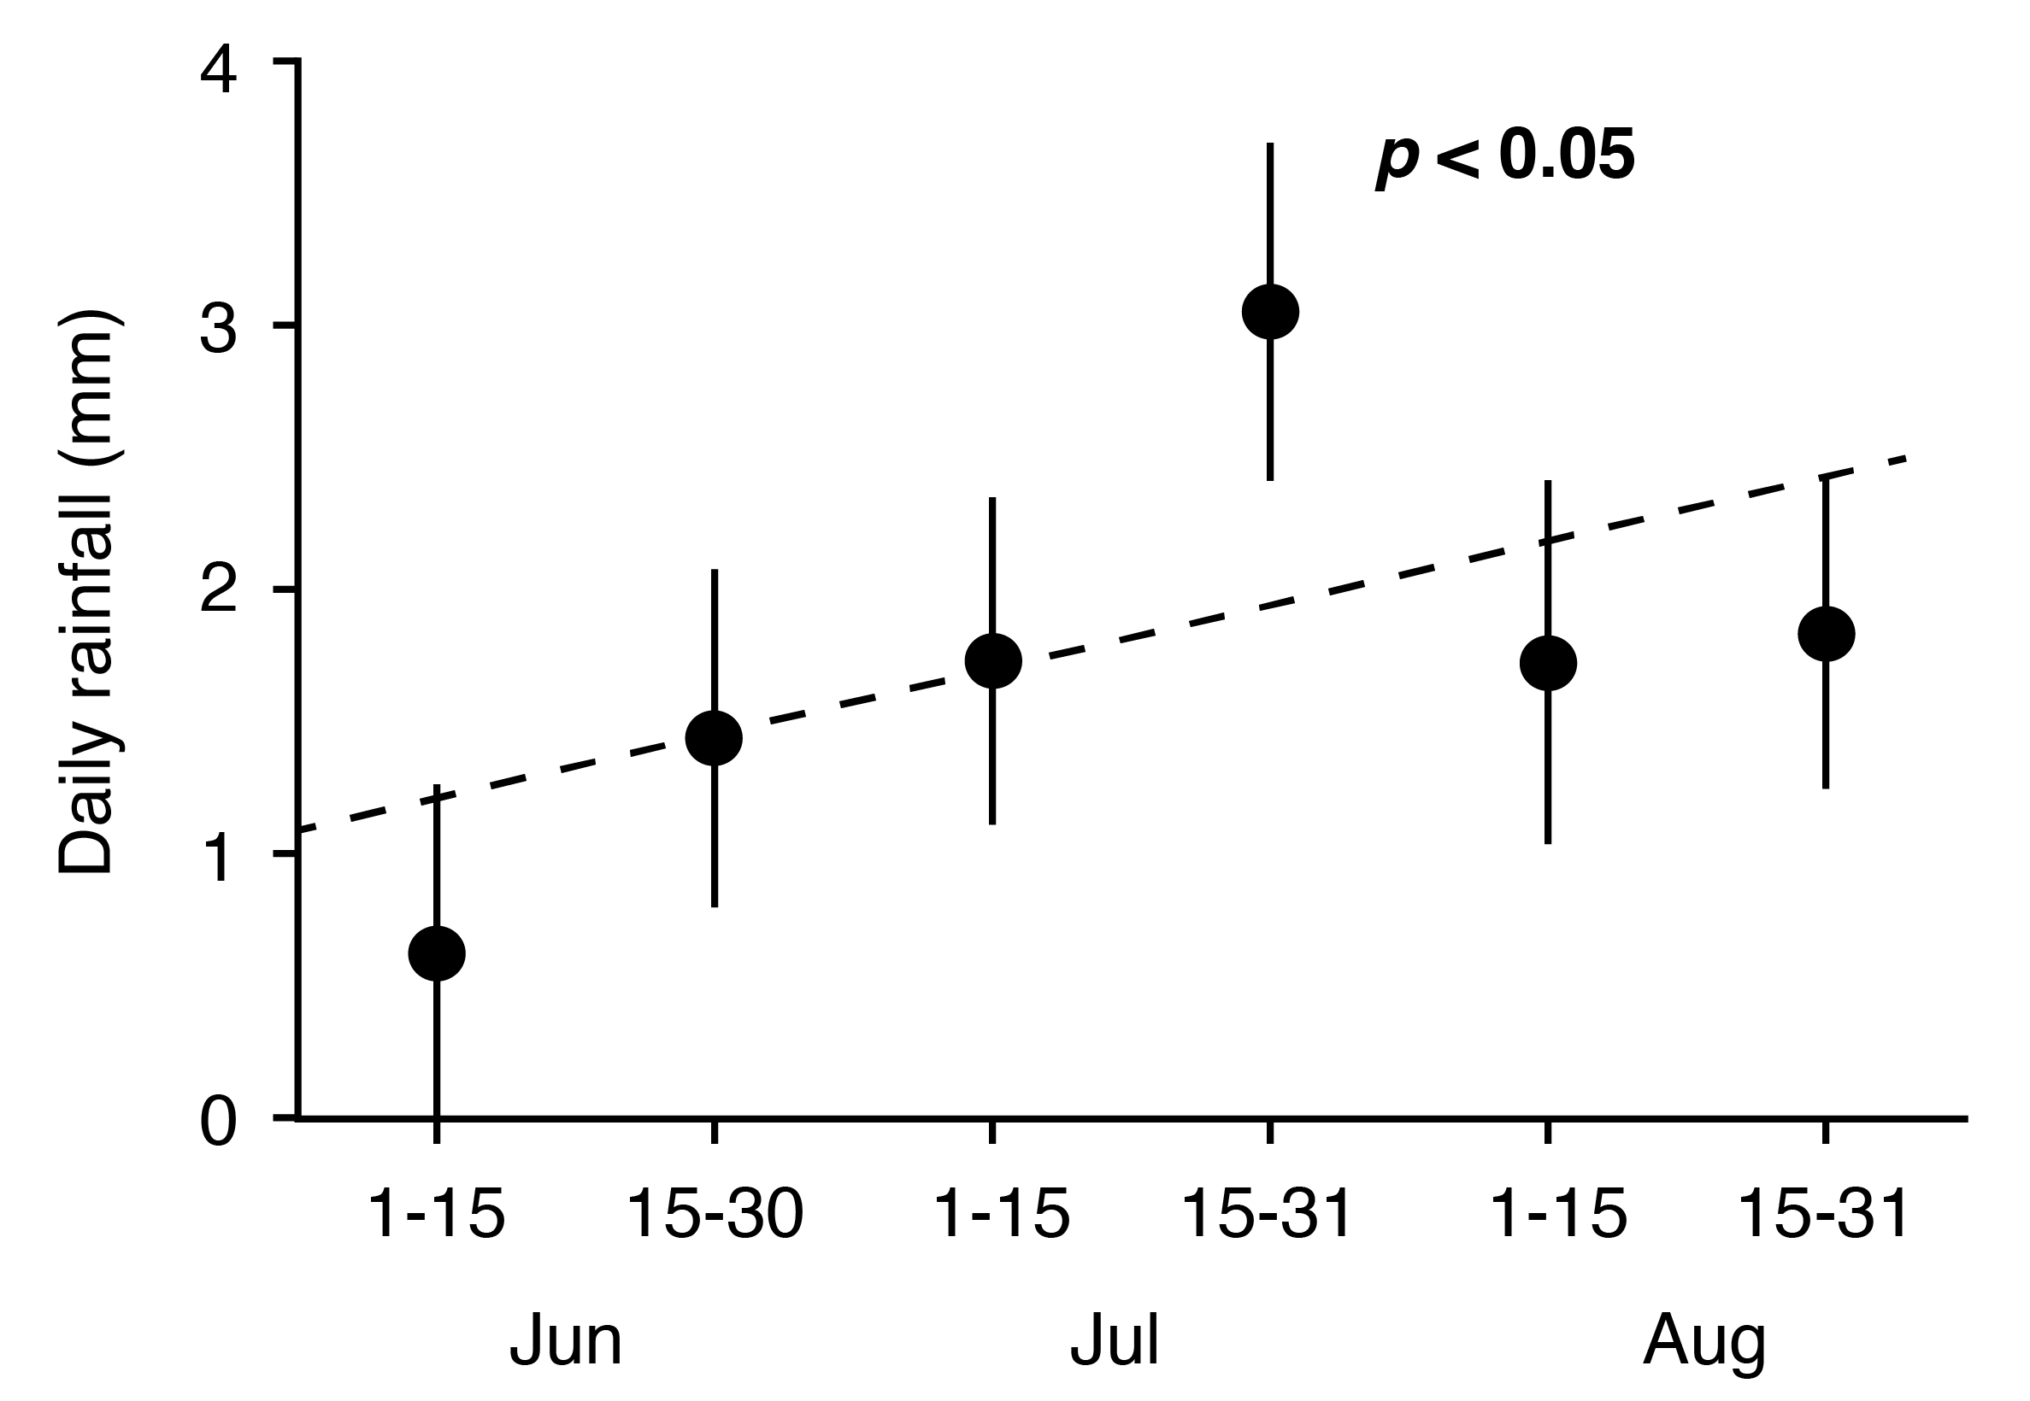

Fig. S8. Mean daily summer (June-Aug; JJA) rainfall (mm; ± 1 sd) in 15/16-day bins for each month from the CBAWO (2003-2019). The heaviest rainfall each year occurs between July 15 and 30 (p < 0.05). In general, mean daily rainfall increases as the summer thaw season progress (dash-line, p < 0.05). Each year at the CBAWO, we capture the largest rainfall events with our integrated hydrological and biogeochemical records (late July). However, we have no hydrological records extending beyond Aug 15 where the mean daily rainfall is statistically similar to Jun 15-30, Jul 1-15 and Aug 1-15.

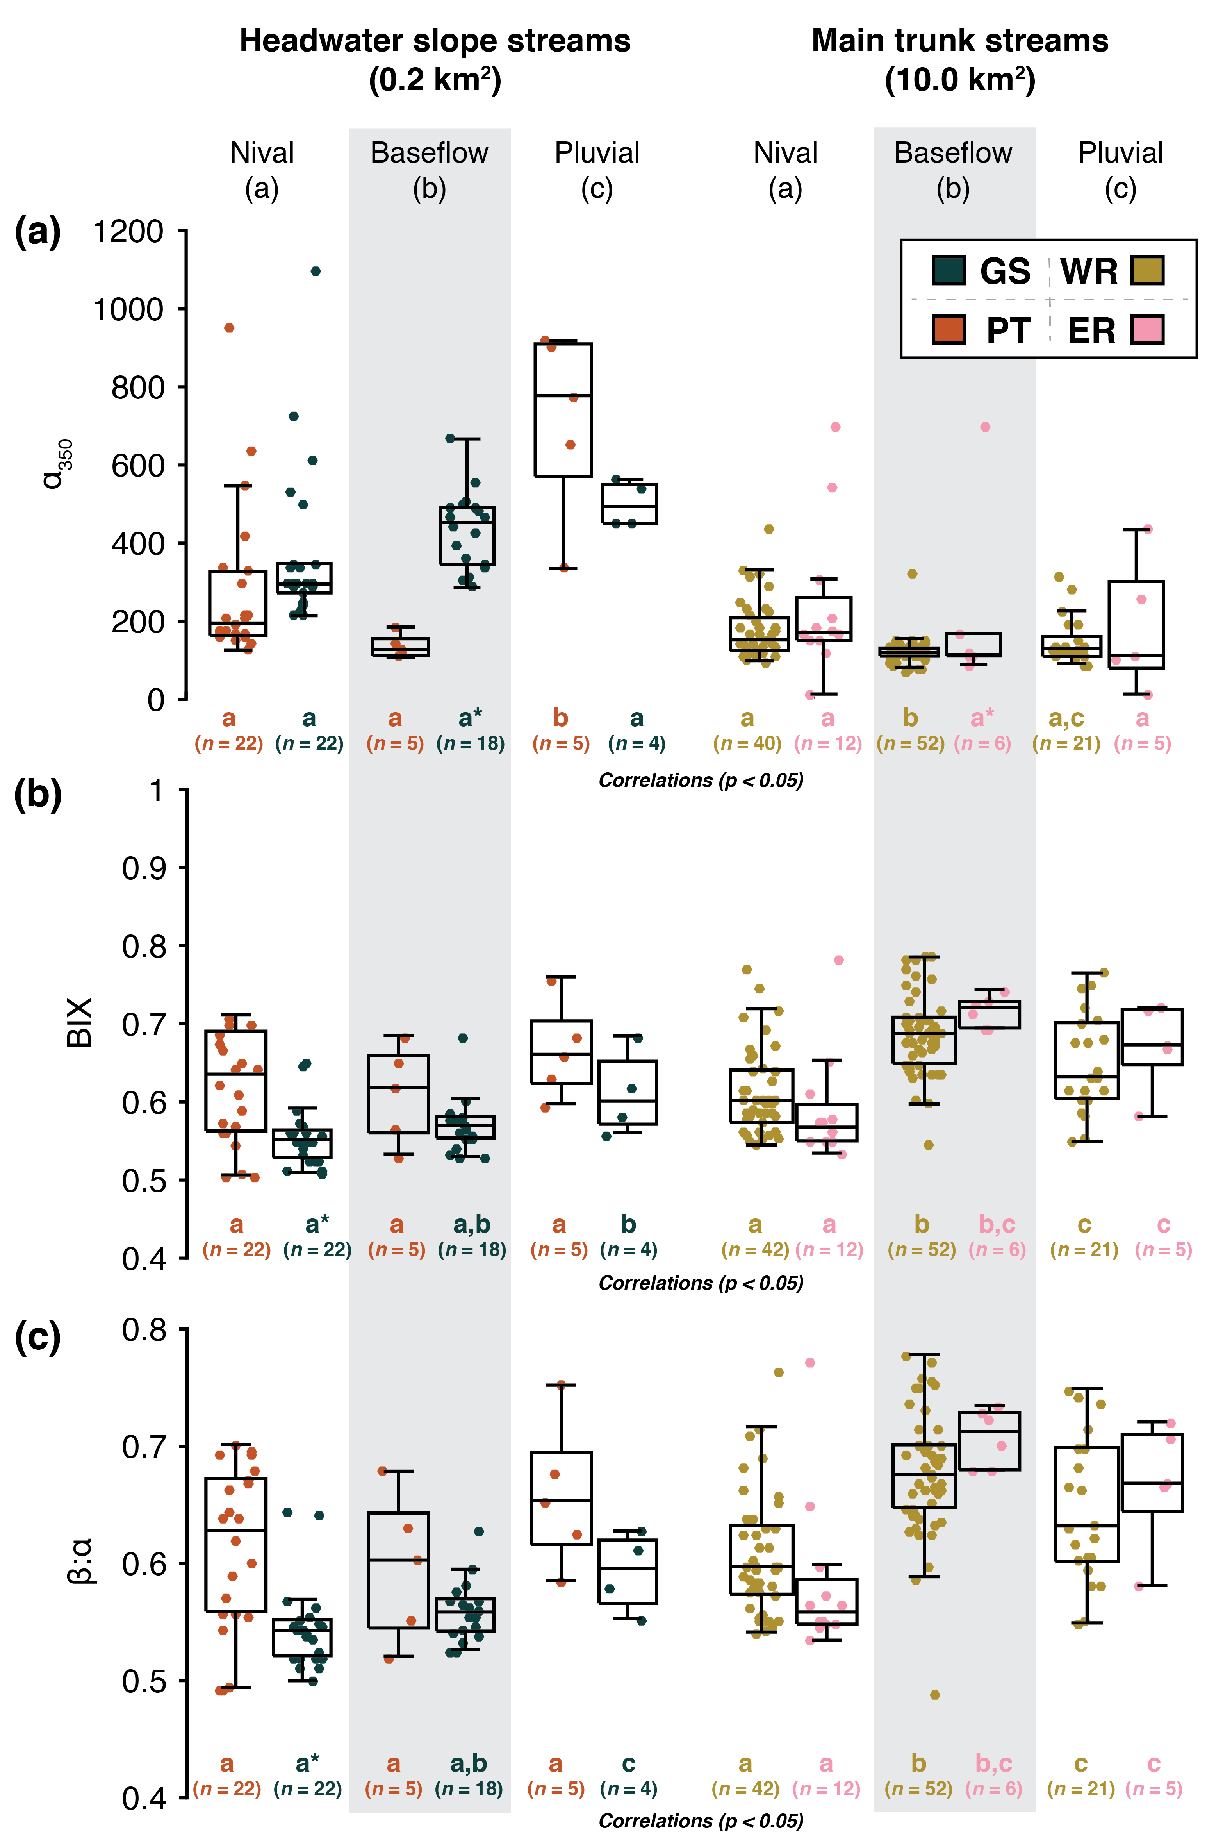
Fig. S9. Box plots showing the DOM optical properties: α₃₅₀ (a), an indicator of terrigenous vegetation-derived DOM; BIX (b), an indicator of autochthonous DOM; and the freshness index (β:α; c), an indicator of recently-produced DOM. Each box plot shows the median (white line), interquartile range (colored boxes), upper and lower fences (black line “whiskers”; calculated as the upper/lower interquartile range limit ± 1.5 times the interquartile range), and potential outlier observations (colored plus symbols). Statistically different differences between hydrological periods (two-sample t-test; p < 0.05) are noted using letters below each box plot (e.g. if the nival and baseflow period both have “a”s they are not significantly different, while a change of letter between periods, or unique letter combinations “a,b” vs. “c” are significantly different); asterisks signify significant (p<0.05) differences between the two watersheds for the same hydrological period. The number of observations used to calculate each box plot are noted beneath. All data are available in the Supplementary Data.
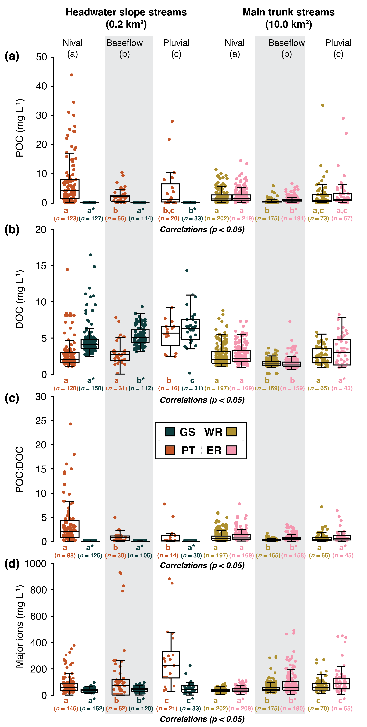
Fig. S10. Box plots showing carbon export in particulate (POC, a) and dissolved (DOC, b) form; ratios of POC to DOC export (c); and major ion concentrations (d). Each box plot shows the median (white line), interquartile range (colored boxes), upper and lower fences (black line “whiskers”; calculated as the upper/lower interquartile range limit ±1.5 times the interquartile range), and potential outlier observations (colored plus symbols). Statistically different differences between hydrological periods (two-sample t-test; p < 0.05) are noted using letters below each box plot (e.g. if the nival and baseflow period both have “a”s they are not significantly different, while a change of letter between periods, or unique letter combinations “a,b” vs. “c” are significantly different); asterisks signify significant (p<0.05) differences between the two watersheds for the same hydrological period. The number of observations used to calculate each box plot are noted beneath. All data are available in the Supplementary Data.

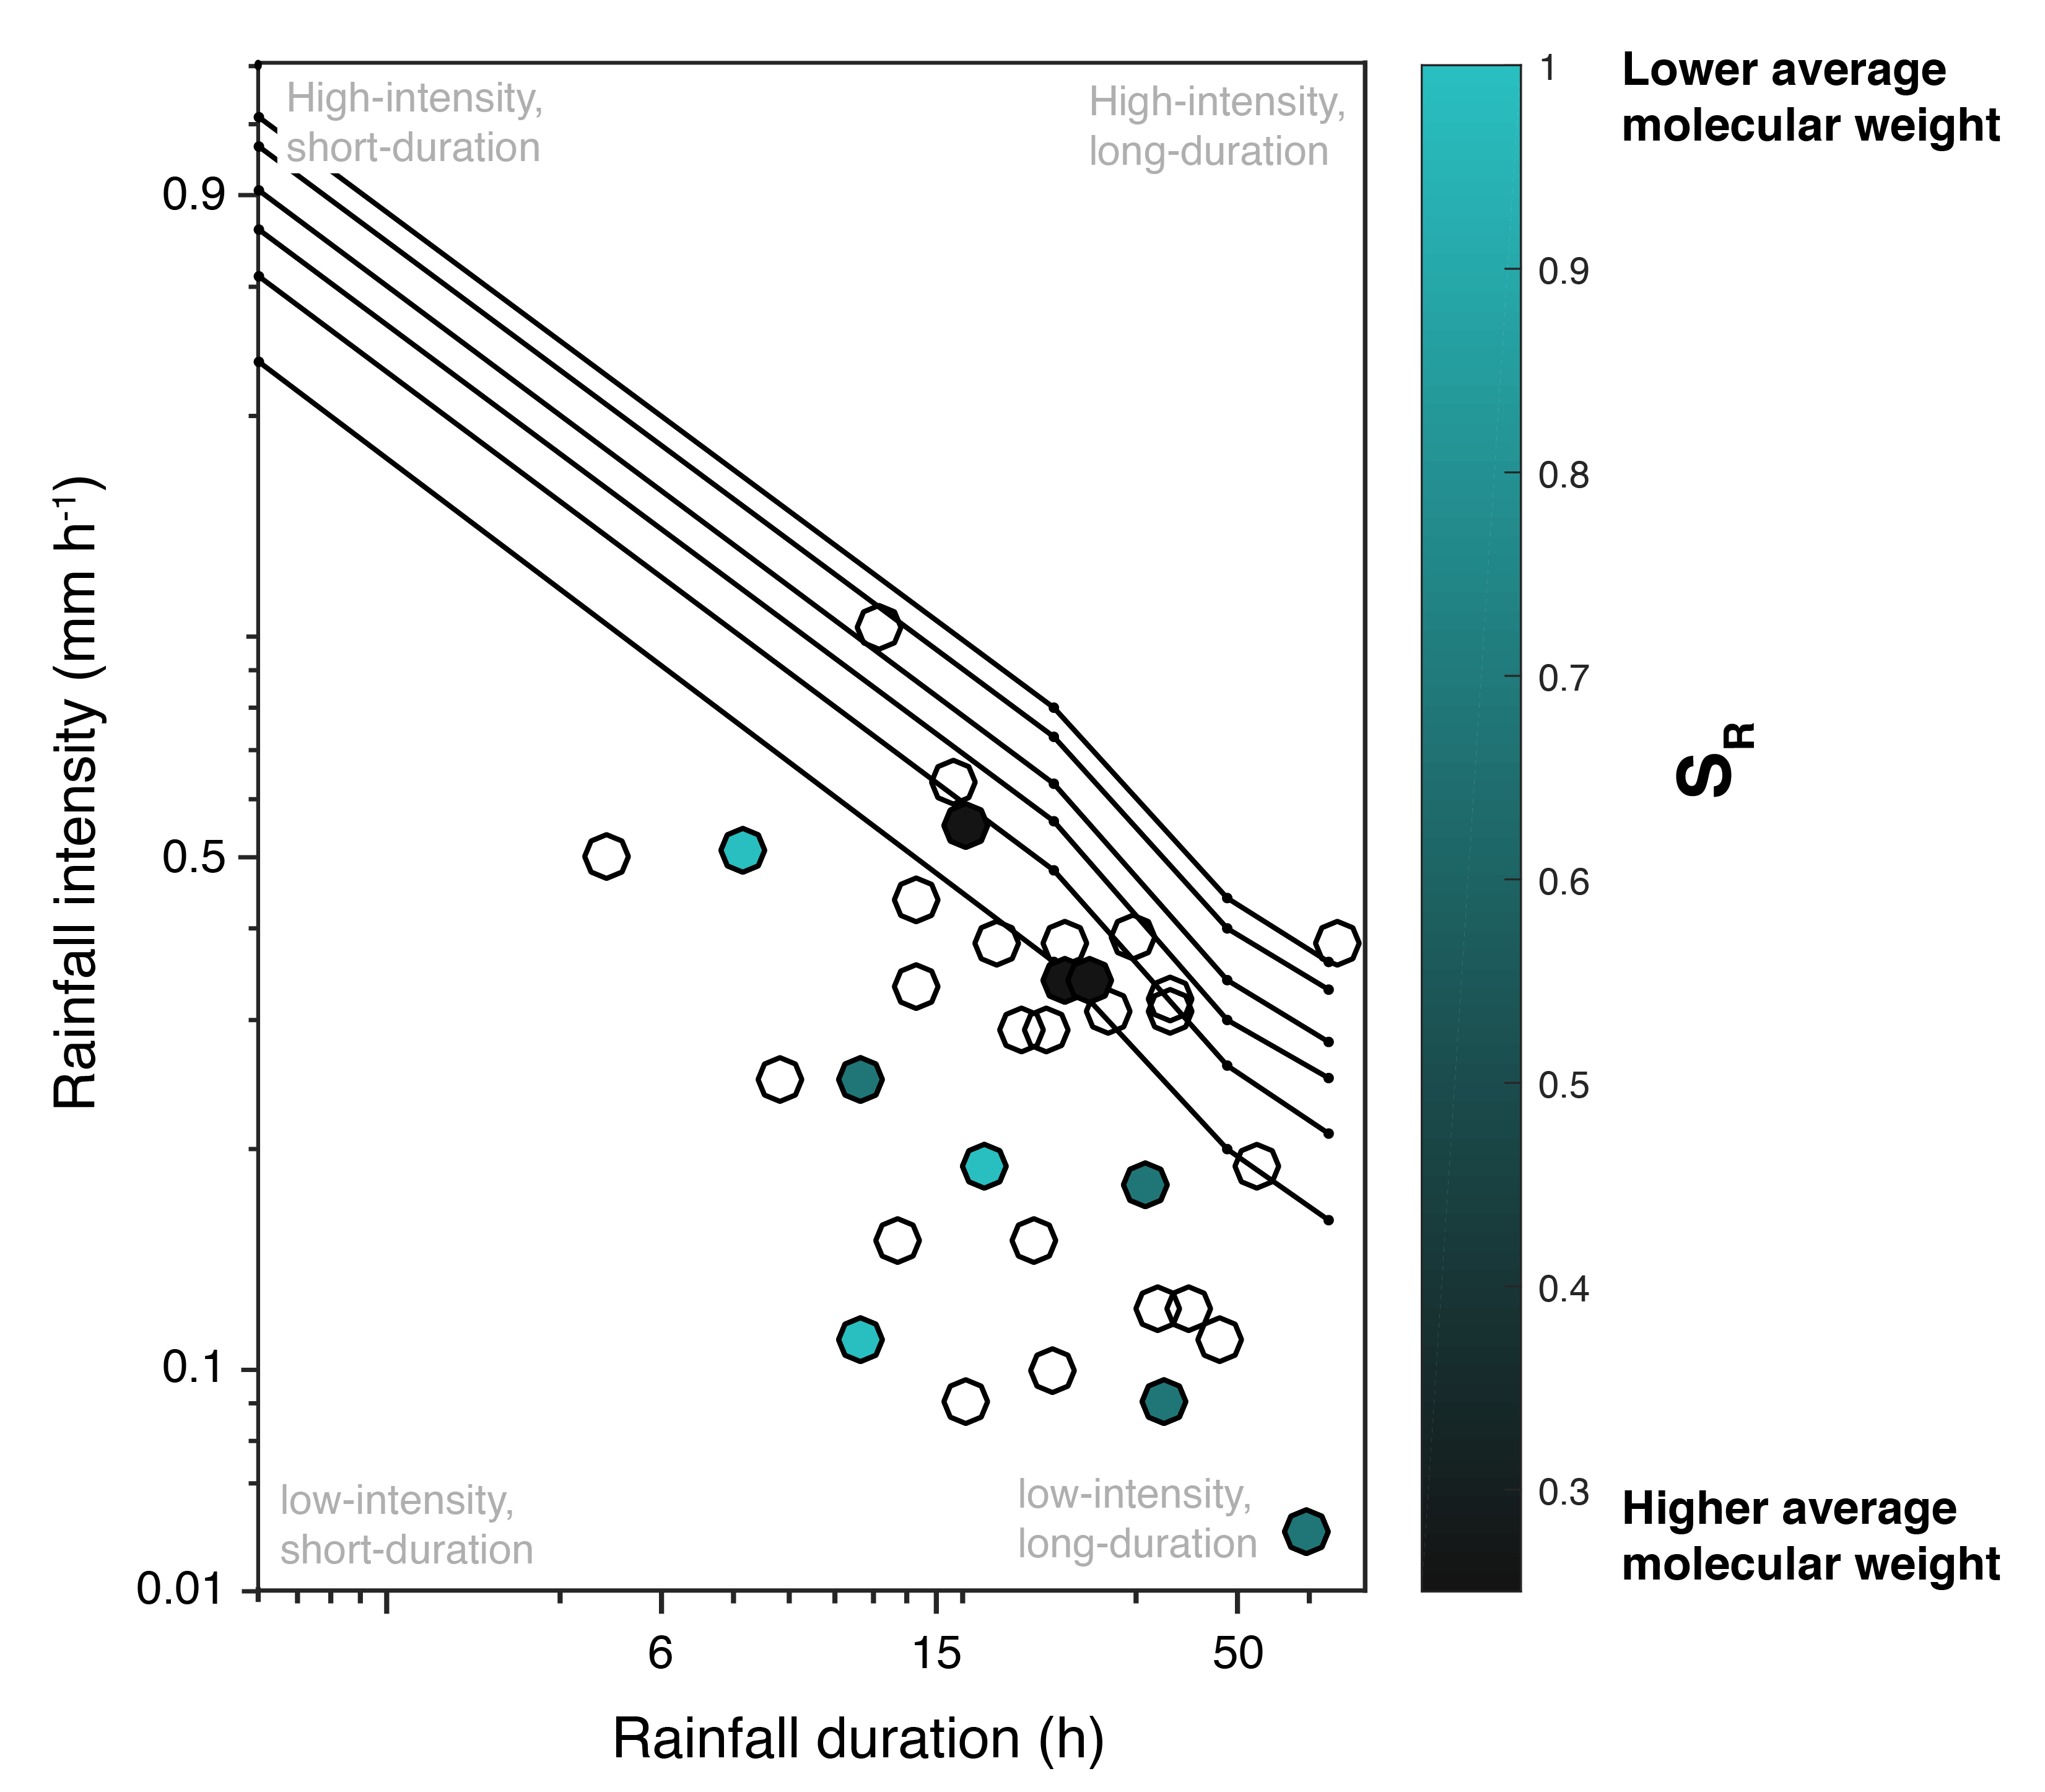

Fig. S11. The 72-hr rainfall intensity-duration-frequency curve overlain with a summary of spectral slope ratios (S_{R}) of chromophoric DOM, an indicator of average molecular weight (Helms et al., 2008) for pluvial data from all watersheds (GS, n = 6; PT, n = 5; WR, n = 10; ER, n = 4). Although limited, our data indicate that rainfall events with higher intensities, longer durations, and/or less frequent recurrence intervals lead to higher average molecular weight DOM in the stream networks during pluvial responses. All data are available in the Supplementary Data.

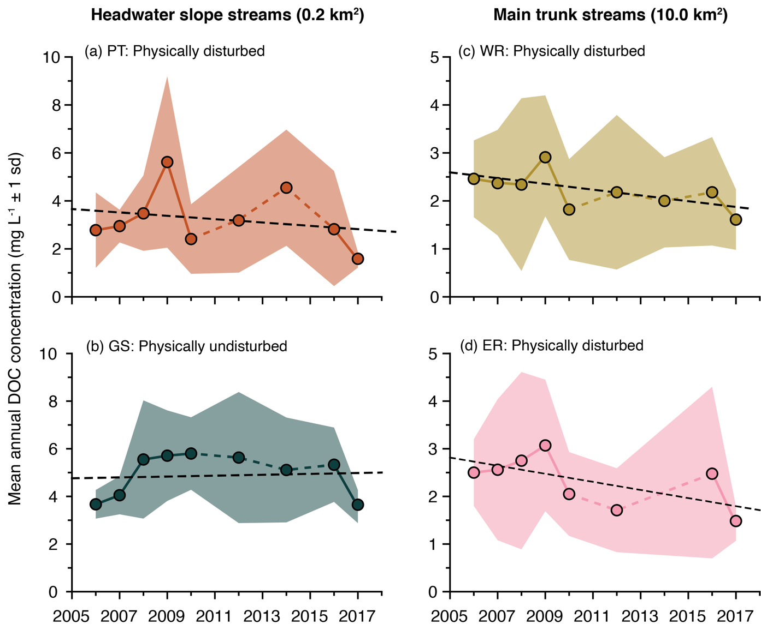

Fig. S12. Mean annual (2006-2017; ± 1sd shaded) DOC concentrations from headwater slope streams: (a) Ptarmigan (PT) and (b) Goose (GS); and mainstem streams: (c) West river (WR) and (d) East river (ER). Physical disturbance resulted in a decline in interannual DOC concentrations post-disturbance at all watershed scales (PT, WR, ER; p < 0.05). In contrast, DOC concentrations from vegetated, physically undisturbed slopes increased during our study period (GS; p < 0.05).

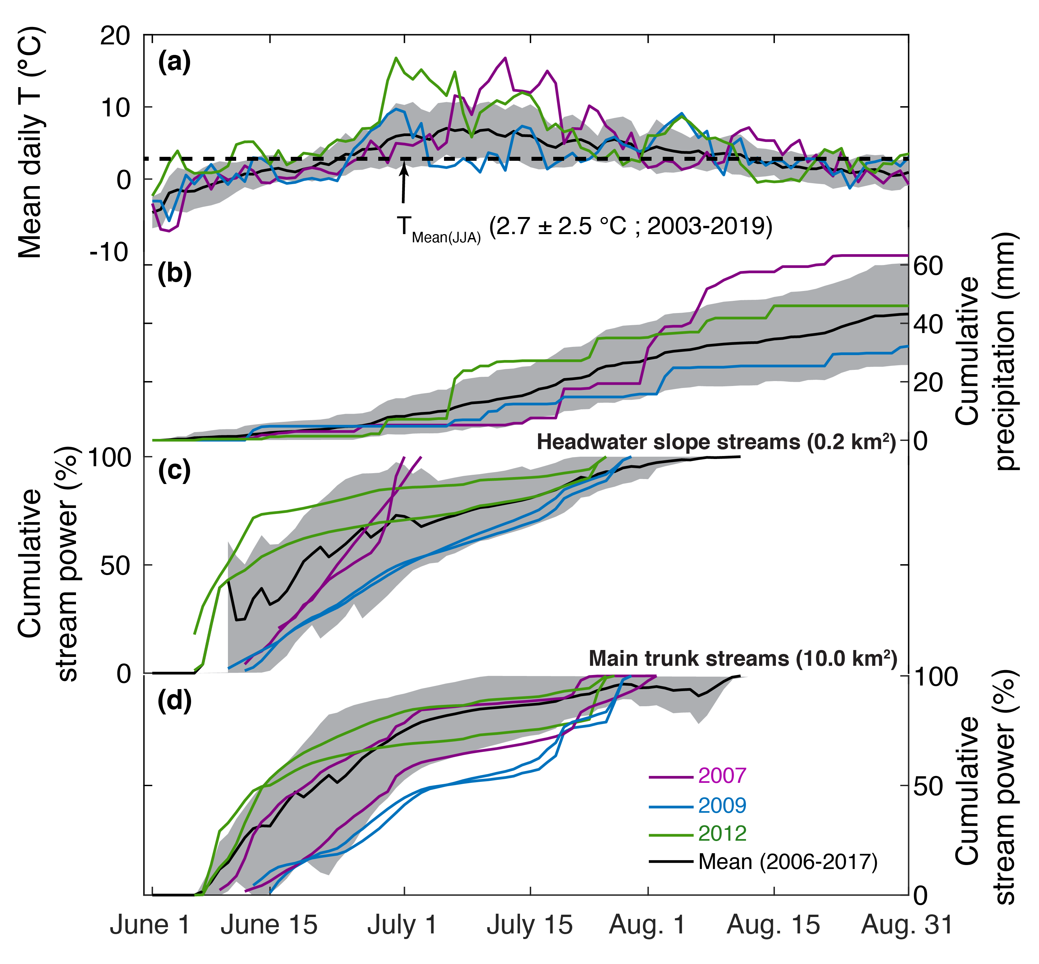
Fig. S13. Mean CBAWO hydrometeorological summary (2006-2017); (a) daily temperature, (b) cumulative precipitation, and cumulative stream power for (c) headwater slope streams and (d) main trunk streams. To demonstrate the significance of changes in the timing and magnitude of fluvial energy, we highlight three key years for comparison: 2007 and 2012 represent the warmest thaw seasons at the CBAWO and 2007 and 2009 represent the two years with the highest magnitude rainfall runoff responses. Summarized in Fig. 2.

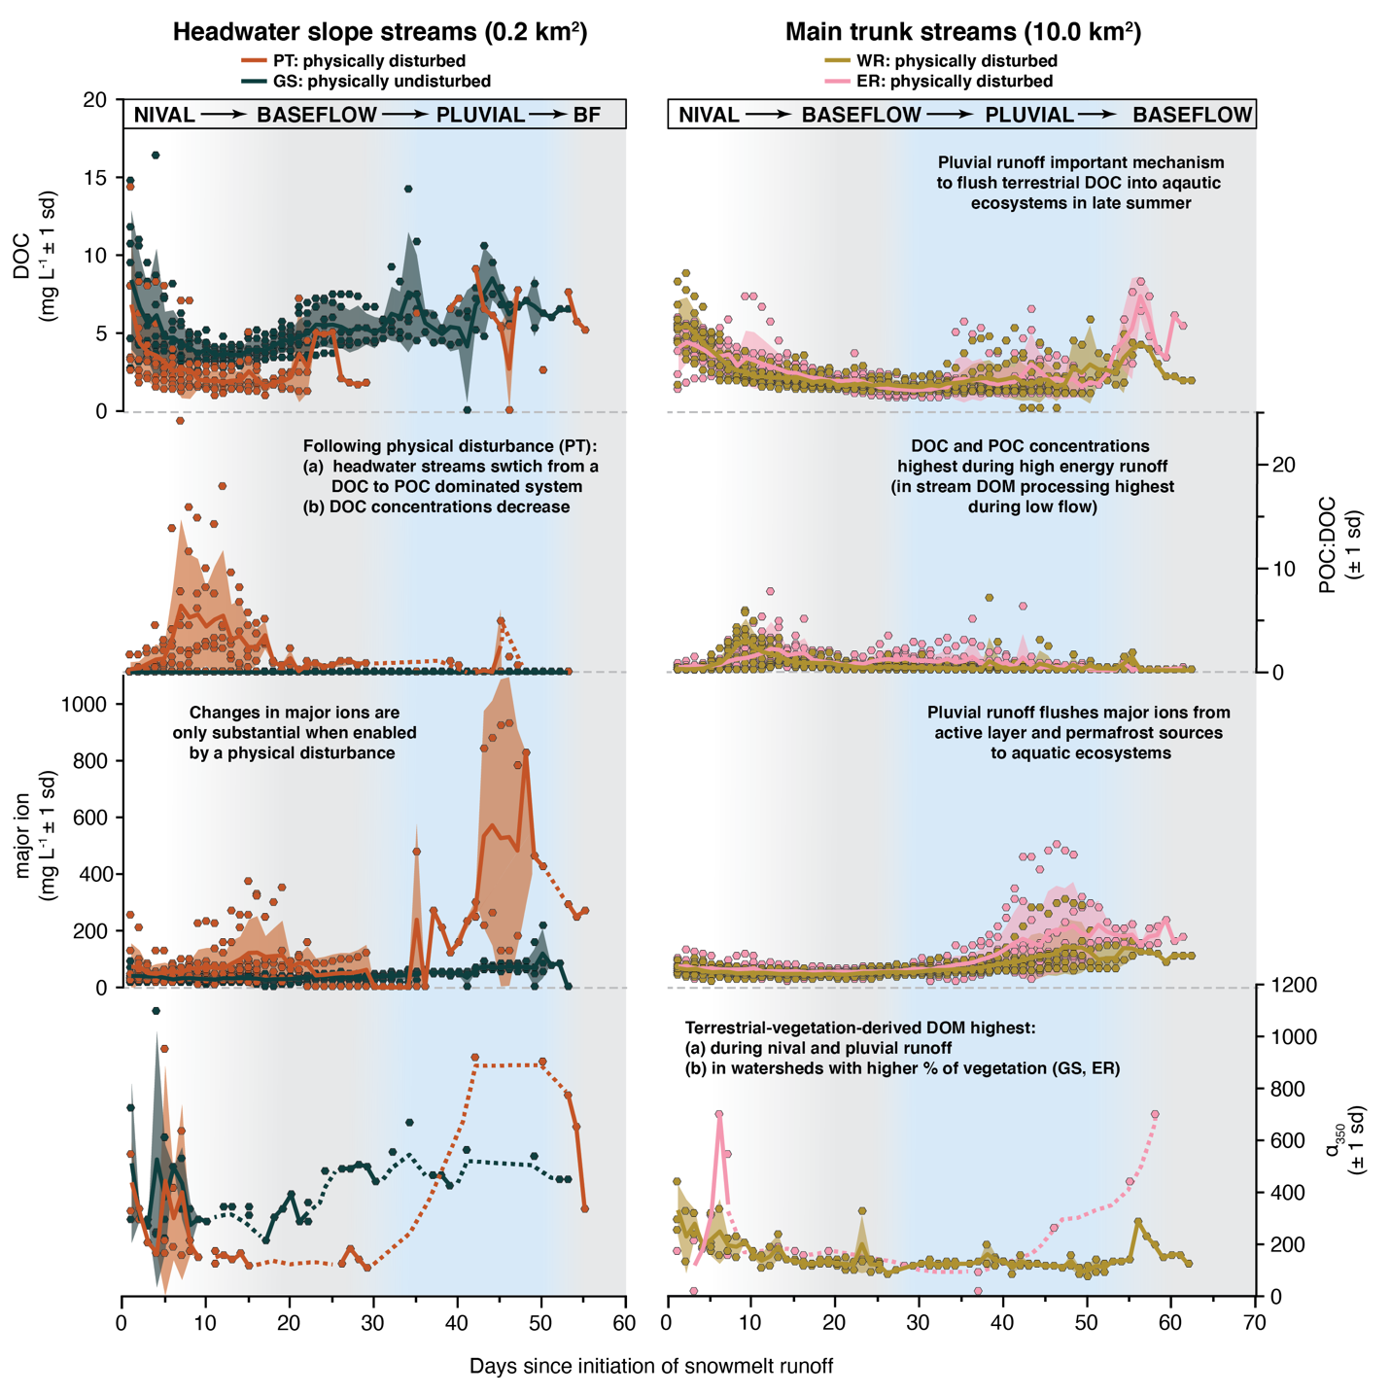
Fig. S14. Annotated mean daily biogeochemical records (± 1 sd) normalized to first day of runoff and separated by watershed; (a) daily DOC concentration, (b) daily POC:DOC ratio, (c) daily major ion concentration, (d) daily a350 values, which are an indicator of terrigenous DOM. Approximate hydrological periods are labeled and shaded. Conceptualized in Fig. 4.
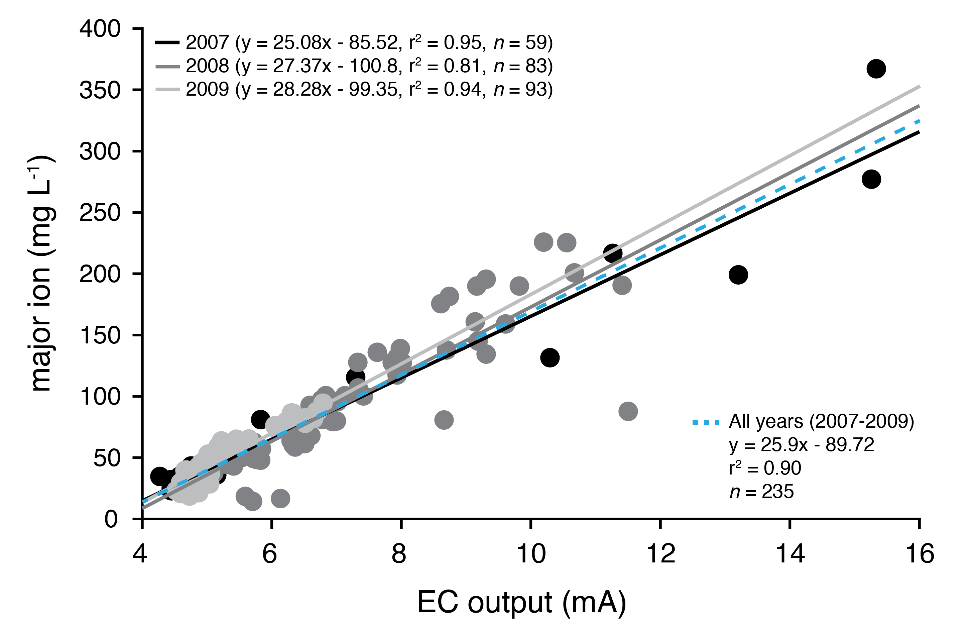
Fig. S15. Fitted linear correlations between in situ electrical conductivity (EC) output and
measured concentrations of major ions for the East River, 2007-2009. Due to
repeated failure of refrigerators used to store water samples prior to analysis (2012-2017), daily
mean major ion concentrations were estimated from EC output, using the mean linear relationship for all years (blue line). One-way analysis of covariance indicates that the slopes are not significantly different from each other (F(3,235) = 1.67, p > 0.1).

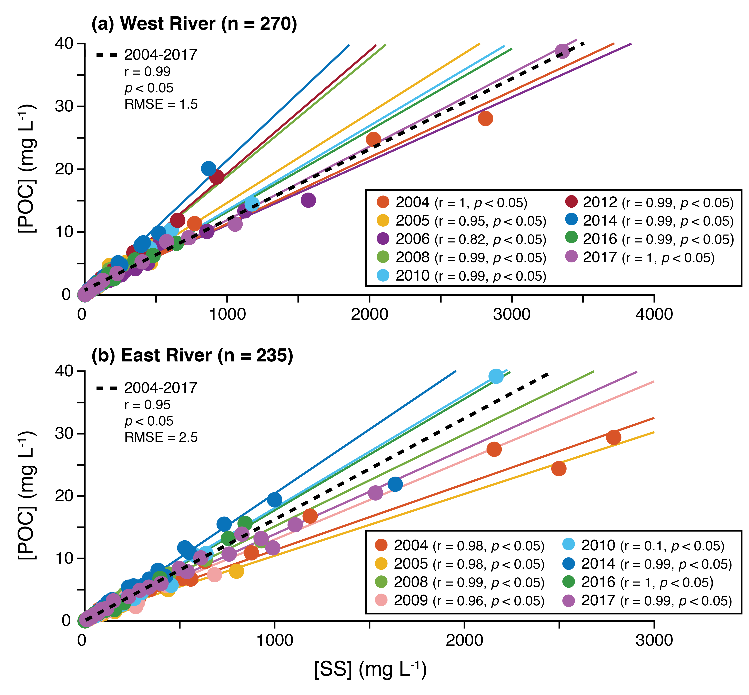
Fig. S16. Seasonal correlations between suspended sediment concentration ([SS]) and particulate organic carbon concentration ([POC]) for (a) WR: West river and (b) ER: East river, 2004-2017 (excluding 2011, 2013, 2015). Also shown is the correlation fit to all data (n = 235; 2004-2017; black dash line). Low root mean square errors (RMSE; standard deviation of residuals) show that the data is closely concentrated around the line of best fit but with more scatter at higher concentrations. Randomly selected replicate samples were run to estimate method uncertainty (Fig. S17; see Beel et al., 2020 for full details).

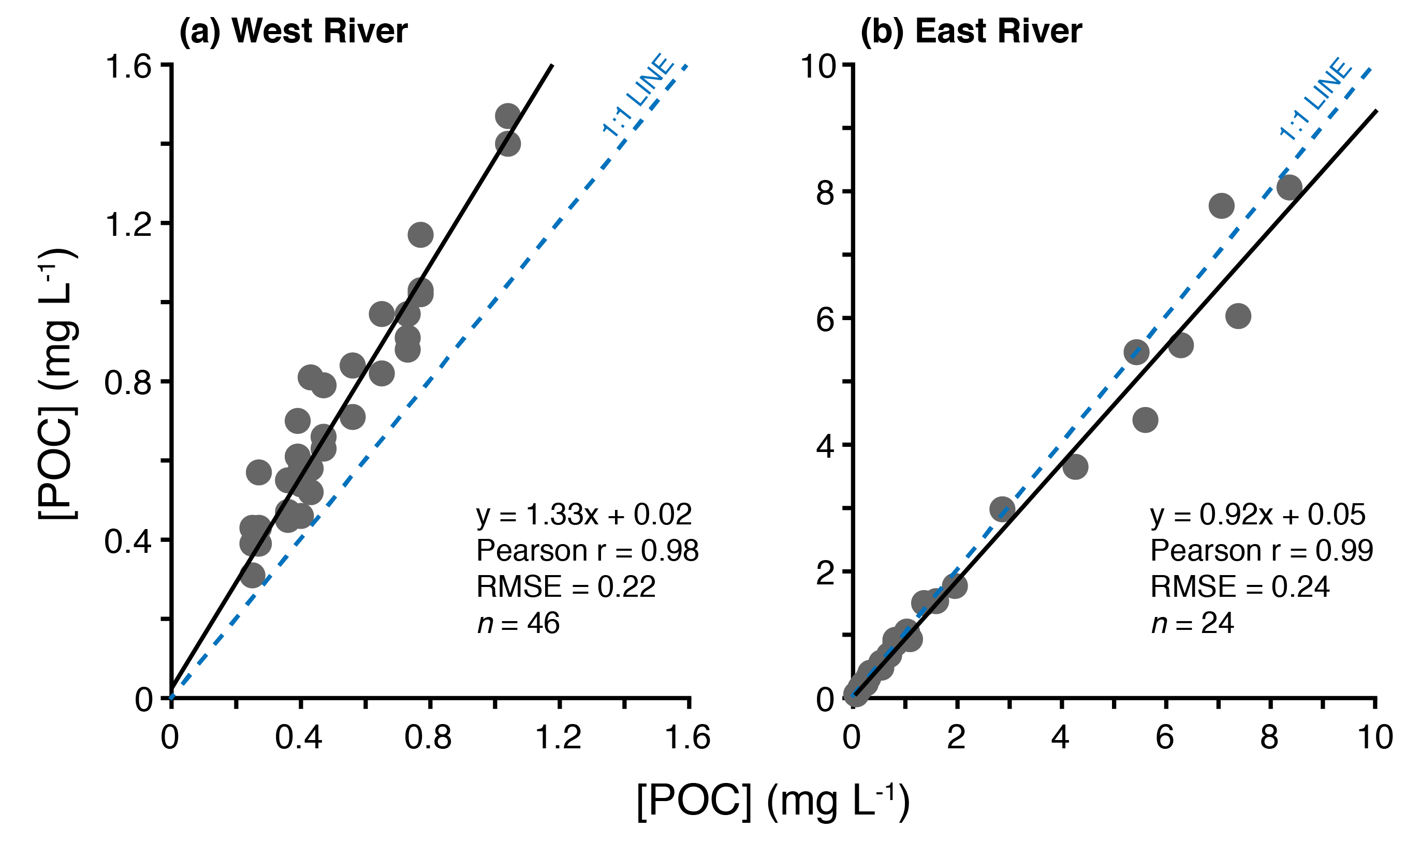
Fig. S17. Fitted linear relationships between POC concentrations ([POC]) for replicate samples for the (a) WR: West (n = 46) and (b) ER: East rivers (n = 24). Two-tailed t-tests indicate that the sample means are equal between both runs (p < 0.05). 1:1 line shown for reference (blue-dashed). For full method details see Beel et al. (2020).

4. Supporting Tables
Table S2. Summary of hydrometeorological and biogeochemical instruments, dataloggers, and analytical methods used at CBAWO (2003-2019). Modified from Lewis et al. (2012).
Parameter | Instrument | Instrument Accuracy | Datalogger | Years Used | Analytical method/material
Air Pressure | Omega-PRTEMP101 | 0.4% | Omega-PRTEMP101 | 2003-2006
Air Pressure | Onset Hobo U20 | 0.3% | Onset Hobo U20 | 2007-2011
Air Pressure | Onset CM50 | 0.4% (5 mb) | Onset CM50 | 2011-2019
Air Temperature | Onset H8 | 0.2°C | Onset H8 | 2003-2006 | Solar radiation shielded, 1.5 m above the surface
Air Temperature | Onset UA-003 | 0.1°C | Onset UA-003 | 2006-2019 | Solar radiation shielded, 1.5 m above the surface
Rainfall | Davis Industrial | 0.2 mm tip | Onset Hobo Event | 2003-2006 | 1.5 m above the surface
Rainfall | Davis Industrial | 0.2 mm tip | Onset UA-003 | 2006-2019 | 1.5 m above the surface
Discharge  (Q) | General Oceanics Flowmeter | 1% | n/a | 2003-2005 | Velocity-area
Discharge  (Q) | Swoffer 2100 | 1% | n/a | 2006-2019 | Velocity-area
Water Level (stage) | Sensym SCX | 2 mm | Onset H8 | 2003 | Stage-Q rating curve
Water Level (stage) | Omega CP-Level101 | 0.2% (0.5 mm) | Omega CR-PRTEMP101 | 2004-2005 | Stage-Q rating curve
Water Level (stage) | Omega OM_CP Level 1000 | 0.2% (0.5 mm) | Omega OM-CP Level 1000 | 2006 | Stage-Q rating curve
Water Level (stage) | Onset Hobo U20 | 0.3% (0.21 cm) | Onset Hobo U20 | 2007-2019 | Stage-Q rating curve
Electrical Conductivity (EC) | Global Water WQ301 | 1% | Onset Hobo H22 | 2007-2019 | EC-[TDS] rating curve
Suspended Sediment Concentration  (SSC) | DH-48 Integrated water sampler | n/a | n/a | 2003-2006 | Volumetric filtration
Suspended Sediment Concentration  (SSC) | Teledyne ISCO 3700C Pump Sampler | n/a | n/a | 2007-2019
Suspended Sediment Concentration  (SSC) | n/a | n/a | n/a | 2003 | 0.45-μm cellulose acetate filters
Suspended Sediment Concentration  (SSC) | n/a | n/a | n/a | 2004-2019 | 1.0-μm glass fiber filters
Particulate Organic Carbon  (POC) | LECO TruSpec CN Elemental Analyzer | 0.0001 ppm | n/a | 2004-2019 | Dumas combustion reaction with non-dispersive infrared absorption
Particulate Organic Carbon  (POC) | n/a | n/a | n/a | 2004-2019 | Non-combusted, 1.0-μm glass fiber SS filters
Major Ion Concentrations | Dionex ICS-3000 | Most species: < 0.010 mg L⁻¹ | n/a | 2006-2019 | Liquid ion chromatography (Anions, Cations). HCO₃⁻ determined by charge balance
Major Ion Concentrations | Dionex ICS-3000 | Ca²⁺: 0.053 mg L⁻¹ | n/a | 2006-2019
Major Ion Concentrations | Dionex ICS-3000 | Mg²⁺: 0.022 mg L⁻¹ | n/a | 2006-2019
Major Ion Concentrations | n/a | n/a | n/a | 2006-2007 | 0.45-μm nitrocellulose membrane filters
Major Ion Concentrations | n/a | n/a | n/a | 2008-2019 | 0.22-μm polyvinylidene fluoride filters

Table S3. Pearson r correlation coefficients during nival periods. Correlations are considered statistically significant when p < 0.05.

 | Date | Stream power (W) | Q (m³ s⁻¹) | SSC (mg L⁻¹) | POC (mg L⁻¹) | DOC (mg L⁻¹) | POC:DOC | TDN (mg L⁻¹) | DOC:TDN
Date | 1.00 |  | -- | -- | -- | -- | -- | -- | --
Stream power (W) | 0.06 | 1.00 | -- | -- | -- | -- | -- | -- | --
Q (m³ s⁻¹) | 0.06 | 1.00* | 1.00 | -- | -- | -- | -- | -- | --
SSC (mg L⁻¹) | -0.05 | -0.02 | -0.02 | 1.00 | -- | -- | -- | -- | --
POC (mg L⁻¹) | -0.04 | 0.02 | 0.02 | 0.95* | 1.00 | -- | -- | -- | --
DOC (mg L⁻¹) | -0.16* | -0.09* | -0.09* | -0.18* | -0.19* | 1.00 | -- | -- | --
POC:DOC | 0.00 | 0.02 | 0.02 | 0.92* | 0.94* | -0.28* | 1.00 | -- | --
TDN (mg L⁻¹) | -0.19* | -0.06 | -0.06 | -0.12* | -0.12* | 0.83* | -0.21* | 1.00 | --
DOC:TDN | -0.04 | -0.07 | -0.08 | -0.17* | -0.19* | 0.48* | -0.24* | 0.02 | 1.00
Major ions  (mg L⁻¹) | 0.08* | -0.14* | -0.14* | 0.15* | 0.12* | 0.11* | 0.08* | 0.19* | -0.16*
pH | 0.16* | -0.14* | -0.14* | 0.02 | 0.03 | -0.10* | 0.06 | -0.04 | -0.13*
GDD (°C) | 0.19* | -0.13* | -0.14* | 0.02 | 0.03 | -0.45* | 0.13* | -0.32* | -0.34*
River T (°C) | -0.11* | -0.36* | -0.36* | -0.04 | -0.08 | -0.30* | -0.05 | -0.26* | -0.12*
Days since snowmelt initiation | -0.06 | -0.22* | -0.22* | -0.02 | -0.02 | -0.49* | -0.00 | -0.42* | -0.26*
α₃₅₀ (m⁻¹) | -0.37* | -0.17 | -0.16 | 0.26* | 0.25* | 0.80* | -0.17 | 0.75* | 0.35*
BIX | -0.13 | 0.01 | -0.00 | 0.01 | -0.02 | -0.36* | 0.28* | -0.34* | -0.26*
S_{R} | 0.14 | -0.14 | -0.14 | -0.09 | -0.07 | -0.47* | 0.33* | -0.47* | -0.20
*Statistically significant (p < 0.05) correlation

Table S3 continued. Pearson r correlation coefficients during nival periods. Correlations are considered statistically significant when p < 0.05.

 | Major ions (mg L⁻¹) | pH | GDD (°C) | River T (°C) | Days since snowmelt initiation | α₃₅₀ (m⁻¹) | BIX | S_{R}
Date | -- | -- | -- | -- | -- | -- | -- | --
Stream power (W) | -- | -- | -- | -- | -- | -- | -- | --
Q (m³ s⁻¹) | -- | -- | -- | -- | -- | -- | -- | --
SSC (mg L⁻¹) | -- | -- | -- | -- | -- | -- | -- | --
POC (mg L⁻¹) | -- | -- | -- | -- | -- | -- | -- | --
DOC (mg L⁻¹) | -- | -- | -- | -- | -- | -- | -- | --
POC:DOC | -- | -- | -- | -- | -- | -- | -- | --
TDN (mg L⁻¹) | -- | -- | -- | -- | -- | -- | -- | --
DOC:TDN | -- | -- | -- | -- | -- | -- | -- | --
Major ions  (mg L⁻¹) | 1.00 | -- | -- | -- | -- | -- | -- | --
pH | 0.12* | 1.00 | -- | -- | -- | -- | -- | --
GDD (°C) | -0.09* | 0.20 | 1.00 | -- | -- | -- | -- | --
River T (°C) | 0.01 | 0.23* | 0.71* | 1.00 | -- | -- | -- | --
Days since snowmelt initiation | -0.04 | 0.18* | 0.65* | 0.74* | 1.00 | -- | -- | --
α₃₅₀ (m⁻¹) | 0.43* | 0.05 | -0.31* | -0.40* | -0.39* | 1.00 | -- | --
BIX | -0.01 | -0.14 | 0.25* | 0.34* | 0.24* | -0.41* | 1.00 | --
S_{R} | -0.39* | 0.11 | 0.12 | 0.37* | 0.16 | -0.50* | 0.37* | 1.00
*Statistically significant (p < 0.05) correlation

Table S4. Pearson r correlation coefficients during baseflow periods. Correlations are considered statistically significant when p < 0.05.

 | Date | Stream power (W) | Q (m³ s⁻¹) | SSC (mg L⁻¹) | POC (mg L⁻¹) | DOC (mg L⁻¹) | POC:DOC | TDN (mg L⁻¹) | DOC:TDN
Date | 1.00 |  | -- | -- | -- | -- | -- | -- | --
Stream power (W) | -0.28* | 1.00 | -- | -- | -- | -- | -- | -- | --
Q (m³ s⁻¹) | -0.28* | 1.00* | 1.00 | -- | -- | -- | -- | -- | --
SSC (mg L⁻¹) | -0.22* | 0.08 | 0.08 | 1.00 | -- | -- | -- | -- | --
POC (mg L⁻¹) | -0.20* | 0.07 | 0.07 | 0.97* | 1.00 | -- | -- | -- | --
DOC (mg L⁻¹) | -0.02 | -0.20* | -0.20* | -0.08 | -0.12* | 1.00 | -- | -- | --
POC:DOC | -0.17* | 0.07 | 0.08 | 0.85* | 0.90* | -0.30* | 1.00 | -- | --
TDN (mg L⁻¹) | -0.22* | -0.13* | -0.13* | 0.03 | 0.02 | 0.37* | -0.06 | 1.00 | --
DOC:TDN | 0.14* | -0.05 | -0.05 | -0.14* | -0.18* | 0.70* | -0.36* | -0.23* | 1.00
Major ions  (mg L⁻¹) | -0.01 | -0.14* | -0.14* | 0.03 | 0.06 | 0.01 | 0.03 | 0.39* | -0.27*
pH | 0.15* | -0.28* | -0.27* | 0.06 | 0.08 | 0.09 | 0.04 | 0.06 | 0.00
GDD (°C) | -0.26* | 0.03 | 0.03 | 0.03 | 0.02 | -0.10* | 0.12* | 0.12* | -0.24*
River T (°C) | -0.11* | -0.14* | -0.14* | -0.06 | -0.06 | 0.24* | -0.04 | 0.15* | 0.09
Days since snowmelt initiation | 0.11* | -0.17* | -0.17* | -0.14* | -0.14* | -0.17* | -0.11* | 0.13* | -0.34*
α₃₅₀ (m⁻¹) | -0.35* | -0.35* | -0.34* | -0.24* | -0.25* | 0.89* | -0.32* | 0.87* | 0.61*
BIX | 0.68* | 0.16 | 0.16 | -0.08 | -0.08 | -0.59* | 0.04 | -0.55* | -0.51*
S_{R} | 0.24* | 0.13 | 0.12 | 0.16 | 0.10 | -0.40* | 0.16 | -0.37* | -0.37*
*Statistically significant (p < 0.05) correlation

Table S4 continued. Pearson r correlation coefficients during baseflow periods. Correlations are considered statistically significant when p < 0.05.

 | Major ions (mg L⁻¹) | pH | GDD (°C) | River T (°C) | Days since snowmelt initiation | α₃₅₀ (m⁻¹) | BIX | S_{R}
Date | -- | -- | -- | -- | -- | -- | -- | --
Stream power (W) | -- | -- | -- | -- | -- | -- | -- | --
Q (m³ s⁻¹) | -- | -- | -- | -- | -- | -- | -- | --
SSC (mg L⁻¹) | -- | -- | -- | -- | -- | -- | -- | --
POC (mg L⁻¹) | -- | -- | -- | -- | -- | -- | -- | --
DOC (mg L⁻¹) | -- | -- | -- | -- | -- | -- | -- | --
POC:DOC | -- | -- | -- | -- | -- | -- | -- | --
TDN (mg L⁻¹) | -- | -- | -- | -- | -- | -- | -- | --
DOC:TDN | -- | -- | -- | -- | -- | -- | -- | --
Major ions  (mg L⁻¹) | 1.00 | -- | -- | -- | -- | -- | -- | --
pH | 0.34* | 1.00 | -- | -- | -- | -- | -- | --
GDD (°C) | 0.06 | 0.18* | 1.00 | -- | -- | -- | -- | --
River T (°C) | 0.06 | 0.29* | 0.84* | 1.00 | -- | -- | -- | --
Days since snowmelt initiation | 0.39* | 0.09 | -0.04 | -0.10* | 1.00 | -- | -- | --
α₃₅₀ (m⁻¹) | 0.06 | 0.39* | 0.01 | 0.18 | -0.17 | 1.00 | -- | --
BIX | 0.01 | -0.54* | -0.09 | -0.37* | 0.44* | -0.55* | 1.00 | --
S_{R} | -0.19 | -0.11 | 0.18 | -0.04 | -0.25* | -0.33* | 0.41* | 1.00
*Statistically significant (p < 0.05) correlation

Table S5. Pearson r correlation coefficients during pluvial (rainfall) periods. Correlations are considered statistically significant when p < 0.05.

 | Date | Stream power (W) | Q (m³ s⁻¹) | SSC (mg L⁻¹) | POC (mg L⁻¹) | DOC (mg L⁻¹) | POC:DOC | TDN (mg L⁻¹) | DOC:TDN
Date | 1.00 |  | -- | -- | -- | -- | -- | -- | --
Stream power (W) | -0.40* | 1.00 | -- | -- | -- | -- | -- | -- | --
Q (m³ s⁻¹) | -0.40* | 1.00* | 1.00 | -- | -- | -- | -- | -- | --
SSC (mg L⁻¹) | -0.27* | 0.45* | 0.45* | 1.00 | -- | -- | -- | -- | --
POC (mg L⁻¹) | -0.29* | 0.49* | 0.50* | 0.99* | 1.00 | -- | -- | -- | --
DOC (mg L⁻¹) | -0.11 | -0.04 | -0.03 | 0.07 | 0.06 | 1.00 | -- | -- | --
POC:DOC | -0.31* | 0.53* | 0.54* | 0.91 | 0.95* | -0.09 | 1.00 | -- | --
TDN (mg L⁻¹) | -0.14 | -0.11 | -0.10 | -0.04 | -0.04 | 0.58* | -0.11 | 1.00 | --
DOC:TDN | 0.03 | 0.08 | 0.08 | 0.15 | 0.13 | 0.45* | -0.01 | -0.32* | 1.00
Major ions  (mg L⁻¹) | 0.04 | -0.13 | -0.12 | 0.02 | 0.03 | 0.19* | -0.05 | 0.59* | -0.33*
pH | 0.28* | -0.34* | -0.34* | -0.27* | -0.25* | -0.09 | -0.22* | 0.11 | -0.24*
GDD (°C) | -0.02 | -0.07 | -0.07 | 0.04 | 0.03 | -0.16 | 0.05 | 0.08 | -0.15
River T (°C) | 0.03 | -0.28* | -0.29* | -0.09 | -0.12 | 0.15 | -0.18* | 0.20* | 0.02
Days since snowmelt initiation | 0.23* | -0.17* | -0.17* | -0.04 | -0.04 | 0.23* | -0.17* | 0.27* | -0.06
α₃₅₀ (m⁻¹) | 0.13 | -0.17 | -0.17 | -0.18 | -0.23 | 0.82* | -0.39* | 0.78* | 0.29
BIX | 0.50* | -0.29 | -0.29 | -0.08 | -0.10 | -0.11 | -0.07 | -0.03 | -0.19
S_{R} | -0.13 | -0.16 | -0.16 | -0.20 | -0.17 | -0.36* | 0.06 | -0.25 | -0.46*
*Statistically significant (p < 0.05) correlation

Table S5 continued. Pearson r correlation coefficients during pluvial (rainfall) periods. Correlations are considered statistically significant when p < 0.05.

 | Major ions (mg L⁻¹) | pH | GDD (°C) | River T (°C) | Days since snowmelt initiation | α₃₅₀ (m⁻¹) | BIX | S_{R}
Date | -- | -- | -- | -- | -- | -- | -- | --
Stream power (W) | -- | -- | -- | -- | -- | -- | -- | --
Q (m³ s⁻¹) | -- | -- | -- | -- | -- | -- | -- | --
SSC (mg L⁻¹) | -- | -- | -- | -- | -- | -- | -- | --
POC (mg L⁻¹) | -- | -- | -- | -- | -- | -- | -- | --
DOC (mg L⁻¹) | -- | -- | -- | -- | -- | -- | -- | --
POC:DOC | -- | -- | -- | -- | -- | -- | -- | --
TDN (mg L⁻¹) | -- | -- | -- | -- | -- | -- | -- | --
DOC:TDN | -- | -- | -- | -- | -- | -- | -- | --
Major ions  (mg L⁻¹) | 1.00 | -- | -- | -- | -- | -- | -- | --
pH | 0.47* | 1.00 | -- | -- | -- | -- | -- | --
GDD (°C) | 0.12 | 0.36* | 1.00 | -- | -- | -- | -- | --
River T (°C) | 0.22* | 0.47* | 0.77* | 1.00 | -- | -- | -- | --
Days since snowmelt initiation | 0.36* | 0.32* | -0.05 | 0.18* | 1.00 | -- | -- | --
α₃₅₀ (m⁻¹) | 0.63* | 0.16 | -0.31 | -0.25 | 0.28 | 1.00 | -- | --
BIX | 0.23 | -0.15 | -0.10 | -0.37* | 0.32 | -0.05 | 1.00 | --
S_{R} | -0.05 | 0.13 | 0.47* | 0.40* | -0.33 | -0.20 | 0.20 | 1.00
*Statistically significant (p < 0.05) correlation

Table S6. Pearson r correlation coefficients versus antecedent weather conditions. Correlations are considered statistically significant when p < 0.05.

 | Prior 48 hr |  | Prior week
 | Mean T (°C) | Total P (mm) | Mean T (°C) | Total P (mm)
Date | 0.02 | -0.02 | 0.05 | -0.01
Stream power (W) | -0.18* | 0.06* | -0.27* | -0.00
Q (m³ s⁻¹) | -0.19* | 0.06* | -0.28* | -0.00
SSC (mg L⁻¹) | -0.05 | 0.13* | -0.09* | 0.11*
POC (mg L⁻¹) | -0.05 | 0.12* | -0.10* | 0.09*
DOC (mg L⁻¹) | -0.32* | 0.16* | -0.33* | 0.13*
POC:DOC | 0.03 | -0.00 | -0.05 | -0.04
TDN (mg L⁻¹) | -0.06 | 0.18* | -0.03 | 0.18*
DOC:TDN | -0.33* | 0.04 | -0.37* | -0.03
Major ions  (mg L⁻¹) | 0.10* | 0.18* | 0.25* | 0.25*
pH | 0.27* | 0.03 | 0.34* | -0.02
GDD (°C) | 0.96* | -0.09* | 0.78* | -0.08*
River T (°C) | 0.77* | 0.00 | 0.75* | 0.07*
Days since snowmelt initiation | 0.29* | 0.32* | 0.45* | 0.49*
α₃₅₀ (m⁻¹) | -0.23* | 0.15* | -0.30* | 0.12
BIX | 0.14* | 0.10 | 0.27* | 0.22*
S_{R} | 0.20* | -0.01 | 0.29* | -0.10
*Statistically significant (p < 0.05) correlation

Table S7. Analysis of variance (ANOVA) results for variables grouped by watershed (WS) and hydrological period (HP). Differences between groups are considered statistically significant when p < 0.05.

 | All data |  | By hydrological period (HP) |  |  |  | By watershed (WS)
 | By WS | By HP | PT | GS | WR | ER | Nival | Base flow | Pluvial
Date | <0.01* | <0.01* | <0.01* | <0.01* | 0.27 | <0.01* | 0.05 | <0.01* | 0.86
Stream power (W) | <0.01* | <0.01* | <0.01* | <0.01* | <0.01* | <0.01* | <0.01* | <0.01* | <0.01*
Q (m³ s⁻¹) | <0.01* | <0.01* | <0.01* | <0.01* | <0.01* | <0.01* | <0.01* | <0.01* | <0.01*
SSC (mg L⁻¹) | <0.01* | <0.01* | <0.01* | <0.01* | <0.01* | <0.01* | <0.01* | <0.01* | <0.01*
POC (mg L⁻¹) | <0.01* | <0.01* | <0.01* | <0.01* | <0.01* | <0.01* | <0.01* | <0.01* | <0.01*
DOC (mg L⁻¹) | <0.01* | <0.01* | <0.01* | <0.01* | <0.01* | <0.01* | <0.01* | <0.01* | <0.01*
POC:DOC | <0.01* | <0.01* | 0.10 | 0.10 | <0.01* | 0.01 | <0.01* | <0.01* | <0.01*
TDN (mg L⁻¹) | <0.01* | <0.01* | <0.01* | <0.01* | 0.26 | <0.01* | <0.01* | <0.01* | <0.01*
DOC:TDN | <0.01* | <0.01* | 0.45 | 0.13 | <0.01* | <0.01* | <0.01* | <0.01* | <0.01*
Major ions  (mg L⁻¹) | <0.01* | <0.01* | <0.01* | <0.01* | <0.01* | <0.01* | <0.01* | <0.01* | <0.01*
pH | <0.01* | <0.01* | <0.01* | 0.01* | <0.01* | <0.01* | <0.01* | <0.01* | 0.63
GDD (°C) | <0.01* | <0.01* | <0.01* | 0.17 | <0.01* | <0.01* | 0.01* | <0.01* | 0.55
River T (°C) | <0.01* | <0.01* | <0.01* | <0.01* | <0.01* | <0.01* | <0.01* | <0.01* | 0.01*
Days since snowmelt initiation | <0.01* | <0.01* | <0.01* | <0.01* | <0.01* | <0.01* | <0.01* | <0.01* | 0.65
α₃₅₀ (m⁻¹) | <0.01* | 0.05 | 0.29 | <0.01* | <0.01* | 0.86 | <0.01* | <0.01* | <0.01*
BIX | <0.01* | <0.01* | 0.03* | 0.34 | <0.01* | <0.01* | <0.01* | <0.01* | 0.46
S_{R} | <0.01* | 0.035 | 0.90 | 0.92 | 0.14 | 0.41 | 0.02* | 0.01* | 0.19
*Statistically significant (p < 0.05) difference between groups

Table S8. Mean ± SD proportions of annual flux from each hydrological period at the CBAWO. We separate years with significant pluvial responses (2007, 2009) from the remainder of the dataset (2005-2017) to show how shifts in the timing and magnitude of pluvial energy affect proportions of annual flux during each hydrological period. Full flux data are available in the Supplementary Data.

 | Physically undisturbed headwater slope stream (GS) |  |  | Physically disturbed headwater slope stream (PT) |  |  | Main stems (WR and ER)
 | Nival | Base flow | Pluvial | Nival | Base flow | Pluvial | Nival | Base flow | Pluvial
2005-2017*
SSC | 74 ± 19% | 19 ± 11% | 8 ± 16% | 67 ± 41% | 2 ± 3% | 14 ± 17% | 84 ± 29% | 1 ± 1% | 24 ± 34%
POC | 73 ± 21% | 21 ± 12% | 9 ± 16% | 75 ± 34% | 3 ± 3% | 17 ± 20% | 84 ± 29% | 1 ± 1% | 24 ± 34%
DOC | 71 ± 19% | 24 ± 15% | 10 ± 12% | 77 ± 27% | 3 ± 6% | 25 ± 28% | 85 ± 17% | 4 ± 2% | 13 ± 18%
TDN | 72 ± 18% | 23 ± 14% | 9 ± 10% | 77 ± 26% | 4 ± 9% | 23 ± 24% | 83 ± 18% | 6 ± 4% | 17 ± 16%
Major ions | 69 ± 22% | 28 ± 20% | 7 ± 11% | 67 ± 34% | 9 ± 13% | 28 ± 22% | 76 ± 22% | 8 ± 4% | 28 ± 20%
Stream power | 72 ± 17% | 20 ± 17% | 11 ± 5% | 81 ± 17% | 11 ± 8% | 13 ± 10% | 80 ± 17% | 8 ± 8% | 14 ± 12%
2007, 2009
SSC | 37 ± 1% | 40 ± 14% | 20 ± 17% | 53 ± 2% | 18 ± 13% | 30 ± 11% | 37 ± 30% | 4 ± 6% | 59 ± 33%
POC | 35 ± 3% | 47 ± 17% | 16 ± 23% | 52 ± 1% | 18 ± 14% | 30 ± 13% | 37 ± 29% | 4 ± 6% | 59 ± 32%
DOC | 41 ± 1% | 46 ± 16% | 13 ± 18% | 40 ± 8% | 11 ± 15% | 50 ± 8% | 63 ± 23% | 6 ± 3% | 32 ± 22%
TDN | 40 ± 2% | 48 ± 17% | 11 ± 16% | 41 ± 16% | 14 ± 20% | 45 ± 4% | 58 ± 23% | 12 ± 8% | 30 ± 20%
Major ions | 42 ± 2% | 45 ± 16% | 12 ± 15% | 37 ± 12% | 24 ± 7% | 40 ± 5% | 41 ± 11% | 12 ± 7% | 47 ± 10%
Stream power | 48 ± 12% | 33 ± 12% | 19 ± 1% | 44 ± 14% | 25 ± 3% | 31 ± 11% | 59 ± 13% | 9 ± 4% | 32 ± 10%
*Excluding 2007 and 2009

Table S9. Two-sample Kolmogorov–Smirnov test results (p-values) comparing stream power distributions across sampled years in each watershed. Steam power distribution was considered significantly different between the two years at the α = 0.05 level when p < 0.05.

 | 2006 | 2007 | 2008 | 2009 | 2010 | 2012 | 2014 | 2016 | 2017
PT
2006 | 1.000 | < 0.001* | < 0.001* | < 0.001* | < 0.001* | < 0.001* | < 0.001* | < 0.001* | < 0.001*
2007 | < 0.001* | 1.000 | 0.076 | 0.003* | 0.249 | 0.001* | < 0.001* | < 0.001* | < 0.001*
2008 | < 0.001* | 0.076 | 1.000 | 0.087 | 0.371 | < 0.001* | < 0.001* | < 0.001* | < 0.001*
2009 | < 0.001* | 0.003* | 0.087 | 1.000 | 0.013* | < 0.001* | < 0.001* | < 0.001* | < 0.001*
2010 | < 0.001* | 0.249 | 0.371 | 0.013* | 1.000 | < 0.001* | < 0.001* | < 0.001* | < 0.001*
2012 | < 0.001* | 0.001* | < 0.001* | < 0.001* | < 0.001* | 1.000 | < 0.001* | < 0.001* | < 0.001*
2014 | < 0.001* | < 0.001* | < 0.001* | < 0.001* | < 0.001* | < 0.001* | 1.000 | 0.075 | < 0.001*
2016 | < 0.001* | < 0.001* | < 0.001* | < 0.001* | < 0.001* | < 0.001* | 0.075 | 1.000 | < 0.001*
2017 | < 0.001* | < 0.001* | < 0.001* | < 0.001* | < 0.001* | < 0.001* | < 0.001* | < 0.001* | 1.000
GS
2006 | 1.000 | < 0.001* | < 0.001* | < 0.001* | < 0.001* | < 0.001* | < 0.001* | < 0.001* | < 0.001*
2007 | < 0.001* | 1.000 | < 0.001* | < 0.001* | < 0.001* | 0.004* | < 0.001* | < 0.001* | 0.004*
2008 | < 0.001* | < 0.001* | 1.000 | 0.017* | < 0.001* | < 0.001* | < 0.001* | < 0.001* | < 0.001*
2009 | < 0.001* | < 0.001* | 0.017* | 1.000 | 0.047* | < 0.001* | < 0.001* | < 0.001* | < 0.001*
2010 | < 0.001* | < 0.001* | 0.002* | 0.047* | 1.000 | < 0.001* | < 0.001* | < 0.001* | < 0.001*
2012 | < 0.001* | 0.004* | < 0.001* | < 0.001* | < 0.001* | 1.000 | < 0.001* | 0.014* | 0.110
2014 | < 0.001* | < 0.001* | < 0.001* | < 0.001* | < 0.001* | < 0.001* | 1.000 | < 0.001* | < 0.001*
2016 | < 0.001* | < 0.001* | < 0.001* | < 0.001* | < 0.001* | 0.014* | < 0.001* | 1.000 | 0.005*
2017 | < 0.001* | 0.004* | < 0.001* | < 0.001* | < 0.001* | 0.110 | < 0.001* | 0.005* | 1.000
WR
2005 | 0.006* | < 0.001* | < 0.001* | < 0.001* | < 0.001* | < 0.001* | < 0.001* | < 0.001* | < 0.001*
2006 | 1.000 | 0.012* | < 0.001* | 0.029* | < 0.001* | < 0.001* | 0.001* | < 0.001* | < 0.001*
2007 | 0.012* | 1.000 | < 0.001* | 0.534 | < 0.001* | < 0.001* | 0.059 | < 0.001* | < 0.001*
2008 | < 0.001* | < 0.001* | 1.000 | < 0.001* | 0.196 | 0.326 | 0.005* | 0.181 | 0.106
2009 | 0.029* | 0.534 | < 0.001* | 1.000 | < 0.001* | < 0.001* | 0.130 | < 0.001* | < 0.001*
2010 | < 0.001* | < 0.001* | 0.196 | < 0.001* | 1.000 | 0.271 | 0.145 | 0.303 | 0.093
2012 | < 0.001* | < 0.001* | 0.326 | < 0.001* | 0.271 | 1.000 | 0.123 | 0.470 | 0.049*
2014 | 0.001* | 0.059 | 0.005* | 0.130 | 0.145 | 0.123 | 1.000 | 0.005* | < 0.001*
2016 | < 0.001* | < 0.001* | 0.181 | < 0.001* | 0.303 | 0.470 | 0.005* | 1.000 | 0.219
2017 | < 0.001* | < 0.001* | 0.106 | < 0.001* | 0.093 | 0.049* | < 0.001* | 0.219 | 1.000
ER
2005 | 0.002* | 0.001* | < 0.001* | < 0.001* | < 0.001* | < 0.001* | < 0.001* | < 0.001* | < 0.001*
2006 | 1.000 | 0.086 | 0.007* | 0.003* | 0.043* | < 0.001* | 0.007* | 0.002* | 0.177
2007 | 0.086 | 1.000 | 0.004* | 0.015* | 0.004* | < 0.001* | < 0.001* | 0.005* | 0.012*
2008 | 0.007* | 0.004* | 1.000 | < 0.001* | < 0.001* | < 0.001* | 0.011* | < 0.001* | 0.001*
2009 | 0.003* | 0.015* | < 0.001* | 1.000 | < 0.001* | < 0.001* | < 0.001* | < 0.001* | 0.075
2010 | 0.043* | 0.004* | < 0.001* | < 0.001* | 1.000 | 0.241 | 0.070 | 0.950 | 0.001*
2012 | < 0.001* | < 0.001* | < 0.001* | < 0.001* | 0.241 | 1.000 | 0.032* | 0.185 | < 0.001*
2014 | 0.007* | < 0.001* | 0.011* | < 0.001* | 0.070 | 0.032* | 1.000 | 0.104 | < 0.001*
2016 | 0.002* | 0.005* | < 0.001* | < 0.001* | 0.950 | 0.185 | 0.104 | 1.000 | < 0.001*
2017 | 0.177 | 0.012* | 0.001* | 0.075 | 0.001* | < 0.001* | < 0.001* | < 0.001* | 1.000
* Statistically significant differences in stream power distributions between the two years

