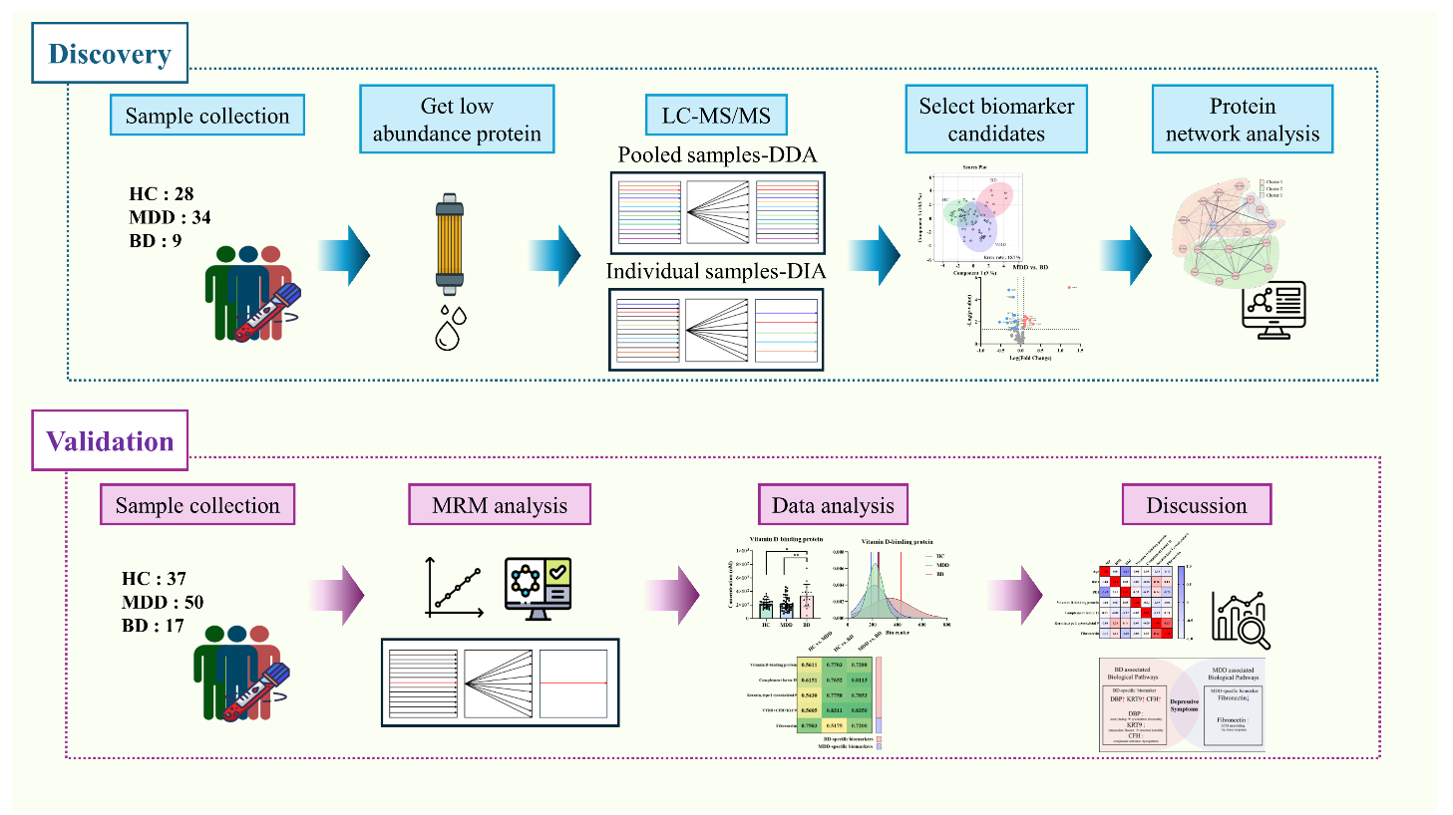

Supplementary Figure 1. Flow chart showing the overall flow of the experiment
The study on bipolar disorder with depressive symptoms was conducted through the discovery process and validation process. The discovery process was conducted to identify proteins that were present in small amounts in the blood and analyze them. Validation was conducted by purchasing the standards of candidates selected in the discovery process, verifying the proteins, and then analyzing them. The validation was conducted using multiple reaction monitoring (MRM).

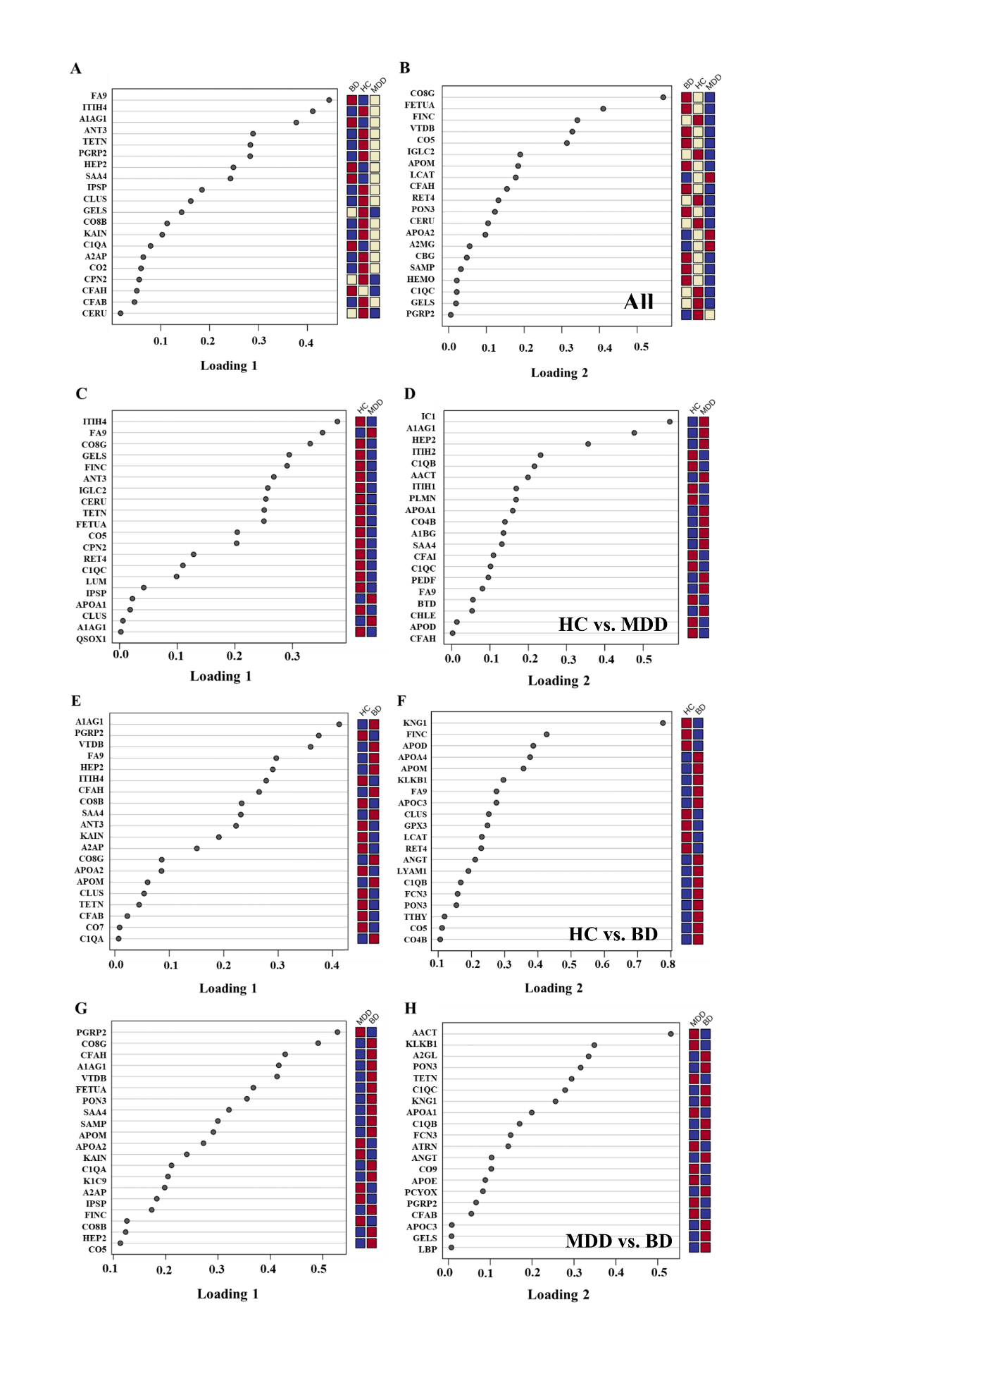
Supplementary Figure 2. Eighty-nine protein cross-group comparison loading plots for sPLS-DA. (A) Loading 1 plot and (B) loading 2 plot for sPLS-DA comparison among the HC, MDD, and BD groups. (C) Loading 1 plot and (D) loading 2 plot for sPLS-DA comparison between the HC and MDD groups. (E) Loading 1 plot and (F) loading 2 plot for sPLS-DA comparison between the HC and BD groups. (G) Loading 1 plot and (H) loading 2 plot for sPLS-DA comparison between the MDD and BD groups. Twenty components were identified for each group.

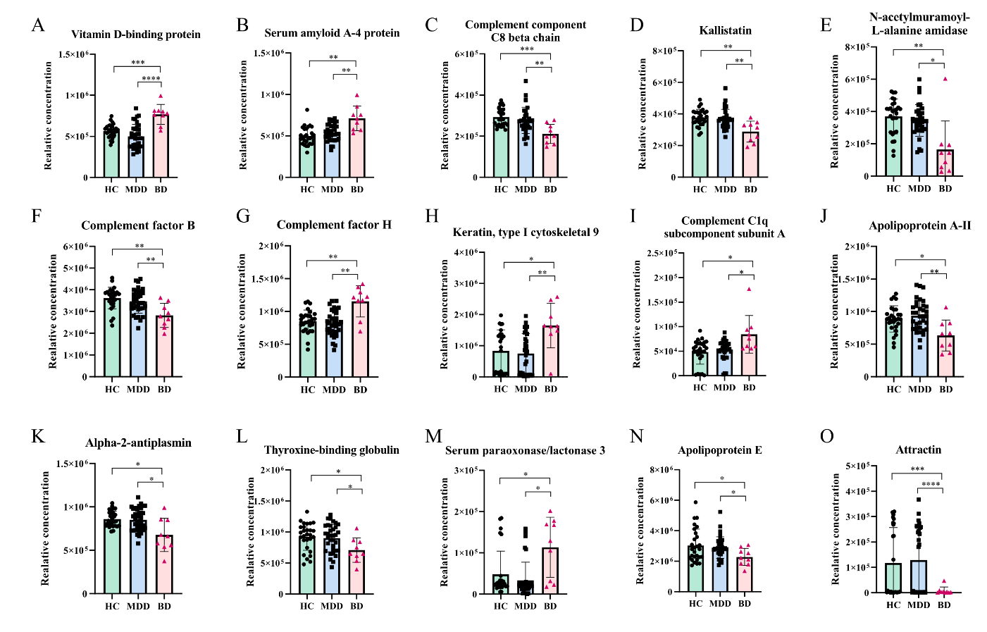
Supplementary Figure 3. Scatter plots of BD-specific biomarkers in the discovery phase. (A)–(O) BD-specific biomarkers. The green bar marked with circles represents the HC groups, the blue bar marked with squares represents the MDD group, and the pink bar marked with triangles represents the BD group. As These figures represent BD-specific biomarkers, the BD dots are marked in pink. The graph values are presented as mean ± standard deviation. *p < 0.05, **p < 0.01, ***p < 0.001, and ****p < 0.0001

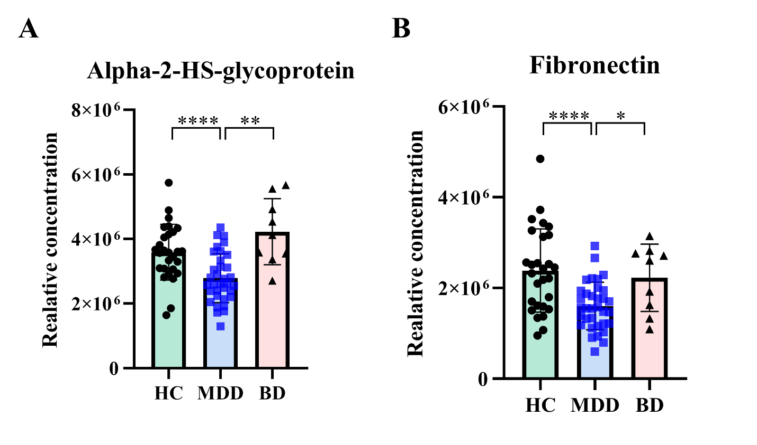
Supplementary Figure 4. Scatter plots of MDD-specific biomarkers in the discovery phase. (A)–(B) The green bar marked with circles represents the HC group, the blue bar marked with squares represents the MDD group, and the pink bar marked with triangles represents the BD group. As These figures represent MDD-specific biomarkers, the MDD dots are marked in blue. The graph values are presented as mean ± standard deviation. *p < 0.05, **p < 0.01, ***p < 0.001, and ****p < 0.0001.
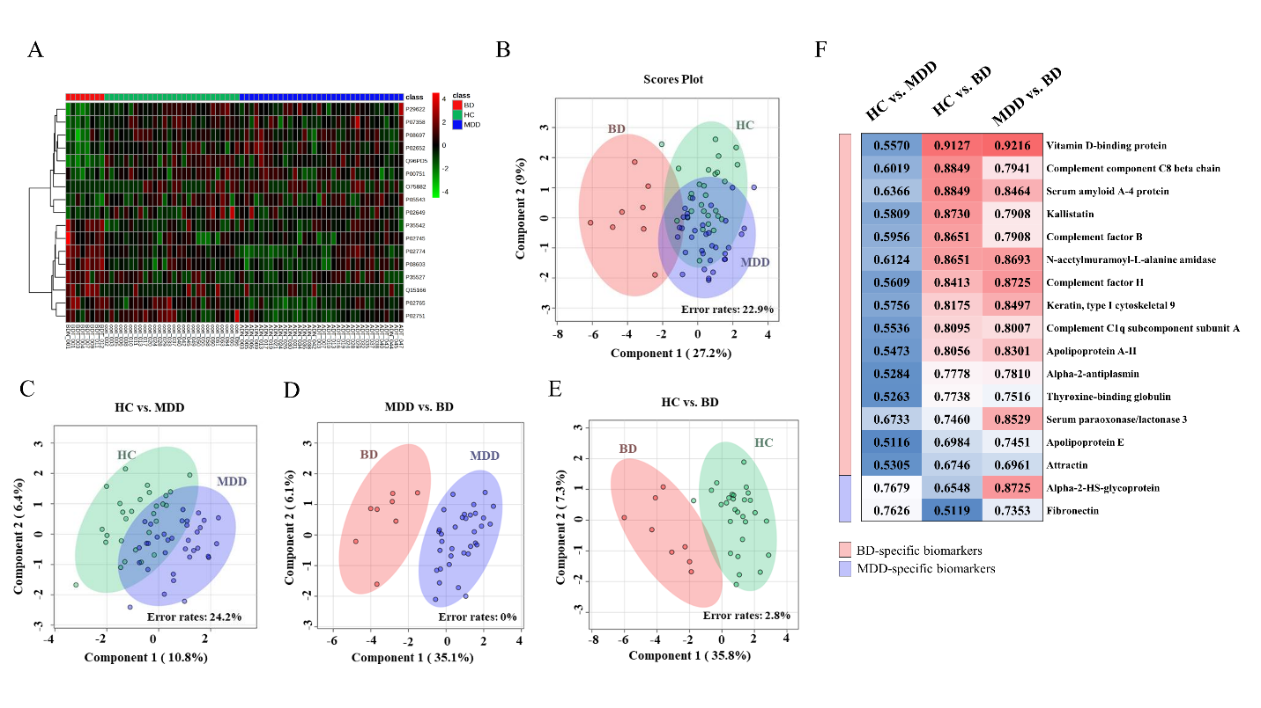
Supplementary Figure 5. Group comparison of the 17 disease-specific proteins. (A) Heatmap showing the expression levels of the 17 proteins. Red represents the bipolar disorder (BD) group, green represents the healthy control (HC) group, and blue represents the major depressive disorder (MDD) group. A higher expression level is indicated with deeper red. (B)-(E) Sparse partial least squares discriminant analysis plots depicting the differentiation of groups based on the level of protein expression. (B) BD, HC, and MDD; (C) HC and MDD; (D) BD and MDD; (E) BD and HC; (F) receiver operating characteristic (ROC) curve analysis results. The lowest area under the curve (AUC) value is expressed in red and the highest in blue. BD-specific biomarkers are indicated with red bars and MDD-specific biomarkers are indicated with blue bars.

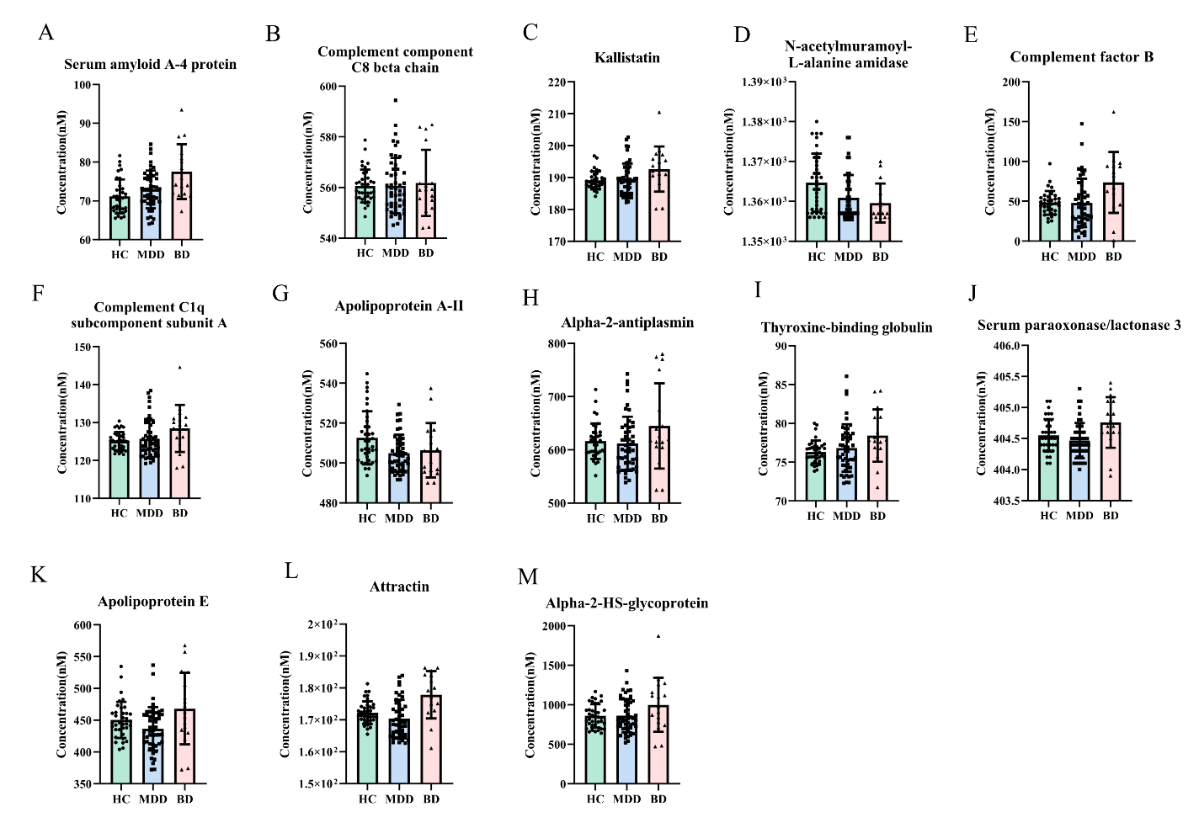
Supplementary Figure 6. Scatter plots of disease-specific biomarkers in the validation phase. The graph value are presented as mean ± standard deviation. (A)–(L) Scatter plots of BD-specific biomarkers and (M) scatter plot of MDD-specific biomarkers in the validation phase. *p < 0.01 and **p < 0.01.

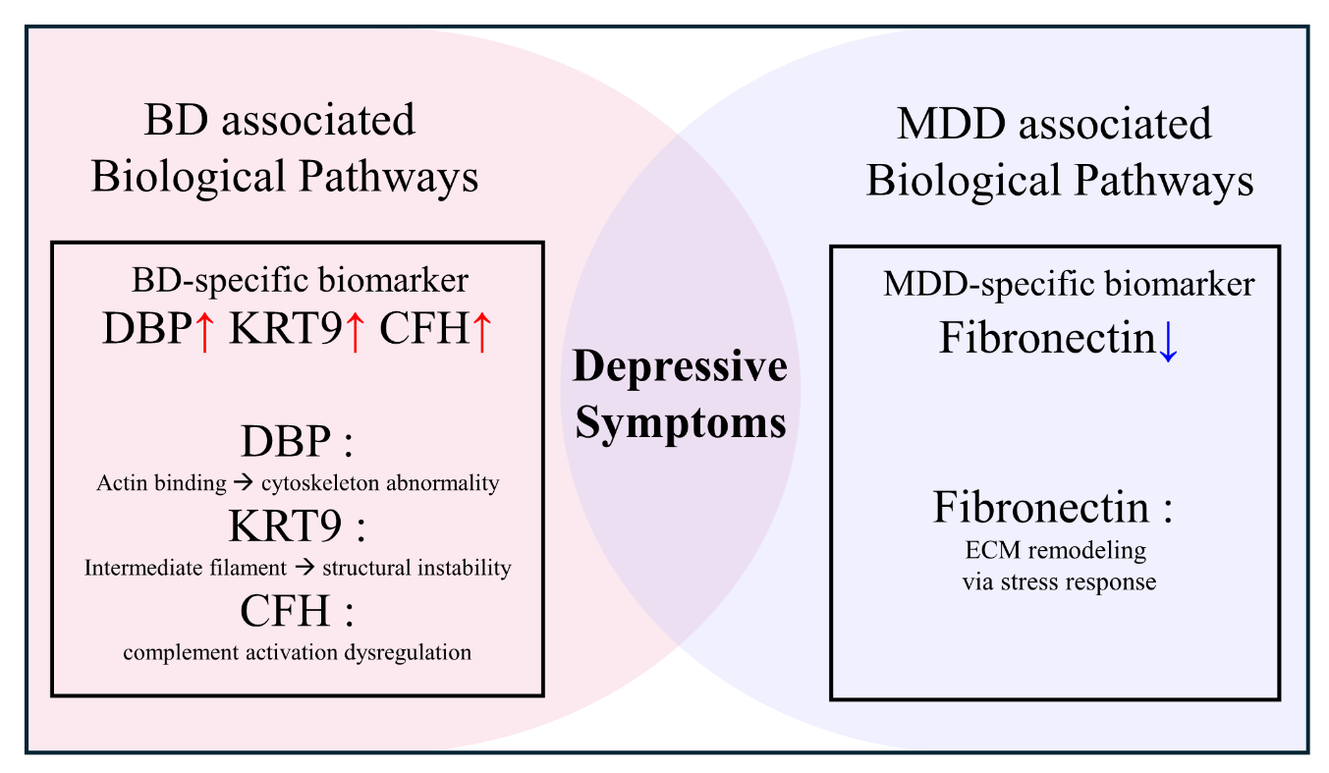
Supplementary Figure 7. Discussion summary. The levels of the bipolar disorder (BD)-specific biomarkers DBP, K1C9, and CFH were found to increase in the BD group compared with those in the healthy control (HC) and major depressive disorder (MDD) groups. DBP and K1C9 are thought to have cytoskeletal-related effects, while CFH is thought to have complement-related effects. The level of the MDD-specific biomarker fibronectin was found to decrease in the MDD group compared with that in the HC and BD groups. This finding suggests that fibronectin may affect the extracellular matrix through stress responses. DBP: vitamin D-binding protein, K1C9: keratin, type I cytoskeletal 9, CFH: complement factor H

