Supplementary Information
for
High-mobility semiconducting polymers with different spin ground states
Xiao-Xiang Chen^{1,2}, Jia-Tong Li¹, Yu-Hui Fang²，Xue-Qing Wang¹, Guangchao Liu¹, Yunfei Wang³, Xin-Yu Deng¹, Xiaodan Gu³, Shang-Da Jiang⁴,Ting Lei^{1,5*}
¹Key Laboratory of Polymer Chemistry and Physics of Ministry of Education, School of Materials Science and Engineering, Peking University, Beijing 100871, China.
²College of Chemistry and Molecular Engineering, Peking University, Beijing 100871, China.
³School of Polymer Science and Engineering, Center for Optoelectronic Materials and Devices, The University of Southern Mississippi, Hattiesburg, MS 39406, USA.
⁴School of Chemistry and Chemical Engineering, South China University of Technology, Guangzhou, China.
⁵Beijing Key Laboratory for Magnetoelectric Materials and Devices, Peking University, Beijing 100871, China.
*Correspondence and requests for materials should be addressed to T.L. (tinglei@pku.edu.cn).

Table of Contents

1. General procedures and experimental details
2. Supplementary figures and tables
3. Material synthesis and characterization
4. References
- General procedures and experimental details
All chemical reagents were purchased and used as received unless otherwise indicated. All air and water sensitive reactions were performed under nitrogen atmosphere. Dichloromethane, tetrahydrofuran, toluene and N, N-Dimethylformamide were dried by a JC Meyer solvent drying system prior to use.
¹H NMR and ¹³C NMR spectra were recorded on Bruker ARX-400 (400 MHz). All chemical shifts were reported in parts per million (ppm). ¹H NMR chemical shifts were referenced to CDCl3 (7.26 ppm) and ¹³C NMR chemical shifts were referenced to CDCl₃ (77.16 ppm). Mass spectra were recorded on an AB Sciex-5800 MALDI-TOF mass spectrometer and a Bruker Solarix XR mass spectrometer. Elemental analyses were performed on Vario EL elemental analyzer. Molecular weights of the polymers were determined by gel permeation chromatography (GPC) performed on Polymer Laboratories PL-GPC220 at 150 ºC using 1,2,4-tricholorobenzene (TCB) as eluent. Thermal gravity analyses (TGA) were carried out on a TA Instrument Q600 SDT analyzer, and differential scanning calorimetry (DSC) analyses were performed on a TA Instrument Q2000 analyzer.

Absorption spectra and cyclic voltammetry
UV-vis-NIR absorption spectra and temperature-depending absorption spectra were performed on PerkinElmer Lambda 750 UV-vis spectrometer. Cyclic voltammetry (CV) was performed on BioLogic SP-300 workstation. Thin film measurements were carried out in aacetonitrile containing 0.1M n-Bu₄NPF6 as a supporting electrolyte. Glassy carbon electrode was used as a working electrode and a platinum wire as a counter electrode, and all potentials were recorded versus AgCl/Ag (saturated) as the reference electrode (scan rate: 50 mV s⁻¹).

DFT Calculations
Theoretical calculation was performed in Gaussian 16 to investigate the relationship of structure and properties. The molecule structure optimization of close-shell and open-shell singlet and triplet was conducted in the gas phase using 6-311G** basis set. For close-shell singlet, B3LYP was used. For open-shell, UB3LYP and broken-symmery approach was used. The repeat number of monomers is from 1 to 6. The alkyl chains were truncated to methyl group for simpilicity. The ΔE_{S-T} was calculated from the energy difference between open-shell singlet and triplet. Diradical character index (y₀) was calculated by the following equations:
$$y_{0}=1-\frac{2T}{1+T^{2}}\text{, }T=\frac{n_{HOMO}-n_{LUMO}}{2}$$
where n_{HOMO} and n_{LUMO} are the occupancy numbers of the HOMO and LUMO in natural orbital analysis.
Torsional potential energy surfaces (PES) were calculated in the gas phase using the B3LYP/6-31G(d,p) basis set. For each dihedral, the defined dihedral angle was fixed and the rest of the molecule was allowed to relax. Calculated PES results were shown in Figure S2. The planarity indexes ⟨cos²φ⟩ of the three polymers are calculated according to Ref. 1.

Inductively coupled plasma (ICP) emission spectroscopy
Polymers p(TDPP-BT) (10.2 mg), p(TDPP-TQ) (12 mg), p(TDPP-BBT) (9.9 mg) were heated to 600 ºC for 10 h, and then the residue was digested in aqua regia for 10 h. The analysis was performed on Prodigy 7 ICP-atomic emission spectrometer.

SQUID Measurement
The static magnetic property measurement was performed on a Quantum Design MPMS XL SQUID magnetometer from 2 to 300 K. The magnetization measurements were performed at 2 K over the magnetic field range of 250-70000 Oe. The sample was packeted by aluminum foil and placed in a non-magnetic holder. The diamagnetic contribution of the sample holder is negligible. The diamagnetic contribution of aluminum foil was corrected with blank holders. The diamagnetic contribution of the polymer was corrected by the Pascal’s constants.

Electron Paramagnetic Resonance Spectroscopy
Electron Paramagnetic Resonance (EPR) Spectroscopy was conducted on on a Bruker E580 spectrometer using ER 4122 SHQE highly sensitive EPR cavity. Oxford ESR900 cryostat was used for temperature control. The microwave frequency is at 9.367902 GHz.
Atomic Force Microscopy (AFM) and GIWAXS measurements
AFM spectropies were performed with a Cypher atomic force microscope (Asylum Research, Oxford Instruments). The surface morphology was recorded with a scan rate of 2-3 Hz at AC mode. GIWAXS experiment is performed on Xenocs Xuess 2.0 beamline, with an incident X ray angle of 0.2 degrees and wavelength of 1.54 angstrom. The scattered signal is collected by Pilatus 1M detector at a sample to detector distance of 150 mm. Data processing is performed in Igor Pro software with Nika and WAXTools package.

Device Fabrication and Characterization

Field effect transistor (FET) devices fabrication and characterization.
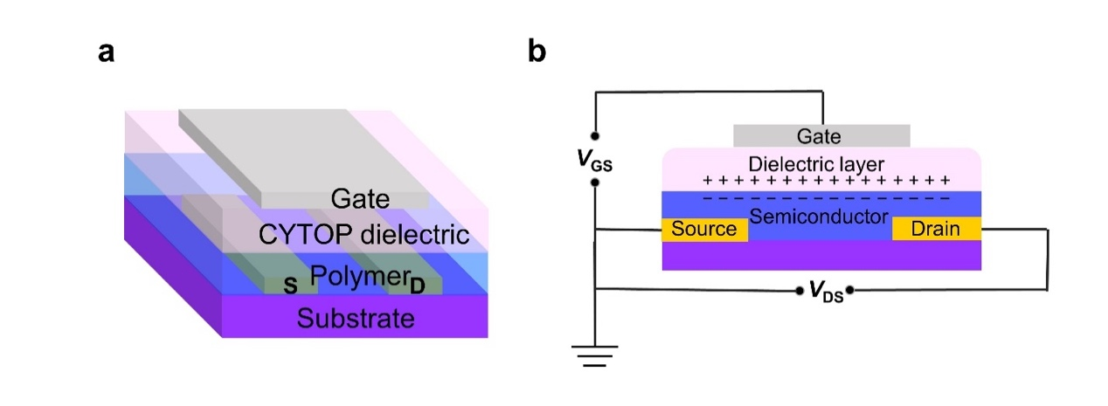
Figure S1. a, Schematic diagram and b, circuit diagram of top-gate/bottom-contact OFET device structure.

Top-gate/bottom-contact FET devices were fabricated to characterize the charge carrier mobility of the polymers. The source and drain electrodes (Ti 2 nm/Au 40 nm) were patterned on SiO₂ substrate by photolithography and lift-off process. The substrates were cleaned by using ultrasonication in acetone, cleaning agent, deionized water (three times), and isopropanol. Thin polymer film was deposited by spin-coating at 1500 rpm for 60 s by using the polymer solution of 3 g/L in 1-chloronaphthalene (CN). The polymer film was first baked at 100 ºC and then annealed at 150 ºC. After depositing the polymer film, a CYTOP solution (CTL809M/CT-solv 180 =3/1) was spin-coated on top of the polymer film at 2000 rpm for 60 s and annealed at 100 ºC, yielding a dielectric layer of 500 nm thick. An aluminum layer of 50 nm was evaporated onto the dielectric layer as the gate electrode. The FET devices were measured on a probe stage under ambient conditions using Keithley 4200 SCS Parameter Analyzer. The carrier mobility μ in the saturated regime, was calculated according to the equation $I_{DS}=(W/2L)C_{i}μ(V_{GS}-V_{T})$, where $I_{DS}$ is the drain current in the saturated regime. $C_{i}$=3.7 nF is the capacitance per unit area of the CYTOP layer, $W$ and $L$ are the channel width and length. The channel length ($L$) of the FET devices was 10 μm and the channel width ($W$) was 200 μm.$V_{GS} and V_{T}$ are the gate voltage and threshold voltage.
Polymer doping and electrical conductivity measurement.
N-doping used in this work is solution blending. p(TDPP-TQ) was dissolved in 1,2-dichlorobenzene (o-DCB) with a concentration of 3 g/L. The p(TDPP-TQ) solution was blended with dopant N-DMBI solution as a function of doping ratio at room temperature. After heating the solution at 100 ºC for 15 min, the heated solution was spin-coated on the glass substrate at 1500 rpm for 60 s and annealed at 120 ºC for 2 h to deposit thin films.
P-doping was performed by immersing p(TDPP-TQ) films in a 10 mM FeCl₃/CH₃NO₂ solution with varied time. The thick p(TDPP-TQ) films were deposited on the glass substrates by spin-coating its 10 g/L trichloroethylene (TCE) solution at 1000 rpm for 60 s and annealed at 150 ºC for 10 min.
All conductvities were collected by four-probe measurements using Keithley 4200 SCS parameter analyzer. The thickness of the films was determined by AFM or by a surface profiler.

2. Supplementary figures and tables
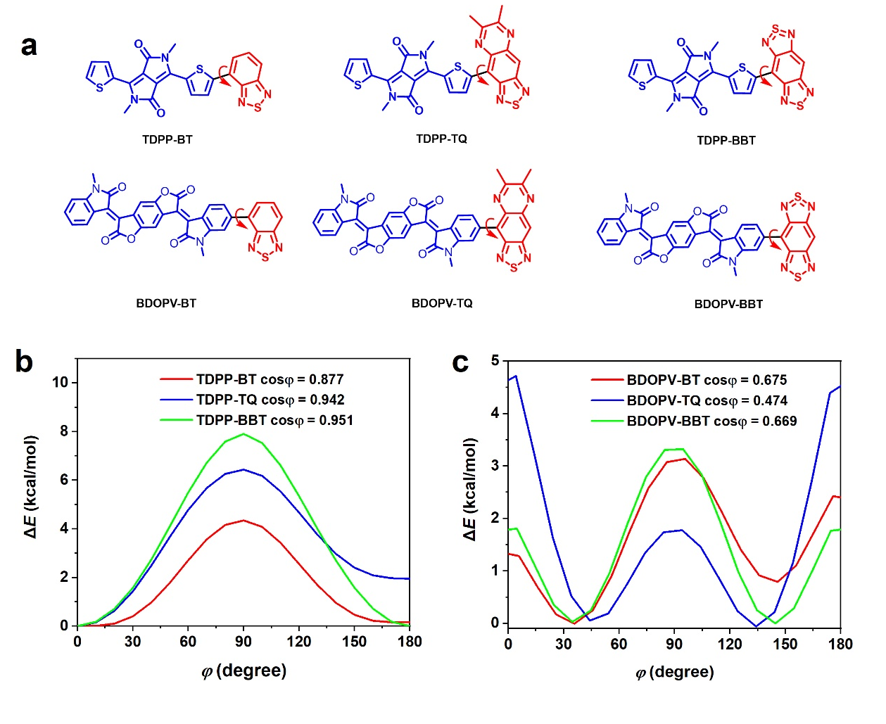
Figure S2. Relaxed potential energy scans (PES) of the torsion angles φ in TDPP-X and BDOPV-X. a, Molecule structure of TDPP-BT, TDPP-TQ, TDPP-BBT, BDOPV-BT, BDOPV-TQ and BDOPV-BBT. The torsion angles φ are the dihedral angles between the “large fused aromatics” and “small-size aromatics” segments. We employed an index ⟨cos²φ⟩ to quantify the planarity of molecules by considering all torsional conformations and their relative contribution to the overall structural disorder.¹ b, All the TDPP-based polymers exhibit dominant conformations with minimal energy at 0° or/and 180°, which could be attributed to the non-covalent interactions between hydrogen in thiphone and nitrogen in “small-size aromatics”. TDPP-BT has the smallest ⟨cos²φ⟩ of 0.877 among these TDPP-copolymers due to its lowest energy barrier at 90°. As for BDOPV family (Fig.S1c) with much lower ⟨cos²φ⟩, i.e., much poorer planarity, the energy minimums are at around 40° and 130°, indicating large steric repulsion between the aromatic building blocks and thus large rotational disorder along the conjugated backbones.

Figure S3. Cyclic voltammograms of a, p(TDPP-BT), b, p(TDPP-TQ) and c, p(TDPP-BBT).
Figure S4. Thermogravimetric analysis (TGA) of a, p(TDPP-BT), b, p(TDPP-TQ) and c, p(TDPP-BBT). The decomposition temperatures (5% weight loss) of three polymers are 400 ℃, 393 ℃, 365 ℃, respectively.
Figure S5. a, Room temperature EPR of p(TDPP-TQ) and measured after 90 days. b, Room temperature EPR of p(TDPP-BBT) and measured after 90 days.
Figure S6. Temperature dependent EPR intensity of a, p(TDPP-TQ) in solid state and b, in o-xylene solution.

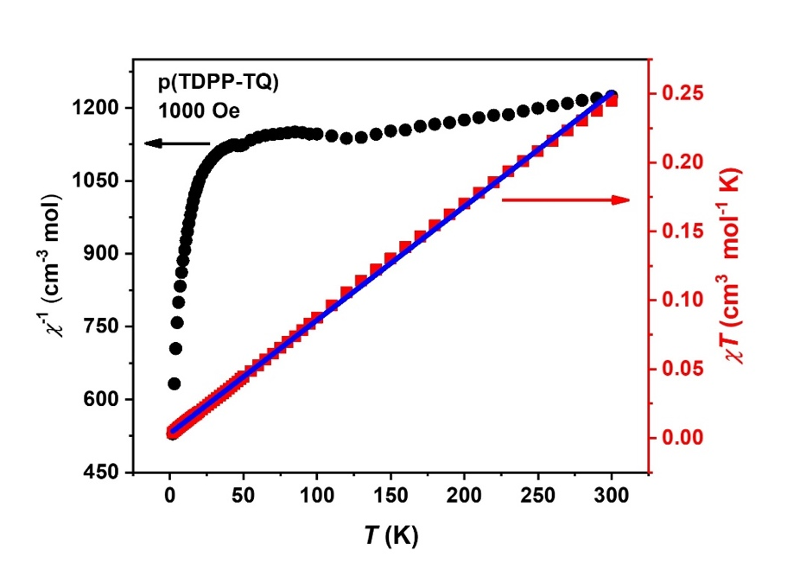
Figure S7. Variable temperature magnetic susceptibility of p(TDPP-TQ) from 2 K to 300 K. Solid squares are the experimental data, solid line is the fitting line from 50 K to 300 K .
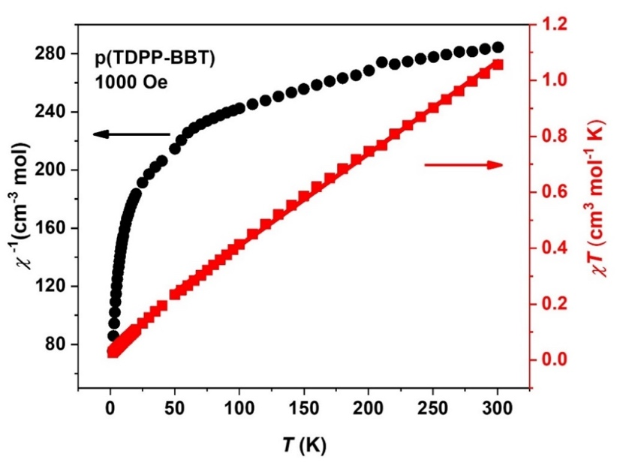
Figure S8. Variable temperature magnetic susceptibility of p(TDPP-BBT) from 2 K to 300 K. Solid squares are the experimental data, solid line is the fitting line from 50 K to 300 K.
Figure S9. UV-vis-NIR absorption spectra of p(TDPP-TQ) at a concentration of 1×10⁻⁵ M. a, in different solvent of toluene (Tol.), o-dichlorobenzene (o-DCB), 1-chloronaphthalene (CN), b, in toluene at different temperature, c, in o-dichlorobenzene at different temperature, d, in 1-CN at different temperature. e, p(TDPP-TQ) shows similar absorption behavior but different λ_{max} which indicate different aggregation properties among the solvents. The temperature dependent absorption between different solvents show the tendency of the disaggregation as increasing the temperature. In 1-CN, p(TDPP-TQ) showed much clear disaggregation phenomenon compared to its toluene and o-dichlorobenzene.
Figure S10. UV-vis-NIR absorption spectra of p(TDPP-BBT) at a concentration of 1×10⁻⁵ mol/L. a, in different solvent of chlorobenzene (CB), o-dichlorobenzene (o-DCB), 1-chloronaphthalene (CN), b, in chlorobenzene at different temperature, c, in o-dichlorobenzene at different temperature, d, in 1-chloronaphthalene at different temperature. e, p(TDPP-BBT) shows similar absorption behavior and no clear λ_{max} difference among different solvent. The temperature dependent absorption between different solvents show the similar tendency of aggregation.

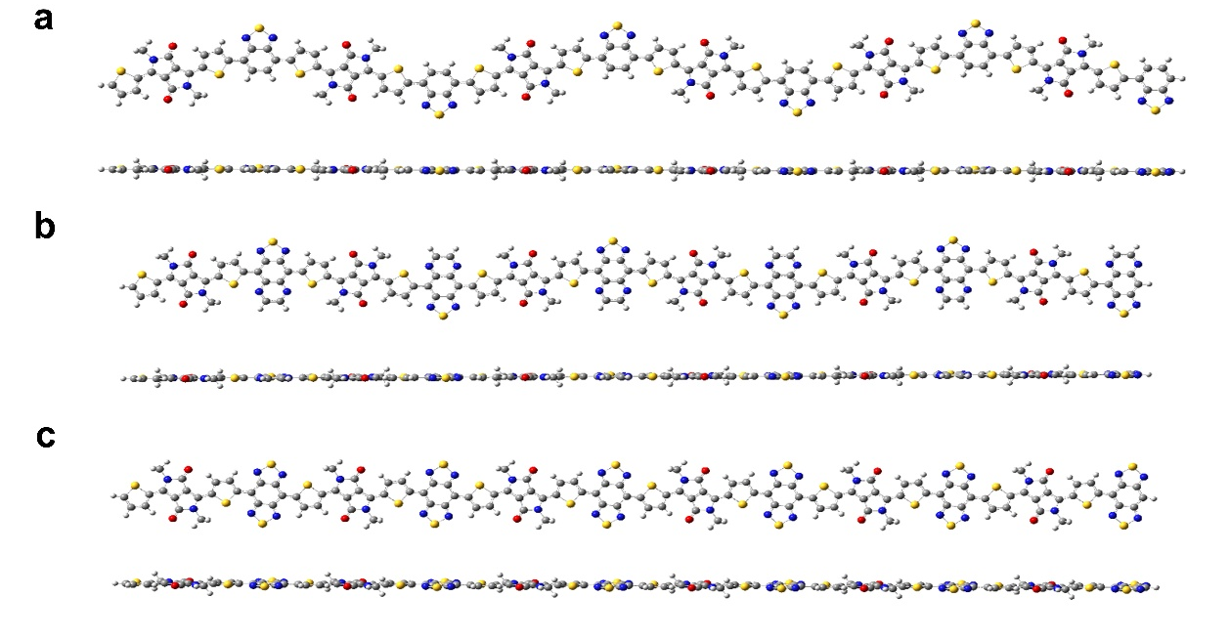
Figure S11. Top view and side view of DFT-optimized closed-shell geometries of a, (TDPP-BT)₆, b, (TDPP-TQ)₆, c, (TDPP-TQ)₆. All three polymers show very good planarity.
Figure S12. Top view and side view of the DFT-optimized close-shell geometries，molecular frontier orbitals and spin density distribution of (TDPP-BBT)₆. (TDPP-BBT)₆ also exhibits similar good planarity. a, α-SOMO and b, β-SOMO c, spin density distribution of the open-shell singlet. The localization of the α and β singly occupied MOs (SOMOs) of the singlet is on the opposite sides of the oligomer.
Figure S13. Spin density distribution of the triplet states of the (TDPP-BT)_{n} (n = 1-6) oligomers. The spin tends to distribute in the middle of the oligomers.
Figure S14. Spin density distribution of the triplet states of the (TDPP-TQ)_{n} oligomers (n = 1-6). As the number n increase, the spin tends to distribute along the whole backbone. The spin density distribution in (TDPP-TQ)_{n} (n = 1-6) clearly indicates the high degree of delocalization of the spin.
Figure S15. Spin density distribution of the triplet states of the (TDPP-BBT)_{n} oligomers (n = 1-6). As the number n increase, the spin tends to distribute on the both ends of the oligomers.

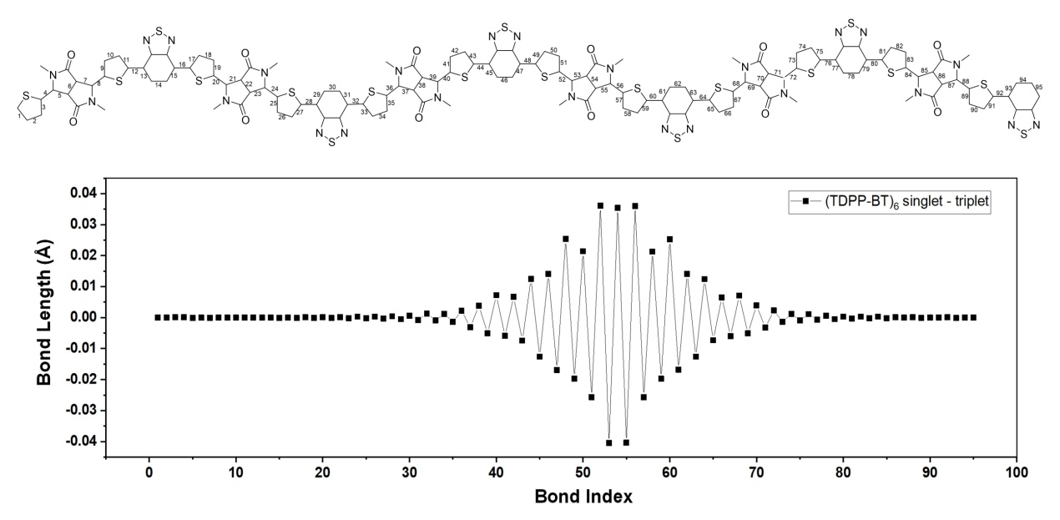
Figure S16. Bond length alternation (BLA) analysis of (TDPP-BT)₆. The chart in the bottom is the bond length difference between open-shell singlet and triplet. The result shows that only in the middle of the oligomer, the bond lengths of open-shell singlet state and triplet state are different, which is consistent with the spin density distribution trend of the triplet state.
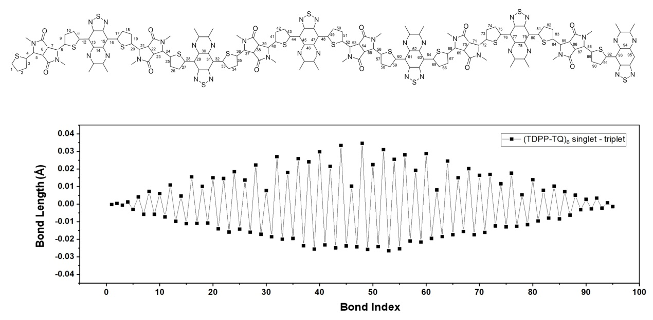
Figure S17. BLA analysis of (TDPP-TQ)₆. The chart in the bottom is the bond length difference between open shell singlet and triplet. In the entire oligomer molecule, the bond lengths of open-shell singlet state and triplet state are different, which is consistent with the spin density distribution trend of the triplet that the spin delocalized in the entire molecule.

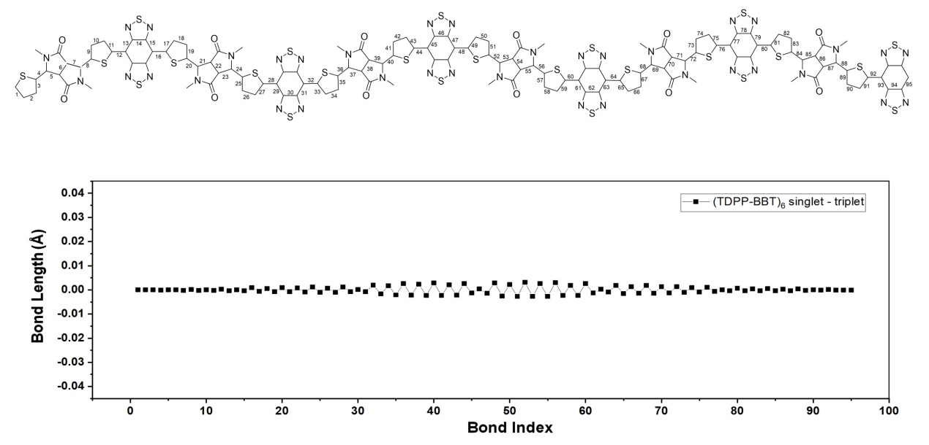
Figure S18. BLA analysis of (TDPP-BBT)₆. The chart in the bottom is the bond length difference between open shell singlet and triplet. The bond length difference between the open-shell state and the singlet state is very small, indicating that the structure difference between the singlet state and the triplet state is very small. This corresponds to the small difference in energy levels between the singlet state and the triplet state.
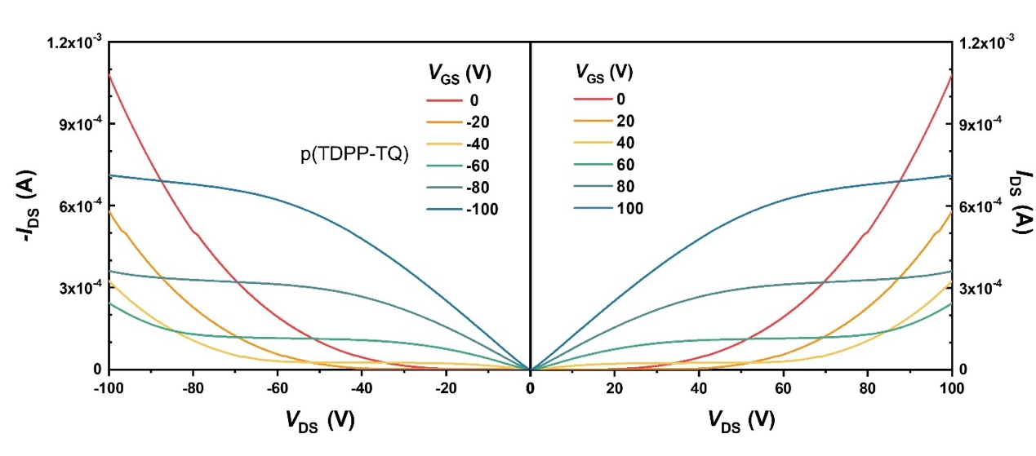
Figure S19. Typical output characteristics of p(TDPP-TQ) OFET devices were fabricated in glovebox and tested in ambient conditions (L = 10 μm, W = 200 μm). 500 nm thick CYTOP was used as the dielectric layer (C_{i} = 3.7 nF cm⁻²).
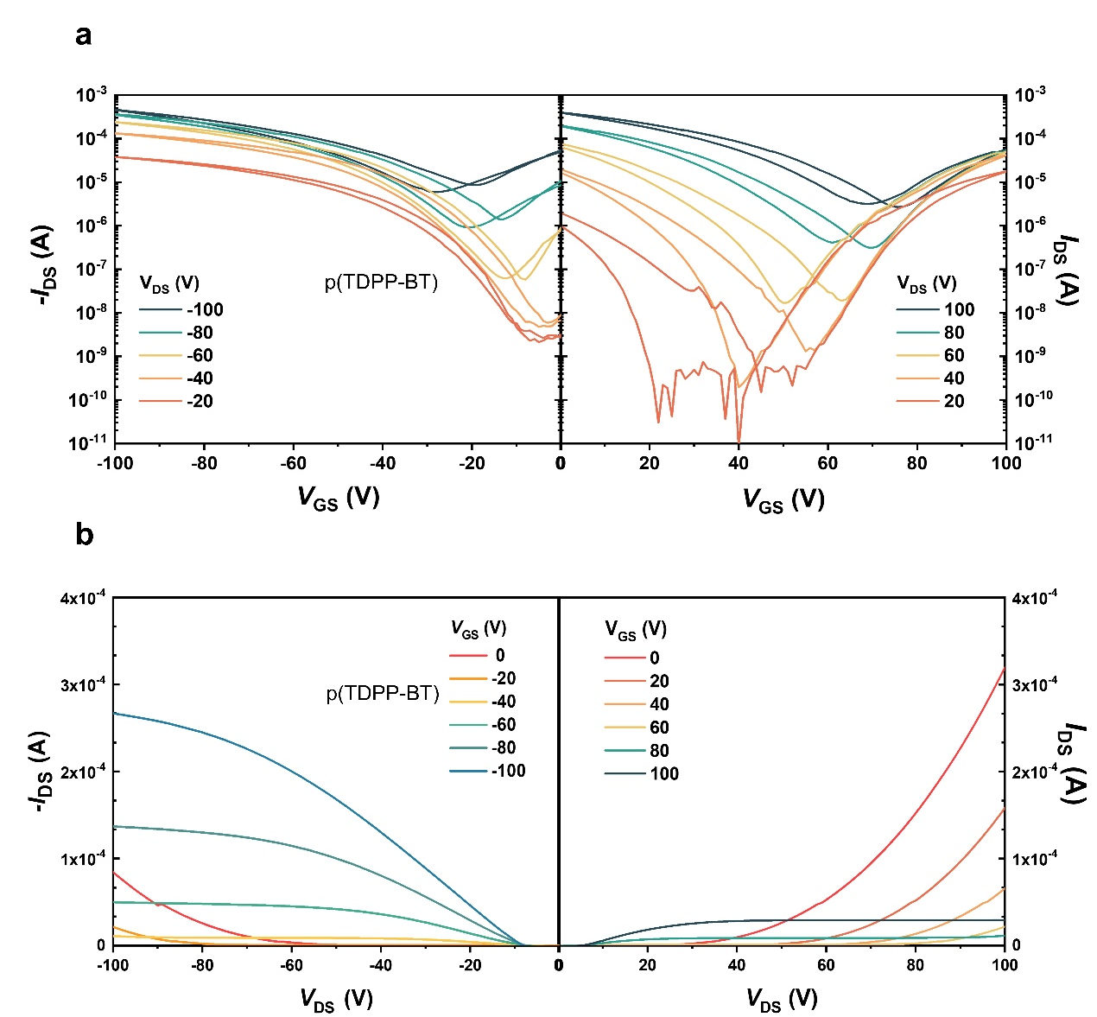
Figure S20. a, Typical transfer and b, output characteristics of a typical p(TDPP-BT) OFET devices fabricated in glovebox and tested in ambient conditions (L = 10 μm, W = 200 μm). 500 nm thick CYTOP was used as the dielectric layer (C_{i} = 3.7 nF cm⁻²).
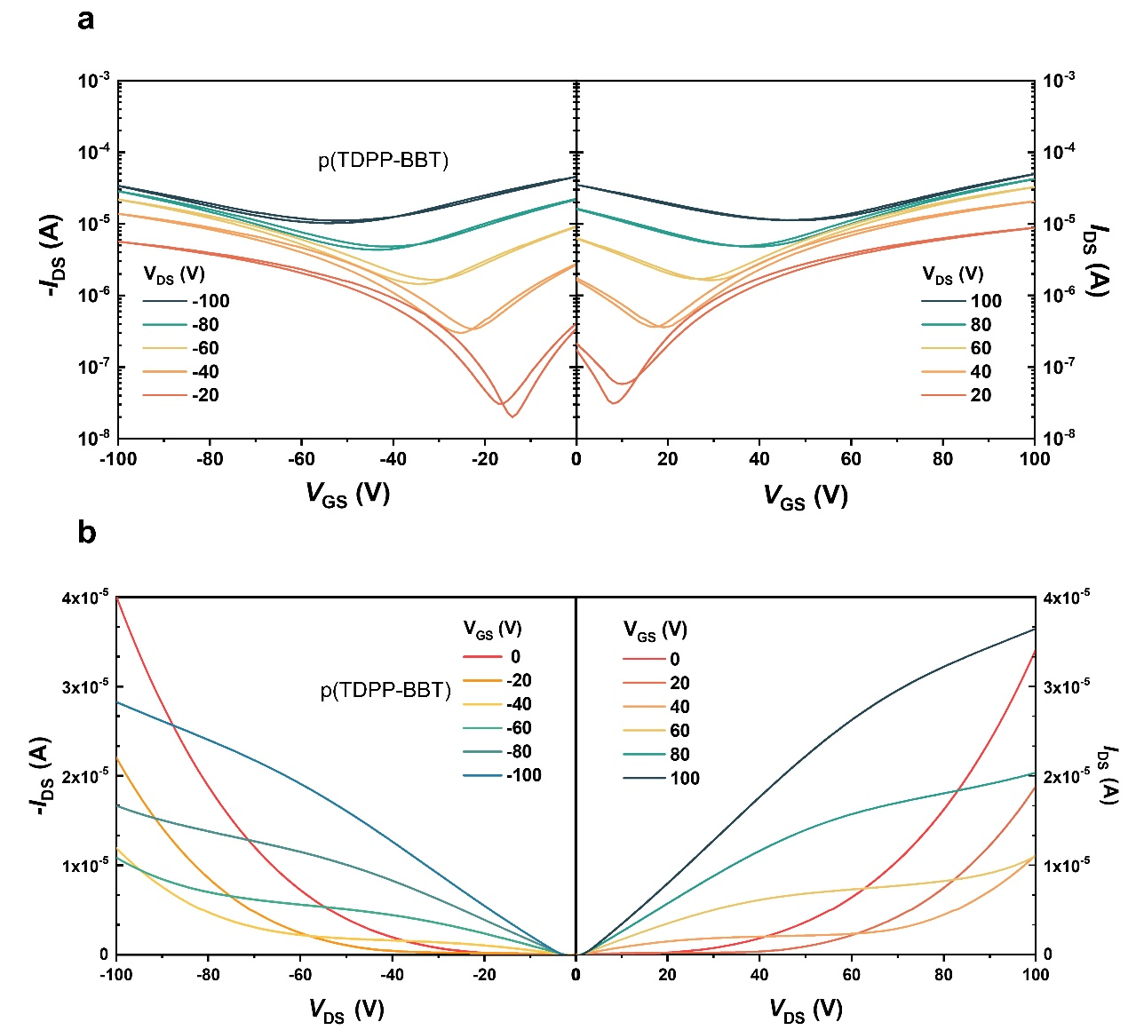
Figure S21. a, Typical transfer and b, output characteristics of p(TDPP-BBT) OFET devices fabricated in glovebox and tested in ambient conditions (L = 10 μm, W = 200 μm). 500 nm thick CYTOP was used as the dielectric layer (C_{i} = 3.7 nF cm⁻²).

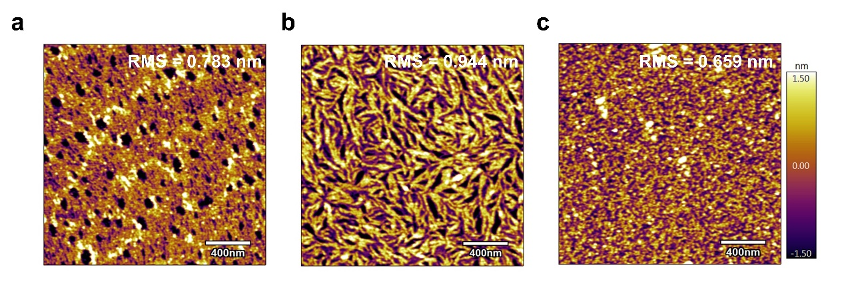
Figure S22. AFM height images of the polymer films. a, p(TDPP-BT) (RMS = 0.783 nm), b, p(TDPP-TQ) (RMS = 0.944 nm) and c, p(TDPP-BBT) (RMS = 0.659 nm).
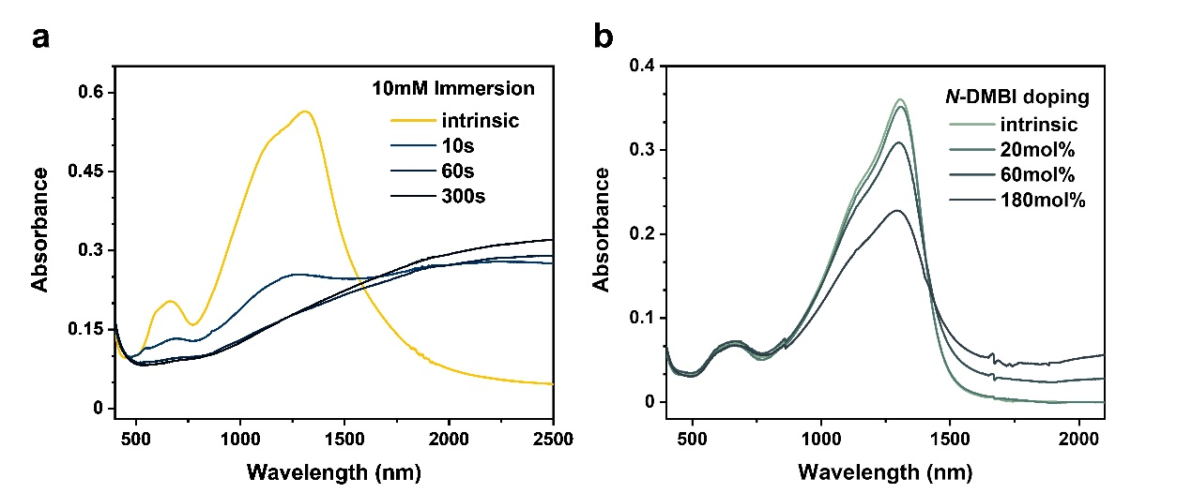
Figure S23. UV-vis-NIR absorption spectra of doped p(TDPP-TQ) films; a, p-doped by immersing in 10 mM FeCl₃ solution, and b, n-doped by blending with various amount of N-DMBI.
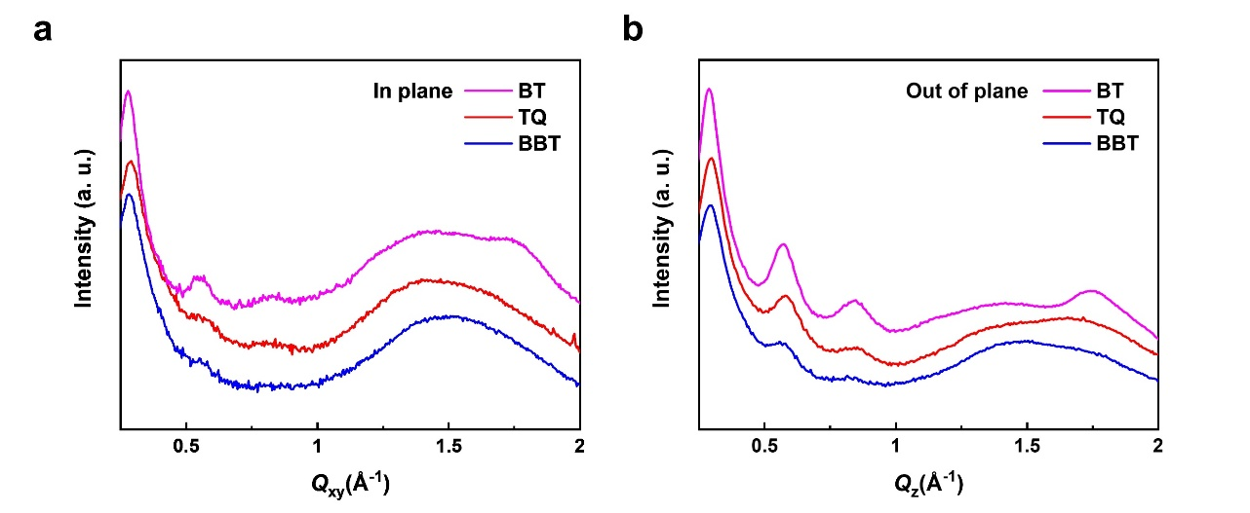
Figure S24. a, In-plane and b, out-of-plane GIWAXS plots of the three polymers

Table S1. Inductively coupled plasma (ICP) emission spectroscopy of the polymers for trace metal analysis. No Fe was detected, and less than 0.1 wt% Pd and Sn were detected.
 | ICP results (ug/mL) |  |  | Metal concentration
Polymer | Fe | Pd | Sn | Fe | Pd | Sn
p(TDPP-BT)  (9.6 mg) | no | 0.27 | 0.32 | no | 0.003 mg, 0.03 wt% | 0.003 mg, 0.03 wt%
p(TDPP-TQ)  (10.0 mg) | no | 0.11 | 0.45 | no | 0.001 mg, 0.01 wt% | 0.005 mg, 0.05 wt%
p(TDPP-BBT)  (10.1 mg) | no | 0.30 | 0.68 | no | 0.003 mg, 0.03 wt% | 0.007 mg, 0.07 wt%

Table S2. Calculated y₀ for (TDPP-BT)_{n} oligomers.
n | n_{HOMO} | n_{LUMO} | y₀
1 | 2 | 0 | 0
2 | 1.92372 | 0.07628 | 0.0031
3 | 1.88275 | 0.11725 | 0.0077
4 | 1.86382 | 0.13618 | 0.0106
5 | 1.85887 | 0.14113 | 0.0115
6 | 1.85615 | 0.14385 | 0.0119

Table S3. Calculated y₀ for (TDPP-TQ)_{n} oligomers.
n | n_{HOMO} | n_{LUMO} | y₀
1 | 1.87516 | 0.12484 | 0.0088
2 | 1.54913 | 0.45087 | 0.1562
3 | 1.47077 | 0.52923 | 0.2293
4 | 1.41697 | 0.58303 | 0.2896
5 | 1.38658 | 0.61342 | 0.3274
6 | 1.36925 | 0.63075 | 0.3501

Table S4. Calculated y₀ for (TDPP-BBT)_{n} oligomers.
n | n_{HOMO} | n_{LUMO} | y₀
1 | 1.62616 | 0.37384 | 0.1004
2 | 1.33741 | 0.66259 | 0.3942
3 | 1.20080 | 0.79920 | 0.6140
4 | 1.10246 | 0.89754 | 0.7972
5 | 1.00624 | 0.99376 | 0.9875
6 | 1.00181 | 0.99819 | 0.9964

Table S5. Charge transport properties of some reported high-spin organic semiconductors.
 | Chemical structure | Ground state | Hole mobility  (cm² V⁻¹ s⁻¹) | Electron mobility  (cm² V⁻¹ s⁻¹) | References
1 |  | singlet | 2×10⁻³ | 4×10⁻³ | 2
2 |  | singlet | / | 0.004 | 3
3 |  | / | FDT: 1.7×10⁻⁵, FDT-Br: 2.4×10⁻⁵ | / | 4
4 |  | / | 2.6×10⁻³ | 3.2×10⁻³ | 5
5 |  | / | 7.2×10⁻¹  (single crystal) | / | 6

Table S6. The q-spacing values and the FWHM of (100) and (010) from the GIWAXS
 | (100) | FWHM of (100) | (200) | (300) | (010) | FWHM of (010)
Polymer | [Å⁻¹] | [Å⁻¹] | [Å⁻¹] | [Å⁻¹] | [Å⁻¹] | [Å⁻¹]
p(TDPP-BT) | 0.29 | 0.05 | 0.57 | 0.83 | 1.76 | 0.21
p(TDPP-TQ) | 0.30 | 0.06 | 0.58 | — | 1.70 | 0.40
p(TDPP-BBT) | 0.29 | 0.06 | — | — | — | —

3. Material synthesis and characterization.
Materials and General Methods. All reactions and manipulations were carried out under nitrogen atmosphere or in nitrogen filled glovebox. 3,6-di(thiophen-2-yl)-2,5-dihydropyrrolo[3,4-c]pyrrole-1,4-dione was synthesized according to the literature.⁷ ¹H NMR spectra were recorded on Bruker ARX-400 (400 MHz). All chemical shifts were reported in parts per million (ppm). ¹H NMR chemical shifts were referenced to CDCl₃ (7.26 ppm).
Monomer synthesis and purification:
Synthetic route of three polymers. Reactions conditions: (i) －78 ℃, LDA, b, Me₃SnCl; (ii) microwave, (ii) Pd(PPh₃)₄, o-xylenes, 120 ℃ for 5 mins, 140 ℃ for 5 mins, 170 ℃ for 30 mins.
TDPP-C₈C₁₀: Under nitrogen atomosphere, 3,6-di(thiophen-2-yl)-2,5-
dihydropyrrolo[3,4-c]pyrrole-1,4-dione (TDPP) (3.0 g, 10.0 mmol), potassium carbonate (5.5 g, 40.0 mmol), and dry DMF were added to a 250 mL round-bottom flask,. The mixture was heated to 120 ℃ for 30 mins. After the mixture was cooled to room temperature, 9-(2-bromoethyl)nonadecane (18.8 g, 50.0 mmol) were added in one portion. The reaction was then stirred at 80 ℃ for 18 h. After the mixture was cooled to room temperature, it was poured to cool water, then extracted with CH₂Cl₂. Then the extract was washed thoroughly with saturated saltwater and dried with Na₂SO₄. The crude product was purified by column chromatography on silica using CH₂Cl₂/petroleum ether as eluent to get TDPP-C₈C₁₀ as dark puper solid (4.5 g, 52%). ¹H NMR (400 MHz, CDCl₃) δ 8.87, 8.86, 7.62, 7.61, 7.27, 7.26, 7.25, 4.01, 1.90, 1.57, 1.21, 0.87, 0.85.

TDPP-C₈C₁₀-SnMe₃: Under nitrogen atomosphere, 2.4 M n-BuLi (1.5 mL, 3.48 mmol) was addded dropwise to 15 mL THF solution of diisopropylamine (352.2 mg, 3.48 mmol) at −78 ℃. The reaction was slowly warmed to room temperature and reacted for 30 mins. Then the mixture was added to 70 mL THF solution of TDPP-C₈C₁₀ (1.16 mmol, 1.0g) at −78 ℃, the reaction was stirred at −78 ℃ for 2 h. Then Me₃SnCl (4.06 mmol, 857.8 mg) was added dropwise at −78 ℃ and keep for 30 mins. The reaction was slowly warmed to room temperature and reacted for 3 h. After the reaction was finished, the solution was poured to cool water and extracted with CH₂Cl₂. The extract was washed thoroughly with saturated saltwater and dried with Na₂SO₄. The crude product was purified by recrystal from ethanol/CH₂Cl₂ to get TDPP-C₈C₁₀-SnMe₃ as dark red solid (826.2 mg, 60%). ¹H NMR (400 MHz, CDCl₃) δ 8.99, 8.98, 7.32, 7.31, 4.05, 4.03, 1.91, 1.21, 0.88, 0.87, 0.85, 0.83, 0.43.

Polymerization and polymer purification:
TDPP-C₈C₁₀-SnMe₃ (0.05 mmol), dibromo BT or TQ or BBT (0.05 mmol), Pd(PPh₃)₄ (8 mol%, 4 μmol) and 0.2 mL xylene were put into a 0.5 mL microwave reaction tube. The reaction was drove by microwave with the following procedure: 120 ℃ for 5 mins, 140 ℃ for 5 mins, 170 ℃ for 30 mins. A deep blue solution was formed after the reaction. After the reaction was finished, N,N’-diethylphenylazothioformamide (0.01 mmol) was added and stirred at 90 ℃ for 30 minutes to remove palladium or other residue metals. The mixture was poured to 100 mL methanol to precipitate the polymers and then filtered The solid product was put into a soxhlet extraction and extracted by methanol (4 h), acetone (4 h), hexane (10 h), tetrahydrofuran (5 h), dichloromethane (5 h), chloroform (12 h) and finally collected by chlorobenzene (24 h).
p(TDPP-BT): 45.7 mg, yield 92 %. GPC analysis M_{n} = 42.0 kg/mol, PDI = 4.90 (against PS standard). ¹H NMR (500 MHz, 1,1,2,2-tetrachloroethane-d₂, 363 K, ppm): δ 9.22, 8.07, 4.14, 2.5-0.5. Elemental Anal. Calcd for (C₆₀H₈₈N₄O₂S₃)_{n}: C, 72.53; H, 8.93; N, 5.64, Found: C, 71.80; H, 8.98; N, 5.12.
p(TDPP-TQ): 47.6 mg, yield 90 %. GPC analysis M_{n} = 16.1 kg/mol, PDI = 3.72 (against PS standard). ¹H NMR (500 MHz, 1,1,2,2-tetrachloroethane-d₂, 363 K, ppm): δ 9.76, 9.48, 9.18, 3.16, 2.5-0.5. Elemental Anal. Calcd for (C₆₄H₉₂N₆O₂S₃)_{n}: C, 71.60; H, 8.64; N, 7.83, Found: C, 69.70; H, 8.41; N, 7.36.
p(TDPP-BBT): 43.3 mg, yield 82 %. GPC analysis M_{n} = 21.0 kg/mol, PDI = 3.1 (against PS standard). ¹H NMR (500 MHz, 1,1,2,2-tetrachloroethane-d₂, 363 K, ppm): δ 9.39, 7.71, 7.48, 2.0-0.5. Elemental Anal. Calcd for (C₆₀H₈₆N₆O₂S₄)_{n}: C, 68.53; H, 8.24; N, 7.99, Found: C, 67.83; H, 8.19; N, 7.47.

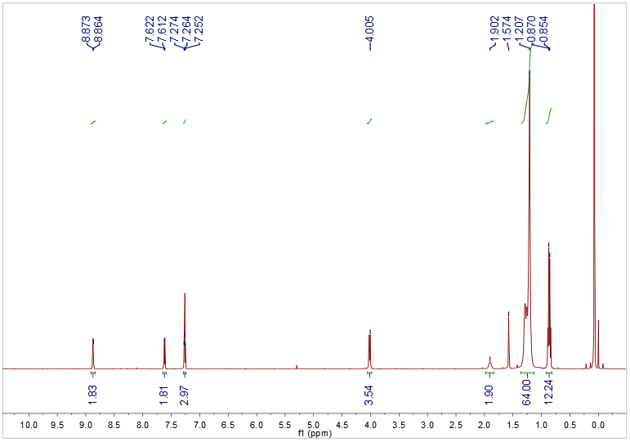
Figure S25. ¹H NMR spectrum (500 MHz) of TDPP-C₈C₁₀ in CDCl₃ at 298 K.

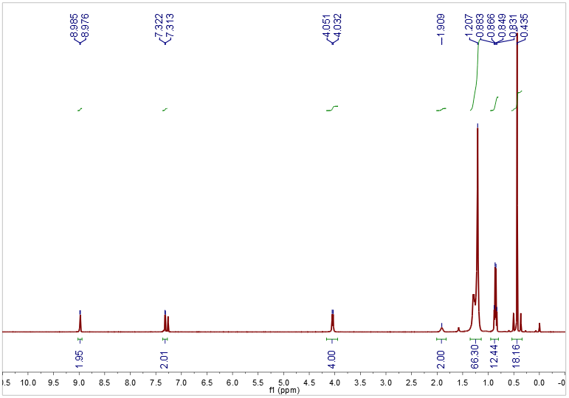
Figure S26. ¹H NMR spectrum (500 MHz) of TDPP-C₈C₁₀-SnMe₃ in CDCl₃ at 298 K
4. References:

1. Che Y, Perepichka DF. Quantifying Planarity in the Design of Organic Electronic Materials. Angew. Chem., Int. Ed. 60, 1364-1373 (2021).
2. Rudebusch GE, Zafra JL, Jorner K, Fukuda K, Marshall JL, Arrechea-Marcos I, et al. Diindeno-fusion of an anthracene as a design strategy for stable organic biradicals. Nat. Chem., 8, 753-759 (2016).
3. Wang W, Ge L, Xue G, Miao F, Chen P, Chen H, et al. Fine-tuning the diradical character of molecular systems via the heteroatom effect. Chem. Commun., 56, 1405-1408 (2020).
4. Zhang Y, Zheng Y, Zhou H, Miao M-S, Wudl F, Thuc-Quyen N. Temperature tunable self-doping in stable diradicaloid thin-film devices. Adv. Mater., 27, 7412-7419 (2015).
5. Kubo T, Shimizu A, Sakamoto M, Uruichi M, Yakushi K, Nakano M, et al. Synthesis, intermolecular interaction, and semiconductive behavior of a delocalized singlet biradical hydrocarbon. Angew. Chem., Int. Ed. 44, 6564-6568 (2005).
6. Koike H, Chikamatsu M, Azumi R, Tsutsumi Jy, Ogawa K, Yamane W, et al. Stable delocalized singlet biradical hydrocarbon for organic field-effect transistors. Adv. Funct. Mater., 26, 277-283 (2016).
7. Huo L, Hou J, Chen H-Y, Zhang S, Jiang Y, Chen TL, et al. Bandgap and Molecular Level Control of the Low-Bandgap Polymers Based on 3,6-Dithiophen-2-yl-2,5-dihydropyrrolo 3,4-c pyrrole-1,4-dione toward Highly Efficient Polymer Solar Cells. Macromolecules, 42, 6564-6571 (2009).

