Supplementary Information for

Multifunctional flipping-based mechanical metasurface enabling optical-microwave dual-modal reconfigurability

Si Qi Huang^{1, 2} , Zi Xuan Cai^{1, 2} , Xin Yu Li^{1, 2*} , Long Chen^{1, 2} , Jie Xu¹ , Jing Yi Liang¹, Jiang Han Bao¹, Che Liu¹, and Jian Wei You^{1*}

¹ State Key Laboratory of Millimeter Waves and Institute of Electromagnetic Space, Southeast University, Nanjing 210096, China
*E-mail: xinyuli@seu.edu.cn, jvyou@seu.edu.cn
² These authors contributed equally to this work

This Supplementary Information includes:
Supplementary Notes S1 to S10
Supplementary Figures S1 to S8
Supplementary Equations S1 to S9
Supplementary Table S1

Supplementary Note 1: Details of the Flip element
Each flip element comprises a nine-layer laminated assembly integrating two distinct meta-atoms and a centrally embedded permanent magnet (Supplementary Fig. 1a). The two opposing meta-atoms laminated on each face are designated “Code-1” (white solder-resist ink) and “Code-0” (black), with the corresponding prototype shown to the right of the element. Mechanical flipping switches both the microwave scattering state and the visible appearance (Supplementary Fig. 1b). The contrasting meta-atom geometries produce a 180° reflection-phase difference while maintaining high reflection amplitudes across the target frequency band centered at approximately $5.4 GHz$.
To characterize the S-parameter characteristics of the meta-atoms, we fabricated a mini MetaScreen prototype containing only $15×14$ meta-atoms and measured the reflection response. The measured reflection amplitudes and phases for both states (Supplementary Fig. 1c), confirming the ${180}^{∘}$ phase contrast with high amplitude over the operational band. Supplementary Fig.1d shows the measurement setup used for S-parameter testing.
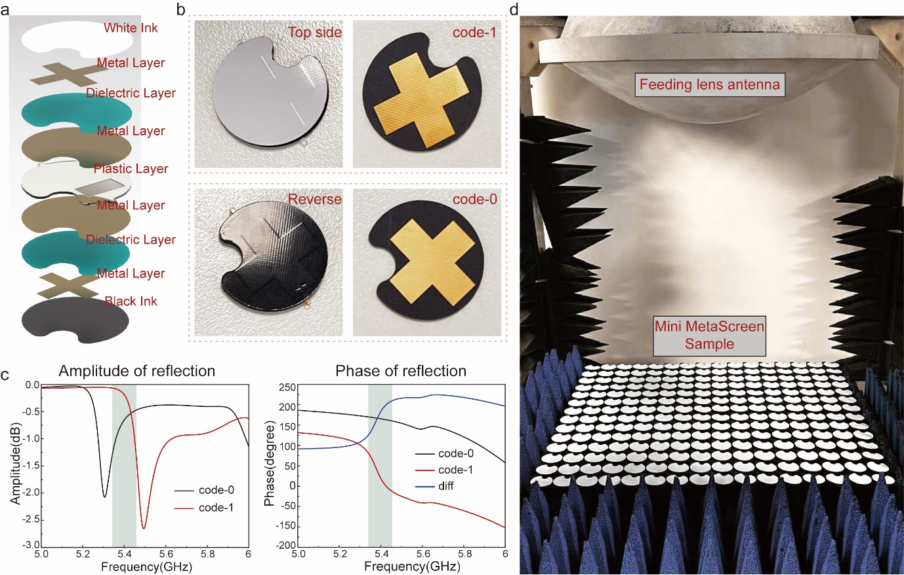
Supplementary Fig. 1 Structure, coding states, and EM response of the flip element. a Exploded schematic of a flip element showing the nine-layer laminated assembly. b Photographs of the fabricated flip element, with the two distinct meta-atoms laminated on each face. The corresponding prototype of the meta-atoms are displayed to the right. c Measured reflection amplitude (left) and phase (right) for the two coding states. d Measurement setup of a mini MetaScreen prototype comprising $15 × 14$ elements for S-parameter characterization of the two coding states.

Supplementary Note 2: Effect of solder-resist ink on meta-atom electromagnetic response.
MetaScreen leverages the flipping mechanism to apply color-specific solder-resist inks onto opposite meta-atoms for optical display. The ink, with a dielectric constant of $3.2$ and a thickness of$0.02 mm$, was evaluated using CST Microwave Studio 2023 to simulate the reflection coefficient ($S_{11}$) with and without the coating. The results reveal that the ink layer induces a frequency downshift of approximately $40 MHz$ relative to the uncoated meta-atom (Supplementary Fig. 2e and 2f). Aside from this minor spectral shift, the reflection amplitude and phase remain essentially unchanged across the operating band, indicating negligible impact on the electromagnetic characteristics of the meta-atom. Simulated flip elements are presented in Supplementary Fig. 2.
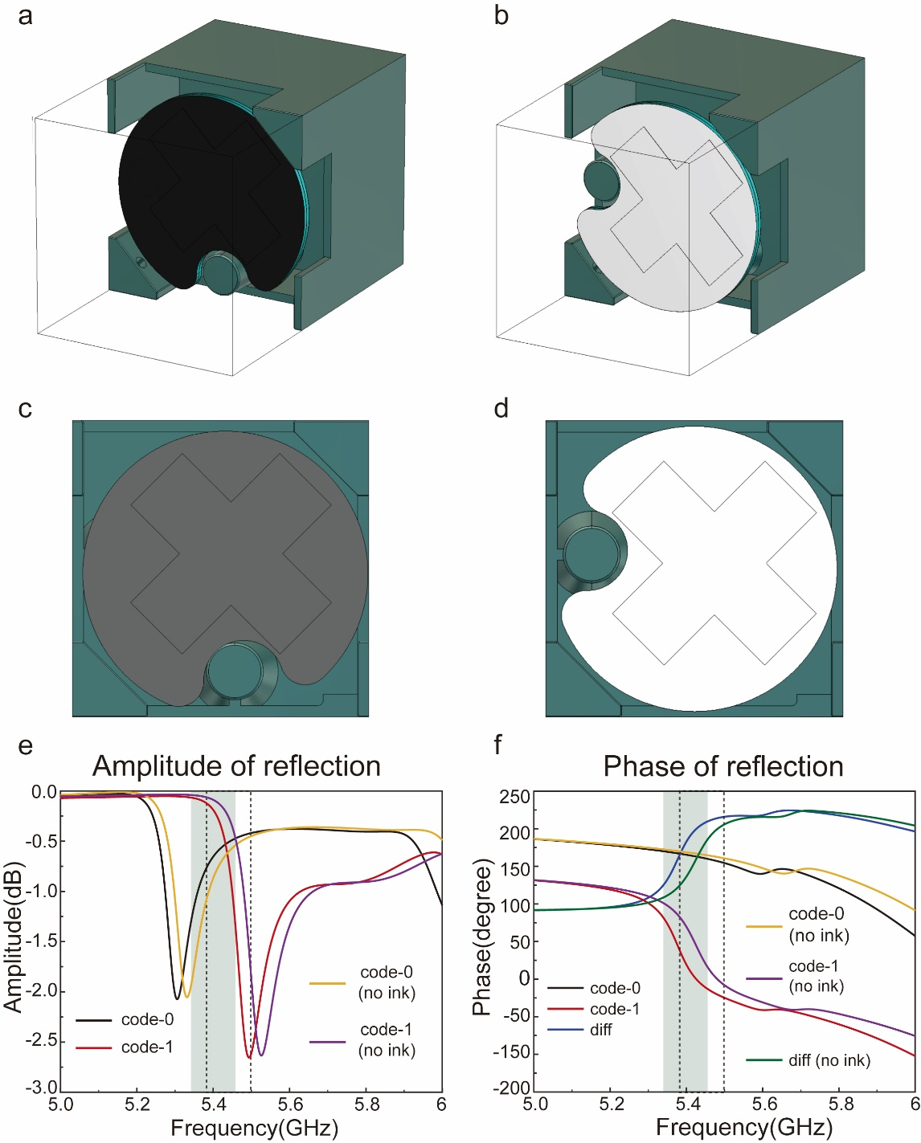
Supplementary Fig. 2 a-d Simulated models of the flip element with solder-resist coatings applied to opposite faces for optical display (perspective and front view of the model) e-f Simulated reflection amplitude and phase of the flip element with and without solder-resist ink, showing that the presence of the ink induces a frequency downshift of approximately 40 MHz relative to the uncoated meta-atom.

Supplementary Note 3: Details of the magnetic-control module
Mechanical actuation of each flip element is controlled by a compact MCU-driven magnetic module that couples transient magnetic fields to a permanent magnet embedded at central of the element. The core of the module consists of two EM coils wound around a U-shaped magnetizable DT4 core (Supplementary Fig. 2a). Short current pulses from the controller energize these coils and produce a transient magnetic field that couples to the embedded magnet, generating the torque required to drive a repeatable, bistable flip.
Electrical connections are established through plated vias linking two header pins on the module to six surface pads. When the header pins are driven with complementary logic levels, the resulting pad voltage distribution follows the pattern (Supplementary Fig. 2b). In the implemented control scheme, dedicated SET and RESET inputs regulate the logic states of the header pins. A current pulse applied to the SET input generates a magnetic impulse that flips the element to the white (code-1) orientation (Supplementary Fig. 2c), whereas a pulse to the RESET input returns it to the black (code-0) orientation (Supplementary Fig. 2d). Notably, the flip motion is mechanically latched: after the transient actuation, the element remains in the selected state without continuous power, providing intrinsic non-volatility and high energy efficiency. The performance information of the magnetic-control module is shown in Supplementary Table. 1.

Item | Specification
Element Size  Voltage | Diameter 25 mm  DC 24 V
Power | 800 W/m²
Control Protocol | CAN 2.0B / RS485
Rotation Speed  Service Life  Operating Environment | 20 Hz, single flip time < 25 ms  > 60 million flips  Temperature: -30°C to +70°C  Humidity: ≤ 90% RH
Supplementary Table. 1 Performance of the magnetic-control module.
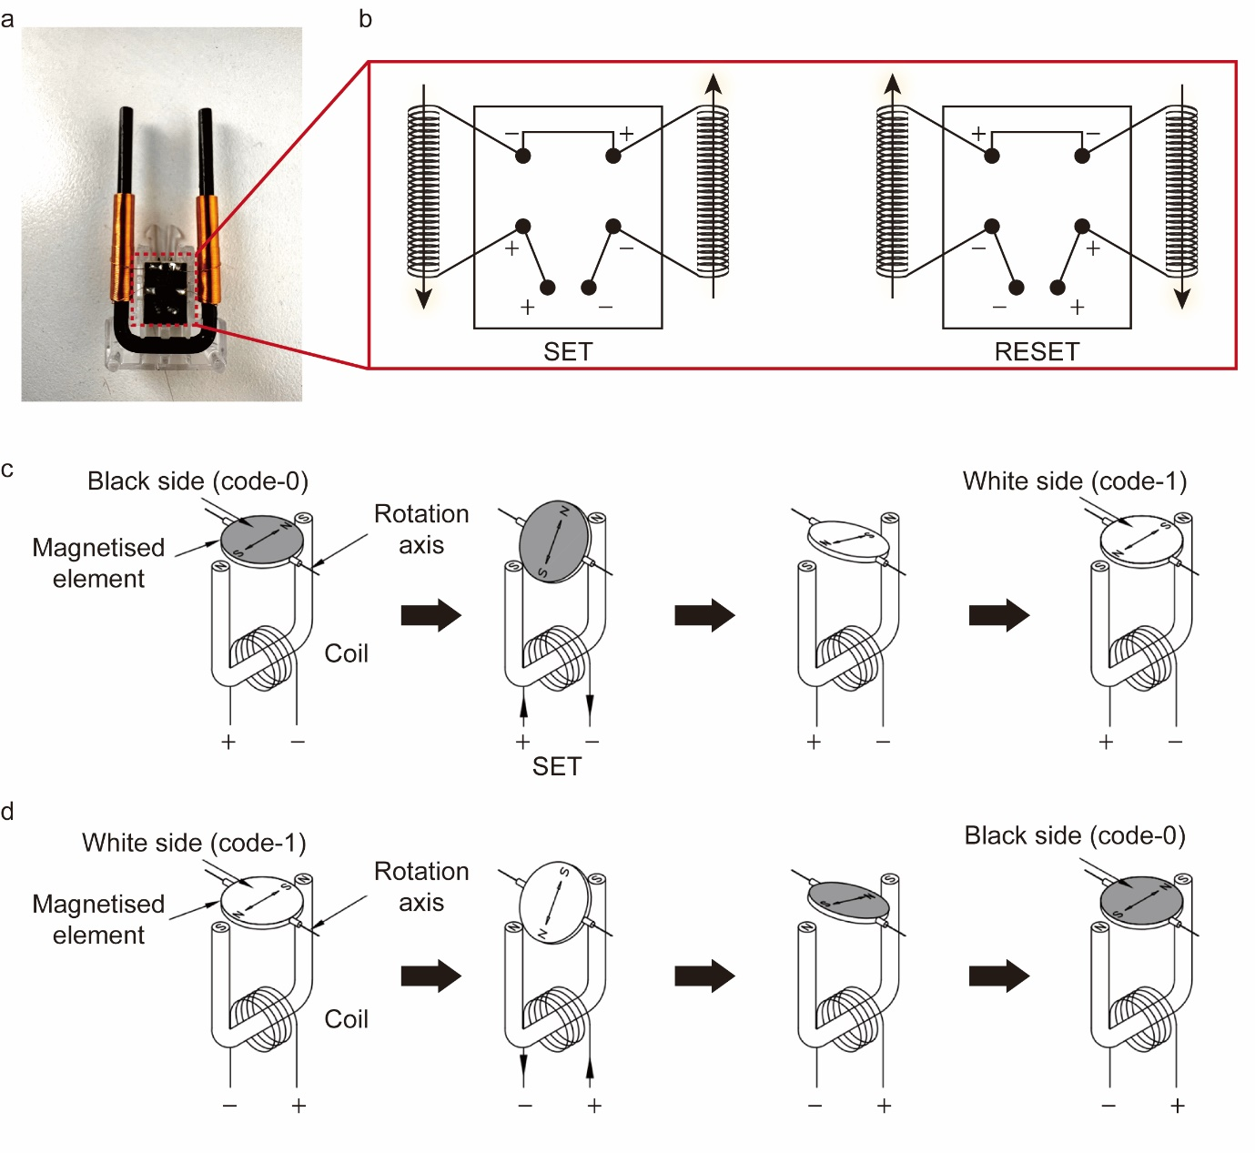
Supplementary Fig. 3 a Photograph of a compact magnetic-control module comprising two copper coils wound around a U-shaped magnetizable core. b Schematic of the electrical configuration, in which complementary logic levels applied to the header pins generate voltage distributions across six surface pads. c-d Operation sequence of a SET and RESET input².

Supplementary Note 4: Far-field analysis with the array synthesis theory
Once the corresponding binary coding pattern is obtained, the beam forming performance of the MetaScreen can be rapidly evaluated using the array synthesis theory. Following our previous work¹, the far-field array pattern can be expressed as:
$$\begin{aligned}f\left(θ,φ\right)=f_{e}\left(θ,φ\right)\sum_{m=1}^{M}{\sum_{n=1}^{N}{\exp\left\{-i\left\{φ\left(m, n\right)+\left(\hat{k}+{\hat{k}}_{in}\right)⋅\hat{r}\right\}\right\}} }\#\left(S1\right)\end{aligned}$$
where $θ$ and $ϕ$ are the elevation and azimuth angles for an arbitrary direction, respectively, and $f_{e}(θ, φ)$ is the far-field pattern function of the lattice. $\hat{k}$ and ${\hat{k}}_{in}$ represent the wave vectors of the scattered and incident waves, respectively. Using this expression, the far-field radiation pattern corresponding to any coding matrix can be calculated rapidly. As an example, under a ${45}^{∘}$ incidence, the coding matrices and corresponding far-field results for several beamforming cases are presented as Supplementary Fig. 4.
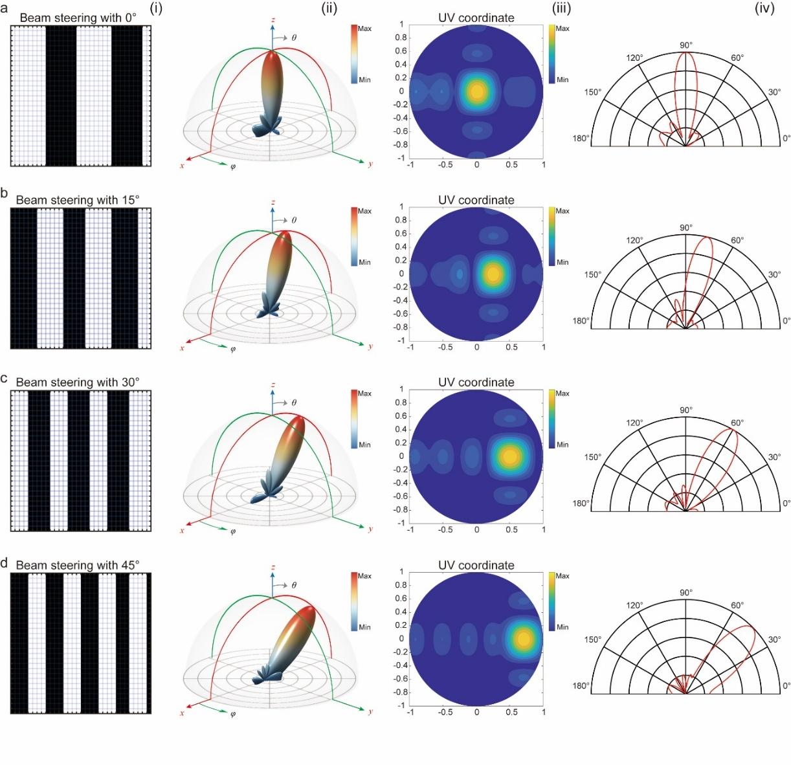
Supplementary Fig. 4. Coding patterns used for spatial wireless communication and corresponding radiation characteristics calculated using the array synthesis theory. Each coding matrix (i) prescribes a distinct phase distribution that steers the far-field beam towards prescribed angles of $0°$ (a), $15°$ (b), $30°$ (c) and $45°$ (d). The resulting 3D radiation patterns (ii), UV-plane field distributions (iii), and 2D field pattern (iv) confirm accurate beam steering with well-defined main lobes directed along the intended angles.

Supplementary Note 5: Experimental characterization of Far-field beamforming
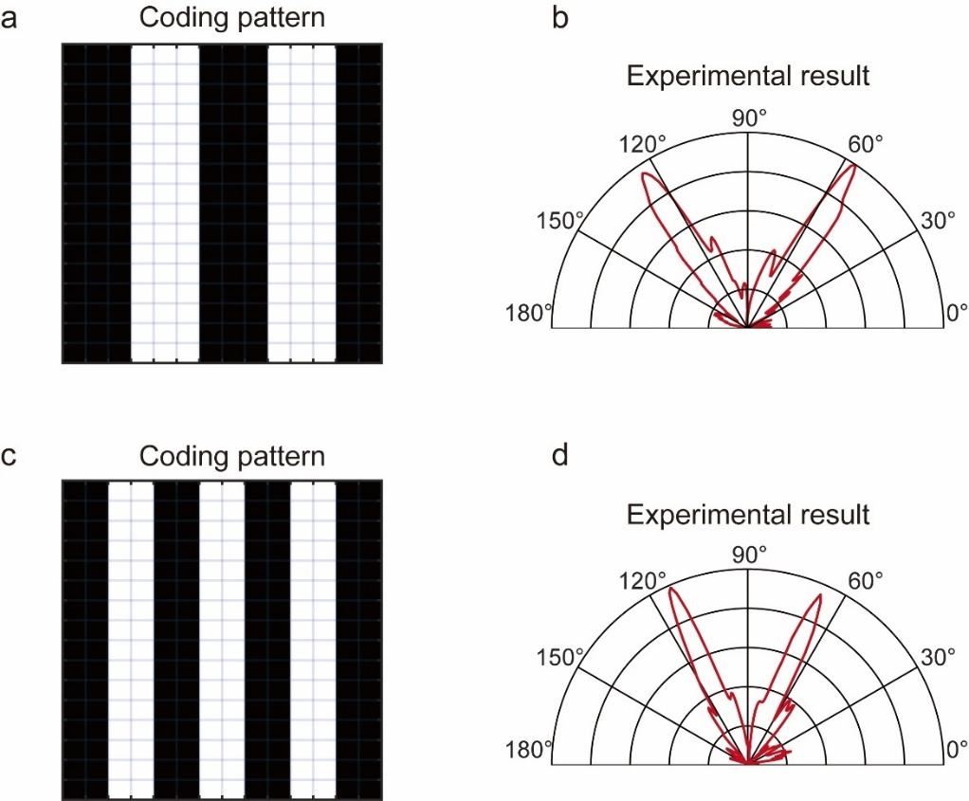
Supplementary Fig. 5 a, c Representative coding patterns designed for dual-beam generation. b, d Measured far-field radiation patterns corresponding to the coding patterns.

Far-field measurements were performed in a microwave anechoic chamber using a mini-MetaScreen prototype comprising a $16 × 14$ array. Two linearly polarized horn antennas were employed: one served as the illuminating source and the other as the receiver. The transmitter and the mini-MetaScreen were mounted on a rotary support providing 360° azimuthal rotation in the horizontal plane, enabling full-angle assessment of the beam-steering response. We employed two coding patterns (Supplementary Fig. 5a and 5c) to evaluate their corresponding far-field distribution characteristics, with the results presented in Supplementary Fig. 5b and 5d.

Supplementary Note 6: Additional results for wireless communication
The main text reports the transmission results received by antennas localized at ${30}^{∘}$ and ${45}^{∘}$ for brevity. Here we provide the full measurement results across four programmed steering angles as shown in Supplementary Fig. 6.
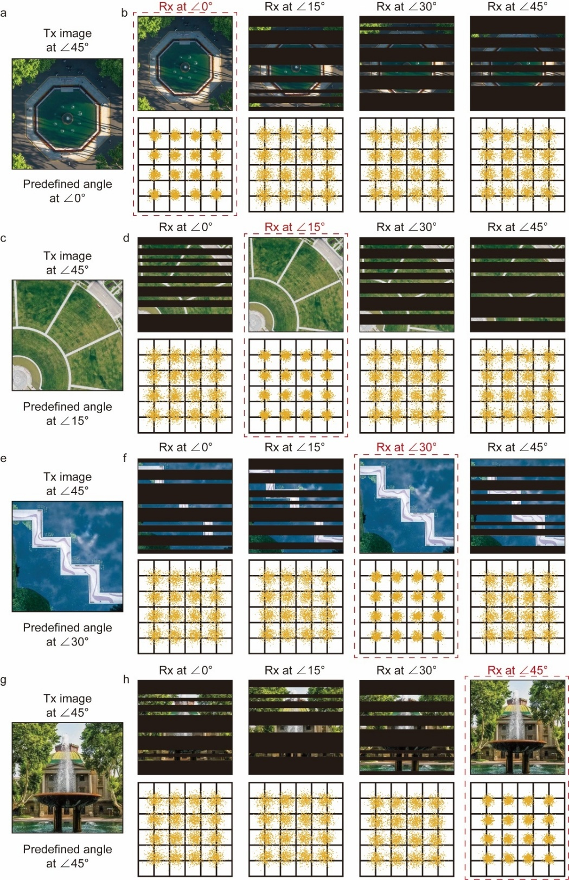
Supplementary Fig. 6 Full transmission results across four spatial communication channels. a, c, e, g Transmitted images (Tx at ${45}^{∘}$) prepared for receiver at predefined azimuth angles of $0°$, $15°$, $30°$, and $45°$, respectively. b, d, f, h Received images (top row) and the corresponding 16-QAM constellation diagrams (bottom row) recorded simultaneously at four spatially separated receivers (Rx at $0°$, $15°$, $30°$, and $45°$).
For each beam steering angle $θ_{s} ={15}^{∘}, {30}^{∘}, {45}^{∘}, {60}^{∘}$ , Supplementary Fig. 4 presents (left column, top to bottom) the transmitted images prepared for the different spatial channels. Four spatially separated receivers, each positioned at a distinct azimuth, simultaneously recorded the received image and the corresponding 16-QAM constellation diagrams. Only the receiver aligned with the target steering angle successfully reconstructed the transmitted image. The non-target receivers exhibit constellations spreading and images fragmentation due to the intentional phase mismatch and sidelobe suppression introduced by the MetaScreen modulation. These observations demonstrate the powerful capability of the system to manipulate spatial channels.

Supplementary Note 7: Coding pattern generation for beam focusing with programmable MetaScreen
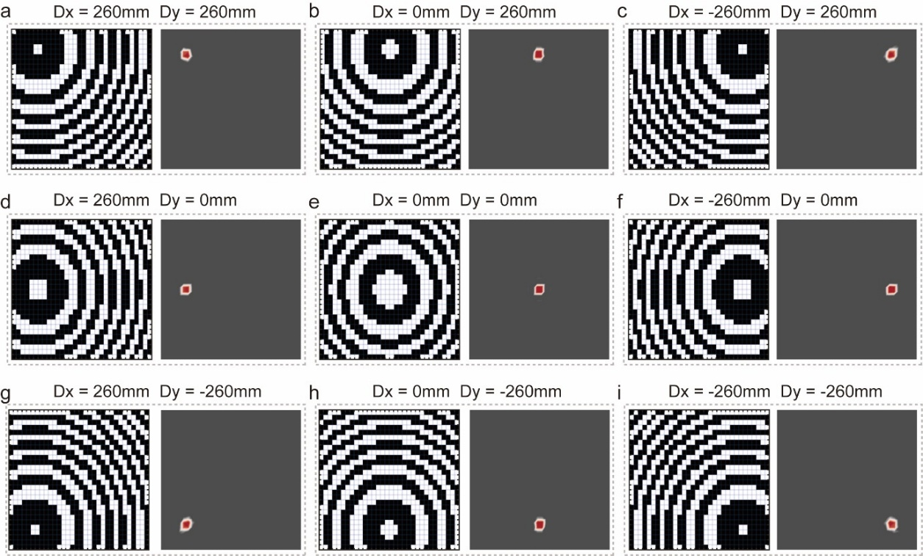
Supplementary Fig. 7 Programmable beam focusing on multiple spatial positions. a–i, Phase coding patterns (left) and the corresponding numerically calculated electrical distributions (right) for nine predefined focal points located at different position.

To demonstrate the powerful wavefront manipulation capability of the platform, we detail the coding patterns design process for beam focusing. In this case, to achieve a focal spot at a target position $(x_{0}, y_{0}, z_{0})$, the required phase distribution of the MetaScreen can be expressed as:
$$\begin{aligned}ϕ\left(x, y\right)= \frac{2π}{λ}\left(\sqrt{{\left(x-x_{0}\right)}^{2}+{\left(y-y_{0}\right)}^{2}+z_{0}^{2}}-z_{0}\right)\#\left(S2\right)\end{aligned}$$
where $λ$ denotes the wavelength. By dynamically programming the MetaScreen according to this expression, the focal point in space can be flexibly reconfigured in 3D space. In our study, we generated the phase coding patterns for nine predefined focusing positions to validate this capability. The corresponding electric field distribution can be numerically calculated through the Fresnel diffraction model:
$$\begin{aligned}E=We^{jϕ}\#\left(S3\right)\end{aligned}$$
where $ϕ$ is the applied phase distribution and $W$ is the Fresnel transmission weight for forward propagation, expressed as the spherical-wave factor
$$\begin{aligned}W=\frac{e^{-jkr}}{r}\#\left(S4\right)\end{aligned}$$
with $k$ the wavenumber and $r$ the distance from a point on the MetaScreen to the observation position. This formulation enables numerical prediction of the focusing performance and illustrates the ability of the programmable platform to focus electromagnetic energy at arbitrary spatial positions. The coding patterns and the corresponding calculated electric field distributions at nine focal positions are presented in Supplementary Fig. 7.

Supplementary Note 8: Details of the visual sensing module for human thorax positioning and human imaging
The MetaScreen system integrates a ZED 2i multi-sensor platform to provide visual sensing for adaptive microwave beam focusing and optical-domain display. The ZED 2i supplies human detection, skeleton extraction and multi-person tracking, and instance segmentation is performed using the YOLOv11x-seg model. Together, these functions enable two application chains: (1) thorax positioning for adaptive beam focusing, and (2) human imaging for optical display.
Thorax positioning begins with per-frame human detection and skeleton extraction performed by the ZED 2i body-tracking module. For each detected person, the system outputs a unique tracking ID together with bounding boxes and skeletal keypoints in both 2-D image coordinates and 3-D metric coordinates. The thoracic location is estimated from an upper-torso joint set derived from the skeletal keypoints and serves as the focal point for subsequent beam focusing. Correspondence between detections across frames is established via Intersection over Union (IoU) of bounding boxes plus tracking and filtering algorithms. This assigns consistent object labels and preserves identity over time. Because the ZED 2i uses a right-handed camera coordinate system with the Y-axis up while the MetaScreen control frame is left-handed with Y down (i.e. different origins and handedness), a rigid transformation matrix is applied to convert chest keypoint coordinates from the camera frame into the MetaScreen coordinate frame. Once the thorax position is expressed in the MetaScreen frame, the control computer generates the appropriate coding pattern to realize adaptive beam focusing.
Human imaging combines detection, persistent tracking and instance segmentation to extract a target individual’s visual representation for display on the MetaScreen. The ZED 2i first detects the person in the scene and assigns consistent tracking ID across frames to identify the target individual. Instance segmentation is then performed with the YOLOv11x-seg model on a left-eye reference image to produce per-pixel masks aligned to depth data. Background pixels are zeroed out and only human pixels are retained to ensure spatial precision. The segmented target region is letterboxed to preserve aspect ratio without geometric distortion and then downsampled to a fixed $28×32$ pixel grid. The downsampled image is binarized to produce the 0/1 coding pattern enabling the visible-domain display on the MetaScreen.

Supplementary Note 9: Flowchart of bidirectional interaction and adaptive EM wave focusing
To demonstrate the bidirectional interaction and contactless sensing, we implemented a dynamic encoding strategy driven by real-time scene perception from the visual sensing module. The corresponding flowchart is siilustrated in Supplementary Fig. 8
For bidirectional interaction (Supplementary Fig. 8a), the visual sensing module continuously captures sequential image frames from the external environment. When detecting the presence of a human, the system extracts the target contour through human detection and tracking, generates the corresponding mask, and converts it into a binary coding matrix after preprocessing steps including cropping, resizing, and binarization. This resulting binary coding pattern is then transmitted to the MetaScreen, enabling direct optical display of the detected human silhouette.
Conversely, when no human target is detected within the field of view, the system operates in a default mode, generating a real-time clock codebook. The clock code is subsequently transmitted and displayed on the MetaScreen, thereby delivering temporal information. Such adaptive functionality underscores the interactive nature of the platform, allowing seamless switching between environment-driven content display and information delivery.
For adaptive EM wave focusing (Supplementary Fig. 8b), we developed a protocol that dynamically responds to human presence in the environment. The process begins with the visual sensing module acquiring sequential frames of the surrounding scene, which are processed through human detection combined with skeleton tracking to identify targets and extract body keypoints. Upon detection, the system assigns a target ID and determines the thoracic position, which serves as the reference focal point for beam focusing. The thoracic position is then transformed into the coordinate system of the MetaScreen, ensuring alignment between the detection and control domains. Based on the thoracic spatial position information, the corresponding coding pattern is calculated using the Eq. (S2). The resulting phase distribution is subsequently binarized into a 28 × 32 coding matrix, forming the coding sequences that drive the programmable MetaScreen. Transmission of these coding sequences continuously enables the MetaScreen to adaptively reshape the incident wavefront and concentrate energy at the designated thoracic position.
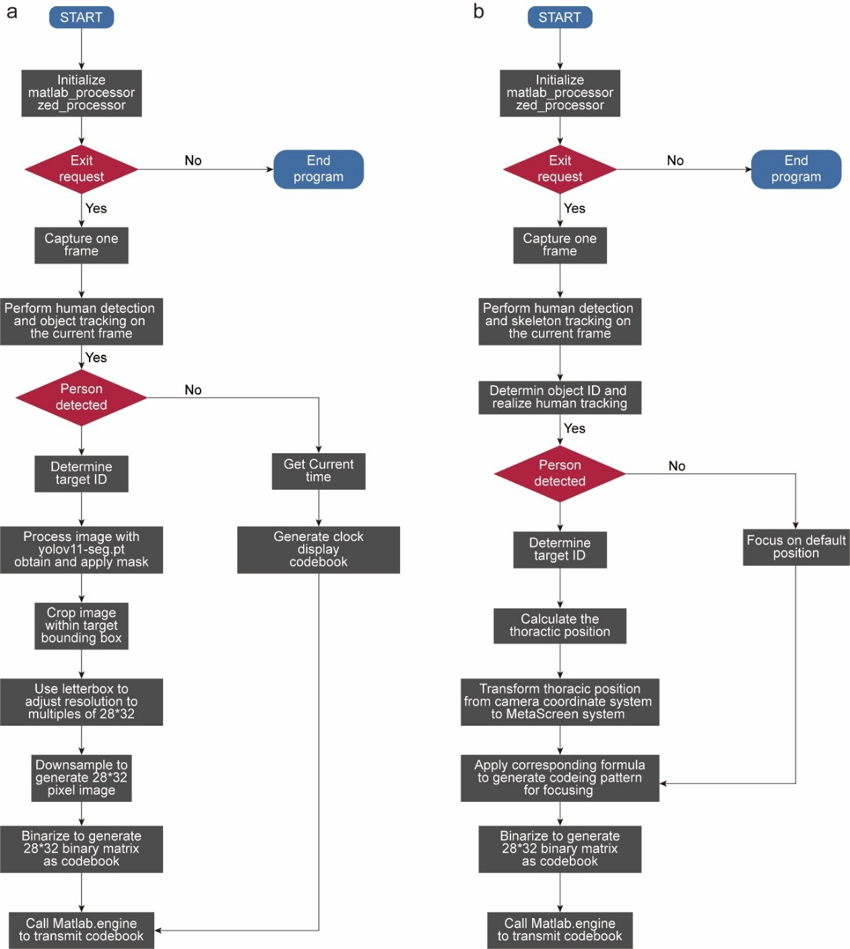
Supplementary Fig. 8 Flowchart of bidirectional interaction and adaptive beam focusing. a Real-time bidirectional interaction, where the system displays either human silhouettes or a default clock pattern depending on target detection. b Adaptive beam focusing, in which the thoracic position of a detected person is tracked and used as the focal point, while a predefined location is used in the absence of targets.
When no person is detected, the system reverts to a predefined focal location, thereby ensuring uninterrupted operation. This adaptive pipeline illustrates the capability of the platform to seamlessly integrate real-time human tracking with programmable beam control, enabling dynamic beam focusing at arbitrary spatial positions that update according to the target’s motion.

Supplementary Note 10: VMD algorithm enabling the contactless respiratory sensing
The contactless respiratory sensing exploits respiration-induced variations in the reflected EM field to recover breathing signals without physical contact. In the main text, the MetaScreen is utilized to generate a focused microwave illumination that enhances the signal-to-noise ratio of reflections from human thorax. As the thorax cyclically expands and contracts during respiration, the nominal reflection point undergoes microscale displacements that produce attendant phase and amplitude modulations in the received signal.
To extract the respiratory component from the complex EM environment return, we employ Variational Mode Decomposition (VMD) algorithm. VMD adaptively decomposes the complex measurement signal into a finite set of band-limited intrinsic mode functions (IMFs), each characterized center frequency. The respiration trace is recovered by selecting the IMF whose spectral content matches the respiratory band.
Among the process of contactless respiratory sensing, respiration-induced thorax displacements modulate the phase of reflected EM signals, which can be modeled as:
$$\begin{aligned}ϕ_{r}\left(t\right)=\frac{4π }{λ}x\left(t\right)\#\left(S5\right)\end{aligned}$$
where $λ$ is the carrier wavelength and $x(t)$ is the instantaneous chest displacement. The corresponding baseband signal after demodulation is:
$$\begin{aligned}u_{r}\left(t\right)=A_{r}\left(t\right)e^{jϕ_{r}\left(t\right)}\#\left(S6\right)\end{aligned}$$
where $A(t)$ represents amplitude variations, and $n(t)$ is additive noise. Then, all the IMFs together with the residual reconstruct the original signal $s(t)$, which can be denoted as
$$\begin{aligned}s\left(t\right)=\sum_{i=1}^{I}{u_{i}\left(t\right)}+n\left(t\right)\#\left(S7\right)\end{aligned}$$
where $u_{i}(t)$ is the $i$th IMF, I is the number of IMFs, and $n\left(t\right)$ is the residual. The residual could be treated as the noise irrelevant to the vital-sign monitoring task. To extract the respiration component $u_{r}(t)$, the received signal is processed by VMD, which formulates the decomposition as an optimization problem:
$$\begin{aligned}\min_{\left\{k_{k}\right\},\left\{w_{k}\right\}}\left\{\sum_{i}{{\left\|∂_{t}\left[\left(δ\left(t\right)+1/{πt}\right)*u_{i}\left(t\right)\right]e^{jw_{i}\left(t\right)t}\right\|}_{2}^{2}}\right\} s.t. \sum_{i}{u_{i}\left(t\right)=s\left(t\right)}\#\left(S8\right)\end{aligned}$$
where$w_{i}(t) := ∂φ_{i}(t)/∂t$ is the instantaneous frequency of $u_{i}(t)$, and $A_{i}(t)$ is amplitude which are nonnegative and vary much slower than $ϕ_{i}(t)$. In this formula, $\{u_{i}(t)\} := \{u_{1}(t), u_{2}(t), . . . , u_I(t)\}$ and {$wi(t)\} :=\{w1(t),w2(t), . . . ,wI(t)\}$ denote the sets of all IMFs and their center frequencies, respectively. The IMF whose frequency falls within the respiratory band (0.1–0.5 Hz) is selected to estimate the respiration rate:
$$\begin{aligned}f_{r}=\frac{N_{peaks}}{T}\#\left(S9\right)\end{aligned}$$
where $N_{peaks}$ is the number of detected breathing peaks within observation time $T$. More details about the VDM algorithm could be found in Ref. S3. Through this approach, the system achieves robust, real-time estimation of respiratory rate in non-contact scenarios.

References
1. Cui, Tie Jun, et al. "Coding metamaterials, digital metamaterials and programmable metamaterials." Light: science & applications 3.10 (2014): e218-e218.
2. Magnetic Flip Disk (El. Di. Elettronica Digitale S.R.L., 2015); https://irp.cdn-website.com/b1813748/files/uploaded/IndicatoriMagnetici_201510_EN_rlZB0xgyQ1mAwQUJxrL2.pdf
3. Li, X., You, J. W., Gu, Z., Ma, Q., Zhang, J., Chen, L., & Cui, T. J. (2024). Multiperson detection and vital-sign sensing empowered by space-time-coding reconfigurable intelligent surfaces. IEEE Internet of Things Journal, 11(17), 28169-28183.

