Supplementary Material for:
ClivD score and risks of dementia, cardiovascular disease, cancer, and mortality

Author:
Guozhe Sun, MD, PhD^{1*}, Jie Chen, MS^{1*}, Hongmei Yang, PhD^{1*}, Caiyu Zhang, MS^{1*}, Chenhua He, MS^{1*}, Lin Guan, MD, PhD³, Ying Zhou, MD¹, Shiyu Zhou, PhD², Yao Yu, MD¹, Jun Wang, MD¹, Xiangyu Tan, MD¹, Yangzhi Yin, MD¹, Ziyi Xie, MD¹, Wei Miao, MD¹, Wenhang Li, MS¹, Yifei Chen, BS¹, Xiaoxuan Tian, MS¹, Tianhao Li, BS¹, Xiaobing Zhou, BS¹, Mengling Lu, BS¹, Guangxiao Li, MD, PhD⁴, Xiaofan Guo, MD, PhD^{1#}

1Department of Cardiology, the First Hospital of China Medical University, Shenyang, Liaoning, China.
2Department of Clinical Epidemiology and Evidence-Based Medicine, The First Hospital of China Medical University, Shenyang, China.
3Department of Gastroenterology, the First Hospital of China Medical University, Shenyang, Liaoning, China.
4Department of Medical Record Management Center, the First Hospital of China Medical University, Shenyang, China.

Supplementary Appendix
Supplementary methods
Supplemental Tables
Table S1. Mortality, cardiovascular disease, hypertension, diatetes, dementia, and cancer ascertainment.
Table S2. Covariate definitions.
Table S3. Baseline characteristics of participants according to ClivDnonlab quartiles.
Table S4. Association of the ClivDnonlab score with dementia, cardiovascular disease, cancer, and all-cause mortality.
Table S5. Association of the ClivDlab with Alzheimer's disease, vascular dementia, coronary heart disease, heart failure and stroke.
Table S6. Association of the ClivDnonlab with Alzheimer's disease, vascular dementia, coronary heart disease, heart failure and stroke.
Table S7. Association of the ClivDlab with dementia, cardiovascular disease, cancer and all-cause mortality (exclusion of participants with diseases and death events in the first 2 years of follow up).
Table S8. Association of the ClivDnonlab with dementia, cardiovascular disease, cancer and all-cause mortality (exclusion of participants with diseases and death events in the first 2 years of follow up).
Table S9. Association of the ClivDlab with Alzheimer's disease, vascular dementia, coronary heart disease, heart failure and stroke (exclusion of participants with diseases and death events in the first 2 years of follow up).
Table S10. Association of the ClivDnonlab with Alzheimer's disease, vascular dementia, coronary heart disease, heart failure and stroke (exclusion of participants with diseases and death events in the first 2 years of follow up).
Table S11. Association of the ClivDlab with dementia, cardiovascular disease, and cancer (Treating death as a competing risk).
Table S12. Association of the ClivDnonlab with dementia, cardiovascular disease, and cancer (Treating death as a competing risk).
Table S13. Association of the ClivDlab with Alzheimer's disease, vascular dementia, coronary heart disease, heart failure and stroke (Treating death as a competing risk).
Table S14. Association of the ClivDnonlab with Alzheimer's disease, vascular dementia, coronary heart disease, heart failure and stroke (Treating death as a competing risk).
Supplemental Figures
Figure S1. Kaplan-Meier survival curves of ClivDnonlab for (A) dementia, (B) cardiovascular diseases, (C) cancer, and (D) all-cause mortality.
Figure S2. Kaplan-Meier survival curves of ClivDlab for (A) coronary heart disease, (B) heart failure, (C) stroke, (D) vascular dementia, and (E) Alzheimer's disease.
Figure S3. Kaplan-Meier survival curves of ClivDnonlab for (A) coronary heart disease, (B) heart failure, (C) stroke, (D) vascular dementia, and (E) Alzheimer's disease.
Figure S4. Restricted cubic spline curve for the association of ClivDnonlab with (A) dementia, (B) cardiovascular diseases, (C) cancer, and (D) all-cause mortality.
Figure S5. Restricted cubic spline curve for the association of ClivDlab with (A) coronary heart disease, (B) heart failure, (C) stroke, (D) vascular dementia, and (E) Alzheimer's disease.
Figure S6. Restricted cubic spline curve for the association of ClivDnonlab with (A) coronary heart disease, (B) heart failure, (C) stroke, (D) vascular dementia, and (E) Alzheimer's disease.
Figure S7. Forest plot of all-cause mortality according to subgroups (ClivDlab)
|Figure S8. Forest plot of all-cause mortality according to subgroups (ClivDnonlab)
Figure S9. Forest plot of all-cause dementia according to subgroups (ClivDlab).
Figure S10. Forest plot of all-cause dementia according to subgroups (ClivDnonlab).
Figure S11. Forest plot of total cardiovascular diseases according to subgroups (ClivDlab).
Figure S12. Forest plot of total cardiovascular diseases according to subgroups (ClivDnonlab).
Figure S13. Forest plot of cancer according to subgroups (ClivDlab).
Figure S14. Forest plot of cancer according to subgroups (ClivDnonlab).
Figure S15. Forest plot of Alzheimer's disease according to subgroups (ClivDlab).
Figure S16. Forest plot of Alzheimer's disease according to subgroups (ClivDnonlab).
Figure S17. Forest plot of vascular dementia according to subgroups (ClivDlab).
Figure S18. Forest plot of vascular dementia according to subgroups (ClivDnonlab).
Figure S19. Forest plot of coronary heart disease according to subgroups (ClivDlab).
Figure S20. Forest plot of coronary heart disease according to subgroups (ClivDnonlab).
Figure S21. Forest plot of heart failure according to subgroups (ClivDlab).
Figure S22. Forest plot of heart failure according to subgroups (ClivDnonlab).
Figure S23. Forest plot of stroke according to subgroups (ClivDlab).
Figure S24. Forest plot of stroke according to subgroups (ClivDnonlab).

Supplementary methods
The Chronic Liver Disease (CLivD) risk prediction score
The equation in R software language
data = name of the R data
AGE = age in years
SEX = men = 1; women = 2
WHR = waist hip ratio
ALCOHOL = number of weekly drinks (1 drink = 10 g ethanol)
Set to = 50, if >50 drinks per week
GGT = gamma glutamyltransferase (U/L)
Set to = 200 U/L if >200 U/L
DIABETES = yes = 1; no = 0
SMOKING = current smoker = 1; never/previous smoker = 2

CLivD_{lab}
data$modellab <- (-6.7922721 + 0.044744302* data$AGE + 0.32961593*( data$WHR*10) + 0.19860813* data$ALCOHOL - 0.0082096868*pmax(data$ALCOHOL-0.1,0)^3 +0.010575035*pmax(data$ALCOHOL-1,0)^3 -0.002004756*pmax(data$ALCOHOL-3,0)^3 -0.00033998925*pmax(data$ALCOHOL-9,0)^3 -2.0602882e-05*pmax(data$ALCOHOL-33,0)^3 +0.011813962* data$GGT +0.18721469*(data$SEX=="2") +0.55249734*(data$DIABETES=="1") + 0.74679941*(data$SMOKING=="1") +0.0054325769* data$GGT*(data$SEX=="2") -0.64903176*( data$SEX=="2")*( data$SMOKING=="1"))

CLivD_{non-lab}
data$modelnonlab <- (-8.0940103 +0.044177151* data$AGE +0.48927753*( data$WHR*10) +0.19222894* data$ALCOHOL -0.00015029544*pmax(data$ALCOHOL-0.1,0)^3 -0.0021265611*pmax(data$ALCOHOL-1,0)^3 +0.0029832769*pmax(data$ALCOHOL-3,0)^3 -0.00068765143*pmax(data$ALCOHOL-9,0)^3 -1.8769011e-05*pmax(data$ALCOHOL-33,0)^3 +0.69669285*(data$DIABETES=="1") +0.75968055*(data$SMOKING=="1")+ 0.63248362*(data$SEX=="2") -0.59146649*(data$SMOKING=="1")*(data$SEX=="2"))

Weekly alcohol consumption: The variable was created by calculating total alcohol content for each reported drink using British measurements (1 pint of beer or cider=16g, 1 standard glass of white/red wine=16.8g, 1 glass of fortified wine=14.08g, 1 shot of spirits or liquor=8g, 1 glass of other alcohol drinks (i.e. alcopops)=12g)^{1,2}.

Table S1. Mortality, cardiovascular disease, hypertension, diatetes, dementia, and cancer ascertainment.
Diseases | ICD-10 codes
Death registry | Mortality data were provided by the NHS Digital for participants in England and Wales. Data were provided by the NHSCR for participants in Scotland.  Linkage for England, Wales were available up to May 31st, 2024  Linkage for Scotland was available up to December 31st, 2022
Inpatient hospitalization | The inpatient hospitalization data were provided by either the Hospital Episode Statistics for England, the Patient Episode Database for Wales, or the Scottish Morbidity Record for Scotland.  Linkage for England was available up to October 31st, 2022 Linkage for Scotland was available up to August 31st, 2022 Linkage for Wales was available up to May 31st, 2022
Cardiovascular Disease | I20-I25 for coronary heart disease  I60-I64 for stroke  I11.0, I13.0, I13.2, I50 for heart failure
Diabetes | E11 for Type 2 Diabetes
Dementia | F00, F00.0, F00.1, F00.2, F00.9, G30, G30.0, G30.1, G30.8, G30.9 for AD  F01, F01.0, F01.1, F01.2, F01.3, F01.8, F01.9, I67.3 for VaD  A81.0, F00, F01, F02, F03, F05.1, F10.6, G30, G31.0, G31.1, G31.8, I67.3 for all-cause dementia
Cancer | C00-C97

Table S2. Covariate definitions.
Variable | Definition | UK Biobank field ID
Ethnicity | White/Other | 21000
Education | College or higher/Other | 6138
TDI | Continuous | 189
Vegetable serving | Servings/d | 1289, 1299
Fruit serving | Servings/d | 1309, 1319
Sedentary duration | Hours spent sleeping | 1070, 1080, 1090
BMI | Underweight, normal weight, overweight, obese | 21001
Cholesterol medication | Yes/No | 6177, 6153
Blood pressure medication | Yes/No | 6177, 6153
LDL | Continuous | 30780
TG | Continuous | 30870
SBP | Continuous | 4079
DBP | Continuous | 4080

Table S3. Baseline characteristics of participants according to ClivD_{nonlab} quartiles.

Characteristic | Overall  N = 84469¹ | Q1  N = 21118¹ | Q2  N = 21117¹ | Q3  N = 21117¹ | Q4  N = 21117¹ | p-value²
Age (years) | 56.20 ± 8.03 | 50.29 ± 7.24 | 56.01 ± 7.45 | 58.44 ± 7.13 | 60.05 ± 6.66 | <0.001
Ethnicity, % |  |  |  |  |  | <0.001
Other | 3,405.00 (4.03%) | 1,272.00 (6.02%) | 858.00 (4.06%) | 683.00 (3.23%) | 592.00 (2.80%)
White | 81,064.00 (95.97%) | 19,846.00 (93.98%) | 20,259.00 (95.94%) | 20,434.00 (96.77%) | 20,525.00 (97.20%)
Townsend Deprivation Index | -1.50 ± 2.73 | -1.53 ± 2.69 | -1.61 ± 2.67 | -1.57 ± 2.70 | -1.28 ± 2.86 | <0.001
Education, % |  |  |  |  |  | <0.001
College | 32,472.00 (38.44%) | 9,350.00 (44.28%) | 8,308.00 (39.34%) | 7,731.00 (36.61%) | 7,083.00 (33.54%)
Other | 51,997.00 (61.56%) | 11,768.00 (55.72%) | 12,809.00 (60.66%) | 13,386.00 (63.39%) | 14,034.00 (66.46%)
Vegetable servings/d | 4.97 ± 3.20 | 4.79 ± 3.10 | 5.01 ± 3.22 | 5.04 ± 3.14 | 5.04 ± 3.35 | <0.001
Fruit servings/d | 2.94 ± 2.42 | 3.01 ± 2.44 | 3.12 ± 2.45 | 3.01 ± 2.42 | 2.62 ± 2.32 | <0.001
Sedentary duration/d | 4.83 ± 2.37 | 4.42 ± 2.30 | 4.71 ± 2.29 | 4.93 ± 2.30 | 5.25 ± 2.49 | <0.001
Body mass index, kg/m² | 26.90 ± 4.31 | 25.38 ± 3.97 | 26.49 ± 4.16 | 27.36 ± 4.21 | 28.36 ± 4.32 | <0.001
Cholesterol medication, % | 11,264.00 (13.34%) | 836.00 (3.96%) | 1,994.00 (9.44%) | 3,177.00 (15.04%) | 5,257.00 (24.89%) | <0.001
Blood pressure medication, % | 14,020.00 (16.60%) | 1,345.00 (6.37%) | 2,804.00 (13.28%) | 3,987.00 (18.88%) | 5,884.00 (27.86%) | <0.001
Diabetes medication, % | 546.00 (0.65%) | 23.00 (0.11%) | 63.00 (0.30%) | 160.00 (0.76%) | 300.00 (1.42%) | <0.001
LDL, mmol/L | 3.61 ± 0.84 | 3.50 ± 0.79 | 3.66 ± 0.82 | 3.68 ± 0.85 | 3.59 ± 0.89 | <0.001
TG, mmol/L | 1.69 ± 0.99 | 1.42 ± 0.83 | 1.63 ± 0.92 | 1.77 ± 0.97 | 1.95 ± 1.12 | <0.001
HbA1c (%) | 35.40 ± 5.79 | 33.94 ± 4.33 | 34.91 ± 4.70 | 35.70 ± 5.64 | 37.04 ± 7.50 | <0.001
Systolic blood pressure, mmHg | 138.11 ± 18.42 | 130.54 ± 17.09 | 136.83 ± 17.83 | 140.49 ± 17.98 | 144.57 ± 17.82 | <0.001
Diastolic blood pressure, mmHg | 82.58 ± 9.99 | 79.69 ± 9.82 | 82.00 ± 9.86 | 83.52 ± 9.76 | 85.10 ± 9.71 | <0.001
¹Mean ± SD; n (%)
²Kruskal-Wallis rank sum test; Pearson's Chi-squared test
Abbreviations: LDL, low-density lipoprotein; TG, triglyceride; HbA1c, glycated hemoglobin;

Table S4. Association of the ClivD_{nonlab} score with dementia, cardiovascular disease, cancer, and all-cause mortality.
 |  | Model 1 |  |  | Model 2 |  |  | Model 3 |  |  | Model 4
 | Group | HR | 95% CI | p-value | HR | 95% CI | p-value | HR | 95% CI | p-value | HR | 95% CI | p-value
Dementia | Q1 | — | — |  | — | — |  | — | — |  | — | —
 | Q2 | 2.42 | 1.89, 3.10 | <0.001 | 2.37 | 1.85, 3.04 | <0.001 | 2.42 | 1.88, 3.10 | <0.001 | 2.10 | 1.64, 2.70 | <0.001
 | Q3 | 3.39 | 2.67, 4.30 | <0.001 | 3.28 | 2.59, 4.17 | <0.001 | 3.43 | 2.70, 4.37 | <0.001 | 2.74 | 2.15, 3.50 | <0.001
 | Q4 | 4.51 | 3.58, 5.69 | <0.001 | 4.29 | 3.40, 5.41 | <0.001 | 4.65 | 3.67, 5.90 | <0.001 | 3.31 | 2.59, 4.23 | <0.001
CVD | Q1 | — | — |  | — | — |  | — | — |  | — | —
 | Q2 | 1.89 | 1.75, 2.05 | <0.001 | 1.88 | 1.73, 2.03 | <0.001 | 1.79 | 1.66, 1.94 | <0.001 | 1.56 | 1.44, 1.69 | <0.001
 | Q3 | 2.53 | 2.34, 2.72 | <0.001 | 2.49 | 2.31, 2.68 | <0.001 | 2.30 | 2.13, 2.48 | <0.001 | 1.83 | 1.69, 1.98 | <0.001
 | Q4 | 3.83 | 3.56, 4.12 | <0.001 | 3.73 | 3.47, 4.01 | <0.001 | 3.32 | 3.08, 3.57 | <0.001 | 2.36 | 2.18, 2.54 | <0.001
Cancer | Q1 | — | — |  | — | — |  | — | — |  | — | —
 | Q2 | 1.40 | 1.33, 1.47 | <0.001 | 1.38 | 1.32, 1.46 | <0.001 | 1.39 | 1.32, 1.46 | <0.001 | 1.32 | 1.26, 1.39 | <0.001
 | Q3 | 1.70 | 1.62, 1.79 | <0.001 | 1.67 | 1.59, 1.76 | <0.001 | 1.69 | 1.60, 1.77 | <0.001 | 1.56 | 1.48, 1.64 | <0.001
 | Q4 | 2.11 | 2.01, 2.21 | <0.001 | 2.08 | 1.98, 2.18 | <0.001 | 2.11 | 2.01, 2.22 | <0.001 | 1.86 | 1.76, 1.95 | <0.001
All-cause mortality | Q1 | — | — |  | — | — |  | — | — |  | — | —
 | Q2 | 1.88 | 1.68, 2.10 | <0.001 | 1.86 | 1.66, 2.07 | <0.001 | 1.83 | 1.63, 2.04 | <0.001 | 1.69 | 1.51, 1.89 | <0.001
 | Q3 | 2.61 | 2.34, 2.90 | <0.001 | 2.54 | 2.29, 2.83 | <0.001 | 2.47 | 2.22, 2.75 | <0.001 | 2.16 | 1.94, 2.41 | <0.001
 | Q4 | 4.46 | 4.04, 4.93 | <0.001 | 4.27 | 3.87, 4.72 | <0.001 | 4.08 | 3.68, 4.52 | <0.001 | 3.28 | 2.95, 3.64 | <0.001

Table S5. Association of the ClivD_{lab} with Alzheimer's disease, vascular dementia, coronary heart disease, heart failure and stroke.
 |  | Model 1 |  |  | Model 2 |  |  | Model 3 |  |  | Model 4
Group | Characteristic | HR | 95% CI | p-value | HR | 95% CI | p-value | HR | 95% CI | p-value | HR | 95% CI | p-value
Alzheimer's disease | Q1 | — | — |  | — | — |  | — | — |  | — | —
 | Q2 | 3.30 | 2.22, 4.90 | <0.001 | 3.21 | 2.16, 4.77 | <0.001 | 3.38 | 2.27, 5.03 | <0.001 | 2.75 | 1.85, 4.11 | <0.001
 | Q3 | 4.59 | 3.13, 6.73 | <0.001 | 4.40 | 3.00, 6.46 | <0.001 | 4.89 | 3.32, 7.20 | <0.001 | 3.57 | 2.41, 5.29 | <0.001
 | Q4 | 5.98 | 4.11, 8.71 | <0.001 | 5.64 | 3.87, 8.23 | <0.001 | 6.79 | 4.62, 9.98 | <0.001 | 4.30 | 2.89, 6.41 | <0.001
Vascular dementia | Q1 | — | — |  | — | — |  | — | — |  | — | —
 | Q2 | 4.43 | 2.06, 9.55 | <0.001 | 4.19 | 1.95, 9.04 | <0.001 | 4.12 | 1.91, 8.90 | <0.001 | 3.49 | 1.61, 7.57 | 0.002
 | Q3 | 6.15 | 2.91, 13.0 | <0.001 | 5.66 | 2.68, 12.0 | <0.001 | 5.59 | 2.63, 11.9 | <0.001 | 4.27 | 1.98, 9.17 | <0.001
 | Q4 | 9.23 | 4.44, 19.2 | <0.001 | 8.18 | 3.93, 17.0 | <0.001 | 8.18 | 3.89, 17.2 | <0.001 | 5.46 | 2.53, 11.8 | <0.001
CHD | Q1 | — | — |  | — | — |  | — | — |  | — | —
 | Q2 | 2.21 | 2.00, 2.43 | <0.001 | 2.19 | 1.98, 2.41 | <0.001 | 2.08 | 1.88, 2.29 | <0.001 | 1.75 | 1.59, 1.93 | <0.001
 | Q3 | 3.18 | 2.90, 3.49 | <0.001 | 3.13 | 2.85, 3.43 | <0.001 | 2.87 | 2.62, 3.15 | <0.001 | 2.19 | 1.99, 2.41 | <0.001
 | Q4 | 4.49 | 4.11, 4.91 | <0.001 | 4.36 | 3.98, 4.76 | <0.001 | 3.82 | 3.48, 4.18 | <0.001 | 2.55 | 2.31, 2.81 | <0.001
Heart failure | Q1 | — | — |  | — | — |  | — | — |  | — | —
 | Q2 | 2.36 | 1.91, 2.91 | <0.001 | 2.33 | 1.89, 2.87 | <0.001 | 2.15 | 1.74, 2.65 | <0.001 | 1.93 | 1.56, 2.39 | <0.001
 | Q3 | 4.52 | 3.72, 5.48 | <0.001 | 4.41 | 3.64, 5.36 | <0.001 | 3.87 | 3.18, 4.70 | <0.001 | 3.21 | 2.63, 3.91 | <0.001
 | Q4 | 7.41 | 6.15, 8.94 | <0.001 | 7.10 | 5.89, 8.56 | <0.001 | 5.85 | 4.84, 7.08 | <0.001 | 4.34 | 3.56, 5.29 | <0.001
Stroke | Q1 | — | — |  | — | — |  | — | — |  | — | —
 | Q2 | 1.67 | 1.39, 2.00 | <0.001 | 1.65 | 1.38, 1.98 | <0.001 | 1.64 | 1.36, 1.96 | <0.001 | 1.44 | 1.20, 1.73 | <0.001
 | Q3 | 2.39 | 2.02, 2.84 | <0.001 | 2.36 | 1.98, 2.80 | <0.001 | 2.33 | 1.96, 2.77 | <0.001 | 1.89 | 1.59, 2.26 | <0.001
 | Q4 | 4.16 | 3.55, 4.89 | <0.001 | 4.06 | 3.45, 4.77 | <0.001 | 3.99 | 3.38, 4.71 | <0.001 | 2.97 | 2.49, 3.54 | <0.001
Abbreviations: CI, Confidence Interval; HR, Hazard Ratio; CHD, coronary heart disease;
Model 1 was adjusted for none.
Model 2 was adjusted for ethnicity, TDI, and education.
Model 3 was adjusted for Model 2 plus vegetable serving, fruit serving, sedentary duration and BMI.
Model 4 was further adjusted for cholesterol medication, blood pressure medication, LDL-c, TG, SBP, and DBP.

Table S6. Association of the ClivD_{nonlab} with Alzheimer's disease, vascular dementia, coronary heart disease, heart failure and stroke.
 |  | Model 1 |  |  | Model 2 |  |  | Model 3 |  |  | Model 4
Group | Characteristic | HR | 95% CI | p-value | HR | 95% CI | p-value | HR | 95% CI | p-value | HR | 95% CI | p-value
Alzheimer's disease | Q1 | — | — |  | — | — |  | — | — |  | — | —
 | Q2 | 2.48 | 1.72, 3.59 | <0.001 | 2.42 | 1.67, 3.49 | <0.001 | 2.50 | 1.73, 3.62 | <0.001 | 2.08 | 1.43, 3.01 | <0.001
 | Q3 | 3.51 | 2.47, 4.99 | <0.001 | 3.37 | 2.37, 4.79 | <0.001 | 3.64 | 2.55, 5.20 | <0.001 | 2.71 | 1.89, 3.89 | <0.001
 | Q4 | 4.87 | 3.46, 6.86 | <0.001 | 4.59 | 3.26, 6.47 | <0.001 | 5.27 | 3.71, 7.47 | <0.001 | 3.42 | 2.38, 4.90 | <0.001
Vascular dementia | Q1 | — | — |  | — | — |  | — | — |  | — | —
 | Q2 | 4.05 | 1.95, 8.40 | <0.001 | 3.85 | 1.85, 7.99 | <0.001 | 3.76 | 1.81, 7.83 | <0.001 | 3.19 | 1.53, 6.67 | 0.002
 | Q3 | 5.57 | 2.73, 11.3 | <0.001 | 5.15 | 2.53, 10.5 | <0.001 | 5.03 | 2.46, 10.3 | <0.001 | 3.83 | 1.85, 7.90 | <0.001
 | Q4 | 7.82 | 3.90, 15.7 | <0.001 | 6.98 | 3.48, 14.0 | <0.001 | 6.83 | 3.37, 13.8 | <0.001 | 4.51 | 2.19, 9.31 | <0.001
CHD | Q1 | — | — |  | — | — |  | — | — |  | — | —
 | Q2 | 1.93 | 1.76, 2.11 | <0.001 | 1.91 | 1.75, 2.09 | <0.001 | 1.82 | 1.66, 2.00 | <0.001 | 1.56 | 1.42, 1.71 | <0.001
 | Q3 | 2.52 | 2.31, 2.75 | <0.001 | 2.48 | 2.27, 2.71 | <0.001 | 2.28 | 2.08, 2.49 | <0.001 | 1.77 | 1.62, 1.94 | <0.001
 | Q4 | 3.69 | 3.39, 4.01 | <0.001 | 3.59 | 3.30, 3.91 | <0.001 | 3.15 | 2.89, 3.44 | <0.001 | 2.17 | 1.99, 2.38 | <0.001
Heart failure | Q1 | — | — |  | — | — |  | — | — |  | — | —
 | Q2 | 2.29 | 1.88, 2.79 | <0.001 | 2.26 | 1.86, 2.75 | <0.001 | 2.10 | 1.73, 2.56 | <0.001 | 1.88 | 1.54, 2.29 | <0.001
 | Q3 | 3.61 | 3.00, 4.34 | <0.001 | 3.53 | 2.94, 4.25 | <0.001 | 3.11 | 2.58, 3.75 | <0.001 | 2.55 | 2.11, 3.09 | <0.001
 | Q4 | 6.44 | 5.40, 7.68 | <0.001 | 6.21 | 5.20, 7.41 | <0.001 | 5.15 | 4.31, 6.16 | <0.001 | 3.74 | 3.11, 4.51 | <0.001
Stroke | Q1 | — | — |  | — | — |  | — | — |  | — | —
 | Q2 | 1.64 | 1.38, 1.96 | <0.001 | 1.63 | 1.36, 1.94 | <0.001 | 1.60 | 1.35, 1.91 | <0.001 | 1.42 | 1.19, 1.70 | <0.001
 | Q3 | 2.20 | 1.86, 2.60 | <0.001 | 2.17 | 1.83, 2.56 | <0.001 | 2.12 | 1.79, 2.51 | <0.001 | 1.74 | 1.46, 2.06 | <0.001
 | Q4 | 3.72 | 3.18, 4.35 | <0.001 | 3.63 | 3.11, 4.25 | <0.001 | 3.52 | 2.99, 4.13 | <0.001 | 2.63 | 2.22, 3.11 | <0.001
Abbreviations: CI, Confidence Interval; HR, Hazard Ratio; CHD, coronary heart disease;
Model 1 was adjusted for none.
Model 2 was adjusted for ethnicity, TDI, and education.
Model 3 was adjusted for Model 2 plus vegetable serving, fruit serving, sedentary duration and BMI.
Model 4 was further adjusted for cholesterol medication, blood pressure medication, LDL-c, TG, SBP, and DBP.

Table S7. Association of the ClivD_{lab} with dementia, cardiovascular disease, cancer and all-cause mortality (exclusion of participants with diseases and death events in the first 2 years of follow up).
 |  | Model 1 |  |  | Model 2 |  |  | Model 3 |  |  | Model 4
 | Group | HR | 95% CI | p-value | HR | 95% CI | p-value | HR | 95% CI | p-value | HR | 95% CI | p-value
Dementia | Q1 | — | — |  | — | — |  | — | — |  | — | —
 | Q2 | 2.95 | 2.24, 3.88 | <0.001 | 2.88 | 2.19, 3.79 | <0.001 | 2.98 | 2.26, 3.92 | <0.001 | 2.58 | 1.95, 3.40 | <0.001
 | Q3 | 4.15 | 3.19, 5.40 | <0.001 | 4.02 | 3.08, 5.23 | <0.001 | 4.29 | 3.29, 5.61 | <0.001 | 3.41 | 2.60, 4.48 | <0.001
 | Q4 | 5.70 | 4.41, 7.38 | <0.001 | 5.39 | 4.17, 6.98 | <0.001 | 6.10 | 4.68, 7.94 | <0.001 | 4.34 | 3.30, 5.72 | <0.001
CVD | Q1 | — | — |  | — | — |  | — | — |  | — | —
 | Q2 | 2.08 | 1.90, 2.27 | <0.001 | 2.06 | 1.88, 2.25 | <0.001 | 1.96 | 1.80, 2.14 | <0.001 | 1.69 | 1.55, 1.85 | <0.001
 | Q3 | 3.06 | 2.82, 3.33 | <0.001 | 3.01 | 2.77, 3.27 | <0.001 | 2.79 | 2.56, 3.03 | <0.001 | 2.20 | 2.02, 2.40 | <0.001
 | Q4 | 4.51 | 4.16, 4.88 | <0.001 | 4.37 | 4.03, 4.73 | <0.001 | 3.89 | 3.58, 4.22 | <0.001 | 2.72 | 2.50, 2.97 | <0.001
Cancer | Q1 | — | — |  | — | — |  | — | — |  | — | —
 | Q2 | 1.47 | 1.39, 1.55 | <0.001 | 1.46 | 1.38, 1.54 | <0.001 | 1.47 | 1.39, 1.55 | <0.001 | 1.41 | 1.33, 1.49 | <0.001
 | Q3 | 1.79 | 1.70, 1.89 | <0.001 | 1.76 | 1.67, 1.86 | <0.001 | 1.80 | 1.71, 1.90 | <0.001 | 1.67 | 1.58, 1.77 | <0.001
 | Q4 | 2.23 | 2.12, 2.35 | <0.001 | 2.21 | 2.10, 2.33 | <0.001 | 2.29 | 2.17, 2.41 | <0.001 | 2.04 | 1.93, 2.16 | <0.001
All-cause mortality | Q1 | — | — |  | — | — |  | — | — |  | — | —
 | Q2 | 2.06 | 1.82, 2.33 | <0.001 | 2.03 | 1.79, 2.30 | <0.001 | 2.00 | 1.77, 2.27 | <0.001 | 1.86 | 1.64, 2.11 | <0.001
 | Q3 | 2.93 | 2.60, 3.29 | <0.001 | 2.86 | 2.55, 3.22 | <0.001 | 2.80 | 2.48, 3.15 | <0.001 | 2.46 | 2.18, 2.78 | <0.001
 | Q4 | 5.13 | 4.59, 5.73 | <0.001 | 4.91 | 4.39, 5.48 | <0.001 | 4.74 | 4.23, 5.31 | <0.001 | 3.87 | 3.43, 4.36 | <0.001
Abbreviations: CI, Confidence Interval; HR, Hazard Ratio; CVD, cardiovascular disease;
Model 1 was adjusted for none.
Model 2 was adjusted for ethnicity, TDI, and education.
Model 3 was adjusted for Model 2 plus vegetable serving, fruit serving, sedentary duration and BMI.
Model 4 was further adjusted for cholesterol medication, blood pressure medication, LDL-c, TG, SBP, and DBP.

Table S8. Association of the ClivD_{nonlab} with dementia, cardiovascular disease, cancer and all-cause mortality (exclusion of participants with diseases and death events in the first 2 years of follow up).
 |  | Model 1 |  |  | Model 2 |  |  | Model 3 |  |  | Model 4
 | Group | HR | 95% CI | p-value | HR | 95% CI | p-value | HR | 95% CI | p-value | HR | 95% CI | p-value
Dementia | Q1 | — | — |  | — | — |  | — | — |  | — | —
 | Q2 | 2.43 | 1.87, 3.14 | <0.001 | 2.38 | 1.84, 3.08 | <0.001 | 2.42 | 1.87, 3.13 | <0.001 | 2.10 | 1.62, 2.73 | <0.001
 | Q3 | 3.46 | 2.70, 4.42 | <0.001 | 3.34 | 2.61, 4.28 | <0.001 | 3.49 | 2.72, 4.48 | <0.001 | 2.78 | 2.16, 3.59 | <0.001
 | Q4 | 4.68 | 3.68, 5.95 | <0.001 | 4.43 | 3.48, 5.64 | <0.001 | 4.81 | 3.76, 6.15 | <0.001 | 3.41 | 2.64, 4.39 | <0.001
CVD | Q1 | — | — |  | — | — |  | — | — |  | — | —
 | Q2 | 1.93 | 1.77, 2.10 | <0.001 | 1.91 | 1.76, 2.08 | <0.001 | 1.83 | 1.68, 1.99 | <0.001 | 1.59 | 1.46, 1.73 | <0.001
 | Q3 | 2.54 | 2.34, 2.75 | <0.001 | 2.50 | 2.31, 2.71 | <0.001 | 2.31 | 2.13, 2.51 | <0.001 | 1.85 | 1.70, 2.01 | <0.001
 | Q4 | 3.86 | 3.58, 4.17 | <0.001 | 3.76 | 3.48, 4.06 | <0.001 | 3.34 | 3.09, 3.61 | <0.001 | 2.39 | 2.20, 2.59 | <0.001
Cancer | Q1 | — | — |  | — | — |  | — | — |  | — | —
 | Q2 | 1.40 | 1.33, 1.48 | <0.001 | 1.38 | 1.31, 1.46 | <0.001 | 1.39 | 1.32, 1.47 | <0.001 | 1.32 | 1.25, 1.40 | <0.001
 | Q3 | 1.68 | 1.60, 1.77 | <0.001 | 1.66 | 1.57, 1.74 | <0.001 | 1.67 | 1.59, 1.76 | <0.001 | 1.54 | 1.46, 1.63 | <0.001
 | Q4 | 2.09 | 1.99, 2.20 | <0.001 | 2.06 | 1.96, 2.17 | <0.001 | 2.10 | 2.00, 2.21 | <0.001 | 1.85 | 1.75, 1.95 | <0.001
All-cause mortality | Q1 | — | — |  | — | — |  | — | — |  | — | —
 | Q2 | 1.93 | 1.72, 2.18 | <0.001 | 1.91 | 1.70, 2.15 | <0.001 | 1.88 | 1.67, 2.11 | <0.001 | 1.73 | 1.54, 1.96 | <0.001
 | Q3 | 2.63 | 2.35, 2.95 | <0.001 | 2.57 | 2.30, 2.88 | <0.001 | 2.49 | 2.22, 2.80 | <0.001 | 2.18 | 1.94, 2.45 | <0.001
 | Q4 | 4.49 | 4.04, 5.00 | <0.001 | 4.31 | 3.87, 4.80 | <0.001 | 4.11 | 3.68, 4.58 | <0.001 | 3.29 | 2.94, 3.69 | <0.001
Abbreviations: CI, Confidence Interval; HR, Hazard Ratio; CVD, cardiovascular disease;
Model 1 was adjusted for none.
Model 2 was adjusted for ethnicity, TDI, and education.
Model 3 was adjusted for Model 2 plus vegetable serving, fruit serving, sedentary duration and BMI.
Model 4 was further adjusted for cholesterol medication, blood pressure medication, LDL-c, TG, SBP, and DBP.

Table S9. Association of the ClivD_{lab} with Alzheimer's disease, vascular dementia, coronary heart disease, heart failure and stroke (exclusion of participants with diseases and death events in the first 2 years of follow up).

 |  | Model 1 |  |  | Model 2 |  |  | Model 3 |  |  | Model 4
Group | Characteristic | HR | 95% CI | p-value | HR | 95% CI | p-value | HR | 95% CI | p-value | HR | 95% CI | p-value
Alzheimer's disease | Q1 | — | — |  | — | — |  | — | — |  | — | —
 | Q2 | 3.23 | 2.16, 4.84 | <0.001 | 3.14 | 2.10, 4.71 | <0.001 | 3.31 | 2.21, 4.97 | <0.001 | 2.69 | 1.79, 4.04 | <0.001
 | Q3 | 4.60 | 3.12, 6.79 | <0.001 | 4.42 | 2.99, 6.53 | <0.001 | 4.92 | 3.32, 7.29 | <0.001 | 3.55 | 2.38, 5.30 | <0.001
 | Q4 | 5.95 | 4.06, 8.72 | <0.001 | 5.62 | 3.83, 8.25 | <0.001 | 6.77 | 4.57, 10.0 | <0.001 | 4.22 | 2.81, 6.34 | <0.001
Vascular dementia | Q1 | — | — |  | — | — |  | — | — |  | — | —
 | Q2 | 4.21 | 1.94, 9.11 | <0.001 | 3.98 | 1.84, 8.61 | <0.001 | 3.89 | 1.79, 8.44 | <0.001 | 3.29 | 1.51, 7.17 | 0.003
 | Q3 | 5.97 | 2.82, 12.7 | <0.001 | 5.50 | 2.59, 11.7 | <0.001 | 5.38 | 2.53, 11.5 | <0.001 | 4.08 | 1.89, 8.81 | <0.001
 | Q4 | 8.60 | 4.12, 17.9 | <0.001 | 7.61 | 3.64, 15.9 | <0.001 | 7.53 | 3.56, 15.9 | <0.001 | 4.93 | 2.27, 10.7 | <0.001
CHD | Q1 | — | — |  | — | — |  | — | — |  | — | —
 | Q2 | 2.24 | 2.02, 2.48 | <0.001 | 2.21 | 2.00, 2.45 | <0.001 | 2.10 | 1.89, 2.33 | <0.001 | 1.78 | 1.60, 1.97 | <0.001
 | Q3 | 3.15 | 2.85, 3.48 | <0.001 | 3.10 | 2.81, 3.42 | <0.001 | 2.84 | 2.57, 3.14 | <0.001 | 2.18 | 1.97, 2.41 | <0.001
 | Q4 | 4.46 | 4.06, 4.91 | <0.001 | 4.33 | 3.94, 4.77 | <0.001 | 3.79 | 3.44, 4.19 | <0.001 | 2.55 | 2.30, 2.83 | <0.001
Heart failure | Q1 | — | — |  | — | — |  | — | — |  | — | —
 | Q2 | 2.34 | 1.88, 2.91 | <0.001 | 2.30 | 1.85, 2.87 | <0.001 | 2.12 | 1.70, 2.64 | <0.001 | 1.92 | 1.54, 2.39 | <0.001
 | Q3 | 4.44 | 3.62, 5.44 | <0.001 | 4.34 | 3.54, 5.31 | <0.001 | 3.79 | 3.09, 4.65 | <0.001 | 3.15 | 2.56, 3.89 | <0.001
 | Q4 | 7.43 | 6.11, 9.03 | <0.001 | 7.09 | 5.83, 8.63 | <0.001 | 5.82 | 4.77, 7.11 | <0.001 | 4.33 | 3.51, 5.33 | <0.001
Stroke | Q1 | — | — |  | — | — |  | — | — |  | — | —
 | Q2 | 1.60 | 1.32, 1.93 | <0.001 | 1.58 | 1.30, 1.91 | <0.001 | 1.57 | 1.29, 1.90 | <0.001 | 1.37 | 1.12, 1.66 | 0.002
 | Q3 | 2.36 | 1.98, 2.83 | <0.001 | 2.33 | 1.95, 2.79 | <0.001 | 2.30 | 1.92, 2.76 | <0.001 | 1.85 | 1.54, 2.23 | <0.001
 | Q4 | 4.08 | 3.45, 4.83 | <0.001 | 3.98 | 3.36, 4.71 | <0.001 | 3.93 | 3.30, 4.68 | <0.001 | 2.88 | 2.40, 3.46 | <0.001
Abbreviations: CI, Confidence Interval; HR, Hazard Ratio; CHD, coronary heart disease;
Model 1 was adjusted for none.
Model 2 was adjusted for ethnicity, TDI, and education.
Model 3 was adjusted for Model 2 plus vegetable serving, fruit serving, sedentary duration and BMI.
Model 4 was further adjusted for cholesterol medication, blood pressure medication, LDL-c, TG, SBP, and DBP.

Table S10. Association of the ClivD_{nonlab} with Alzheimer's disease, vascular dementia, coronary heart disease, heart failure and stroke (exclusion of participants with diseases and death events in the first 2 years of follow up).

 |  | Model 1 |  |  | Model 2 |  |  | Model 3 |  |  | Model 4
Group | Characteristic | HR | 95% CI | p-value | HR | 95% CI | p-value | HR | 95% CI | p-value | HR | 95% CI | p-value
Alzheimer's disease | Q1 | — | — |  | — | — |  | — | — |  | — | —
 | Q2 | 2.47 | 1.69, 3.60 | <0.001 | 2.40 | 1.65, 3.51 | <0.001 | 2.49 | 1.71, 3.64 | <0.001 | 2.06 | 1.41, 3.01 | <0.001
 | Q3 | 3.58 | 2.49, 5.13 | <0.001 | 3.43 | 2.39, 4.93 | <0.001 | 3.72 | 2.58, 5.36 | <0.001 | 2.75 | 1.90, 3.99 | <0.001
 | Q4 | 4.97 | 3.50, 7.05 | <0.001 | 4.68 | 3.30, 6.66 | <0.001 | 5.38 | 3.76, 7.71 | <0.001 | 3.45 | 2.39, 5.00 | <0.001
Vascular dementia | Q1 | — | — |  | — | — |  | — | — |  | — | —
 | Q2 | 3.85 | 1.85, 8.02 | <0.001 | 3.65 | 1.75, 7.61 | <0.001 | 3.56 | 1.70, 7.43 | <0.001 | 3.02 | 1.44, 6.32 | 0.003
 | Q3 | 5.29 | 2.59, 10.8 | <0.001 | 4.88 | 2.39, 9.97 | <0.001 | 4.73 | 2.31, 9.71 | <0.001 | 3.59 | 1.73, 7.45 | <0.001
 | Q4 | 7.36 | 3.66, 14.8 | <0.001 | 6.54 | 3.25, 13.2 | <0.001 | 6.34 | 3.12, 12.9 | <0.001 | 4.14 | 1.99, 8.58 | <0.001
CHD | Q1 | — | — |  | — | — |  | — | — |  | — | —
 | Q2 | 1.97 | 1.78, 2.17 | <0.001 | 1.95 | 1.77, 2.15 | <0.001 | 1.86 | 1.69, 2.05 | <0.001 | 1.60 | 1.45, 1.76 | <0.001
 | Q3 | 2.51 | 2.28, 2.75 | <0.001 | 2.47 | 2.25, 2.72 | <0.001 | 2.27 | 2.06, 2.49 | <0.001 | 1.77 | 1.61, 1.96 | <0.001
 | Q4 | 3.71 | 3.39, 4.06 | <0.001 | 3.62 | 3.31, 3.96 | <0.001 | 3.18 | 2.90, 3.48 | <0.001 | 2.20 | 2.00, 2.42 | <0.001
Heart failure | Q1 | — | — |  | — | — |  | — | — |  | — | —
 | Q2 | 2.31 | 1.87, 2.84 | <0.001 | 2.28 | 1.85, 2.81 | <0.001 | 2.11 | 1.71, 2.60 | <0.001 | 1.90 | 1.54, 2.34 | <0.001
 | Q3 | 3.67 | 3.01, 4.46 | <0.001 | 3.59 | 2.95, 4.37 | <0.001 | 3.15 | 2.59, 3.84 | <0.001 | 2.60 | 2.13, 3.18 | <0.001
 | Q4 | 6.63 | 5.50, 7.99 | <0.001 | 6.37 | 5.28, 7.68 | <0.001 | 5.27 | 4.36, 6.37 | <0.001 | 3.84 | 3.15, 4.67 | <0.001
Stroke | Q1 | — | — |  | — | — |  | — | — |  | — | —
 | Q2 | 1.62 | 1.35, 1.95 | <0.001 | 1.61 | 1.34, 1.94 | <0.001 | 1.59 | 1.32, 1.91 | <0.001 | 1.40 | 1.16, 1.69 | <0.001
 | Q3 | 2.21 | 1.86, 2.64 | <0.001 | 2.19 | 1.83, 2.61 | <0.001 | 2.14 | 1.79, 2.55 | <0.001 | 1.74 | 1.45, 2.08 | <0.001
 | Q4 | 3.67 | 3.11, 4.32 | <0.001 | 3.58 | 3.04, 4.23 | <0.001 | 3.48 | 2.93, 4.12 | <0.001 | 2.57 | 2.15, 3.06 | <0.001
Abbreviations: CI, Confidence Interval; HR, Hazard Ratio; CHD, coronary heart disease;
Model 1 was adjusted for none.
Model 2 was adjusted for ethnicity, TDI, and education.
Model 3 was adjusted for Model 2 plus vegetable serving, fruit serving, sedentary duration and BMI.
Model 4 was further adjusted for cholesterol medication, blood pressure medication, LDL-c, TG, SBP, and DBP.

Table S11. Association of the ClivD_{lab} with dementia, cardiovascular disease, and cancer (Treating death as a competing risk).

Group | Characteristic | HR | 95% CI | p-value
Dementia | Q1 | — | —
 | Q2 | 2.56 | 1.96, 3.34 | <0.001
 | Q3 | 3.34 | 2.57, 4.34 | <0.001
 | Q4 | 4.30 | 3.30, 5.61 | <0.001
CVD | Q1 | — | —
 | Q2 | 1.69 | 1.55, 1.84 | <0.001
 | Q3 | 2.20 | 2.03, 2.39 | <0.001
 | Q4 | 2.72 | 2.51, 2.95 | <0.001
Cancer | Q1 | — | —
 | Q2 | 1.42 | 1.34, 1.49 | <0.001
 | Q3 | 1.68 | 1.59, 1.77 | <0.001
 | Q4 | 2.05 | 1.94, 2.16 | <0.001
Abbreviations: CI, Confidence Interval; HR, Hazard Ratio; CVD, cardiovascular disease;
All was adjusted for ethnicity, TDI, education, vegetable serving, fruit serving, sedentary duration and BMI, cholesterol medication, blood pressure medication, LDL-c, TG, SBP, and DBP.

Table S12. Association of the ClivD_{nonlab} with dementia, cardiovascular disease, and cancer (Treating death as a competing risk).

Group | Characteristic | HR | 95% CI | p-value
Dementia | Q1 | — | —
 | Q2 | 2.10 | 1.64, 2.70 | <0.001
 | Q3 | 2.74 | 2.15, 3.50 | <0.001
 | Q4 | 3.31 | 2.59, 4.23 | <0.001
CVD | Q1 | — | —
 | Q2 | 1.56 | 1.44, 1.69 | <0.001
 | Q3 | 1.83 | 1.69, 1.98 | <0.001
 | Q4 | 2.36 | 2.18, 2.54 | <0.001
Cancer | Q1 | — | —
 | Q2 | 1.32 | 1.26, 1.39 | <0.001
 | Q3 | 1.55 | 1.48, 1.63 | <0.001
 | Q4 | 1.85 | 1.76, 1.95 | <0.001
Abbreviations: CI, Confidence Interval; HR, Hazard Ratio; CVD, cardiovascular disease;
All was adjusted for ethnicity, TDI, education, vegetable serving, fruit serving, sedentary duration and BMI, cholesterol medication, blood pressure medication, LDL-c, TG, SBP, and DBP.

Table S13. Association of the ClivD_{lab} with Alzheimer's disease, vascular dementia, coronary heart disease, heart failure and stroke (Treating death as a competing risk).

 |  | HR | 95% CI | p-value
Alzheimer's disease | Q1 | — | —
 | Q2 | 2.75 | 1.85, 4.11 | <0.001
 | Q3 | 3.57 | 2.41, 5.29 | <0.001
 | Q4 | 4.30 | 2.89, 6.41 | <0.001
Vascular dementia | Q1 | — | —
 | Q2 | 3.49 | 1.61, 7.57 | 0.002
 | Q3 | 4.27 | 1.98, 9.17 | <0.001
 | Q4 | 5.46 | 2.53, 11.8 | <0.001
CHD | Q1 | — | —
 | Q2 | 1.75 | 1.59, 1.93 | <0.001
 | Q3 | 2.19 | 1.99, 2.41 | <0.001
 | Q4 | 2.55 | 2.31, 2.81 | <0.001
Heart failure | Q1 | — | —
 | Q2 | 1.93 | 1.56, 2.39 | <0.001
 | Q3 | 3.21 | 2.63, 3.91 | <0.001
 | Q4 | 4.34 | 3.56, 5.29 | <0.001
Stroke | Q1 | — | —
 | Q2 | 1.44 | 1.20, 1.73 | <0.001
 | Q3 | 1.89 | 1.59, 2.26 | <0.001
 | Q4 | 2.97 | 2.49, 3.54 | <0.001
Abbreviations: CI, Confidence Interval; HR, Hazard Ratio; CHD, coronary heart disease;
All was adjusted for ethnicity, TDI, education, vegetable serving, fruit serving, sedentary duration and BMI, cholesterol medication, blood pressure medication, LDL-c, TG, SBP, and DBP.

Table S14. Association of the ClivD_{nonlab} with Alzheimer's disease, vascular dementia, coronary heart disease, heart failure and stroke (Treating death as a competing risk).

 |  | HR (95% CI) | 95% CI | p-value
Alzheimer's disease | Q1 | — | —
 | Q2 | 2.08 | 1.43, 3.01 | <0.001
 | Q3 | 2.71 | 1.89, 3.89 | <0.001
 | Q4 | 3.42 | 2.38, 4.90 | <0.001
Vascular dementia | Q1 | — | —
 | Q2 | 3.19 | 1.53, 6.67 | 0.002
 | Q3 | 3.83 | 1.85, 7.90 | <0.001
 | Q4 | 4.51 | 2.19, 9.31 | <0.001
CHD | Q1 | — | —
 | Q2 | 1.56 | 1.42, 1.71 | <0.001
 | Q3 | 1.77 | 1.62, 1.94 | <0.001
 | Q4 | 2.17 | 1.99, 2.38 | <0.001
Heart failure | Q1 | — | —
 | Q2 | 1.88 | 1.54, 2.29 | <0.001
 | Q3 | 2.55 | 2.11, 3.09 | <0.001
 | Q4 | 3.74 | 3.11, 4.51 | <0.001
Stroke | Q1 | — | —
 | Q2 | 1.42 | 1.19, 1.70 | <0.001
 | Q3 | 1.74 | 1.46, 2.06 | <0.001
 | Q4 | 2.63 | 2.22, 3.11 | <0.001
Abbreviations: CI, Confidence Interval; HR, Hazard Ratio; CHD, coronary heart disease;
All was adjusted for ethnicity, TDI, education, vegetable serving, fruit serving, sedentary duration and BMI, cholesterol medication, blood pressure medication, LDL-c, TG, SBP, and DBP.

Figure S1. Kaplan-Meier survival curves of ClivDnonlab for (A) dementia, (B) cardiovascular diseases, (C) cancer, and (D) all-cause mortality.

Figure S2. Kaplan-Meier survival curves of ClivD_{lab} for (A) coronary heart disease, (B) heart failure, (C) stroke, (D) vascular dementia, and (E) Alzheimer's disease.

Figure S3. Kaplan-Meier survival curves of ClivD_{nonlab} for (A) coronary heart disease, (B) heart failure, (C) stroke, (D) vascular dementia, and (E) Alzheimer's disease.

Figure S4. Restricted cubic spline curve for the association of ClivD_{nonlab} with (A) dementia, (B) cardiovascular diseases, (C) cancer, and (D) all-cause mortality.
Abbreviations: HR = Hazard Ratio；CI = confidence interval

Figure S5. Restricted cubic spline curve for the association of ClivD_{lab} with (A) coronary heart disease, (B) heart failure, (C) stroke, (D) vascular dementia, and (E) Alzheimer's disease.
Abbreviations: HR = Hazard Ratio；CI = confidence interval

Figure S6. Restricted cubic spline curve for the association of ClivD_{nonlab} with (A) coronary heart disease, (B) heart failure, (C) stroke, (D) vascular dementia, and (E) Alzheimer's disease.
Abbreviations: HR = Hazard Ratio；CI = confidence interval

Figure S7. Forest plot of all-cause mortality according to subgroups (ClivD_{lab})
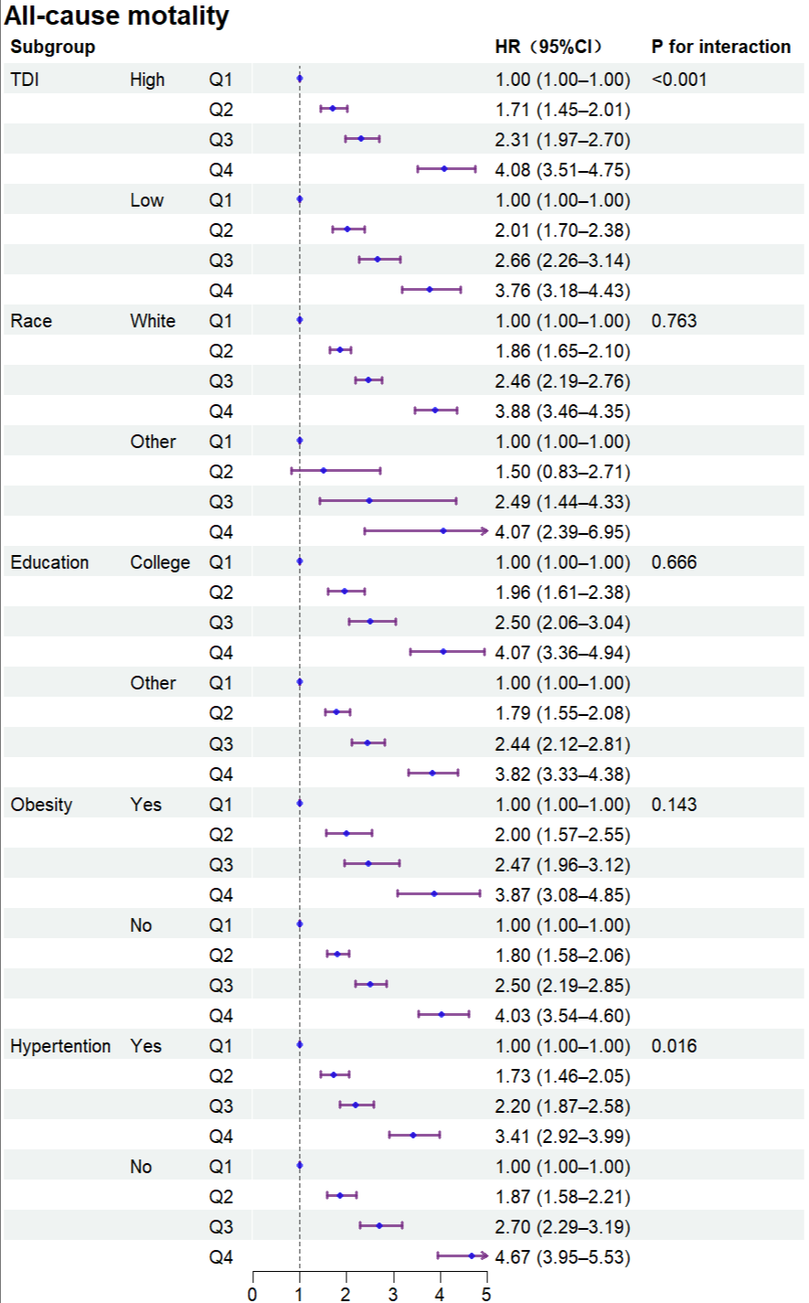
Abbreviations: HR = Hazard Ratio; CI = confidence interval; TDI= Townsend deprivation index
Figure S8. Forest plot of all-cause mortality according to subgroups (ClivD_{nonlab})
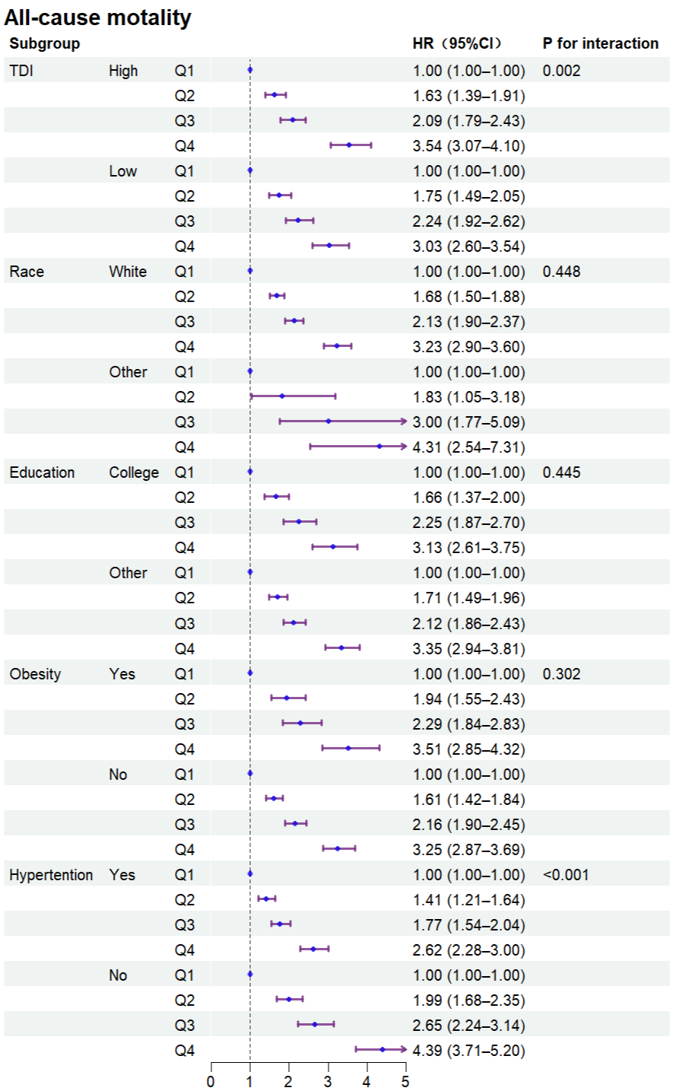
Abbreviations: HR = Hazard Ratio; CI = confidence interval; TDI= Townsend deprivation index
Figure S9. Forest plot of all-cause dementia according to subgroups (ClivD_{lab}).
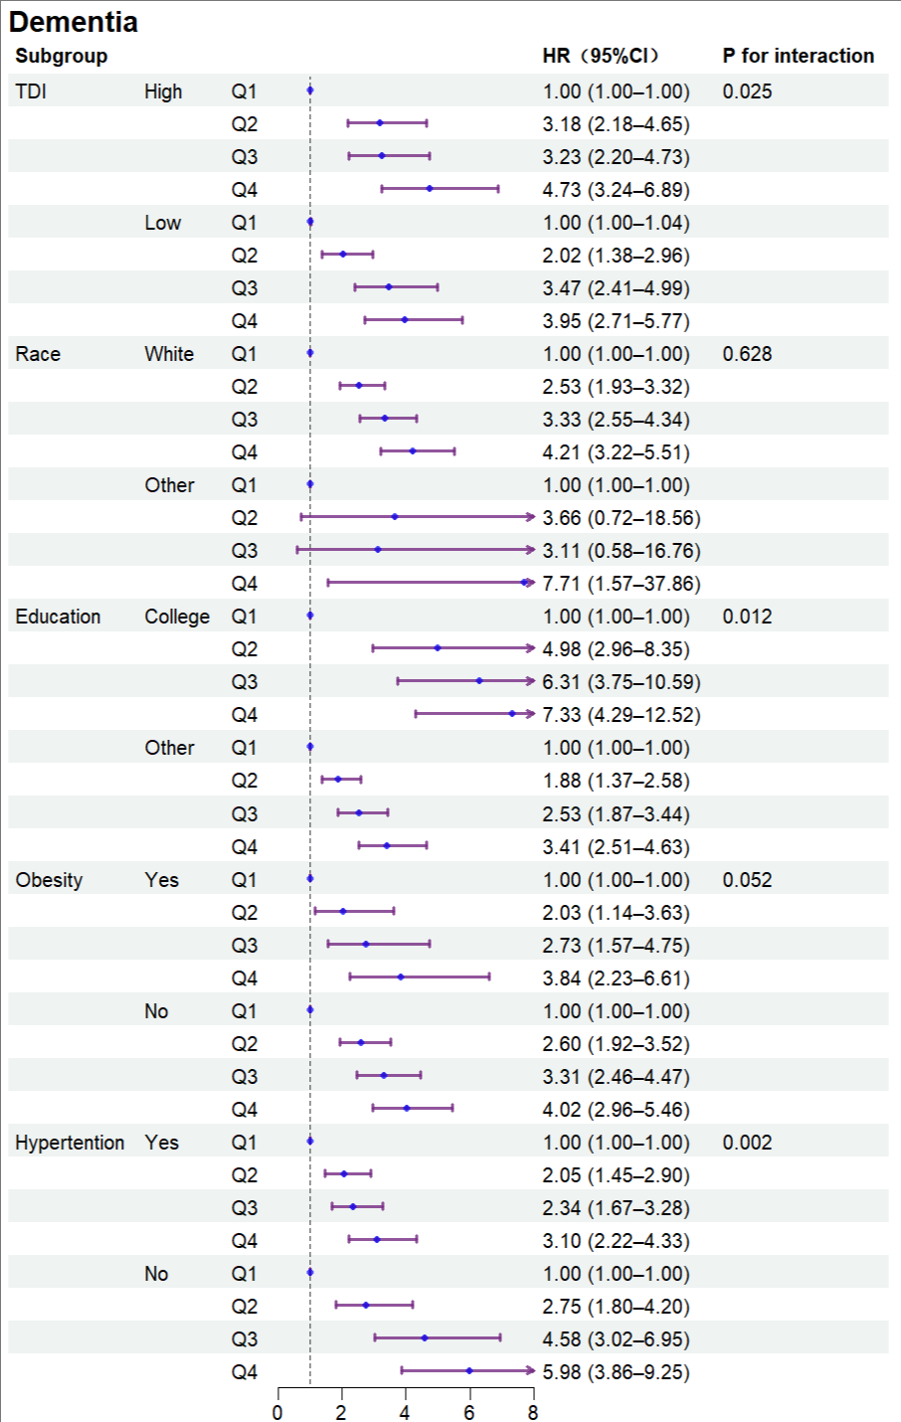
Abbreviations: HR = Hazard Ratio; CI = confidence interval; TDI= Townsend deprivation index
Figure S10. Forest plot of all-cause dementia according to subgroups (ClivD_{nonlab}).
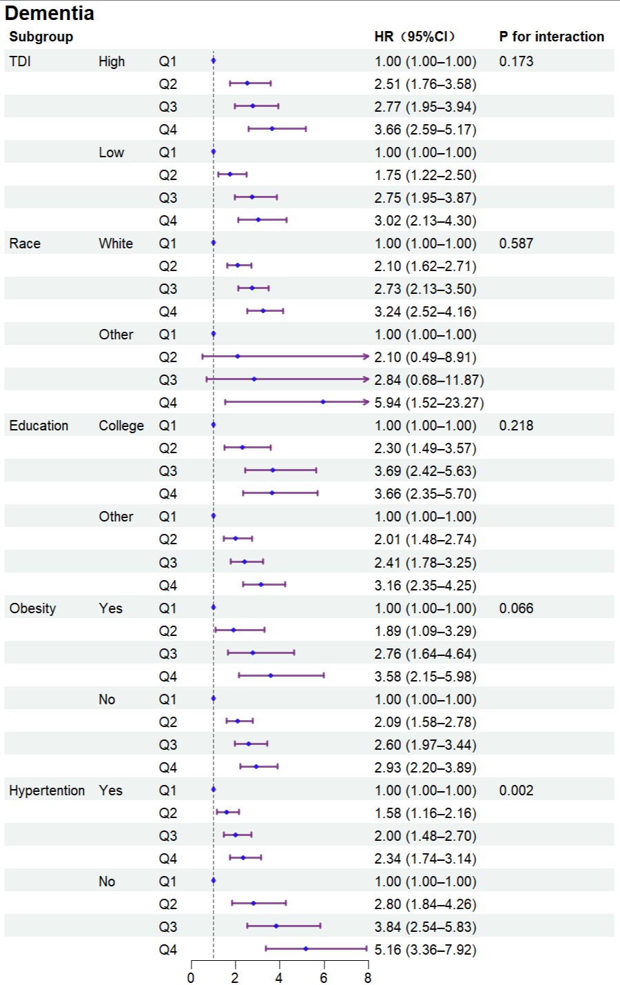
Abbreviations: HR = Hazard Ratio; CI = confidence interval; TDI= Townsend deprivation index
Figure S11. Forest plot of total cardiovascular diseases according to subgroups (ClivD_{lab}).
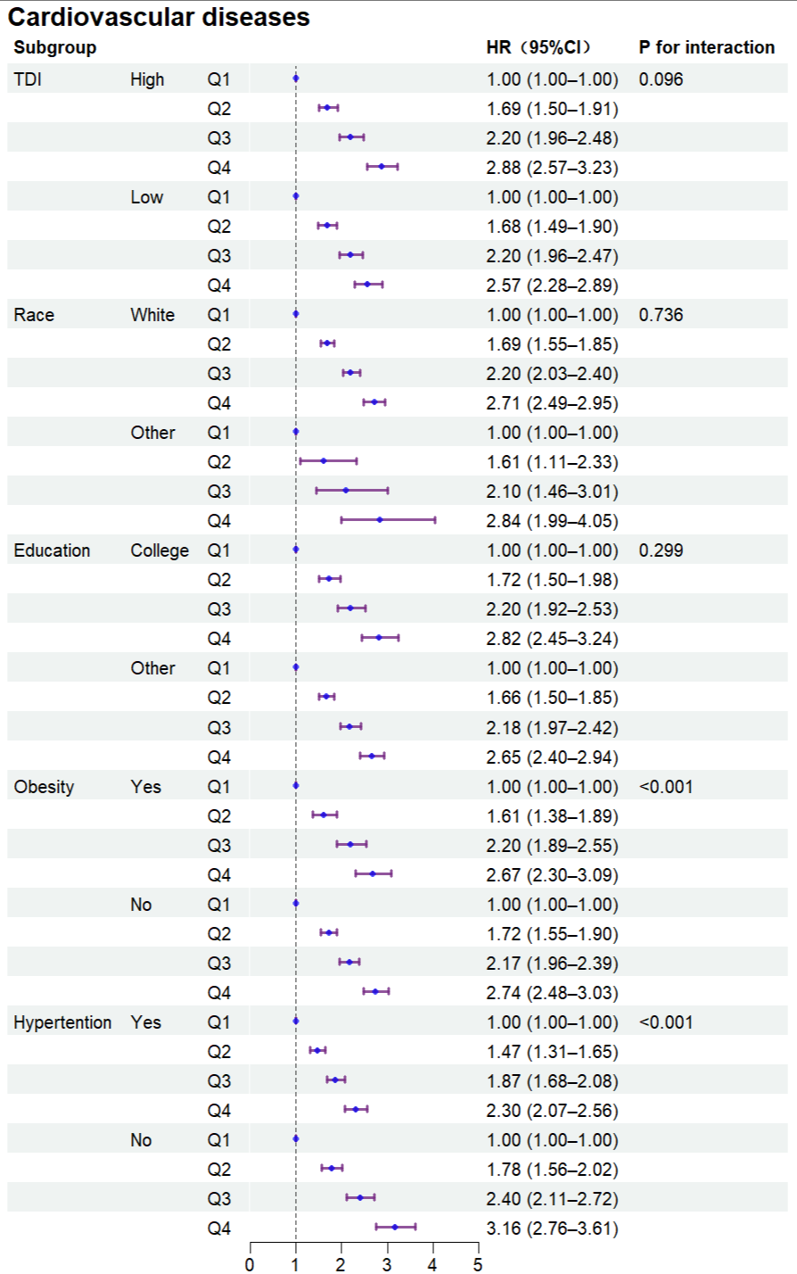
Abbreviations: HR = Hazard Ratio; CI = confidence interval; TDI= Townsend deprivation index
Figure S12. Forest plot of total cardiovascular diseases according to subgroups (ClivD_{nonlab}).
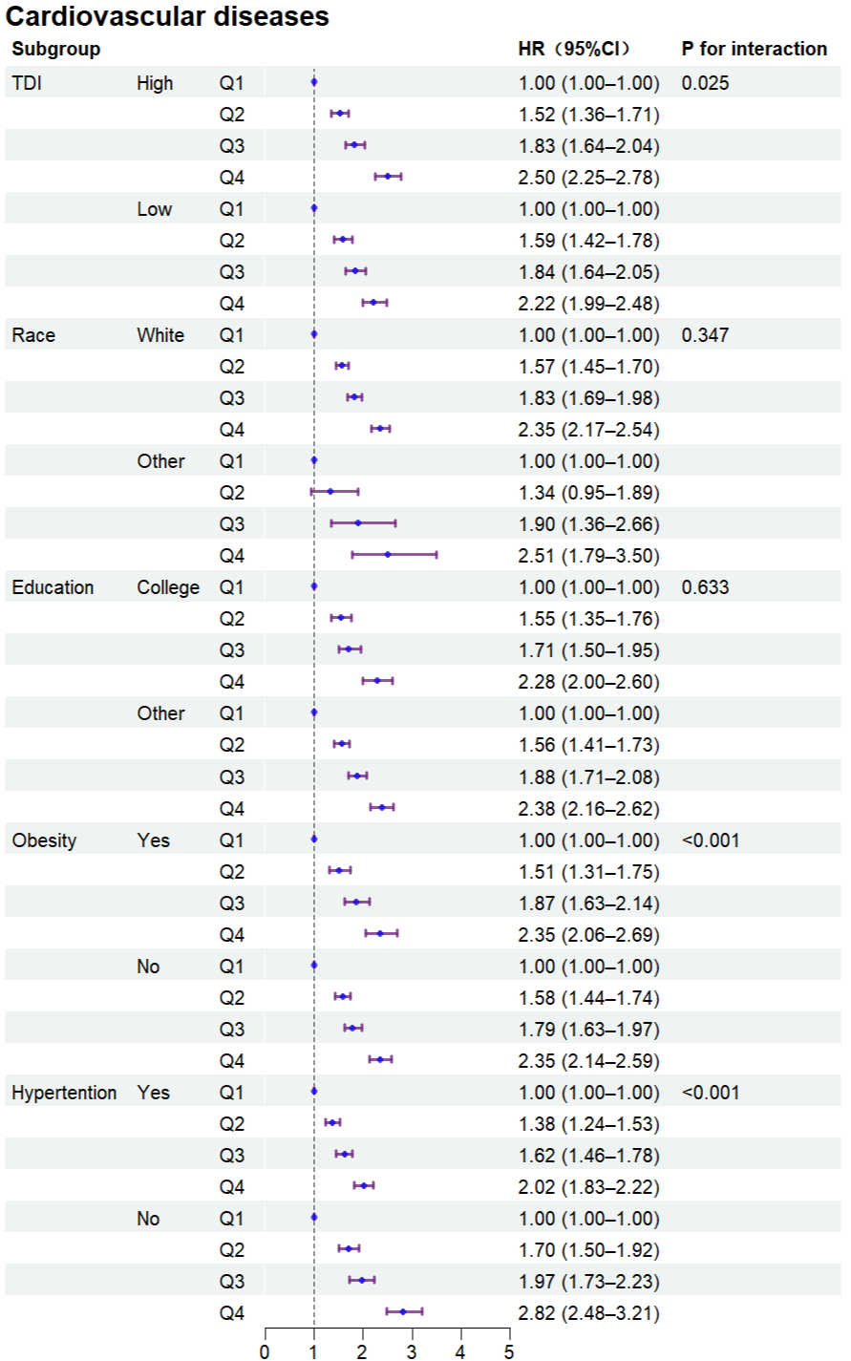
Abbreviations: HR = Hazard Ratio; CI = confidence interval; TDI= Townsend deprivation index
Figure S13. Forest plot of cancer according to subgroups (ClivD_{lab}).
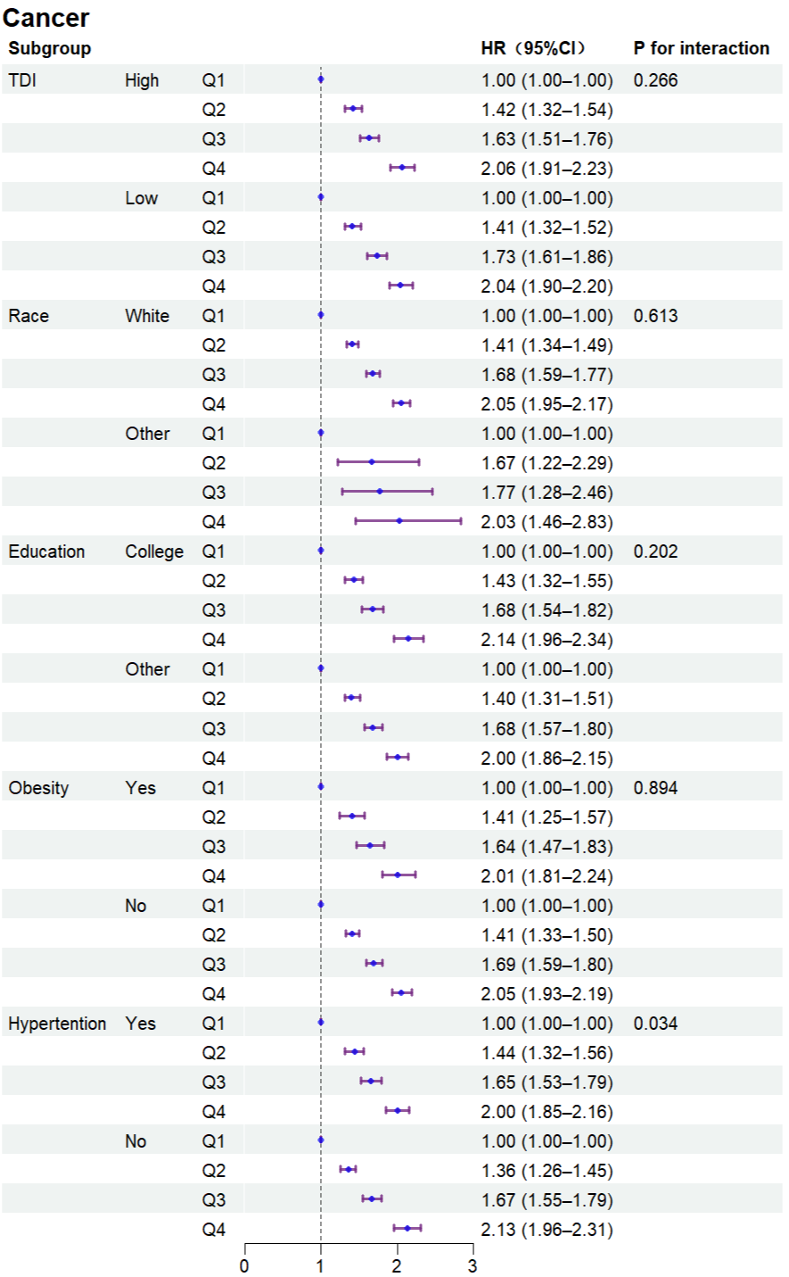
Abbreviations: HR = Hazard Ratio; CI = confidence interval; TDI= Townsend deprivation index
Figure S14. Forest plot of cancer according to subgroups (ClivD_{nonlab}).
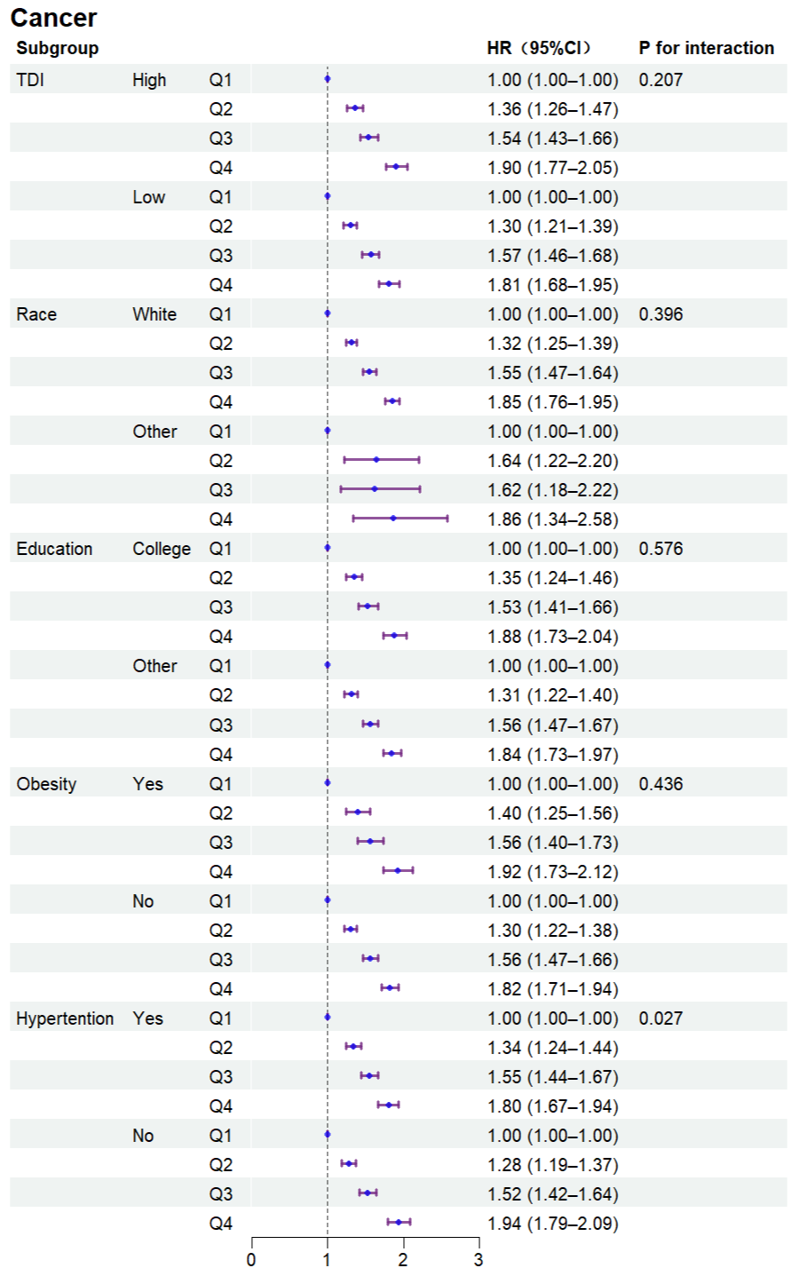
Abbreviations: HR = Hazard Ratio; CI = confidence interval; TDI= Townsend deprivation index
Figure S15. Forest plot of Alzheimer's disease according to subgroups (ClivD_{lab}).
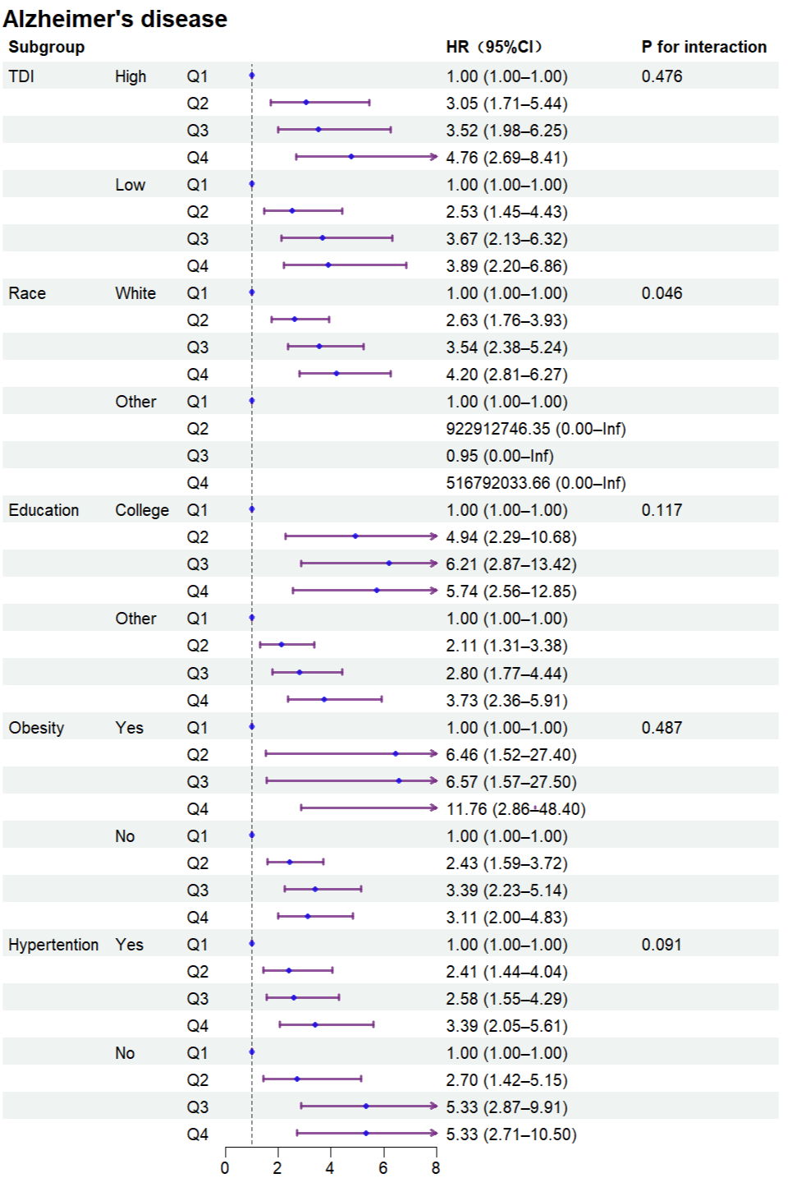
Abbreviations: HR = Hazard Ratio; CI = confidence interval; TDI= Townsend deprivation index

Figure S16. Forest plot of Alzheimer's disease according to subgroups (ClivD_{nonlab}).
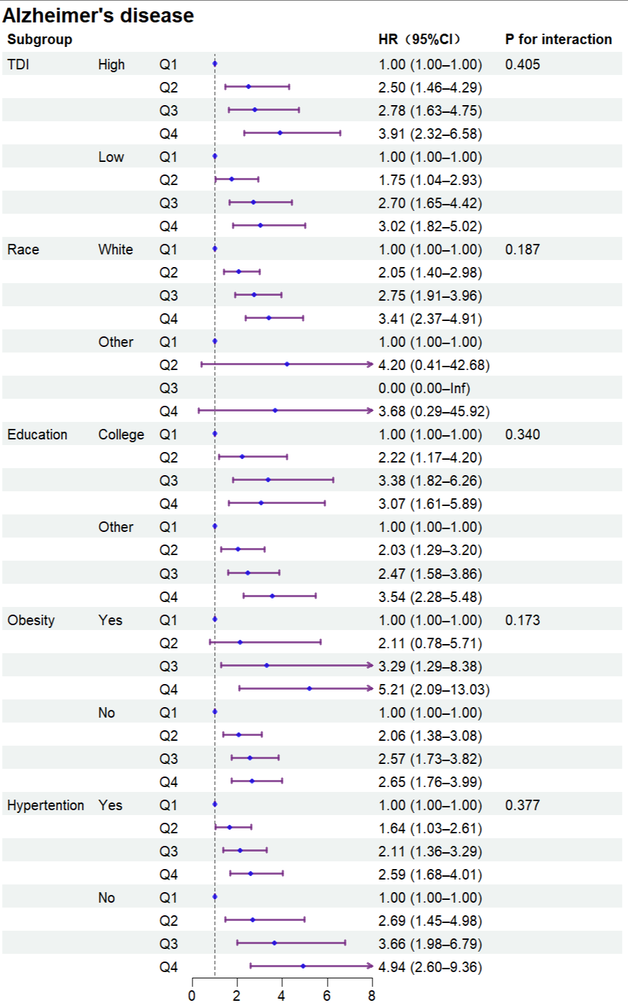
Abbreviations: HR = Hazard Ratio; CI = confidence interval; TDI= Townsend deprivation index
Figure S17. Forest plot of vascular dementia according to subgroups (ClivD_{lab}).
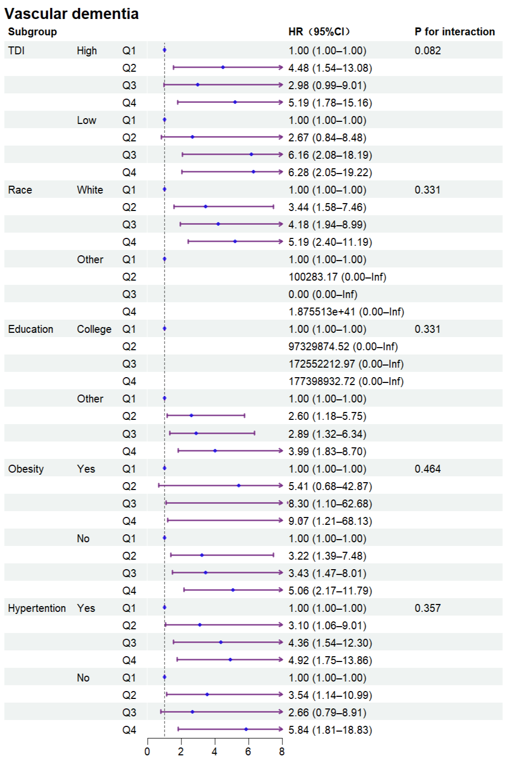
Abbreviations: HR = Hazard Ratio; CI = confidence interval; TDI= Townsend deprivation index

Figure S18. Forest plot of vascular dementia according to subgroups (ClivD_{nonlab}).
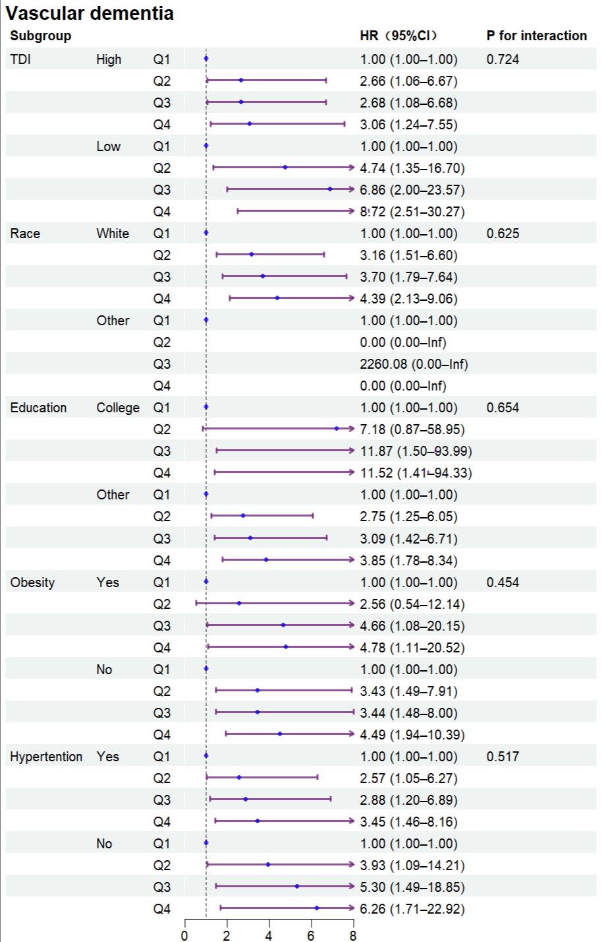
Abbreviations: HR = Hazard Ratio; CI = confidence interval; TDI= Townsend deprivation index
Figure S19. Forest plot of coronary heart disease according to subgroups (ClivD_{lab}).
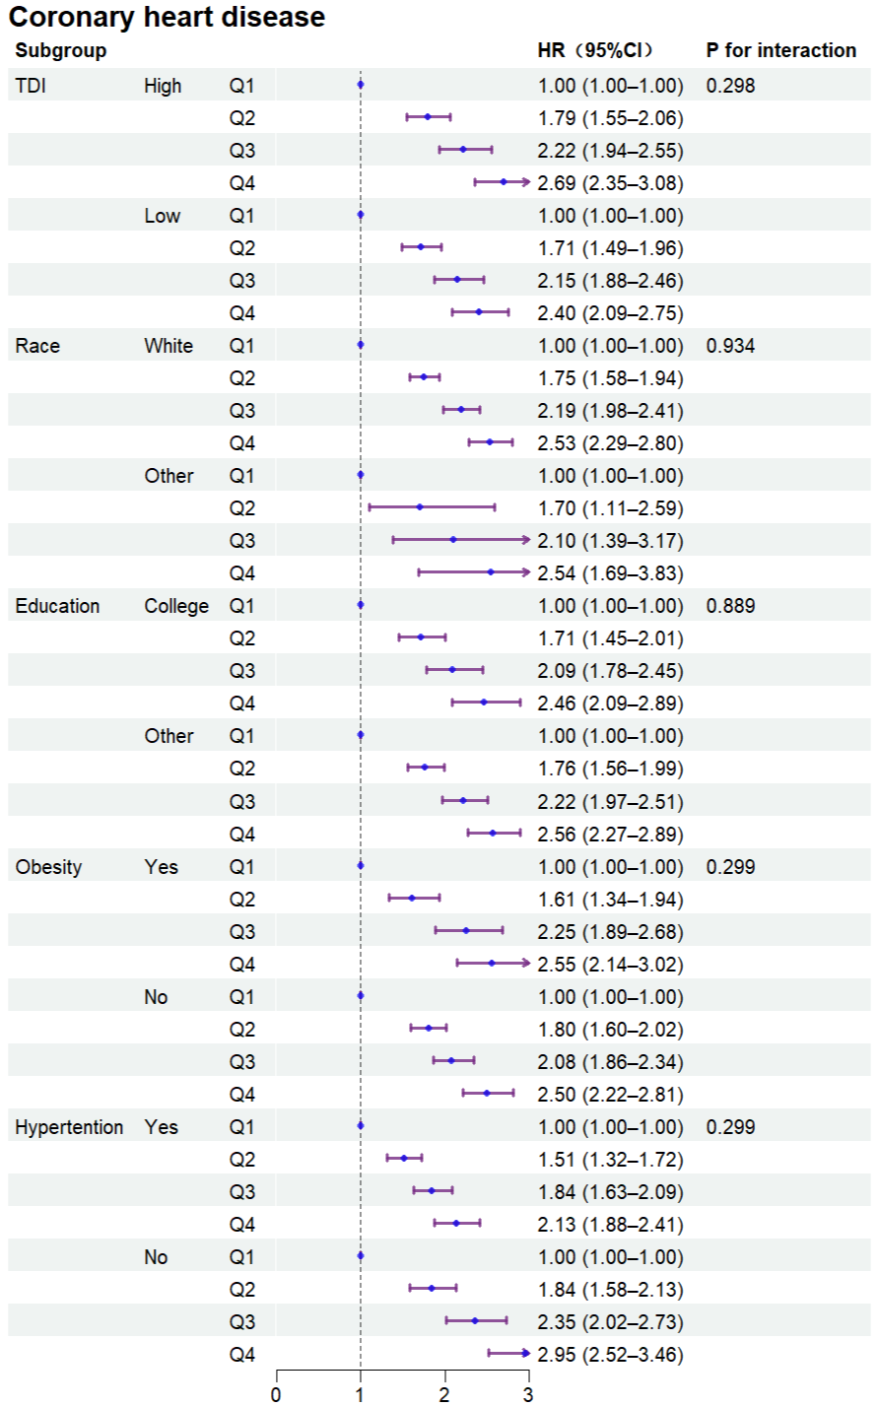
Abbreviations: HR = Hazard Ratio; CI = confidence interval; TDI= Townsend deprivation index
Figure S20. Forest plot of coronary heart disease according to subgroups (ClivD_{nonlab}).
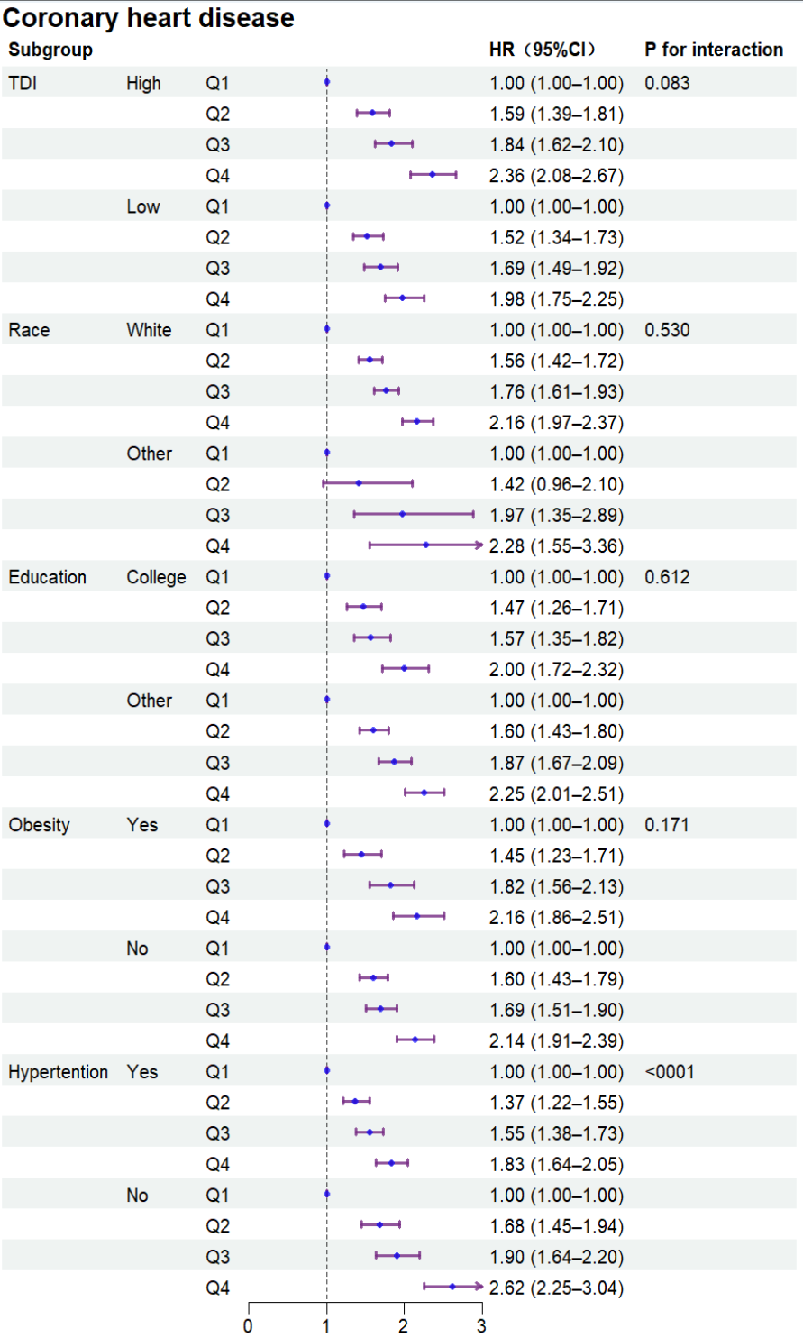 Abbreviations: HR = Hazard Ratio; CI = confidence interval; TDI= Townsend deprivation index
Figure S21. Forest plot of heart failure according to subgroups (ClivD_{lab}).
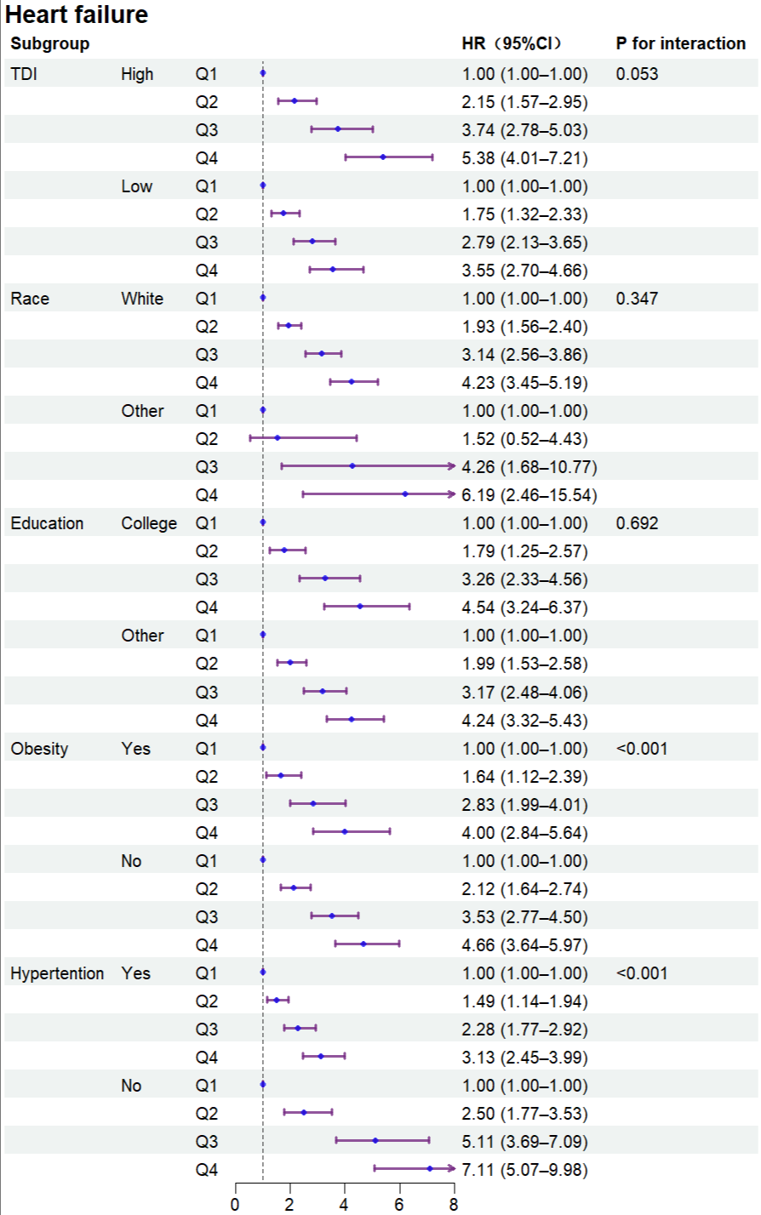
Abbreviations: HR = Hazard Ratio; CI = confidence interval; TDI= Townsend deprivation index
Figure S22. Forest plot of heart failure according to subgroups (ClivD_{nonlab}).
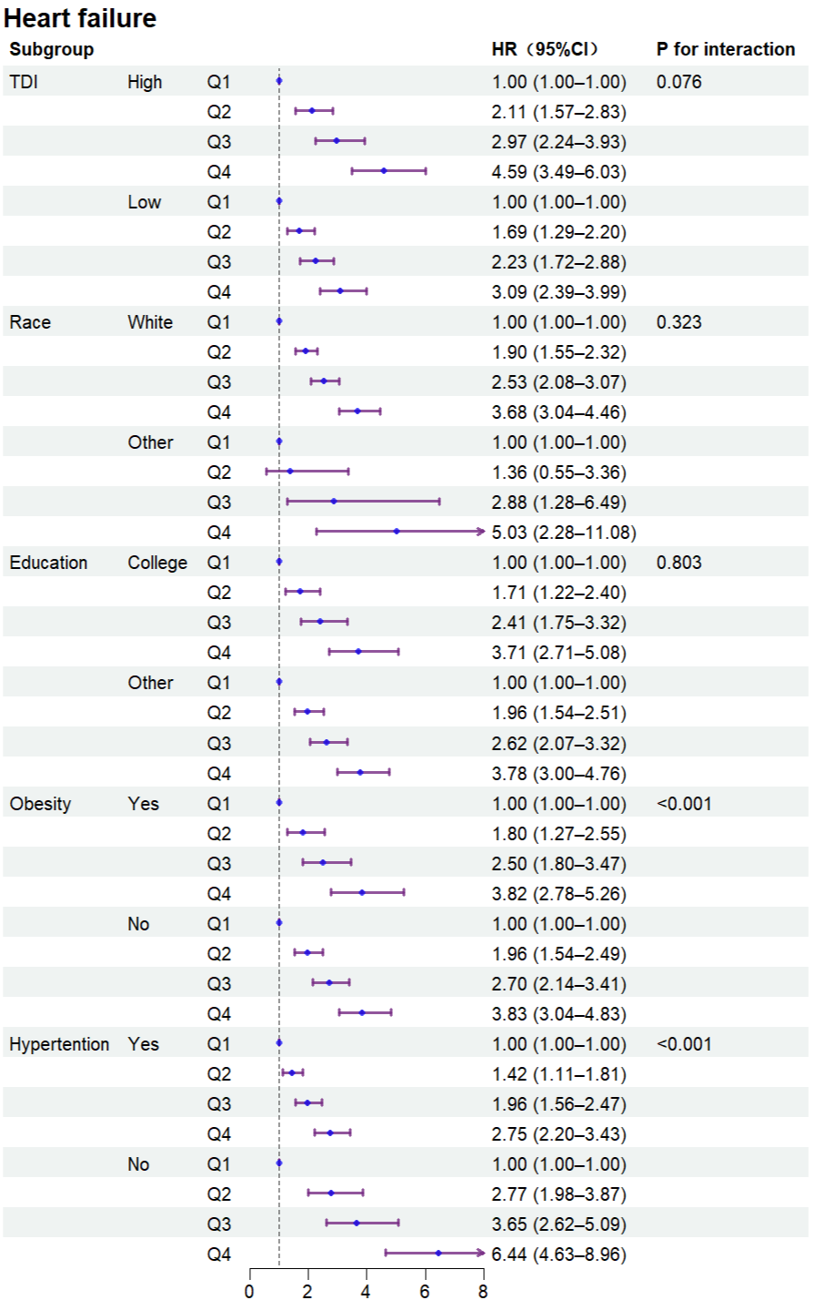
Abbreviations: HR = Hazard Ratio; CI = confidence interval; TDI= Townsend deprivation index
Figure S23. Forest plot of stroke according to subgroups (ClivD_{lab}).
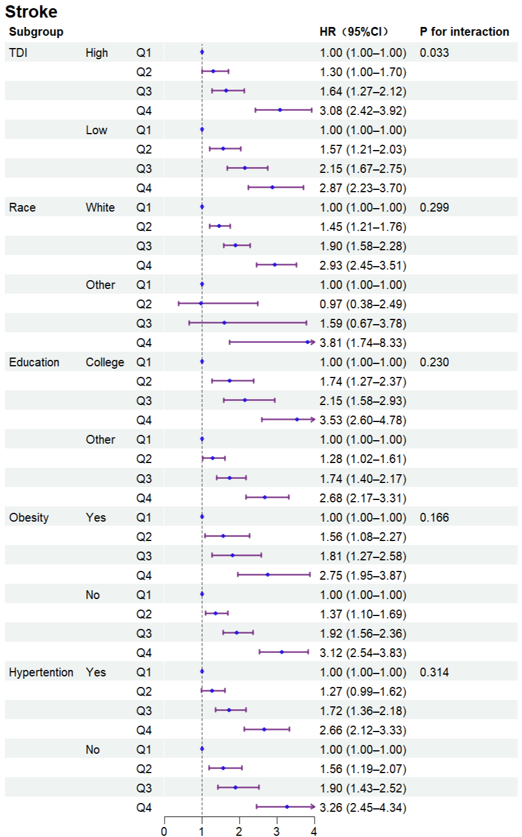
Abbreviations: HR = Hazard Ratio; CI = confidence interval; TDI= Townsend deprivation index
Figure S24. Forest plot of stroke according to subgroups (ClivD_{nonlab}).
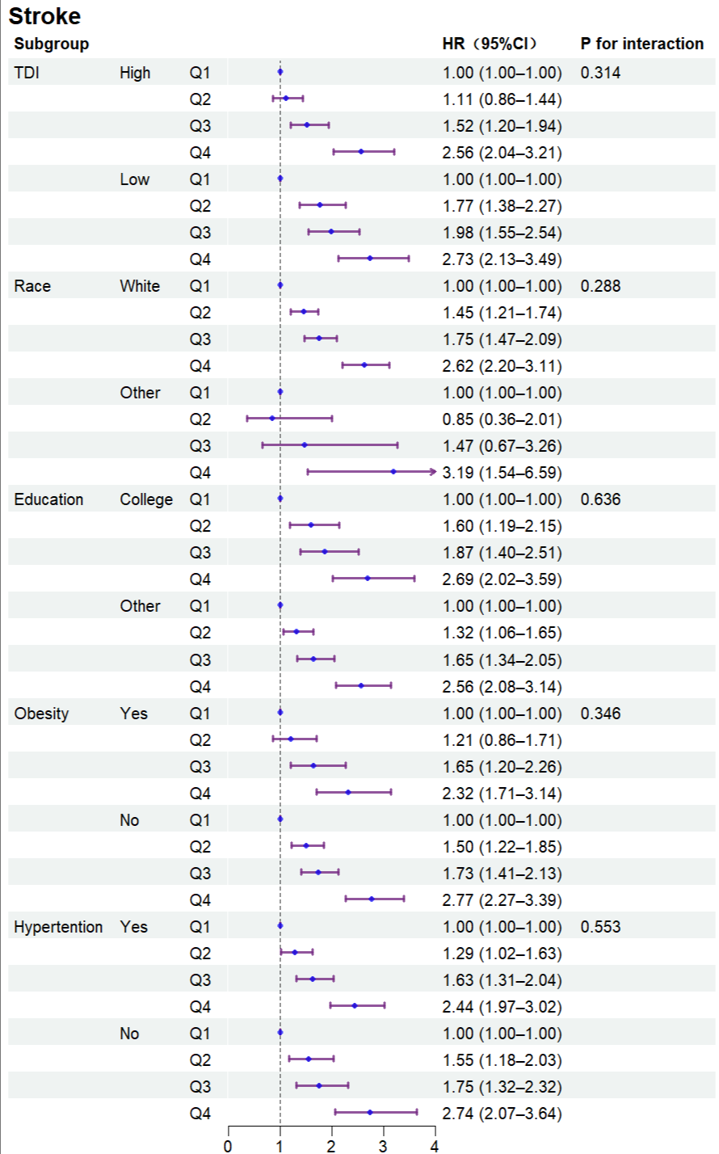
Abbreviations: HR = Hazard Ratio; CI = confidence interval; TDI= Townsend deprivation index

eReferences
1. Alcohol units. nhs.uk. Accessed June 9, 2020. https://www.nhs.uk/live-well/alcohol-advice/calculating-alcohol-units/
2. What Is Fortified Wine? Types, Benefits, and Downsides. . Accessed June 9, 2020. https://www.healthline.com/nutrition/fortified-wine#types

