Supplementary

Cotton's Ancient Genesis: Amber Fossils from 99 Million-Year-Old Mid-Cretaceous Redefine Evolutionary Significance in Malvaceae
Weijia Huang¹, Wenzhe Liu², Jie Sun³, Yali Li⁴, Xin Wang^{5,*}

Affiliation
¹Blue Miracle Museum Science Research Studio, Guangzhou 510000, China, ORCID: 0000-0002-5112-8931
²Key Laboratory of Resource Biology and Biotechnology in Western China
(Ministry of Education), School of Life Sciences, Northwest University, Xi’an 710069, China, ORCID: 0000-0002-7738-0086
³Shaanxi Key Laboratory of Early Life and Environments, State Key Laboratory of Continental Dynamics, Department of Geology, Northwest University, Xi’an 710069, China, ORCID: 0009-0005-4870-9670
⁴Qinling National Botanical Garden, Xi’an 712100, China, ORCID: 0009-0003-9241-9043
⁵State Key Laboratory of Palaeobiology and Stratigraphy, Nanjing Institute of Geology and Palaeontology and Center for Excellence in Life and Paleoenvironment, Chinese Academy of Sciences, Nanjing 210008, China
*Email: xinwang@nigpas.ac.cn, ORCID: 0000-0002-4053-5515

Fig. S1 General information of the Myanmar amber. A. The whole block of amber. B. Fifteen seed-containing bubbles of variable sizes in the amber.
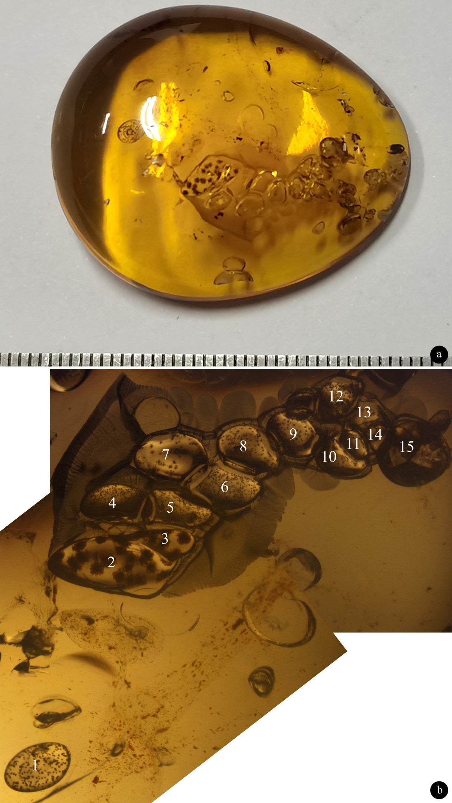

Table S1. Comparison among extant angiosperms producing hairy seeds.
Family | Taxa | Age | Hair form | Hair attachement | Hair length | Seed body position | Seed form | Seed length | Reference
Malvaceae | Eogossypium maxima | Cretaceous | twisted | seed-surface | 119-254 μm | central | spheroid | 131-160 μm | Present study
Malvaceae | Eogossypium intermedia | Cretaceous | sinuous | seed-surface | 100-110 μm | central | spheroid | 40-75 μm | Present study
Malvaceae | Eogossypium minuta | Cretaceous | sinuous | seed-surface | 62 μm | central | spheroid | 28-43 μm | Present study
Malvaceae | Eogossypium minima | Cretaceous | spine-like | seed-surface | up to 23 μm | central | spheroid | 69-82 μm | Present study
Malvaceae | Gossypium hirsutum, G. tomentosum, G. sturtianum, G. arboreum, G. herbaceum subsp. africanum, G. raimondii, G. davidsonii, G. longicalyx, G. anomalum | extant | sinuous | seed-surface | 0-60 mm | central | oval, tapered | 4.5-13 mm | ¹⁻⁶
Malvaceae | Bombax | extant | sinuous | seed pod | up to 30 mm | basal | obovoid | 6~9 mm | ⁷⁻⁹
Malvaceae | Ceiba | extant | sinuous | seed pod | up to 32 mm | basal | obovoid | up to 6 mm | ^{10,11}
 | Baisian achene | Cretaceous | twisted, in facsicles | basal | >7 mm | apical | flasked | 3.6 mm | ¹²
 | Problematospermum | Jurassic-Cretaceous | straight, forked | basal | 16 mm | apical | fusiform | 1.6-8.4 mm | ¹³
Salicaceae | Salix | extant | straight, cylindrical | basal | 3.8~4.2 mm | apical | flasked | 1.2~1.4 mm | ¹⁴
Salicaceae | Populus | extant | straight , cylindrical | basal | 4 mm | apical | fusiform | ~1.1 mm | ^{9,14}
Tamaricaceae | Tamarix | extant | straight | apical | >1 mm | basal | oval | 0.5 mm | ¹⁵

Table S2. Numbers of linted seeds in various bubbles.
Bubble | Seed type | Number of seeds
1 | Eogossypium minima | 259
2 | Eogossypium maxima | 18
3 | Eogossypium maxima | 6
4 | Eogossypium minima | 200
5 | Eogossypium minima | 200
6 | Eogossypium minima | 155
7 | Eogossypium intermedia | 30
8 | Eogossypium minuta | 82
9 | Eogossypium minuta | 50
10 | Eogossypium intermedia | 18
11 | Eogossypium minuta | 29
12 | Eogossypium minuta | 119
13 | Eogossypium minuta | 15
14 | Eogossypium minuta | 18
15 | Eogossypium minuta | 14

Table S3. Measurements of various species of Eogossypium.
Taxon | Number of seeds | Diameter of seed | Length of hairs
Eogossypium minima | 814 | 69-82 μm | up to 23 μm
Eogossypium minuta | 327 | 100-120 μm | up to 62 μm
Eogossypium intermedia | 48 | 200-260 μm | up to 110 μm
Eogossypium maxima | 24 | 530-630 μm | up to 254 μm
TOTAL | 1213

References
1 Wendel, J. F. & Grover, C. E. in Cotton Vol. 57 (eds David D. Fang & Richard G. Percy) 25-44 (2015).
2 Dowd, M. K. in Cotton Vol. 57 (eds David D. Fang & Richard G. Percy) 745-781 (2015).
3 Kim, H. J. in Cotton Vol. 57 (eds David D. Fang & Richard G. Percy) 97-127 (2015).
4 Turley, R. B. & Kloth, R. H. Identification of a third fuzzless seed locaus in upland cotton (Gossypium hirsutum L.). The Journal of Heredity 93, 359-364, (2002).
5 Haigler, C. H. in Physiology of Cotton (ed J. McD. Stewart)Ch. 4, 33-47 (Springer, 2010).
6 Wendel, J. F., Brubaker, C. L. & Seelanan, T. in Physiology of Cotton (eds James McD. Stewart, Derrick M. oosterhuis, James J. Heitholt, & Jack R. Mauney) 1-18 (Springer Science, 2010).
7 Shah, N. C. The identification, etymology and uses of Bombax ceiba (semal) sold by street vendors as Semarkanda: a review. Indian Journal of History of Science 57, 10-15, (2022).
8 Rajendra, K. C. A breif introduction to Semal (Bombax ceiba Linn). 14 (George-August University, 2007).
9 Likon, M., Remškar, M., Ducman, V. & Švegl, F. Populus seed fibers as a natural source for production of oil super absorbents. Journal of Environmental Management 114, 158-167, (2013).
10 Gómez-Maqueo, X. & Gamboa-deBuen, A. The Biology of the genus Ceiba, a potential source for sustainable production of natural fiber. Plants 11, 521, (2022).
11 Paton, S. Ceiba pentandra seeds, <https://biogeodb.stri.si.edu/bioinformatics/dfm/> (2025).
12 Krassilov, V. A. New paleobotanical data on origin and early evolution of angiospermy. Annals Missouri Botanical Garden 71, 577-592, (1984).
13 Wang, X., Zheng, S. L. & Jin, J. H. Structure and relationships of Problematospermum, an enigmatic seed from the Jurassic of China. International Journal of Plant Sciences 171, 447-456, (2010).
14 Li, J. et al. Development, structure and evolutionary significance of seed appendages in Salix matsudana (Salicaceae). PLoS ONE 13, e0203061, (2018).
15 Li, C., Wei, X. & Lan, H. The environmental adaptation strategy of seed germination, and roles of the seed pappus on dispersal and hypocotyl hairs on seedling anchorage in Tamarix ramosissima. AoB Plants 13, 1-12, (2021).

