Enhancing 1-month temperature predictions in South Korea through dynamical downscaling of machine learning global ensemble forecasts

Supplementary Materials

Subin Ha¹, Xiaohui Zhong², Lei Chen², Hao Li², Jina Hur³, Hyun-Han Kwon⁴,
and Eun-Soon Im^{1,5}

¹ Department of Civil and Environmental Engineering, The Hong Kong University of Science and Technology, Hong Kong SAR
² Artificial Intelligence Innovation and Incubation Institute, Fudan University, Shanghai, China
³ National Institute of Agricultural Sciences, Rural Development Administration, Wanju-gun, Republic of Korea
⁴ Department of Civil and Environmental Engineering, Sejong University, Seoul, Republic of Korea
⁵ Division of Environment and Sustainability, The Hong Kong University of Science and Technology, Hong Kong SAR
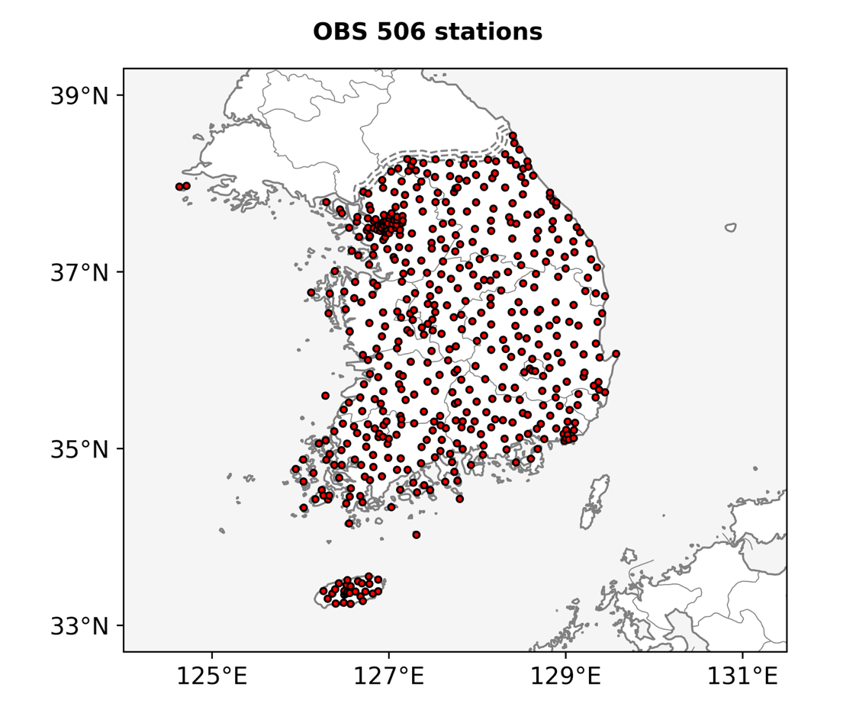
Fig. S1. Locations of the 506 observation stations

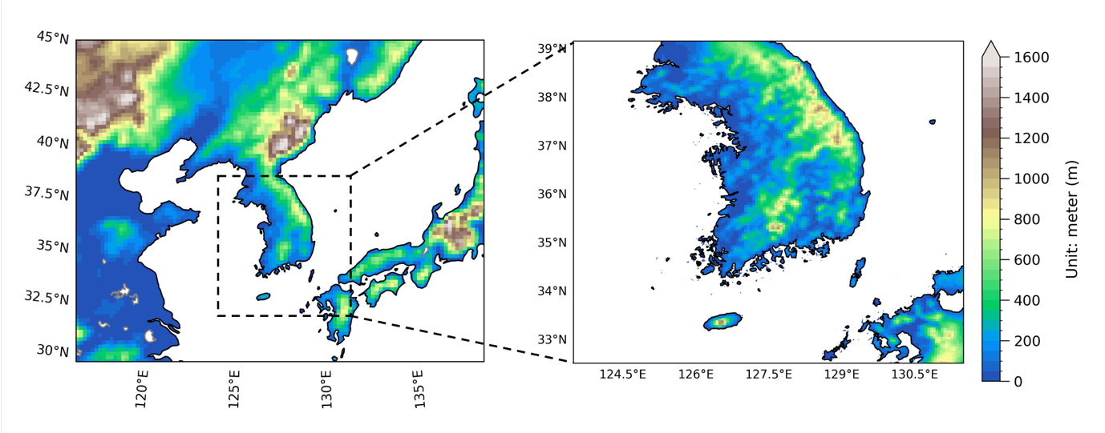
Fig. S2. The model domains that comprise of the 20-km mother domain and the 5-km nested domain

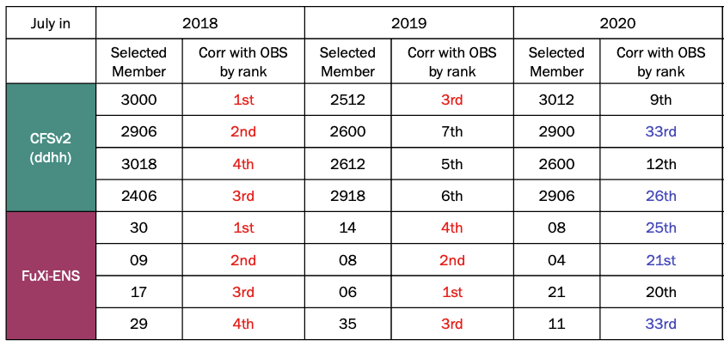
Table S1. Selected CFSv2 and Fuxi members and their actual daily Tmean correlations with OBS by rank out of 40 members (The top 10% rankings are colored in red, and the bottom 50% rankings are colored in blue.)

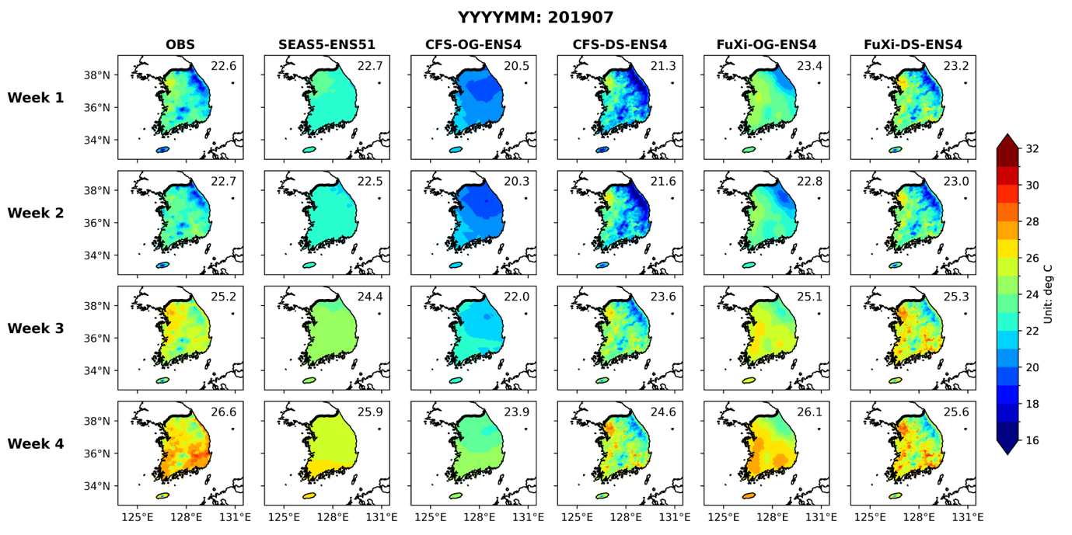
Fig. S3. Weekly Tmean spatial maps of OBS, SEAS5-ENS, CFS-OG-ENS4, CFS-DS-ENS4, FuXi-OG-ENS4, and FuXi-DS-ENS4 for July 2019

