Supplementary information to

Single-molecule mass measurements reveal distinct effects of sodium and potassium on mini-spidroin assembly

Hannah Osterholz, Shree Senthil Jeyalekshmy, Benjamin Schmuck, Tomas Bohn Pessatti, Justin.P. Benesch, Anna Rising, Axel Leppert, Michael Landreh

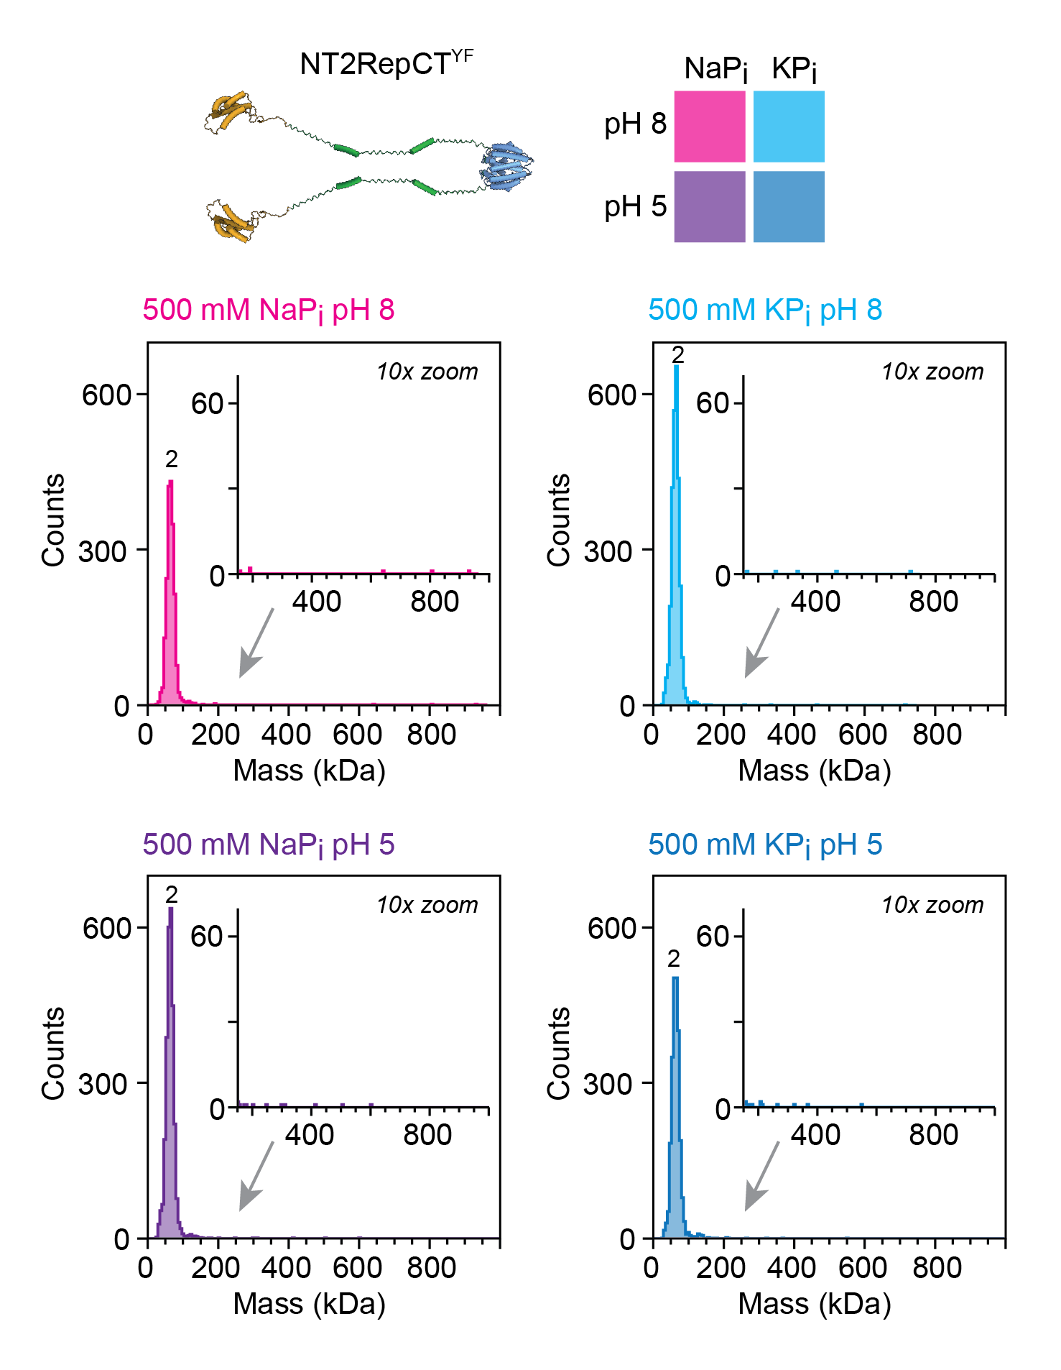
Figure S1. MP histograms of 10 nM NT2RepCT^{YF} in 500 mM NaP_{i} or KP_{i} show exclusively spidroin dimers with no pronounced differences between conditions.

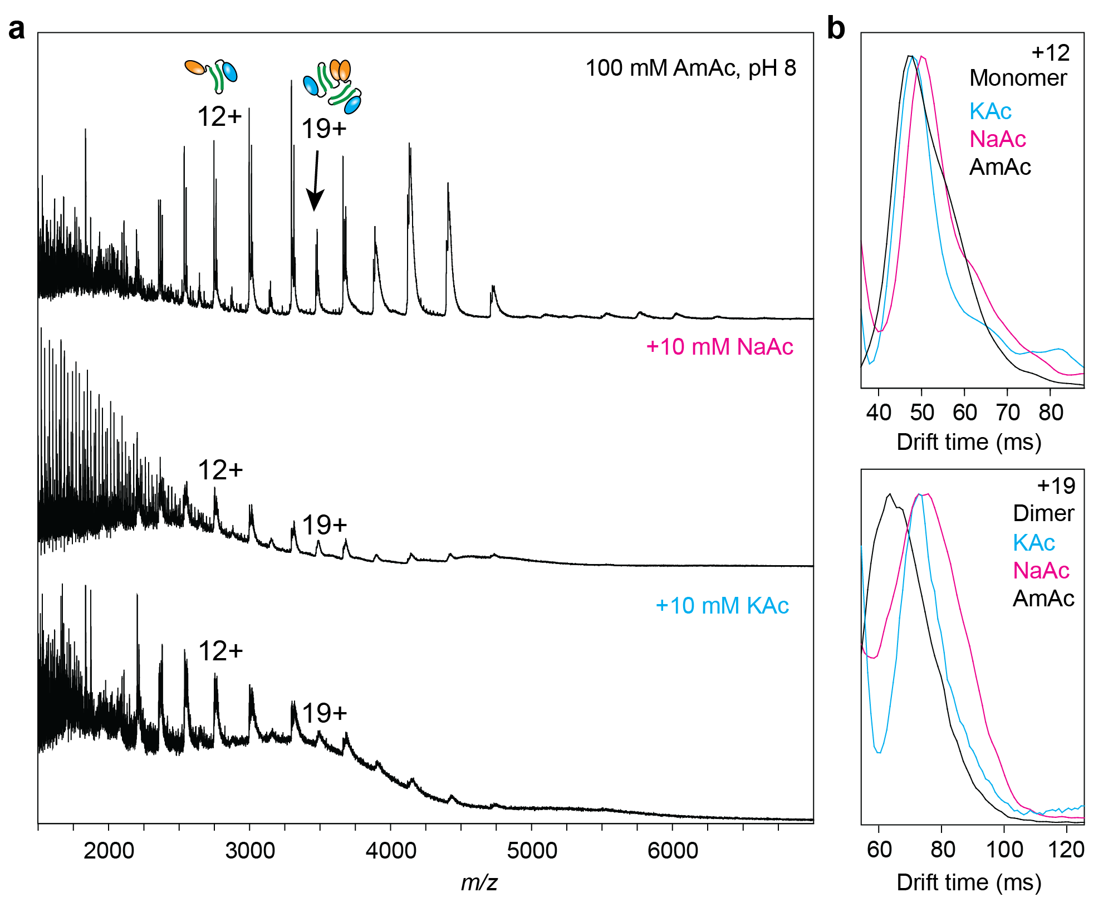
Figure S2. Native IM-MS of NT2RepCT^{YF} shows conformational effects of sodium and potassium. (a) Mass spectra of NT2RepCT^{YF} in 100 mM AmAc supplemented with NaAc or KAc show partial signal suppression but discernable peaks for the 12+ charge state of the monomer and the 19+ charge state of the dimer. (b) Comparison of the arrival time distributions for the 12+ monomer (top) or the 19+ dimer (bottom) at each condition shows a lower arrival time for the protein ionized in the presence of potassium (blue) compared to sodium (pink).

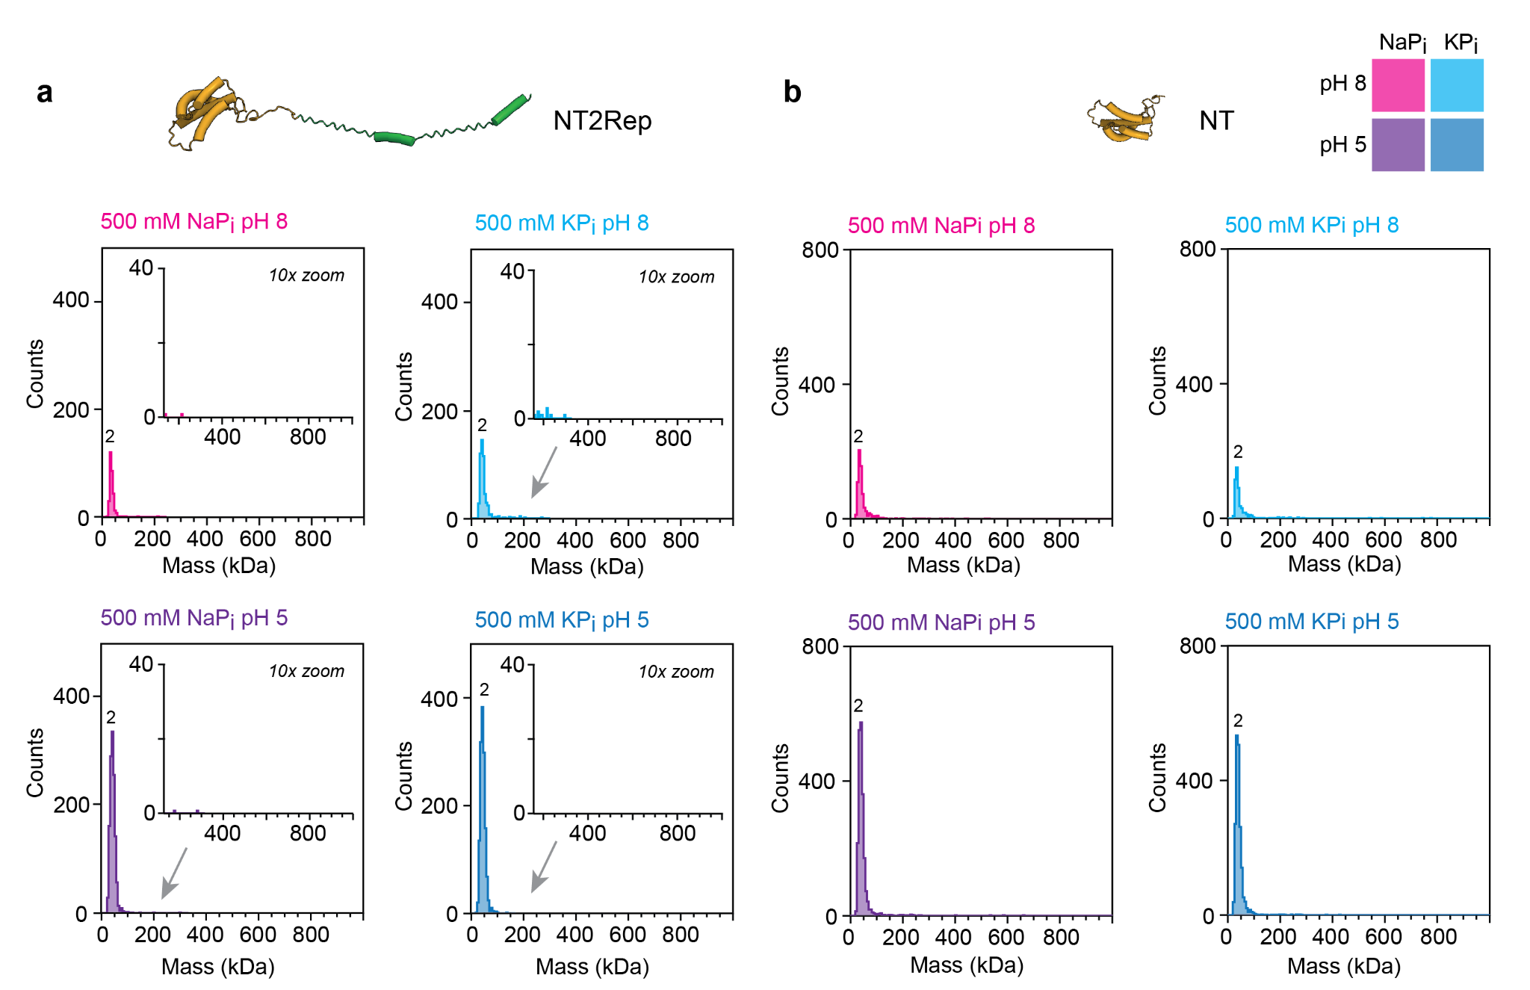
Figure S3. MP histograms of NT2Rep in 500 mM NaP_{i} or KP_{i} show increased dimerization at pH 5, but no pronounced differences between NaP_{i} or KP_{i}.

