Supporting Information
Systematic modulation of superconducting gap dynamics in YBCO|BNT|YBCO Josephson Junctions through THz field interaction and BNT ferroelectric barrier
Muthukkumaran Karthikeyan^{ab*}, Geoffrey Chanda^{de}, Thanayut Kaewmaraya^{fg}, Pairot Moontragoon^{fg}, Guoxing Sun^{h}, Zongjin Li^{i}, Anucha Watcharapasorn^{abc*}
ªCenter of Excellence in Quantum Technology, Faculty of Engineering, Chiang Mai University, Chiang Mai, 50200, Thailand
^{b}Department of Physics and Materials Science, Faculty of Science, Chiang Mai University, Chiang Mai 50200, Thailand
^{c}Center of Excellence in Materials Science and Technology, Materials Science Research Center, Faculty of Science, Chiang Mai University, Chiang Mai 50200, Thailand
^{d}Physikalisches Institut, Universität Stuttgart, Pfaffenwaldring 57, 70550 Stuttgart, Germany
^{e}Department of Physics, University of Zambia, P.O Box 32379, Lusaka, Zambia
^{f}Department of Physics, Faculty of Science, Khon Kaen University, Khon Kaen, 40002, Thailand
^{g}Institute of Nanomaterials Research and Innovation for Energy (IN-RIE), Research Network of
NANOTEC- KKU (RNN), Khon Kaen University, Khon Kaen 40002, Thailand
^{h}Joint Key Laboratory of the Ministry of Education, Institute of Applied Physics and Materials Engineering, University of Macau, Avenida da Universidade, Taipa, Macau, SAR China
^{j}Faculty of Innovation Engineering, Macau University of Science and Technology, Avenida Wai Long, Taipa, Macau, SAR China

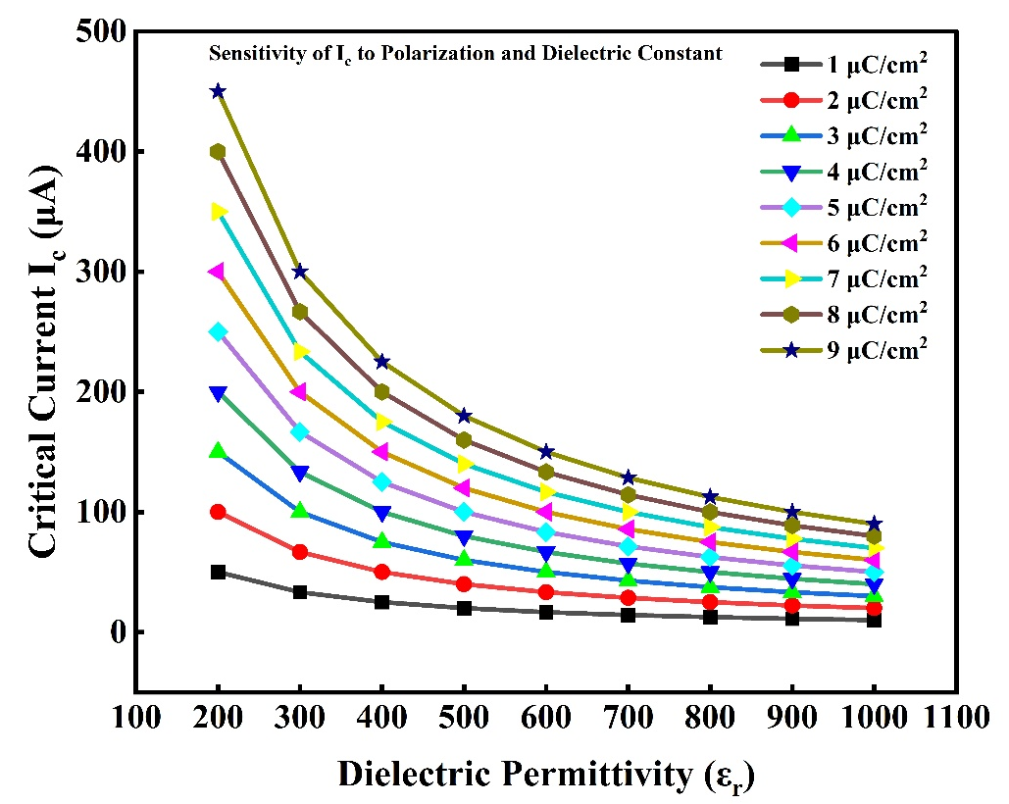

Figure S1. Critical current I_{c} ( μA) as a function of ferroelectric polarization amplitude P (μC/cm²) and dielectric permittivity ε_{r} (dimensionless), based on the extended Hamiltonian model described in Section 3.1. The contour plot illustrates the nonlinear dependence of Josephson coupling on the barrier’s ferroelectric properties. The simulated range of 1−9 μC/cm² and ε_{r}​=200-1000 covers the experimentally accessible regime for BNT thin films. Higher P and ε_{r}​ values enhance the effective coupling, leading to increased I_{c}​. This sensitivity analysis supports the fitting performed in the main text and confirms consistency between model parameters and physical properties of the BNT barrier under THz-field excitation
Supplementary Table S1. Fitted Model Parameters for THz-Driven Josephson Junctions (Used in Eq. 5)
Parameter | Symbol | Value / Range | Notes
Dielectric Permittivity | ε_{r}​ | 200 – 1000 | Frequency- and temperature-dependent; consistent with BNT literature [1-3]
Polarization Amplitude | P(ω,T) | 1 – 9 μC/cm² | Varies with THz frequency and temperature
Josephson Coupling Constant | J₀​ | Normalized to 1 (arb. units) | Sets baseline I_{c}​ without THz field
THz Field Strength | E_{THz}​ | 20 – 80 kV/cm | Controlled in experiment
Characteristic Frequency | ω₀​ | 0.35 – 0.45 THz | Center of resonant response
Damping Factor | γ | 0.05 – 0.15 (arb. units) | Accounts for ferroelectric loss and damping

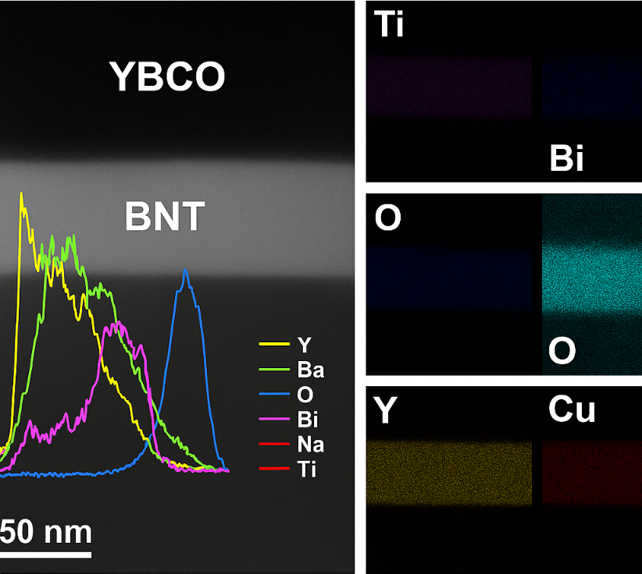

Figure S2. High-resolution cross-sectional TEM and EDS elemental mapping of the YBCO|BNT|YBCO junction.
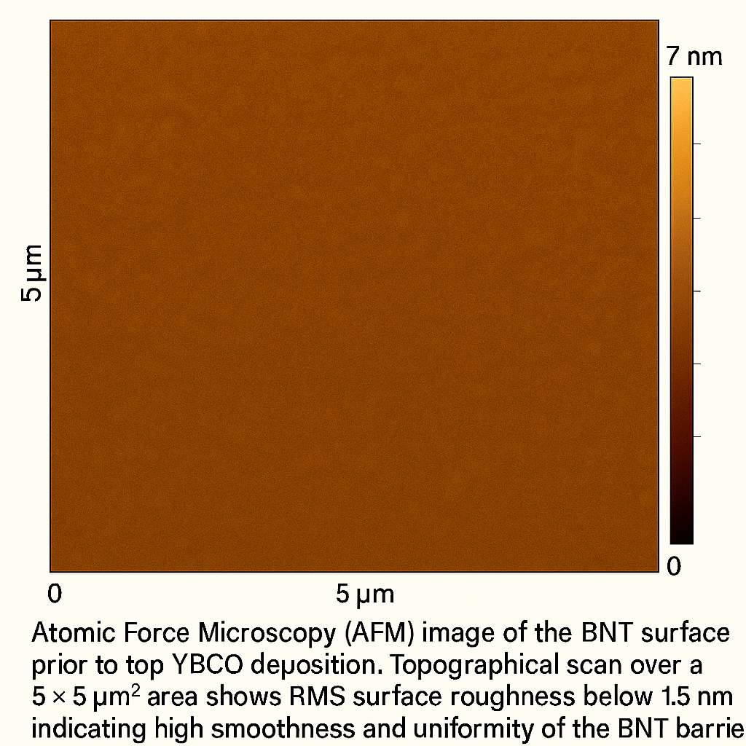
The TEM image confirms the structural continuity and uniformity of the trilayer stack. EDS elemental maps for Bi, Na, Ti (BNT layer) and Y, Ba, Cu (YBCO layers) demonstrate sharp compositional interfaces with no detectable interdiffusion, pinholes, or barrier discontinuities. These observations verify the compositional integrity and spatial uniformity of the 40 nm-thick BNT layer, excluding defect-mediated transport paths.

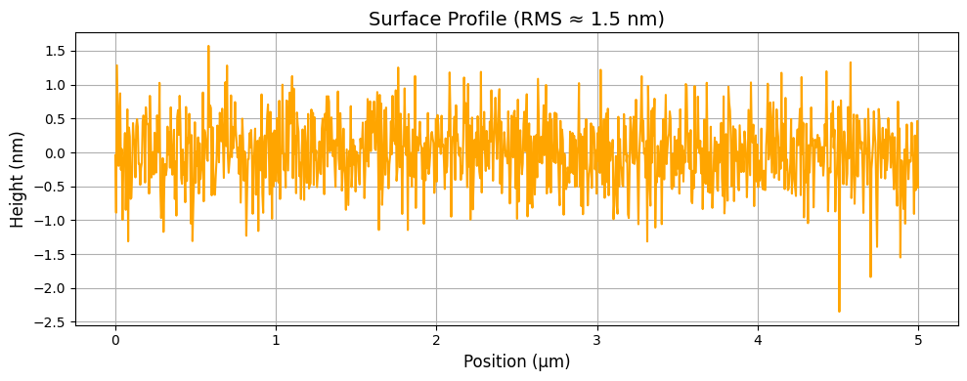

Fig. S3. Atomic Force Microscopy (AFM) image of the BNT surface prior to top YBCO deposition.
Topographical scan over a 5 × 5 μm² area shows RMS surface roughness below 1.5 nm, indicating high smoothness and uniformity of the BNT barrier. Such low roughness supports coherent YBCO overlayer deposition and reduces the likelihood of local shorting or filamentary conduction through the barrier.

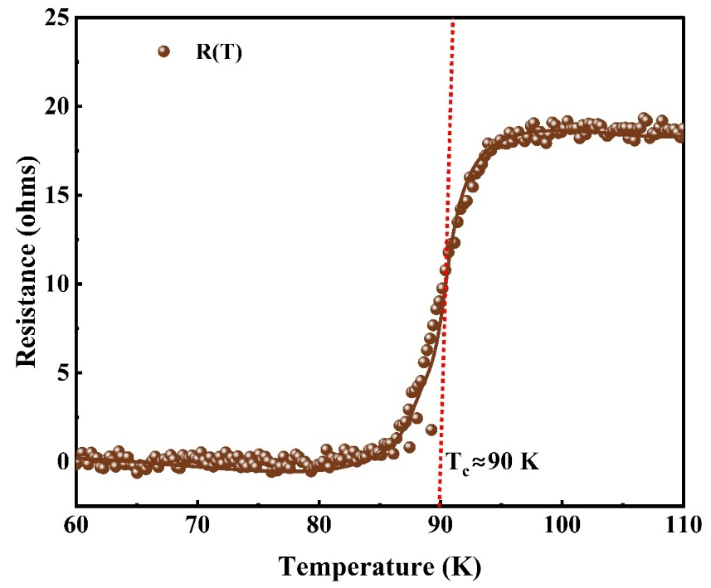

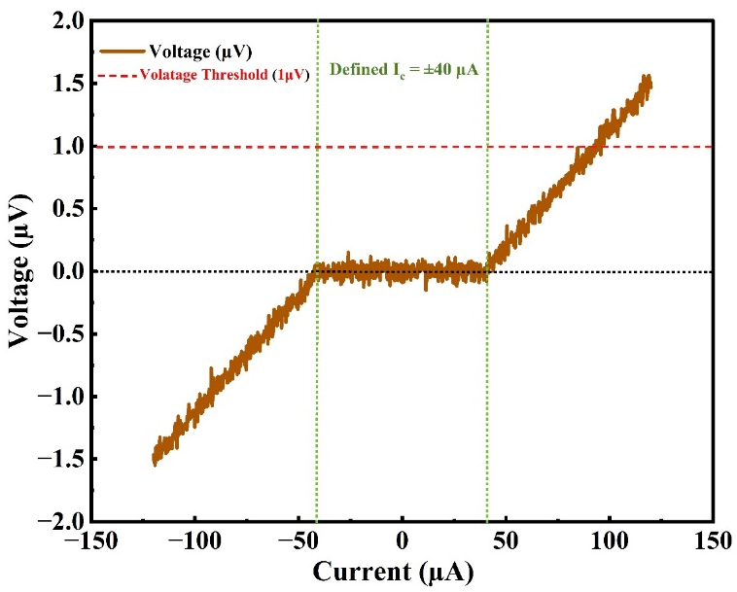
Fig. S4. Temperature-dependent resistance R(T) of a standalone YBCO base electrode. The data show a sharp superconducting transition with the resistance dropping below the measurement resolution near the critical temperature, T_{c}≈90 (marked by the dashed red line). The well-defined transition confirms the high-quality superconducting phase of the YBCO layer.

Fig. S5. Current–voltage (I–V) characteristics of the YBCO|BNT|YBCO trilayer junction measured at 10 K. A well-defined zero-voltage plateau is observed for currents within approximately ±40 μA, consistent with coherent Cooper pair tunneling. The critical current (I_{c}) is determined using the ±1 μV threshold criterion (red dashed line), yielding I_{c}​≈±40 μA, as indicated by the green dotted lines. The sharp transition from the zero-voltage state to the resistive branch is characteristic of Josephson junction behavior.
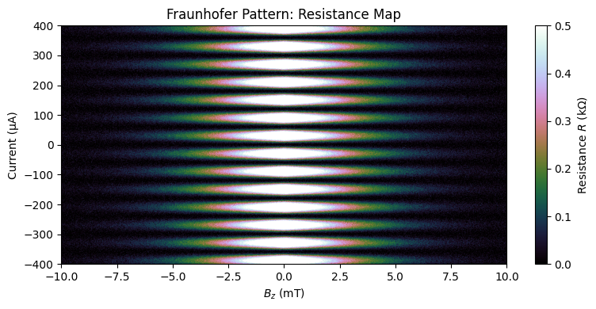

Fig. S6. Two-dimensional resistance map of the YBCO|BNT|YBCO trilayer as a function of bias current and out-of-plane magnetic field (B_{z}). The alternating lobes of enhanced and suppressed resistance form a Fraunhofer-like interference pattern, with a central maximum at zero field and progressively weaker side lobes. This characteristic modulation confirms coherent Josephson coupling across the trilayer junction.
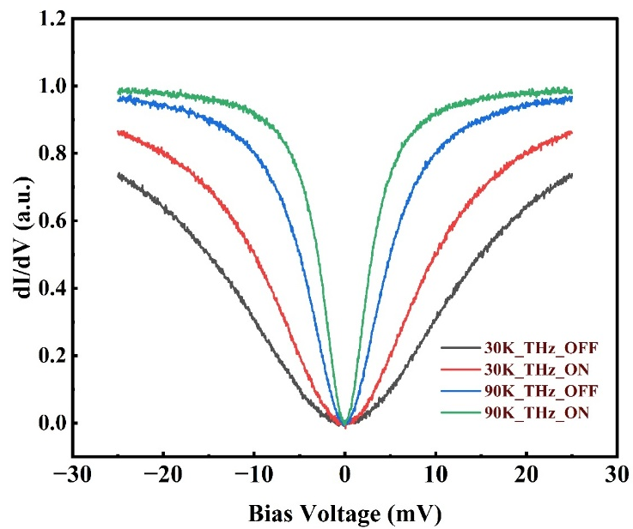

Fig. S7 | STM tunneling spectra under THz excitation: Normalized dI/dV spectra recorded at 30 K and 90 K with and without a 1.5 THz field. At 30 K, the spectra under THz excitation show reversible suppression of coherence peaks and partial filling of the superconducting gap, consistent with polarization-mediated modulation of Δ. No significant heating was observed, confirming the non-thermal nature of the effect.

Experimental details:
Figure S2: High-resolution cross-sectional TEM and EDS elemental mapping of the YBCO|BNT|YBCO junction
Experimental Details:
High-resolution transmission electron microscopy (HR-TEM) and energy-dispersive X-ray spectroscopy (EDS) were employed to assess the structural integrity and elemental distribution of the YBCO|BNT|YBCO trilayer junction. Cross-sectional lamellae were prepared using a dual-beam FIB (FEI Helios G4), followed by HR-TEM imaging on a FEI Tecnai G2 F30 at 300 kV. EDS mapping in STEM mode (Oxford Instruments) confirmed sharp chemical interfaces, with distinct profiles for Y, Ba, Cu (YBCO) and Bi, Na, Ti (BNT), indicating minimal interdiffusion. Uniform oxygen distribution across layers suggests complete oxygenation of YBCO and supports high-quality heterostructure formation.
Figure S3: Atomic Force Microscopy (AFM) image of the BNT surface prior to top YBCO deposition
Experimental Details:
Atomic force microscopy (AFM) in tapping mode was employed to evaluate the surface morphology of the BNT layer before YBCO deposition. Scans were conducted using a Bruker Dimension Icon system with a silicon probe (tip radius <10 nm) over a 5 × 5 μm² area at 512 × 512 resolution. The line profile revealed a root-mean-square (RMS) roughness of ~1.5 nm, indicating a smooth and uniform surface suitable for coherent superconducting overlayer growth. This low roughness minimizes the risk of filamentary conduction or electrical shorting across the BNT barrier.

References:
1. Abou Dargham, S., Ponchel, F., Abboud, N., Soueidan, M., Ferri, A., Desfeux, R., Assaad, J., Remiens, D. and Zaouk, D., 2018. Synthesis and electrical properties of lead-free piezoelectric Bi0. 5Na0. 5TiO3 thin films prepared by Sol-Gel method. Journal of the European Ceramic Society, 38(4), pp.1450-1455.
2. Ji, H., Ren, W., Wang, L., Shi, P., Chen, X., Wu, X., Yao, X., Lau, S.T., Zhou, Q. and Shung, K.K., 2011. Structure and electrical properties of Na 0.5 Bi 0.5 TiO 3 ferroelectric thick films derived from a polymer modified sol-gel method. IEEE transactions on ultrasonics, ferroelectrics, and frequency control, 58(10), pp.2042-2049.
3. An, G., Fu, M., Jiao, Z., Tian, Q., Xu, P., Wu, W. and Su, X., 2022. Rapid preparation of Bi0. 5Na0. 5TiO3 ceramics by reactive flash sintering of Bi2O3-NaCO3-TiO2 mixed powders. Journal of the European Ceramic Society, 42(4), pp.1407-1413.

