Persistent Magnetic Fields from Subsea HVAC Cables: A Revised Empirical Model
Valentina Caradonna, Peter Sigray, Andrew B. Gill, Arianna Azzellino, Diego Vicinanza, Junio Fabrizio Borsani.
Supplementary Information
Figure S1 represents the validity of the implementation of Eq. 13 and 16 in MATLAB. To understand if the equations presented by P&S were correctly executed in MATLAB, we replicated the results obtained by P&S using the same parameters they used, i.e. $a$ = 0.1 m, $p$ = 1 m, $I$ = 200 A, and $r$ varying. Then, the two obtained fits were overlapped with Figure 3 of Pettersson and Schönborg (1997). In Figure 3 they compare the approximate case, the exact case and the untwisted case. We got the confirmation that the equations were correctly implemented because of the strong overlap with the original curves.
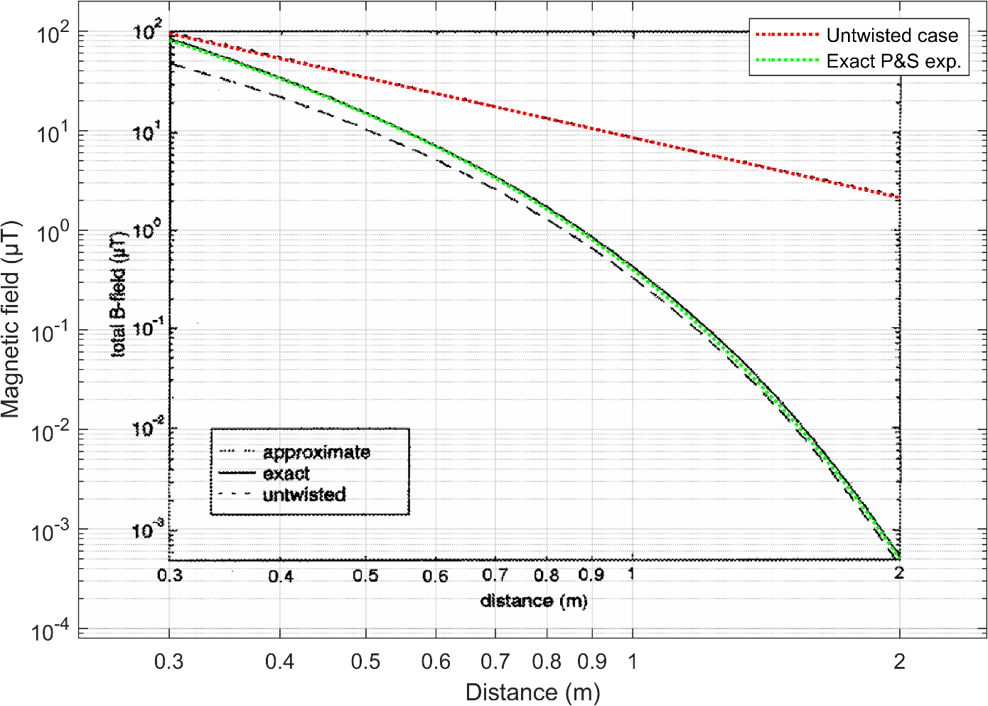
Figure S1. The exact case (green) and the untwisted case (red) obtained by us overlapped with the exact case (continuous black line) and the untwisted case (dashed black line) obtained by P&S.
Figure S1 can be used also to explain why we did not use the final approximations presented by P&S. Starting from 2 m away from the cable and going closer to the latter, the distance between the exact curve of P&S and the approximate one progressively increases. In other words, when the distance to the cable decreases, the error caused by the approximated formula becomes higher. In fact, such approximations were made for $p≪r$ and at the same time $p≫a$. The authors state that the error is less than 10% when $γ$ > 10. This means that if they used $p$ = 1 m and $γ$ = 10, according to equation (11), an error less than 10% is obtained starting from 1.6 m. Since the investigated subsea cable came with a burial depth of 1.5 m and we expected the pitch to be at least 3m, the assumption $r≫p$ could not be respected. If such approximations had been used, the error in the near field of the cable would have been significantly high, resulting not useful for correctly modelling the magnetic field. Hence, this is the reason why the exact expressions were used instead of the final equations obtained with the first-term approximations.

