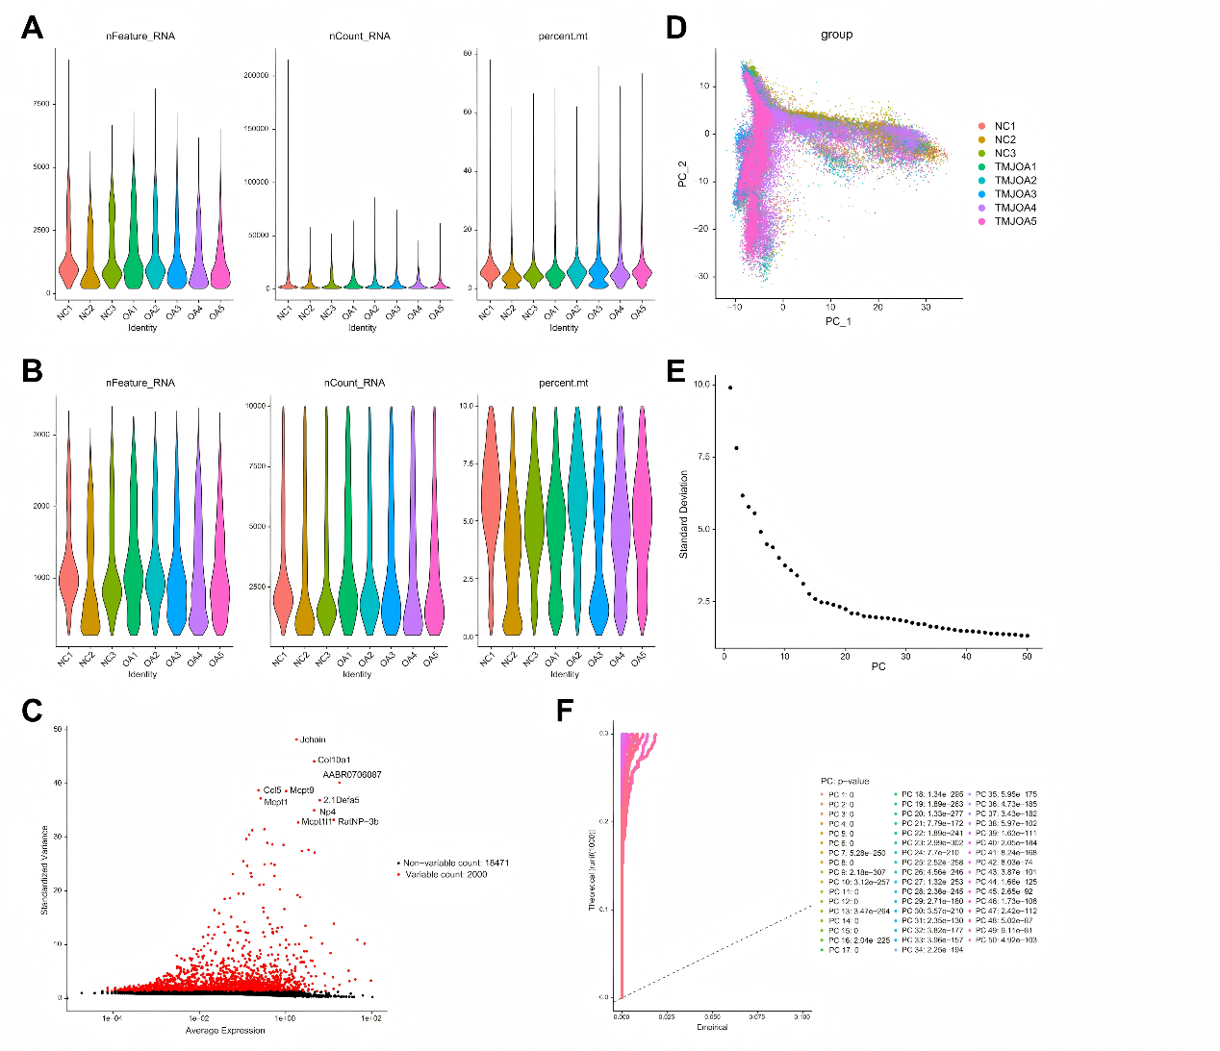
Supplementary figure 1. Reflecting the data processing and quality control process. (A and B) Violin plots illustrating the number of detected features, total RNA counts and mitochondrial gene percentages in condylar samples from the NC and OA groups, compared before (A) and after (B) quality control. (C) Mean-variance plot showing selection of highly variable genes (HVGs), with 2,000 genes (in red) exhibiting high standardized variance across cells. (D) PCA plot showing the distribution of cells from the NC and OA groups along the PC1 and PC2 dimensions. (E) The elbow plot shows that the first 30 principal components account for the majority of variance, with a plateau observed thereafter. (F) JackStraw analysis revealed that the first 30 principal components exhibit significantly lower p-values, indicating strong biological relevance.

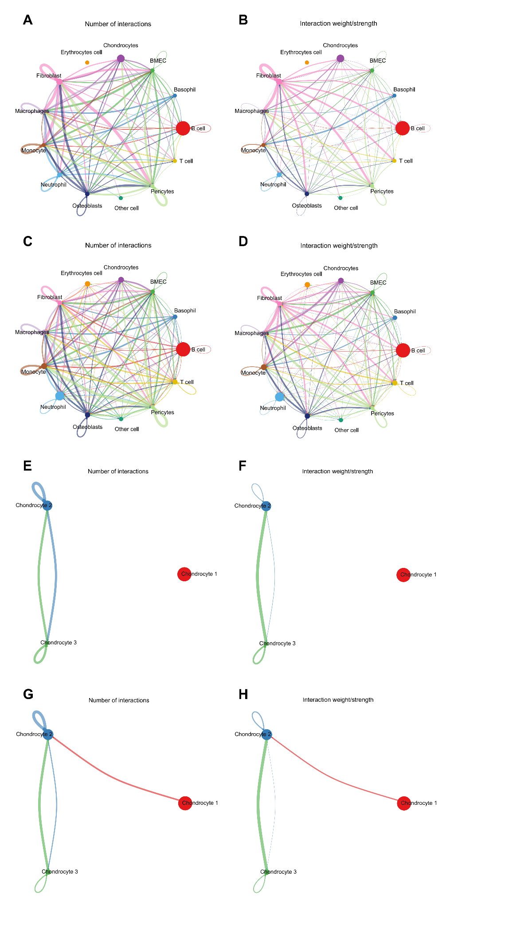
Supplementary figure 2. Cell-cell communication analysis. (A and B) NetVisual_circle plot illustrating the number (A) and strength (B) of cell-cell interactions among major cell types in the TMJ of the NC group. (C and D) NetVisual_circle plot illustrating the number (C) and strength (D) of cell-cell interactions among major cell types in the TMJ of the OA group. (E and F) The circo plot illustrating the number (E) and strength (F) of cell-cell communication among chondrocyte subsets in the NC group. (G and H) The circo plot illustrating the number (G) and strength (H) of cell-cell communication among chondrocyte subsets in the OA group.

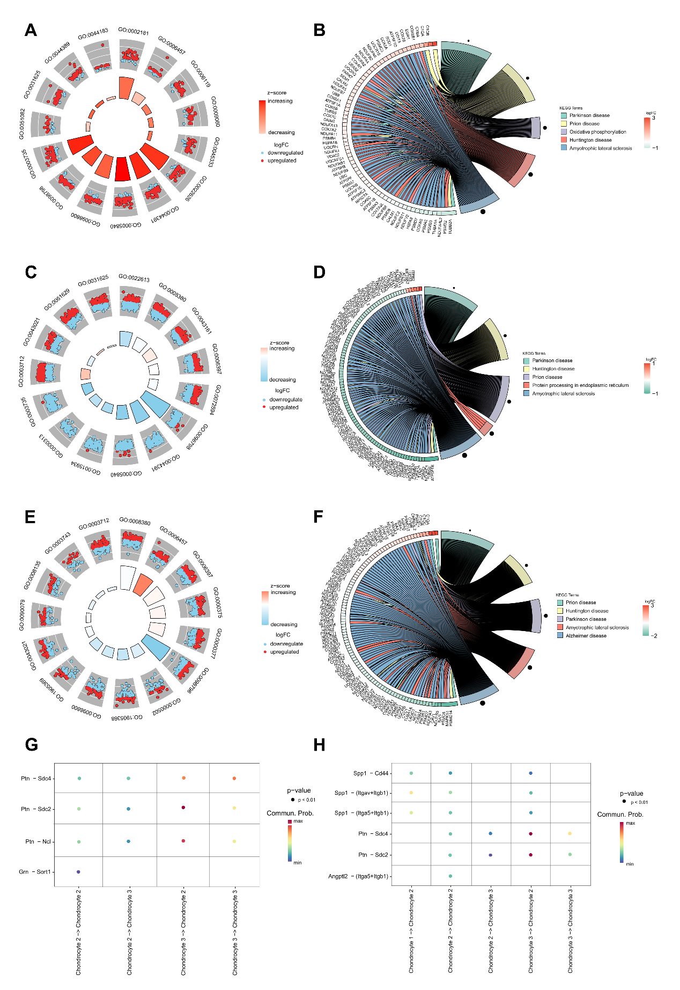
Supplementary figure 3. Demonstration of the heterogeneity among subsets of condylar chondrocytes. (A) Circular heatmap illustrating the GO enrichment results of HomCs, with pathways colored by significance and genes labeled by log fold change. (B) Circos plot depicting the association between genes and enriched KEGG pathways in HomCs. (C) Circular heatmap illustrating the GO enrichment results of PreInfCs, with pathways colored by significance and genes labeled by log fold change. (D) Circos plot depicting the association between genes and enriched KEGG pathways in PreInfCs. (E) Circular heatmap illustrating the GO enrichment results of InfCs, with pathways colored by significance and genes labeled by log fold change. (F) Circos plot depicting the association between genes and enriched KEGG pathways in InfCs.

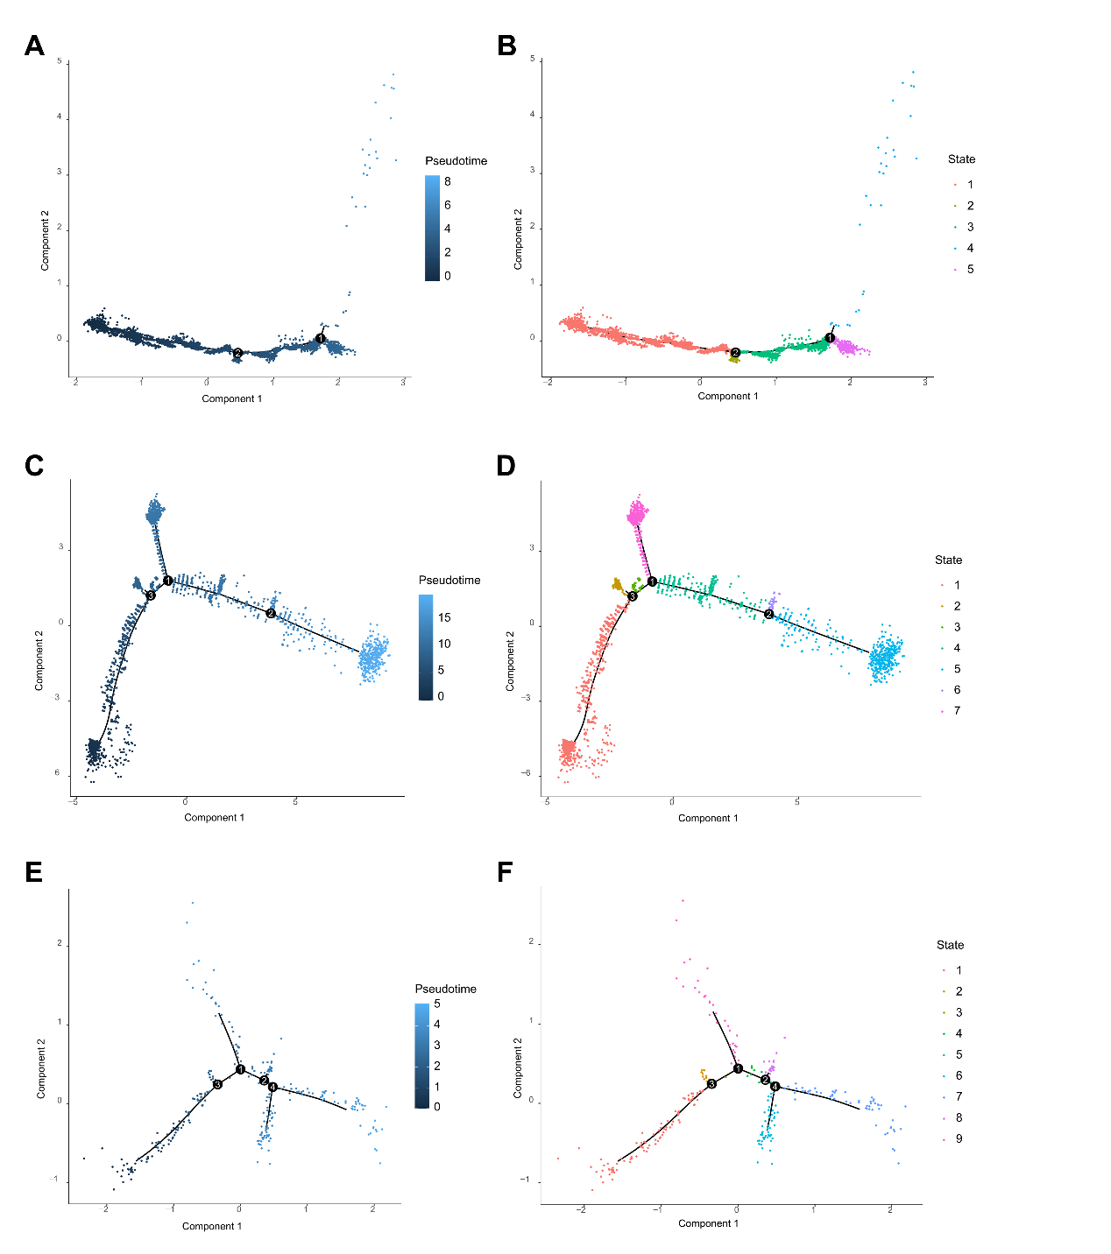
Supplementary figure 4. Pseudotime trajectory analysis of condylar chondrocyte subsets. (A) The pseudotime trajectory of HomCs is colored in a gradient from dark to light blue, indicating a progression from left to right. The annotated key nodes (1 and 2) may represent critical differentiation stages or state transition points. (B) The pseudotime trajectory of HomCs is shown colored by different cell states. (C) The pseudotime trajectory of PreInfCs is colored in a gradient from dark to light blue, indicating a progression from left to right. The annotated key nodes (1, 2 and 3) may represent critical differentiation stages or state transition points. (D) The pseudotime trajectory of PreInfCs is shown colored by different cell states. (E) The pseudotime trajectory of InfCs is colored in a gradient from dark to light blue, indicating a progression from left to right. The annotated key nodes (1, 2, 3 and 4) may represent critical differentiation stages or state transition points. (F) The pseudotime trajectory of InfCs is shown colored by different cell states.

