This file contains the full uncropped gels and blots corresponding to Figures 5 in the main manuscript. Each blot is labeled with the target protein and linked to its corresponding figure panel in the article.

Page 1
Protein: GAPDH
Corresponding to: Figure 5A
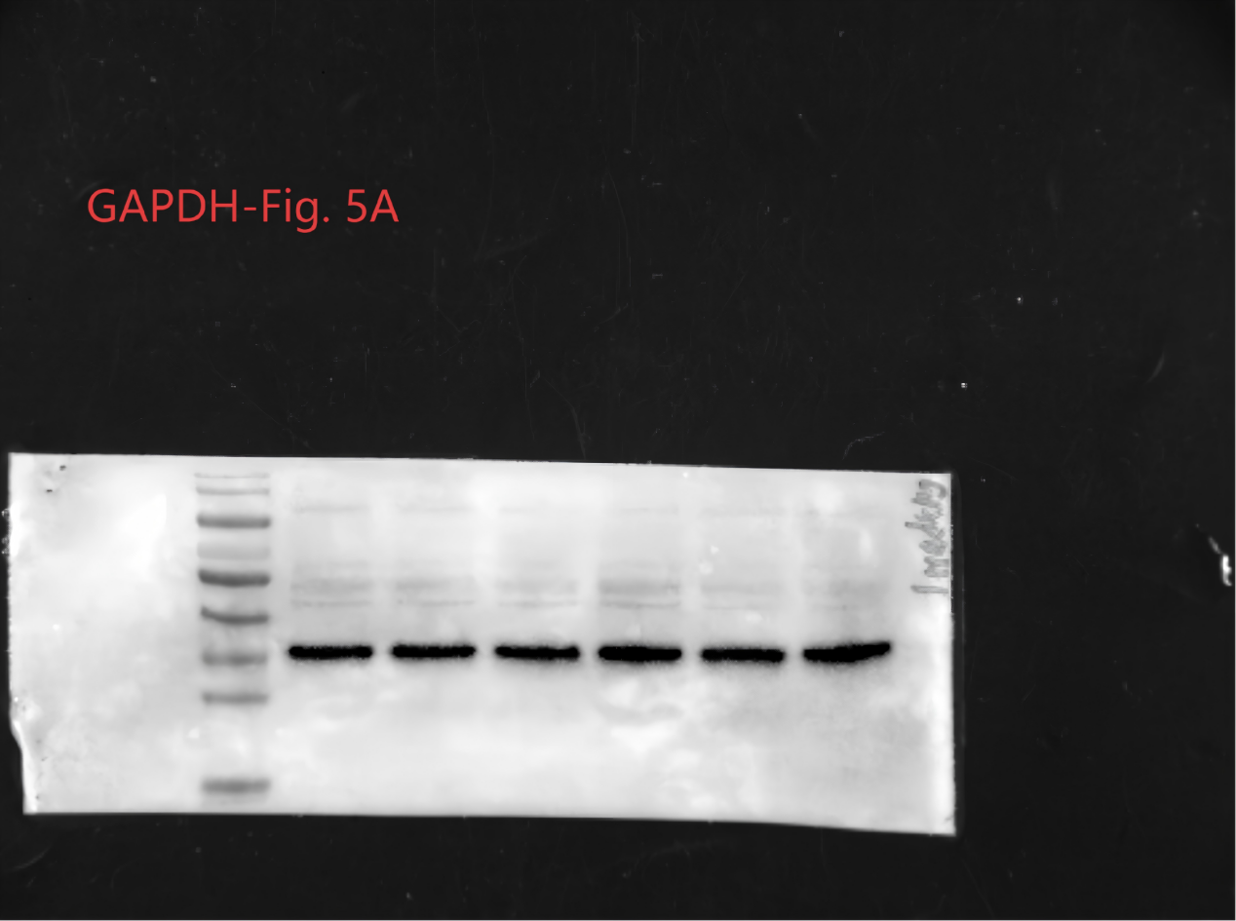

Page 2
Protein: ADAMTS5
Corresponding to: Figure 5A
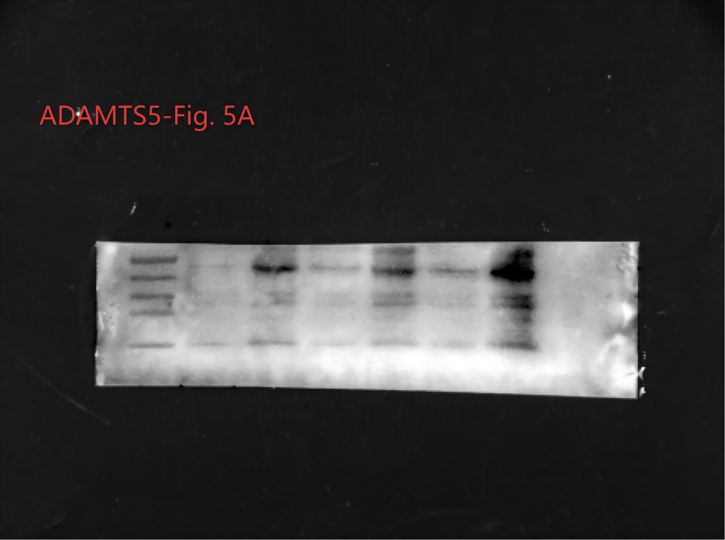

Page 3
Protein:CAMP
Corresponding to: Figure 5A
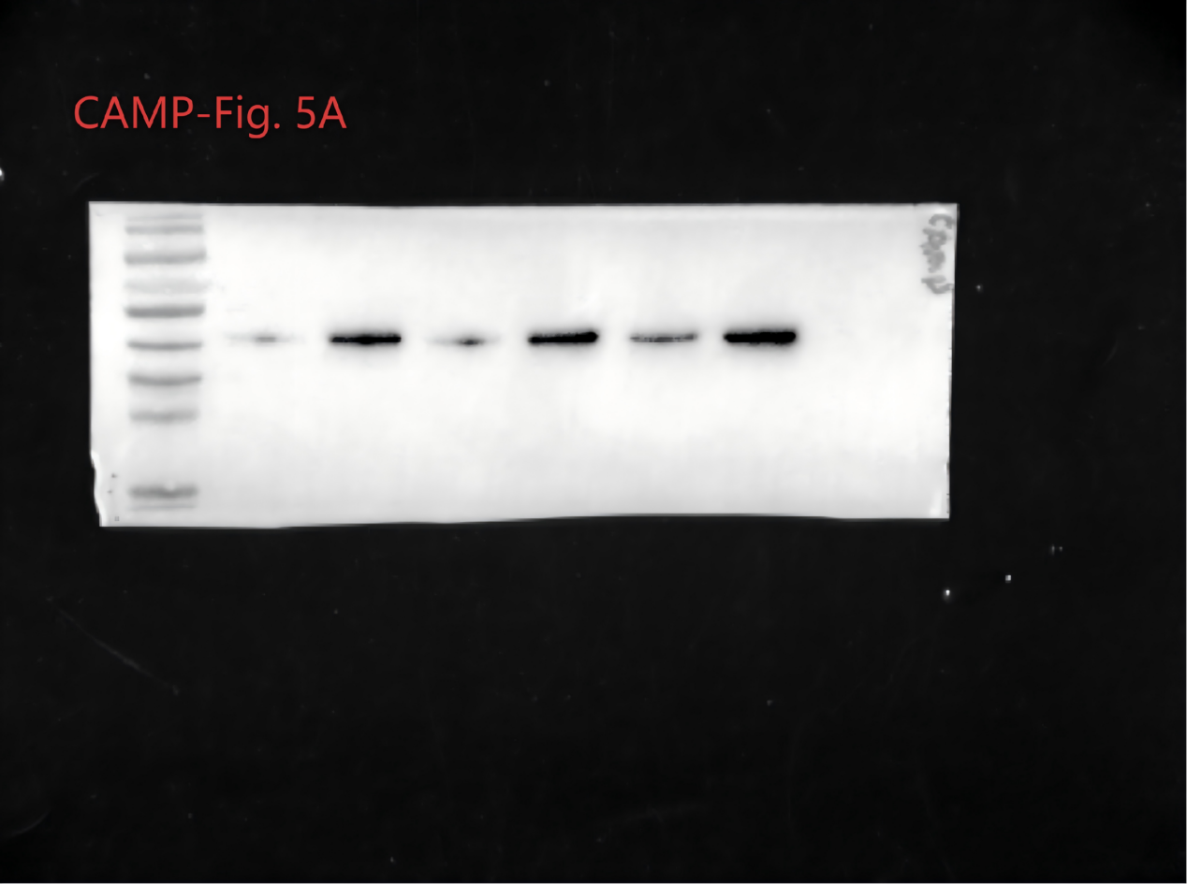

Page 4
Protein: COL2A1
Corresponding to: Figure 5A
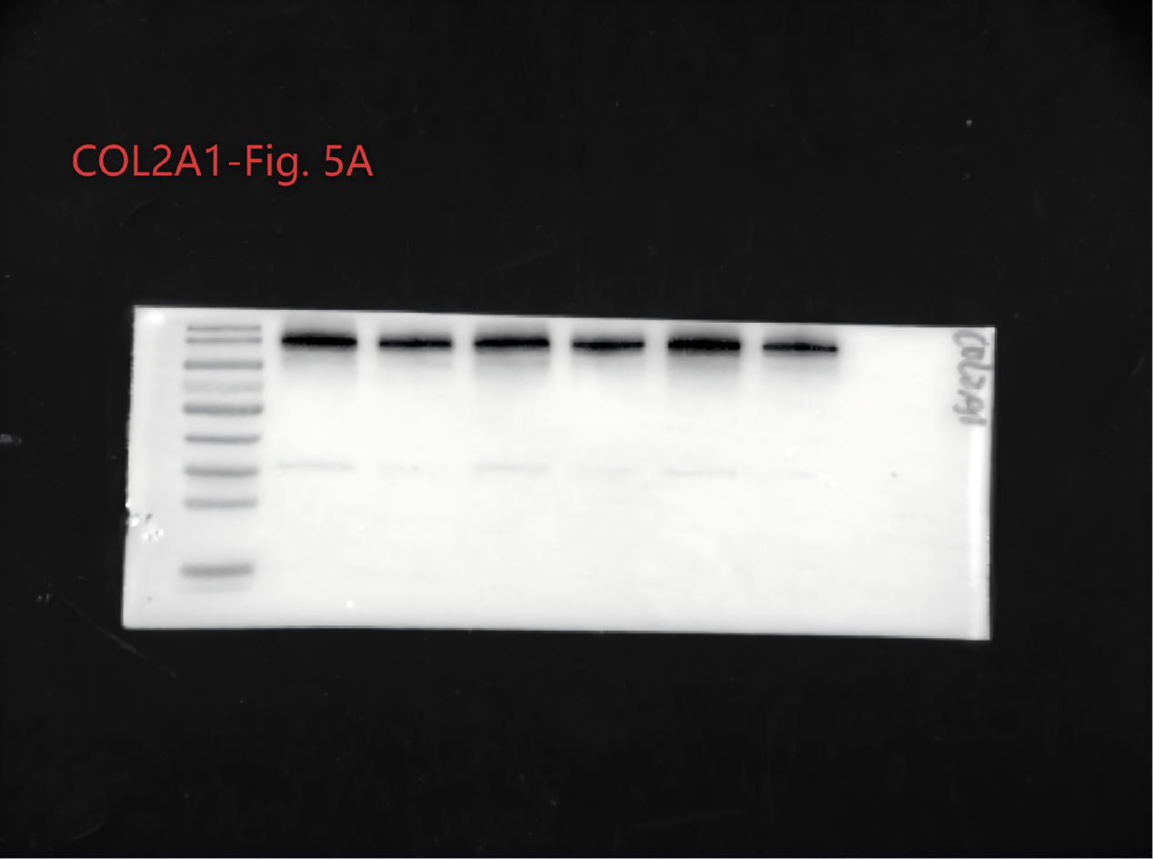

Page 5
Protein: IL-1β
Corresponding to: Figure 5A
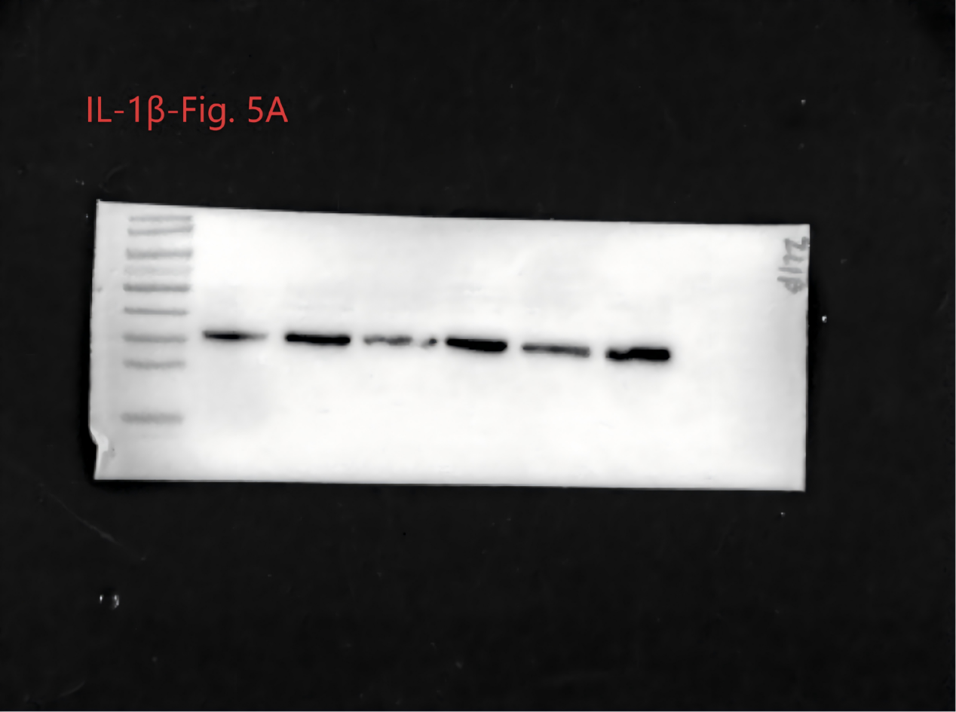

Page 6
Protein: MMP13
Corresponding to: Figure 5A
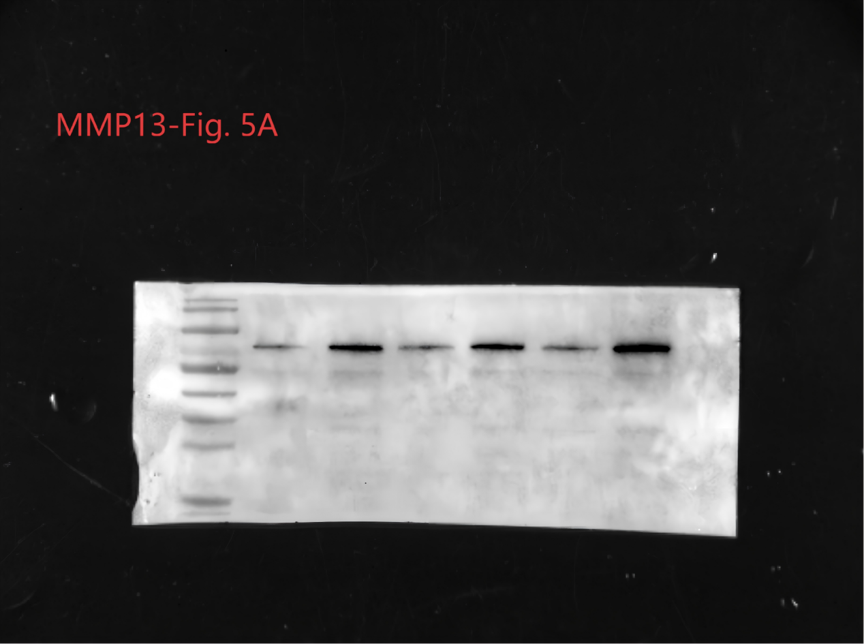

Page 7
Protein: S100a9
Corresponding to: Figure 5A
