Supplementary Materials for

Interfacial excess charge dynamics as a quantitative descriptor for deciphering lithium dendrite growth

Xuezhong Li ^{1, 3, †}, Genmin Lai ^{2, †}, Wei Deng ^{1, 3, *}, Zhifang Wei ⁴, Jianwei Li ², Chi Fang ², Taisen Zuo ^{5, 6}, He Cheng ^{5, 6}, Phakkhananan Pakawanit ⁷, Suihan Cui ², Bao Qiu ⁴, Xufeng Zhou ⁴, Jiaxin Zheng ^{2, *}, Yongbing Tang ^{1, 3, *}

1. Advanced Energy Storage Technology Research Center, Shenzhen Institutes of Advanced Technology, Chinese Academy of Sciences, Shenzhen, Guangdong 518055, China
2. School of Advanced Materials, Peking University, Shenzhen Graduate School, Shenzhen, Guangdong 518055, China
3. University of Chinese Academy of Sciences (UCAS), Beijing, 100049, China
4. Ningbo Institute of Materials Technology and Engineering, Chinese Academy of Sciences, Ningbo 315201, PR China
5. Spallation Neutron Source Science Center, Dongguan, Guangdong 518055, China
6. Institute of High Energy Physics, Chinese Academy of Sciences, Beijing, China.
7. Synchrotron Light Research Institute, Nakhon Ratchasima, 30000, Thailand
† These authors contribute equally.
∗ Correspondence: w.deng@siat.ac.cn, zhengjx@pkusz.edu.cn, tangyb@siat.ac.cn

Supplementary Table 1. The formula of employed electrolytes.
Label | Formula of electrolyte
A | 1.0 M LiPF₆ in DMC/FEC (vol. 1/1)
B | 1.0 M LiDFOB+0.7M LiBF₄ in DEC/FEC (vol. 1/2)
C | 1.0 M LiFSI in DOL/DME (vol. 1/1)
D | 1.0 M LiFSI in DME
E | 1.0 M LiFSI in CPME
F | 1.0 M LiFSI in DEE
G | 4.0 M LiFSI in DME
H | 4.0 M LiFSI in CPME
I | 4.0 M LiFSI in DEE
J | 8.0 M LiFSI in DME
K | LiFSI/DME/TTE (mol. 1/1.2/3)
L | 8.0 M LiFSI in DMC/TTE (mol. 1/1)

Supplementary Note 1
Machine learning model details. To achieve accurate prediction of atomic charge for large-scale systems, we trained the QMTP model for the interfaces of Li metal with LiFSI, DEE mixed solution and LiFSI, DME mixed solution. The QMTP model includes two modules, the charge module as well as the energy and force module.¹ To fully leverage the advantages of QMTP and improve the simulation efficiency, we only used the charge module in this work. The charge module obtains the electronegativity ${V(n}_{i})$ based on the local atomic environment and then outputs the charge value for each atom using the charge equilibration scheme². The model parameters ${lev}_{max}^{Q}$ was set as 12 and the $r_{c}^{Q}$ was chosen to be 5.0 for atomic charge fitting. The training datasets are derived from AIMD simulations sampling and active learning sampling strategy³. The CP2K^{4,5} based on density functional theory (DFT) was used to generate the training and testing datasets. The wave function was extended to the Gaussian DZVP basis set (DZVP-MOLOPT-SR-GTH) by using the Gaussian and plane waves (GPW) methods with the Goedecker-Teter-Hutter (GTH)⁶ pseudopotentials. The Grimme's D3 method was employed to account for dispersion effects⁷. The plane wave cut-off was set to 800 Ry for the auxiliary basis set. The Г-centered k-point sampling grid of 2 × 2 × 1 and 4 × 4 × 1 were set for interface between Li metal and LiFSI, DEE mixed solution as well as LiFSI, DME mixed solution, respectively. Details on models training and testing are provided in Supplementary Table 2.

Supplementary Table 2. Mean absolute errors (MAE) of charge for the machine learning models.
System | State | Datasets | Charge (me)
Interface between Li metal and LiFSI, DEE mixed solution | train | 620 | 4.121
Interface between Li metal and LiFSI, DEE mixed solution | test | 173 | 4.112
Interface between Li metal and LiFSI, DME mixed solution⁷ | train | 3678 | 8.278
Interface between Li metal and LiFSI, DME mixed solution⁷ | test | 740 | 7.278

Supplementary Note 2
For interfacial charge distribution factors ($f$) calculation.
As proposed in the main text, the interfacial charge distribution factor ($f$) is defined as the exchange current density normalized by the net surface charge. For the excess charge on electrode, the term $σ_{excess}$ can be calculated using Expression S3, where $C_{dl}$ corresponds to the double layer capacitance.
 | $$σ_{excess}={(E}_{PZC}-E_{plating})*C_{dl}$$ | S3
In the case of excess countercharge arising from cation screening, $σ_{screening}$ can be evaluated using Expression S4, where it is expressed as the function of electrolyte concentration ($c_{0}$). Here, $γ$ and $m$ represent the magnitude and scaling behavior of the concentration-dependent contribution, respectively.
 | $$σ_{screening}= γ*c_{0}^{m}$$ | S4
Based on the relationships described in Expression S3-4, the overall relationship of the interfacial charge distribution factor can be generalized in Expression S5.
 | $$f=\frac{J_{0}}{{(E}_{PZC}-E_{plating})*C_{dl}-γ*c_{0}^{m}}$$ | S5
However, due to the inaccessibility of explicit values for $γ$ and $m$ across different electrolyte, system-specific simplifications are introduced to enable practical evaluation of $f$ under distinct regimes.
For DE/WSE, given the relatively low electrolyte concentration (typically ~1.0 M), the contribution of $σ_{screening}$ is considered negligible. Expression S5 can therefore be simplified to Expression S6.
 | $$f=\frac{J_{0}}{{(E}_{PZC}-E_{plating})*C_{dl}}$$ | S6
By assuming $C_{dl}$ remains constant for the fixed coin cell configuration and electrodes, and the parameters of $J_{0}$, $E_{PZC}$ and $E_{plating}$are experimentally accessible, the distribution factor ($f$) can be quantitatively compared across DE/WSE.
For HCE/LHCE, in these high-concentration electrolytes, the influence of electrode excess charge is significantly reduced due to enhanced cation–anion interactions. Thus, Expression S5 can be reduced to Expression S7, where the term $σ_{excess}$ (associated with electrode excess charge) is omitted.
 | $$f=\frac{J_{0}}{-γ*c_{0}^{m}}$$ | S7
Under this assumption, the distribution factor is primarily governed by the exchange current density ($J_{0}$) and the concentration-dependent term $σ_{screening}$, facilitating direct comparative analysis.
For HWSE, both electrode excess charge and cation screening effects are significant. To enable quantitative comparison, we assume the distribution factor ($f$) for electrolyte D is unity (equals to 1.0), and usually the $C_{dl}$ for the Li symmetric cell is approximately 20 μF. By further assuming the scaling factor m = 1 in Expression S5, by using the distribution factor ($f$) of electrolyte D and $C_{dl}$, the $γ$ is calculated as 12.3. Then Expression S5 can be simplified to Expression S8. Substituting experimentally determined values for $J_{0}$, $E_{PZC}$, $E_{plating}$and $c_{0}$into Expression S8 allows for quantitative comparison of distribution factor variations within HWSE.
 | $$f=\frac{J_{0}}{{(E}_{PZC}-E_{plating})*20.0-12.3*c_{0}}$$ | S8

Supplementary Note 3
Details about the exchange current density calculation.
Since the applied voltage during potentiostatic plating reflects the combined effects of cell polarization, charge transfer resistance and interfacial impedance, the PEIS measurement is immediately performed after the plating step to isolate the voltage contribution specifically associated with charge transfer. The exchange current density ($J_{0}$) was calculated based on impedance data obtained from PEIS. The EIS data were deconvoluted using the distribution of relaxation times (DRT) method to separate the contributions of cell resistance ($R_{s}$), SEI resistance ($R_{SEI}$) for 0.5-10 Hz and charge transfer resistance ($R_{ct}$) for 100-1000 Hz. At the end of the potentiostatic step, the voltage ($η_{ct}$) accounting for the R_{ct} were used to calculate ($J_{0}$) using the classical small-overpotential approximation in Equation S1 and Expression S2:
 | $$J_{0}=\frac{iRT}{η_{ct}F*A}$$ | S1
 | $$η_{ct}=η*\frac{R_{ct}-R_{s}}{R_{SEI}-R_{s}}$$ | S2
where $i$ is the current density at the end of the potentiostatic step, $η$ is the overpotentials applied over the cells (20 mV in this work), $R_{s}$, $R_{ct}$ and $R_{SEI}$ are obtained from PEIS results, and A is the electrode area, F denotes the Faraday constant, R is the universal gas constant, and T is the temperature (298 K).

Supplementary Note 4
For the calculation of variations of ECSA during potentiostatic Li plating.
According to the Cottrell equation (Equation S9), the time-dependent current density ($i$) in the diffusion-limited regime is expressed as:
 | $$i=\frac{nFD^{1/2}cA}{\sqrt{πt}}$$ | S9
where $n$ is the number of electrons transferred, $F$ is the Faraday constant, $D$ is the diffusion coefficient of electrolyte, $c$ is the initial concentration of electrolyte, $A$ is the ECSA of electrode, and $t$ is time. Under potentiostatic electroplating conditions, the current in the diffusion-limited regime is inversely proportional to $\sqrt{t}$.
To evaluate ECSA variation associated with dendrite growth, current-time curve in the diffusion-limited region is analyzed, as illustrated in Supplementary Figure 1. Let the inflection point be defined at ($t_{1}$, $i_{t1}$), and the endpoint at ($t_{3}$, $i_{t3}$). Assuming the ECSA at $t_{1}$ is $A_{1}$, and that ECSA evolves over time ($A_{n}$) according to the linear growth function defined in Expression S10:
 | $$A_{n}=A_{1}*\left[1+k_{1}*(t_{n}-t_{1})\right]$$ | S10
where $k_{1}$ represents the rate of ECSA variation, corresponding to dendrite growth rate assigned in main text. Substituting Expression S10 into the Cottrell equation (Equation S9) gives the instantaneous current ($i_{tn}$) at time $t_{n}$ as Expression S11:
 | $$i_{tn}=\frac{nF}{\sqrt{π}}*D_{1}^{\frac{1}{2}}*c_{1}*\frac{A_{1}}{\sqrt{t_{1}}}*\left[1+k_{1}*(t_{n}-t_{1})\right]$$ | S11
To compare $k_{1}$ across different electrolytes while eliminating the influence of $D$ and $c$, we refer to Equation S9 and define the current–time behavior at two characteristic points for different electrolyte as the initial points, e.g., ($t_{1}$, $i_{t1}$) and ($t_{2}$, $i_{t2}$). Taking the ratio of these two points leads to Expression S12 and S13.
 | $$i_{t1}=\frac{nF}{\sqrt{π}}*D_{1}^{\frac{1}{2}}*c_{1}*\frac{A_{1}}{\sqrt{t_{1}}}$$ | S12
 | $$i_{t2}=\frac{nF}{\sqrt{π}}*D_{2}^{\frac{1}{2}}*c_{2}*\frac{A_{2}}{\sqrt{t_{2}}}$$ | S13
Then we observe that the contribution of $D$ and $c$ can be replaced by the variation of current density and time across different electrolyte at the initial point as Expression S14, enabling the normalized comparison $k_{1}$ of between electrolytes.
 | $$\frac{i_{t1}*\sqrt{t_{1}}}{i_{t2}*\sqrt{t_{2}}}=\frac{D_{1}^{\frac{1}{2}}*c_{1}*A_{1}}{D_{2}^{\frac{1}{2}}*c_{2}*A_{2}}$$ | S14
The goal is to relate the slope of the rising segment in the current-time curve to the assumed growth rate of ECSA. Herein by using Expression S11 for different points in different electrolytes, as shown in Supplementary Figure 1 ($t_{1}$, $i_{t1}$) and ($t_{3}$, $i_{t3}$) for one electrolyte, and ($t_{2}$, $i_{t2}$) and ($t_{4}$, $i_{t4}$) for another one, we can obtain the Expression S15.
 | $$\frac{∆i_{t4-t2}}{∆i_{t3-t1}}=\frac{D_{2}^{\frac{1}{2}}*c_{2}*A_{2}}{D_{1}^{\frac{1}{2}}*c_{1}*A_{1}}*\frac{\left[\frac{k_{2}*∆t_{4-2}}{\sqrt{t_{2}}}+\frac{1}{\sqrt{t_{4}}}-\frac{1}{\sqrt{t_{2}}}\right]}{\left[\frac{k_{1}*∆t_{3-1}}{\sqrt{t_{3}}}+\frac{1}{\sqrt{t_{3}}}-\frac{1}{\sqrt{t_{1}}}\right]}$$ | S15
Substituting Expression S14 into Expression S15 yields Expression S16:
 | $$\frac{∆i_{t4-t2}}{∆i_{t3-t1}}*\frac{i_{t1}*\sqrt{t_{4}}}{i_{t2}*\sqrt{t_{3}}}=\frac{\left[k_{2}*∆t_{4-2}*\sqrt{t_{4}}+\sqrt{t_{2}}-\sqrt{t_{4}}\right]}{\left[k_{1}*∆t_{3-1}*\sqrt{t_{3}}+\sqrt{t_{1}}-\sqrt{t_{3}}\right]}$$ | S16
Herein, we define A, B and C as Expression S17-19.
 | $$\frac{Slope2*i_{t1}}{Slope1*i_{t2}}=A and \frac{Slope2}{Slope1}=\frac{{∆i_{t4-t2}}/{∆t_{4-2}}}{{∆i_{t3-t1}}/{∆t_{3-1}}}$$ | S17
 | $$\frac{\sqrt{t_{2}}-\sqrt{t_{4}}}{∆t_{4-2}*\sqrt{t_{4}}}=B$$ | S18
 | $$\frac{\sqrt{t_{1}}-\sqrt{t_{3}}}{∆t_{3-1}*\sqrt{t_{3}}}=C$$ | S19
Assuming one electrolyte as the baseline (e.g., setting $k_{1}$ = 1), the relative ECSA growth rate $k_{2}$ for another electrolyte can then be calculated via Expression S20-21.
 | $$k_{2}=A*\left(1+C\right)-B$$ | S20
 | $$k_{2}=\frac{Slope2*i_{t1}}{Slope1*i_{t2}}*\left(1+\frac{\sqrt{t_{1}}-\sqrt{t_{3}}}{∆t_{3-1}*\sqrt{t_{3}}}\right)-\frac{\sqrt{t_{2}}-\sqrt{t_{4}}}{∆t_{4-2}*\sqrt{t_{4}}}$$ | S21
Thus, by measuring the onset points and endpoint of each electrolyte, the quantitative comparison of different electrolytes on ECSA variation rates during potentiostatic electroplating can be achieved.

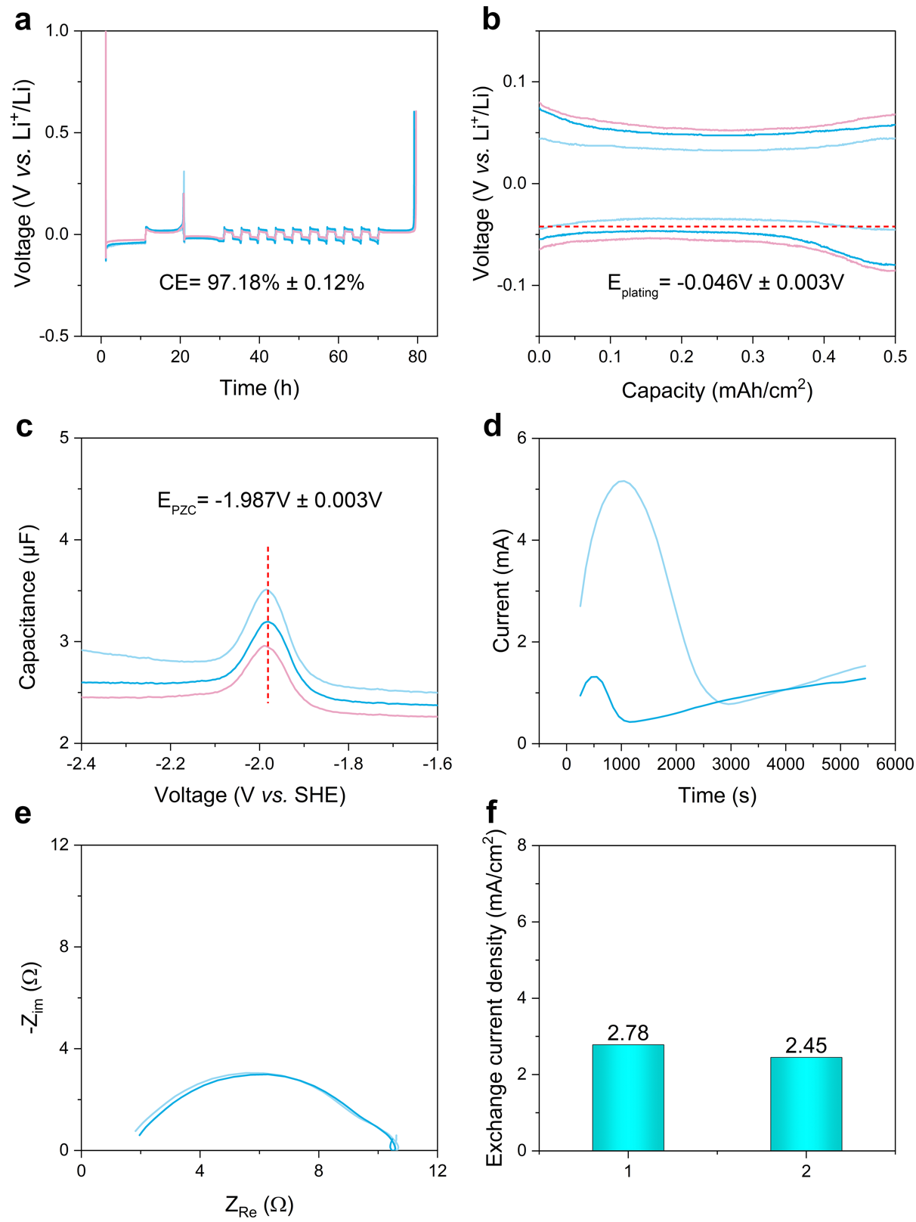
Supplementary Figure 1. Electrochemical characterization of electrolyte A (1.0 M LiPF₆ in DMC/FEC (vol. 1/1)): (a) average CE for Li plating/stripping determined using the modified Aurbach method; (b) the curves for E_{plating} and (c) the curves for E_{PZC} from single-frequency impedance spectroscopy; (d) current-time profile during potentiostatic Li plating; (e) PEIS curve recorded immediately after Li plating during potentiostatic control experiment; (f) calculated average exchange current density derived from (d, e) and the detailed was discussed in Supplementary Note 2.

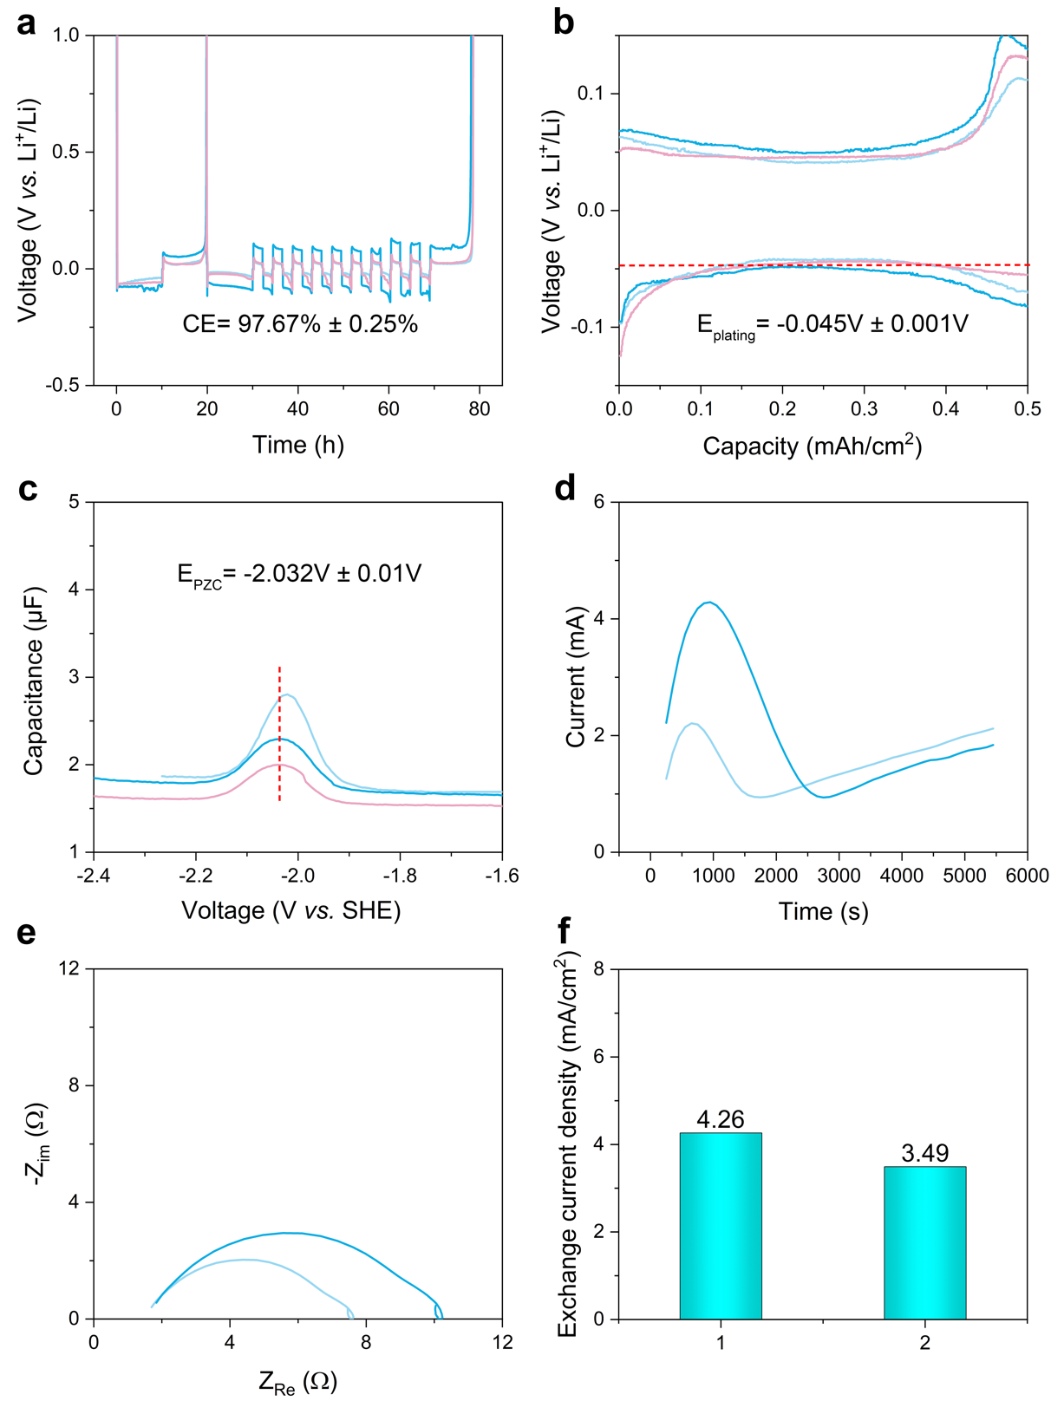
Supplementary Figure 2. Electrochemical characterization of electrolyte B (1.0 M LiDFOB+0.7M LiBF₄ in DEC/FEC (vol. 1/2)): (a) average CE for Li plating/stripping determined using the modified Aurbach method; (b) the curves for E_{plating} and (c) the curves for E_{PZC} from single-frequency impedance spectroscopy; (d) current-time profile during potentiostatic Li plating; (e) PEIS curve recorded immediately after Li plating during potentiostatic control experiment; (f) calculated average exchange current density derived from (d, e) and the detailed was discussed in Supplementary Note 2.

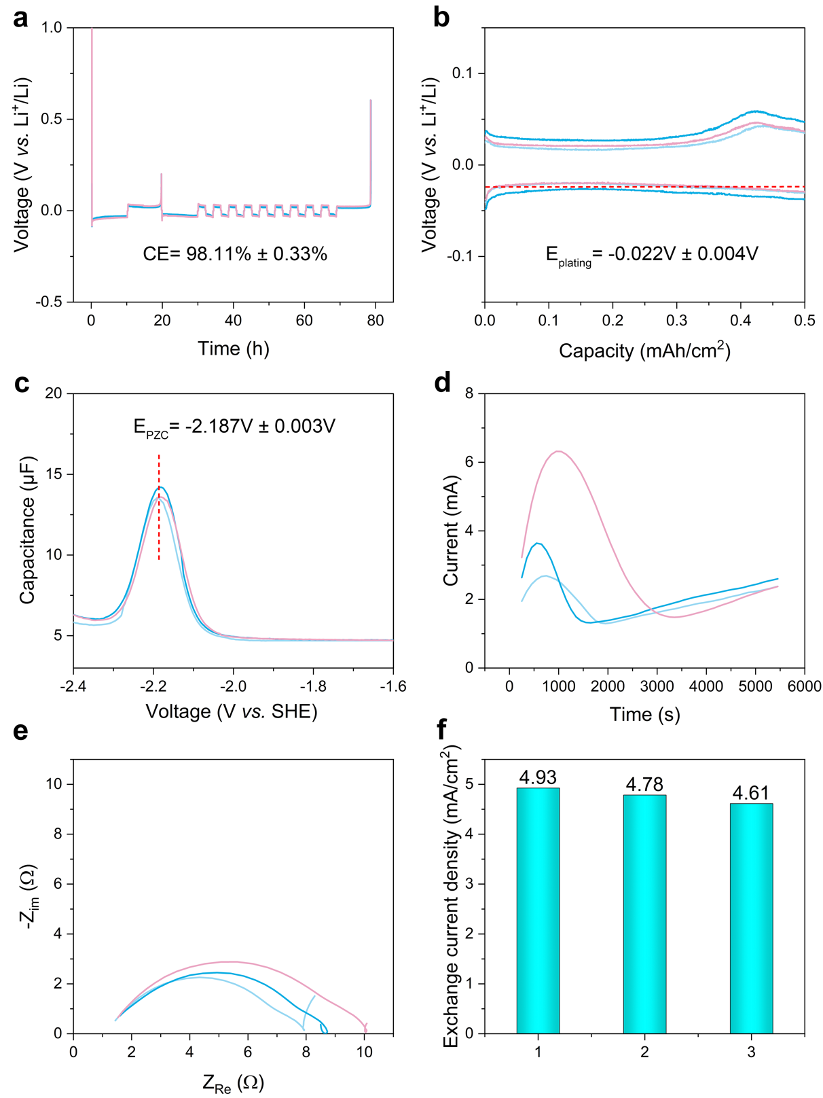
Supplementary Figure 3. Electrochemical characterization of electrolyte C (1.0 M LiFSI in DOL/DME (vol. 1/1)): (a) average CE for Li plating/stripping determined using the modified Aurbach method; (b) the curves for E_{plating} and (c) the curves for E_{PZC} from single-frequency impedance spectroscopy; (d) current-time profile during potentiostatic Li plating; (e) PEIS curve recorded immediately after Li plating during potentiostatic control experiment; (f) calculated average exchange current density derived from (d, e) and the detailed was discussed in Supplementary Note 2.

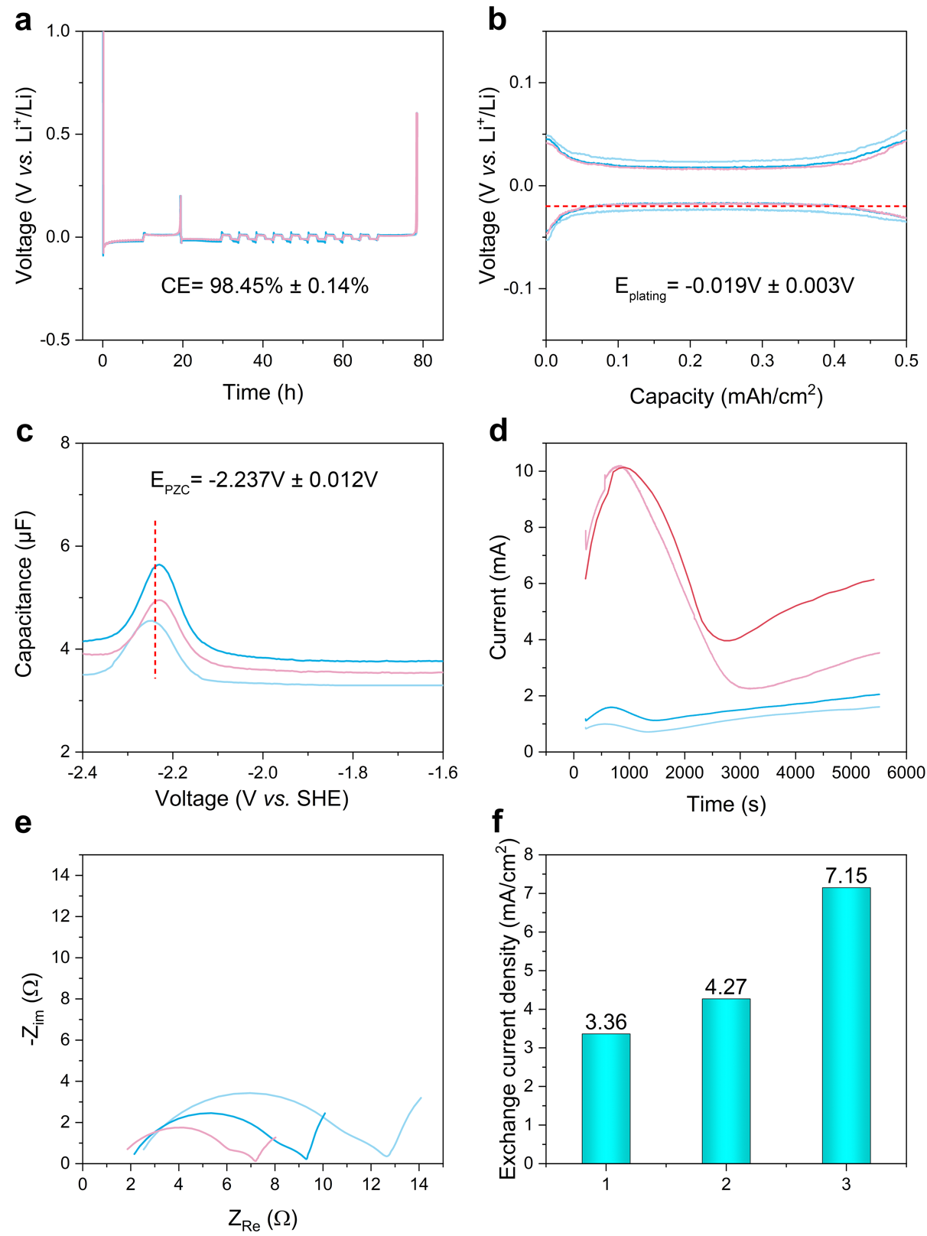
Supplementary Figure 4. Electrochemical characterization of electrolyte D (1.0 M LiFSI in DME): (a) average CE for Li plating/stripping determined using the modified Aurbach method; (b) the curves for E_{plating} and (c) the curves for E_{PZC} from single-frequency impedance spectroscopy; (d) current-time profile during potentiostatic Li plating; (e) PEIS curve recorded immediately after Li plating during potentiostatic control experiment; (f) calculated average exchange current density derived from (d, e) and the detailed was discussed in Supplementary Note 2.

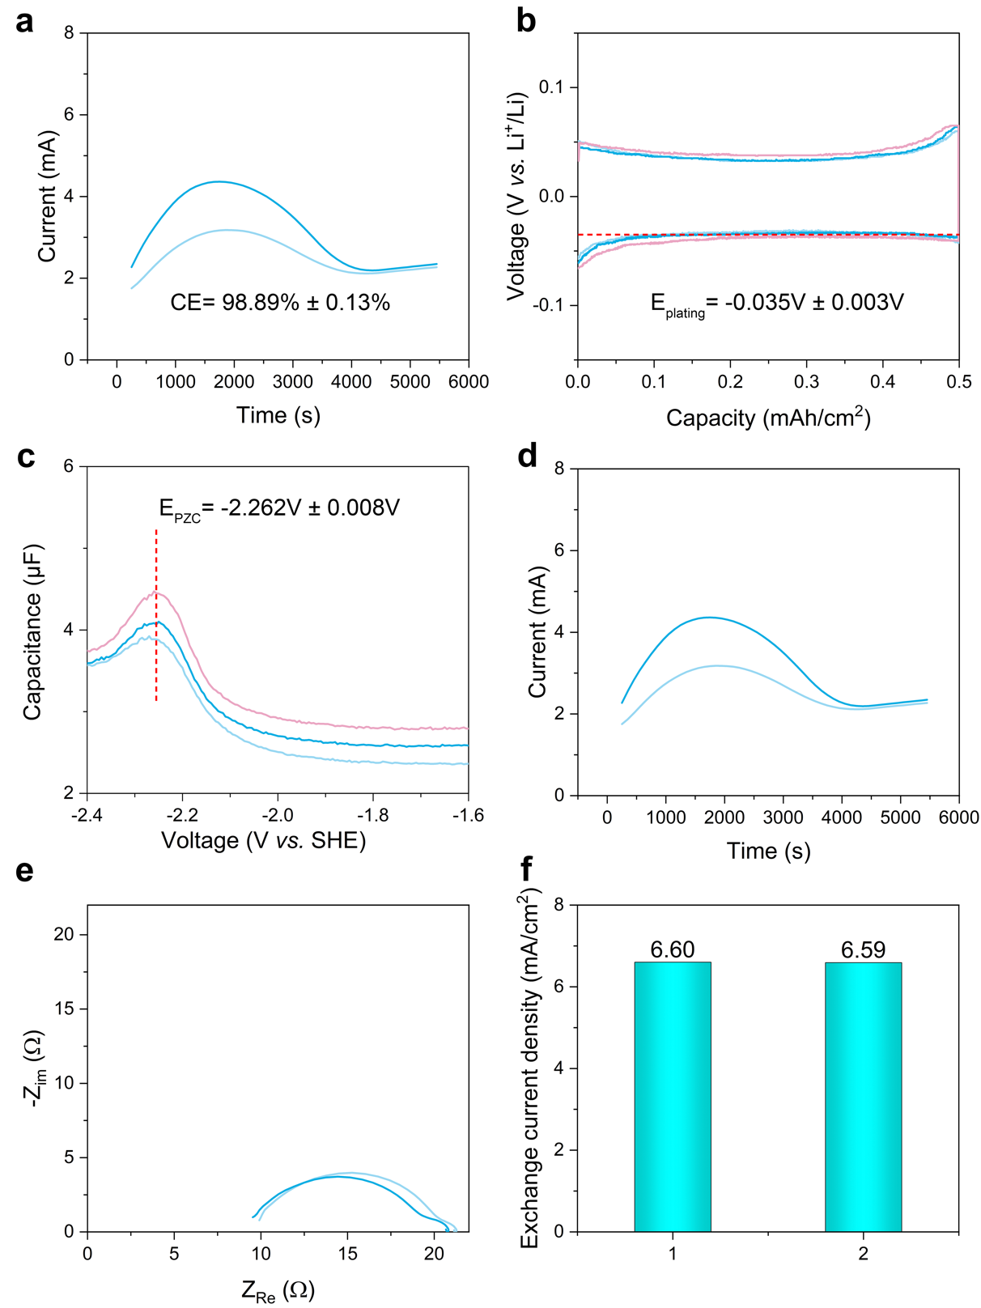
Supplementary Figure 5. Electrochemical characterization of electrolyte E (1.0 M LiFSI in CPME): (a) average CE for Li plating/stripping determined using the modified Aurbach method; (b) the curves for E_{plating} and (c) the curves for E_{PZC} from single-frequency impedance spectroscopy; (d) current-time profile during potentiostatic Li plating; (e) PEIS curve recorded immediately after Li plating during potentiostatic control experiment; (f) calculated average exchange current density derived from (d, e) and the detailed was discussed in Supplementary Note 2.

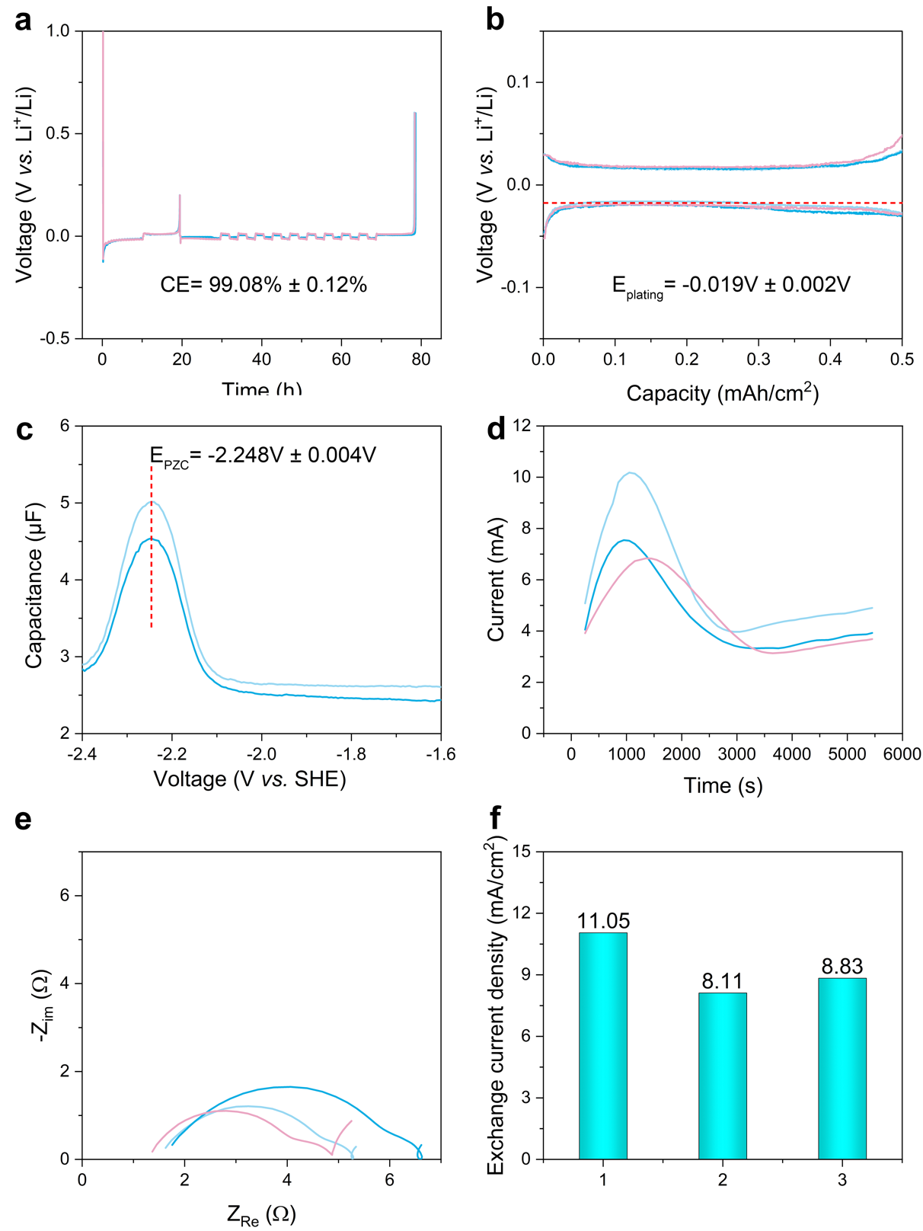
Supplementary Figure 6. Electrochemical characterization of electrolyte F (1.0 M LiFSI in DEE): (a) average CE for Li plating/stripping determined using the modified Aurbach method; (b) the curves for E_{plating} and (c) the curves for E_{PZC} from single-frequency impedance spectroscopy; (d) current-time profile during potentiostatic Li plating; (e) PEIS curve recorded immediately after Li plating during potentiostatic control experiment; (f) calculated average exchange current density derived from (d, e) and the detailed was discussed in Supplementary Note 2.

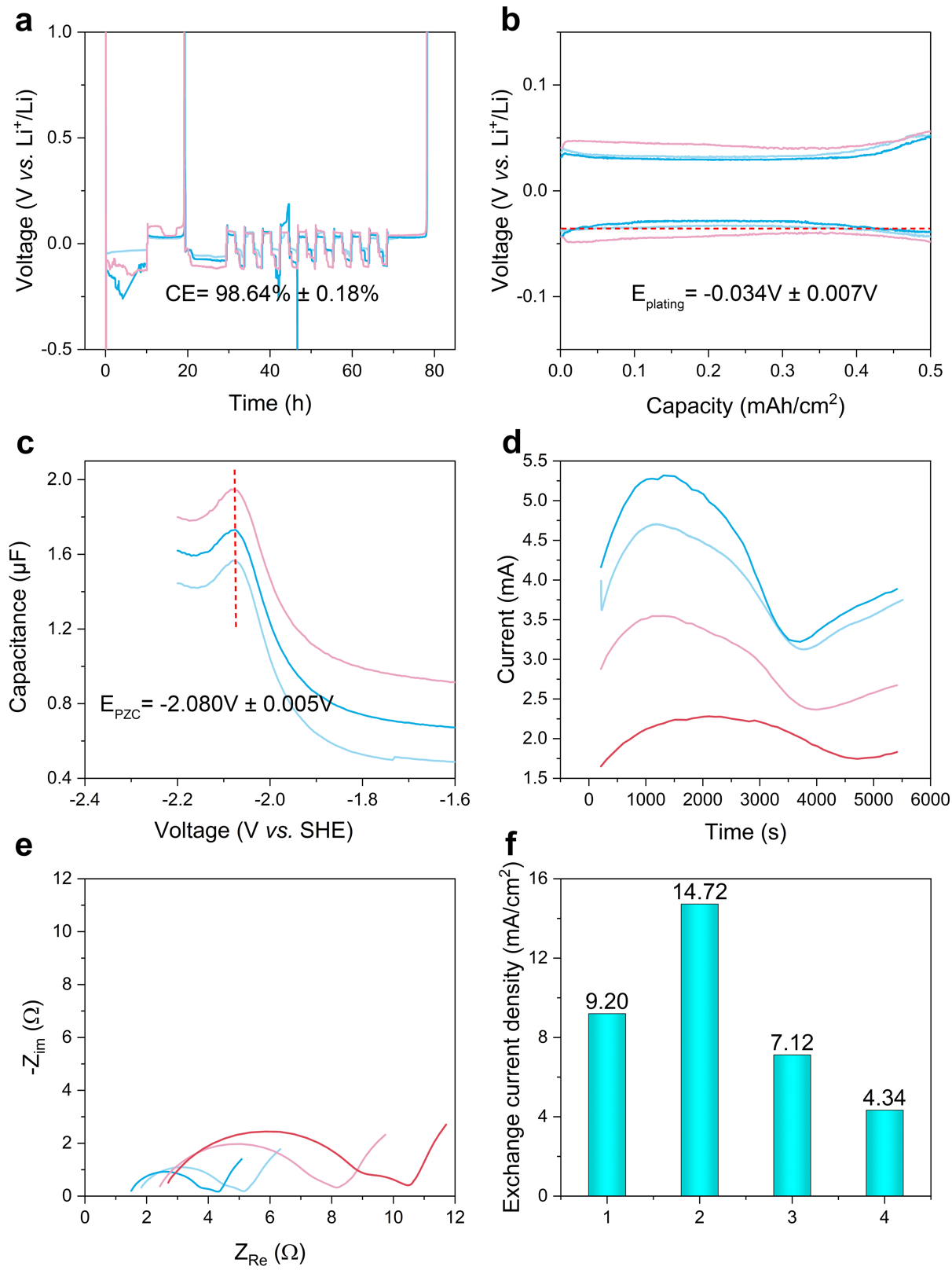
Supplementary Figure 7. Electrochemical characterization of electrolyte G (4.0 M LiFSI in DME): (a) average CE for Li plating/stripping determined using the modified Aurbach method; (b) the curves for E_{plating} and (c) the curves for E_{PZC} from single-frequency impedance spectroscopy; (d) current-time profile during potentiostatic Li plating; (e) PEIS curve recorded immediately after Li plating during potentiostatic control experiment; (f) calculated average exchange current density derived from (d, e) and the detailed was discussed in Supplementary Note 2.

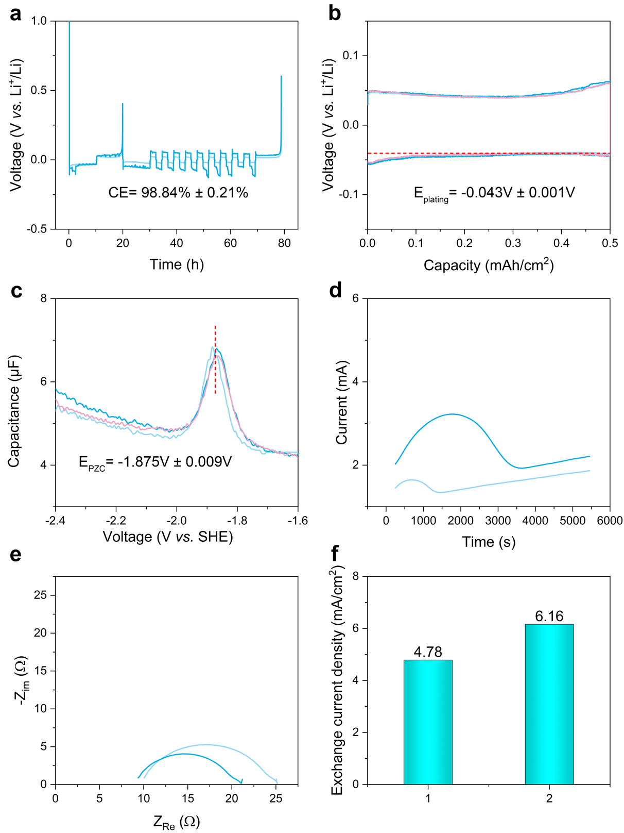
Supplementary Figure 8. Electrochemical characterization of electrolyte H (4.0 M LiFSI in CPME): (a) average CE for Li plating/stripping determined using the modified Aurbach method; (b) the curves for E_{plating} and (c) the curves for E_{PZC} from single-frequency impedance spectroscopy; (d) current-time profile during potentiostatic Li plating; (e) PEIS curve recorded immediately after Li plating during potentiostatic control experiment; (f) calculated average exchange current density derived from (d, e) and the detailed was discussed in Supplementary Note 2.

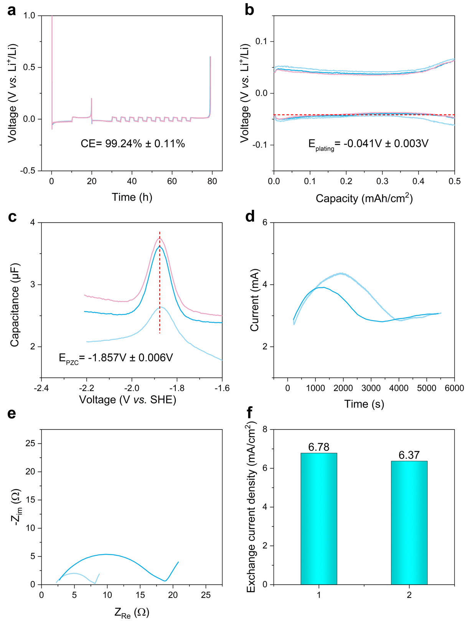
Supplementary Figure 9. Electrochemical characterization of electrolyte I (4.0 M LiFSI in DEE): (a) average CE for Li plating/stripping determined using the modified Aurbach method; (b) the curves for E_{plating} and (c) the curves for E_{PZC} from single-frequency impedance spectroscopy; (d) current-time profile during potentiostatic Li plating; (e) PEIS curve recorded immediately after Li plating during potentiostatic control experiment; (f) calculated average exchange current density derived from (d, e) and the detailed was discussed in Supplementary Note 2.

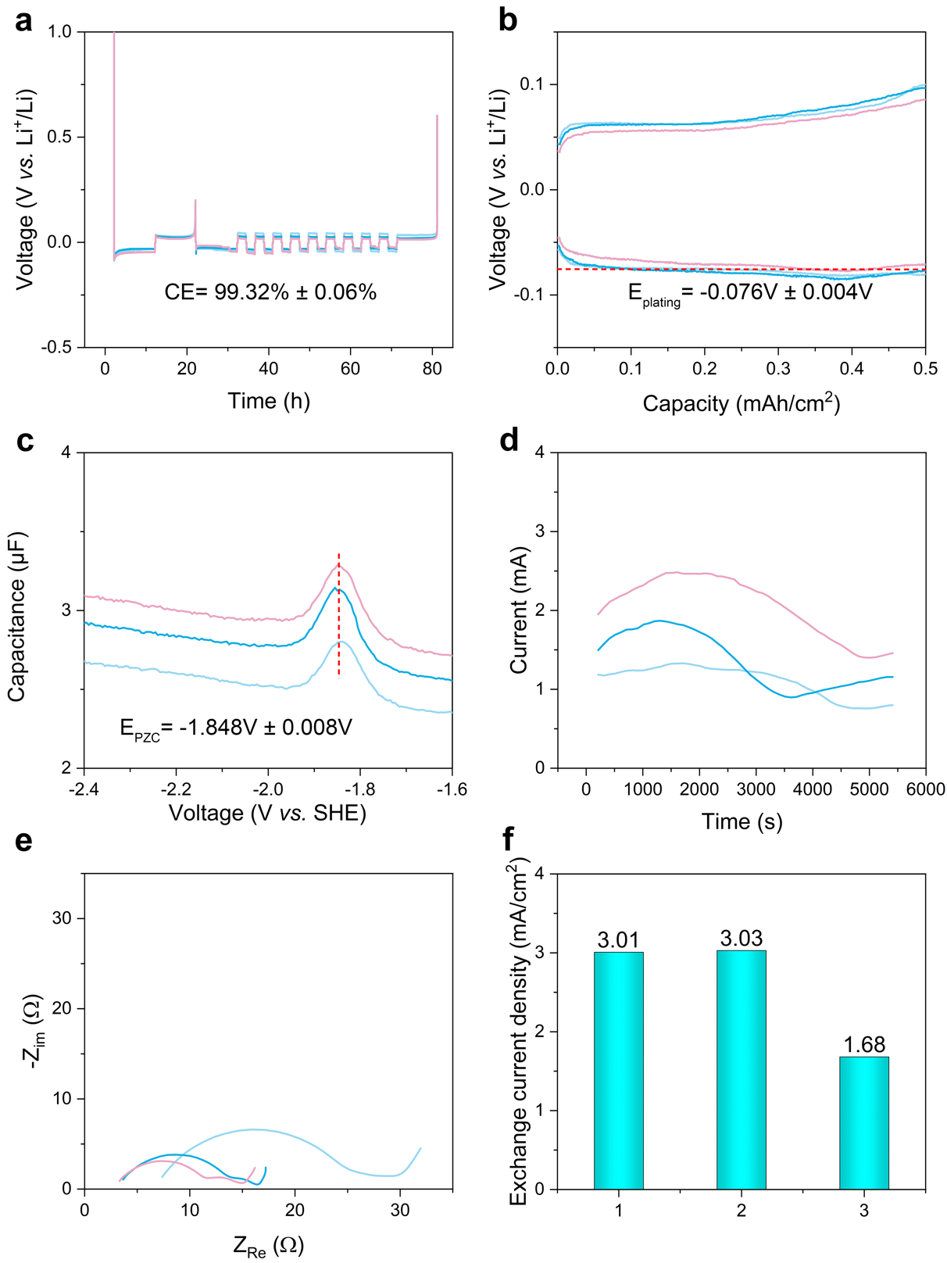
Supplementary Figure 10. Electrochemical characterization of electrolyte J (8.0 M LiFSI in DME): (a) average CE for Li plating/stripping determined using the modified Aurbach method; (b) the curves for E_{plating} and (c) the curves for E_{PZC} from single-frequency impedance spectroscopy; (d) current-time profile during potentiostatic Li plating; (e) PEIS curve recorded immediately after Li plating during potentiostatic control experiment; (f) calculated average exchange current density derived from (d, e) and the detailed was discussed in Supplementary Note 2.

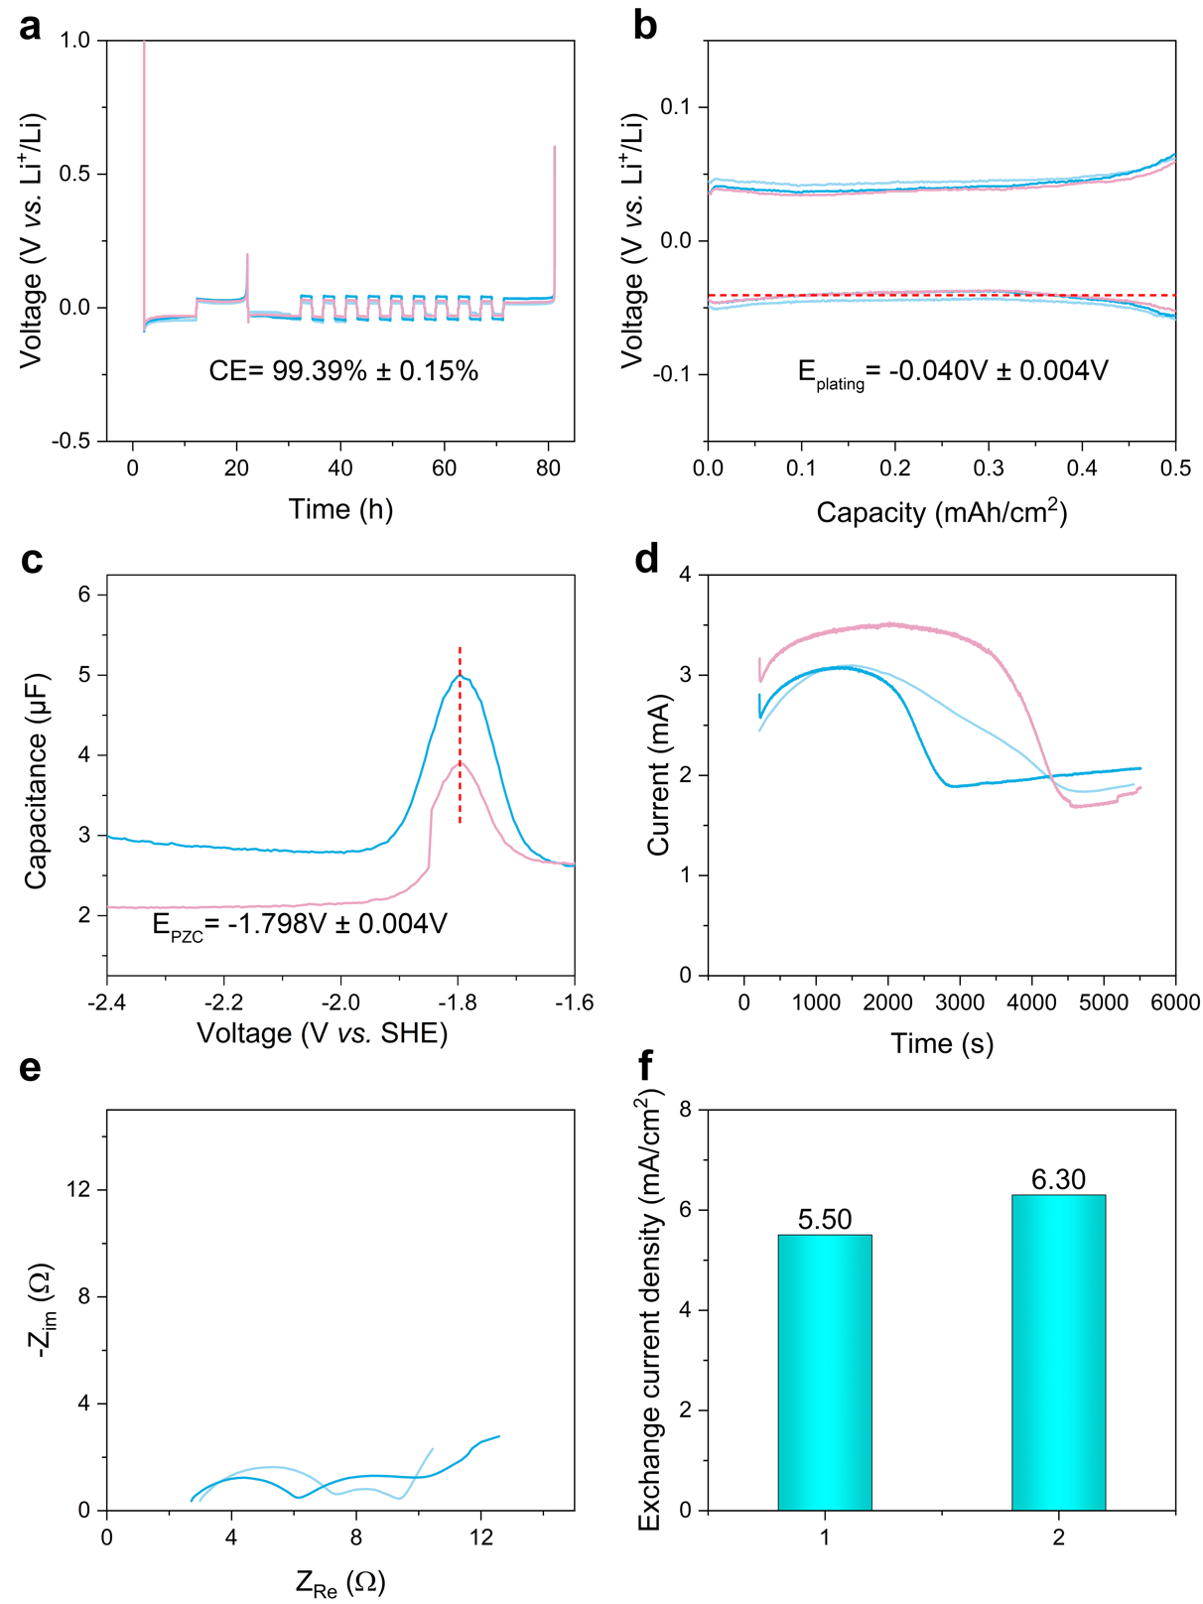
Supplementary Figure 11. Electrochemical characterization of electrolyte K (LiFSI/DME/TTE (mol. 1/1.2/3)): (a) average CE for Li plating/stripping determined using the modified Aurbach method; (b) the curves for E_{plating} and (c) the curves for E_{PZC} from single-frequency impedance spectroscopy; (d) current-time profile during potentiostatic Li plating; (e) PEIS curve recorded immediately after Li plating during potentiostatic control experiment; (f) calculated average exchange current density derived from (d, e) and the detailed was discussed in Supplementary Note 2.

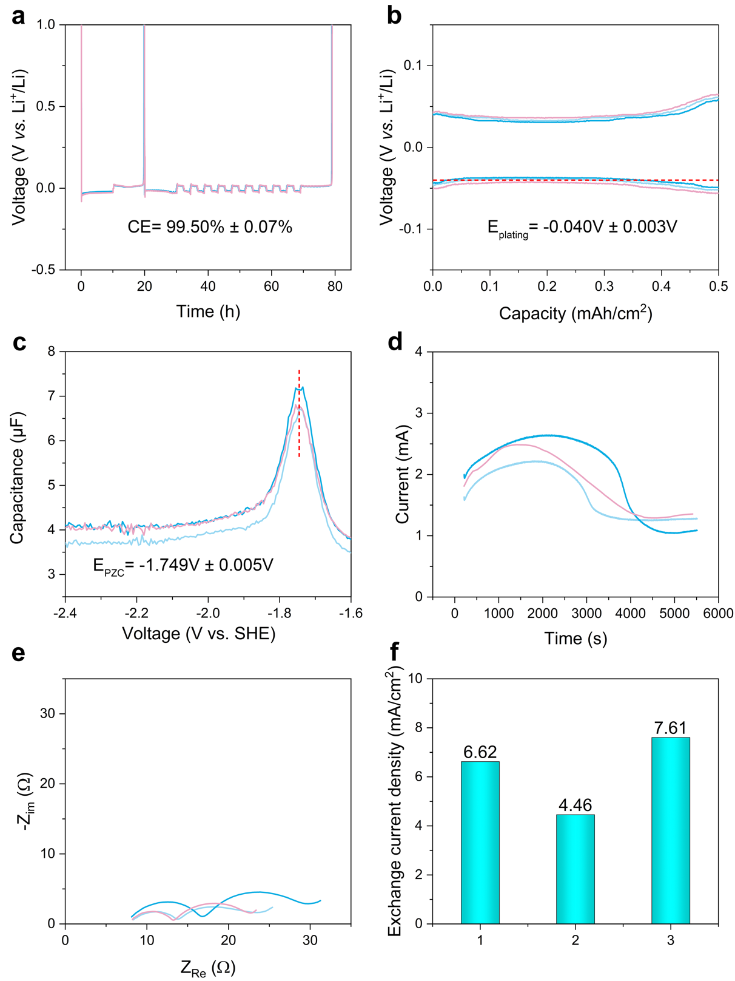
Supplementary Figure 12. Electrochemical characterization of electrolyte L (8.0 M LiFSI in DMC/TTE (mol. 1/1)): (a) average CE for Li plating/stripping determined using the modified Aurbach method; (b) the curves for E_{plating} and (c) the curves for E_{PZC} from single-frequency impedance spectroscopy; (d) current-time profile during potentiostatic Li plating; (e) PEIS curve recorded immediately after Li plating during potentiostatic control experiment; (f) calculated average exchange current density derived from (d, e) and the detailed was discussed in Supplementary Note 2.

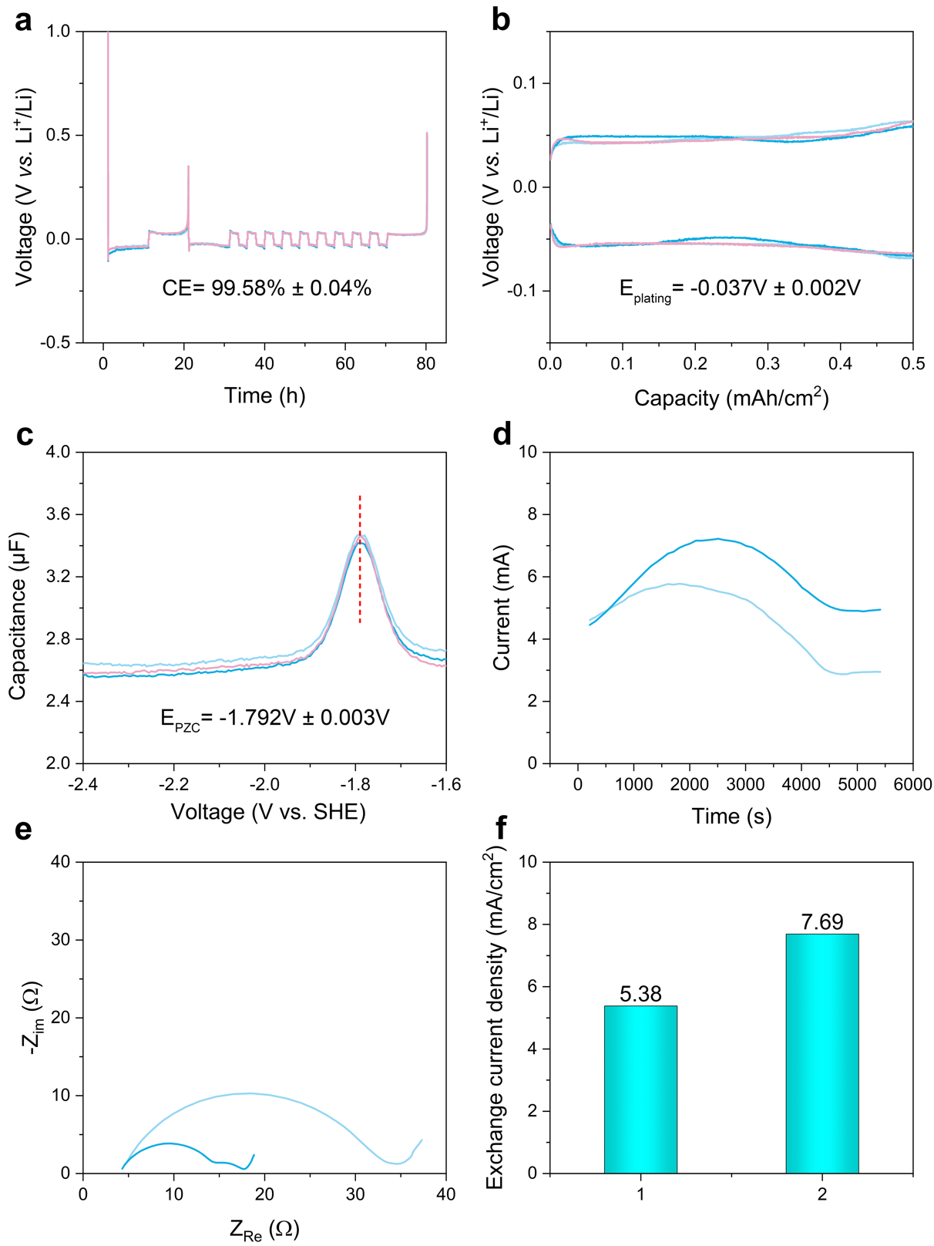
Supplementary Figure 13. Electrochemical characterization of LHWSE (LiFSI/DEE/TTE (mol. 1/1/4)): (a) average CE for Li plating/stripping determined using the modified Aurbach method; (b) the curves for E_{plating} and (c) the curves for E_{PZC} from single-frequency impedance spectroscopy; (d) current-time profile during potentiostatic Li plating; (e) PEIS curve recorded immediately after Li plating during potentiostatic control experiment; (f) calculated average exchange current density derived from (d, e) and the detailed was discussed in Supplementary Note 2.

Supplementary Table 3. The measured CEs, E_{plating} and E_{PZC}, along with their corresponding average values and standard deviations, are summarized for the various electrolytes as presented in the supplementary figures above.
Electrolyte | CEs |  |  | Average  CEs | STD  CEs | E_{plating} (vs. Li⁺/Li) |  |  | Average  E_{plating} | STD  E_{plating} | E_{PZC} (vs. SHE) |  |  | Average  E_{PZC} | STD  E_{PZC}
A | 97.08 | 97.32 | 97.15 | 97.18 | 0.12 | -0.0421 | -0.046 | -0.0486 | -0.0456 | 0.003 | -1.985 | -1.985 | -1.99 | -1.987 | 0.003
B | 97.95 | 97.47 | 97.59 | 97.67 | 0.25 | -0.0344 | -0.0465 | -0.0546 | -0.0452 | 0.010 | -2.021 | -2.035 | -2.04 | -2.032 | 0.010
C | 98.23 | 98.37 | 97.74 | 98.11 | 0.33 | -0.0195 | -0.0195 | -0.0269 | -0.0220 | 0.004 | -2.185 | -2.19 | -2.185 | -2.187 | 0.003
D | 98.44 | 98.32 | 98.59 | 98.45 | 0.14 | -0.0174 | -0.0174 | -0.0233 | -0.0194 | 0.003 | -2.25 | -2.23 | -2.23 | -2.237 | 0.012
E | 99.01 | 98.89 | 98.76 | 98.89 | 0.13 | -0.0317 | -0.0339 | -0.0378 | -0.0345 | 0.003 | -2.26 | -2.255 | -2.27 | -2.262 | 0.008
F | 98.94 | 99.18 | 99.12 | 99.08 | 0.12 | -0.0161 | -0.0195 | -0.02 | -0.0185 | 0.002 | / | -2.245 | -2.25 | -2.248 | 0.004
G | 98.81 | 98.45 | 98.65 | 98.64 | 0.18 | -0.0282 | -0.033 | -0.0421 | -0.0344 | 0.007 | -2.08 | -2.075 | -2.085 | -2.080 | 0.005
H | 98.78 | 99.07 | 98.67 | 98.84 | 0.21 | -0.0421 | -0.0438 | -0.0441 | -0.0433 | 0.001 | -1.885 | -1.87 | -1.87 | -1.875 | 0.009
I | 99.32 | 99.29 | 99.12 | 99.24 | 0.11 | -0.0381 | -0.04 | -0.0438 | -0.0406 | 0.003 | -1.85 | -1.86 | -1.86 | -1.857 | 0.006
J | 99.33 | 99.26 | 99.37 | 99.32 | 0.06 | -0.0716 | -0.0756 | -0.0794 | -0.0755 | 0.004 | -1.855 | -1.85 | -1.84 | -1.848 | 0.008
K | 99.294 | 99.57 | 99.32 | 99.39 | 0.15 | -0.0375 | -0.0375 | -0.0443 | -0.0398 | 0.004 | / | -1.795 | -1.8 | -1.798 | 0.004
L | 99.58 | 99.47 | 99.46 | 99.50 | 0.07 | -0.0375 | -0.0388 | -0.0434 | -0.0399 | 0.003 | -1.745 | -1.755 | -1.748 | -1.749 | 0.005
LHWSE | 99.62 | 99.57 | 99.55 | 99.58 | 0.04 | -0.037 | -0.0356 | -0.0388 | -0.0371 | 0.002 | -1.79 | -1.79 | -1.795 | -1.792 | 0.003

Supplementary Table 4. Detailed parameters for calculating ECSA in Figure 3b, c.
Label | Formula of electrolyte | t₁ | i₁ | t₃ | i₃ | t₂ | i₂ | t₄ | i₄ | k_{x}/k_{base}
base | 75 mV with 0.5 h under potentiostatic control | 999 | 0.58473 | 1800 | 0.6156 | 999 | 0.5847 | 1800 | 0.6156 | 1.000
base-1 | 100 mV with 0.5 h under potentiostatic control | 999 | 0.58473 | 1800 | 0.6156 | 1273 | 3.785 | 1800 | 4.52 | 4.953
base-2 | 125 mV with 0.5 h under potentiostatic control | 999 | 0.58473 | 1800 | 0.6156 | 993 | 7.36 | 1800 | 13.7 | 16.244
base-3 | 100 mV with 1.0 h under potentiostatic control | 999 | 0.58473 | 1800 | 0.6156 | 2215 | 4.15 | 3600 | 6.5 | 5.892
base+FEC | 100 mV with 0.5 h under potentiostatic control,  electrolyte with 5% FEC as additives | 999 | 0.58473 | 1800 | 0.6156 | 1273 | 3.4 | 1800 | 3.85 | 3.376

Supplementary Note 5
The formula of base electrolyte is 1.0 M LiPF₆ in DMC/EMC (vol. 1/1) for Li symmetrical cells, and the The formula of base+FEC electrolyte is 1.0 M LiPF₆ in DMC/EMC (vol. 1/1) with additional 5% wt. FEC solvent. In this section, the cell with base electrolyte with potentiostatic control set as 75 mV and 0.5 h is selected as baseline for calculating the growth rate of ECSA. Thus, the ($t_{1}$, $i_{t1}$) and ($t_{3}$, $i_{t3}$) points of cell was used as the parameter of k_{base} for the calculations in Supplementary Table 4.

Supplementary Table 5. Detailed parameters for calculating growth rate of ECSA and exchange current densities for different electrolytes.
Label | t₁ | i₁ | t₃ | i₃ | t₂ | i₂ | t₄ | i₄ | kx/k_{base} | ave. k | R_{s} | R_{ct} | R_{ct}+R_{SEI} | J₀ | ave. J₀
D/baseline | 2810 | 3.966 | 5410 | 6.240 | 2810 | 3.966 | 5410 | 6.240 | 1.000 | 0.938 | /
D | 2810 | 3.966 | 5410 | 6.240 | 3093 | 1.250 | 5505 | 1.719 | 0.705 | 0.938 | 2.000 | 10.288 | 12.615 | 3.36 | 4.93
D | 2810 | 3.966 | 5410 | 6.240 | 1465 | 1.129 | 5505 | 2.053 | 0.919 | 0.938 | 1.950 | 7.685 | 9.283 | 4.27 | 4.93
D | 2810 | 3.966 | 5410 | 6.240 | 3240 | 2.260 | 5505 | 3.535 | 1.129 | 0.938 | 1.500 | 6.055 | 7.171 | 7.15 | 4.93
A | 2810 | 3.966 | 5410 | 6.240 | 2940 | 0.777 | 5450 | 1.528 | 1.744 | 1.930 | 1.350 | 8.886 | 10.678 | 2.78 | 2.62
A | 2810 | 3.966 | 5410 | 6.240 | 1250 | 0.433 | 5450 | 1.282 | 2.115 | 1.930 | 1.700 | 8.807 | 10.575 | 2.45 | 2.62
B | 2810 | 3.966 | 5410 | 6.240 | 1750 | 0.942 | 5450 | 2.120 | 1.532 | 1.561 | 1.400 | 6.402 | 7.623 | 4.26 | 3.88
B | 2810 | 3.966 | 5410 | 6.240 | 2750 | 0.938 | 5450 | 1.826 | 1.589 | 1.561 | 1.650 | 8.531 | 10.235 | 3.49 | 3.88
C | 2810 | 3.966 | 5410 | 6.240 | 1950 | 1.297 | 5450 | 2.378 | 1.08 | 1.199 | 1.600 | 6.515 | 7.926 | 4.93 | 4.77
C | 2810 | 3.966 | 5410 | 6.240 | 1650 | 1.318 | 5450 | 2.602 | 1.163 | 1.199 | 1.200 | 7.293 | 8.723 | 4.78 | 4.77
C | 2810 | 3.966 | 5410 | 6.240 | 3450 | 1.489 | 5450 | 2.378 | 1.354 | 1.199 | 1.400 | 8.064 | 10.065 | 4.61 | 4.77
E | 2810 | 3.966 | 5410 | 6.240 | 4250 | 2.115 | 5450 | 2.270 | 0.482 | 0.401 | 9.500 | 18.859 | 21.186 | 6.60 | 6.60
E | 2810 | 3.966 | 5410 | 6.240 | 4450 | 2.195 | 5450 | 2.348 | 0.439 | 0.401 | 8.700 | 18.175 | 20.707 | 6.59 | 6.60
F | 2810 | 3.966 | 5410 | 6.240 | 3030 | 3.971 | 5450 | 4.902 | 0.316 | 0.297 | 1.500 | 4.510 | 5.282 | 11.05 | 9.33
F | 2810 | 3.966 | 5410 | 6.240 | 3750 | 3.325 | 5450 | 3.926 | 0.277 | 0.297 | 1.500 | 5.618 | 6.625 | 8.11 | 9.33
F | 2810 | 3.966 | 5410 | 6.240 | 3650 | 3.314 | 5450 | 3.684 | 0.281 | 0.297 | 1.350 | 3.944 | 4.842 | 8.83 | 9.33
G | 2810 | 3.966 | 5410 | 6.240 | 3832 | 3.131 | 5510 | 3.750 | 0.534 | 0.462 | 1.700 | 4.406 | 5.167 | 9.20 | 8.84
G | 2810 | 3.966 | 5410 | 6.240 | 3710 | 3.221 | 5410 | 3.887 | 0.552 | 0.462 | 2.200 | 3.657 | 4.297 | 14.72 | 8.84
G | 2810 | 3.966 | 5410 | 6.240 | 4010 | 2.366 | 5410 | 2.673 | 0.420 | 0.462 | 2.430 | 6.391 | 8.213 | 7.12 | 8.84
G | 2810 | 3.966 | 5410 | 6.240 | 4810 | 1.753 | 5410 | 1.832 | 0.341 | 0.462 | 2.700 | 8.311 | 10.338 | 4.34 | 8.84
H | 2810 | 3.966 | 5410 | 6.240 | 1550 | 1.347 | 5450 | 1.867 | 0.449 | 0.412 | 9.000 | 21.561 | 25.064 | 4.78 | 5.47
H | 2810 | 3.966 | 5410 | 6.240 | 3650 | 1.925 | 5450 | 2.211 | 0.374 | 0.412 | 9.000 | 18.657 | 20.946 | 6.16 | 5.47
I | 2810 | 3.966 | 5410 | 6.240 | 4105 | 2.834 | 5512 | 3.086 | 0.287 | 0.233 | 2.050 | 6.772 | 8.080 | 6.78 | 6.58
I | 2810 | 3.966 | 5410 | 6.240 | 3210 | 2.824 | 5410 | 3.069 | 0.179 | 0.233 | 2.700 | 14.179 | 18.552 | 6.37 | 6.58
J | 2810 | 3.966 | 5410 | 6.240 | 5085 | 1.258 | 5510 | 1.313 | 0.467 | 0.349 | 6.000 | 18.472 | 22.240 | 3.01 | 2.57
J | 2810 | 3.966 | 5410 | 6.240 | 4710 | 1.261 | 5410 | 1.338 | 0.396 | 0.349 | 3.700 | 12.808 | 16.053 | 3.03 | 2.57
J | 2810 | 3.966 | 5410 | 6.240 | 5010 | 0.647 | 5410 | 0.657 | 0.186 | 0.349 | 3.500 | 11.850 | 14.920 | 1.68 | 2.57
K | 2810 | 3.966 | 5410 | 6.240 | 4810 | 1.840 | 5410 | 1.909 | 0.283 | 0.243 | /
K | 2810 | 3.966 | 5410 | 6.240 | 2915 | 1.888 | 5510 | 2.067 | 0.166 | 0.243 | 2.800 | 7.315 | 9.361 | 5.50 | 5.90
K | 2810 | 3.966 | 5410 | 6.240 | 4602 | 1.684 | 5172 | 1.743 | 0.279 | 0.243 | 2.600 | 6.168 | 10.041 | 6.30 | 5.90
L | 2810 | 3.966 | 5410 | 6.240 | 4062 | 1.256 | 5511 | 1.278 | 0.055 | 0.211 | 8.000 | 13.724 | 23.089 | 6.62 | 6.23
L | 2810 | 3.966 | 5410 | 6.240 | 4916 | 1.044 | 5511 | 1.089 | 0.329 | 0.211 | 7.600 | 16.840 | 29.437 | 4.46 | 6.23
L | 2810 | 3.966 | 5410 | 6.240 | 4510 | 1.291 | 5410 | 1.355 | 0.250 | 0.211 | 8.000 | 13.193 | 22.694 | 7.61 | 6.23
LHWSE | 2810 | 3.966 | 5410 | 6.240 | 4810 | 2.875 | 5410 | 2.947 | 0.188 | 0.180 | 4.700 | 24.019 | 33.870 | 5.38 | 6.54
LHWSE | 2810 | 3.966 | 5410 | 6.240 | 5110 | 4.889 | 5410 | 4.944 | 0.169 | 0.180 | 4.000 | 14.570 | 17.440 | 7.69 | 6.54

Supplementary Table 6. The quantitative comparison of detailed parameters of different electrolytes: CEs, E_{plating}, E_{PZC}, J₀, distribution factor and k_{x}. The comparison of distribution factor between electrolytes are categorized three groups: electrolytes A-F, electrolytes G-I and electrolytes J-L.
Label | Formula of electrolyte | CE (%) | E_{pzc}  (V vs. SHE) | E_{plating}  (V vs. Li⁺/Li) | J₀  (mA/cm2) | Distribution factor (f) | k_{x}/k_{baseline}
A | 1.0 M LiPF₆ in DMC/FEC (vol. 1/1) | 97.18 | -2.032 | -0.0456 | 2.62 | 0.415 | 1.930
B | 1.0 M LiDFOB+0.7M LiBF₄ in DEC/FEC (vol. 1/2) | 97.67 | -1.987 | -0.0452 | 3.88 | 0.581 | 1.561
C | 1.0 M LiFSI in DOL/DME (vol. 1/1) | 98.11 | -2.187 | -0.0220 | 4.77 | 0.910 | 1.199
D | 1.0 M LiFSI in DME | 98.45 | -2.237 | -0.0194 | 4.93 | 1.000 | 0.938
E | 1.0 M LiFSI in CPME | 99.10 | -2.248 | -0.0185 | 6.60 | 1.349 | 0.401
F | 1.0 M LiFSI in DEE | 99.21 | -2.262 | -0.0345 | 9.33 | 1.917 | 0.297
G | 4.0 M LiFSI in DME | 98.64 | -2.080 | -0.0344 | 8.84 | 1.000 | 0.462
H | 4.0 M LiFSI in CPME | 98.84 | -1.875 | -0.0433 | 5.47 | 3.788 | 0.412
I | 4.0 M LiFSI in DEE | 99.24 | -1.877 | -0.0406 | 6.58 | 4.125 | 0.233
J | 8.0 M LiFSI in DME | 99.32 | -1.848 | -0.0755 | 2.57 | 1.000 | 0.349
K | LiFSI/DME/TTE (mol. 1/1.2/3) | 99.39 | -1.798 | -0.0398 | 5.90 | 2.294 | 0.243
L | 8.0 M LiFSI in DMC/TTE (mol. 1/1) | 99.50 | -1.749 | -0.0399 | 6.23 | 2.420 | 0.211
LHWSE | LiFSI/DEE/TTE (mol. 1/1/4) | 99.58 | -1.792 | -0.0371 | 6.54 | 2.527 | 0.180

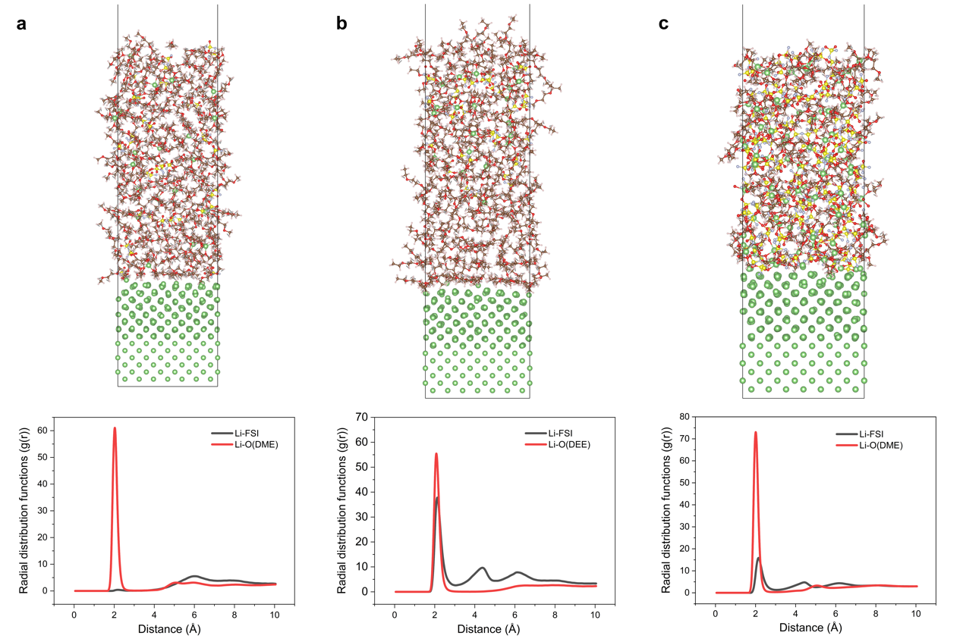
Supplementary Figure 14. Snapshots and radial distribution functions near the electrolyte/electrode interface for electrolyte D (a), electrolyte F (b) and electrolyte J (c) were obtained from CMD simulations.

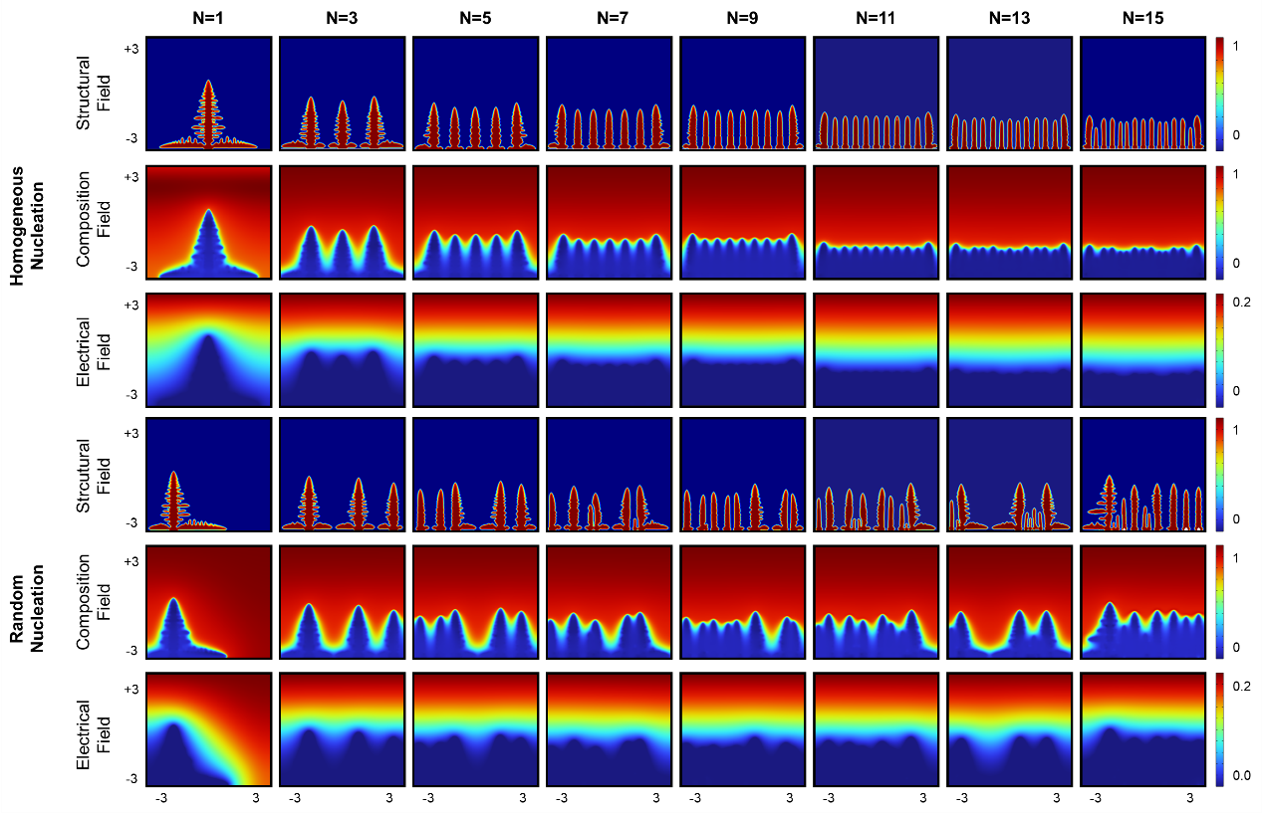
Supplementary Figure 15. Phase-field simulations were conducted to investigate dendrite growth morphology, composition field and electrical field under varying nucleation conditions, with nucleation site numbers of 1, 3, 5, 7, 9, 11, 13 and 15 under uniform and random nucleation behavior.

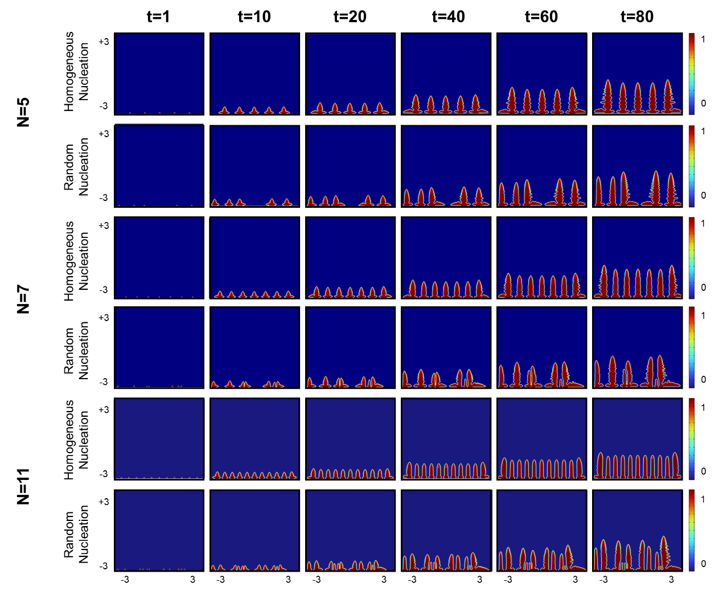
Supplementary Figure 16. Phase-field simulations were conducted to investigate dendrite growth under varying nucleation conditions, with nucleation site numbers of 5, 7, and 11. Two nucleation behaviors, namely uniform and random spatial distributions, were considered. Simulations were carried out at time intervals of 0, 10, 20, 40, 60, and 80 s to track the evolution of dendrite growth morphology.

Supplementary Figure 17. The SANS data for the Li deposit in LHWSE under the areal Li plating capacity of 6.0 mAh cm⁻², and the related slope for the curve showing the fractal character.

Supplementary Table 7. The detailed parameters and mass of each part of Li/NCM811 pouch cell.
Components | Cell parameters | Values
Cathode | Cathode type | NCM811
Cathode | Cathode areal loading (mg/cm²) | 26.0
Cathode | Ratio of active cathode material (%) | 96
Cathode | Areal capacity of cathode (mAh/cm²) | 5.0
Cathode | Electrode size (cm²) | 6.2*7.2
Cathode | Number of electrode sheets | 15
Cathode | Thickness of Al foil (μm) | 10
Cathode | Total mass of cathode electrode (g) | 36.602
LMA | Thickness of LMA (μm) | 20
LMA | Total mass of LMA (g) | 1.517
Electrolyte | Injection ratio (g/Ah) | 1.00
Electrolyte | Total mass of electrolyte (g) | 6.50
Separator | Thickness of separator (μm) | 12.0
Separator | Total mass of separator (g) | 1.644
Packing Al | Total mass of packing Al (g) | 0.982
Tabs | Total mass of tabs (g) | 0.324
Pouch cell | N/P ratio | 0.80
Pouch cell | Charge/discharge rate (C) | 0.1C/0.1C
Pouch cell | Capacity (Ah) | 6.48
Pouch cell | Energy (Wh) | 24.50
Pouch cell | Mass of cell (g) | 47.569
Pouch cell | Energy density (Wh/kg) | 515

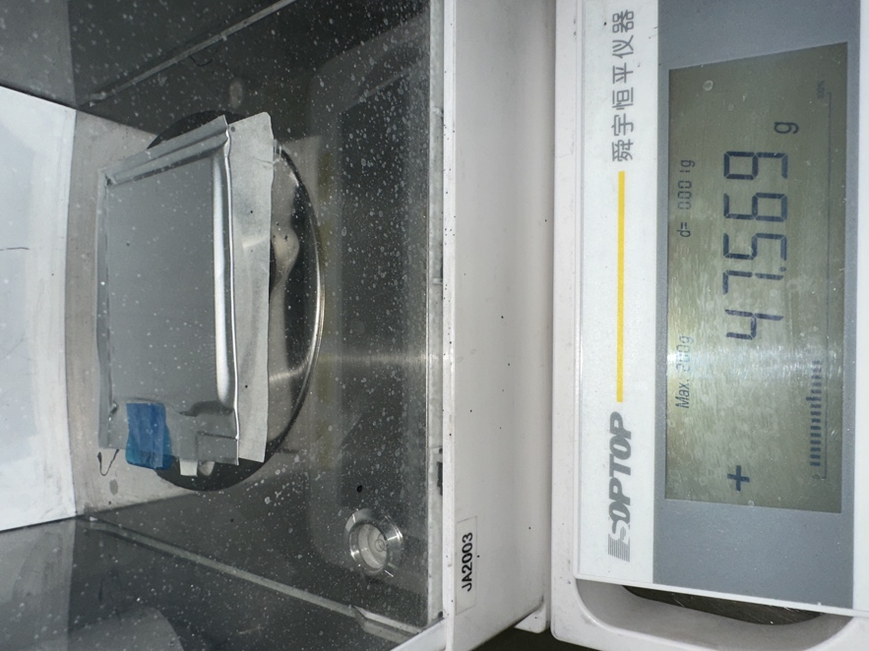
Supplementary Figure 18. Digital photograph of LMB pouch cell for showing its mass.

Supplementary Figure 19. Cycling performances of 1.2 Ah Li/NCM pouch cells by using LHWSE under stack pressure of 100 kPa.

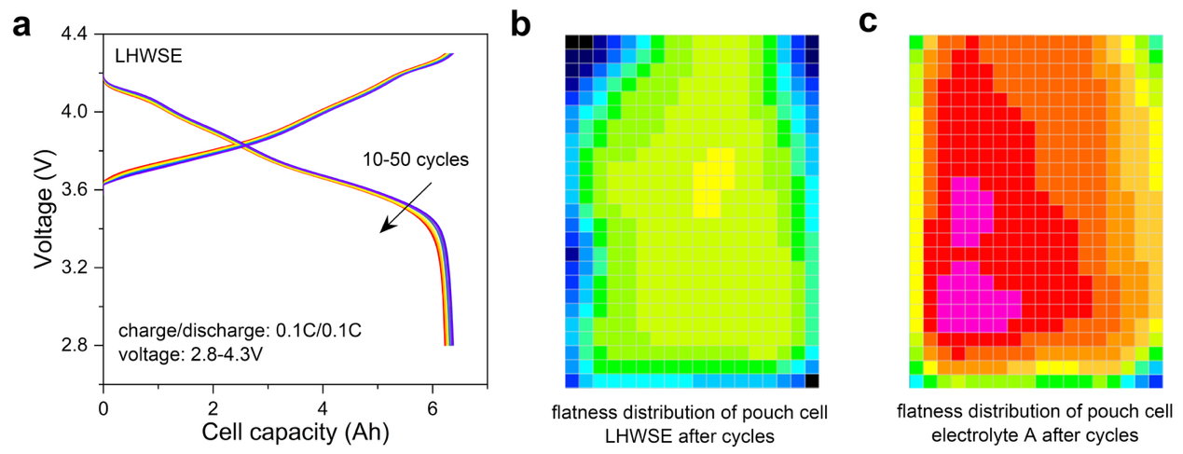
Supplementary Figure 20. (a) The charge and discharge profiles the pouch cell with LHWSE in Fig.4f for 10th to 50th cycles. Cell flatness distribution of Li/NCM811 pouch cells with LHWSE (b) and electrolyte A (c) after cycling.

Reference:
1 Lai, G. et al. Unraveling charge effects on interface reactions and dendrite growth in lithium metal anode. npj Computational Materials 11, 121 (2025).
2 Rappe, A. K. & Goddard III, W. A. Charge equilibration for molecular dynamics simulations. The Journal of Physical Chemistry 95, 3358-3363 (1991).
3 Novikov, I. S., Gubaev, K., Podryabinkin, E. V. & Shapeev, A. V. The MLIP package: moment tensor potentials with MPI and active learning. Machine Learning: Science and Technology 2, 025002 (2020).
4 Kühne, T. D. et al. CP2K: An electronic structure and molecular dynamics software package-Quickstep: Efficient and accurate electronic structure calculations. The Journal of Chemical Physics 152 (2020).
5 Hutter, J., Iannuzzi, M., Schiffmann, F. & VandeVondele, J. cp2k: atomistic simulations of condensed matter systems. Wiley Interdisciplinary Reviews: Computational Molecular Science 4, 15-25 (2014).
6 Goedecker, S., Teter, M. & Hutter, J. Separable dual-space Gaussian pseudopotentials. Physical Review B 54, 1703 (1996).
7 Grimme, S., Antony, J., Ehrlich, S. & Krieg, H. A consistent and accurate ab initio parametrization of density functional dispersion correction (DFT-D) for the 94 elements H-Pu. The Journal of Chemical Physics 132 (2010).

