Table S1. Incidence of “dead heart” symptoms (%) caused by pink stem borer in wheat, as influenced by foliar application of elicitors (treatments T1–T9) across two winter seasons (2021–22 & 2022–23) and multiple observation periods (42–63 DAS).

Treatment | Per cent dead heart symptom* |  |  |  | Mean | % Reduction
Treatment | 42  DAS | 49  DAS | 56  DAS | 63  DAS | Mean | % Reduction
Salicylic acid 8 mM | 4.35^{bcd} | 4.53^{bcd} | 4.70^{bcd} | 3.97^{bcd} | 4.39^{bcd} | 19.15
Salicylic acid 16 mM | 4.43^{bc} | 4.33^{bc} | 4.77^{bc} | 3.48^{bc} | 4.26^{bc} | 21.55
Methyl salicylate 8 mM | 4.84^{cde} | 4.72^{cde} | 4.76^{cde} | 3.98^{cde} | 4.58^{cde} | 15.65
Methyl salicylate 16 mM | 4.66^{bcd} | 4.57^{bcd} | 4.86^{bcd} | 3.67^{bcd} | 4.44^{bcd} | 18.23
Jasmonic acid 2.5 mM | 3.88^{ab} | 4.26^{ab} | 4.33^{ab} | 3.71^{ab} | 4.05^{ab} | 25.41
Jasmonic acid 5 mM | 3.60ª | 4.02ª | 3.98ª | 3.20ª | 3.71ª | 31.68
Chitosan 2.5 mM | 4.99de | 5.09de | 5.35de | 4.39de | 4.96de | 8.66
Chitosan 5 mM | 4.85^{ef} | 5.00^{ef} | 5.39^{ef} | 4.51^{ef} | 4.94^{ef} | 9.02
Control | 5.38^{f} | 5.56^{f} | 5.95^{f} | 4.84^{f} | 5.43^{f} | -
SE(d) | 0.13 | 0.10 | 0.10 | 0.11 | 0.03 | -
CD (P<0.0.025,0.017,  0.018,0.052,0.000) | 0.39 | 0.28 | 0.28 | 0.33 | 0.08 | -
*Data represent mean values of three replications; Data on dead heart were subject to ANOVA after arcsine transformation; DAS: Days after sowing; mM: Millimolar; In a column, means followed by same letter(s) are not significantly different by Tukey’s HSD, α = 0.05.

Table S2. Incidence of “white ear” symptoms (%) caused by pink stem borer in wheat, as influenced by foliar application of elicitors (treatments T1–T9) across two winter seasons (2021–22 & 2022–23) and multiple observation periods (73–90 DAS).

Main/sub/sub-sub plots | Per cent white ear symptom* |  |  | Mean | % Reduction | Yield (grain kg/ha) | % Increase
Main/sub/sub-sub plots | 73  DAS | 83  DAS | 90  DAS
Treatment (Sub-plot)
Salicylic acid 8 mM | 3.96^{b} | 6.81^{b} | 7.48^{b} | 6.08^{b} | 20.11 | 3687.33^{d} | 8.10
Salicylic acid 16 mM | 3.86^{ab} | 6.44^{ab} | 7.10^{ab} | 5.80^{ab} | 23.78 | 3877.78^{b} | 12.62
Methyl salicylate 8 mM | 4.60^{bc} | 6.95^{bc} | 7.25^{bc} | 6.27^{bc} | 17.61 | 3648.72e | 7.13
Methyl salicylate 16 mM | 4.02^{ab} | 6.83^{ab} | 7.23^{ab} | 6.03^{ab} | 20.76 | 3851.89^{c} | 12.03
Jasmonic acid 2.5 mM | 3.75^{ab} | 6.56^{ab} | 7.24^{ab} | 5.85^{ab} | 23.13 | 3872.22^{b} | 12.49
Jasmonic acid 5 mM | 3.64ª | 6.23ª | 6.60ª | 5.49ª | 27.86 | 4763.75ª | 28.87
Chitosan 2.5 mM | 4.86^{d} | 7.61^{d} | 8.10^{d} | 6.86^{d} | 9.86 | 3561.11^{g} | 4.85
Chitosan 5 mM | 4.95^{cd} | 7.52^{cd} | 8.06^{cd} | 6.84^{cd} | 10.12 | 3605.56^{f} | 6.02
Control | 5.41e | 8.50e | 8.93e | 7.61e | - | 3388.49^{h} | -
SE(d) | 0.10 | 0.10 | 0.10 | 0.02 | - | 0.01 | -
CD (P<0.029,0.001,0.000) | 0.27 | 0.23 | 0.24 | 0.07 | - | 0.01 | -
*Data represent mean values of three replications; Data on dead heart were subject to ANOVA after arcsine transformation; DAS: Days after sowing; mM: Millimolar; In a column, means followed by same letter(s) are not significantly different by Tukey’s HSD, α = 0.05.

Table S3. List of organic volatile compounds, emitted by healthy wheat pot plants; wheat pot plants infested with 3rd instar pink stem borer larvae and wheat plants with foliar application of JA; *Means of three replications; In a column, means followed by the same letter(s) do not differ significantly from each other by Tukey’s HSD test (α = 0.05). Per cent occupied by volatiles in all three profiles were subject to statistical analysis after applying arcsine transformation.

S. No. | Compound name | Molecular formula | Wheat healthy | % Area | Wh + PSB | % Area | Wh + JA | % Area
1. | 1-Hexen-4-yne, 3-ethylidene-2-methyl- | C9H12 | √ | 2.20^{g}  ±0.63 | - | 0^{n} | - | 0^{k}
2. | Azulene | C10H8 | - | 0^{j} | - | 0^{n} | √ | 0.78^{j}  ±0.50
3. | Octadecane,5-methyl- | C19H40 | √ | 0.93^{i}  ±0.50 | √ | 0.76^{m}  ±0.59 | √√ | 4.21^{def}  ±0.50
4. | 5,5-Diethylpentadecane | C19H40 | - | 0 | - | 0^{n} | √ | 0.77^{j}  ±0.44
5. | 1-Nonadecene | C19H38 | - | 0^{j} | √ | 5.50^{ef}  ±0.50 | √ | 0.57^{j}  ±0.44
6. | Eicosane, 2,4-dimethyl- | C22H46 | - | 0^{j} | √ | 1.15^{kl}  ±0.50 | - | 0^{k}
7. | Tetracosane | C24H50 |  | 0^{j} | √ | 3.37^{i}  ±0.44 | √√√ | 4.69^{d}  ±0.50
8. | 2,5-Cyclohexadiene-1,4-dione, 2,6-bis(1,1-dimethyl | C14H20O2 | √ | 1.85^{gh}  ±0.50 | - | 0^{n} | - | 0^{k}
9. | Benzaldehyde, 3-ethoxy-4-propoxy- | C12H16O3 | √ | 3.07^{f}  ±0.44 | - | 0^{n} | - | 0^{k}
10. | 1-dodecanol | C12H26O | - | 0^{j} | √ | 0.78^{lm}  ±0.44 | √√ | 3.23^{g}  ±0.63
11. | Methyl 4-tert-butylbenzoate | C12H16O2 | - | 0^{j} | √ | 1.33^{jk}  ±0.50 | - | 0^{k}
12. | Phenol, 2,6-bis(1,1-dimethylethyl)- | C14H22O | √ | 3.53^{f}  ±0.44 | √ | 6.70^{d}  ±0.63 | √ | 4.53de  ±0.50
13. | 2-Butenedioic acid (Z)-, monododecyl ester | C16H28O4 | √ | 1.62^{h}  ±0.50 | √√ | 8.28^{c}  ±0.50 | √ | 3.66^{efg}  ±0.50
14. | Benzenedicarboxylic acid, bis(2-methylpropyl) | C16H22O4 | √ | 9.07^{d}  ±0.63 | √ | 4.04^{hi}  ±0.50 | √ | 11.11ª  ±0.44
15. | n-hexadecanoic acid | C16H32O2 | - | 0^{j} | √ | 5.18^{f}  ±0.44 | √ | 3.46^{fg}  ±0.44
16. | Oxirane, hexadecyl- | C19H36O3 | - | 0^{j} | √√ | 11.0^{b}  ±0.44 | √√ | 9.80ª  ±0.50
17. | Methyl stearate | C19H38O2 | - | 0^{j} | √ | 1.61^{ij}  ±0.50 | √ | 1.26^{i}  ±0.63
18. | Carbonic acid, decylnonyl ester | C20H40O3 | - | 0^{j} | √√ | 4.86^{fgh}  ±0.63 | √√ | 3.40^{fg}  ±0.50
19. | Malonicacid, dodecyl 4-methylpent-2-yl ester | C21H42O2 | - | 0^{j} | - | 0^{n} | √ | 2.98^{g}  ±0.50
20. | Eicosanoic acid, methyl ester | C21H42O2 | - | 0^{j} | √ | 6.30de  ±0.50 | √ | 5.99^{c}  ±0.44
21. | 1-pentacosanol | C25H52O | - | 0^{j} | √ | 4.16^{gh}  ±0.50 | - | 0^{k}
22. | 2-(3-Hydroxyprop-1-yn-1-yl)benzonitrile | C10H7NO | √ | 6.92e  ±0.50 | - | 0^{n} | - | 0^{k}
23. | 4-Nitro-5,6,7,8-tetrahydronaphthalen-1-ol | C10H11NO3 | - | 0^{j} | √ | 7.85^{c}  ±0.44 | √ | 6.03^{c}  ±0.43
24. | trans-2-Dodecen-1-ol, trifluoroacetate | C14H23F3O2 | √ | 2.24^{g}  ±0.50 | - | 0^{n} | - | 0^{k}
25. | cis-1-Chloro-9-octadecene | C18H35Cl | √ | 11.73^{c}  ±0.44 | - | 0^{n} | - | 0^{k}
26. | Heptafluorobutyric acid, n-tetradecyl ester | C18H29F7O2 | - | 0^{j} | - | 0^{n} | √ | 6.38^{c}  ±0.50
27. | 4-(4,7-Dimethoxy-2H-1,3-benzodioxol-5-yl)-1,3-dimethyl-4H,5H,7H-pyrazolo[3,4-b]pyridin-6-one | C17H19N3O5 | √ | 16.75^{b}  ±0.44 | - | 0^{n} | - | 0^{k}
28. | 3,5-dimethyl-pyrazol-1-yl)-[1,2,5]oxadiazolo | C17H17N7O | √ | 40.08ª  ±0.50 | - | 0^{n} | - | 0^{k}
29. | Nonadecylheptafluorobutyrate | C23H39F7O2 | - | 0^{j} | √ | 4.72^{fgh}  ±0.44 | √√ | 7.83^{b}  ±0.63
30. | Eicosylheptafluorobutyrate | C24H41F7O2 | - | 0^{j} | - | 0^{n} | √ | 3.62^{fg}  ±0.50
31. | Docosylheptafluorobutyrate | C26H45F7O2 | - | 0^{j} | - | 0^{n} | √ | 2.13^{h}  ±0.50
32. | 1,2-Oxathiane, 6-dodecyl-, 2,2-dioxide | C16H32O3S | - | 0^{j} | √ | 4.89^{fg}  ±0.44 | - | 0^{k}
33. | (3-Nitro-phenoxy)-acetic acid pyridin-2-ylmethylene-hydrazide | C14H12N4O4 | - | 0^{j} | √ | 17.51ª  ±0.50 | - | 0^{k}
SE(d) |  |  |  | 0.439 | - | 4.178 | - | 0.631
CD (P<0.0001) |  |  |  | 1.166 | - | 11.097 | - | 1.676
Wh: Wheat; JA: Jasmonic acid
Table S4. Per cent parasitization of T. chilonis on eggs of Corcyra, as influenced by selected hydrocarbons induced by pink stem borer feeding and foliar application of JA in wheat pot plants; *Mean of six replications; In a column, values followed by the same letter(s) do not differ significantly from each other by Tukey’s HSD test (α = 0.05); DAI: Days after inoculation

S. No. | Compounds | % parasitization at*
S. No. | Compounds | 3 DAI | 5 DAI | 7 DAI
1. | Octadecane | 17.0^{b} | 73.5^{c} | 90.4^{b}
2. | 1-Nonadecene | 13.5^{d} | 31.4^{d} | 32.3^{d}
3. | Eicosane | 18.1ª | 78.5ª | 91.8ª
4. | n-Hexadecanoic acid | 18.8ª | 75.8^{b} | 89.4^{c}
5. | Hexane washed eggs | 15.1^{c} | 28.2e | 25.3e
6. | Untreated control eggs | 18.4ª | 75.4^{b} | 90.2^{b}
SE(d) |  | 0.303 | 0.243 | 0.341
CD (P<0.0001) |  | 0.925 | 0.742 | 1.041

Table S5. Per cent parasitization of Trichogramma chilonis on eggs of Corcyra, as influenced by selected hydrocarbons induced by pink stem borer feeding and foliar application of JA in wheat pot plants; *Mean of six replications; In a column, values followed by the same letter(s) do not differ significantly from each other by Tukey’s HSD test (α = 0.05); DAI: Days after inoculation

S. No. | Compounds | % parasitization at
S. No. | Compounds | 3 DAI | 5 DAI | 7 DAI
1. | Octadecane | 18.4ª | 74.2ª | 92.5^{b}
2. | 1-Nonadecane | 12.5^{b} | 30.2^{c} | 31.7e
3. | Eicosane | 18.5ª | 74.3ª | 82.5^{d}
4. | n-Hexadecanoic acid | 19.2ª | 72.6^{b} | 90.4^{c}
5. | Hexane washed eggs | 13.2ª | 24.0^{d} | 28.1^{f}
6. | Untreated control eggs | 18.3^{b} | 73.2^{b} | 94.5ª
SE(d) |  | 0.306 | 0.254 | 0.361
CD (P<0.0001) |  | 0.936 | 0.777 | 1.104

Figure S1. Chromatogram and volatiles deducted in healthy wheat seedlings
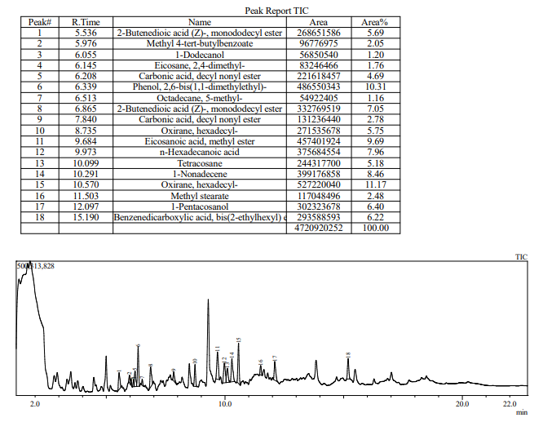
Figure S2. Chromatogram and volatiles deducted in wheat seedlings induced by pink stem borer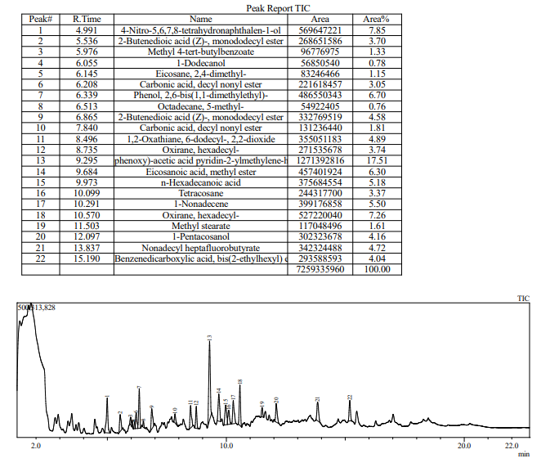

Figure S3. Chromatogram and volatiles deducted in wheat seedlings induced by exogenous JH application
