Supplementary Information

for

Improved electrocatalytic activity and stability of PtPd/graphene nanoplates using sulfated zirconia for methanol electro-oxidation in DMFC application: An experimental and computational study

Maryam Yaldagard^{1, *}, Mina Sedighi², Hassan Sabzyan³
¹ Department of Chemical Engineering, Faculty of Engineering, Urmia University, Urmia 5766-151818, Iran
² Department of Chemical Engineering, Faculty of Engineering, University of Isfahan, Isfahan 81746-73441, Iran
³ Department of Chemistry, University of Isfahan, Isfahan 81746-73441, Iran

Table of Contents
- Texts | Title | Page
Text S1 | Materials | 1
Text S2 | Preparation of GO and GNPs | 1
Text S3 | Preparation of S-ZrO₂-GNPs support | 2
Text S4 | Characterization analyses and instrumentation | 2
Text S5 | Details of density functional theory (DFT) computations | 3
Text S6 |  | 4
Text S7 | Raman analysis | 4
Text S8 | Description of PXRD peaks of PtPd/S-ZrO₂-GNP electrocatalyst shown in Fig. 3 | 5
- Figures | Caption | Page
Figure S1 | The supercells of a) ZrO_{1.33}S_{0.67} and b) PtPd_{1.67} compounds studied computationally in this work. The red, yellow, cyan, orange and gray spheres represent the O, S, Zr, Pt, and Pd elements, respectively. | 6
Figure S2 | AFM (2D and 3D) topography images along with the corresponding height profiles for (a) S-ZrO₂/GNPs and (b) GNPs, (c) the phase scan and pore size distribution of the GNPs. | 7
Figure S3 | (a) BET diagram and (b) N₂ adsorption isotherm obtained for the GNPs doped with ZrO₂ particles, based on N₂ absorption/desorption at 77.3 K, P₀ = 90 kPa. | 8
Figure S4 | (a) FTIR spectra of GO, GNPs, ZrO₂-GNPs, and S-ZrO₂-GNPs powders (b) Raman spectra of GNPs and S-ZrO₂-GNPs support. | 9
Figure S5 | Chronoamperometric curves of PtPd/S-ZrO₂-GNPs, PtPd/ZrO₂-GNPs and Pt/C electrocatalysts in N₂ saturated $0.5 M H_{2}{SO}_{4}$ aqueous solution containing 1 M CH₃OH at fixed potential of 0.4 V for 1 h. | 10
Figure S6 | The DFT-calculated band structure of graphene (obtained for a 2×1×1 supercell) along high symmetry paths of the first Brillouin zone (left), and the corresponding DOS (right). | 11

Text S1. Materials
Graphite powder (Gr) of 99.9999% purity was obtained from Alfa Aesar. PdCl₂ (59 wt%) was obtained from Scharlau. Pt/C (20 wt%) and Nafion solution (5 wt%, Dupont) were purchased from Fuel Cell Earth Company. CO (99.9900%) and N₂ (99.9995%) gases were supplied by Canadian Sigma. Milli-Q water was used in all preparation experiments. Polishing kits, including pads and powders, and glassy carbon (GC) electrodes (5 mm diameter) were obtained from Bio-Analytical System (USA). Other chemicals, including H₂PtCl₆·6H₂O (40%), ZrOCl₂·8H₂O, KMnO₄, H₂SO₄, ammonium hydroxide (28% in water), 2-propanol, ethanol, ethylene glycol ((CH₂OH)₂), AgNO₃, hydrazine monohydrate, and H₂O₂, were all obtained from Sigma-Aldrich.
Text S2. Preparation of GO and GNPs
Graphite was converted into graphene oxide using the Hummers–Offeman method with slight modifications. [1]. To perform this oxidation synthesis process, 1 g of sodium nitrate and 2 g of graphite were added to 90 mL of concentrated sulfuric acid in an ice bath. Gradually, 6 g of KMnO₄ was added to the mixture, which was then stirred at a temperature of 30 ± 5 °C for approximately 10 hours. Next, the solution was diluted in two steps with 300 mL and 500 mL of deionized (DI) water. A 5% H₂O₂ solution was added to the mixture until the color of the slurry changed from brown to yellow. The solution was then filtered through a vacuum Buchner filtration system and dispersed in DI water using an ultrasonic bath. To remove any impurities, the filtrate was washed with a 1:25 hydrochloric acid (37%): water solution, then diluted with water until reaching pH 7, and finally dried in an oven at 70 °C for 30 hours. The resulting product was dispersed in DI water and exfoliated to generate graphene oxide (GO) by sonication. It was then added to a round-bottom flask, and hydrazine monohydrate was introduced as a reducing agent. The mixture was refluxed at 110 °C for 2 hours, during which the color of the solution changed to dark black and the GNP dispersion formed and floated at the air/solution interface. The dispersion was centrifuged at 3500 rpm (SW14, Froilabo) for 10 minutes to separate a small amount of precipitate. The supernatant of the GNP dispersion was then dried using a freeze dryer to obtain bulk GNP powder.

Text S3. Preparation of S-ZrO₂-GNPs support
Starting materials for the preparation of S-ZrO₂-GNPs nanocomposites included GNPs, ZrOCl₂·8H₂O, H₂SO₄ (as sulfating agent), and NH₃ (as precipitating agent). First, the ZrOCl₂·8H₂O solution (0.20 M) was blended with an appropriate amount of GNPs. The mixture was brought to pH 10 by gradually adding 28% aqueous ammonia to the prepared solution. Then, the mixture was stirred for 30 hours, resulting in a ZrOCl₂·nH₂O sol, which was washed with purified water in several cycles using a centrifuge until total removal of the Cl⁻ ion (AgNO₃ did not detect Cl⁻). The sol was then dried at 120 °C for 8 hours and pulverized. The mixture of ZrOCl₂·8H₂O and GNPs was then vigorously stirred for 20 min in 0.50 M H₂SO₄, filtered, and dried at 120 °C. The obtained powder was calcined at 600 °C for 45 min under airflow to prepare the support, labeled as S-ZrO₂-GNPs. For comparative study, the ZrO₂-GNPs powder was also prepared using the same procedure without adding H₂SO₄.
Text S4. Characterization analyses and instrumentation
A TESCAN (MIRA, MAG 100.00 kx, 15 kV) FE-SEM equipped with an EDX analyzer with a silicon detector was used to study the morphology and composition of the graphene nanosheets. The PtPd nanoparticles deposited on the S-ZrO₂-GNPs support were characterized by a turbomolecular-pumped TEM device (ZEISS, Germany) operating at 80 kV to examine their microstructures and sizes. A WQF-510A/520 Fourier transform infrared spectrometer was used to obtain FT-IR spectra of GO, GNPs, ZrO₂-GNPs, and S-ZrO₂-GNPs nanocomposites. An INEL X-ray diffractometer Equinox 3000 was used to carry out PXRD experiments with Cu Kα (λ = 0.15406 nm) radiation source produced at 40 kV and 30 mA, with a resolution of ≤ 0.1°. The prepared GNP was also analyzed to measure its BET surface area, pore volume, and pore size distribution. A PHSCHINA PHS-1020 BET adsorption analyzer was applied at a cold bath temperature of 77.3 K for N₂ adsorption. Prior to BET measurements, the sample was outgassed in a vacuum oven at 200 °C for 10 h. To study the topography and structure of the GNPs, a Nanosurf EasyScan 2 AFM was utilized in contact mode.
Electrochemical assessments were carried out in a traditional three-electrode cell using a Vertex IviumStat potentiostat/galvanostat. An auxiliary electrode made of Pt was used, while an Ag/AgCl electrode saturated with KCl was applied as the reference electrode. The working electrode was a glassy carbon (GC) disk coated with electrocatalyst ink. Before preparing the electrode surface, it was polished using aqueous alumina slurries in a sequential pattern, starting from larger particle sizes (1 µm) to smaller ones (0.05 µm) on polishing pads. Subsequently, the electrode was sonicated for 15 minutes in C₂H₅OH and DI water to eliminate any contamination.
Text S5. Details of density functional theory (DFT) computations
Based on the EDX elemental composition analysis (Section 3.1.2), the weight percent ratios of S/Zr and Pt/Pd in the electrocatalyst were found to be approximately 0.23 and 1.13, respectively. Although EDX has inherent limitations in quantitative accuracy, particularly for light elements such as sulfur, it provides a reasonable estimation suitable for qualitative computational modeling. This approach enables an initial evaluation of the electrocatalyst’s structural and chemical behavior. Accordingly, the electrocatalyst composition is approximated by the stoichiometric formula PtPd₁.₆₇/ZrO₁.₃₇S₀.₆₃, which offers a reasonable framework for computational simulations aimed at capturing the key physicochemical characteristics of the catalyst.
Depending on the reaction condition, sulfur atoms in the S-ZrO₂ can also be found in the form of the S/O replacement in the ZrO₂ bulk structure, in addition to the existence of sulfate groups grafted to its surface. The present atomic simulation was implemented by ignoring the surface sulfate groups and applying the Zr₃O₄S₂ or ZrO₁.₃₃S₀.₆₇ molecular formula, which is the closest round stoichiometry to that of the approximate experimental condition. Accordingly, to construct the S-ZrO₂ structure, face-centered cubic (fcc) ZrO₂ lattice with a = b = c = 5.097 Å was replicated three times along the z-axis to make a 1×1×3 supercell, and then 8 out of 24 oxygen atoms in this supercell were replaced by sulfur atoms. Similarly, for the PtPd alloy, the closest round stoichiometry to the experimental stoichiometry of PtPd1.62 is considered, which is Pt3Pd5 or PtPd1.67. A 1×1×2 supercell was constructed from the Pt fcc unit cell lattice with a = b = c = 3.9239 Å, and 5 out of 8 platinum atoms in this supercell were replaced by palladium atoms. The crystal structures of ZrO1.33S0.67 and PtPd1.67, presented in Fig. S1, are tetragonal lattices with space groups 15 and 47, respectively.
DFT computations were performed based on the generalized gradient approximation (GGA) with the Perdew, Burke, and Ernzerhof (PBE) exchange-correlation functional. The Monkhorst-Pack k-point sampling of the Brillouin zone was set to 6×6×3 for S-ZrO₂ and 8×8×4 for PtPd. The atomic configurations and lattice constants were optimized by the conjugate gradient approach within a 0.02 eV/Å maximum force criterion. The self-consistent field (SCF) convergence criterion was considered equal to 10⁻⁵ with an energy cutoff of 200 Ry for the DZVP plane wave basis set. Spin-polarized DFT computations were implemented in the SIESTA package [2] for all the calculations.
Text S6. Textural characteristics of pure and zirconia-doped GNPs
Using the BET diagram and N₂ adsorption isotherm obtained in these measurements, plotted in Fig. S3(a), the specific surface areas of the nanocomposite and pure GNPs (with an average diameter of 2.42 nm) were found to be 420.5 and 451.3 cm²g⁻¹, respectively. The N₂ adsorption/desorption isotherms of GNPs doped with ZrO₂ particles display relatively narrow hysteresis loops (Fig. S3(b)). According to the IUPAC classification [2], the isotherms follow the third type of adsorption/desorption, implying that the GNPs have irregular internal nanoholes, including both meso- and macropores.
Text S7. Raman analysis

The G-band is a prominent feature of graphitic layers and represents the tangential vibration of sp²-bonded carbon atoms in a two-dimensional hexagonal lattice. Another feature of carbon materials is their Raman D-band, which corresponds to the vibration of defective graphitic structures resulting from the doubly resonant disorder-induced mode [3-11]. The intensity ratio of D-bands/G-bands of the Raman spectrum (I_{D}/I_{G}) indicates the quality of the GNP sample, with a higher value indicating a more ordered structure. The G, D, and 2D bands are clearly observable in the Raman spectrum of GNPs at 1586, 1311, and 2612 ${cm}^{-1}$, respectively. The incorporation of S-ZrO₂ does not alter the shape of these bands, suggesting that the structure of graphene sheets remains unchanged after doping with S-ZrO₂. The Raman spectra of the two nanostructures (Fig. S4(b)) show that the I_{D}/I_{G} intensity ratio is not significantly changed by adding zirconia. However, a slight shift of the D, G, and 2D bands to higher wavenumbers indicates that the addition of zirconia does not bring about the formation of new functional groups on the surface of GNPs [12, 13].
Text S8. Description of PXRD peaks of PtPd/S-ZrO₂-GNP electrocatalyst shown in Fig. 3
The peaks observed at the Bragg 2θ angles of 86.9°, 82.5°, 68.4°, 46.9°, and 40.10° correspond to the diffractions from the [222], [311], [220], [200], and [111] crystalline planes of the Pt fcc lattice. The slightly shifted XRD peaks to higher diffraction angles signify the contraction of the lattice relative to those of Pt in the Pt/C electrode (not shown here), confirming the formation of the PtPd alloy in the PtPd/S-ZrO₂-GNP electrode. This indicates that the interatomic distances in the PtPd lattice are smaller than those in the pure Pt lattice as a result of replacing some of the Pt atoms with Pd. Apart from the specific peaks of graphite and PtPd lattices, other diffraction peaks appearing at 2θ values of 29.95° and 31.69° can be assigned to the planes of [–111] and [111] of the ZrO₂ nanoparticles [14-16]. The d-spacing of 2.24 Å obtained from the PXRD of PtPd/S-ZrO₂-GNPs confirms that the presence of nanocrystalline sulfated ZrO₂ (S-ZrO₂) does not alter the inherent properties of PtPd [17, 18]. The mean crystallite size of PtPd is estimated to be approximately 4.55 nm using the Scherrer formula [19] based on the full width at half maximum (fwhm) of the most intense peak of the [111] planes.

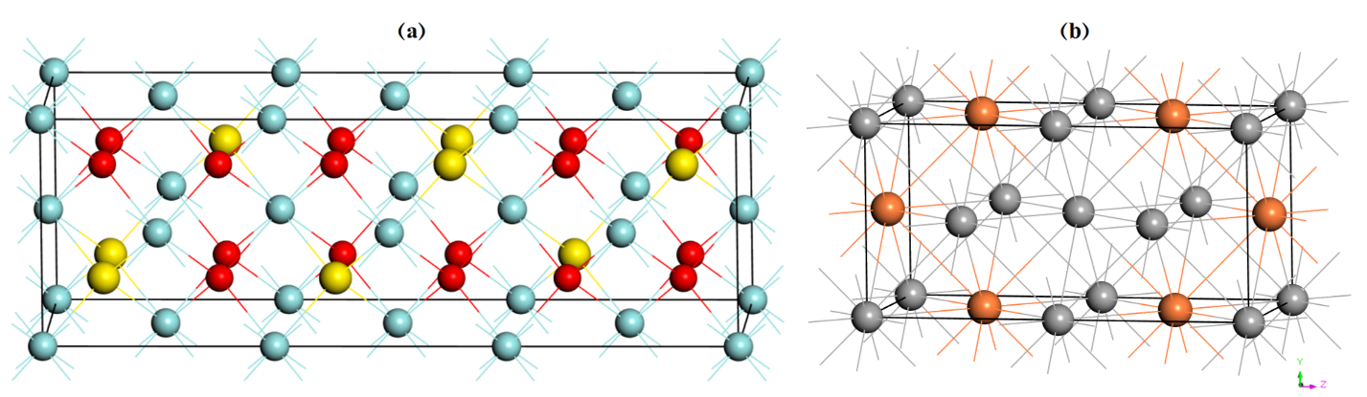
Figure S1. The supercells of a) ZrO_{1.33}S_{0.67} and b) PtPd_{1.67} compounds studied computationally in this work. The red, yellow, cyan, orange and gray spheres represent the O, S, Zr, Pt, and Pd elements, respectively.

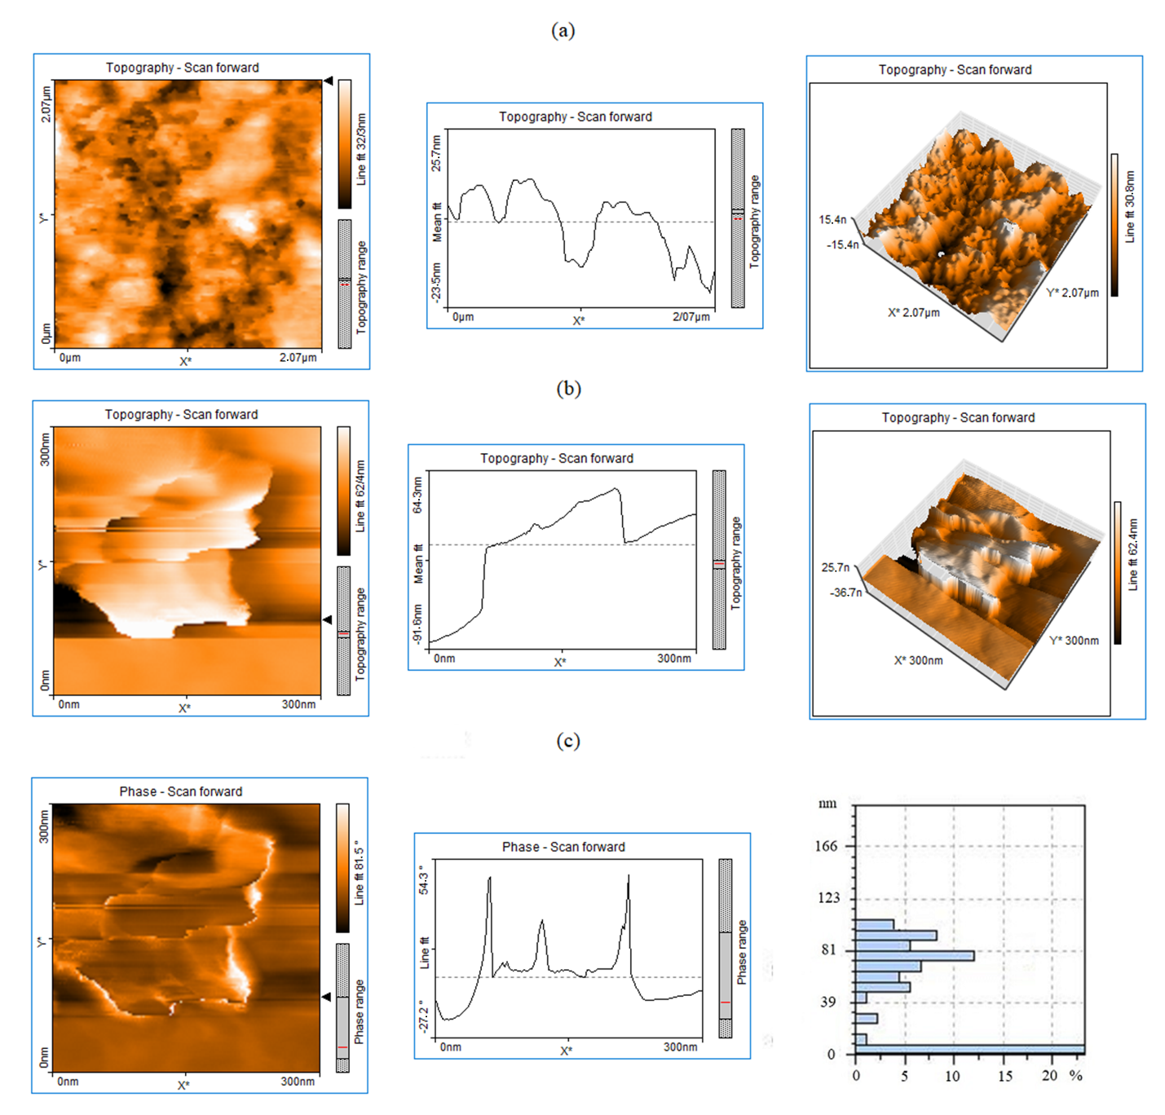
Figure S2. AFM (2D and 3D) topography images along with the corresponding height profiles for (a) S-ZrO₂/GNPs and (b) GNPs, (c) the phase scan and pore size distribution of the GNPs.

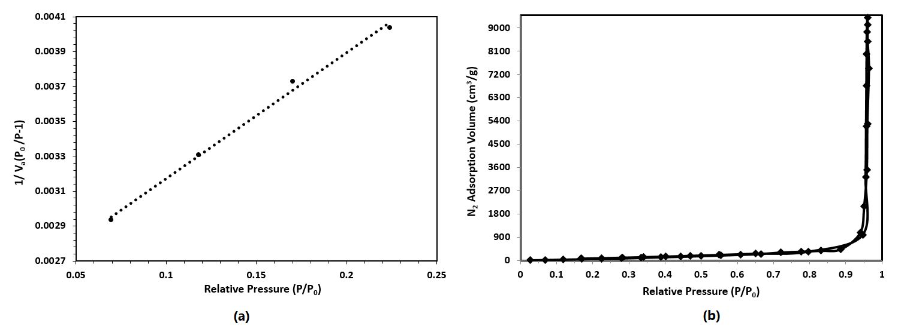
Figure S3. (a) BET diagram and (b) N₂ adsorption isotherm obtained for the GNPs doped with ZrO₂ particles, based on N₂ absorption/desorption at 77.3 K, P₀ = 90 kPa.

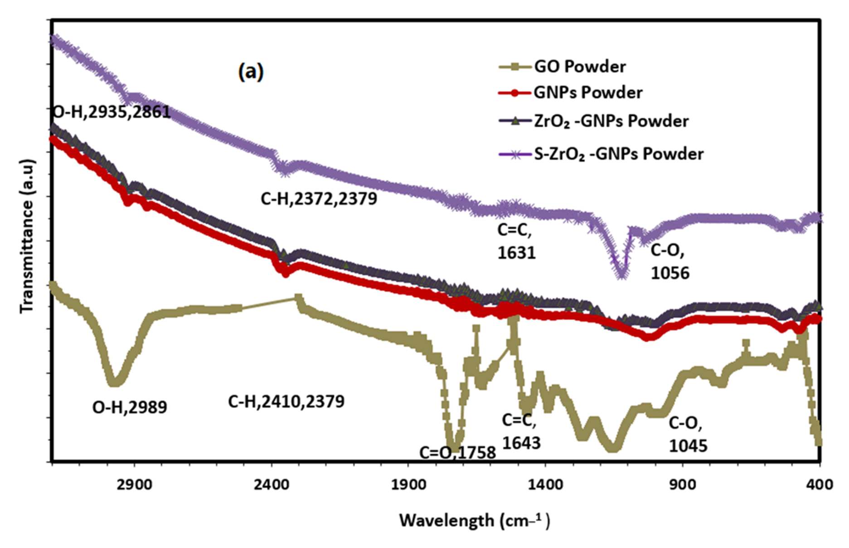 | 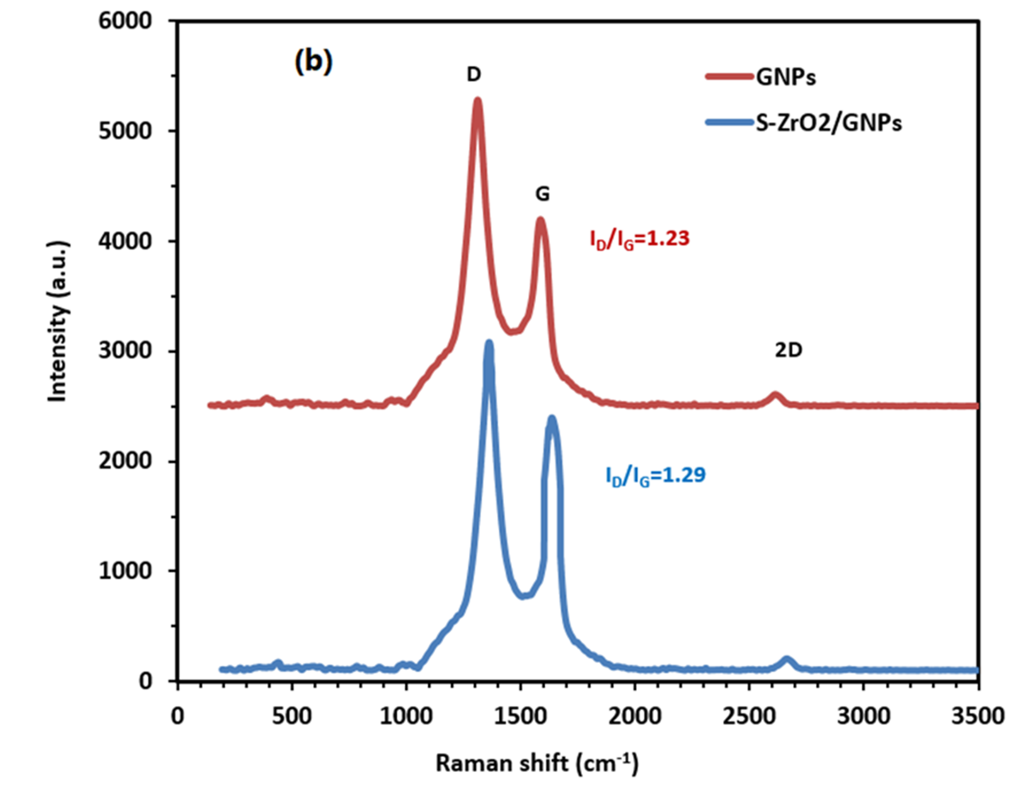
Figure S4: (a) FTIR spectra of GO, GNPs, ZrO₂-GNPs, and S-ZrO₂-GNPs powders (b) Raman spectra of GNPs and S-ZrO₂-GNPs support.

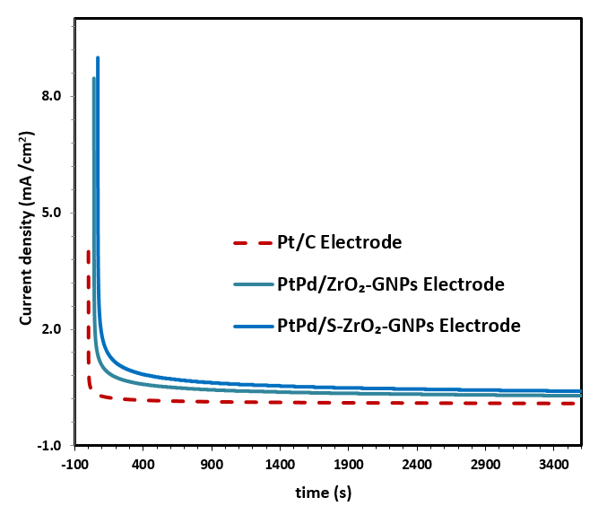
Figure S5. Chronoamperometric curves of PtPd/S-ZrO₂-GNPs, PtPd/ZrO₂-GNPs and Pt/C electrocatalysts in N₂ saturated $0.5 M H_{2}{SO}_{4}$ aqueous solution containing 1 M CH₃OH at fixed potential of 0.4 V for 1 h.

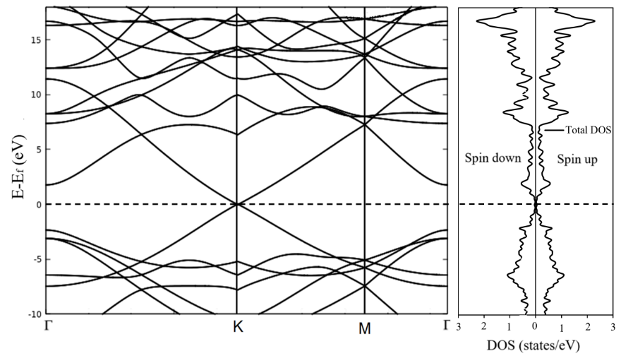
Figure S6. The DFT-calculated band structure of graphene (obtained for a 2×1×1 supercell) along high symmetry paths of the first Brillouin zone (left), and the corresponding DOS (right).

References
[1] Wang G, Shen X, Wang B, Yao J, Park J. Synthesis and characterisation of hydrophilic and organophilic graphene nanosheets. Carbon 2009;47(5):1359-64.
[2] Thommes M, Kaneko K, Neimark AV, Olivier JP, Rodriguez-Reinoso F, Rouquerol J, et al. Physisorption of gases, with special reference to the evaluation of surface area and pore size distribution (IUPAC Technical Report). Pure Appl Chem 2015;87(9-10):1051-69.
[3] Park S, Ruoff RS. Chemical methods for the production of graphenes. NatNanotechnol 2009;4(4):217-24.
[4] Stankovich S, Piner RD, Chen X, Wu N, Nguyen ST, Ruoff RS. Stable aqueous dispersions of graphitic nanoplatelets via the reduction of exfoliated graphite oxide in the presence of poly (sodium 4-styrenesulfonate). J Mater Chem 2006;16(2):155-8.
[5] Stankovich S, Dikin DA, Piner RD, Kohlhaas KA, Kleinhammes A, Jia Y, et al. Synthesis of graphene-based nanosheets via chemical reduction of exfoliated graphite oxide. Carbon 2007;45(7):1558-65.
[6] Park S, An J, Jung I, Piner RD, An SJ, Li X, et al. Colloidal suspensions of highly reduced graphene oxide in a wide variety of organic solvents. Nano Lett 2009;9(4):1593-7.
[7] Hassan HM, Abdelsayed V, Abd El Rahman SK, AbouZeid KM, Terner J, El-Shall MS, et al. Microwave synthesis of graphene sheets supporting metal nanocrystals in aqueous and organic media. J Mater Chem 2009;19(23):3832-7.
[8] Ferrari AC. Raman spectroscopy of graphene and graphite: disorder, electron–phonon coupling, doping and nonadiabatic effects. Solid State Commun 2007;143(1):47-57.
[9] Berciaud S, Ryu S, Brus LE, Heinz TF. Probing the intrinsic properties of exfoliated graphene: Raman spectroscopy of free-standing monolayers. Nano Lett 2008;9(1):346-52.
[10] Dresselhaus MS, Jorio A, Hofmann M, Dresselhaus G, Saito R. Perspectives on carbon nanotubes and graphene Raman spectroscopy. Nano Lett 2010;10(3):751-8.
[11] Yang G, Zhou Y, Pan H-B, Zhu C, Fu S, Wai CM, et al. Ultrasonic-assisted synthesis of Pd–Pt/carbon nanotubes nanocomposites for enhanced electro-oxidation of ethanol and methanol in alkaline medium. Ultrason Sonochem 2016;28:192-8.
[12] Yıldrım A, Seçkin T. In situ preparation of polyether amine functionalized MWCNT nanofiller as reinforcing agents. Advances in Materials Science and Engineering 2014;2014.
[13] Chaudhary B, Panwar V, Roy T, Pal K. Thermomechanical behaviour of zirconia–multiwalled carbon nanotube-reinforced polypropylene hybrid composites. Polymer Bulletin 2019;76:511-21.
[14] Mangla O, Roy S. Monoclinic zirconium oxide nanostructures having tunable band gap synthesized under extremely non-equilibrium plasma conditions. Proceedings. 3. 2019:10.
[15] Ding S, Zhao J, Yu Q. Effect of zirconia polymorph on vapor-phase ketonization of propionic acid. Catalysts 2019;9(9):768.
[16] Manoharan D, Loganathan A, Kurapati V, Nesamony VJ. Unique sharp photoluminescence of size-controlled sonochemically synthesized zirconia nanoparticles. Ultrason Sonochem 2015;23:174-84.
[17] Arikan T, Kannan AM, Kadirgan F. Binary Pt–Pd and ternary Pt–Pd–Ru nanoelectrocatalysts for direct methanol fuel cells. Int J Hydrogen Energy 2013;38(6):2900-7.
[18] Maghsodi A, Hoseini MM, Mobarakeh MD, Kheirmand M, Samiee L, Shoghi F, et al. Exploration of bimetallic Pt-Pd/C nanoparticles as an electrocatalyst for oxygen reduction reaction. Appl Surf Sci 2011;257(15):6353-7.
[19] Gregory N. Elements of X-Ray Diffraction. JAm Chem Soc 1957;79(7):1773-4.

