Supporting Information

Template-Directed Vertical Photopolymerisation for Construction of Triphenylamine-Based Poly(diacetylene) Nanofibers
Yingbo Lu,¹ Luyao Jin,¹ Jiani Wang,¹ Qiang Fang,² Shuping Wang,¹ Jianying Huang,² Zibin Zhang,*^{,1} Feihe Huang,³ Shijun Li*^{,1}
¹College of Material, Chemistry and Chemical Engineering, Key Laboratory of Organosilicon Chemistry and Material Technology of Ministry of Education, Hangzhou Normal University, Hangzhou 311121, P. R. China.
²College of Food Science and Biotechnology, Zhejiang Gongshang University, Hangzhou 310018, P. R. China.
³Stoddart Institute of Molecular Science, Department of Chemistry, Zhejiang University, Hangzhou 310058, P. R. China.
Correspondence and requests for materials should be addressed to Z.Z. (Email: zzhang@hznu.edu.cn) or S.L. (Email: l_shijun@hznu.edu.cn).

Contents
1. Materials and methods S3
2. Additional AFM images S3
3. Synthesis of the compounds S4
4. NMR spectra of the compounds S10

- Materials and methods
2,3,5,6-Tetrafluorobenzoic acid, n-butyllithium, iodine, methyl 3,4,5-trihydroxybenzoate, potassium carbonate, 1-bromododecane, ethane-1,2-diamine, thionyl chloride, 1,4-bis(trimethylsilyl)buta-1,3-diyne, MeLi-LiBr, 4-iodopyridine, copper(I) iodide, tetrakis(triphenylphosphine)palladium, tetrabutylammonium fluoride, tris(4-iodophenyl)amine, trans-bis(triphenylphosphine)palladium(II) chloride, ethane-1,2-diol, anhydrous Na₂SO₄, and all of the solvent used were purchased and used without further purification. The chromatographic separation was carried out on 300-400 mesh silica gel under pressure. ¹H, ¹³C and ¹⁹F NMR spectra were recorded on a Bruker AVANCE III-500M NMR spectrometer at room temperature, and chemical shifts are reported in ppm (δ) with the signal of tetramethylsilane (TMS) as internal standard at 0.00 ppm. MS spectra were measured on an Agilent 1290LC-6530QTOF. UV-vis absorption spectra were recorded on a SHIMADZU UV-2600i. Fluorescent spectra were recorded on a HITACHI F-7000. AFM imaging was performed under ambient conditions using a Being Nano-Instruments CSPM5500Z in Tapping mode. Samples were drop-casted onto silicon wafer which was treated with piranha solution.

Sample preparation and photo-irradiation experiments
The mixture of 1 and 2 was prepared by mixing compound 1 and compound 2 in CH₂Cl₂. The Solvent was removed in vacuo and MCH was added to the mixture. Before UV-vis, FL, photo-cross linking experiment and the preparation of films, the sample was ultrasonicated at r.t. for 5 min and then leave to stand for 1 h. The same procedure was also carried out when performing experiments with the other sample like pure 1, pure 2 and 2 + 3.

- Additional AFM images
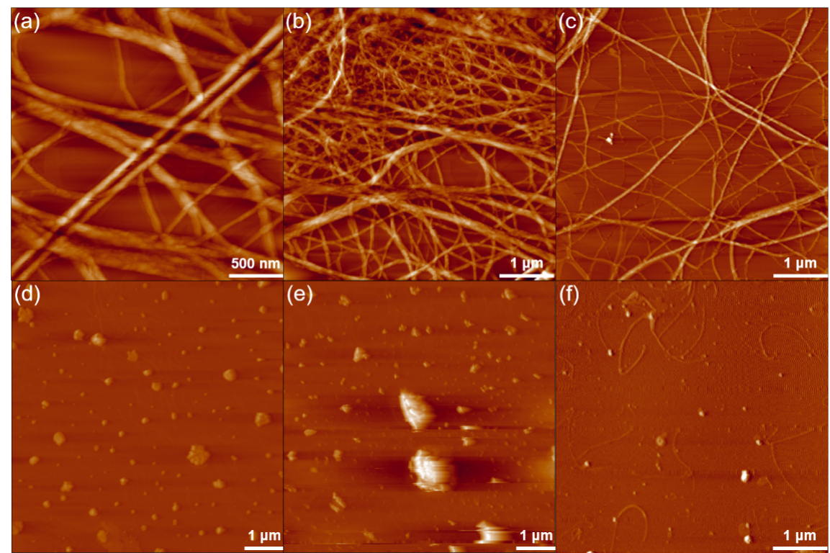
Fig. S1 The AFM images of (a,b,c) 1 + 2; (d,e) 1 and (f) 6.

- Synthesis of the compounds
2,3,5,6-Tetrafluoro-4-iodobenzoic acid[]: 2,3,5,6-Tetrafluorobenzoic acid (970 mg, 5 mmol) was dissolved in 80 mL dry THF. The solution was then cooled to ‒40 °C and n-butyllithium (2.5 M in hexane, 5 mL, 12.5 mmol) was added carefully. After stirred at ‒40 °C for 2 h, iodine (1650 mg, 6.5 mmol) was added and the reaction was further stirred at r.t. for 12 h. After completion of the reaction, HCl (2 M) was added and the organic layer was separated. The aqueous layer was extracted by diethyl ether, and the combined organic layer was washed with Na₂S₂O₃ solution, and brine. The solution was then dried over anhydrous MgSO₄, filtered, the solvent was evaporated. The product was obtained as a grey solid in 87% yield. ¹⁹F NMR (471 MHz, CDCl₃, 298 K, ppm) δ 118.05, 135.91.

Methyl 3,4,5-tris(dodecyloxy)benzoate: Methyl 3,4,5-trihydroxybenzoate (5.1 g, 27.7 mmol) and potassium carbonate (23.8 g, 172.2 mmol) was placed in a two-necked flask, the reactant was vacuum purged and the flask was fulfilled with nitrogen. Followed by addition of DMF (150 mL), and the reaction was stirred for 2 hours at 60 °C. 1-Bromododecane (21.3 mL, 112.0 mmol) was then added slowly and the reaction was stirred at 80 °C for 12 hours. After completion of the reaction, the mixture was poured into icy water and the residue was collected by filtration and purified by silica gel chromatography (PE:EA = 200:1) to obtain 2 as a grey solid in 89% yield. ¹H NMR (500 MHz, CDCl₃) δ 7.25 (d, J = 5.9 Hz, 2H), 4.01 (td, J = 6.5, 3.8 Hz, 6H), 3.88 (s, 3H), 1.78 (ddd, J = 28.7, 14.4, 7.3 Hz, 6H), 1.52–1.42 (m, 6H), 1.39–1.21 (m, 50H), 0.88 (t, J = 6.9 Hz, 9H). ¹³C NMR (126 MHz, CDCl₃) δ 166.9, 152.8, 142.3, 124.6, 108.0, 73.5, 69.1, 52.1, 31.9, 29.68, 29.65, 29.6, 29.38, 29.35, 26.1, 22.7, 14.1.

N-(2-aminoethyl)-3,4,5-tris(dodecyloxy)benzamide: Methyl 3,4,5-tris(dodecyloxy)benzoate (15.0 g, 21.8 mmol) was dissolved in ethane-1,2-diamine (100 mL), and the reaction was refluxed at 135 °C for 48 hours. After completion of the reaction, the solvent was removed by using an evaporator, and the crude product was purified by silica gel chromatography (DCM: MeOH: TEA = 200:2:1) to give the product as a grey solid in 48% yield. ¹H NMR (500 MHz, CDCl₃) δ 7.00 (s, 2H), 6.77 (s, 1H), 3.99 (dt, J = 13.0, 6.5 Hz, 6H), 3.51 (dd, J = 11.5, 5.7 Hz, 2H), 2.97 (t, J = 5.7 Hz, 2H), 1.83–1.70 (m, 7H), 1.45 (dd, J = 14.2, 8.5 Hz, 7H), 1.37–1.22 (m, 54H), 0.88 (t, J = 6.9 Hz, 9H).

2,3,5,6-Tetrafluoro-4-iodo-N-(2-(3,4,5-tris(dodecyloxy)benzamido)ethyl)benzamide (1): 2,3,5,6-Tetrafluoro-4-iodobenzoic acid (1189.8 mg, 3.72 mmol) was dissolved in dry DCM (12 mL), thionyl chloride (0.33 mL) and Et₃N (1.0 mL) was added slowly to the solution and the suspension was stirred for 2 h. After evaporation of the solvent, the resulting residue was redissolved in 25 mL of dry DCM. N-(2-aminoethyl)-3,4,5-tris(dodecyloxy)benzamide (400.0 mg, 5.58 mmol) and Et₃N (1 mL) was added and the reaction was further stirred for 12 h. After completion of the reaction, icy water was added and the mixture was then extracted with DCM. The organic phase was collected and dried over anhydrous Na₂SO₄, and then filtered. The crude product was purified by silica gel chromatography (DCM: MeOH: TEA = 400:2:1) to give the product as a grey solid in 59% yield. ¹H NMR (500 MHz, CDCl₃) δ 8.09 (s, 1H), 7.48 (s, 1H), 6.93 (s, 2H), 3.95 (t, J = 6.5 Hz, 2H), 3.87 (t, J = 6.3 Hz, 4H), 3.57 (dd, J = 9.2, 4.4 Hz, 4H), 1.71 (dd, J = 16.7, 9.0 Hz, 6H), 1.48–1.37 (m, 6H), 1.27 (d, J = 18.2 Hz, 48H), 0.87 (t, J = 6.9 Hz, 9H). ¹³C NMR (126 MHz, CDCl3) δ 168.5, 159.4, 152.9, 148.0 (d, J = 14.9 Hz), 146.0 (d, J = 15.4 Hz), 143.7 (d, J = 16.3 Hz), 141.6 (d, J = 16.3 Hz), 140.9, 128.3, 116.8 (t, J = 19.3 Hz), 105.2, 77.3, 77.0, 76.8, 73.4, 69.0, 53.3, 40.3, 40.1, 31.9, 30.3, 29.70, 29.68, 29.62, 29.55, 29.4, 29.33, 29.27, 26.0, 22.6, 14.0. HRMS (ESI) exact mass calculated for C₅₂H₈₃F₄IN₂O₅ ([M + H]⁺): 1019.5356; found: 1019.5326.

Buta-1,3-diyn-1-yltrimethylsilane[]: 1,4-Bis(trimethylsilyl)buta-1,3-diyne (19.8 g, 102.0 mmol) was placed in a three-necked flask, the reactant was vacuum purged and the flask was fulfilled with nitrogen, then MeLi-LiBr (1.5 M in Et₂O, 71.4 mL, 107.1 mmol) and diethyl ether (200 mL) was added carefully. The solution was stirred for 4 h at r.t. and then cooled to 0 °C, followed with the addition of methanol. The mixture was then extracted with saturated NH₄Cl solution and diethyl ether. The collected organic layer was washed with brine, dried over anhydrous Na₂SO₄, and filtered. Diethyl ether was removed by using a rotary evaporator with an ice bath. The product was obtained as a clear oil in 72% yield. ¹H NMR (500 MHz, CDCl₃) δ 2.11 (s, 1H), 0.21 (t, J = 3.5 Hz, 9H). ¹³C NMR (126 MHz, CDCl₃) δ 87.4, 84.7, 68.3, 68.0, ‒0.6.

4-((Trimethylsilyl)buta-1,3-diyn-1-yl)pyridine []: Buta-1,3-diyn-1-yltrimethylsilane (7.0 g, 57.3 mmol), 4-iodopyridine (9.0 g, 44.0 mmol), copper(I) iodide (0.3 g, 1.5 mmol), tetrakis(triphenylphosphine)palladium (2.7 g, 2.4 mmol) was dissolved in 60 mL diisopropylamine. To remove dissolved oxygen, the reaction mixture was then performed three freeze–pump–thaw cycles, after which the flask was purged with nitrogen. After the reaction was stirred for 6 h at r.t., the mixture was filtered and the volatiles were removed by using a rotary evaporator. The crude product was purified by silica gel chromatography (CH₂Cl₂:Et₂O = 1:1) to give the product as a dark brown solid in 93% yield. ¹H NMR (500 MHz, CDCl₃, 25 °C) δ 8.34 (d, J = 6.1 Hz, 2H), 7.07 (d, J = 6.1 Hz, 2H), 0.00 (s, 9H). ¹³C NMR (125 MHz, CDCl₃, 25 °C) δ 149.7, 129.6, 126.1, 93.5, 86.8, 78.3, 73.4, ‒0.7.

4-(Buta-1,3-diyn-1-yl)pyridine []: 4-((Trimethylsilyl)buta-1,3-diyn-1-yl)pyridine (0.8 g, 4.0 mmol) was dissolved in THF (160 mL), the solution was cooled to 0 °C and then tetrabutylammonium fluoride (1 M in THF, 4.4 mL) was added carefully. After stirred at 0 °C for 30 min, the reaction was treated with water. Subsequently, the resulting suspension was extracted with Et₂O. The organic phase was separated, dried over anhydrous Na₂SO₄, and then filtered. After the solvent was removed by a rotary evaporator, the crude product was purified by silica gel chromatography (CH₂Cl₂:Et₂O = 1:1) to give the product as a dark brown solid in 83% yield. ¹H NMR (500 MHz, DMSO-d₆) δ 8.60 (d, J = 6.1 Hz, 2H), 7.35 (d, J = 6.1 Hz, 2H), 2.59 (s, 1H).

Tris(4-(pyridin-4-ylbuta-1,3-diyn-1-yl)phenyl)amine (2): Tris(4-iodophenyl)amine (269.5 mg, 0.43 mmol), 4-(buta-1,3-diyn-1-yl)pyridine (220.0 mg, 1.73 mmol), copper(I) iodide (27.2 mg, 0.14 mmol), trans-bis(triphenylphosphine)palladium(II) chloride (60.7 mg, 0.09 mmol) was dissolved in 65 mL of diisopropanolamine (DIPA). The mixture was stirred at 50 °C for 16 h. After completion of the reaction, the mixture was concentrated by a rotary evaporator, and the crude product was purified by silica gel chromatography (CH₂Cl₂:MeOH:TEA = 50:2:1) to give the product as a pale yellow solid in 83% yield. ¹H NMR (500 MHz, CDCl₃) δ 8.61 (dd, J = 4.6, 1.4 Hz, 6H), 7.46 (d, J = 8.7 Hz, 6H), 7.36 (dd, J = 4.5, 1.5 Hz, 6H), 7.06 (d, J = 8.7 Hz, 6H). ¹³C NMR (126 MHz, CDCl₃) δ 149.9, 147.3, 134.1, 130.1, 126.0, 124.2, 116.2, 83.5, 78.6, 78.4, 73.4. HRMS (ESI) exact mass calculated for C₄₅H₂₄N₄ ([M + H]⁺): 621.2074; found: 621.2008.

2-Hydroxyethyl 3,4,5-tris(dodecyloxy)benzoate：3,4,5-Tris(dodecyloxy)benzoic acid (1450.0 mg, 2.15 mmol) was dissolved in dry DCM (7 mL), thionyl chloride (0.2 mL) and Et₃N (0.6 mL) was added slowly to the solution and the suspension was stirred for 2 h. After evaporation of the solvent, the resulting residue was redissolved in 15 mL of dry DCM. Ethane-1,2-diol (5.6 mL, 100.00 mmol) and Et₃N (0.6 mL) was added and the reaction was further stirred for 12 h. After completion of the reaction, icy water was added and the mixture was extracted with DCM. The organic phase was collected and dried over anhydrous Na₂SO₄, and then filtered. The crude product was purified by silica gel chromatography (PE: EA = 100:1) to give the product as a grey solid in 70% yield. ¹H NMR (500 MHz, CDCl₃) δ 4.49–4.41 (m, 2H), 4.01 (q, J = 6.6 Hz, 6H), 3.94 (d, J = 4.0 Hz, 2H), 1.85–1.70 (m, 6H), 1.50–1.44 (m, 6H), 1.37–1.23 (m, 50H), 0.88 (t, J = 6.9 Hz, 9H). ¹³C NMR (126 MHz, CDCl₃) δ 166.9, 152.8, 142.7, 124.3, 108.2, 73.5, 69.2, 66.8, 61.6, 31.9, 29.71, 29.70, 29.68, 29.64, 29.62, 29.38, 29.35, 29.3, 26.1, 22.7, 14.1.

2-((3,4,5-tris(dodecyloxy)benzoyl)oxy)ethyl 2,3,5,6-tetrafluoro-4-iodobenzoate (3)：2,3,5,6-Tetrafluoro-4-iodobenzoic acid (360.00 mg, 1.13 mmol) was dissolved in dry DCM (3.5 mL). Thionyl chloride (0.11 mL) and Et₃N (0.33 mL) was added slowly to the solution and the suspension was stirred for 2 h. After evaporation of the solvent, the resulting residue was redissolved in 7 mL of dry DCM. 2-Hydroxyethyl 3,4,5-tris(dodecyloxy)benzoate (423.5 mg, 1.25 mmol) and Et₃N (0.33 mL) was added and the reaction was further stirred for 12 h. After completion of the reaction, icy water was added and the mixture was extracted with DCM. The organic phase was collected and dried over anhydrous Na₂SO₄, and then filtered. The crude product was purified by silica gel chromatography (PE: EA = 100:1) to give the product as a grey solid in 63% yield. ¹H NMR (500 MHz, CDCl₃) δ 7.25 (s, 2H), 4.74–4.66 (m, 2H), 4.63–4.55 (m, 2H), 4.00 (dt, J = 9.1, 6.5 Hz, 6H), 1.78 (dd, J = 24.2, 16.3 Hz, 6H), 1.45 (dd, J = 10.5, 4.6 Hz, 6H), 1.36–1.21 (m, 50H), 0.86 (t, J = 6.9 Hz, 9H). ¹³C NMR (126 MHz, CDCl₃) δ 166.0, 159.2, 152.8, 148.4 (d, J = 14.6 Hz), 146.4 (d, J = 15.1 Hz), 145.1 (d, J = 16.9 Hz), 143.0 (d, J = 17.6 Hz), 142.6, 123.9, 112.8 (t, J = 15.9 Hz), 108.0, 73.5, 69.1, 64.3, 62.0, 31.9, 30.3, 29.9 – 29.5 (m), 29.5 – 29.1 (m), 26.04, 26.03, 22.7, 14.1. HRMS (ESI) exact mass calculated for C₅₂H₈₁F₄IO₇ ([M + Na] ⁺): 1043.4855; found: 1043.4787.

- NMR spectra of the compounds
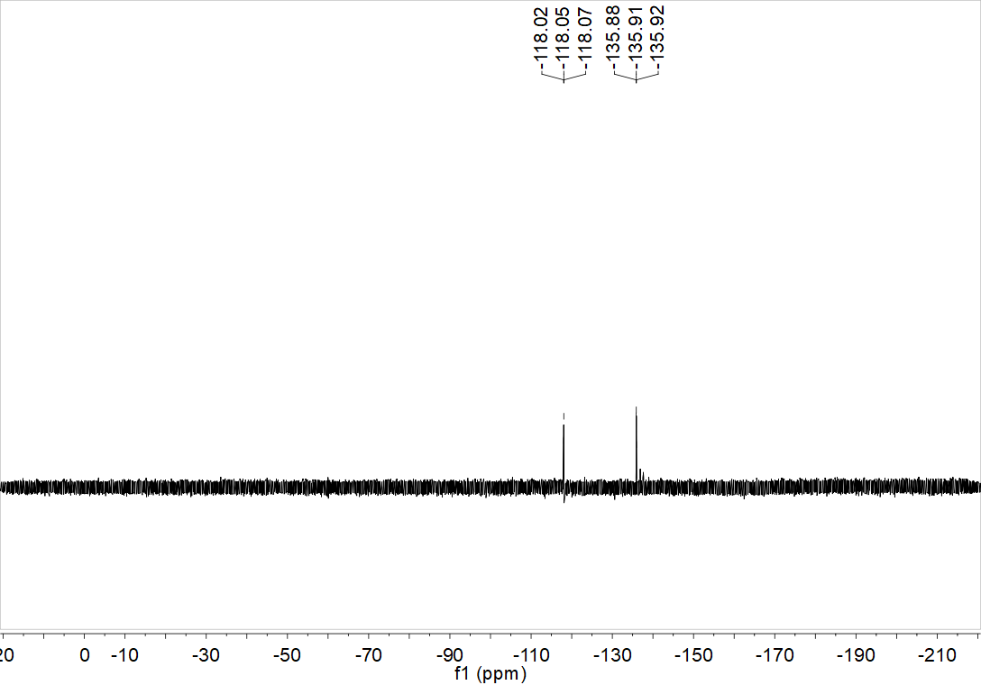
Fig. S2 ¹⁹F NMR spectrum of 2,3,5,6-tetrafluoro-4-iodobenzoic acid.

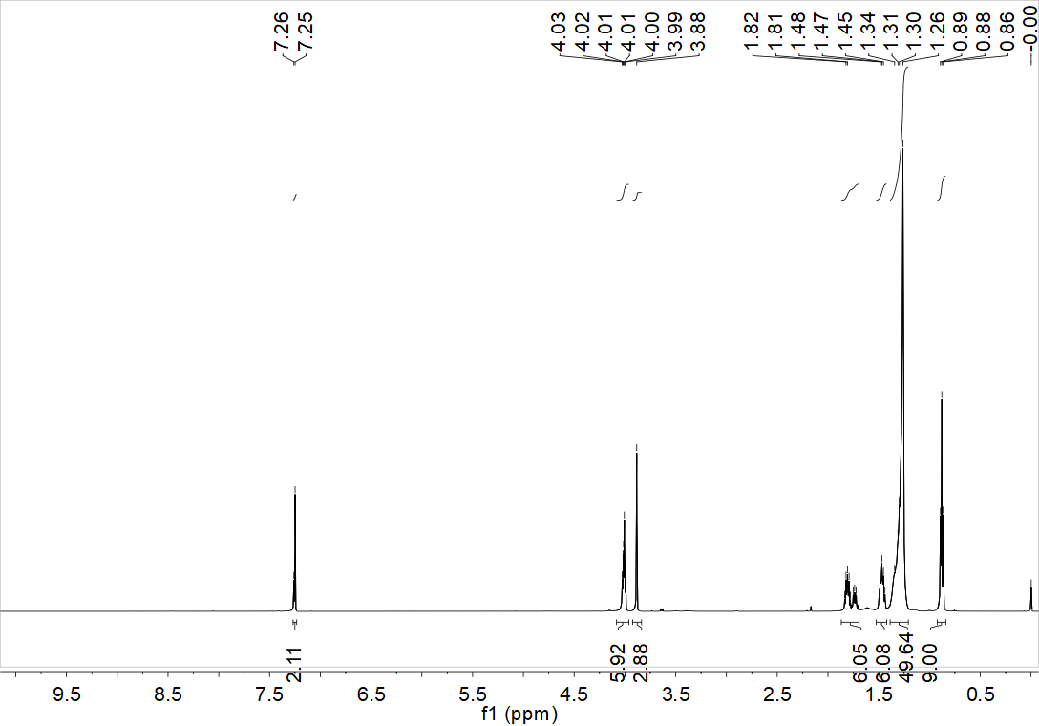
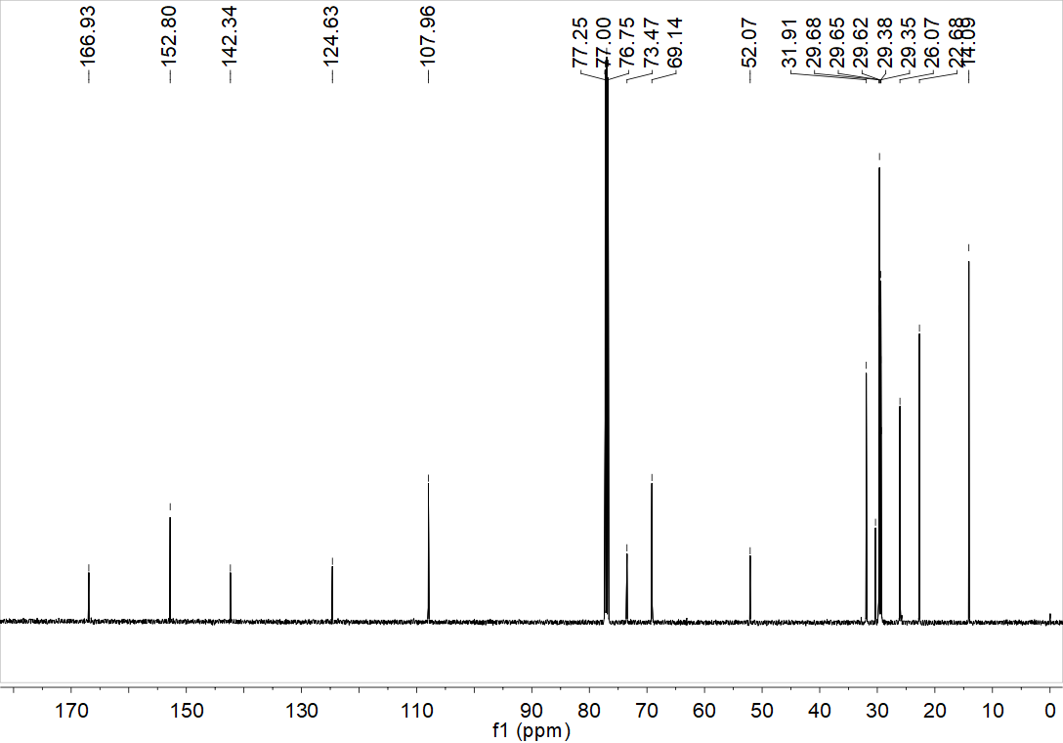
Fig. S3 ¹H NMR and ¹³C NMR spectra of Methyl 3,4,5-tris(dodecyloxy)benzoate.

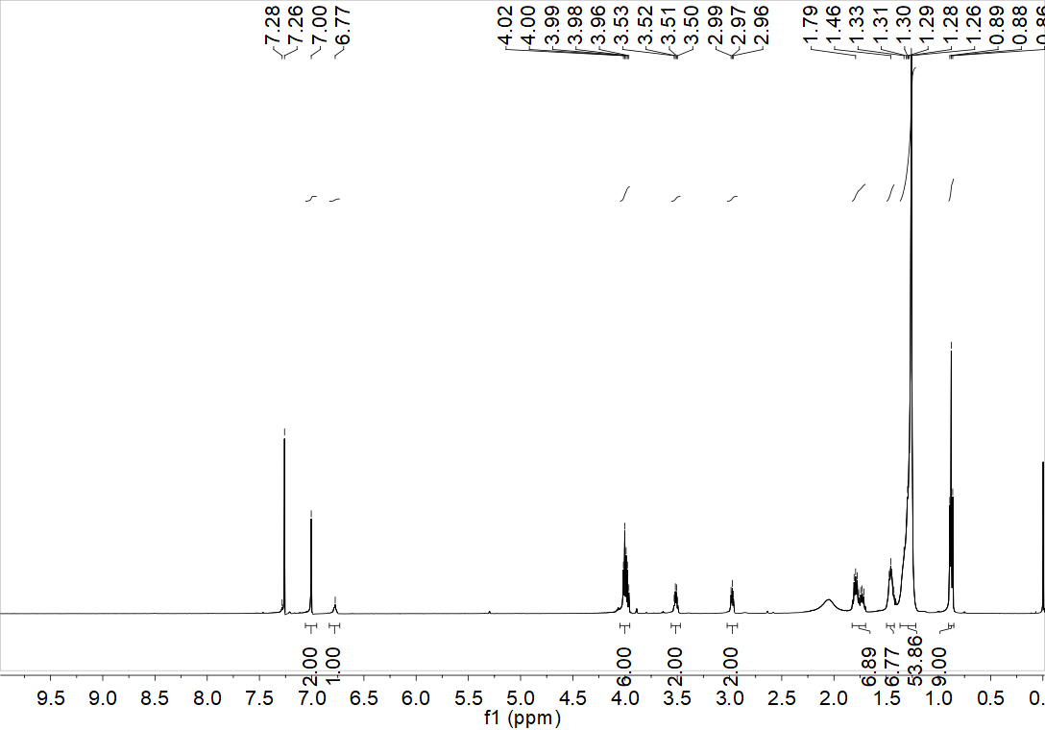
Fig. S4 ¹H NMR spectrum of N-(2-aminoethyl)-3,4,5-tris(dodecyloxy)benzamide.

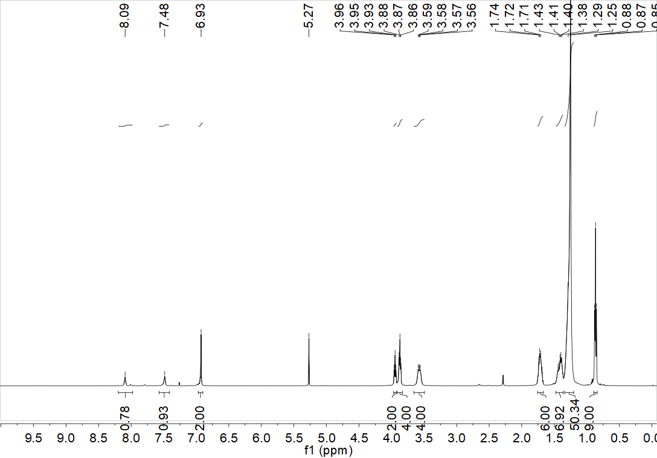
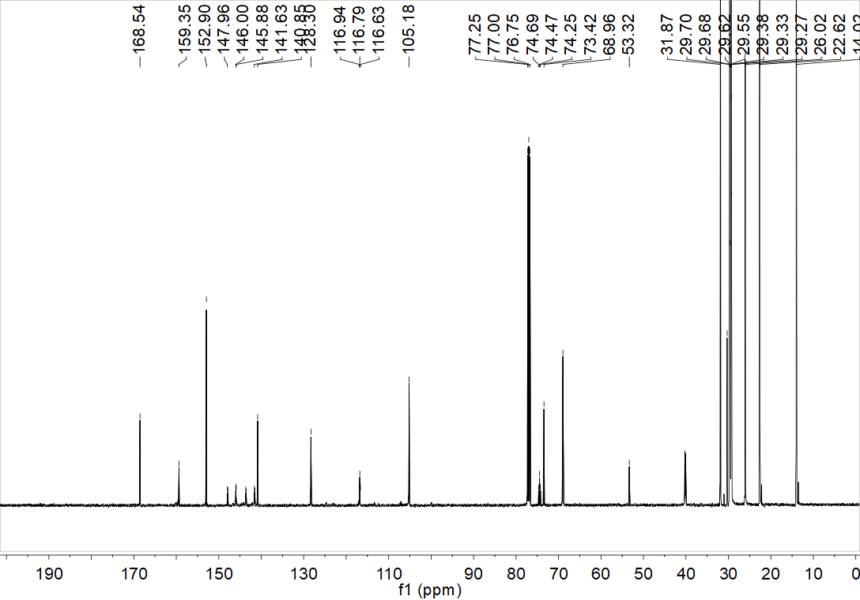
Fig. S5 ¹H NMR and ¹³C NMR spectra of 2,3,5,6-tetrafluoro-4-iodo-N-(2-(3,4,5-tris(dodecyloxy)benzamido)ethyl)benzamide (1).

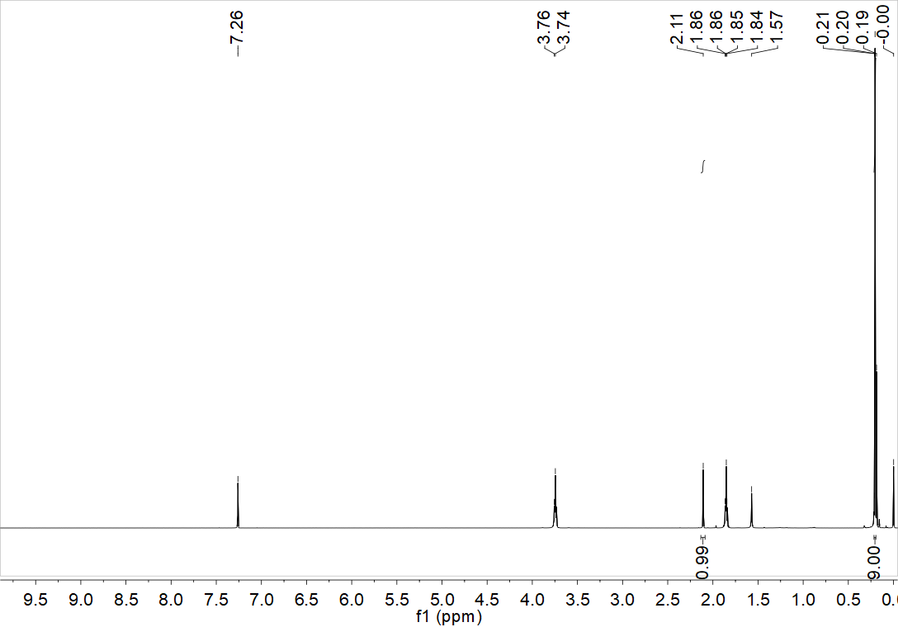
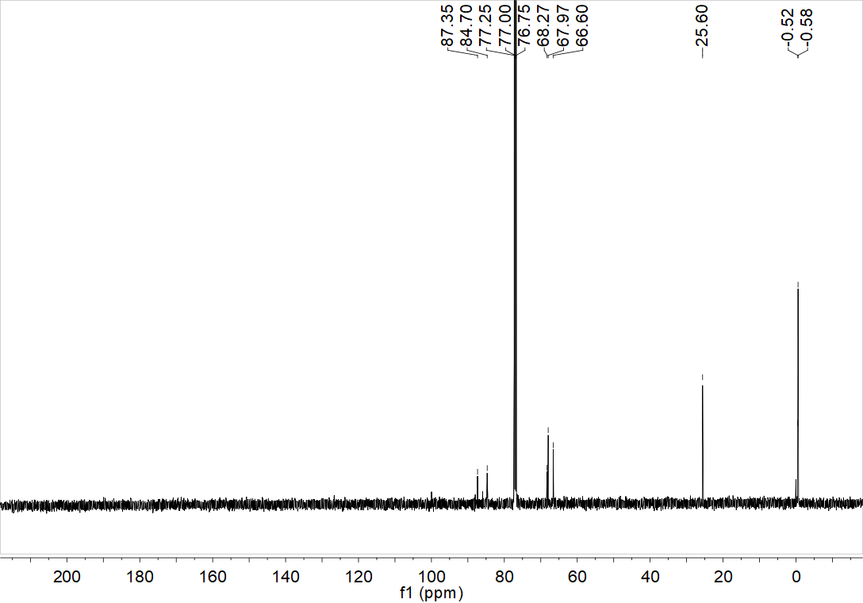
Fig. S6 ¹H NMR and ¹³C NMR spectra of buta-1,3-diyn-1-yltrimethylsilane.

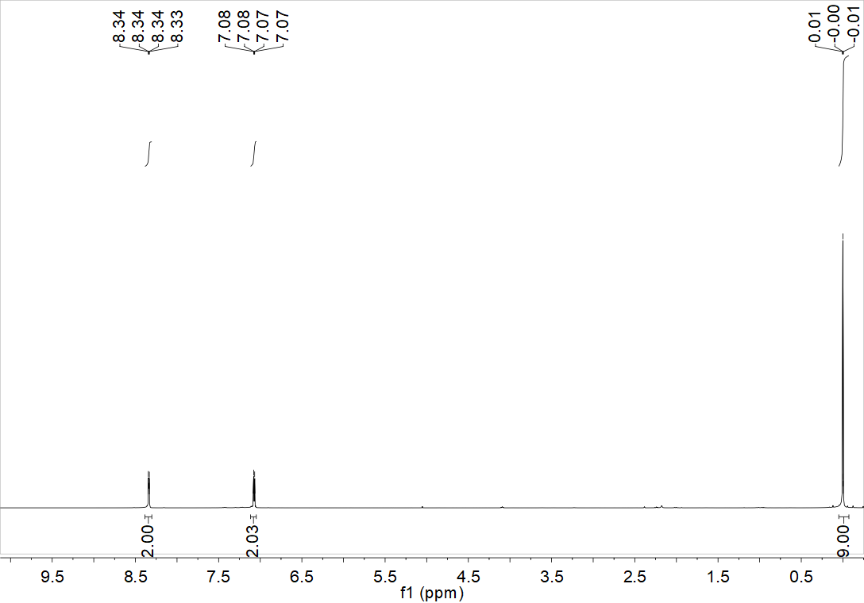
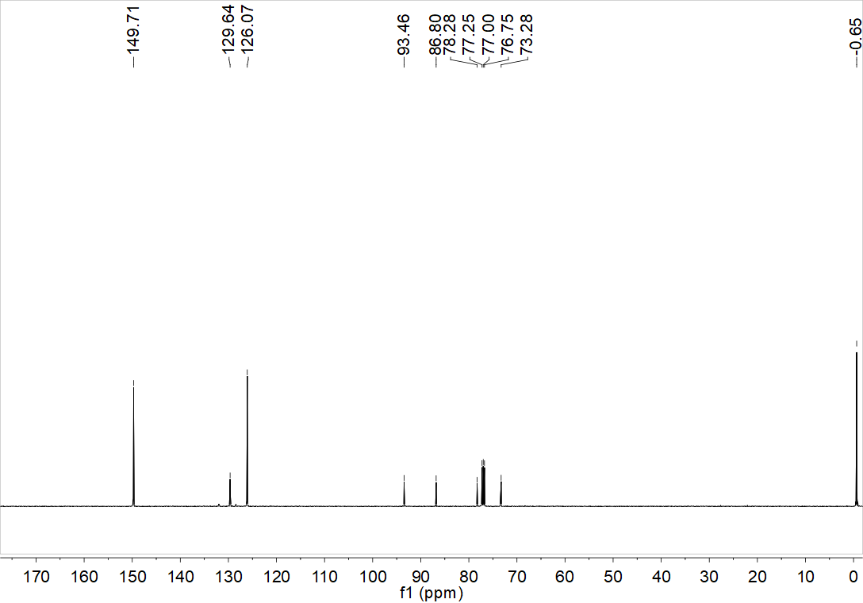
Fig. S7 ¹H NMR and ¹³C NMR spectra of 4-((Trimethylsilyl)buta-1,3-diyn-1-yl)pyridine.

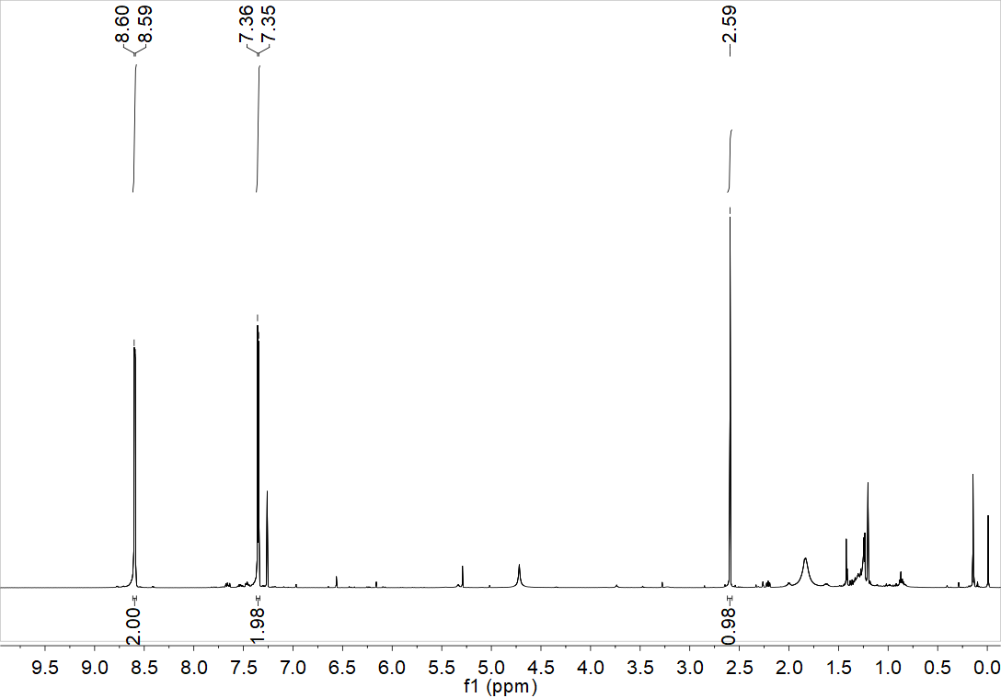
Fig. S8 ¹H NMR spectrum of 4-(buta-1,3-diyn-1-yl)pyridine.

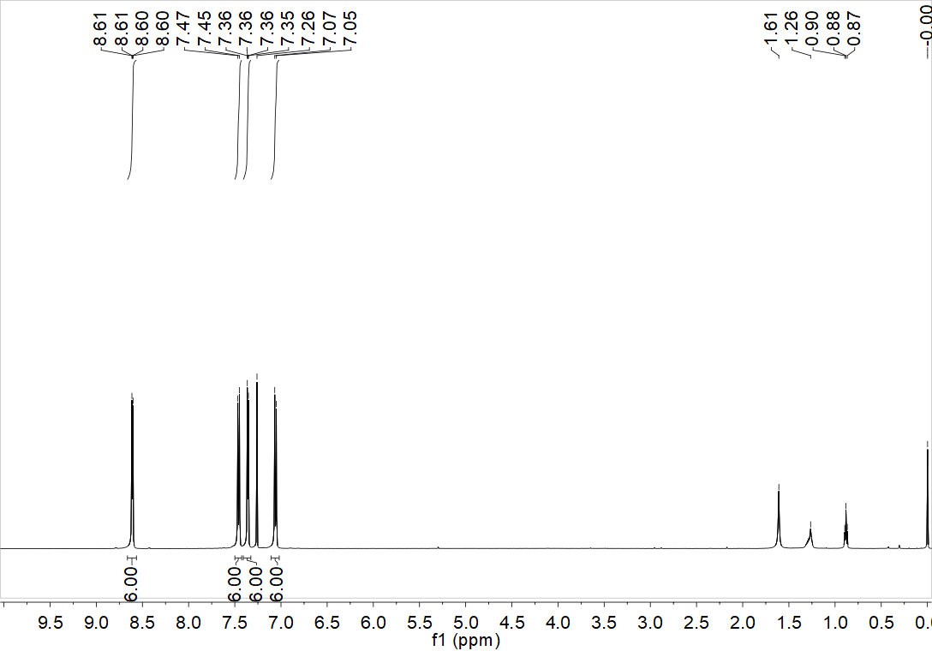
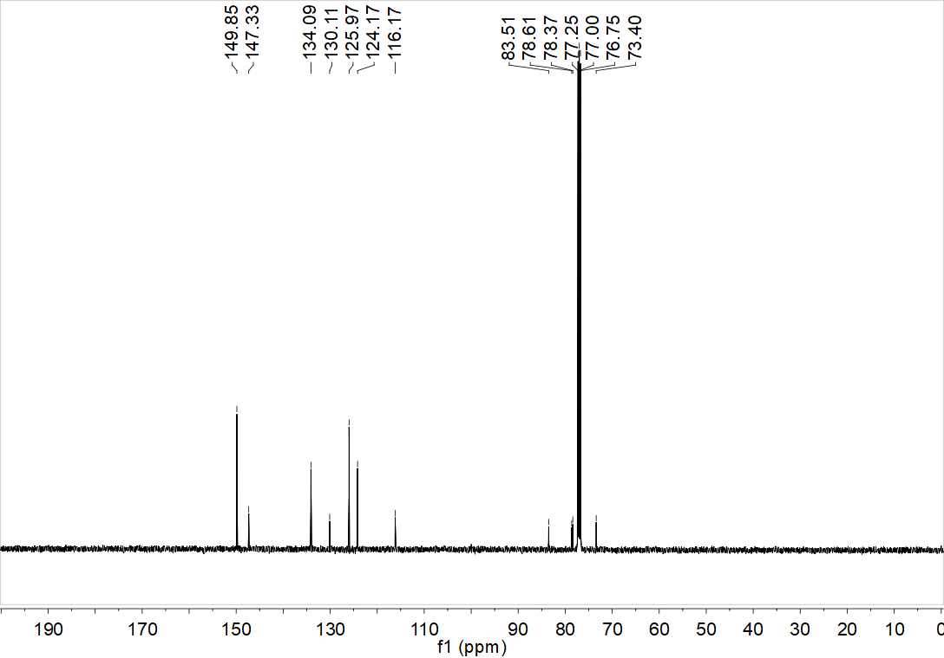
Fig. S9 ¹H NMR and ¹³C NMR spectra of tris(4-(pyridin-4-ylbuta-1,3-diyn-1-yl)phenyl)amine (2).

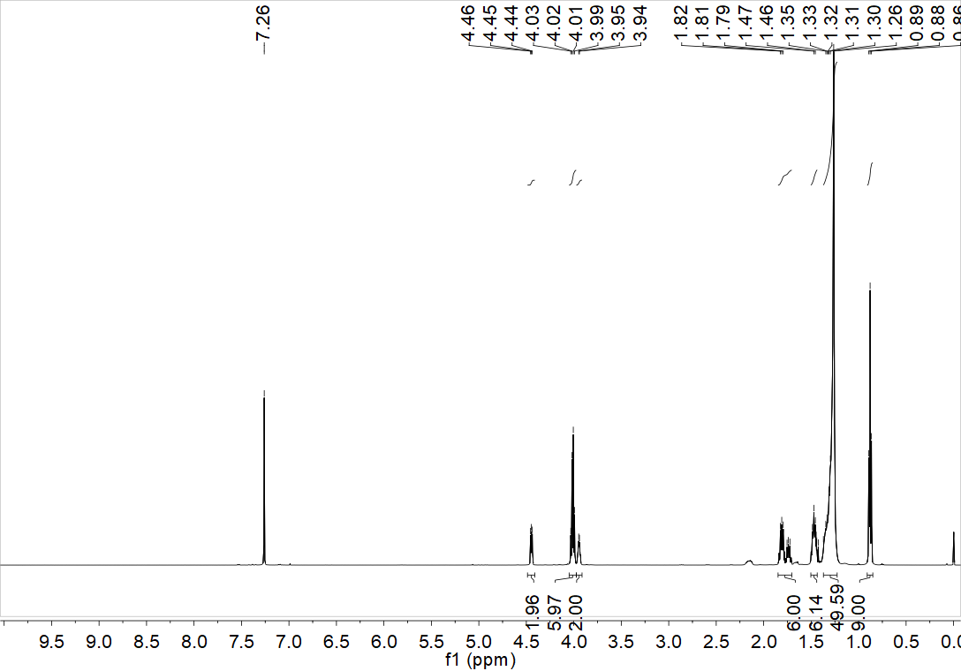
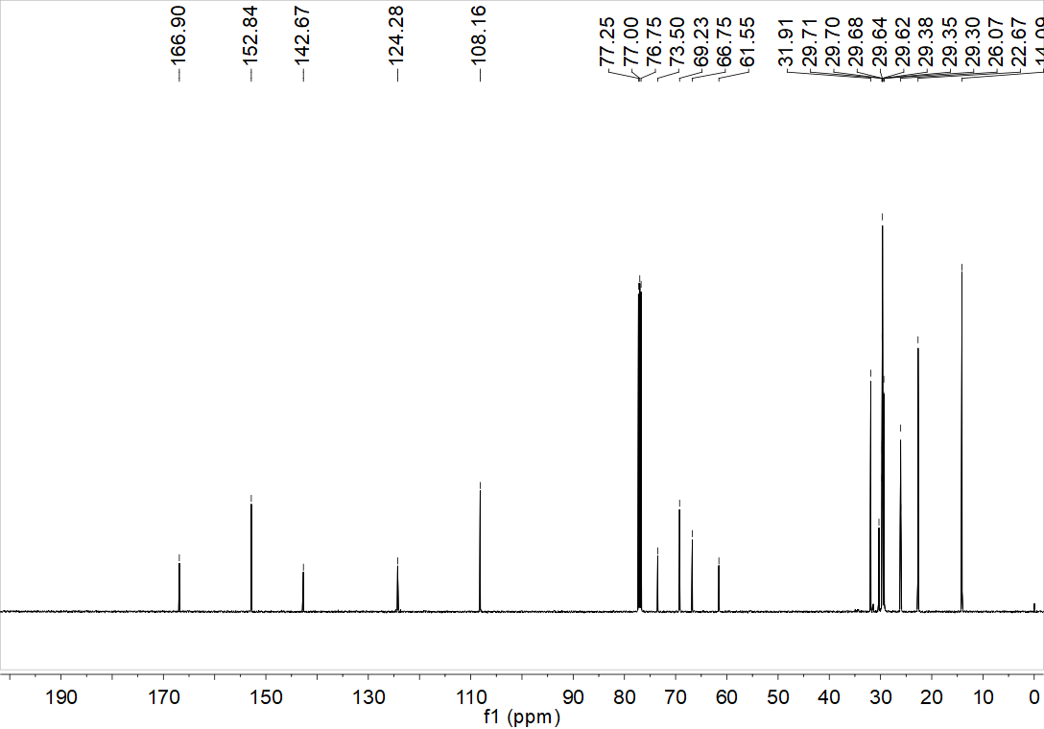
Fig. S10 ¹H NMR and ¹³C NMR spectra of tris(4-(pyridin-4-ylbuta-1,3-diyn-1-yl)phenyl)amine (2).

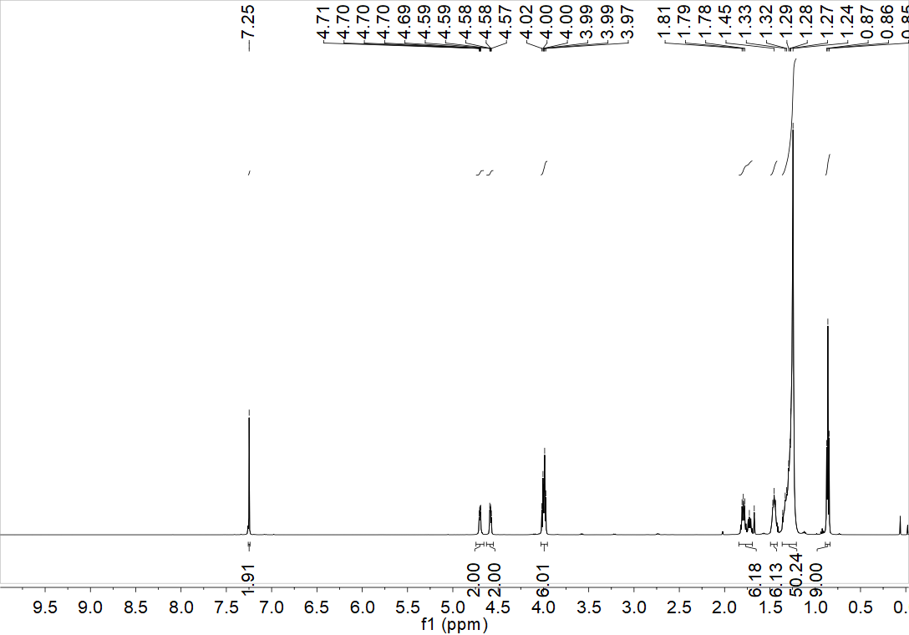
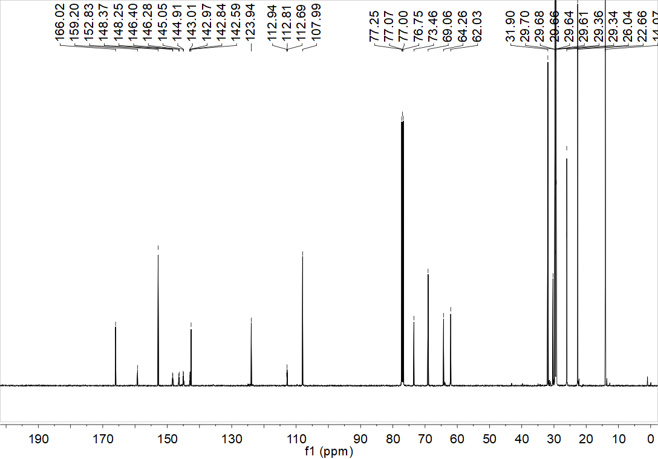
Fig. S11 ¹H NMR and ¹³C NMR spectra of 2-((3,4,5-tris(dodecyloxy)benzoyl)oxy)ethyl 2,3,5,6-tetrafluoro-4-iodobenzoate (3).

[] Hori, T., Kakinuma, S., Ohtsuka, N., Fujinami, T., Suzuki, T. & Momiyama, N. Synthesis of Halogen-Bond-Donor-Site-Introduced Functional Monomers through Wittig Reaction of Perfluorohalogenated Benzaldehydes: Toward Digitalization as Reliable Strategy in Small-Molecule Synthesis. Synlett 34, 2455–2460 (2023).
[] Farha, O. K., Wilmer, C. E., Eryazici, I., Hauser, B. G., Parilla, P. A., Oneill, K., Sarjeant, A. A., Nguyen, S. T., Snurr, R. Q. & Hupp, J. T. Designing Higher Surface Area Metal–Organic Frameworks: Are Triple Bonds Better Than Phenyls? J. Am. Chem. Soc. 134, 9860–9863 (2012).
[] Moreno-Garcia, P., Gulcur, M., Manrique, D. Z., Pope, T., Hong, W., Kaliginedi, V., Huang, C., Batsanov, A. S., Bryce, M. R., Lambert, C. & Wandlowski, T. Single-Molecule Conductance of Functionalized Oligoynes: Length Dependence and Junction Evolution. J. Am. Chem. Soc. 135, 12228–12240 (2013).
[] Iwasaki, M., Shichibu, Y. & Konishi, K. Unusual Attractive Au–π Interactions in Small Diacetylene-Modified Gold Clusters. Angew. Chem. Int. Ed. 58, 2443–2447 (2019).

