Optomechanics based soft artificial skin
Abhijit Chandra Roy^{*1}, Navin Kumar¹, Shreyas B S¹, Ananya Gupta¹, Aloke Kumar² and V. Venkataraman¹†
- Department of Physics, Indian Institute of Science, Bangalore, Karnataka, India-560012
- Department of Mechanical Engineering, Indian Institute of Science, Bangalore, Karnataka, India-560012
* Corresponding author’s E-mail: abhijitroy@iisc.ac.in
† Author now deceased, died on 24th Jan 2020.

- Details of Fabrication techniques

Figure S1. Fabrication of the soft-a-skin. (a) Array of through holes are made on a rectangular slab of PMMA with smooth surface, the diameter of the holes is equivalent to still ball to be fitted on the holes. The thickness of the slab is greater than the diameter of the still balls. (b) Steel balls are set on the hole by gluing from the back side to make them array of hemispherical positive mold for soft hemispherical structure. (c) Liquid UV curable resin is poured on the positive mold followed by exposer of UV light for 10 minutes. (d) The cured resin work as a negative mold for making array of PDMS hemispherical lens. (e) Pour the liquid PDMS on the resin negative mold, cure it at ${60}^{o}C$ for 24 hours. (f) The making of array of hemispherical PDMS lens extracted from resin mold after curing the PDMS. (g) 3D printed rectangular walls with slope edges covered with cellulose acetate sheet on a smooth PMMA sheet. (h) The PDMS filled rectangular mold in (g) is covered by a PMMA sheet with array of through holes to make array of pillars to hold the hemispherical structures. (i) Cure the PDMS inside the template at ${60}^{o}$ C centigrade for 24 hrs.
(j) Rectangular waveguide with array of pillars after removing from template in (i). (k-m)
Soft electronic skin resulted from the combination of ‘k’, ‘f’ array of light sources (LED) and phototransistors.

Figure S1a-f indicate the making of mold-based array of soft hemispherical lenses. In this step as shown in Figure S1a, an array of holes with equal separation are drilled on a Poly(methyl methacrylate)(PMMA) sheet of thickness 5 $mm$ and area ~150x150 ${mm}^{2}$. The diameter of the holes is 3 $mm$ that is precisely done by the LASER cutting facility. Smooth steel balls of diameter 3 $mm$ are attached to each of the 25 holes in such a way that the half of the balls remain above the smooth surface of the PMMA sheet. The steel balls are attached to the holes of the PMMA sheet by adhesive (e.g. DOWSIL 789) from the back of the holes. These halves exposed steel balls work as a hemispherical template for the SHL lens. A boundary of height of 3 $mm$ is attached to the PMMA sheet and instant UV curable resin (Sigma Aldrich) is poured on the template. A plane PMMA sheet of same size is used to cover the resin. UV light source (ENFIS UNO, Air Cooled Light Engine,) of wavelength 365 nm and power 38 Watt is used for curing the resin for 30 mins (Figure S1c). The cured resin becomes solid and is removed from the template that gives array of hemispherical cavities (Figure S1d) and used to make the array of hemispherical lenses on a soft polymer layer. The resin template walled by a square with each side length of 150 $mm$ , height 3 $mm$, and width 2 $mm$, polydimethylsiloxane(PDMS) with a cross-linking agent (10:1 ratio) is poured on the template and covered by a plain PMMA sheet (Figure S1e, walls and PMMA cover are not shown for better visibility). The PDMS is cured at ${60}^{o}$C for 24 hours, cured PDMS results a layer with array of PDMS hemispherical lenses with similar dimension as the templates. It is worth to note here that the thickness of the film above the hemispherical lenses can be modulated by adjusting the wall height of the 3D printed cage. The making of soft waveguide (SOW) with micropillars are conducted in a similar template-assisted soft lithography technique, see Figure S1g-m. 3D printed boundary wall of desired height (here it is ~3 mm) with inward slopes around the wall is placed on a smooth PMMA sheet (Figure S1g). Thin cellulose sheets are placed on the sloped surfaces for making the sloped surface smooth. PDMS with cross-linking agent (10:1 ratio) is poured on the template and covered with another PMMA sheet having array of micro holes Figure S1h-i. Before covering the PDMS, the holes on the PMMA sheet are filled with PDMS using capillary action. As shown in the Figure S1i, the thermal curing of PDMS filled template is conducted at${60}^{o}$C for 24 hrs. The removal from the template gives the SOW containing micropillars Figure S1j.
The height and diameter of the micro-pills can be modulated by adjusting the thickness of the PMMA sheet and the diameter of the holes. The pillars are arranged in such a way that each SHL in the array of SHL sits at the center among the four pillars. The light source and photodetector holders are made by 3D printing technique. Polylactic acid (PLA) is used as a feeding material for 3D printing. To complete the making of the soft electronic skin, the SOW with micro-pillars is attached with the array of PDMS lenses followed by attaching the light sources and the detectors (Figure S1k-m). To join the micropillars with the array of PDMS SHL, a thin layer of liquid PDMS is spread uniformly on a PMMA sheet, then the pillars of the SOW are carefully touched the liquid PDMS layer. The withdrawal of the micropillars from the liquid PDMS layer, small drop of PDMS forms on each pillar. It is then carefully transferred on a membrane containing array of SHLs and thermally cross-link the PDMS to properly stick to the membrane of SHL array (Figure S1m). Finally, the phototransistors (PT) are attached against each light source to the adjacent sides (two sides) by using 3D printed holders. We have used various light sources including diode LASER, LEDs and colored light sources, etc. The colored light sources are made by using white LED light and absorptive filters. In some specific design, the absorptive filters corresponding to each light source are also attached to respective PT to reduce the interference of the signal among the PTs.

- Making of the liquid-based 3D printer
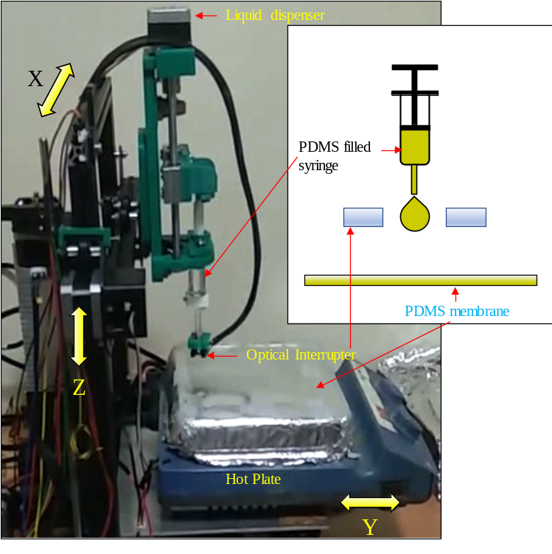
Figure S2. Optical image with schematic diagram to demonstrate the liquid-based 3D printer.
In Figure S2, a fused deposition modeling (FDM) based commercial 3D printer is modified to print liquid PDMS on a thin PDMS film. We have removed the extruder of the 3D printer and a small lab made 3D printed liquid dispenser with an optical interrupter is attached. As soon as, the liquid drop release from the dispenser, the optical interrupter detects the droplet to stop the dispensing of the liquid and dispenser move at different position. The PDMS drop fall on a hot PDMS film and undergo crosslinking. This 3D liquid printer helps in customize the array dimensions and the number of lenses in the array.

- Fabrication of PDMS oligomer filled hemispherical lens (OFHL):
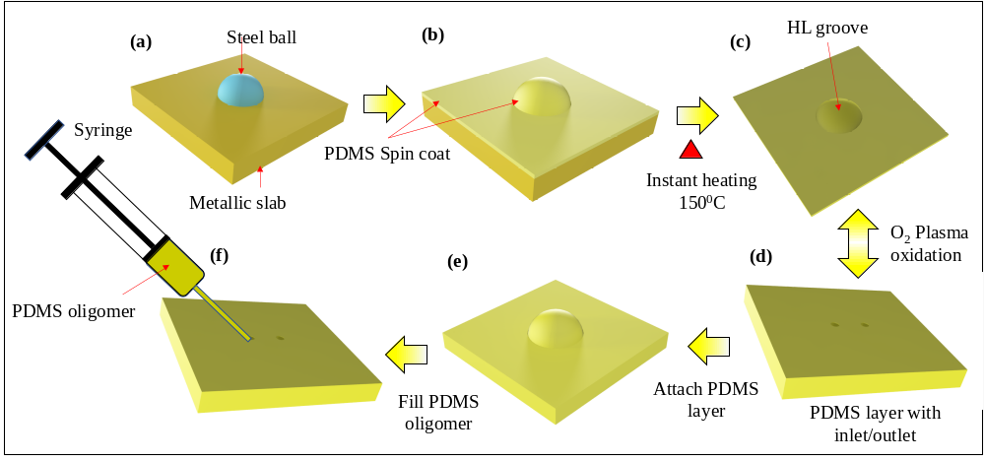
Figure S3. 3D schematic diagram of the preparation of the PDMS oligomer filled soft hemispherical lens. (a) A metallic slab (Al) with a steel ball half of it exposed to the air. (b) PDMS with curing agent (10:1 ratio) is spin coated on the metallic slab with a steel ball. (c) The spin coated layer is removed from the surface after instant curing at 150º C. (d) A thin film of PDMS is attached to the spin coated layer using oxygen plasma oxidation. (e-f) The hemispherical chamber is filled with PDMS oligomer and tightly closed with two probes.

As shown in Figure S3, a steel ball is attached to a metallic slab in such a way that half of the ball is exposed to the air and other half inside the slab Figure S3a. A thin layer (20-30 $µm$) of PDMS (PDMS: curing agent; 10:1 ratio) is spin coated throughout the surface Figure S3b. Instantly, the spin coated slab is placed on a hot plate which is set at ${200}^{0}C$ for the instant curing of the spin coated film. The crosslinked PDMS film is removed from the metallic slab and attached $O_{2}$ plasma Oxidation to a PDMS block containing two channels (Figure S3c-e). The Oligomer is filled through one channel and finally both the channels are sealed.

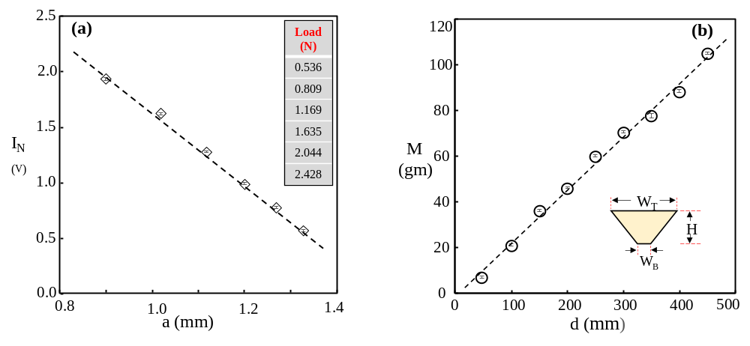
Figure S4. Fabrication of the Electronic skin (a) Linear relation between the radius ‘a’ arises from the contact of HL and SDP and Intensity of light at the output. (b) The plot shows the calibration between distance and load (3mm dia. lens).
- Geometrical Ray tracing analysis
To understand the light ray propagation of incident light and the refracted light rays through the soft Dove prism (SDP), we have shown the geometrical ray tracing analysis (see Figure S5. Figure S5 a and b show the 2D side and top view schematic of the SDP with incident rays making angle $Ɵ_{y}$ and $Ɵ_{x}$ with Y and X axis respectively. The dependence of the prism angle ($α$), incident angles ($Ɵ_{x},Ɵ_{y})$, refracted angles ($Ɵ_{x}^{'} ,$ $Ɵ_{y}^{'}$), and top width $W_{T}$ of the SDP on the input ($x_{1},y_{1}$) and output ($x_{2},y_{2}$) ray position is cited in equation (1- 4).
$x_{2}= x_{1}+L\frac{\tan\left(Ɵ_{x}\right)+\tan\left(α\right)\tan\left(α+Ɵ_{y}^{'}\right)\tan\left(Ɵ_{x}^{'}\right)}{1+\tan\left(α\right)\tan\left(α+Ɵ_{y}^{'}\right)}$……………………………………………..……(1)
$y_{2}= L\left(\frac{\tan\left(α\right)-\tan\left(Ɵ_{y}\right)}{1+\tan\left(α\right)\tan\left(α+Ɵ_{y}^{'}\right)}\right)-y_{1}$…………………………………………………..…………(2)

The refraction angles ( $Ɵ_{x}^{'},{ Ɵ}_{y}^{'}$ ) is deduced from incident angle ($Ɵ_{x}{, Ɵ}_{y}$) which are$Ɵ_{x}^{'}=arcsin⁡\left(\frac{n_{2}}{n_{3}}sin⁡(Ɵ_{x})\right)$, $Ɵ_{y}^{'}=arcsin⁡\left(\frac{n_{2}}{n_{3}}cos⁡(α+Ɵ_{y})\right)$ respectively. Considering the paraxial approximation, we perform Taylor expansion ^{[1]} to express the equations (3) and (4) as in equation (3) and (4) respectively.
$x_{2}=x_{1}+\left[\frac{n_{2}}{n_{3}}L+\frac{C_{o}}{tan⁡(α)} \left(1-\frac{n_{2}}{n_{3}}\right)\right]Ɵ_{x}$………………………………………………...……….(3)
$y_{2}=\left(C_{o}-y_{1}\right)-C_{o}\left(\frac{n_{2}µ}{n_{3}}-\frac{1}{\tan\left(α\right)}\right)Ɵ_{y}$…………………………………………………..…….(4)
Where
$C_{o}=L{\left[\tan\left\{α+\sin^{-1}\left(\frac{n_{2}}{n_{3}} cos α\right)\right\}+\frac{1}{\tan\left(α\right)}\right]}^{-1}$
$$µ=\frac{C_{o}sin⁡(α)}{L}{\left[1-{\left(\frac{n_{2}cos⁡(α)}{n_{3}}\right)}^{2}\right]}^{-\frac{1}{2}}\cos^{-2}\left\{α+\sin^{-1}\left(\frac{n_{2}cos⁡(α)}{n_{3}}\right)\right\}$$

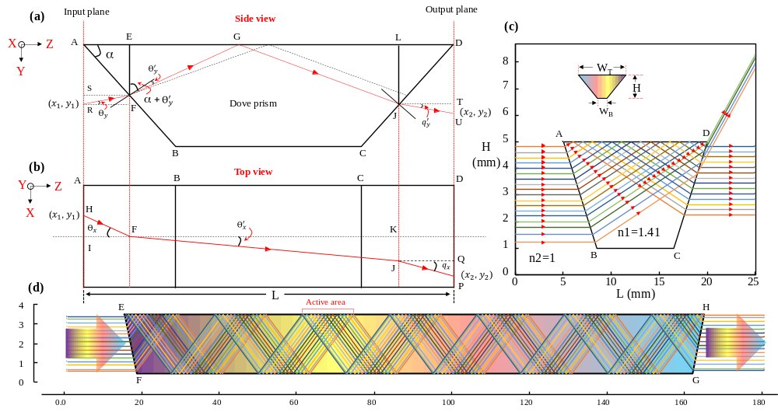
Figure S5. Ray tracing geometrical configuration of a soft Dove prism. (a-b) Side (YZ−plane), and top view (XZ−plane) of SDP. Red solid line depicts the ray passing through the prism. EF is the plane where light hit for the first time. (c) 2D Ray tracing diagram simulation using MATLAB-2018 platform on soft-a-skin-Cell. (d) 2D Ray tracing simulation for PDMS rectangular waveguide.
Let’s us first find the position of $x_{2}$
$AE + EG + GL +LD=L$…………………………………………………………….(5)
$AE= \frac{FE}{tan⁡(α)}$; LD$= \frac{LJ}{tan⁡(α)}$; EG$=FE tan(α+Ɵ_{y}^{'})$; GL$=LJ tan(α+Ɵ_{y}^{'})$; $Ɵ_{x}=q_{x}$;${- Ɵ}_{y}=q_{y}$
From (1)
$\frac{FE}{tan⁡(α)} + FE tan\left(α+Ɵ_{y}^{'}\right)+LJ tan\left(α+Ɵ_{y}^{'}\right)+ \frac{LJ}{tan⁡(α)} =L$
$EF+JL=\frac{Ltan⁡(α)}{1+tan⁡(α)tan\left(α+Ɵ_{y}^{'}\right)}$…………………………………………………………….(6)
Again
$FK=\frac{ EG + GL}{⁡tan\left(α+Ɵ_{y}^{'}\right)}$………………………………………………………………………….(7)
Or
$KJ=\frac{L \tan\left(α\right)\tan\left(α+Ɵ_{y}^{'}\right)\tan\left(Ɵ_{x}^{'}\right)}{⁡tan\left(α+Ɵ_{y}^{'}\right)}$……………………………………………………………(8)
Again, using equation (1) and top view drawing of the prism
$HI+QP=\frac{L\tan\left(Ɵ_{x}\right)}{1+tan⁡(α)tan\left(α+Ɵ_{y}^{'}\right)}$…………………………………………………………....(9)
Hence $x_{2}=x_{1}+ HI+QP+KJ$………………………………………………………………(10)
Using Equations (4), (5) & (6)
$x_{2}= x_{1}+L\frac{\tan\left(Ɵ_{x}\right)+\tan\left(α\right)\tan\left(α+Ɵ_{y}^{'}\right)\tan\left(Ɵ_{x}^{'}\right)}{1+\tan\left(α\right)\tan\left(α+Ɵ_{y}^{'}\right)}$…………………………………………….(11)
Let us find the $y_{2}$
$y_{1}+y_{2}=SR+EF+JL+UT$………………………………………………………..(12)
$SR+UT=\frac{Ltan(-Ɵ_{x})}{1+\tan\left(α\right)\tan\left(α+Ɵ_{y}^{'}\right)}$………………………………………………………….(13)
Using equation (2),(8) & (9)
$y_{2}=L\left\{\frac{\tan\left(α\right)-\tan\left(Ɵ_{y}\right)}{1+\tan\left(α\right)\tan\left(α+Ɵ_{y}^{'}\right)}\right\}-y_{1}$………………………………………………………..(14)
The refraction angles ( $Ɵ_{x}^{'},{ Ɵ}_{y}^{'}$ ) is deduced from incident angle ($Ɵ_{x}{, Ɵ}_{y}$) which are $Ɵ_{x}^{'}=arcsin⁡\left(\frac{n_{2}}{n_{3}}sin⁡(Ɵ_{x})\right)$, $Ɵ_{y}^{'}=arcsin⁡\left(\frac{n_{2}}{n_{3}}cos⁡(α+Ɵ_{y})\right)$ respectively. Due to paraxial approximation tan($Ɵ_{x}$)~$Ɵ_{x}$; sin($Ɵ_{x}^{'}) \sim Ɵ_{x}^{'}= \sin^{-1}\frac{n_{2}}{n_{3}}Ɵ_{x}\sim \frac{n_{2}}{n_{3}}Ɵ_{x}$; $Ɵ_{y}^{'}=$ $\sin^{-1}\left(\frac{n_{2}}{n_{3}} cos α\right) \sim \frac{n_{2}}{n_{3}} cos α$ ;

$$x_{2}= x_{1}+\frac{LƟ_{x}+L tan\left(α\right)\tan\left\{α+\sin^{-1}\left(\frac{n_{2}}{n_{3}} cos α\right)\right\}{ \frac{n_{2}}{n_{3}}Ɵ_{x}}}{1+\tan\left(α\right)\tan\left\{α+\sin^{-1}\left(\frac{n_{2}}{n_{3}} cos α\right)\right\}}$$
$x_{2}= x_{1}+\frac{LƟ_{x}}{1+\tan\left(α\right)\tan\left\{α+\sin^{-1}\left(\frac{n_{2}}{n_{3}} cos α\right)\right\}}+\frac{L tan\left(α\right)\tan\left\{α+\sin^{-1}\left(\frac{n_{2}}{n_{3}} cos α\right)\right\}{ \frac{n_{2}}{n_{3}}Ɵ_{x}}}{1+\tan\left(α\right)\tan\left\{α+\sin^{-1}\left(\frac{n_{2}}{n_{3}} cos α\right)\right\}}$…………………(15)

Considering
$$C_{o}=\frac{L tan\left(α\right)}{1+\tan\left(α\right)\tan\left\{α+\sin^{-1}\left(\frac{n_{2}}{n_{3}} cos α\right)\right\}}$$
Or $C_{o}=L{\left[\tan\left\{α+\sin^{-1}\left(\frac{n_{2}}{n_{3}} cos α\right)\right\}+\frac{1}{\tan\left(α\right)}\right]}^{-1}$

$$x_{2}= x_{1}+Ɵ_{x}\left[\frac{L}{1+\tan\left(α\right)\tan\left\{α+\sin^{-1}\left(\frac{n_{2}}{n_{3}} cos α\right)\right\}}+\frac{L tan\left(α\right)\tan\left\{α+\sin^{-1}\left(\frac{n_{2}}{n_{3}} cos α\right)\right\}{ \frac{n_{2}}{n_{3}}}}{1+\tan\left(α\right)\tan\left\{α+\sin^{-1}\left(\frac{n_{2}}{n_{3}} cos α\right)\right\}}\right]$$
$$x_{2}= x_{1}+Ɵ_{x}\left[\frac{C_{o}}{\tan\left(α\right)}+C_{o} \frac{n_{2}}{n_{3}}\tan\left\{α+\sin^{-1}\left(\frac{n_{2}}{n_{3}} cos α\right)\right\}\right]$$
$x_{2}= x_{1}+Ɵ_{x}\left[\frac{C_{o}}{\tan\left(α\right)}+C_{o} \left[\frac{n_{2}}{n_{3}}+\frac{n_{2}}{n_{3}}\tan\left\{α+\sin^{-1}\left(\frac{n_{2}}{n_{3}} cos α\right)\right\}-\frac{n_{2}}{n_{3}}\right]\right]$.
$x_{2}= x_{1}+Ɵ_{x}\left[\frac{C_{o}}{\tan\left(α\right)}+ \frac{\frac{n_{2}}{n_{3}}L tan\left(α\right)\left[1+\tan\left\{α+\sin^{-1}\left(\frac{n_{2}}{n_{3}} cos α\right)\right\}-1\right]}{1+\tan\left(α\right)\tan\left\{α+\sin^{-1}\left(\frac{n_{2}}{n_{3}} cos α\right)\right\}}\right]$.

$$x_{2}= x_{1}+Ɵ_{x}\left[\frac{C_{o}}{\tan\left(α\right)}+ \frac{\frac{n_{2}}{n_{3}}L\left[1+\tan\left(α\right)\tan\left\{α+\sin^{-1}\left(\frac{n_{2}}{n_{3}} cos α\right)\right\}-1\right]}{1+\tan\left(α\right)\tan\left\{α+\sin^{-1}\left(\frac{n_{2}}{n_{3}} cos α\right)\right\}}\right]$$

$$x_{2}= x_{1}+Ɵ_{x}\left[\frac{C_{o}}{\tan\left(α\right)}+ \frac{\frac{n_{2}}{n_{3}}L\left[1+\tan\left(α\right)\tan\left\{α+\sin^{-1}\left(\frac{n_{2}}{n_{3}} cos α\right)\right\}\right]}{1+\tan\left(α\right)\tan\left\{α+\sin^{-1}\left(\frac{n_{2}}{n_{3}} cos α\right)\right\}}-\frac{L\frac{n_{2}}{n_{3}}}{1+\tan\left(α\right)\tan\left\{α+\sin^{-1}\left(\frac{n_{2}}{n_{3}} cos α\right)\right\}}\right]$$

$$x_{2}= x_{1}+Ɵ_{x}\left[\frac{C_{o}}{\tan\left(α\right)}+\frac{n_{2}}{n_{3}}L-\frac{n_{2}}{n_{3}}\frac{1}{\tan\left(α\right)}\left[\frac{L\tan\left(α\right)}{1+\tan\left(α\right)\tan\left\{α+\sin^{-1}\left(\frac{n_{2}}{n_{3}} cos α\right)\right\}}\right]\right]$$
$$x_{2}= x_{1}+Ɵ_{x}\left[\frac{C_{o}}{\tan\left(α\right)}+\frac{n_{2}}{n_{3}}L-\frac{n_{2}}{n_{3}}\frac{1}{\tan\left(α\right)}\left[\frac{L\tan\left(α\right)}{1+\tan\left(α\right)\tan\left\{α+\sin^{-1}\left(\frac{n_{2}}{n_{3}} cos α\right)\right\}}\right]\right]$$
$$x_{2}= x_{1}+Ɵ_{x}\left[\frac{C_{o}}{\tan\left(α\right)}+\frac{n_{2}}{n_{3}}L-\frac{n_{2}}{n_{3}}\frac{1}{\tan\left(α\right)}C_{o}\right]$$
$x_{2}={x_{1}+Ɵ}_{x}\left[\left(1-\frac{n_{2}}{n_{3}}\right)\frac{C_{o}}{\tan\left(α\right)}+\frac{n_{2}}{n_{3}}L\right]$………………………………………………………………………… (16)
Similarly,
From equation (16) $y_{2}$ can be express in terms of $C_{o}$ as
$y_{2}=\left(C_{o}-y_{1}\right)-C_{o}\left(\frac{n_{2}µ}{n_{3}}-\frac{1}{\tan\left(α\right)}\right)Ɵ_{y}$……………………………………………………..(17)
$µ=\frac{C_{o}sin⁡(α)}{L}{\left[1-{\left(\frac{n_{2}cos⁡(α)}{n_{3}}\right)}^{2}\right]}^{-\frac{1}{2}}\cos^{-2}\left\{α+\sin^{-1}\left(\frac{n_{2}cos⁡(α)}{n_{3}}\right)\right\}$…………………………...(18)

The geometrical ray tracing analysis shows that the prism angle and the incident angle of the light are the two parameters mainly determines the output of the light rays. The Matlab-2018 simulation result on SAS-Cell considering the RI of PDMS ~1.41 is shown in Figure S5c. Figure S5d shows the 2D ray tracing diagram for parallel incident light on the rectangular waveguide of dimension $W_{T}\sim 149.3$ , $W_{B}\sim 146.3$, $H\sim 3$ $mm$ ($W_{T}$= top width, $W_{B}$= bottom width, $H$ = height, see insert Figure S5c). Considering the parallel incident light, the simulation shows that the TIR light does not cover continuously on the top surface of the rectangular waveguide. Therefore, the simulation results show the importance of the placing of the sensing node. Moreover, position of the active sensing area dimension parameter of the soft optical waveguide (SOW) must be chosen carefully so that the position of the TIR on the top surface of the SOW and the SHL coincide each other. The detail of the sensing node placements is discussed in the later part of this paper.

Design of high spatial density soft-a-skin for detecting bending.
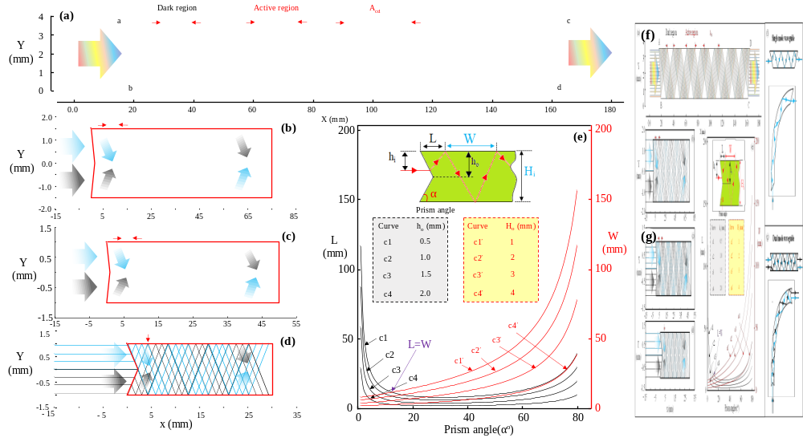
Figure S6. Ray tracing simulation results for single and double mode structured waveguide at various thickness (H_{i}, h_{i}) and the prism angle(α). (a) Depict the ray tracing simulation of a single mode structure (SMS) waveguide of thickness 3 mm and prism angle 45º. (b) The ray tracing simulation of a dual mode structure (DMS) waveguide of thickness 3 mm and prism angle 45º. (c) The ray tracing simulation of a double DDP of thickness 2 mm and prism angle 45º. (d) The ray tracing simulation of a DMS waveguide of thickness 2 mm and prism angle 23.9º. (f)The plots between L and W with various H_{i}, h_{i}, and prism angle (α).(f, g) Ray propagation in a single and dual mode waveguide in straight and bending conditions respectively.

The design of the waveguide is crucial especially for achieving better spatial resolution and sensing during both normal and bending positions of the soft-a-skin. For single mode waveguide (SMW) structure, as shown in Figure S6a, due to TIR of light, the rays selectively hit the top and bottom surfaces of the waveguide. However, for the proper functioning of the soft-a-skin, the sensing nodes must be placed on the active region as shown in Figure S6a. Hence, the spatial resolution of the sensing node of the soft-a-skin is limited by the width of the active region for SMW structure. Eliminating the dark region (Figure S6a) of the waveguide is one of the solutions to the above problem. However, it is unlikely to get rid of dark region from an SMW structure, Figure S6a. Also, in Figure S6e, the bending of an SMW causes the shift of the position of the active region. Therefore, for detecting the bending of the soft-a-skin, a single mode waveguide module needs to be modified. Hence, we have come up with a design of dual mode waveguide (DMW) structure Figure S6b-d, f. In the modified design a mirrored symmetric dual slope is generated to nullify the dark region and make uniform active region throughout the waveguide. We observed that the width of the active and dark region also depends on the thickness and the prism angles of the waveguide. For example, when the thickness of the waveguide reduced from 3 mm to 2 mm keeping the prism angle (45º) constant, the width of the dark region of the waveguide reduces from ~ 4.6 mm to ~2.8 mm (Figure S6b). Therefore, we have analytically found the relation between the L, W, α, h_{o}, and H_{o} as (equation 3, 4, considering parallel incident light)

$L=h_{o}\left[cot\left(α\right)+tan\left[α+\sin^{-1}\left\{\frac{n_{1}}{n_{2}}cos⁡(α)\right\}\right]\right]$………………………….……….………….(3)

$W={2H}_{o}\sin^{-1}\left[\frac{n_{2}}{n_{1}}sin\left\{\tan^{-1}\left(\frac{1}{\tan\left(α\right)}\right)\right\}\right]- \tan^{-1}\left(\frac{1}{\tan\left(α\right)}\right)$…………………….….…………(4)

The variation of L and W are plotted with respect to the prism angles (α) at various values of h_{i} (half width of the dual mode waveguide) and H_{i} (width of the dual mode waveguide) and shown in insert Figure S6g. The plots in the Figure S6e guide to find the conditions where L=W. Following the guidance from the graph in Figure S6e at $h_{o}=1$ mm, $H_{o}=2$ mm, and $α={23.9}^{o}$, we have achieved the width of the dark region as small as 0.1 mm (Figure S6d). This spatial resolution (0.1 mm) of an e-skin is sufficient for most of the applications in various fields of science and engineering.
- Calculation the limits of detection (LoD)
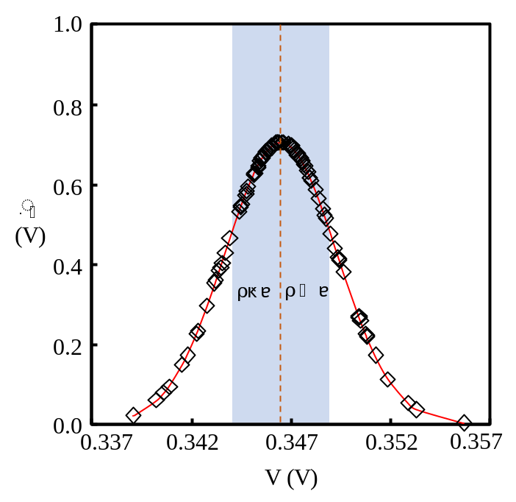
Figure S7. Plot of the normal distribution of the deviation of the repetition of ~ 100 numbers of the null sensor value after each release of a finite pressure.
The limit of detection (LoD) of a pressure sensor is the smallest pressure that can be detected by the sensor. Limit of detection has a strong relation with uncertainty of the sensor value and the sensitivity of the sensor which is determined from the slop of the calibration curve in main article Figure 4a. To determine the uncertainty of the signal, a statistically significant numbers of data points (~100 numbers) have been collected. We have observed that the deviation of the data follows a Gaussian distribution around a mean value μ which is shown in Figure S7 and fitted with equation (21).
$f_{p}\left(V\right)=\frac{L}{σ\sqrt{2Π}}e^{-\frac{1}{2}{\left(\frac{V-µ}{σ}\right)}^{2}}$………………………………………………………...(21)
$µ=\frac{∑_{j}^{n_{i}}(V_{ij}-µ)}{n_{i}}$……………………………………………………………………(22)
$σ=\sqrt{\frac{∑_{j=1}^{n_{i}}{\left(V_{ij}-µ\right)}^{2}}{n_{i}-1}}$……………………………………………………………..…(23)
Where $n_{i}$ set of measurements carried out in the i^{th} position on the calibration curve.
The limit of detection of a pressure sensor can be estimated by repeating measurements of the sensor value ($V_{b}$) at null pressure^{[2]}. We have calculated the LoD of the soft-a-skin sensor by reiterating ~100 measurements of the pressure signal with null pressure i.e. repetition of return of the null sensor value after each release of a finite pressure. Since variations of the measured values follow a Gaussian distribution, the mean(µ) and standard deviation(δ) of the measurement are calculated by the equations (22) and (23) respectively.
LoD is strongly related to the idea known as critical value of the signal ($V_{c}$). The $V_{c}$ of the signal $V_{s}$ is the minimum value exciding of which the sensor signal shows nonzero pressure value despite no application of pressure for a given probability of error $α$ ^{[3][4]}. The signal detection limit ($V_{d}$) is the central value of a normal distribution which probability of being under critical value ($V_{c}$) is $β$.
Considering the signal deviations follows a Gaussian distribution and the standard deviation less than 5% of the null signal, the relations among $V_{b}$, $V_{c}$, $V_{d}$, $α$, and $β$, is $V_{d}-V_{b}=kδ=3δ$ (we choose $α=β$) which gives $α=β=0.067(6.7\%)$ recommended by^{[5]}.
Hence, the limit of detection (LoD) of the soft-a-skin sensor is calculated from analytical sensitivity a of the soft-a-skin sensor (slope of the calibration curve) by the below formula
$P\left(LoD\right)=\frac{kσ}{Sensitivity}$……………………………………………………………………….(24)
Now, putting $k=3$, $Sensitivity=50 Pa per 28 mV$ standard deviation ($δ=\sim 2.8 mV$), the limit of detection of the soft-a-skin sensor for sensitivities respectively. Now considering the sensitivity of the sensor ~150 ${kPa}^{-1}$, the lower detection limit is come out to be 0.056 $kPa$.
- Aspheric equation
A rotationally symmetric surface profile in optics is traditionally described using the general equation for an aspheric surface given by the equation (25),
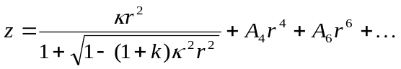 …………………….………………………(25)
where is the height from the vertex of the surface, is the radial co-ordinate, is the curvature at the vertex of the surface, is the conic constant and the coefficients 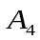, represent aspheric deformation of the surface profile (Figure S8). The first term in the equation represents the conic section which is obtained when the aspheric deformation coefficients are zero. The nature of the conic is given by the value of : 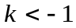, 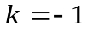, 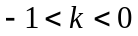, 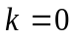 and 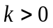 represent respectively a hyperboloid, paraboloid, prolate spheroid, spheroid and oblate spheroid surface. A prolate spheroid.

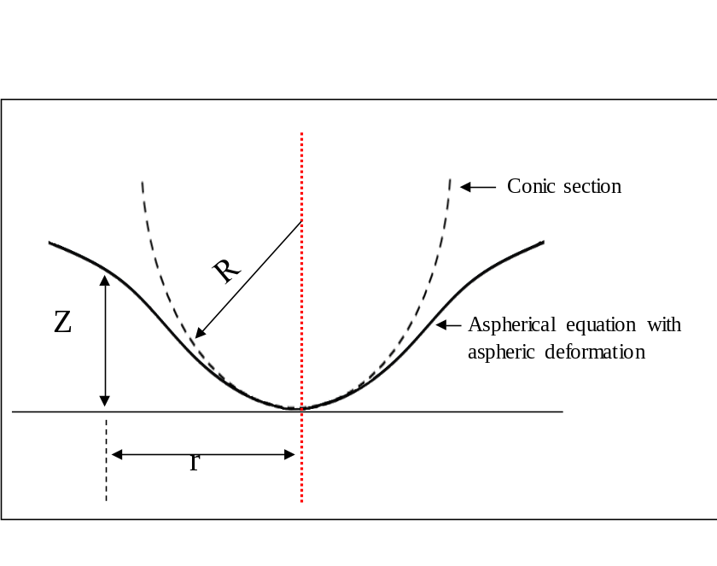
Figure S8. Representation of the aspheric equation (Black curve) along with the conic part.

- Soft-a-skin construction
The soft-a-skin (SAS) is composed of array of SAS-Cell arranged in a way as schematically depicted in Figure S9a. In the left and bottom parts, the light sources of various color are attached to the soft optical waveguide (SOW). On the right and top parts of the SOW, the detectors against each of the light sources are attached. The blue dots represent the SHL hold by array of micropillars just above SOW arranged in such a way that they aligned with light sources and detector. The soft-a-skin works perfectly when the light follows a geometric straight path like as shown by blue (Light 2-Detector14) and magenta (Light 9-Detector17) marks. However, in practice, for a LED light source it does not follow a straight path rather it spread like as shown by yellow shades due to the diffraction of light emitting from light source 3. As a result, an overlap of the intensity from the nearby light source affects the performance of the soft-a-skin. Initially, we have adopted light filters in fronts of the light sources as well as detectors to overcome the problem of overlap of light from different sources. We have used different cellulose acetated sheets of various colors for making absorptive filter as shown in Figure S9c. Interestingly, the soft-a-skin with introduction of filters performed better than without filters. However, since absorptive filters has the capability of filtering band of wavelength, with increasing density of light sources and thereby the density of SHLs and detectors, in that scenario, the soft-a-skin may not work efficiently.

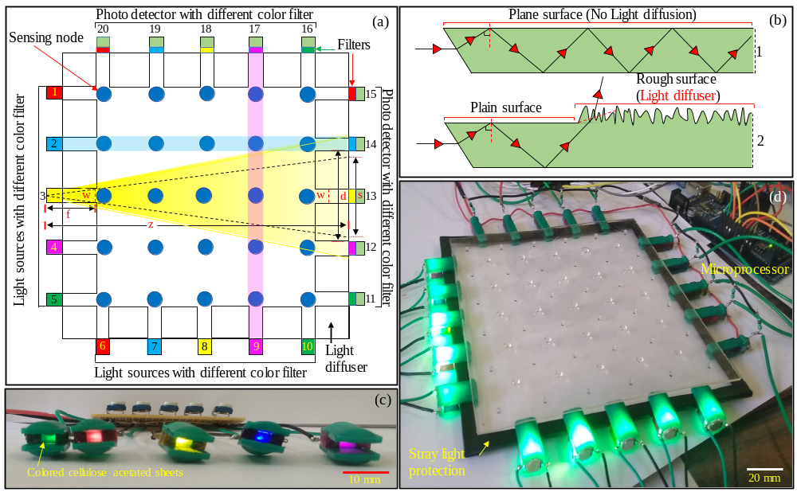
Figure S9. Schematic architecture and optical image of soft electronic skin (a)Schematic 2D architecture of the soft-a-skin. (b)2D Schematic representation of the diffusion of light due to the rough surface on the rectangular waveguide. (c) Various color light sources result of different color filter used in front of the light source (LED, 1 Watt). (d) Complete soft-a-skin with light sources and detectors.
Therefore, we have come out with an interesting idea of resolving the issue by introducing light diffuser along the sides of the soft-a-skin as shown in Figure S9a. The working of the light diffuser is depicted in Figure S9b. When light incident at a suitable angle (above the critical angle) on a slab with higher refractive index than its surroundings and having smooth surfaces, it gets TIR from both surfaces of the slab (PDMS, Figure S9b1). However, if the one of the surfaces is not smooth, light ray deviate from getting total internal reflection due to the mismatch of RIT condition at the interface resulted from the roughness of the surface (Figure S9b2). Therefore, we have derived a simple dimensional parametric condition for correctly finding the values of $f$,$w$,$z$,$d$, and $s$. The first criterion of light not getting overlapped from various light sources at the detector is: $d>s$ , where $d$ is the separation between the two detectors closest from the detector where intensity is measured, s width of the dispersed light at the detector front (Figure S9a). The relation among the parameters be expressed by a simple equation
$s=\frac{z}{f}×w$…………………………………………………………………………...(26)
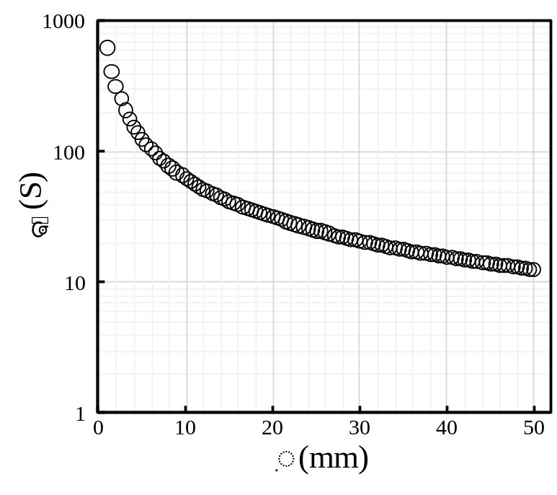
Figure S10. Graph representing $f$ distance of light source from to the end of the diffuser with respect to s width of the dispersed light at the detector front.

Where, $z$ is the distance from the light source to the detector front, $f$ distance of light from to the end of the diffuser. We have plotted the values of the s with respect to f considering w and z constant (Figure S10). For the soft-a-skin with $w=4.5 mm$, $z=149.3 mm$ the values of $d=25 mm$, at critical separation $d=s$ ; equation 4 gives $f=26.87 mm$. However, our chosen value of $f=32.5 mm$, which gives the value of $s=19.38 mm$ which is significantly less than $d=25 mm$. Another important aspect of the design of the soft-a-skin is that the side walls which is unused by the soft-a-skin light sources and detector must be covered by opaque substances to avoid interferences from the environments. In addition, top PDMS membrane too required to be covered by opaque materials for avoiding interference from the environmental stray lights. To make an opaque PDMS layer, we have mixed fine powder of charcoal with PDMS and made the top membrane containing transparent soft hemispherical lens (SHL, 40% weight ratio of Charcoal is used to get an opaque PDMS layer, see Figure S10). Figure S9d shows a transparent soft-a-skin fabricated using an array of $5×5$3D printed SHLs. Ten light sources, five in left side of the soft-a-skin and five on the bottom side of the soft-a-skin. Against each five light sources five PT are arranged in a way that they face exactly opposite to them. We observed that transparent skin gives discrepancy in the detection of the exact pressure nodes due to the environmental light (EL). When EL incident on the soft-a-skin at a suitable angle, it may get TIR inside the RW and can contribute to the output intensity. Although, we have shown a transparent soft-a-skin in Figure S9d for better visualization of the e skin, however, it would be better to use the top opaque PDMS layer for restricting stray light. The preparation and optical characterization of the opaque PDMS is described in next section (section 9, Figure S11). All the cages for light sources and detectors are made using 3D printing.
The relation among the parameters be expressed by a simple equations
$s=\frac{z}{f}×w$…………………………………………………………………………...(26)

- Making of flexible opaque sheet of PDMS
As mentioned in the main paper, the variation of the environmental starry light affects the performance of the e-skin. Therefore, the top cover of the e-skin is covered by a flexible opaque sheet containing the sensing nodes. The sheet is made of PDMS mixed with activated carbon. The PDMS oligomer is first rigorously mixed with activated carbon the (10: 1 ratio) crosslinking agent is mixed. The ratio of crosslinking agent is considered according to the weight of oligomer only. To find the ideal weight ratio of the activated carbon to the PDMS oligomer, we have mixed the PDMS with 0, 5, 10, 20 and 50% ratio of activated carbon and the opacity of the as prepared film is tested by measuring the intensity of the light intensity through the films. Figure S 11a shows the normalized intensity profile of the light after passing through the films, the intensity profile is capture through a line as shown in the insert Figure S11a. The thickness of the membrane is ~ 1mm. Figure S11 (c-f) depicts the optical image of the PDMS film mixed with activated carbon with percentage 0, 5,10,20 and 50% respectively. We have observed that PDMS with 50% activated carbon mix shows height opacity and used the same percentage to make the opaque film for the e-skin.

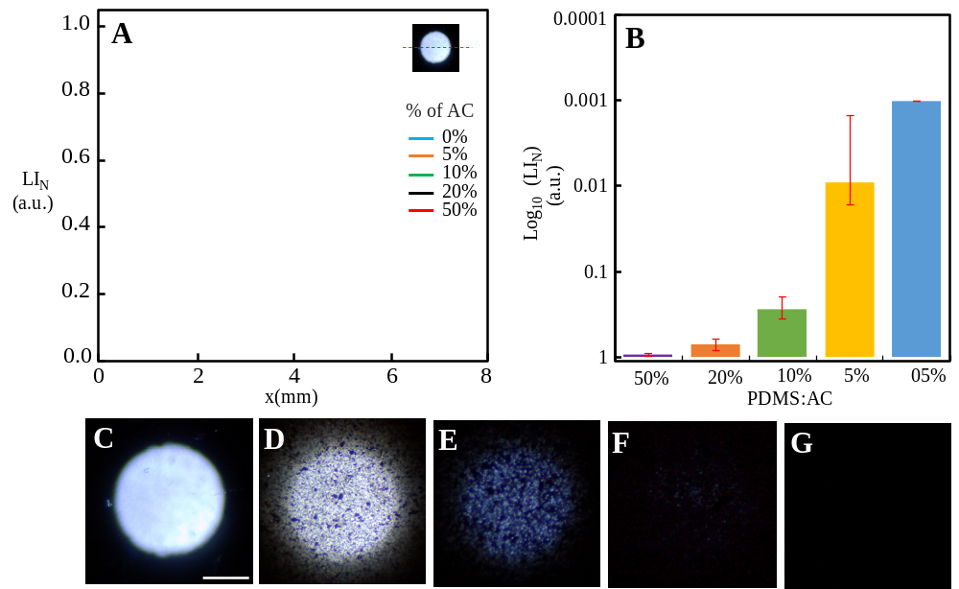
Figure S11. The opacity test for the activated carbon (AC) incorporated PDMS layer of thickness 1 mm. (a) Intensity of white light when passed through the PDMS layer incorporated with powder of activated carbon with various percentages. (b) Bar diagram of the mean intensity of various concentration AC. (c-g) Optical image of PDMS layer incorporated with AC with 0, 5,10,20 and 50% masses. (scale 2 mm)

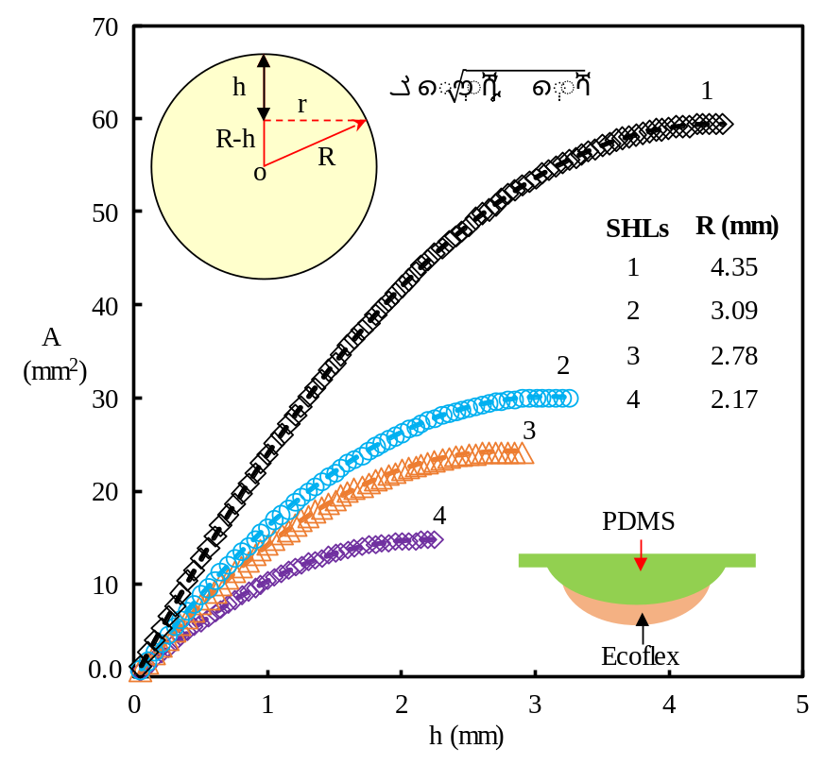
Figure S12. Graphs between the height (h) with respect to the area of the circle when a plan cut a sphere at a height (h) from the surface of the sphere. (1-4) h vs A for radius of curvature of the HLSs 4.35, 3.09, 2.78 and 2.17 mm respectively.
- Comparison of the soft-a-skin with previous works

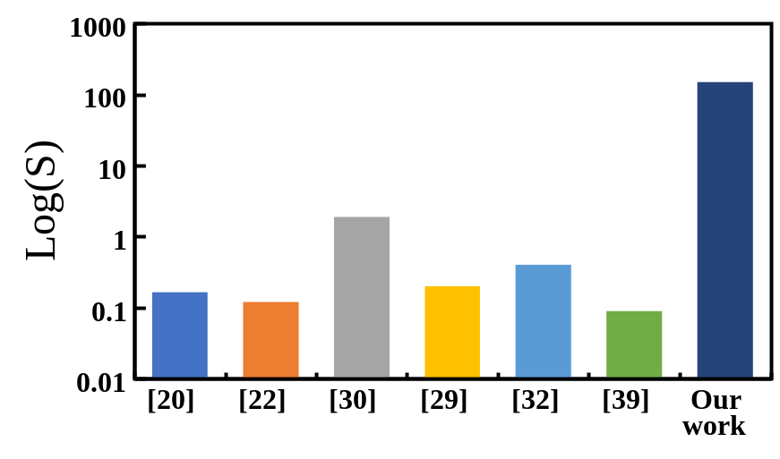
Figure S13. Comparison of sensitivity of our sensor with previously reported works, considering the response time less than 1000 msec.

From the above comparison of our soft-a-skin with the electronic skin published in the high impact journals, the overall performance of our soft-a-skin is better than the work mentioned in table 1. We have observed that many of the e-skin sensors cited in table SI 1, are made of organic field effect transistor (OFET). Despite most of their attractive sensitivity, the long-term stability of the OFET is a problem which is a well-known challenge for long time in the scientific community [ref_31, main article]. Moreover, OFET based pressure measurement shows significantly high response time compared to the electronic skins works on the principle such as resistive, piezoresistive, capacitive, etc. For example, response times cited in reference ref_25 and ref_25 (main article) show in the range of 1000-2000 msec. However, in most of real-life application such as robotic e-skin ref_19 (main article) demand response time in the range of a few msec. Therefore, considering these hurdles of real-life application of some of the sensors with high response time, we have compared the sensitivity of the sensors with the prior arts which show response time below 1000 msec (Figure S12). The comparison bar chart in Figure S12 shows the sensitivity of our soft electronic skin multifold superior to the electronic skin in the Table S1 with response time less than 1 sec. Also, our e-skin shows a very reliable stability for long term, we have observed excellent performance even after 10 months.

Table S1: Comparison of sensitivity of our sensor with previously reported works

References  (Main article) | Sensitivity  (kPa⁻¹) | Resp. time (τ$τ_{r}$)  (msec) | Detection range(kPa) | Spatial periodicity (mm) | Area (mm²) | Hysteresis | Working principle
^{[6]} | 1.25 MPa⁻¹ | -- | 0-360 | ~2 | 20x20 | Noticeable  hysteresis | Capacitive
^{[7]} | 0.02-0.55 kPa⁻¹ | 1000 | 0-20 | -- | 64x64 | Negligible hysteresis | Organic field-effect transistors (OFETs)
^{[8]} | 40kPa⁻¹ | -- | 0-50 | -- | 25x25 | Noticeable  hysteresis | Resistive based
^{[9]} | 0.165 kPa⁻¹ | 200 | 0.128-44 | 8 | 30x30 | -- | Piezoresistive
^{[10]} | 0.12 kPa⁻¹ | ~10 | 0-40 | 2.5 | -- | -- | Coplanar-Gate Graphene Transistors
^{[11]} | 30kPa⁻¹ | ~480 | -- | 2.54 | 80x80 | Significant  hysteresis | Organic field effect transistor
^{[12]} | -- | -- | 0-30 | 4 | 44 x44 | Significant  hysteresis | Organic field effect transistor
^{[13]} | ~0.01 kPa⁻¹ | 2100 | 0-40 | 4.5 | 22x22 | -- | OFETs for tactile pressure sensors
^{[14]} | 0.2 kPa⁻¹ | -- | 0-35 | -- | -- | Small hysteresis | Optical based
^{[15]} | 1.93 kPa⁻¹ | -- | 0-40 | -- | -- | -- | Optical based
^{[16]} | 0.4 kPa⁻¹ | ~50 | 0-100 | -- | 150x150 | Significant hysteresis | Resistive based
^{[17]} | 0.09 kPa⁻¹ | ~80-100 | 0-2000 | -- | -- | -- | Piezoresistive
Our work | ~30-150 kPa⁻¹ | ~63 | ~0-350 | ~0.2 | 140x140 | Negligible hysteresis | Optical
Supplementary references
1. N. González, G. Molina-Terriza, J. P. Torres, Opt. Express. 2006, 14, 9093.
2. Á. Lavín, J. de Vicente, M. Holgado, M. F. Laguna, R. Casquel, B. Santamaría, M. V. Maigler, A. L. Hernández, Y. Ramírez. Sensors (Switzerland). 2018, 18, doi:10.3390/s18072038.
3. L. A. Currie, Nomenclature in evaluation of analytical methods including detection and quanti ® cation capabilities 1 ( IUPAC Recommendations 1995 ). 1999, 391, 105–126.
4. L. A. Currie, Detection and quantification limits: origins and historical overview1Adapted from the Proceedings of the 1996 Joint Statistical Meetings (American Statistical Association, 1997). Original title: “Foundations and future of detection and quantification limi. Anal. Chim. Acta. 1999, 391, 127–134.
5. A. M. Committee, Recommendations for the definition, estimation and use of the detection limit. Analyst. 1987, 112, 199–204.

