Supplementary Information

Table S1
Sampling statistics of EW trajectories
Study Cities(central urban areas ) | Number of valid EW grid cells | Number of Valid EW trajectories in Summer | Number of Valid EW trajectories in Winter
Beijing | 4410 | 14225 | 4692
Wuhan | 2291 | 8401 | 3032
Guangzhou | 3216 | 7894 | 4590

Table S2
Data sources
Name | Format | Data source
Political boundaries, roads, green space, waterbodies, buildings and landuse typologies,etc | .shp | China resource and environmental science data platform（https://www.resdc.cn/Default.aspx）,  Open street map（https://www.openstreetmap.org）
Land coverage tupes | .tif | Sentinel-2 satelite data (https://www.esa.int/Applications/Observing_the_Earth/Copernicus/Sentinel-2)
Tree cover height | .tif | https://meta-forest-monitoring-okw37.projects.earthengine.app/view/canopyheight
Point of Interests | .json | https://lbs.amap.com/
Population density | .tif | https://landscan.ornl.gov/
Walking score | .shp | Evaluation of Pedestrian-Friendliness in Chinese Cities: A Study on Streets and Walkability
GDP | .shp | Chen et al. derived the results based on calibrated nighttime light data.
House price | .shp | An Ju Ke house exchange online platform（https://m.anjuke.com/bj/）
Population Density | .tif | https://www.worldpop.org/
Humid, Atmospheric Temperature, Air quality, Wind, Heat Index | .tif | MOD13A3 dataset by NASA(https://ladsweb.modaps.eosdis.nasa.gov/), Landsat 8 Thermal Infrared Sensor（https://earthexplorer.usgs.gov/）, Intitute of Tibetan Plateau Research Chinese Academy of sciences（https://data.tpdc.ac.cn/）

Table S3
Descriptive statistics
Variable | City_Season | Min | Max | Mean | StdDev | Variance
BD | Beijing_Summer | 0.00 | 0.47 | 0.12 | 0.09 | 0.01
RD | Beijing_Summer | 0.00 | 0.30 | 0.09 | 0.06 | 0.00
ID | Beijing_Summer | 0.00 | 157.00 | 10.89 | 16.33 | 266.67
TD | Beijing_Summer | 0.00 | 110.00 | 10.72 | 15.28 | 233.59
POI_D | Beijing_Summer | 0.00 | 432.00 | 42.17 | 54.02 | 2918.15
LDI | Beijing_Summer | 0.00 | 1.77 | 0.38 | 0.39 | 0.15
PDI | Beijing_Summer | 0.00 | 2.08 | 1.15 | 0.67 | 0.45
WS | Beijing_Summer | 0.04 | 98.83 | 60.20 | 24.70 | 610.12
RC | Beijing_Summer | 0.00 | 4.00 | 1.91 | 0.59 | 0.34
LP | Beijing_Summer | 0.00 | 9498.25 | 1109.97 | 1246.06 | 1552668.25
BH | Beijing_Summer | 0.00 | 44.17 | 12.77 | 5.05 | 25.46
SF | Beijing_Summer | 0.00 | 84.00 | 2.96 | 6.31 | 39.76
Dist_P | Beijing_Summer | 0.00 | 8933.54 | 668.99 | 838.79 | 703569.00
Dist_W | Beijing_Summer | 0.00 | 11797.37 | 1092.54 | 941.59 | 886583.12
Dist_T | Beijing_Summer | 0.00 | 9725.29 | 539.83 | 815.57 | 665149.54
GD | Beijing_Summer | 0.00 | 1.00 | 0.22 | 0.21 | 0.04
WD | Beijing_Summer | 0.00 | 0.97 | 0.03 | 0.07 | 0.01
LA_SHDI | Beijing_Summer | 0.00 | 1.78 | 0.73 | 0.35 | 0.13
Slope | Beijing_Summer | 0.00 | 30.41 | 3.60 | 3.10 | 9.64
TH | Beijing_Summer | 0.00 | 1173.44 | 186.67 | 140.76 | 19814.71
Pop_D | Beijing_Summer | 0.00 | 959.34 | 97.65 | 99.90 | 9980.39
GDP | Beijing_Summer | 0.00 | 90.90 | 70.80 | 14.10 | 198.86
House_P | Beijing_Summer | 26951.22 | 217300.07 | 62662.79 | 22742.14 | 517205026.24
Humid | Beijing_Summer | 15.05 | 19.09 | 18.33 | 0.30 | 0.09
HiTIC | Beijing_Summer | 26.31 | 33.11 | 31.40 | 0.76 | 0.58
Temp | Beijing_Summer | 24.20 | 28.20 | 27.85 | 0.26 | 0.07
Wind | Beijing_Summer | 3.70 | 6.68 | 5.43 | 0.66 | 0.43
AQI | Beijing_Summer | 70.75 | 78.49 | 74.25 | 1.49 | 2.22
EW | Beijing_Summer | 0.00 | 234.00 | 18.70 | 24.24 | 587.53
BD | Beijing_Winter | 0.00 | 0.47 | 0.12 | 0.09 | 0.01
RD | Beijing_Winter | 0.00 | 0.30 | 0.09 | 0.06 | 0.00
ID | Beijing_Winter | 0.00 | 157.00 | 10.89 | 16.33 | 266.67
TD | Beijing_Winter | 0.00 | 110.00 | 10.72 | 15.28 | 233.59
POI_D | Beijing_Winter | 0.00 | 432.00 | 42.17 | 54.02 | 2918.15
LDI | Beijing_Winter | 0.00 | 1.77 | 0.38 | 0.39 | 0.15
PDI | Beijing_Winter | 0.00 | 2.08 | 1.15 | 0.67 | 0.45
WS | Beijing_Winter | 0.04 | 98.83 | 60.20 | 24.70 | 610.12
RC | Beijing_Winter | 0.00 | 4.00 | 1.91 | 0.59 | 0.34
LP | Beijing_Winter | 0.00 | 9498.25 | 1109.97 | 1246.06 | 1552668.25
BH | Beijing_Winter | 6.04 | 44.17 | 13.10 | 4.63 | 21.43
SF | Beijing_Winter | 0.00 | 84.00 | 2.96 | 6.31 | 39.76
Dist_P | Beijing_Winter | 0.00 | 8933.54 | 668.99 | 838.79 | 703569.00
Dist_W | Beijing_Winter | 0.00 | 11797.37 | 1092.54 | 941.59 | 886583.12
Dist_T | Beijing_Winter | 0.00 | 9725.29 | 539.83 | 815.57 | 665149.54
GD | Beijing_Winter | 0.00 | 1.00 | 0.22 | 0.21 | 0.04
WD | Beijing_Winter | 0.00 | 0.97 | 0.03 | 0.07 | 0.01
LA_SHDI | Beijing_Winter | 0.00 | 1.78 | 0.73 | 0.35 | 0.13
Slope | Beijing_Winter | 0.00 | 30.41 | 3.60 | 3.10 | 9.64
TH | Beijing_Winter | 0.00 | 1173.44 | 186.67 | 140.76 | 19814.71
Pop_D | Beijing_Winter | 0.00 | 959.34 | 97.65 | 99.90 | 9980.39
GDP | Beijing_Winter | 0.00 | 90.90 | 70.80 | 14.10 | 198.86
House_P | Beijing_Winter | 26951.22 | 217300.07 | 62662.79 | 22742.14 | 517205026.24
Humid | Beijing_Winter | 0.94 | 1.52 | 1.12 | 0.07 | 0.00
HiTIC | Beijing_Winter | -5.47 | -0.49 | -2.39 | 0.77 | 0.59
Temp | Beijing_Winter | -6.00 | -3.40 | -3.67 | 0.23 | 0.05
Wind | Beijing_Winter | 5.65 | 7.88 | 6.85 | 0.50 | 0.25
AQI | Beijing_Winter | 58.91 | 66.16 | 62.58 | 1.29 | 1.66
EW | Beijing_Winter | 0.00 | 160.00 | 5.90 | 10.74 | 115.37
BD | Wuhan_Summer | 0.00 | 0.58 | 0.11 | 0.09 | 0.01
RD | Wuhan_Summer | 0.00 | 0.28 | 0.11 | 0.06 | 0.00
ID | Wuhan_Summer | 0.00 | 237.00 | 5.93 | 10.93 | 119.39
TD | Wuhan_Summer | 0.00 | 77.00 | 6.24 | 9.36 | 87.60
POI_D | Wuhan_Summer | 0.00 | 696.00 | 53.54 | 78.68 | 6190.37
LDI | Wuhan_Summer | 0.00 | 1.69 | 0.31 | 0.36 | 0.13
PDI | Wuhan_Summer | 0.00 | 2.27 | 1.19 | 0.80 | 0.64
WS | Wuhan_Summer | 0.06 | 98.88 | 65.29 | 25.06 | 627.92
RC | Wuhan_Summer | 0.00 | 4.00 | 1.80 | 0.74 | 0.54
LP | Wuhan_Summer | 0.00 | 8299.63 | 345.43 | 582.51 | 339321.95
BH | Wuhan_Summer | 0.00 | 85.39 | 13.75 | 6.25 | 39.07
SF | Wuhan_Summer | 0.00 | 35.00 | 0.66 | 2.35 | 5.54
Dist_P | Wuhan_Summer | 0.00 | 20341.56 | 1111.02 | 1830.91 | 3352230.52
Dist_W | Wuhan_Summer | 0.00 | 14436.08 | 1138.95 | 1117.48 | 1248758.07
Dist_T | Wuhan_Summer | 0.00 | 13307.85 | 554.49 | 1073.54 | 1152486.92
GD | Wuhan_Summer | 0.00 | 0.94 | 0.12 | 0.15 | 0.02
WD | Wuhan_Summer | 0.00 | 1.00 | 0.12 | 0.24 | 0.06
LA_SHDI | Wuhan_Summer | 0.00 | 1.80 | 0.79 | 0.39 | 0.15
Slope | Wuhan_Summer | 0.00 | 16.60 | 3.97 | 1.77 | 3.12
TH | Wuhan_Summer | 0.00 | 1377.64 | 75.94 | 121.15 | 14677.87
Pop_D | Wuhan_Summer | 0.00 | 1313.29 | 93.53 | 133.42 | 17800.26
GDP | Wuhan_Summer | 0.00 | 87.97 | 59.20 | 14.02 | 196.63
House_P | Wuhan_Summer | 5165.58 | 52381.53 | 17090.98 | 5007.60 | 25076029.58
Humid | Wuhan_Summer | 19.67 | 21.91 | 20.84 | 0.38 | 0.14
HiTIC | Wuhan_Summer | 29.01 | 34.28 | 32.75 | 0.57 | 0.33
Temp | Wuhan_Summer | 30.00 | 30.30 | 30.13 | 0.09 | 0.01
Wind | Wuhan_Summer | 3.79 | 4.64 | 4.08 | 0.15 | 0.02
AQI | Wuhan_Summer | 18.89 | 50.92 | 42.87 | 5.16 | 26.65
EW | Wuhan_Summer | 0.00 | 228.00 | 20.44 | 27.25 | 742.42
BD | Wuhan_Winter | 0.00 | 0.58 | 0.11 | 0.09 | 0.01
RD | Wuhan_Winter | 0.00 | 0.28 | 0.11 | 0.06 | 0.00
ID | Wuhan_Winter | 0.00 | 237.00 | 5.93 | 10.93 | 119.39
TD | Wuhan_Winter | 0.00 | 77.00 | 6.24 | 9.36 | 87.60
POI_D | Wuhan_Winter | 0.00 | 696.00 | 53.54 | 78.68 | 6190.37
LDI | Wuhan_Winter | 0.00 | 1.69 | 0.31 | 0.36 | 0.13
PDI | Wuhan_Winter | 0.00 | 2.27 | 1.19 | 0.80 | 0.64
WS | Wuhan_Winter | 0.06 | 98.88 | 65.29 | 25.06 | 627.92
RC | Wuhan_Winter | 0.00 | 4.00 | 1.80 | 0.74 | 0.54
LP | Wuhan_Winter | 0.00 | 8299.63 | 345.43 | 582.51 | 339321.95
BH | Wuhan_Winter | 0.00 | 85.39 | 13.75 | 6.25 | 39.07
SF | Wuhan_Winter | 0.00 | 35.00 | 0.66 | 2.35 | 5.54
Dist_P | Wuhan_Winter | 0.00 | 20341.56 | 1111.02 | 1830.91 | 3352230.52
Dist_W | Wuhan_Winter | 0.00 | 14436.08 | 1138.95 | 1117.48 | 1248758.07
Dist_T | Wuhan_Winter | 0.00 | 13307.85 | 554.49 | 1073.54 | 1152486.92
GD | Wuhan_Winter | 0.00 | 0.94 | 0.12 | 0.15 | 0.02
WD | Wuhan_Winter | 0.00 | 1.00 | 0.12 | 0.24 | 0.06
LA_SHDI | Wuhan_Winter | 0.00 | 1.80 | 0.79 | 0.39 | 0.15
Slope | Wuhan_Winter | 0.00 | 16.60 | 3.97 | 1.77 | 3.12
TH | Wuhan_Winter | 0.00 | 1377.64 | 75.94 | 121.15 | 14677.87
Pop_D | Wuhan_Winter | 0.00 | 1313.29 | 93.53 | 133.42 | 17800.26
GDP | Wuhan_Winter | 0.00 | 87.97 | 59.20 | 14.02 | 196.63
House_P | Wuhan_Winter | 5165.58 | 52381.53 | 17090.98 | 5007.60 | 25076029.58
Humid | Wuhan_Winter | 4.21 | 5.04 | 4.67 | 0.10 | 0.01
HiTIC | Wuhan_Winter | 0.46 | 4.83 | 2.38 | 0.66 | 0.43
Temp | Wuhan_Winter | 4.70 | 4.90 | 4.81 | 0.05 | 0.00
Wind | Wuhan_Winter | 4.57 | 5.34 | 4.81 | 0.15 | 0.02
AQI | Wuhan_Winter | 31.45 | 119.75 | 101.36 | 14.46 | 209.15
EW | Wuhan_Winter | 0.00 | 71.00 | 7.76 | 11.03 | 121.75
BD | Guangzhou_Summer | 0.00 | 0.55 | 0.12 | 0.09 | 0.01
RD | Guangzhou_Summer | 0.00 | 0.39 | 0.11 | 0.06 | 0.00
ID | Guangzhou_Summer | 0.00 | 172.00 | 10.82 | 16.42 | 269.70
TD | Guangzhou_Summer | 0.00 | 19.00 | 1.45 | 1.97 | 3.87
POI_D | Guangzhou_Summer | 0.00 | 226.00 | 10.90 | 18.70 | 349.65
LDI | Guangzhou_Summer | 0.00 | 1.65 | 0.35 | 0.39 | 0.15
PDI | Guangzhou_Summer | 0.00 | 2.16 | 0.71 | 0.68 | 0.46
WS | Guangzhou_Summer | 0.00 | 99.01 | 40.68 | 39.23 | 1539.16
RC | Guangzhou_Summer | 0.00 | 3.00 | 1.91 | 0.42 | 0.18
LP | Guangzhou_Summer | 0.00 | 9852.76 | 1072.47 | 1191.39 | 1419399.91
BH | Guangzhou_Summer | 0.00 | 63.96 | 13.48 | 7.24 | 52.44
Dist_P | Guangzhou_Summer | 0.00 | 15645.00 | 1363.74 | 1406.46 | 1978129.64
SF | Guangzhou_Summer | 0.00 | 103.00 | 1.29 | 4.68 | 21.86
Dist_W | Guangzhou_Summer | 0.00 | 12840.52 | 1082.78 | 949.82 | 902157.53
Dist_T | Guangzhou_Summer | 0.00 | 10210.06 | 487.79 | 832.34 | 692781.61
GD | Guangzhou_Summer | 0.00 | 1.00 | 0.10 | 0.20 | 0.04
WD | Guangzhou_Summer | 0.00 | 0.94 | 0.06 | 0.12 | 0.01
LA_SHDI | Guangzhou_Summer | 0.00 | 1.67 | 0.71 | 0.39 | 0.15
Slope | Guangzhou_Summer | 0.00 | 25.10 | 7.20 | 3.95 | 15.58
TH | Guangzhou_Summer | 0.00 | 1795.76 | 254.59 | 320.58 | 102772.71
Pop_D | Guangzhou_Summer | 0.00 | 1450.61 | 94.83 | 159.30 | 25377.26
GDP | Guangzhou_Summer | 0.00 | 93.46 | 62.23 | 15.84 | 250.92
House_P | Guangzhou_Summer | 6779.30 | 97313.07 | 25960.67 | 11102.48 | 123265004.77
Humid | Guangzhou_Summer | 19.65 | 21.86 | 20.71 | 0.29 | 0.08
HiTIC | Guangzhou_Summer | 28.89 | 34.13 | 32.43 | 0.72 | 0.52
Temp | Guangzhou_Summer | 27.76 | 29.50 | 29.24 | 0.17 | 0.03
Wind | Guangzhou_Summer | 2.04 | 3.54 | 2.70 | 0.24 | 0.06
AQI | Guangzhou_Summer | 35.00 | 43.65 | 39.06 | 1.24 | 1.54
EW | Guangzhou_Summer | 0.00 | 133.00 | 10.35 | 16.96 | 287.56
BD | Guangzhou_Winter | 0.00 | 0.55 | 0.12 | 0.09 | 0.01
RD | Guangzhou_Winter | 0.00 | 0.39 | 0.11 | 0.06 | 0.00
ID | Guangzhou_Winter | 0.00 | 172.00 | 10.82 | 16.42 | 269.70
TD | Guangzhou_Winter | 0.00 | 19.00 | 1.45 | 1.97 | 3.87
POI_D | Guangzhou_Winter | 0.00 | 226.00 | 10.90 | 18.70 | 349.65
LDI | Guangzhou_Winter | 0.00 | 1.65 | 0.35 | 0.39 | 0.15
PDI | Guangzhou_Winter | 0.00 | 2.16 | 0.71 | 0.68 | 0.46
WS | Guangzhou_Winter | 0.26 | 99.01 | 60.36 | 27.23 | 741.52
RC | Guangzhou_Winter | 0.00 | 3.00 | 1.91 | 0.42 | 0.18
LP | Guangzhou_Winter | 0.00 | 9852.76 | 1072.47 | 1191.39 | 1419399.91
BH | Guangzhou_Winter | 0.00 | 63.96 | 13.48 | 7.24 | 52.44
Dist_P | Guangzhou_Winter | 0.00 | 15645.00 | 1363.74 | 1406.46 | 1978129.64
SF | Guangzhou_Winter | 0.00 | 103.00 | 1.29 | 4.68 | 21.86
Dist_W | Guangzhou_Winter | 0.00 | 12840.52 | 1082.78 | 949.82 | 902157.53
Dist_T | Guangzhou_Winter | 0.00 | 10210.06 | 487.79 | 832.34 | 692781.61
GD | Guangzhou_Winter | 0.00 | 1.00 | 0.10 | 0.20 | 0.04
WD | Guangzhou_Winter | 0.00 | 0.94 | 0.06 | 0.12 | 0.01
LA_SHDI | Guangzhou_Winter | 0.00 | 1.67 | 0.71 | 0.39 | 0.15
Slope | Guangzhou_Winter | 0.00 | 25.10 | 7.20 | 3.95 | 15.58
TH | Guangzhou_Winter | 0.00 | 1795.76 | 254.59 | 320.58 | 102772.71
Pop_D | Guangzhou_Winter | 0.00 | 2256.61 | 95.10 | 162.20 | 26309.70
GDP | Guangzhou_Winter | 0.00 | 93.46 | 62.23 | 15.84 | 250.92
House_P | Guangzhou_Winter | 6779.30 | 97313.07 | 25960.67 | 11102.48 | 123265004.77
Humid | Guangzhou_Winter | 6.96 | 8.23 | 7.55 | 0.15 | 0.02
HiTIC | Guangzhou_Winter | 11.32 | 16.20 | 13.91 | 0.72 | 0.52
Temp | Guangzhou_Winter | 13.71 | 15.40 | 14.91 | 0.21 | 0.04
Wind | Guangzhou_Winter | 2.36 | 3.55 | 2.94 | 0.17 | 0.03
AQI | Guangzhou_Winter | 65.79 | 98.72 | 84.50 | 5.29 | 27.93
EW | Guangzhou_Winter | 0.00 | 156.00 | 6.12 | 11.75 | 137.98

Table S4
Comparison of model performance and best hyperparameters
City-seasons | Model |  | R² |  | MAE | RMSE |  | Best Hyperparameters
Beijing-Summer | GW-XGBoosting |  | 0.66 |  | 0.57 | 0.74 |  | colsample_bytree=0.6; learning_rate=0.01; max_depth=4; min_child_weight=1; n_estimators=300; reg_lambda=0.5; subsample=0.6
Beijing-Summer | XGBoost |  | 0.58 |  | 0.65 | 0.82 |  | colsample_bytree=0.6043327699741743; learning_rate=0.03578036087601594; max_depth=7; min_child_weight=6; n_estimators=600; reg_lambda=0.9433335901508912; subsample=0.7980382119255633
Beijing-Summer | Random Forest |  | 0.55 |  | 0.67 | 0.84 |  | max_depth=10; max_features=0.3; min_samples_leaf=1; min_samples_split=2; n_estimators=800
Beijing-Summer | OLS |  | 0.50 |  | 0.74 | 0.92 |  | N/A
Beijing-Summer | GWR |  | 0.60 |  | 0.66 | 0.83 |  | N/A
Beijing-Winter | GW-XGBoosting | 0.57 |  | 0.54 |  | 0.71 | colsample_bytree=0.6; learning_rate=0.01; max_depth=10; min_child_weight=1; n_estimators=800; reg_lambda=0.5; subsample=0.6
Beijing-Winter | XGBoost | 0.48 |  | 0.60 |  | 0.78 | colsample_bytree=0.7250235470218216; learning_rate=0.018806501141285; max_depth=8; min_child_weight=5; n_estimators=781; reg_lambda=0.5719036847851698; subsample=0.8490816189412147
Beijing-Winter | Random Forest | 0.40 |  | 0.65 |  | 0.84 | max_depth=10; max_features=1.0; min_samples_leaf=1; min_samples_split=2; n_estimators=800
Beijing-Winter | OLS | 0.32 |  | 0.74 |  | 0.94 | N/A
Beijing-Winter | GWR | 0.46 |  | 0.64 |  | 0.83 | N/A
Wuhan-Summer | GW-XGBoosting | 0.66 |  | 0.57 |  | 0.74 | colsample_bytree=0.6; learning_rate=0.01; max_depth=4; min_child_weight=1; n_estimators=300; reg_lambda=0.5; subsample=0.6
Wuhan-Summer | XGBoost | 0.58 |  | 0.65 |  | 0.82 | colsample_bytree=0.6043327699741743; learning_rate=0.03578036087601594; max_depth=7; min_child_weight=6; n_estimators=600; reg_lambda=0.9433335901508912; subsample=0.7980382119255633
Wuhan-Summer | Random Forest | 0.55 |  | 0.67 |  | 0.84 | max_depth=10; max_features=0.3; min_samples_leaf=1; min_samples_split=2; n_estimators=800
Wuhan-Summer | OLS | 0.50 |  | 0.74 |  | 0.92 | N/A
Wuhan-Summer | GWR | 0.60 |  | 0.66 |  | 0.83 | N/A
Wuhan-Winter | GW-XGBoosting | 0.66 |  | 0.57 |  | 0.74 | colsample_bytree=0.6; learning_rate=0.01; max_depth=4; min_child_weight=1; n_estimators=300; reg_lambda=0.5; subsample=0.6
Wuhan-Winter | XGBoost | 0.58 |  | 0.65 |  | 0.82 | colsample_bytree=0.6043327699741743; learning_rate=0.03578036087601594; max_depth=7; min_child_weight=6; n_estimators=600; reg_lambda=0.9433335901508912; subsample=0.7980382119255633
Wuhan-Winter | Random Forest | 0.55 |  | 0.67 |  | 0.84 | max_depth=10; max_features=0.3; min_samples_leaf=1; min_samples_split=2; n_estimators=800
Wuhan-Winter | OLS | 0.50 |  | 0.74 |  | 0.92 | N/A
Wuhan-Winter | GWR | 0.60 |  | 0.66 |  | 0.83 | N/A
Guangzhou-Summer | GW-XGBoosting | 0.57 |  | 0.57 |  | 0.76 | colsample_bytree=0.6; learning_rate=0.01; max_depth=10; min_child_weight=1; n_estimators=300; reg_lambda=0.5; subsample=0.6
Guangzhou-Summer | XGBoost | 0.48 |  | 0.64 |  | 0.84 | colsample_bytree=0.6; learning_rate=0.022922576623966698; max_depth=8; min_child_weight=6; n_estimators=800; reg_lambda=1.0; subsample=0.6943223765483802
Guangzhou-Summer | Random Forest | 0.45 |  | 0.67 |  | 0.86 | max_depth=10; max_features=1.0; min_samples_leaf=2; min_samples_split=2; n_estimators=800
Guangzhou-Summer | OLS | 0.405 |  | 0.73 |  | 0.91 | N/A
Guangzhou-Summer | GWR | 0.50 |  | 0.66 |  | 0.83 | N/A
Guangzhou-Winter | GW-XGBoosting | 0.57 |  | 0.57 |  | 0.76 | colsample_bytree=0.6; learning_rate=0.01; max_depth=10; min_child_weight=1; n_estimators=300; reg_lambda=0.5; subsample=0.6
Guangzhou-Winter | XGBoost | 0.48065 |  | 0.64 |  | 0.84 | colsample_bytree=0.6; learning_rate=0.022922576623966698; max_depth=8; min_child_weight=6; n_estimators=800; reg_lambda=1.0; subsample=0.6943223765483802
Guangzhou-Winter | Random Forest | 0.45 |  | 0.67 |  | 0.86 | max_depth=10; max_features=1.0; min_samples_leaf=2; min_samples_split=2; n_estimators=800
Guangzhou-Winter | OLS | 0.40 |  | 0.73 |  | 0.91 | N/A
Guangzhou-Winter | GWR | 0.50 |  | 0.66 |  | 0.83 | N/A

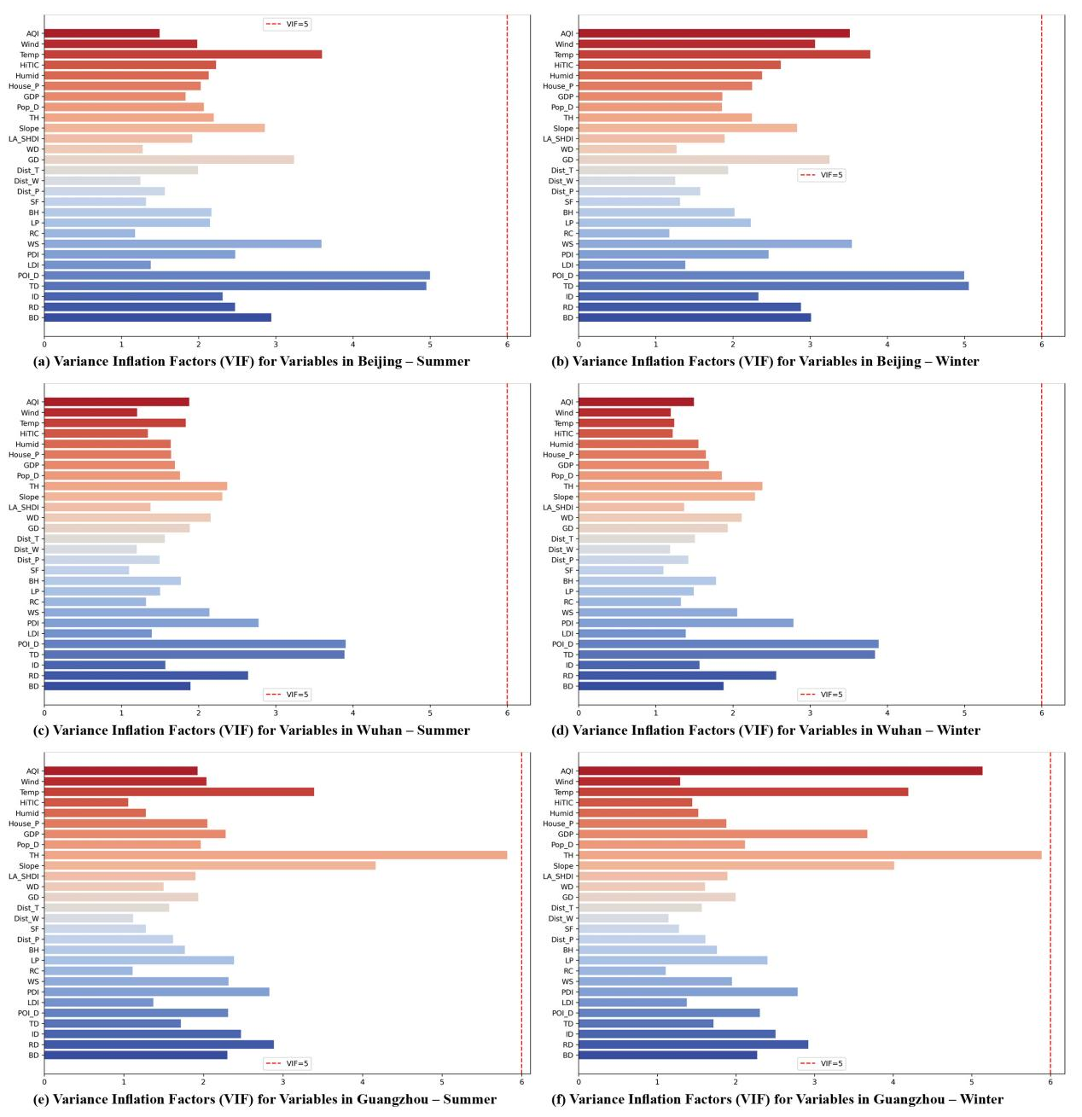
Fig. S1. Variance Inflation Factors(VIF) for variables across different city-seasons.
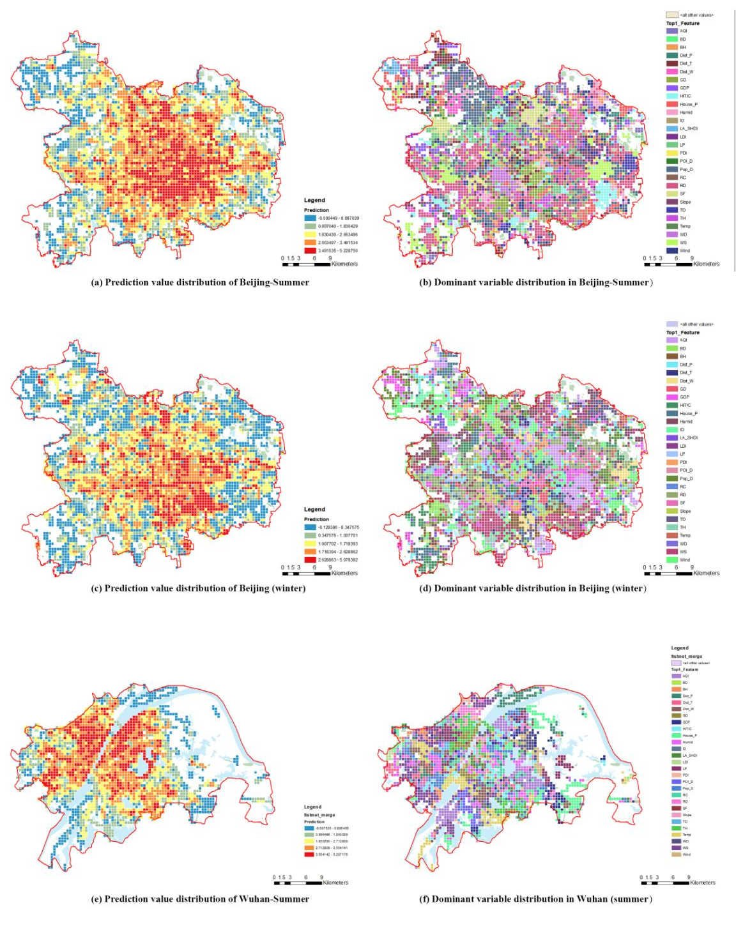
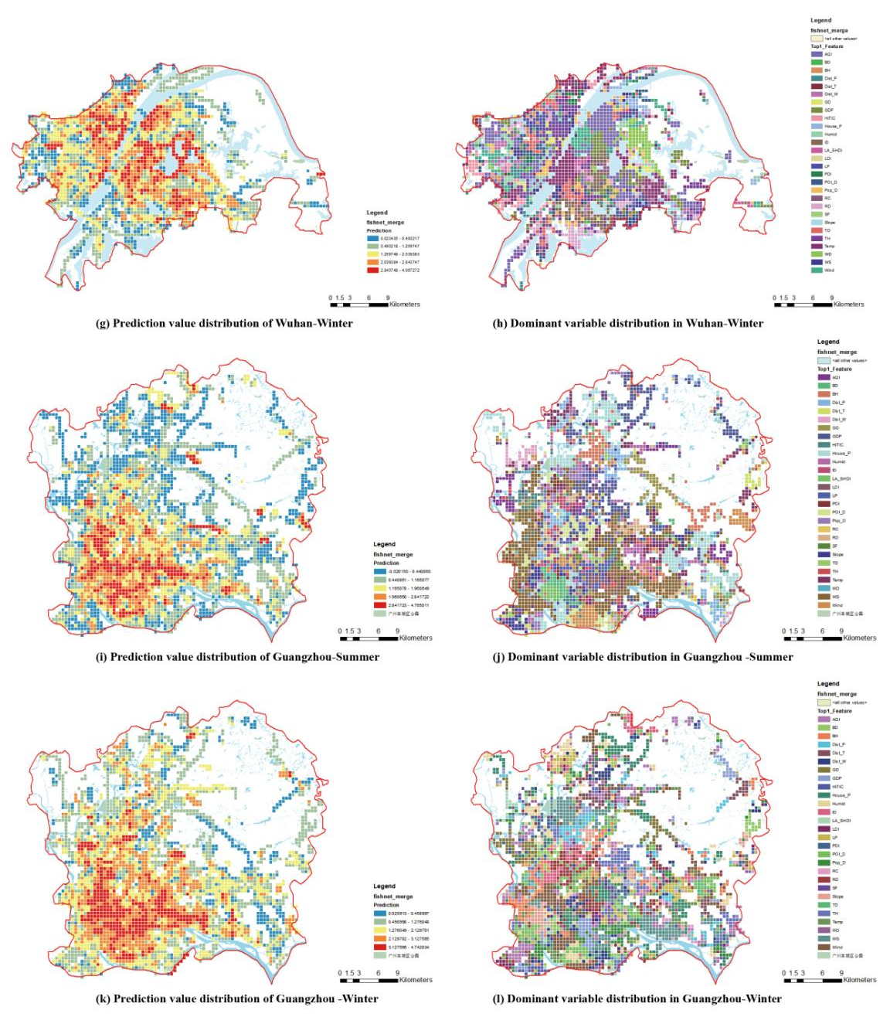
Fig. S2. Prediction value and dominant variable distribution across different city-seasons.

