Tables
Table 1
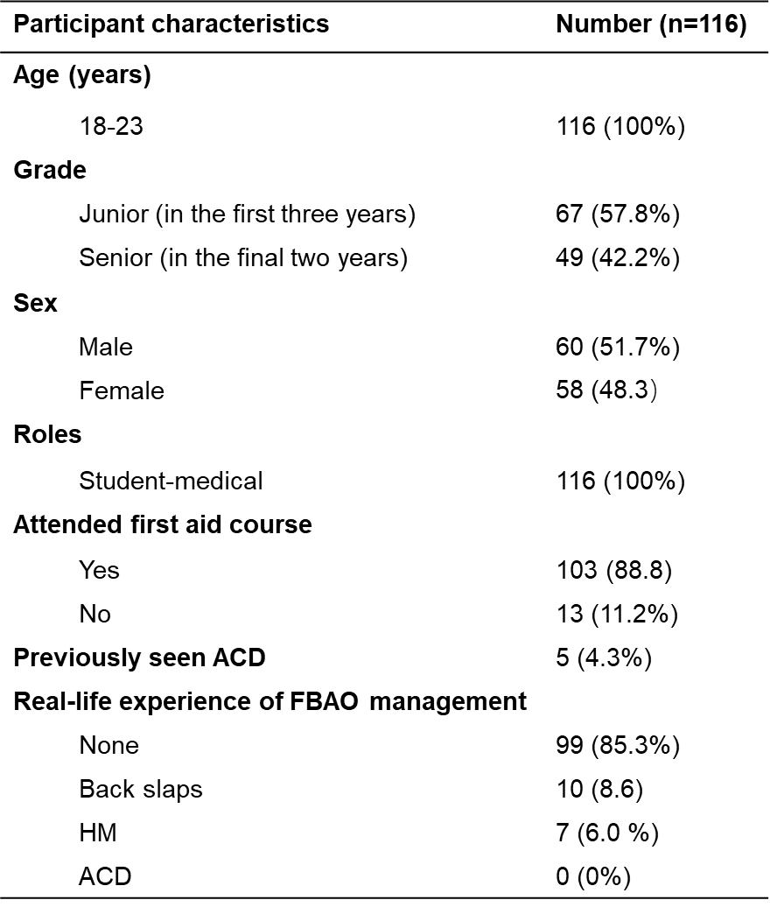
Table 1. Participant characteristics.

Table 2
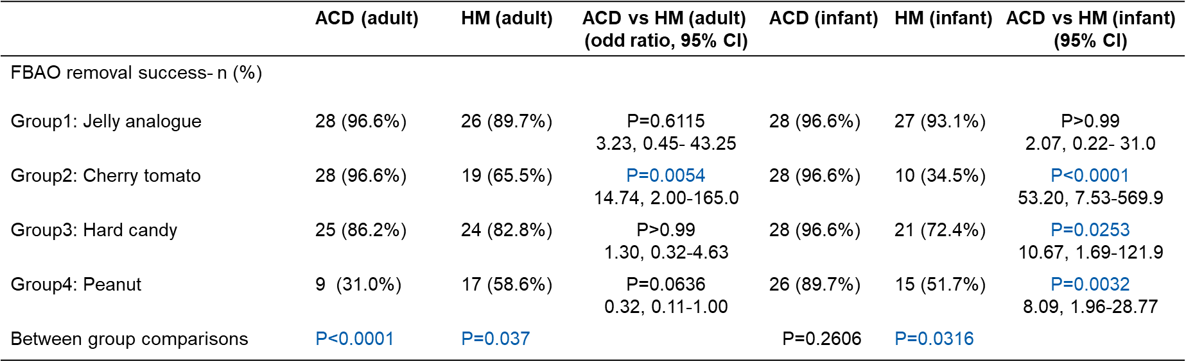
Table 2. Comparison of the effectiveness of ACD and the HM.

Table 3
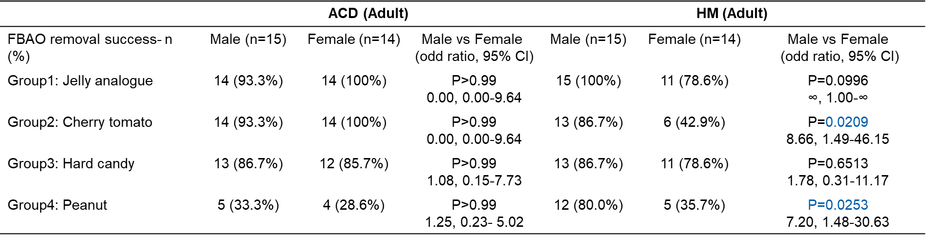
Table 3. Gender-related study outcomes in adult model.

Table 4
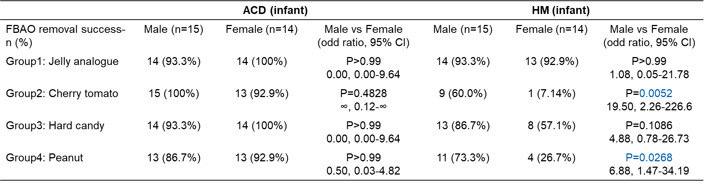
Table 4. Gender-related Study outcomes in infant model.

