Supplementary Information
Polyoxometallic chemistry towards all-in-one layered double hydroxides for boosting oxygen evolution electrocatalysis
Cai et al.

Experimental Section
Chemicals: The chemicals were used as received without further purification. Hydrochloric acid (HCl, AR, Adamas, Shanghai, P.R. China), Phosphotungstic acid hydrate (H₃O₄₀PW₁₂·xH₂O, AR, Aladdin Co., P.R. China), Tungstosilicic acid hydrate (H₄[Si(W₃O₁₀)₄]·xH₂O, AR, Aladdin Co., P.R. China), Phosphomolybdic acid hydrate (H₃Mo₁₂O₄₀P·xH₂O, AR, Aladdin Co., P.R. China), Sulfuric Acid (H₂SO₄, AR, Greagent Co., P.R. China), Nitric acid (HNO₃, AR, Greagent Co., P.R. China), ethanol (C₂H₆O, ≥ 99.7%, Adamas, Shanghai, P.R. China), Nickel(II) nitrate hexahydrate (NiN₂O₆·6H₂O, 98%, Aladdin Co., P.R. China), Ferrous(II) sulfate heptahydrate (FeSO₄·7H₂O, 99.95%, Aladdin Co., P.R. China), Nafion D-521 solution (5%, Alfa Aesar, U.S.A.), Iridium(IV) Oxide (IrO₂, 99.9%, Adamas, Shanghai, P.R. China), Potassium hydroxide (KOH, ACS, Aladdin Co., P.R. China), and Ni foam (1.5 mm in thickness, Tianjin EVS Co., P.R. China). Deionized (DI) water with a resistance of ~18.2 MΩ was used throughout all experiments.

Preparation of NiFe LDH: The NiFe LDH nanosheets were electrically deposited on Ni foam in a standard three-electrode system equipped with Ni foam, Pt plate and Ag/AgCl electrode as the working, counter and reference electrode, respectively. 100 mL of the aqueous solution containing a desired weight ratio of Ni(NO₃)₂·6H₂O and FeSO₄·7H₂O precursors was used as electrolyte The whole system was continuously flowed by high-puriry N₂ (5.0 quality) through to avoid the oxidation of Fe²⁺. In order to promote the deposition of Ni²⁺ and Fe²⁺, the given potentials resulting from a pulsed electric field was -0.86 V vs. Ag/AgCl for 5 s and -1.1 V vs. Ag/AgCl for another 5 s. The total cyclic time of 90 s. The obtained samples were washed by DI water and dried under vacuum. The NiFe LDH powder was prepared by a coprecipitation method. The precursor solution was the same as that used in electrodeposition and the pH value was adjusted to 10 by 6 M KOH. After continuously stirring for 24 h at room temperature, the products were centrifuged and intensively washed with ethanol, and then dried under vacuum.

Preparation of NiFe LDH-X: The as-prepared NiFe LDH was then immersed in the etching agent solutions and denoted as NiFe LDH-X, where X represents different etching agents, including three Keggin-structured polyoxometallic acids (phosphotungstic acid hydrate (named pure PW12), tungstosilicic acid hydrate (pure SiW12) and phosphomolybdic acid hydrate (pure PMo12)) and three ordinary acids (sulfuric acid (pure H₂SO₄), hydrochloric acid (pure HCl) and nitric acid (pure HNO₃)). To be specific, the detailed preparation procedure of NiFe LDH-PMo12 is as follows. Firstly, PMo12 is dissolved in DI water to prepare a homogenous solution with pH = 2.5. Then, the as-prepared NiFe LDH was immersed for 30 s. The obtained electrodes were washed with DI water and dried under vacuum. The mass loadings of NiFe LDH-X on NF were kept with the same amount of 2 mg·cm⁻². For comparison, the powder-form NiFe LDH-PMo12 was prepared by the similar method.

Preparation of Powder NiFe LDH, Powder NiFe LDH-PMo12 and IrO₂ electrodes: The powder electrodes were synthesized by same procedure. For example, to prepare the IrO₂ electrode, 40 mg IrO₂ and 60 μL Nafion, 540 μL ethanol and 400 μL DI water were ultrasonicated for homogeneous dispersion. Then, the suspension was coated onto Ni foam, and then dry at room temperature. The loading amount of NiFe LDH powder, NiFe LDH-PMo12 powder and IrO₂ powder on NF was kept the same amount of 2 mg·cm⁻² with those of NiFe LDH-X.

Characterizations: The morphology and structure of the as-synthesized samples were detected with scanning electron microscopy (SEM, LEO 1530VP), transmission electron microscope (TEM, FEI Tecnai G2 F20 S-TWIN) coupled with energy dispersive X-ray spectroscopy (EDX), HAADF-STEM analyses (JEOL JEM-ARM200F S/TEM with a spherical aberration corrector) and Atomic Force Microscopy (AFM, Asylum Research Cypher ES). The phase composition and chemical bonding nature in the samples was characterized by Raman spectra (Horiba-Jobin-Yvon T64000 instrument) and Fourier Transform infrared spectroscopy (FTIR, Thermo Nicolet NEXUS 470). Surface chemical compositions of the samples were characterized by an X-ray photoelectron spectroscopy (XPS, AXIS ultra DLD, Shimazu) in a vacuum of 10⁻⁷ Pa with an Al Kα monochrome anode. The X-band Electron paramagnetic resonance (EPR) spectra were recorded on Bruker A300 spectrometers at the temperature of 100 K. The Fe contents were analyzed by Inductively Coupled Plasma-Optical Emission Spectrometry (ICP-OES, PerkinElmer Optima 2100DV).

Electrochemical measurements: Electrochemical measurements were carried out on an electrochemical station (Ivium Technologies, Vertex.1A, The Netherlands) in a standard three-electrode system equipped with the as-prepared samples as the working electrode, a Φ6 carbon rod as the counter electrode, and a standard Hg/HgO electrode as the reference electrode. The OER activities were evaluated using cyclic voltammetry (CV) methods in 1 M KOH aqueous solution. To determine the double-layer capacitance values (C_{dl}), the CV measurements were carried out at different scan rates (from 10 to 100 mV·s⁻¹) in a potential range from 0.927 V to 1.027 V vs. RHE. The stability tests for OER were performed by chronopotentiometry method at a constant current density of 20 mA·cm⁻² in 1 M KOH aqueous solution for 10 or 11 h. Electrochemical impedance spectra (EIS) were measured at an overpotential of 1.48 V vs. RHE from 0.1 Hz to 100 kHz with an amplitude of 10 mV. Notably, all the measured potentials vs. Hg/HgO were converted to RHE by the Nernst equation (E_{RHE} = E_{Hg/HgO} + 0.0592 pH + 0.098) and except where otherwise stated, an iR compensation of 90 % was applied to all the CV curves.

ICP-OES measurement: For chemical composition analysis, each sample with the geometric area of 1 cm² was immersed in dilute HNO₃ solution (20 mL, 0.1 M) with the help of ultrasonication. Then, 10 mL of the sample solution was further diluted to 50 mL with deionized water and measured with ICP-OES.

Supplementary Note 1: Calculation for Turnover frequency (TOF)
The TOF values were calculated as the number of oxygen molecules evolved per active site per second based on the following equation:
$$\text{TOF=}\frac{\text{J}\text{ × A × FE}}{\text{4 × F × m}}$$
Where J is the current density (A cm⁻²) at a given overpotential, A is the effective surface geometric area of the working electrode (1 cm²), FE is the Faradaic efficiency, F is the Faraday constant, and m is the number of moles of the active metal on the electrode. For TOF calculations, we assumed that the Faradaic efficiency equals to 1 and all Fe atoms in catalysts were accessible for catalyzing the OER.

Supplementary Note 2: Detailed descriptions of SICCAS equation
The constants a and b in the formula are weighted according to the degree of influence of Fe and Ni on OER. Specifically, in order to eliminate the influence of Ni in Ni foam, we use the atomic ratio of Ni and Fe measured by TEM-EDS (~ 5:1, Supplementary Fig. 3d) and combine Fe³⁺ and α-Ni(OH)₂ contents in the XPS results, then calculate TOF_{Fe3+} and TOF_{α-Ni(OH)2} respectively. We found that the average number of TOF_{Fe3+/α-Ni(OH)2} ~2 (Supplementary Table 5). Therefore, a = 2 and b = 1 in this formula. Since η has a linear relationship with the number of active sites (Fe³⁺ and α-Ni(OH)₂), k and c are obtained by linear fitting of the weighted the total amount of α-Ni(OH)₂, Fe³⁺ and η. That is, k = - 0.6 and c = 410. In addition, we added Vo into consideration. In order to amplify the difference, η₅₀₀ was selected for different samples for comparison. It can be seen that as the oxygen vacancy concentration increases, η₅₀₀ first decreases and then increases. Therefore, the relationship between Vo and η should be fitted with Gaussian distribution. Δη = 34 mV (the difference between the best and worst η₅₀₀), the average value of Vo is 23.8 from the Vo results of XPS, and the fitting is within the error of ±0.2%, Vo1 = 24.1, Vo2 = 23.9. The literature data used in the formula for trial and error are listed in the Supplementary Table 6.

Computational methods
We employed the Vienna Ab Initio Package (VASP)^{1, 2} to perform all the spin-polarized density functional theory (DFT) calculations within the generalized gradient approximation (GGA) using the PBE formulation³. We have chosen the projected augmented wave (PAW) potentials to describe the ionic cores and take valence electrons into account using a plane wave basis set with a kinetic energy cutoff of 500 eV^{4, 5}. Partial occupancies of the Kohn-Sham orbitals were allowed using the Gaussian smearing method and a width of 0.05 eV. The electronic energy was considered self-consistent when the energy change was smaller than 10⁻⁵ eV. A geometry optimization was considered convergent when the force change was smaller than 0.03 eV/Å. Grimme’s DFT-D3 methodology was used to describe the dispersion interactions⁶. The on-site corrections (DFT+U) has been applied to the 3d electron of both Ni (U_{eff} = 6.2 eV) and Fe atoms (U_{eff} = 5.3 eV) by the approach from Dudarev et al⁷. The equilibrium lattice constant of hexagonal γ-NiOOH monolayer unit cell seperated by vacuum in depth of 15 Å was optimized, when using a 15×15×2 Monkhorst-Pack k-point grid for Brillouin zone sampling, to be a = 3.1737 Å. We then use it to construct a γ-NiOOH monolayer supercell model with p(2x2) periodicity in the x and y directions seperated by vacuum in at least 15 Å vacuum layer. in order to separate the graphene monolayer from its periodic duplicates. This graphene model contains 16 Ni atoms and 32 OH groups. 4 Ni atoms were replaced by 4 Fe atoms in order to simulate the Fe doping. During structural optimizations, the 2×2×1, Γ point in the Brillouin zone was used for k-point sampling, and all atoms were allowed to fully relax. An initial linear mixing which can result in faster convergence in Transition metal slabs system are introduced to our calculation.
To model the thermochemistry mechanism of OER elementary steps, the following four electrons reaction pathways is the most convenient way to proceed:

H₂O(l) + * → *OH + H⁺ + e⁻ 1
*OH → *O + H⁺ + e⁻ 2
H₂O(l) + *O → *OOH + H⁺ + e⁻ 3
*OOH → * + O₂(g) + H⁺ + e⁻ 4

The free energy of a gas phase molecule or an adsorbate on the surface was calculated by the equation G = E + ZPE − TS, where E is the total energy, ZPE is the zero-point energy, T is the temperature in kelvin (298.15 K is set here), and S is the entropy.

The X-ray absorption find structure (XAFS) measurements:
The XAFS Mo K-edge were collected at BL14W1 beamline of Shanghai Synchrotron Radiation Facility (SSRF) while Ni, Fe K-edge were collected at 1W1B beamline of Beijing Synchrotron Radiation Facility (BSRF). The data were collected in transmission mode or fluorescence mode using a Lytle detector while the corresponding reference sample were collected in transmission mode. The sample were grinded and uniformly daubed on the special adhesive tape.

XAFS Analysis and Results:
The acquired EXAFS data were processed according to the standard procedures using the ATHENA module of Demeter software packages.
The EXAFS spectra were obtained by subtracting the post-edge background from the overall absorption and then normalizing with respect to the edge-jump step. Subsequently, the χ(k) data of were Fourier transformed to real (R) space using a hanning windows (dk=1.0 Å⁻¹) to separate the EXAFS contributions from different coordination shells. To obtain the quantitative structural parameters around central atoms, least-squares curve parameter fitting was performed using the ARTEMIS module of Demeter software packages
The following EXAFS equation was used:
$$χ\left(k\right)=\sum_{j}{\frac{N_{j}S_{0}^{2}F_{j}(k)}{kR_{j}^{2}}⋅exp⁡[-2k^{2}σ_{ j}^{2}]⋅exp⁡[\frac{-2R_{j}}{λ(k)}]}⋅sin⁡[2kR_{j}+ϕ_{j}(k)]$$
the theoretical scattering amplitudes, phase shifts and the photoelectron mean free path for all paths calculated. S₀² is the amplitude reduction factor, F_{j}(k) is the effective curved-wave backscattering amplitude, N_{j} is the number of neighbors in the j^{th} atomic shell, R_{j} is the distance between the Xray absorbing central atom and the atoms in the j^{th} atomic shell (backscatterer), λ is the mean free path in Å, ϕ _{j}(k) is the phase shift (including the phase shift for each shell and the total central atom phase shift), σ_{j} is the Debye-Waller parameter of the j^{th} atomic shell (variation of distances around the average R_{j}). The functions F_{j}(k), λ and ϕ _{j}(k) were calculated with the ab initio code FEFF9. The additional details for EXAFS simulations are given below.
All fits were performed in the R space with k-weight of 2 while phase correction was also applied in the first coordination shell to make R value close to the physical interatomic distance between the absorber and shell scatterer. The coordination numbers of model samples were fixed as the nominal values. While the S₀², internal atomic distances R, Debye-Waller factor σ², and the edge-energy shift Δ were allowed to run freely.

Supplementary Figures
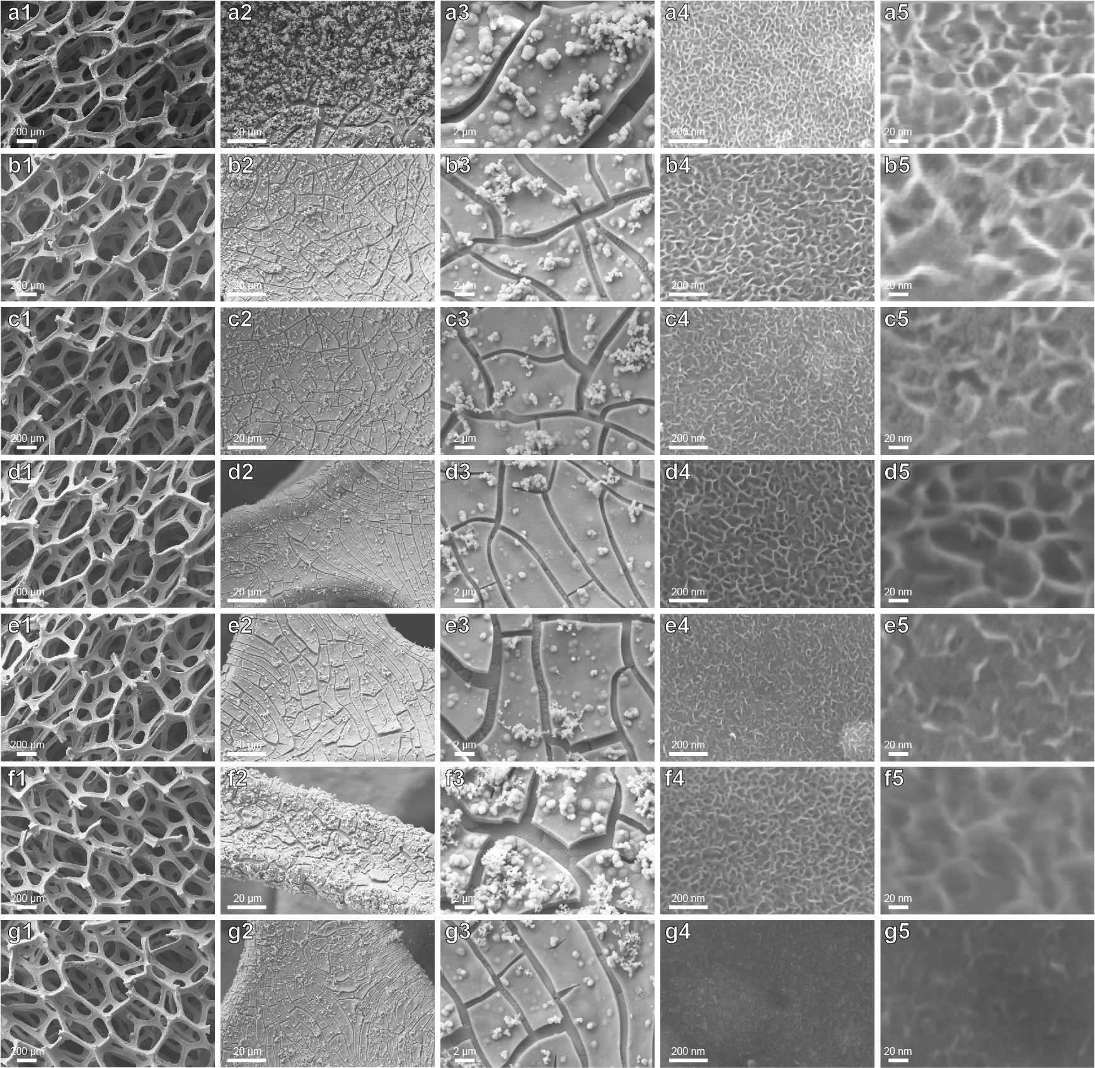
- SEM images at low and high magnifications. a1-5 NiFe LDH. b1-5 NiFe LDH-PW12. c1-5 NiFe LDH-SiW12. d1-5 NiFe LDH-PMo12. e1-5 NiFe LDH-H₂SO₄. f1-5 NiFe LDH-HCl. g1-5 NiFe LDH-HNO₃.
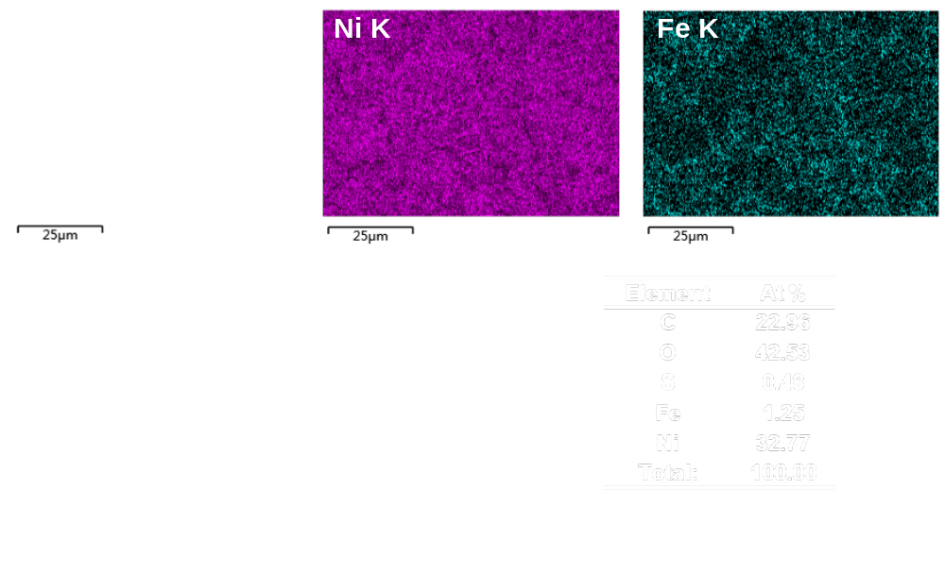
- SEM-EDX elemental mapping analysis of NiFe LDH. a SEM image of NiFe LDH and corresponding EDX elemental mappings of Ni and Fe, b EDX analysis of NiFe LDH. Inset of b corresponds to the atomic ratio.

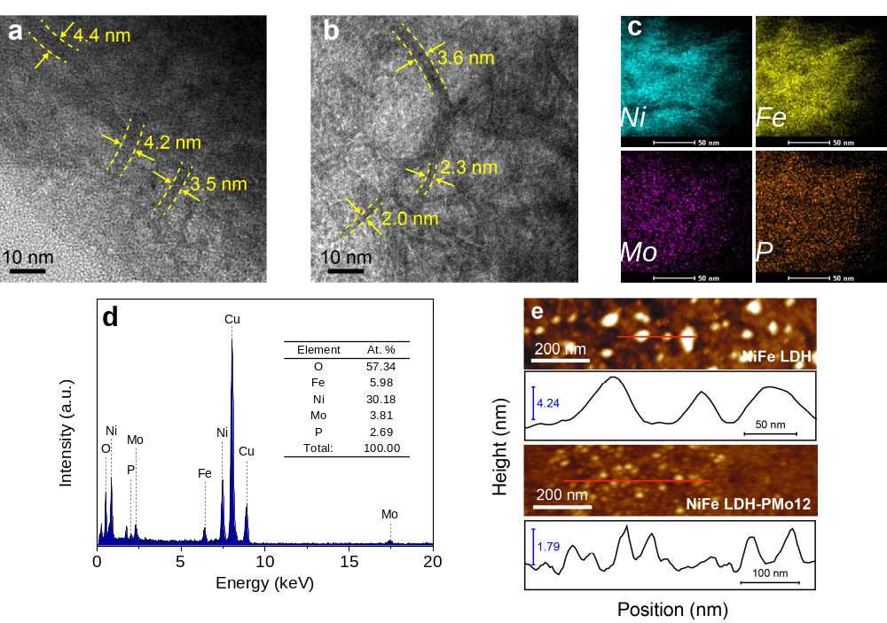
- a-b TEM images of NiFe LDH and NiFe LDH-PMo12, c Elemental distribution maps of Ni, Fe, Mo and P in the NiFe LDH-PMo12, d EDX of NiFe LDH-PMo12, inset corresponds to the atomic ratio. e AFM images of NiFe LDH and NiFe LDH-PMo12 and corresponding height profiles.

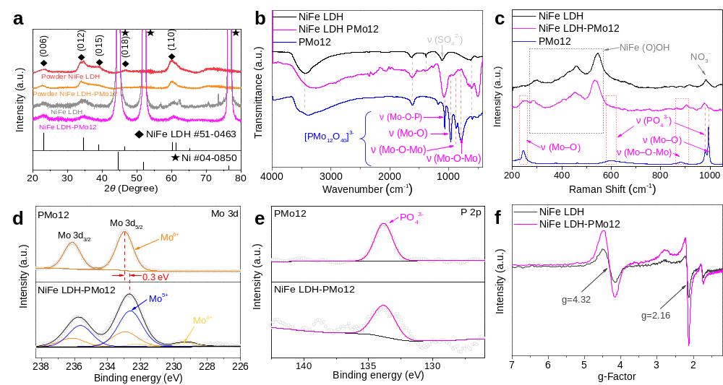
- a XRD pattern of powder-form NiFe LDH and powder-form NiFe LDH-PMo12, b FTIR spectra and c Raman spectra of NiFe LDH, NiFe LDH-PMo12 and pure PMo12, d High-resolution Mo 3d XPS spectra of PMo12 and NiFe LDH-PMo12, e High-resolution P 2p XPS spectra of pure PMo12 and NiFe LDH-PMo12, f EPR spectra of Fe³⁺ for NiFe LDH and NiFe LDH-PMo12.
In Supplementary Fig. 4b, the bands at around 618 cm⁻¹ are related to the metal-oxygen-metal lattice vibrations of the layer cations of NiFe LDH⁸. The stretching modes of the hydroxyl groups and the bending modes of free water molecules are also observed, which are located at 3400-3600 and 1635 cm⁻¹, respectively^{9, 10}. The antisymmetric stretching vibration peak of interlayered nitrate anions located at 1385 cm⁻¹ almost disappeared after etching, which might be attributed to less residue nitrate anions and the thickness of the NiFe LDH nanosheets are reduced to be few atomic layers^{8, 11}. Two new peaks located at 963 and 802 cm⁻¹ which related to the vibration of Mo-O-Mo along with a broad bands at around 1080 cm⁻¹ which related to the vibrations of SO₄²⁻ and PO₄³⁻ are observed in NiFe LDH-PMo12¹²⁻¹⁴. Three main Raman peaks located at 298, 455 and 542 cm⁻¹ can be assigned to the Ni and Fe (oxy)hydroxide species^{9, 15} (Supplementary Fig. 4c). The Raman results also show that with POMs or common inorganic acids etching, the peaks located at 457 and 544 cm⁻¹ become lower and wider. It reveals that the nanosheets are disordered and exfoliated into few layers, and more structural defects are created. The decreased intensity of the peak located at 986 cm⁻¹ shows the amount of the related interlayered anions (e. g. NO₃⁻, SO₄²⁻) are decreased. Instead, the new PMo12 species can be readily observed (Supplementary Fig. 4c), confirming the reduction of nanosheets thickness and existence of ion-exchanged PMo12 polyanionic clusters. The Mo 3d spectrum (Supplementary Fig. 4d) suggested that only Mo⁶⁺ (232.97 eV of Mo 3d_{5/2} and 236.14 eV of Mo 3d_{3/2}) can be identified in pure PMo12^{16, 17}. The deconvoluted Mo 3d spectra of NiFe LDH-PMo12 illustrated that the existence of mixed valence states of Mo ions, i.e., valence states of Mo⁵⁺ (232.58 eV of Mo 3d_{5/2} and 235.58 eV of Mo 3d_{3/2}) and Mo⁴⁺ (229.28 eV of Mo 3d_{5/2} and 232.18 eV of Mo 3d_{3/2}).

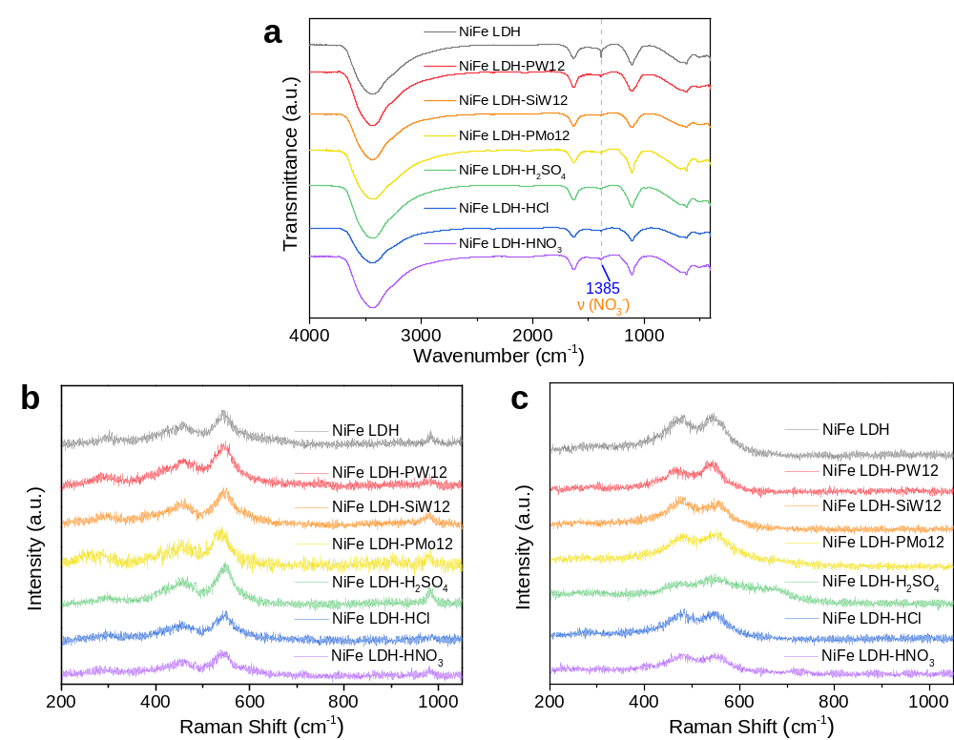
- a FTIR spectra and b-c Raman spectra of NiFe LDH and samples treated by different acids (NiFe LDH-X are abbreviated as X, X represents different acids), b and c before and after OER stability test.

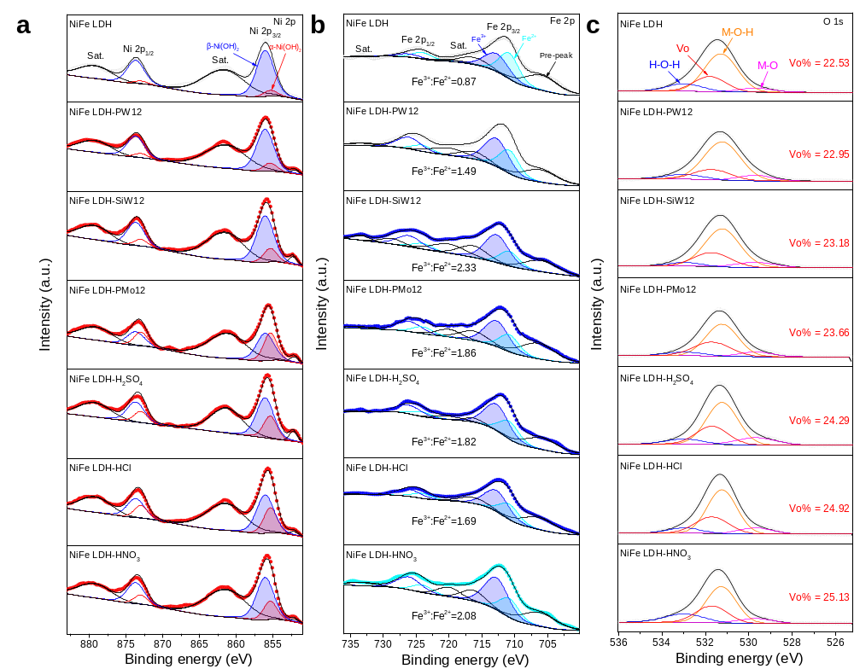
- High-resolution XPS spectra of NiFe LDH and samples treated by different acids. a Ni 2p, b Fe 2p and c O 1s. As for the Ni 2p spectra of NiFe LDH and NiFe LDH-PMo12 (Supplementary Fig. 6a), the binding energies at 855.40 and 856.10 eV are attributed to Ni 2p_{3/2} of α-Ni(OH)₂ and β-Ni(OH)₂, respectively, along with their shakeup satellite peaks at 861.74 eV^{18, 19}. The binding energies at 873.00 and 873.70 eV are assigned to Ni 2p_{1/2} of α-Ni(OH)₂ and β-Ni(OH)₂, respectively, along with their shakeup satellite peaks at 879.29 eV^{18, 19}. The additional Ni 2p peak at 852.28 eV can be assigned to the Ni⁰ oxidation state originated from NF substrates. Supplementary Fig. 6b shows that the Fe 2p_{3/2} peaks at 710.86 and 712.80 eV with shakeup satellite peaks at 716.35 and720.04 eV confirm the presence of the Fe²⁺ and Fe³⁺ oxidation states, respectively^{9, 20}.
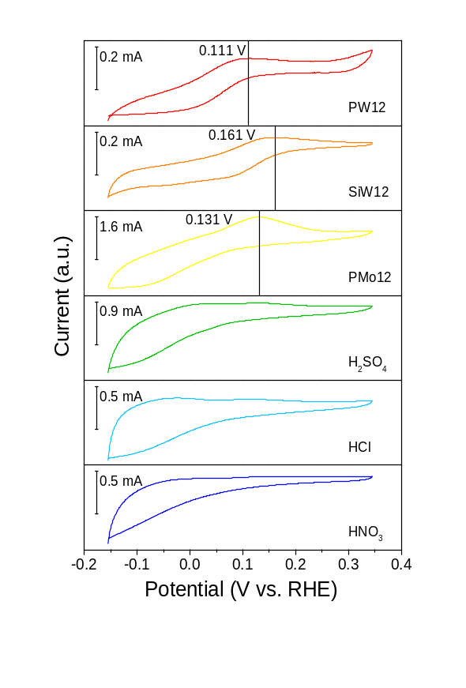
- a CV curves of different acids (PW12, SiW12, PMo12, H₂SO₄, HCl, HNO₃) recorded between - 0.155 V and 0.345 V vs. RHE at a scan rate of 5 mV s⁻¹, and the pH value of each solution is adjusted to 2.5.

- a Normalized Ni K-edge XANES spectra of NiFe LDH, NiFe LDH-PMo12 and reference samples (NiO, commercial Ni foil, and Ni(OH)₂). d The corresponding k²-weighted FT profiles in R-space from EXAFS at Ni K-edge. c Normalized Fe K-edge XANES spectra of NiFe LDH, NiFe LDH-PMo12 and reference samples (commercial Fe foil, Fe₂O₃, FeO and Fe(OH)₃). d The corresponding k²-weighted FT profiles in R-space from EXAFS at Fe K-edge. e Mo K‐edge EXAFS oscillation function k² χ (k). f - j Full-range Wavelet Transform (WT) representation of the EXAFS signal for NiFe LDH-PMo12 and reference samples (PMo12 acid, commercial Mo foil, FeMoO₄ and MoO₂) samples, respectively.

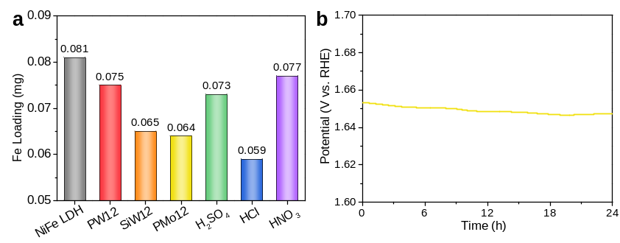
- a ICP-OES results of the loading amounts of Fe cation on NiFe LDH and samples treated by different acids (NiFe LDH-X are abbreviated as X, X represents different acids). b Chronopotentiometric measurements of NiFe LDH-PMo12 perform OER at the current densitie of 500 mA cm² for 24 h, without iR compensation.

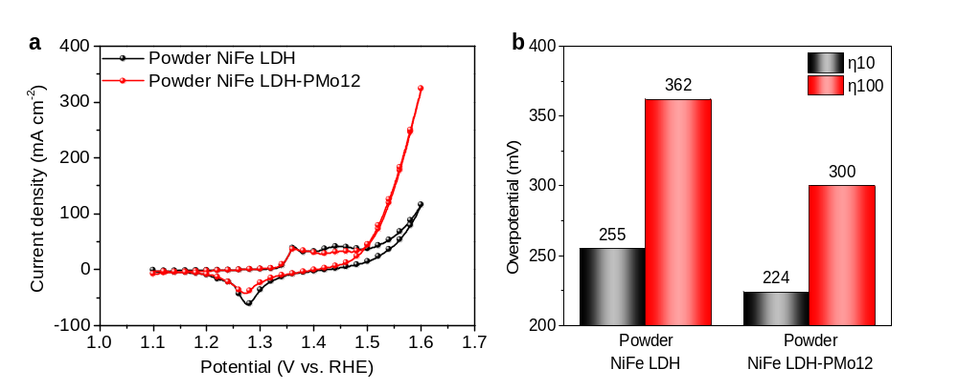
- a CV curves tested in 1 M KOH at a scan rate of 5 mV·s⁻¹. b The overpotentials required for J = 10 and 100 mA cm⁻².

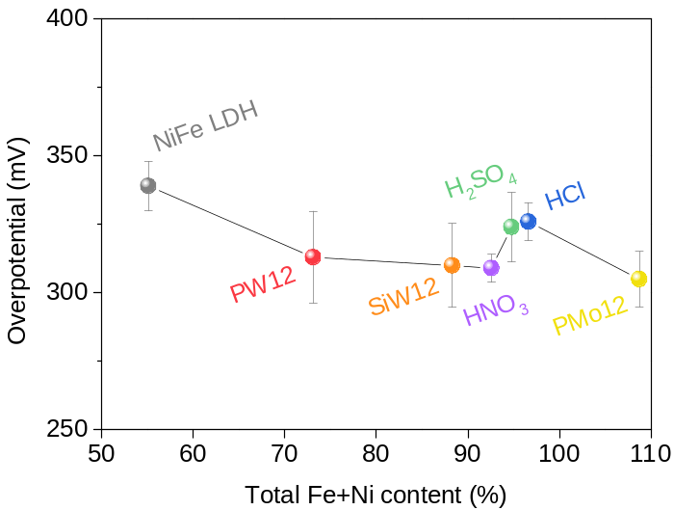
- Variation trend of overpotential (η₅₀₀) with total content of α-Ni(OH)₂ and Fe³⁺ (NiFe LDH-X are abbreviated as X, X represents different acids).

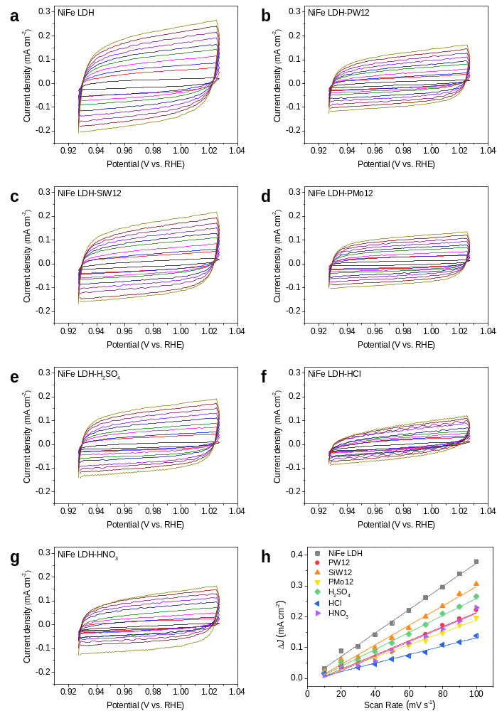
- Typical CV at different scan rates. a NiFe LDH, b NiFe LDH-PW12, c NiFe LDH-SiW12, d NiFe LDH-PMo12, e NiFe LDH-H₂SO₄, f NiFe LDH-HCl, g NiFe LDH-HNO₃ with scan rates ranging from 10 to 100 mV·s⁻¹ with an interval of 10 mV·s⁻¹, h Capacitive currents as a function of scan rates.

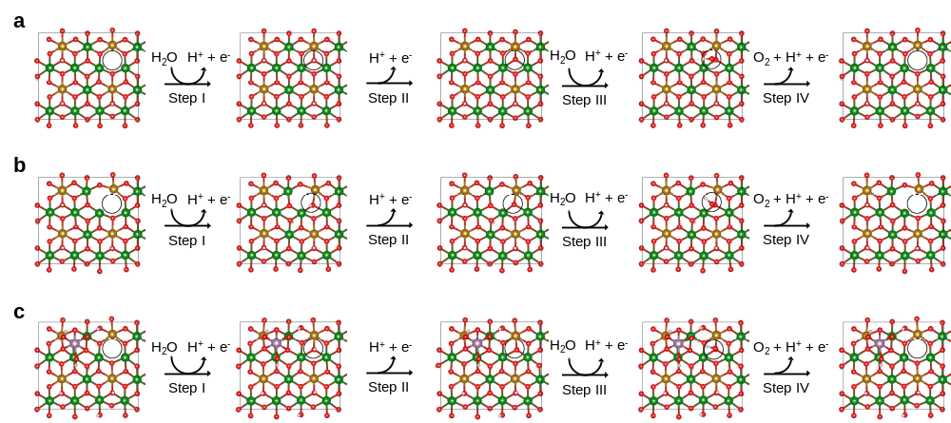
- Primitive steps of the OER process on the (001) surface of a NiFe LDH, b NiFe LDH + Vo, c NiFe LDH + MoO₄²⁻. The Roman numerals represent (I) adsorption step, (II and III) dissociation steps, and (IV) desorption step during the OER process. Brown: Fe; green: Ni; violet: Mo; red: O; pink: H.

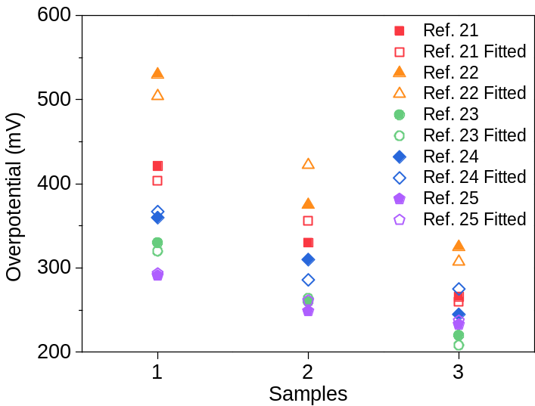
- Plot of the reported and fitted overpotential of the samples in the literature (Ref. 21-25) according to the SICCAS equation.

Supplementary Tables

Supplementary Table 1. ICP-OES analysis data for the loading amounts of metals of the as-prepared NiFe LDH and NiFe LDH-X (X = PW12, SiW12, PMo12, H₂SO₄, HCl, HNO₃).
Samples | Loading amount of metals (mg cm⁻²)
Samples | Fe | W | Mo
NiFe LDH | 0.081 | -- | --
NiFe LDH-PW12 | 0.075 | < 0.005 | --
NiFe LDH-SiW12 | 0.065 | < 0.005 | --
NiFe LDH-PMo12 | 0.064 | -- | < 0.005
NiFe LDH-H₂SO₄ | 0.073 | -- | --
NiFe LDH-HCl | 0.059 | -- | --
NiFe LDH-HNO₃ | 0.077 | -- | --

Supplementary Table 2. ICP-OES analysis data for the metal element contents of the as-prepared powder NiFe LDH-PMo12.
 | Ni | Fe | Mo | P
Concentration (mg L⁻¹) | 141.15 | 19.43 | 112.15 | 5.88
Wt. % | 50.66 | 6.97 | 40.25 | 2.11
At. % | 58.49 | 8.46 | 28.43 | 4.62

Supplementary Table 3. Comparison of OER performance for the NiFe LDH-PMo12 catalyst in the work with other recently reported electrocatalysts in 1 M alkaline electrolytes (KOH). η₁₀, η₁₀₀ correspond to the overpotentials at current densities of 10 and 100 mA·cm⁻², respectively.
Catalysts | η₁₀  (mV) | η₁₀₀  (mV) | Tafel Slope  (mV dec⁻¹) | Substrate | Ref. | Year
NiFe LDH-PMo12 | 206 | 249 | 47.5 | NF | The Work
Ni@NiFe LDH | 218 | 269 | 66.3 | NF¹ | 26 | 2019
w-Ni(OH)₂ | 237 | -- | 33 | GC² | 27 | 2019
O₂-Cat-1 | 269 | -- | 48.3 | Iron plate | 28 | 2018
Ni-Fe NP | 210 | 270 | 53 | NF | 29 | 2019
Ru/CoFe-LDHs | 198 | -- | 39 | CFP³ | 30 | 2019
Ni₃Fe_{0.5}V_{0.5} | 200 | 264 | 39 | CFP | 31 | 2018
NiFe LDH@NiCoP/NF | 220 | -- | 48.6 | NF | 32 | 2018
Ni₅P₄/NiP₂/NiFe LDH | 197 | 243 | 46.6 | NF | 33 | 2018
NF@Ni/C | 265 | 470 | 54 | NF | 34 | 2018
NiCo₂P₂/GQD NSs | 340 | 400 | 65.9 | Ti mesh | 35 | 2018
Cu@CoFe LDH | 240 | 300 | 44.4 | Cu foam | 36 | 2017
NiFe LDH NS@DG10 | 210 | -- | 52 | GC | 37 | 2017
Co_{0.85}Se/NiFe LDH/EG | -- | 260* | 57 | GF⁴ | 9 | 2016
NiFeMn LDH | 270 | -- | 47 | CFP | 38 | 2016
MoFe:Ni(OH)₂/NiOOH | 240 | 295* | 47 | NF | 39 | 2018
Cu@NiFe LDH | 199 | 281 | 27.8 | Cu foam | 40 | 2017
NiFeRu LDH/Ni foam | 225 | 265* | 32.4 | NF | 41 | 2018
NiFe-Pt LDH | 230 | 310* | 33 | CC⁵ | 42 | 2017
Exfoliated NiFe LDH | 302 | -- | 40 | GC | 43 | 2014
NiFe LDH/CNT | 247 | -- | 31 | CFP | 44 | 2013
Note: * The value is roughly calculated from the curves shown in the corresponding literature.
¹ Nickel foam, ² Glassy carbon, ³ Carbon fiber paper, ⁴ Graphite foil, ⁵ Carbon cloth.

Supplementary Table 4. Details of Gibbs free energy change during OER process.
Models | ΔG₁  (* to *OH) | ΔG₂  (*OH to *O) | ΔG₃  (*O to *OOH) | ΔG₄  (*OOH to *) | η  (V)
NiFe LDH | 0.80 | 2.02 | 1.37 | 0.73 | 0.79
NiFe LDH + Vo | 0.21 | 1.50 | 1.91 | 1.30 | 0.68
NiFe LDH + MoO₄²⁻ | 0.73 | 1.74 | 1.70 | 0.75 | 0.51
NiFe LDH-PMo12 | 0.39 | 1.45 | 1.57 | 1.51 | 0.34

Supplementary Table 5. Details of adsorption free energy of OH, O and OOH during OER process.
Models | ΔG_{OH} | ΔG_{O} | ΔG_{OOH}
NiFe LDH | 0.80 | 2.82 | 4.19
NiFe LDH + Vo | 0.21 | 1.71 | 3.62
NiFe LDH + MoO₄²⁻ | 0.73 | 2.47 | 4.17
NiFe LDH-PMo12 | 0.39 | 1.84 | 3.41

Supplementary Table 6. Corresponding values of Fe³⁺, α-Ni(OH)₂, Vo, Tafel Slope, R_{ct}, C_{dl} and η₅₀₀,in the radar map in main text.
Values | NiFe LDH | PW12 | SiW12 | PMo12 | H₂SO₄ | HCl | HNO₃
Fe³⁺ (%) | 46.52 | 59.84 | 69.97 | 65.03 | 64.54 | 62.83 | 67.53
α-Ni(OH)₂ (%) | 8.59 | 13.27 | 18.30 | 43.66 | 30.22 | 33.77 | 25.04
Vo (%) | 22.53 | 22.95 | 23.18 | 23.66 | 24.29 | 24.92 | 25.13
η₅₀₀ (mV) | 339.00 | 313.00 | 310.00 | 305.00 | 324.00 | 326.00 | 309.00
C_{dl} (mF cm⁻²) | 1.90 | 1.15 | 1.58 | 1.01 | 1.38 | 0.69 | 1.16
R_{ct} (Ω) | 1.70 | 0.43 | 0.41 | 0.35 | 0.31 | 0.36 | 0.48
Tafel Slope (mV dec⁻¹) | 57.60 | 48.60 | 51.50 | 47.50 | 52.90 | 52.60 | 47.80

Supplementary Table 7. Calculated TOF values.
Samples | I@η = 350 mV | n_{Fe} (mol) | Fe³⁺ (%) | n_{Fe3+} (mol) | TOF_{Fe} (s⁻¹) | TOF_{Fe3+} (s⁻¹) | α-Ni(OH)₂ (%) | n_{α-Ni(OH)2} (mol) | TOF_{α-Ni(OH)2} (s⁻¹) | TOF_{Fe3+/α-Ni(OH)2} (s⁻¹)
NiFe LDH | 0.55542 | 1.45E-06 | 0.46524 | 6.75E-07 | 0.99 | 2.13276 | 0.08592 | 6.23E-07 | 2.30961 | 0.92343
PW12 | 0.75777 | 1.34E-06 | 0.59839 | 8.04E-07 | 1.46 | 2.44325 | 0.1327 | 8.91E-07 | 2.20355 | 1.10878
SiW12 | 0.79087 | 1.16E-06 | 0.6997 | 8.14E-07 | 1.76 | 2.51629 | 0.18301 | 1.07E-06 | 1.92413 | 1.30775
PMo12 | 0.89795 | 1.15E-06 | 0.65035 | 7.45E-07 | 2.03 | 3.12181 | 0.43662 | 2.50E-06 | 0.92999 | 3.35681
H₂SO₄ | 0.67042 | 1.31E-06 | 0.64539 | 8.44E-07 | 1.33 | 2.05912 | 0.30216 | 1.97E-06 | 0.87962 | 2.34094
HCl | 0.6486 | 1.06E-06 | 0.62825 | 6.64E-07 | 1.59 | 2.53206 | 0.33775 | 1.78E-06 | 0.94199 | 2.688
HNO₃ | 0.84833 | 1.38E-06 | 0.67532 | 9.31E-07 | 1.59 | 2.3607 | 0.25037 | 1.73E-06 | 1.27348 | 1.85374

Supplementary Table 8. Literature data used for trial and error of formulas.
Samples | Fe³⁺ (%) | α-Ni(OH)₂ (%) | k(aX_{Fe}+bX_{Ni})+c |  |  |  | Vo | η₁₀ in Ref. | η₁₀ Fitted | Ref.
Samples | Fe³⁺ (%) | α-Ni(OH)₂ (%) | k | a | b | c
1 | 0 | 0 | - 2.4 | 2 | 1 | 404 | -- | 421 | 404 | 25
2 | 10 | 0 |  |  |  |  | -- | 330 | 356 | 25
3 | 30 | 0 |  |  |  |  | -- | 266 | 260 | 25
1 | 0 | 100 | - 4.1 | 2 | 1 | 914.3 | -- | 530 | 504.3 | 22
2 | 10 | 100 |  |  |  |  | -- | 375 | 422.3 | 22
3 | 24 | 100 |  |  |  |  | -- | 325 | 307.5 | 22
1 | 0 | 100 | - 2.8 | 2 | 1 | 600 | -- | 330 | 320 | 23
2 | 10 | 100 |  |  |  |  | -- | 260 | 264 | 23
3 | 20 | 100 |  |  |  |  | -- | 220 | 208 | 23
1 | 0 | 100 | - 2.7 | 2 | 1 | 637 | -- | 360 | 367 | 24
2 | 15 | 100 |  |  |  |  | -- | 310 | 286 | 24
3 | 17 | 100 |  |  |  |  | -- | 245 | 275.2 | 24
1 | 0 | 100 | - 1 | 2 | 1 | 393.6 | -- | 291 | 293.6 | 21
2 | 16 | 100 |  |  |  |  | -- | 249 | 261.6 | 21
3 | 28 | 100 |  |  |  |  | -- | 233 | 237.6 | 21

References

1. Kresse G., Furthmüller J. Efficiency of ab-initio total energy calculations for metals and semiconductors using a plane-wave basis set. Computational materials science 6, 15-50 (1996).
2. Kresse G., Furthmüller J. Efficient iterative schemes for ab initio total-energy calculations using a plane-wave basis set. Physical review B 54, 11169 (1996).
3. Perdew J. P., Burke K., Ernzerhof M. Generalized gradient approximation made simple. Phys. Rev. Lett. 77, 3865 (1996).
4. Kresse G., Joubert D. From ultrasoft pseudopotentials to the projector augmented-wave method. Physical review b 59, 1758 (1999).
5. Blöchl P. E. Projector augmented-wave method. Physical review B 50, 17953 (1994).
6. Grimme S., Antony J., Ehrlich S., Krieg H. A consistent and accurate ab initio parametrization of density functional dispersion correction (DFT-D) for the 94 elements H-Pu. The Journal of chemical physics 132, 154104 (2010).
7. Dudarev S., Botton G., Savrasov S., Humphreys C., Sutton A. Electron-energy-loss spectra and the structural stability of nickel oxide: An LSDA + U study. Physical Review B 57, 1505 (1998).
8. Lv J. J., et al. Incorporating Nitrogen-Doped Graphene Quantum Dots and Ni₃S₂ Nanosheets: A Synergistic Electrocatalyst with Highly Enhanced Activity for Overall Water Splitting. Small 13, 1700264 (2017).
9. Hou Y., Lohe M. R., Zhang J., Liu S., Zhuang X., Feng X. Vertically oriented cobalt selenide/NiFe layered-double-hydroxide nanosheets supported on exfoliated graphene foil: an efficient 3D electrode for overall water splitting. Energy Environ. Sci. 9, 478-483 (2016).
10. Gunjakar J. L., et al. Two-Dimensional Layered Hydroxide Nanoporous Nanohybrids Pillared with Zero-Dimensional Polyoxovanadate Nanoclusters for Enhanced Water Oxidation Catalysis. Small 14, 1703481 (2018).
11. Ge X., Gu C., Yin Z., Wang X., Tu J., Li J. Periodic stacking of 2D charged sheets: Self-assembled superlattice of Ni-Al layered double hydroxide (LDH) and reduced graphene oxide. Nano Energy 20, 185-193 (2016).
12. Renuka C., Shinde A. B., Krishna P. S. R., Reddy C. N. Structural analysis of molybdo-zinc-phosphate glasses: Neutron scattering, FTIR, Raman scattering, MAS NMR studies. J. Mol. Struct. 1118, 83-90 (2016).
13. Rocchiccioli-Deltcheff C., Aouissi A., Bettahar M. M., Launay S., Fournier M. Catalysis by 12-Molybdophosphates : 1. Catalytic Reactivity of 12-Molybdophosphoric Acid Related to Its Thermal Behavior Investigated through IR, Raman, Polarographic, and X-ray Diffraction Studies: A Comparison with 12-Molybdosilicic Acid. J. Catal. 164, 16-27 (1996).
14. Song I. K., Barteau M. A. Redox properties of Keggin-type heteropolyacid (HPA) catalysts: effect of counter-cation, heteroatom, and polyatom substitution. Journal of Molecular Catalysis A Chemical 212, 229-236 (2004).
15. Qiu Z., Tai C. W., Niklasson G. A., Edvinsson T. Direct observation of active catalyst surface phases and the effect of dynamic self-optimization in NiFe-layered double hydroxides for alkaline water splitting. Energy Environ. Sci. 12, 572-581 (2019).
16. Ma R., Zhou Y., Chen Y., Li P., Liu Q., Wang J. Ultrafine Molybdenum Carbide Nanoparticles Composited with Carbon as a Highly Active Hydrogen-Evolution Electrocatalyst. Angew. Chem. Int. Ed. 54, 14723-14727 (2015).
17. Zhao Y., Kamiya K., Hashimoto K., Nakanishi S. In Situ CO2-Emission Assisted Synthesis of Molybdenum Carbonitride Nanomaterial as Hydrogen Evolution Electrocatalyst. J. Am. Chem. Soc. 137, 110-113 (2015).
18. Mansour A. N. Characterization of β‐Ni(OH)2 by XPS. Surf. Sci. Spectra 3, 239-246 (1994).
19. Mansour A. N., Melendres C. A. Characterization of α‐Ni(OH)2 by XPS. Surf. Sci. Spectra 3, 255-262 (1994).
20. Cai Z., et al. Introducing Fe²⁺ into Nickel-Iron Layered Double Hydroxide: Local Structure Modulated Water Oxidation Activity. Angew. Chem. 130, 9536-9540 (2018).
21. Hung S. F., et al. Unraveling Geometrical Site Confinement in Highly Efficient Iron-Doped Electrocatalysts toward Oxygen Evolution Reaction. Adv. Energy Mater. 8, 1701686 (2018).
22. Swierk J. R., Klaus S., Trotochaud L., Bell A. T., Tilley T. D. Electrochemical Study of the Energetics of the Oxygen Evolution Reaction at Nickel Iron (Oxy)Hydroxide Catalysts. J. Phys. Chem. C 119, 19022-19029 (2015).
23. Zhao D., Jiang K., Pi Y., Huang X. Superior Electrochemical Oxygen Evolution Enabled by Three-Dimensional Layered Double Hydroxide Nanosheet Superstructures. Chemcatchem 9, 84-88 (2017).
24. Zhou Q., et al. Active-Site-Enriched Iron-Doped Nickel/Cobalt Hydroxide Nanosheets for Enhanced Oxygen Evolution Reaction. ACS Catal. 8, 5382-5390 (2018).
25. Zhu K., et al. Atomic-scale topochemical preparation of crystalline Fe³⁺-doped β-Ni(OH)₂ for an ultrahigh-rate oxygen evolution reaction. J. Mater. Chem. A 5, 7753-7758 (2017).
26. Cai Z., et al. Simple and cost effective fabrication of 3D porous core-shell Ni nanochains@NiFe layered double hydroxide nanosheet bifunctional electrocatalysts for overall water splitting. J. Mater. Chem. A 7, 21722-21729 (2019).
27. Yan J., et al. Single atom tungsten doped ultrathin α-Ni(OH)₂ for enhanced electrocatalytic water oxidation. Nat. Commun. 10, 2149 (2019).
28. Liu Y., et al. Corrosion engineering towards efficient oxygen evolution electrodes with stable catalytic activity for over 6000 hours. Nat. Commun. 9, 2609 (2018).
29. Suryanto B. H. R., Wang Y., Hocking R. K., Adamson W., Zhao C. Overall electrochemical splitting of water at the heterogeneous interface of nickel and iron oxide. Nat. Commun. 10, 5599 (2019).
30. Li P. S., et al. Boosting oxygen evolution of single-atomic ruthenium through electronic coupling with cobalt-iron layered double hydroxides. Nat. Commun. 10, 1711 (2019).
31. Jiang J., et al. Atomic-level insight into super-efficient electrocatalytic oxygen evolution on iron and vanadium co-doped nickel (oxy)hydroxide. Nat. Commun. 9, 2885 (2018).
32. Zhang H., et al. Bifunctional Heterostructure Assembly of NiFe LDH Nanosheets on NiCoP Nanowires for Highly Efficient and Stable Overall Water Splitting. Adv. Funct. Mater. 28, 1706847 (2018).
33. Yu L., et al. Amorphous NiFe layered double hydroxide nanosheets decorated on 3D nickel phosphide nanoarrays: a hierarchical core-shell electrocatalyst for efficient oxygen evolution. J. Mater. Chem. A 6, 13619-13623 (2018).
34. Sun H., et al. A hierarchical nickel-carbon structure templated by metal-organic frameworks for efficient overall water splitting. Energy Environ. Sci. 11, 2363-2371 (2018).
35. Tian J., Chen J., Liu J., Tian Q., Chen P. Graphene quantum dot engineered nickel-cobalt phosphide as highly efficient bifunctional catalyst for overall water splitting. Nano Energy 48, 284-291 (2018).
36. Yu L., et al. Hierarchical Cu@CoFe layered double hydroxide core-shell nanoarchitectures as bifunctional electrocatalysts for efficient overall water splitting. Nano Energy 41, 327-336 (2017).
37. Jia Y., et al. A Heterostructure Coupling of Exfoliated Ni-Fe Hydroxide Nanosheet and Defective Graphene as a Bifunctional Electrocatalyst for Overall Water Splitting. Adv. Mater. 29, 1700017 (2017).
38. Lu Z., Qian L., Tian Y., Li Y., Sun X., Duan X. Ternary NiFeMn layered double hydroxides as highly-efficient oxygen evolution catalysts. Chem. Commun. 52, 908-911 (2016).
39. Jin Y., Huang S., Yue X., Du H., Shen P. K. Mo- and Fe-Modified Ni(OH)₂/NiOOH Nanosheets as Highly Active and Stable Electrocatalysts for Oxygen Evolution Reaction. ACS Catal. 8, 2359-2363 (2018).
40. Yu L., et al. Cu nanowires shelled with NiFe layered double hydroxide nanosheets as bifunctional electrocatalysts for overall water splitting. Energy Environ. Sci. 10, 1820-1827 (2017).
41. Chen G., et al. Accelerated Hydrogen Evolution Kinetics on NiFe-Layered Double Hydroxide Electrocatalysts by Tailoring Water Dissociation Active Sites. Adv. Mater. 30, 1706279 (2018).
42. Anantharaj S., et al. Enhancing electrocatalytic total water splitting at few layer Pt-NiFe layered double hydroxide interfaces. Nano Energy 39, 30-43 (2017).
43. Song F., Hu X. Exfoliation of layered double hydroxides for enhanced oxygen evolution catalysis. Nat. Commun. 5, 4477 (2014).
44. Gong M., et al. An Advanced Ni-Fe Layered Double Hydroxide Electrocatalyst for Water Oxidation. J. Am. Chem. Soc. 135, 8452-8455 (2013).

