Supporting Information for
Global health risk assessment of antibiotic resistance in agricultural soils
Zekai Li¹, Sean Fettrow², Thomas Borch², Miao Han¹, Antti Karkman³, Xiaojie Hu¹, Jian Wang¹, Hefei Wang¹, Chao Qin^{1,}*, Jianhua Guo^{4,}* and Yanzheng Gao^{1,}*
¹Institute of Organic Contaminant Control and Soil Remediation, College of Resources and Environmental Sciences, Nanjing Agricultural University, Nanjing 210095, P.R. China.
²Department of Soil and Crop Sciences and Department of Chemistry, Colorado State University, 1170 Campus Delivery, Fort Collins, Colorado 80523, United States
³Department of Microbiology, University of Helsinki, Helsinki 00790, Finland.
⁴Australian Centre for Water and Environmental Biotechnology (ACWEB), The University of Queensland, St. Lucia, Queensland 4072, Australia.

*Corresponding author: Chao Qin, Dr/Associate Professor; Jianhua Guo, Professor; Yanzheng Gao, Professor.
Address: Weigang Road 1, Nanjing 210095, China; St Lucia QLD 4072, Australia.
ORCID No.: 0000-0002-6732-5884; 0000-0002-4732-9175; 0000-0002-3814-3555.
Tel: +86-15996210615; +61-7-33463222; +86-025-84395019.
E-mail: qinchao@njau.edu.cn; jianhua.guo@uq.edu.au; gaoyanzheng@njau.edu.cn.
Submitted to Nature Microbiology
Contents
- Supplemental Figures
- Supplemental Tables
7 pages, 12 figures, 10 tables (Attached excel)

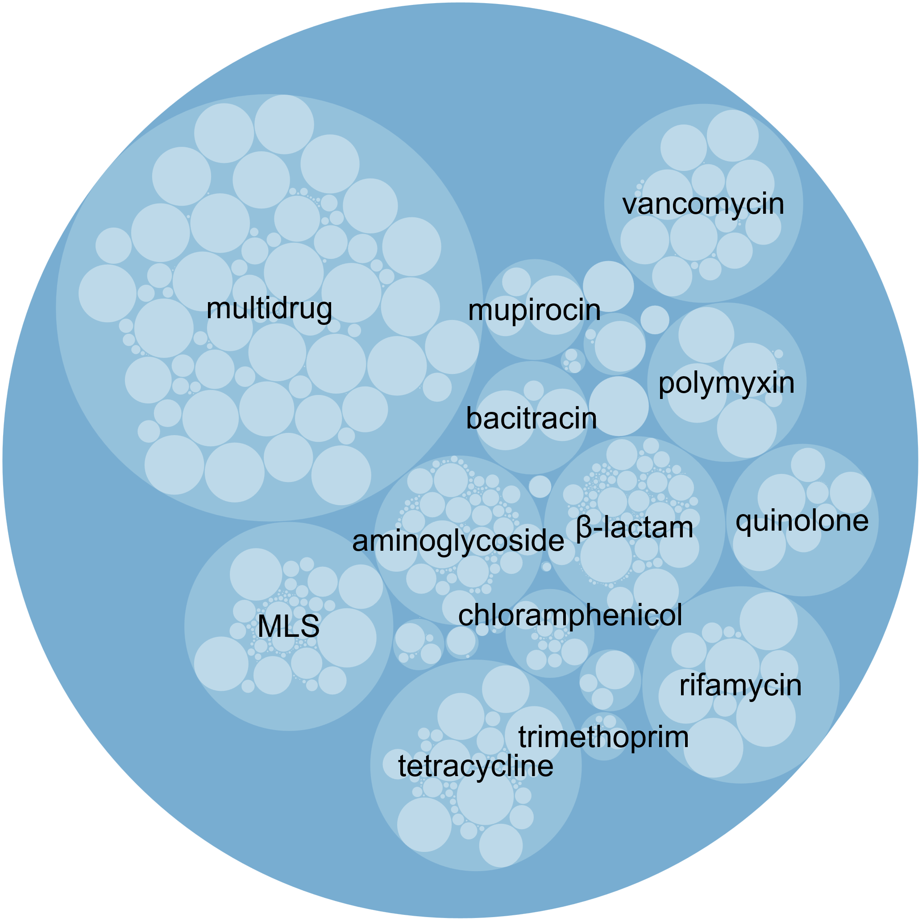
Supplementary Fig. 1 Composition of soil ARGs. The outer and inner circles represent ARG types and subtypes, respectively. The size of the circles represents the detection count of ARGs in the samples.

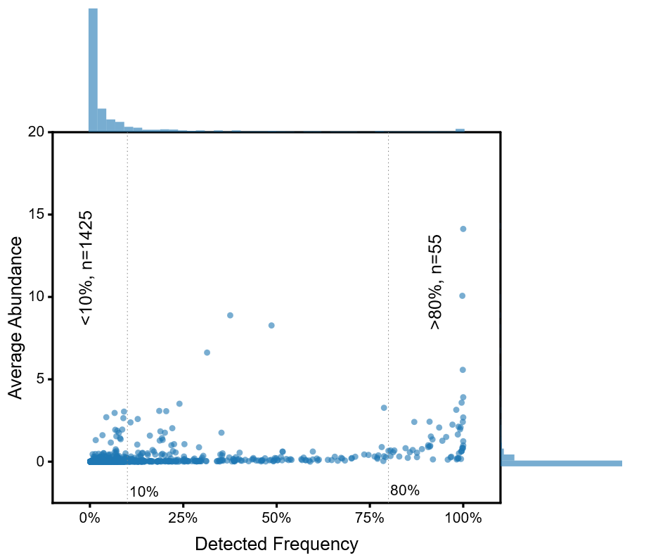
Supplementary Fig. 2 Detected frequency and average abundance of ARGs subtypes (n=1745) detected in all samples. The upper and right blue bars represent the distribution of detected frequency and average abundance, respectively. Most ARGs (1425/1745) are detected in less than 10% of samples.

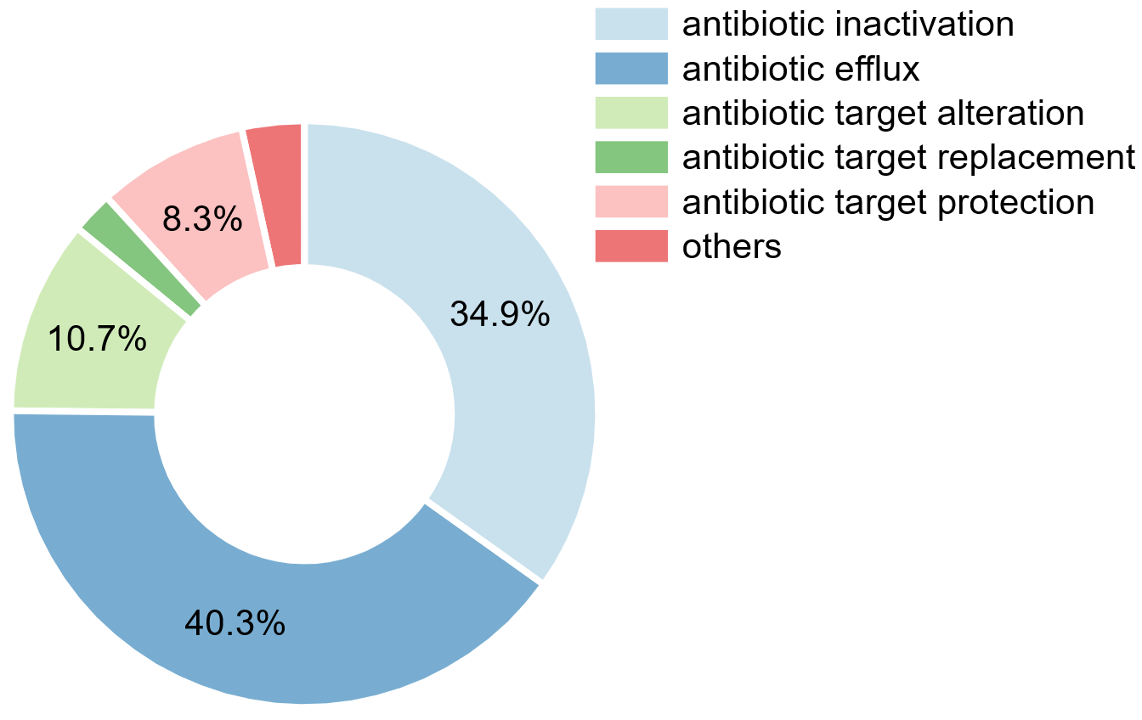

Supplementary Fig. 3 Compositions of ARGs resistance mechanisms. Antibiotic inactivation and antibiotic efflux are the main resistance mechanisms in all agricultural soils.
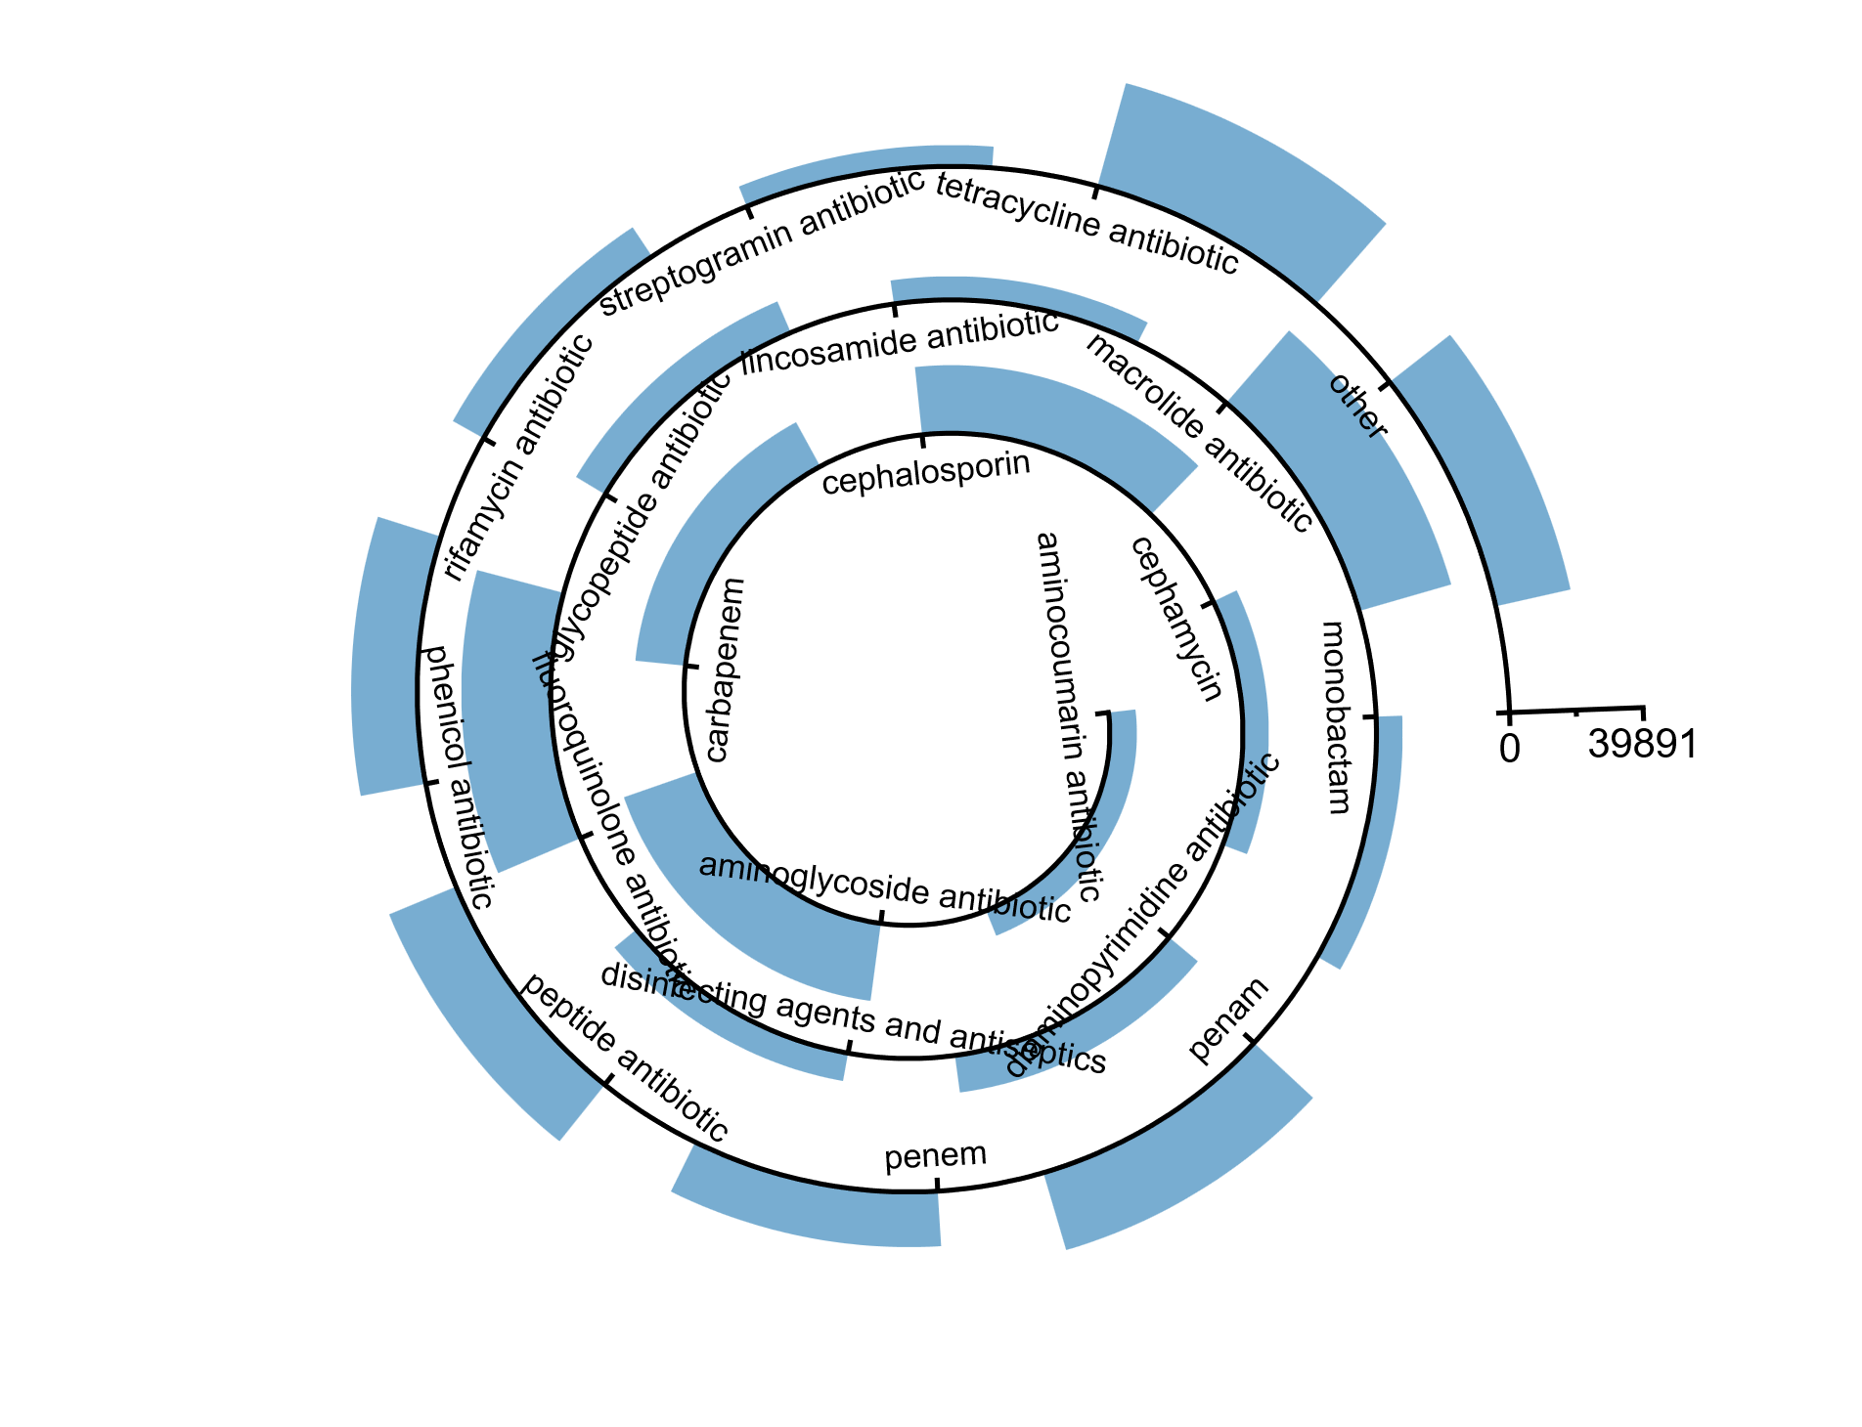
Supplementary Fig. 4 Compositions of ARGs resistance drug class (n=20). More than half of the ARGs (1128/1745) developed resistance to 1 drug class, whereas an additional 617 ARGs developed resistance to up to 2~16 drug classes.

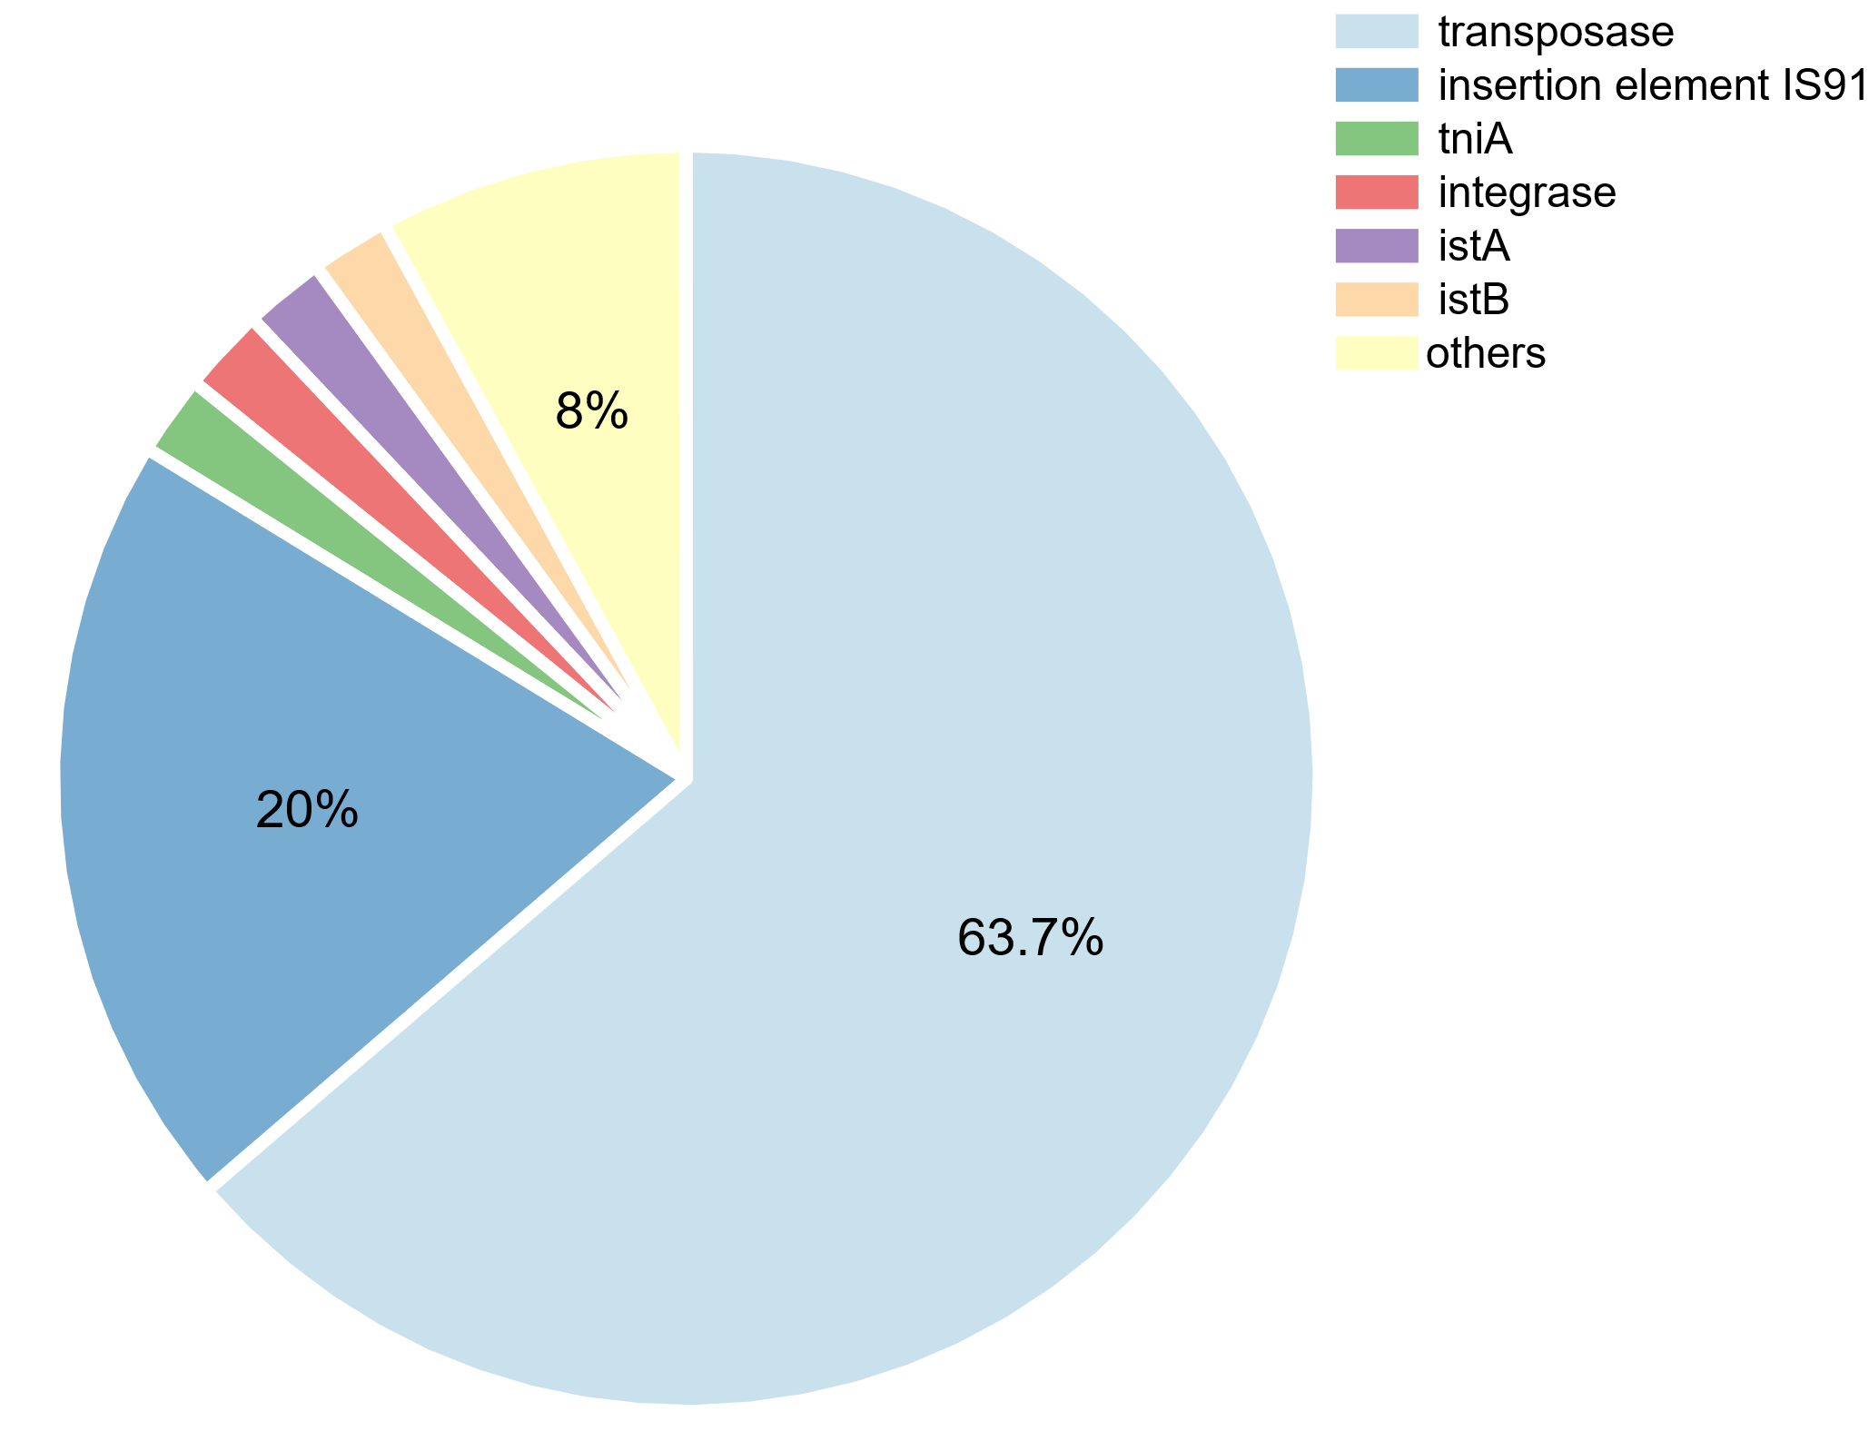
Supplementary Fig. 5 Compositions of MGEs detected in this study. Transposase and IS91 accounted for 63.7% and 20% of the total detected count, respectively.

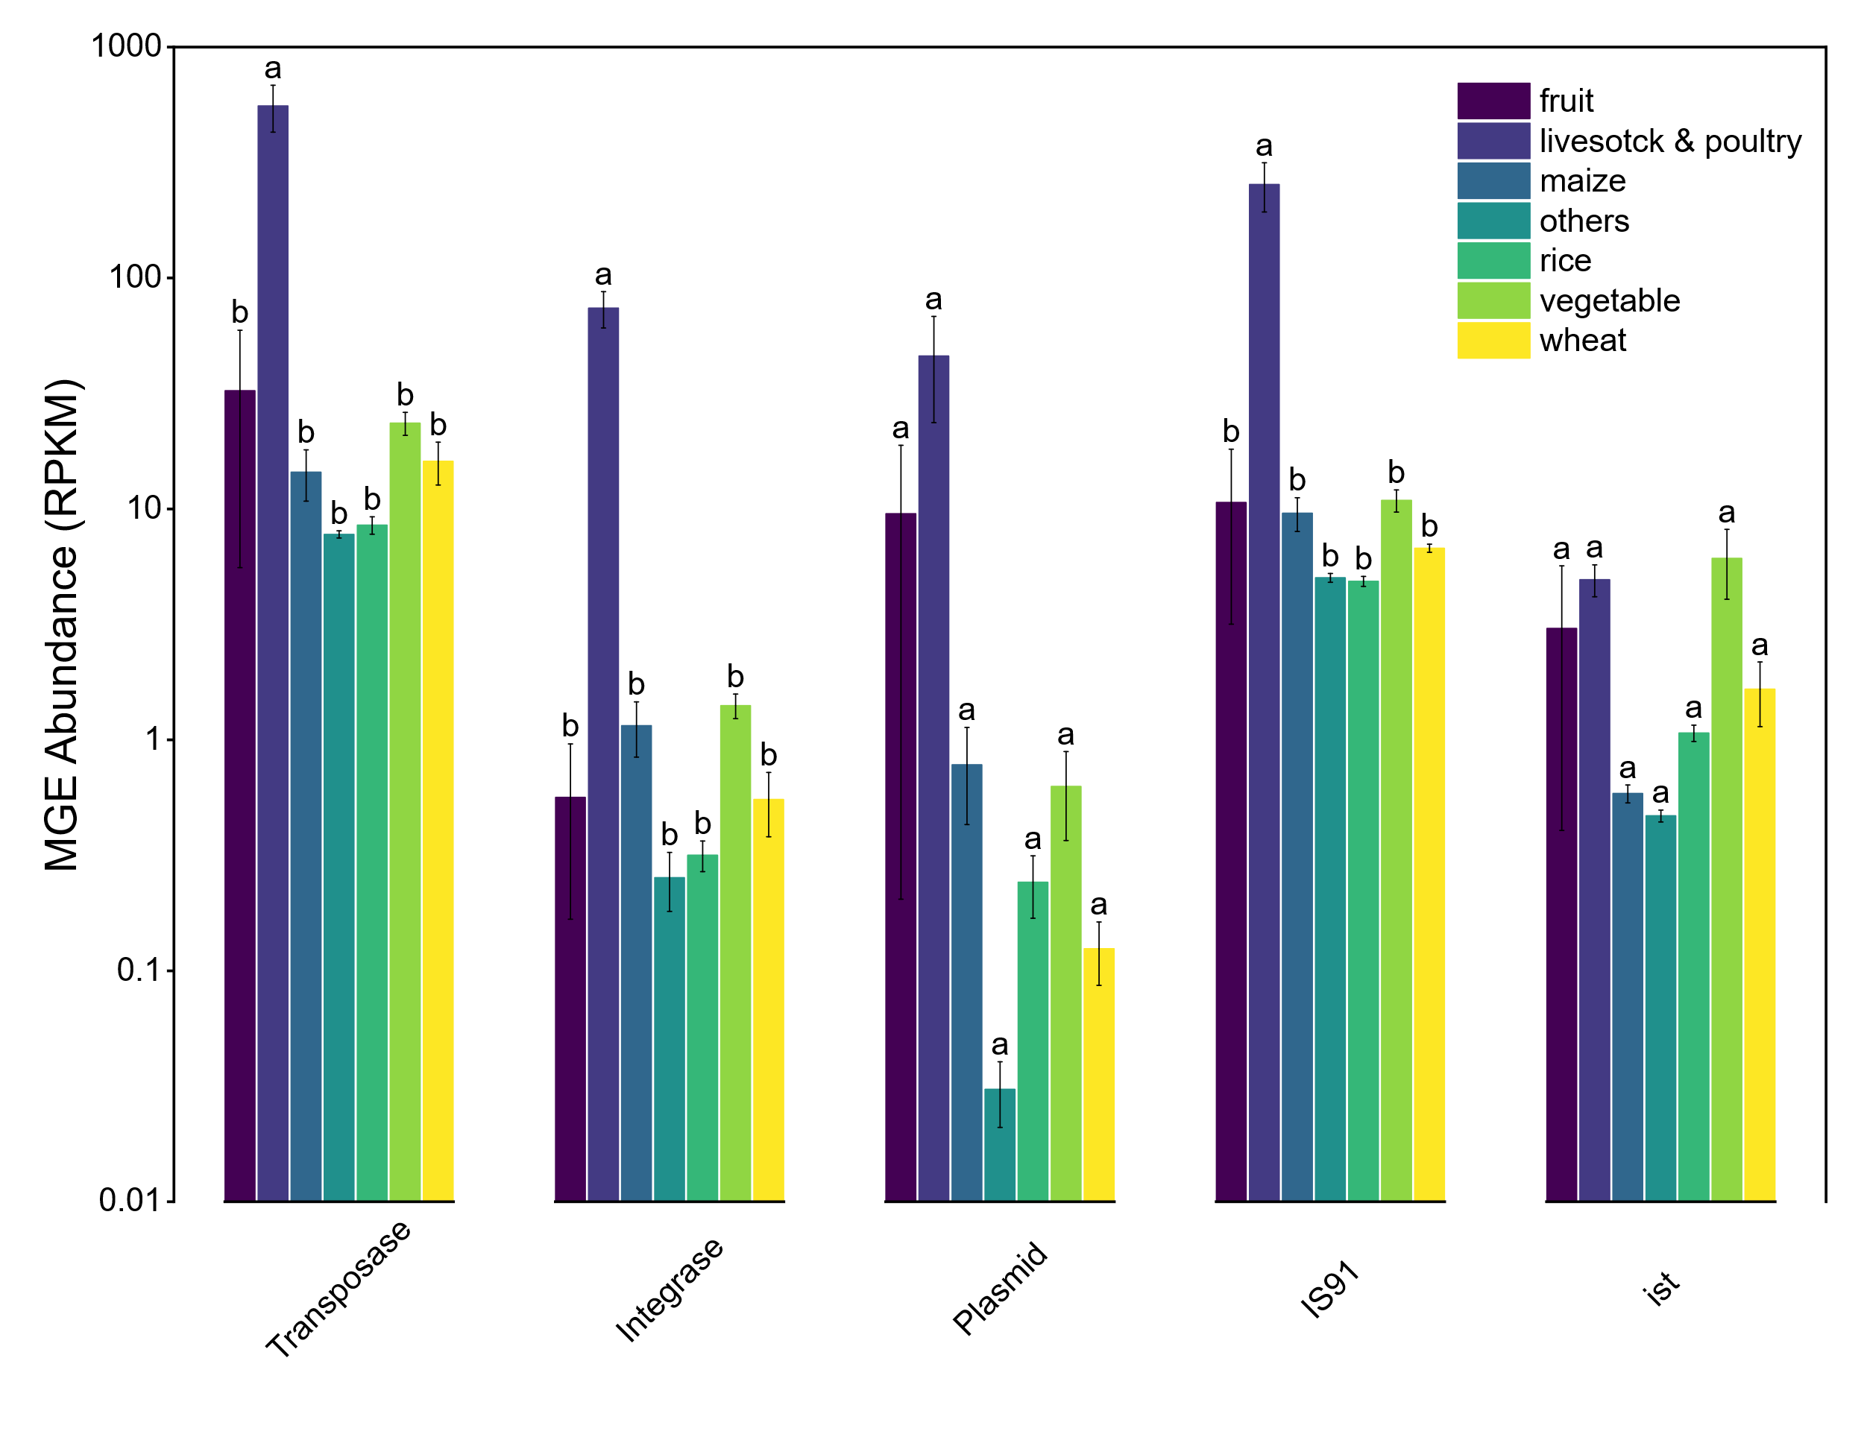
Supplementary Fig. 6 Abundance and comparison of MGEs in different soil types. Lowercase letters above the bars indicate significant differences among groups (Tukey’s HSD test, p < 0.05).
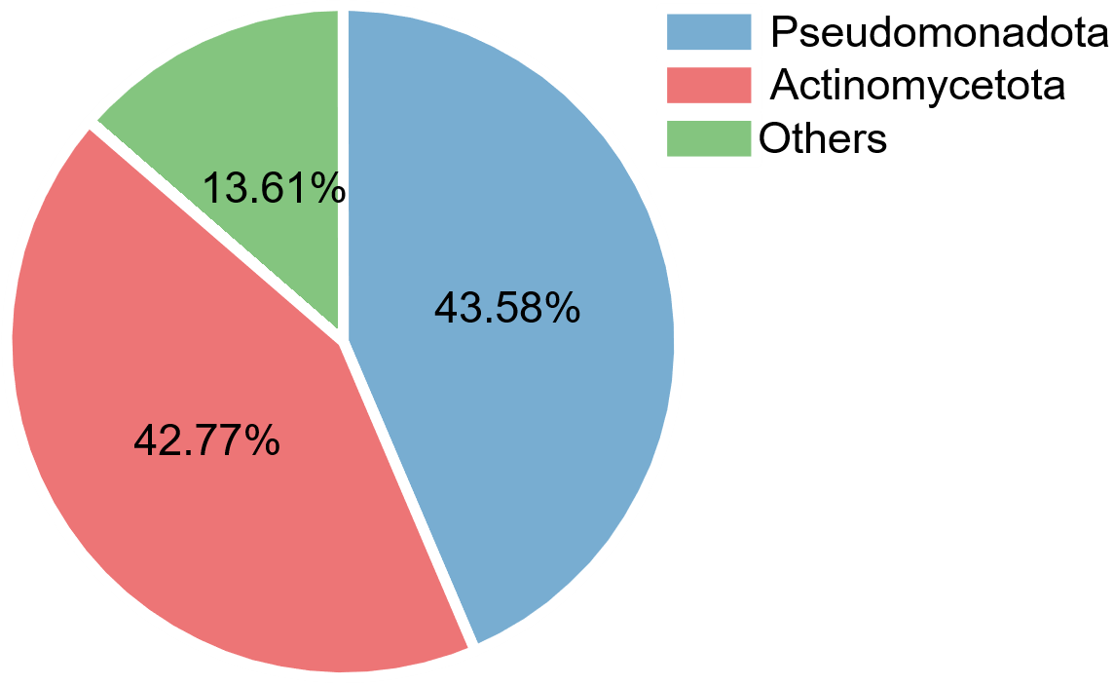
Supplementary Fig. 7 Compositions of Microorganisms in Phylum level detected in this study. Pseudomonadota and Actinomycetota account for 43.58% and 42.77% of the total microbial population respectively.

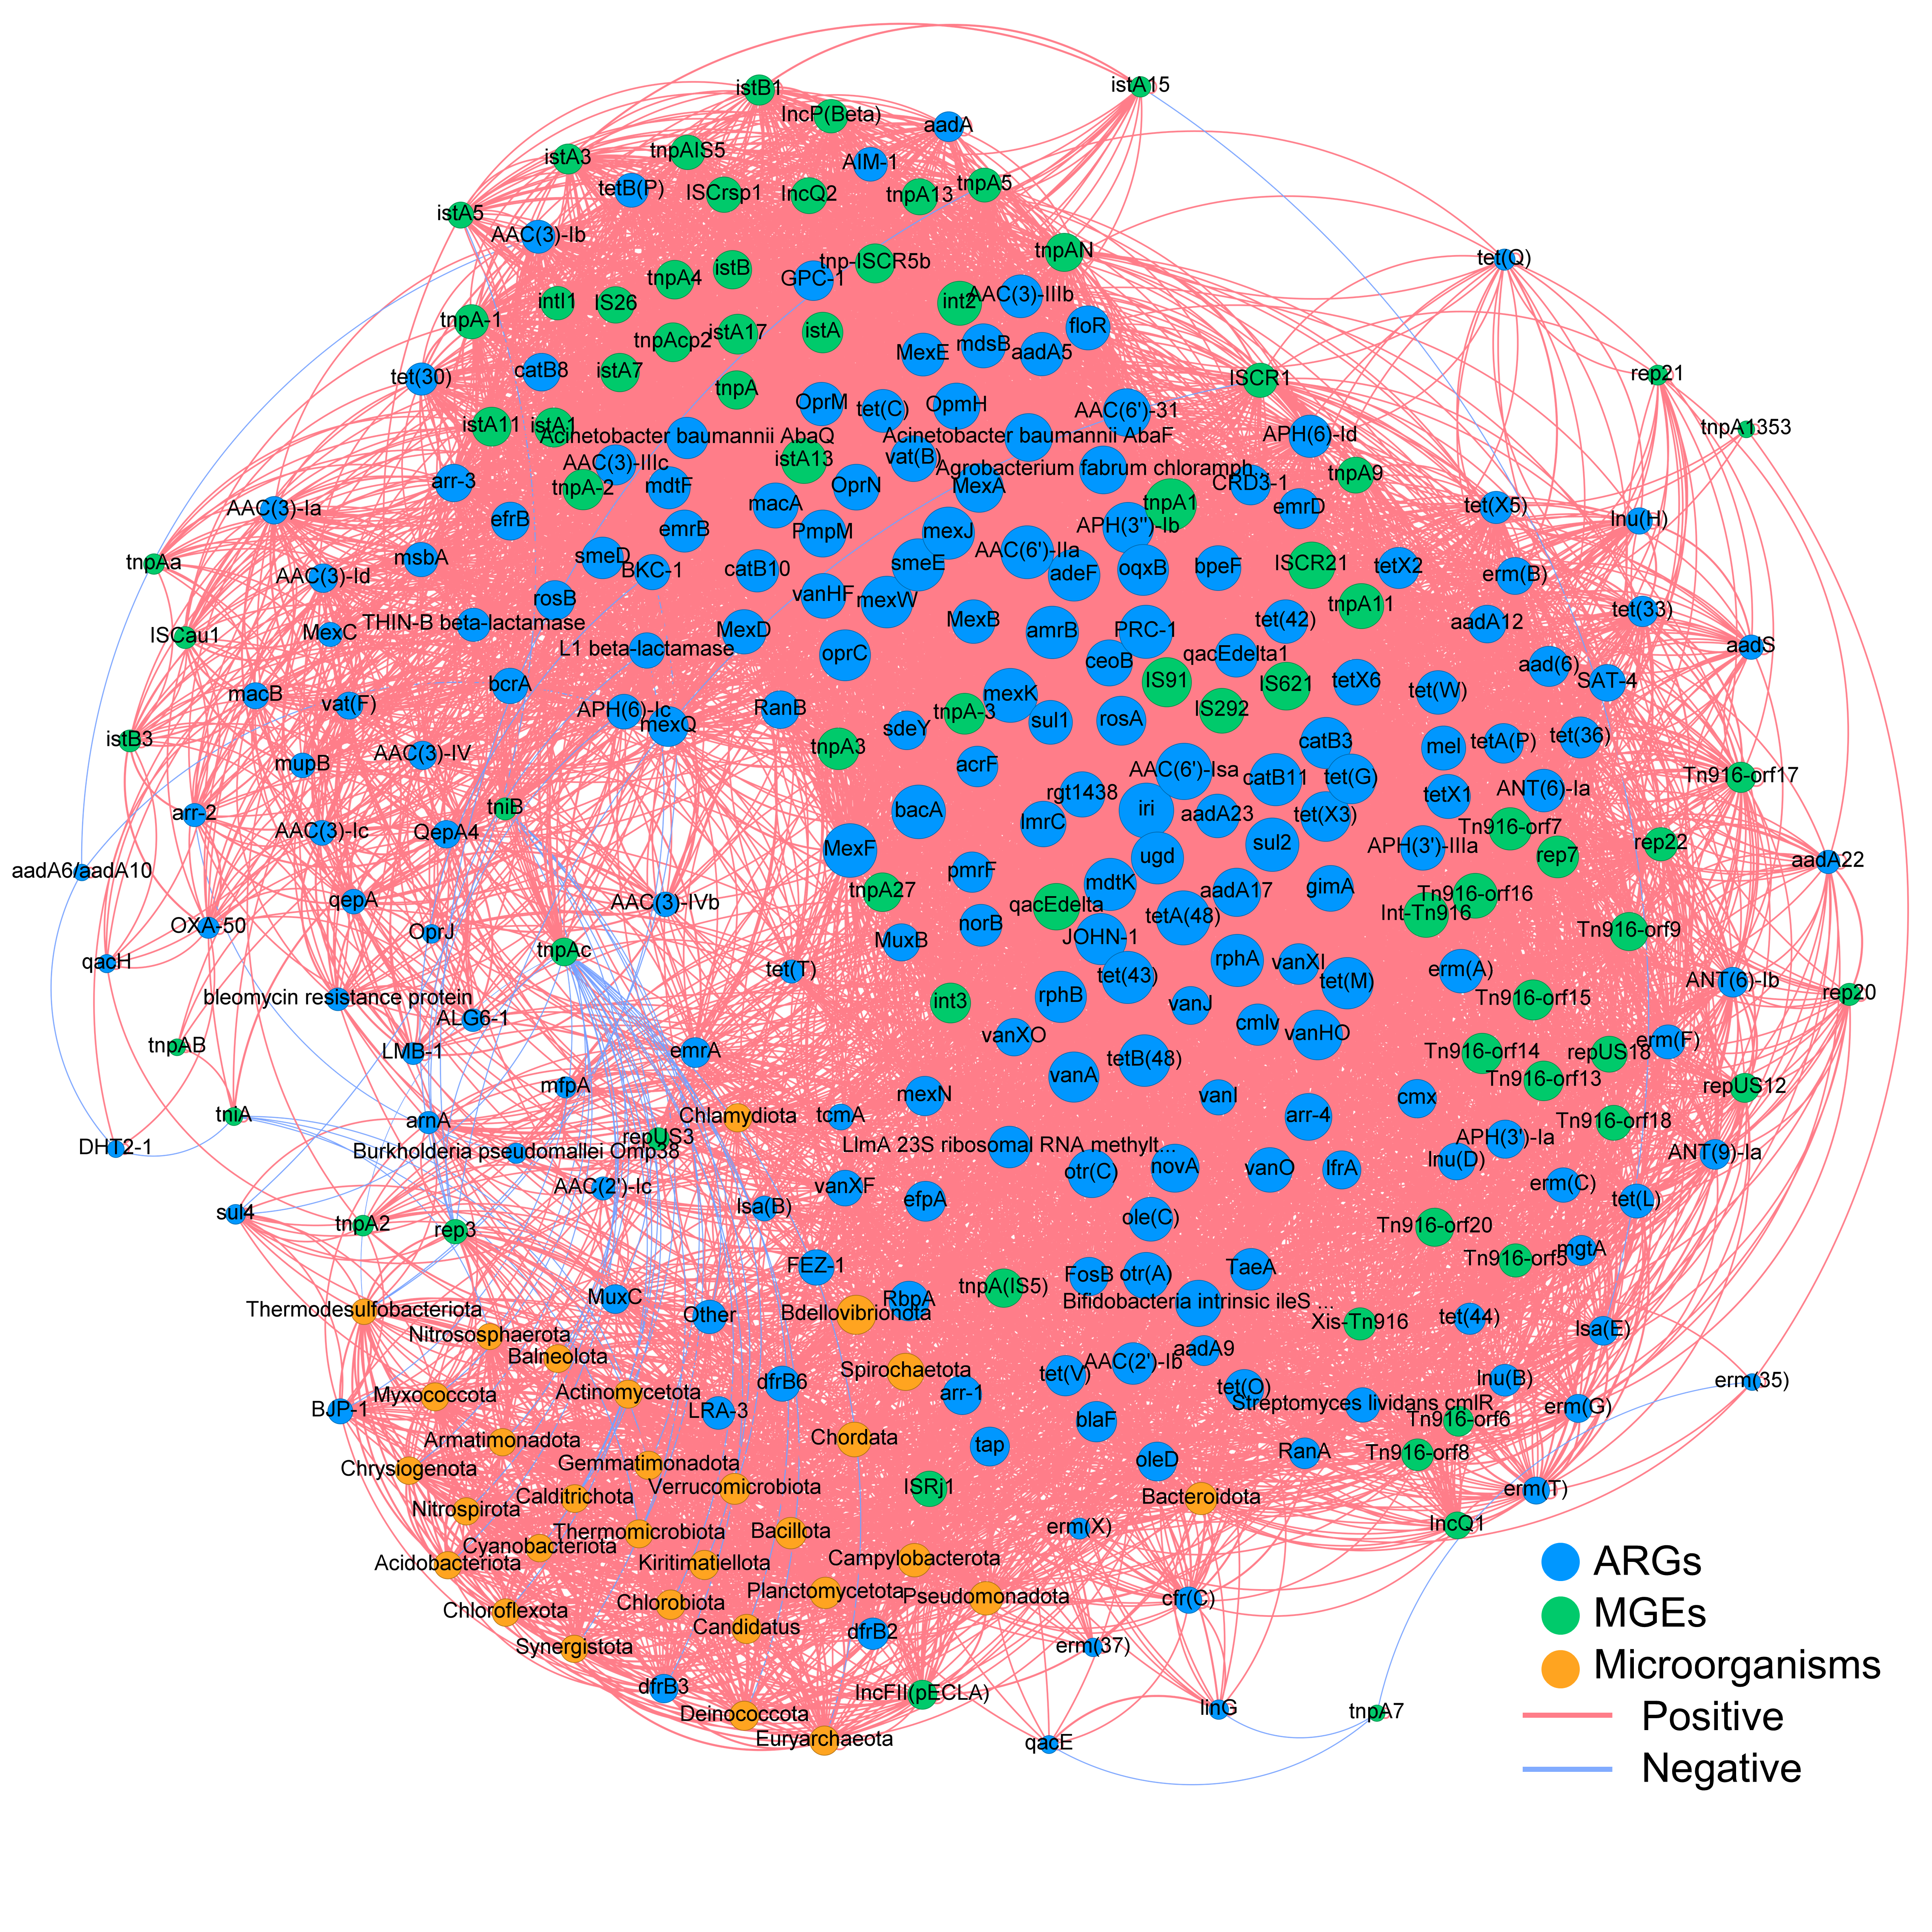
Supplementary Fig. 8 Co-occurrence network analysis. Network showing Spearman correlations among ARGs, MGEs and microorganisms. The size of nodes and labels represents the degree of connection. The layout method of this network is Fruchterman Reingold. The red line represents the positive interaction and blue line represents negative interaction.

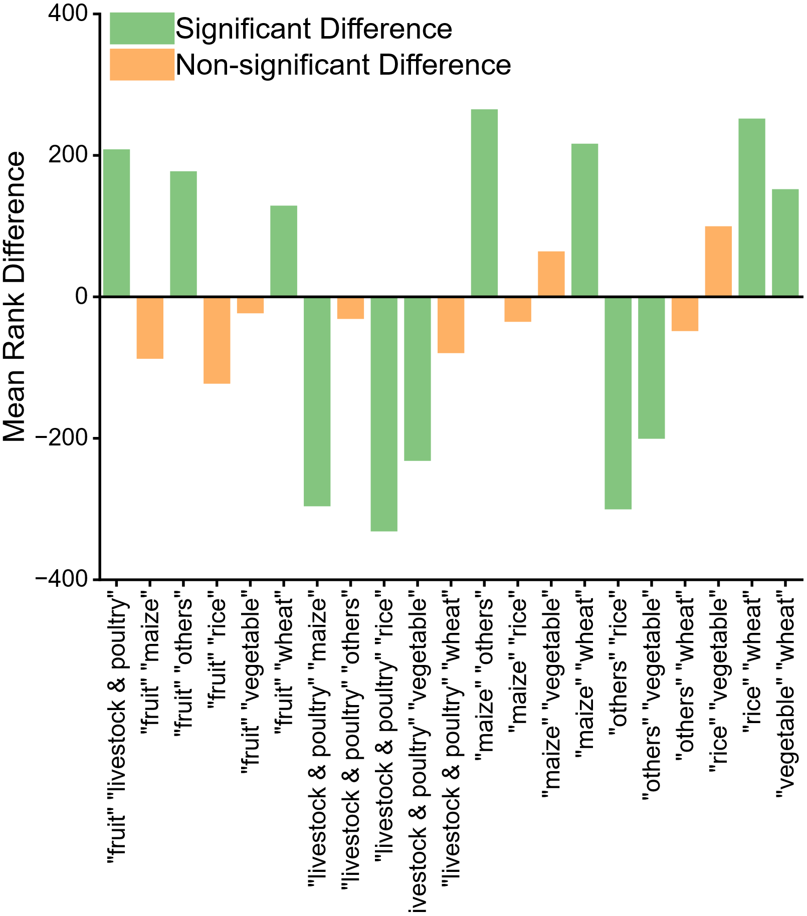
Supplementary Fig. 9 Pairwise comparison plot of microbial Shannon index across different soil types using the Kruskal-Wallis test with Dunn’s multiple comparisons test. Where orange bars indicate significant differences between pairs (p<0.05) and green bars indicate no significant differences between pairs (p>0.05).

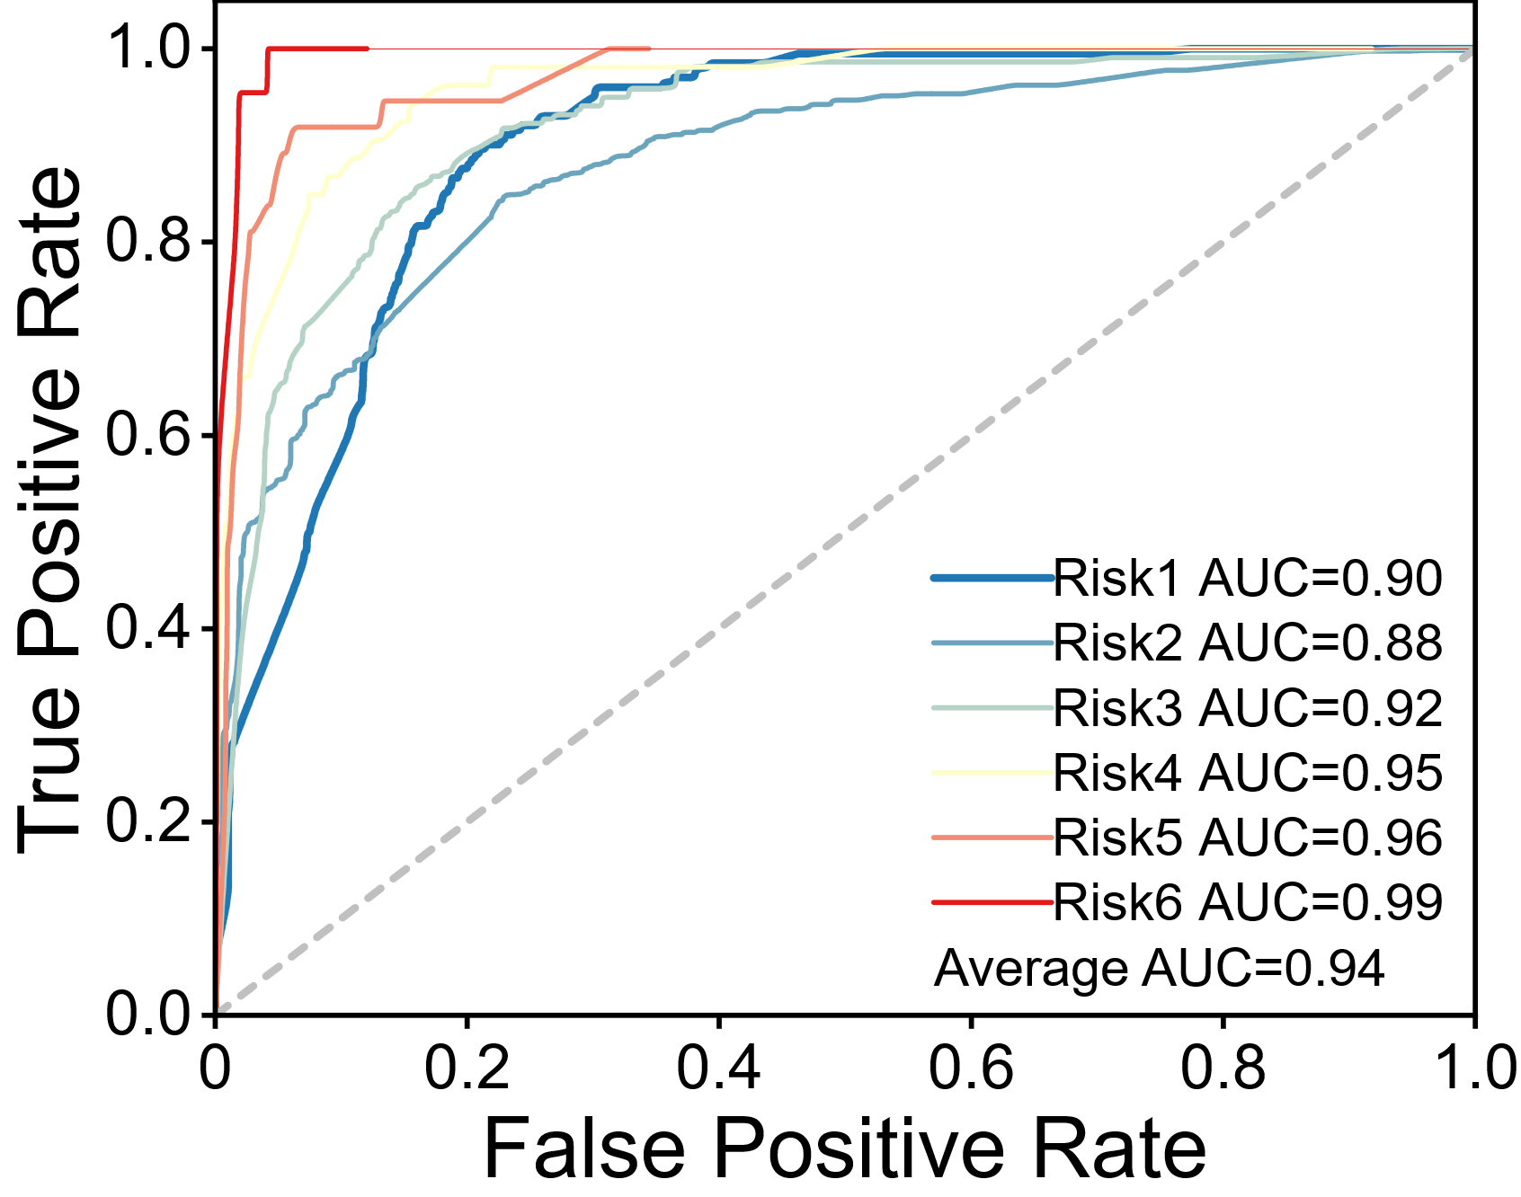
Supplementary Fig. 10 ROC curves across six different risk levels. The horizontal axis represents the false positive rate (FPR), and the vertical axis represents the true positive rate (TPR). Curves close to the top-left corner are associated with better model performance at the respective risk level.
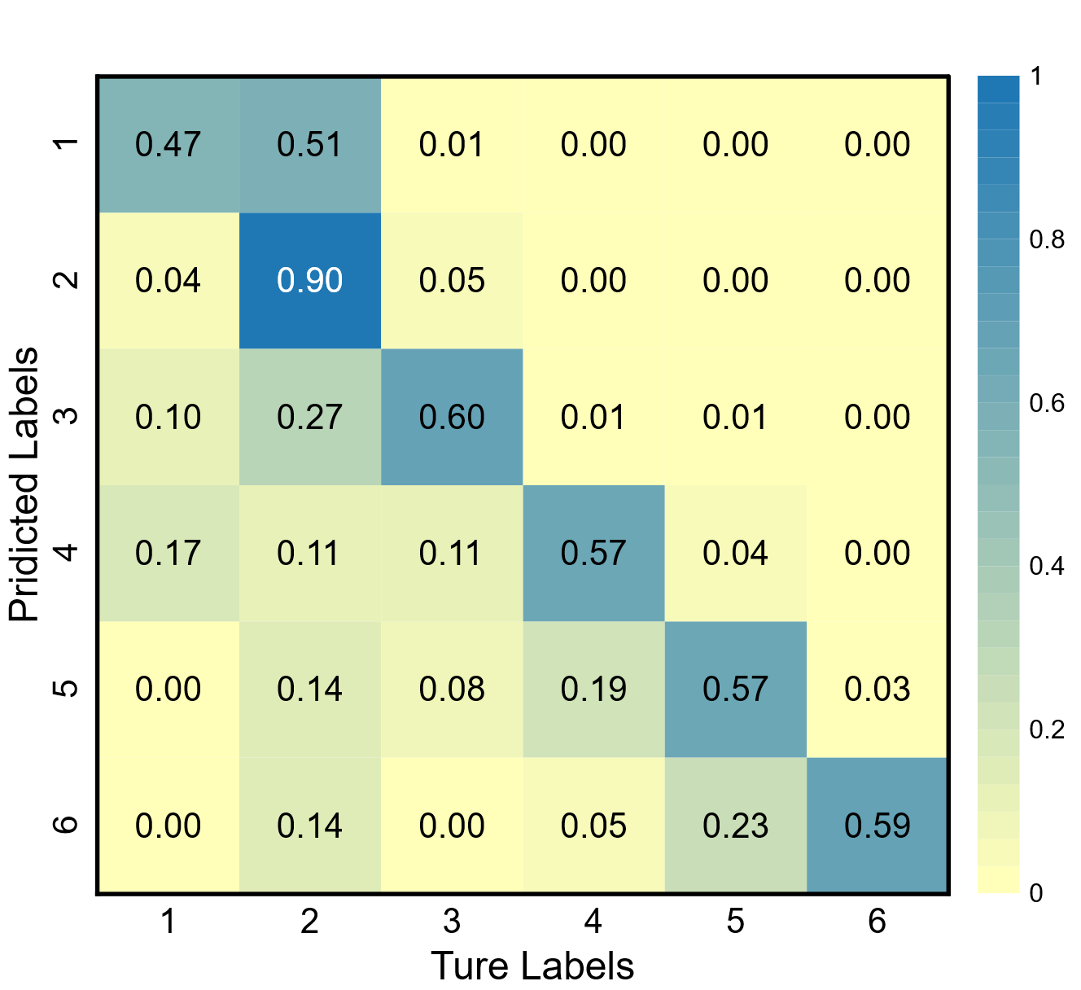
Supplementary Fig. 11 The number of predicted ranks by the random forest algorithm in machine learning illustrated by the confusion matrix. Our model demonstrates robust discrimination performance.

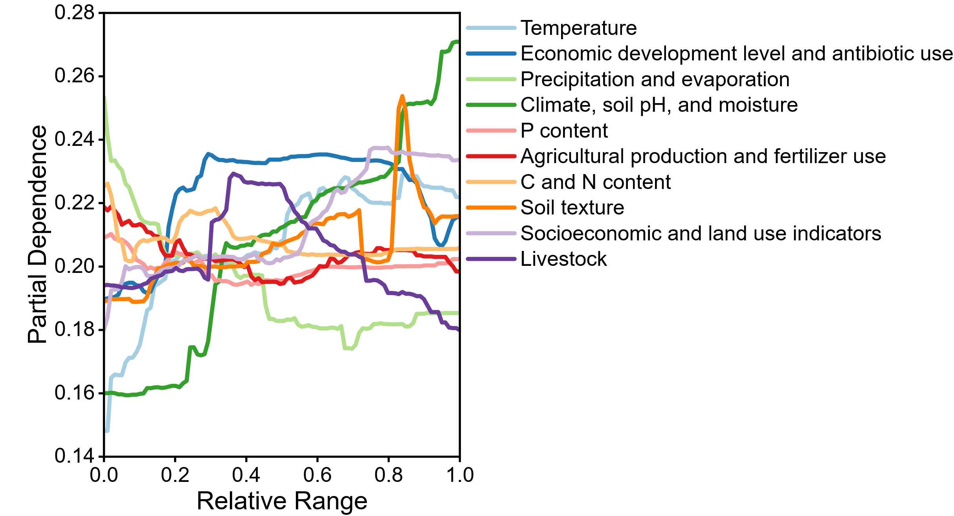
Supplementary Fig. 12 The partial dependence plots. The impact of the 10 factors on the prediction results during the machine learning process.

