Supplemental Figure 1
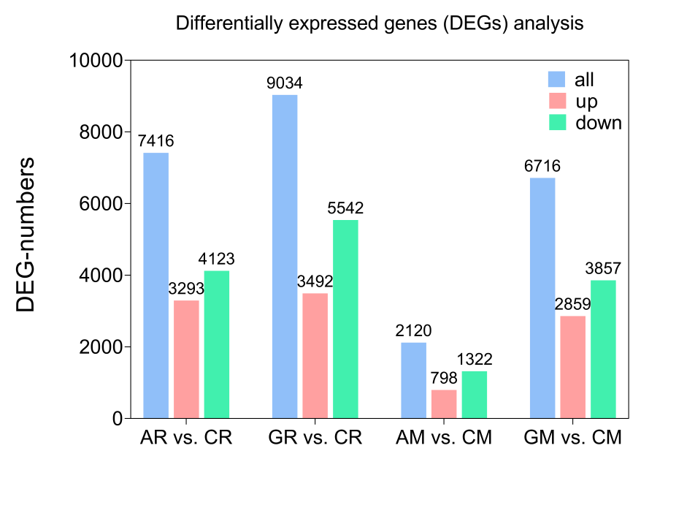
Supplemental Figure 1. DEGs in the adventitious roots and mother roots of R. glutinosa treated with ABA or GA.

Supplemental Figure 2
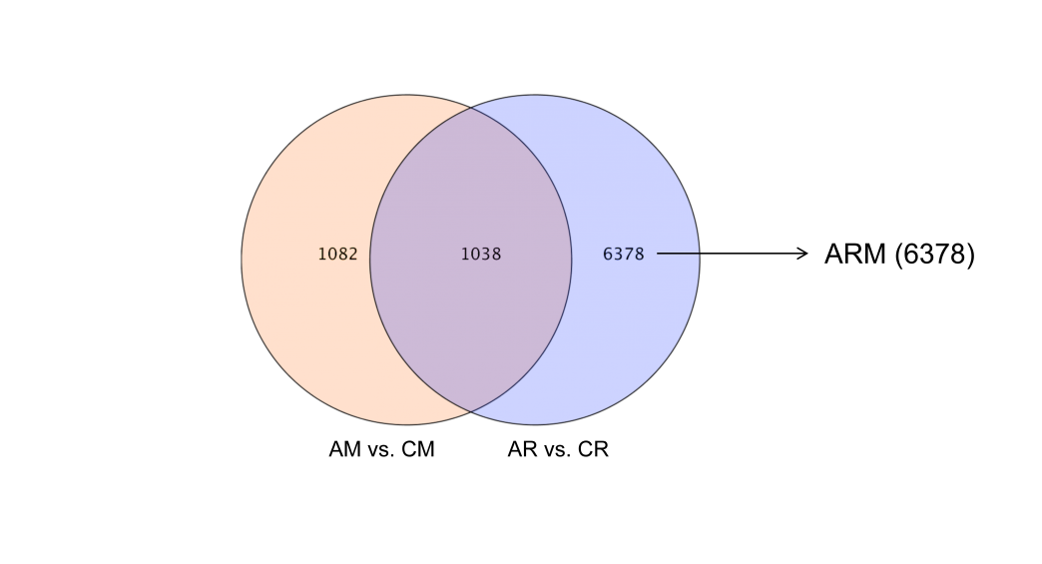
Supplemental Figure 2. Venn diagram of DEGs in AM vs. CM and AR vs. CR.

Supplemental Figure 3
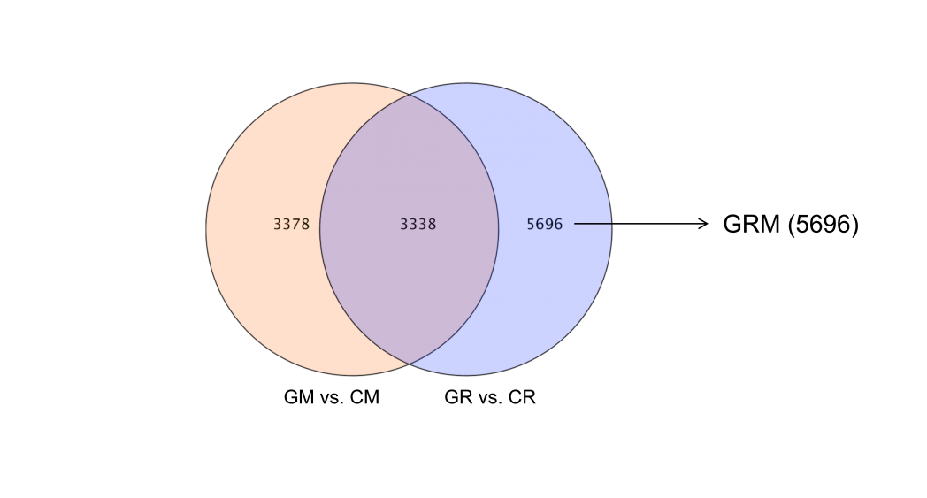
Supplemental Figure 3. Venn diagram of DEGs in GM vs. CM and GR vs. CR.

Supplemental Figure 4
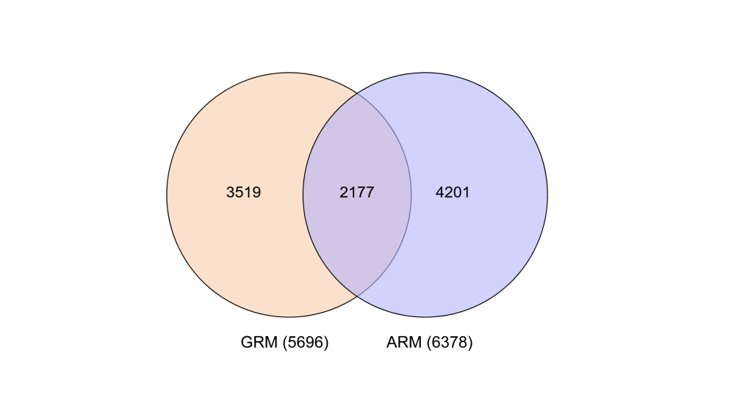
Supplemental Figure 4. Venn diagram of DEGs in ARM and GRM.

Supplemental Figure 5
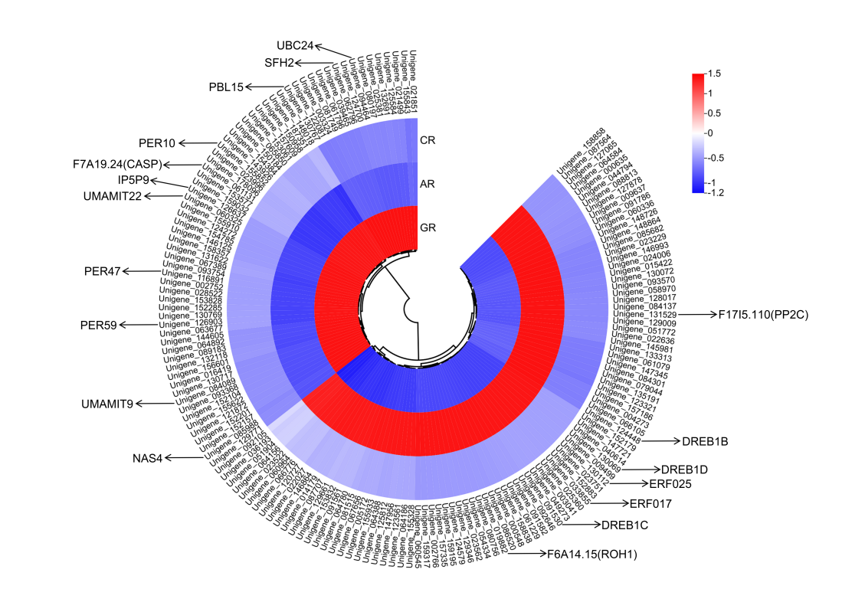
Supplemental Figure 5. 160 DEGs with opposite expression patterns between ARM and GRM.

Supplemental Figure 6
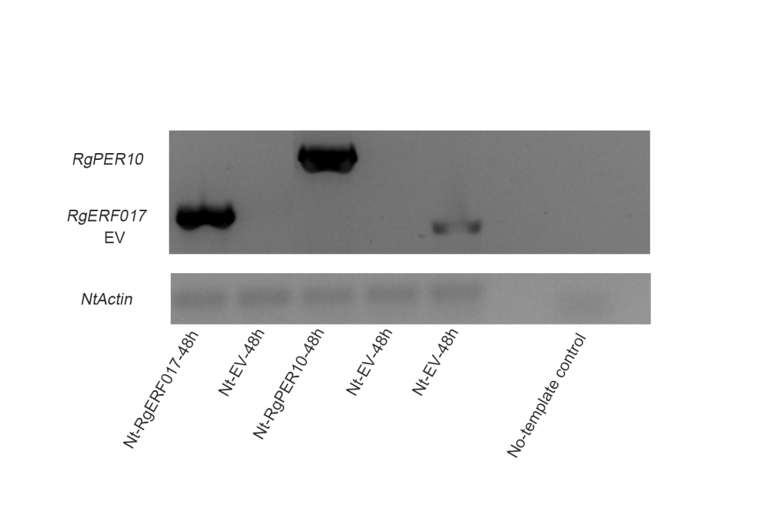
Supplemental Figure 6. PCR verification of RgERF017 and RgPER10 expression in tobacco leaves infiltrated with recombinant plasmids. Lanes 1–2 were amplified using the 1300-RgERF017-F/R primer pair, and lanes 3–4 were amplified using the 1300-RgPER10-F/R primer pair. Lane 5 was amplified with the 1300-F/R vector-specific primers to confirm the presence of the plasmid. NtActin was used as an internal reference gene, and a no-template control was included to exclude potential contamination.
Supplemental Figure 7
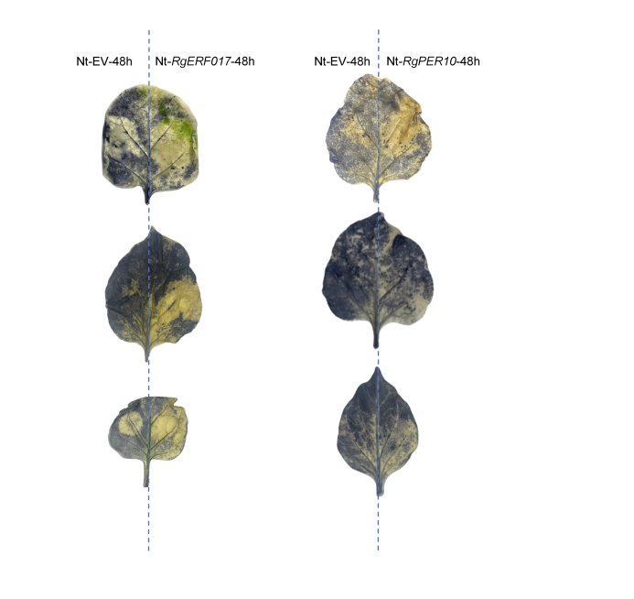
Supplemental Figure 7. NBT staining was performed to detect reactive oxygen species (ROS) accumulation in tobacco leaves. The left side of each leaf was infiltrated with Agrobacterium tumefaciens carrying an empty vector (Nt-EV), while the right side was infiltrated with Agrobacterium harboring the RgERF017 (left panel) or RgPER10 (right panel) recombinant plasmid. Samples were collected 48 h after infiltration, and the dark-blue precipitate indicates the accumulation level of superoxide anion (O₂⁻).

