Supplementary Materials
Table of Contents
Tables
Table S1. Missing number and percentage of variables in the dataset …… p.1
Table S2. LASSO regression variable selection process …… p.4
Table S3. Baseline characteristics of test and training sets …… p.12
Table S4. Hyperparameters and selected settings for each algorithm …… p.16
Table S5. Multi-model classification — Training set results …… p.17
Table S6. Multi-model classification — Validation set results …… p.17
Table S7. Z-value averages for DeLong test across models …… p.19
Table S8. P-value means for DeLong test across models …… p.19
Table S9. Predictive performance of the Random Forest (RF) model …… p.26
Table S10. Abbreviations of Variables and Methods …… p.31
Figures
Figure S1. Coefficient profile plot of the LASSO regression model …… p.7
Figure S2. Cross-validation curve for LASSO regression …… p.7
Figure S3. Variable selection using the Boruta method …… p.8
Figure S4. SVM-RFECV results (18 selected predictors) …… p.9
Figure S5. RFECV results (28 selected predictors) …… p.10
Figure S6. Correlation heatmap of candidate predictors …… p.11
Figure S7. ROC curves of nine models in the training cohort …… p.19
Figure S8. ROC curves of nine models in the validation cohort …… p.20
Figure S9. Forest plot of AUC distributions …… p.21
Figure S10. Decision curve analysis (DCA) in the validation cohort …… p.22

Figure S11. Calibration curves of machine learning models …… p.23
Figure S12. Precision–recall curves (training cohort) …… p.24
Figure S13. Precision–recall curves (validation cohort) …… p.25
Figure S14. Learning curves of the Random Forest (RF) model …… p.27
Figure S15. Calibration plot of the RF model (test cohort) …… p.28
Figure S16. Decision curve analysis (DCA) in the test cohort …… p.29
Figure S17. Kolmogorov–Smirnov (KS) curve of the RF model …… p.30
Acknowledgment
Acknowledgment of MIMIC-IV database contributors and Extreme Smart Analysis platform …… p.34

Table S1. Missing number and percentage of variables in the dataset.
Number | Variables | Missing Count | MissingPercent (%)
1 | Gender | 0 | 0.00%
2 | MI | 0 | 0.00%
3 | CHF | 0 | 0.00%
4 | CBD | 0 | 0.00%
5 | CPD | 0 | 0.00%
6 | Diabetes_with_cc | 0 | 0.00%
7 | Renal_disease | 0 | 0.00%
8 | Malignant_cancer | 0 | 0.00%
9 | Severe_liver_disease | 0 | 0.00%
10 | Metastatic_solid_tumor | 0 | 0.00%
11 | APSⅢ | 0 | 0.00%
12 | SOFA | 0 | 0.00%
13 | Age | 0 | 0.00%
14 | Lactate | 268 | 18.73%
15 | pH | 268 | 18.73%
16 | SO₂ | 268 | 18.73%
17 | PO₂ | 268 | 18.73%
18 | PCO₂ | 268 | 18.73%
19 | TotalCO₂ | 268 | 18.73%
20 | CCI | 0 | 0.00%
21 | Hct | 2 | 0.14%
22 | Hb | 3 | 0.21%
23 | PLT | 2 | 0.14%
24 | WBC | 3 | 0.21%
25 | Albumin | 187 | 13.07%
26 | AG | 3 | 0.21%
27 | Bicarbonate | 3 | 0.21%
28 | BUN | 2 | 0.14%
29 | Calcium | 60 | 4.19%
30 | Chloride | 3 | 0.21%
31 | Cr | 2 | 0.14%
32 | Sodium | 3 | 0.21%
33 | Potassium | 3 | 0.21%
34 | Fibrinogen | 174 | 12.16%
35 | INR | 38 | 2.66%
36 | PT | 36 | 2.52%
37 | PTT | 40 | 2.80%
38 | ALT | 198 | 13.84%
39 | ALP | 198 | 13.84%
40 | AST | 185 | 12.93%
41 | Amylase | 156 | 10.90%
42 | Bilirubin_total | 133 | 9.29%
43 | Ck-CPK | 134 | 9.36%
44 | CK-MB | 134 | 9.36%
45 | LDH | 254 | 17.75%
46 | HR | 3 | 0.21%
47 | SBP | 14 | 0.98%
48 | DBP | 14 | 0.98%
49 | MBP | 3 | 0.21%
50 | RR | 3 | 0.21%
51 | Temperature | 210 | 14.68%
52 | SPO2 | 6 | 0.42%
53 | Glucose | 2 | 0.14%
54 | Gcs_min | 2 | 0.14%

Table S2. Comparison of baseline characteristics for the test and training sets in the model screening phase.
Variables | Total | Validation | Training | P
N | 1431 | 430 | 1001 | -
Age(years old)  Median (Q1, Q3) | 67.00 (56.00, 78.00) | 68.00 (55.00, 78.00) | 67.00 (56.00, 77.00) | 0.649
Gender n (%) |  |  |  | 0.326
Female | 540(37.74) | 154(35.81) | 386(38.56)
Male | 891(62.26) | 276(64.19) | 615(61.44)
Vital Signs on ICU Admission, Median (Q1, Q3)
HR,(bmp) | 66.00 (56.00, 79.00) | 66.00 (56.00, 80.00) | 66.00 (57.00, 79.00) | 0.766
SBP,(mmHg) | 146.00(132.00,163.00) | 148.00(133.25,165.00) | 145.00(131.00,162.00) | 0.051
DBP,(mmHg) | 43.00 (36.00, 50.00) | 44.00 (36.00, 51.75) | 43.00 (36.00, 50.00) | 0.407
MBP,(mmHg) | 56.00 (47.00, 62.00) | 56.00 (48.00, 64.00) | 55.00 (47.00, 62.00) | 0.094
RR,(bpm) | 28.00 (24.00, 32.00) | 28.00 (24.00, 32.38) | 28.00 (24.50, 32.00) | 0.423
Temperature,(℃) | 37.24 (36.83, 37.72) | 37.24 (36.78, 37.72) | 37.22 (36.89, 37.72) | 0.359
SpO2,(%) | 92.00 (89.00, 95.00) | 93.00 (89.00, 96.00) | 92.00 (89.00, 95.00) | 0.056
Laboratory parameters on ICU admission, Median (Q1, Q3)
WBC count,(10³/μL) | 10.30 (7.10, 13.70) | 9.90 (6.65, 13.50) | 10.40 (7.30, 13.90) | 0.103
Hematocrit | 30.40 (25.45, 36.10) | 31.15 (26.20, 36.58) | 30.10 (25.20, 35.90) | 0.059
Hb,(g/dL) | 10.00 (8.40, 11.90) | 10.15 (8.60, 12.00) | 9.90 (8.30, 11.80) | 0.081
PLT(10³/μL) | 215.00(157.00,282.50) | 216.00(155.25,279.75) | 215.00(157.00,284.00) | 0.882
pH | 7.27 (7.18, 7.33) | 7.27 (7.18, 7.33) | 7.27 (7.18, 7.33) | 0.962
PO₂,(mmHg) | 104.00(98.00,110.00) | 103.00(100.00,109.00) | 102.00(100.00,105.00) | 0.653
PCO₂,(mmHg) | 33.00 (29.00, 38.00) | 33.00 (29.00, 38.00) | 33.00 (29.00, 38.00) | 0.725
Aniongap,(mmol/L) | 18.00 (15.00, 23.00) | 19.00 (16.00, 22.00) | 18.00 (15.00, 23.00) | 0.951
Lactate,(mmol/L) | 3.17 (2.24, 5.50) | 3.12 (2.21, 5.77) | 3.18 (2.25, 5.50) | 0.705
BicarbonTate,(mmol/L) | 23.00 (20.00, 26.00) | 23.00 (20.25, 26.00) | 23.00 (20.00, 26.00) | 0.992
Albumin,(g/dL) | 3.10 (2.90, 3.28) | 3.11 (2.97, 3.25) | 3.10 (2.90, 3.30) | 0.522
ALT,(U/L) | 52.34 (30.00, 109.00) | 51.40 (31.00, 101.75) | 52.60 (30.00, 109.00) | 0.609
AST,(U/L) | 110.00 (56.00, 241.50) | 110.00 (59.25, 268.25) | 110.00 (56.00, 233.00) | 0.788
ALP,(U/L) | 8.63 (7.20, 11.95) | 8.64 (6.93, 12.07) | 8.62 (7.20, 11.90) | 0.934
Na⁺,(mmol/L) | 140.00(138.00,143.00) | 141.00(138.00,143.00) | 140.00(138.00,143.00) | 0.960
K⁺,(mmol/L) | 4.70 (4.30, 5.40) | 4.70 (4.30, 5.30) | 4.70 (4.30, 5.40) | 0.693
BUN,(mg/dL) | 29.00 (20.00, 46.00) | 28.50 (20.00, 44.00) | 29.00 (20.00, 47.00) | 0.418
Creatinine(mg/dL) | 1.50 (1.00, 2.50) | 1.50 (1.00, 2.40) | 1.50 (1.00, 2.50) | 0.357
TBil(μmol/L) | 0.69 (0.50, 1.10) | 0.70 (0.50, 1.17) | 0.69 (0.50, 1.10) | 0.193
Ck-MB(U/L) | 292.87(170.50,359.86) | 294.00(164.25,356.30) | 292.48(173.00,360.13) | 0.807
Ck-CPK(IU/L) | 292.87(170.50,359.86) | 294.00(164.25,356.30) | 292.48(173.00,360.13) | 0.807
LDH(U/L) | 396.65(365.86,486.00) | 393.42(357.37,468.95) | 398.86(369.25,490.00) | 0.126
Glucose,(mmol/L) | 108.00 (88.00, 136.00) | 109.00 (90.00, 138.00) | 108.00 (87.00, 136.00) | 0.666
Fibrinogen,(mg/dL) | 254.36(241.82,287.17) | 255.22(242.59,283.90) | 254.23(241.82,288.01) | 0.803
PT,(S) | 15.40 (13.50, 20.20) | 15.40 (13.30, 19.90) | 15.40 (13.60, 20.60) | 0.196
PTT,(S) | 40.30 (31.10, 77.30) | 40.80 (31.33, 85.52) | 40.10 (30.90, 72.60) | 0.411
INR | 40.30 (31.10, 77.30) | 40.80 (31.33, 85.52) | 40.10 (30.90, 72.60) | 0.411
Critical assessment on admission, Median (Q1, Q3)
APS Ⅲ | 67.00 (48.00, 92.00) | 64.50 (48.00, 93.00) | 68.00 (48.00, 92.00) | 0.921
SOFA | 9.00 (6.00, 12.00) | 9.00 (5.00, 12.00) | 9.00 (6.00, 12.00) | 0.853
GCS | 13.00 (6.00, 15.00) | 12.00 (5.00, 14.75) | 13.00 (7.00, 15.00) | 0.142
Comorbidity, n (%)
CCI | 6.00 (4.00, 8.00) | 6.00 (4.00, 8.00) | 6.00 (4.00, 8.00) | 0.966
MI | 429 (29.98) | 121 (28.14) | 308 (30.77) | 0.320
CHD | 823 (57.51) | 251 (58.37) | 572 (57.14) | 0.666
CBD | 214 (14.95) | 63 (14.65) | 151 (15.08) | 0.833
CPD | 408 (28.51) | 116 (26.98) | 292 (29.17) | 0.399
Diabeteswithcc | 201 (14.05) | 60 (13.95) | 141 (14.09) | 0.947
RenTaldisease | 424 (29.63) | 133 (30.93) | 291 (29.07) | 0.480
Malignancy | 148 (10.34) | 40 (9.30) | 108 (10.79) | 0.959
SevereLiverDisease | 62(4.33) | 22(5.12) | 40(4.00) | 0.340
MetastaticSolidTumor | 56(3.91) | 19(4.42) | 37(3.70) | 0.518
Advanced life support,n(%)
RR | 152(10.62) | 54(12.59) | 119(11.89) | 0.725
IMV | 774(54.09) | 225(52.32) | 528(52.75) | 0.884
Vasoactive_agent | 749(52.34) | 237(55.12) | 546(54.55) | 0.843
Antibiotic | 990(69.18) | 298(69.30) | 719(71.83) | 0.697
Length of Stay (LOS), Median (Q1, Q3)
Los of Hospital (day) | 9.13 (4.48, 17.69) | 9.11 (4.29, 17.08) | 9.13 (4.61, 17.86) | 0.502
Los of ICU (day) | 4.16 (2.08, 8.48) | 4.40 (2.10, 8.64) | 4.10 (2.07, 8.44) | 0.722

Table S3. LASSO regression variable selection process.
Name | Minimum mean square error coefficient | Minimum distance standard error coefficient
(Intercept) | -28.716 | -12.968
Gender | -0.159 | -0.037
MI | 0.0 | 0.0
CHF | 0.612 | 0.427
CBD | 0.387 | 0.245
CPD | 0.274 | 0.101
Diabetes_with_cc | -0.546 | -0.358
Renal_disease | -0.097 | -0.014
Malignant_cancer | 0.157 | 0.061
Severe_liver_disease | 0.56 | 0.283
Metastatic_solid_tumor | 1.216 | 1.034
APSⅢ | 0.035 | 0.022
SOFA | 0.0 | 0.0
Age | 0.016 | 0.012
CCI | 0.0 | 0.0
Lactate | 0.134 | 0.085
pH | 2.694 | 0.841
SO₂ | 0.0 | 0.0
PO₂ | 0.0 | -0.001
PCO₂ | 0.013 | 0.001
TotalCO₂ | 0.0 | 0.0
Hct | 0.067 | 0.016
Hb | -0.118 | 0.0
PLT | 0.001 | 0.001
WBC | 0.007 | 0.008
Albumin | -0.111 | -0.045
AG | 0.014 | 0.016
Bicarbonate | -0.106 | -0.054
BUN | 0.001 | 0.0
Calcium | 0.031 | 0.0
Chloride | -0.038 | 0.0
Cr | -0.073 | -0.002
Sodium | 0.083 | 0.039
Potassium | -0.007 | 0.0
Fibrinogen | 0.0 | 0.0
INR | 0.0 | 0.0
PT | 0.007 | 0.005
PTT | 0.0 | 0.0
ALT | 0.0 | 0.0
ALP | 0.022 | 0.018
AST | 0.0 | 0.0
Amylase | 0.001 | 0.0
Bilirubin_total | -0.024 | 0.0
CK-CPK | 0.0 | 0.0
Ck-MB | 0.001 | 0.0
LDH | 0.0 | 0.0
HR | -0.002 | 0.0
SBP | 0.0 | 0.0
DBP | -0.004 | 0.0
MBP | 0.009 | 0.0
RR | 0.005 | 0.007
Temperature | -0.134 | -0.117
SpO₂ | -0.019 | -0.002
Glucose | 0.004 | 0.004
Gcs_min | 0.074 | 0.021
The Lasso regression model was established using the binomial distribution. The coefficient table, coefficient profile plot, and cross-validation curve of the Lasso regression are presented in [Lasso Coefficient Table], [Coefficient Profile Plot, Fig.1.], and [Lasso Regression Cross-Validation Curve, Fig.2.], respectively.The λ value corresponding to the Minimum Mean Squared Error (MMSE) was 0.003, with selected variables including:
Gender + CHD + CBD + CPD + Diabetes_with_CC + Renal_disease + Malignant_cancer + Severe_liver_disease + Metastatic_solid_tumor + APS Ⅲ + Age + Lactate + pH + PO₂ + PCO₂ + Hct + Hb + PLT + WBC + Albumin + AG + Bicarbonate + BUN + Calcium + Chloride + Cr + Sodium + Potassium + PT + ALT + ALP + AST + Amylase + Bilirubin_total + CK-MB + HR + DBP + MBP + RR + Temperature + SpO2 + Glucose + GCS_min(n=43).
The λ value for the Minimum Distance Standard Error was 0.012, with selected variables: Gender+CHF+CBD+CPD+Diabetes_with_cc+Renal_disease+Malignant_cancer+Severe_liver_disease+Metastatic_solid_tumor+APSⅢ+Age+Lactate+pH+PO₂+PCO₂+Hct+PLT+WBC+Albumin+AG+Bicarbonate+Cr+Sodium+PT+ALP+AST+Amylase+Ck-mb+RR+Temperature+SpO₂+Glucose+Gcs_min(n=34).
The analysis was performed using R version 4.2.3 with the glmnet package (version 4.1.8).
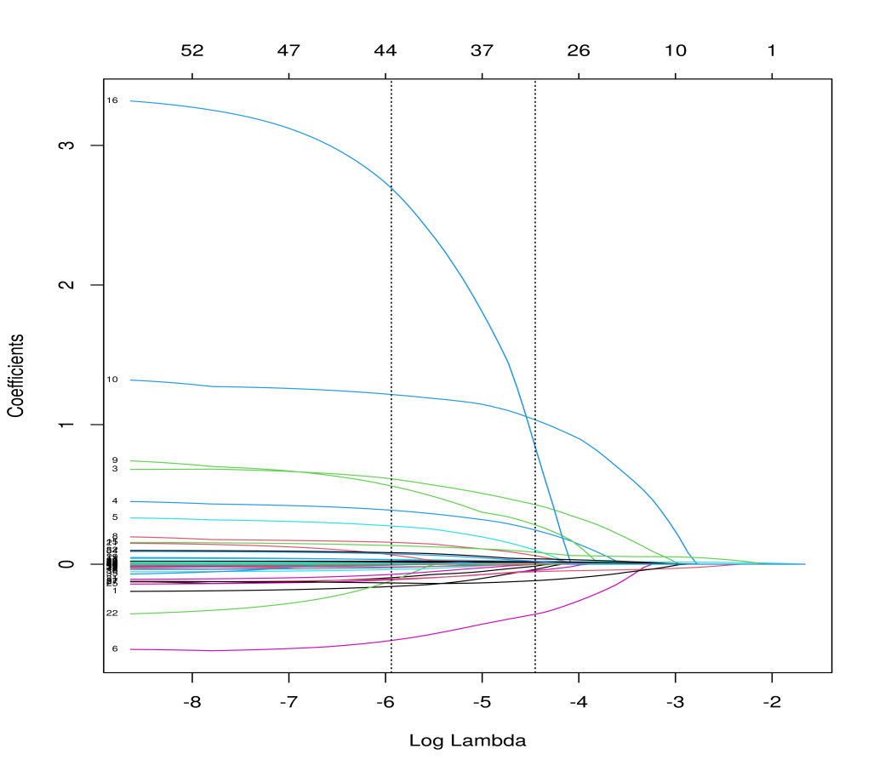
Fig. S1. Coefficient profile plot of the LASSO regression model, showing the shrinkage paths of coefficients as the penalty parameter λ changes.
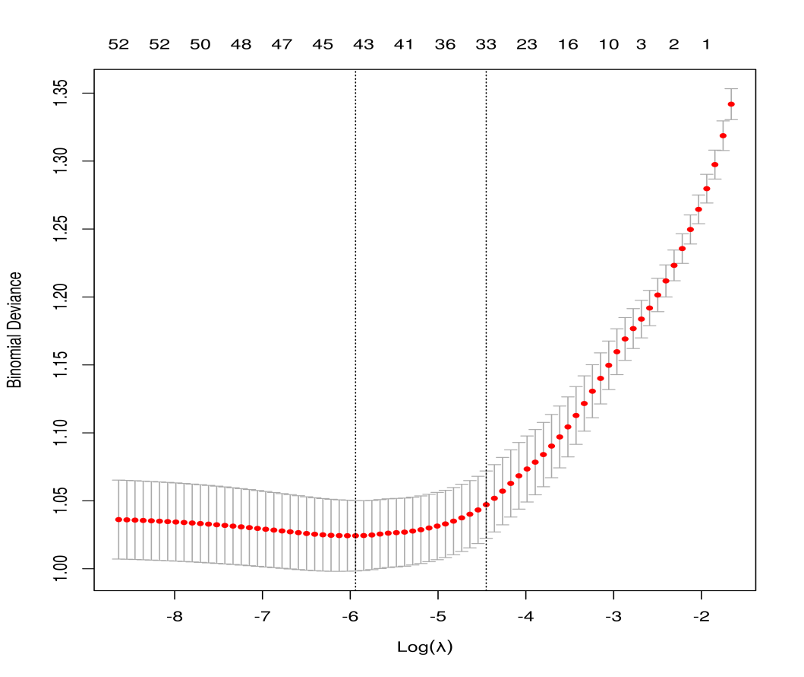
Fig. S2. Cross-validation curve for LASSO regression, indicating the minimum mean squared error (MMSE) and the λ value selected for optimal variable retention.
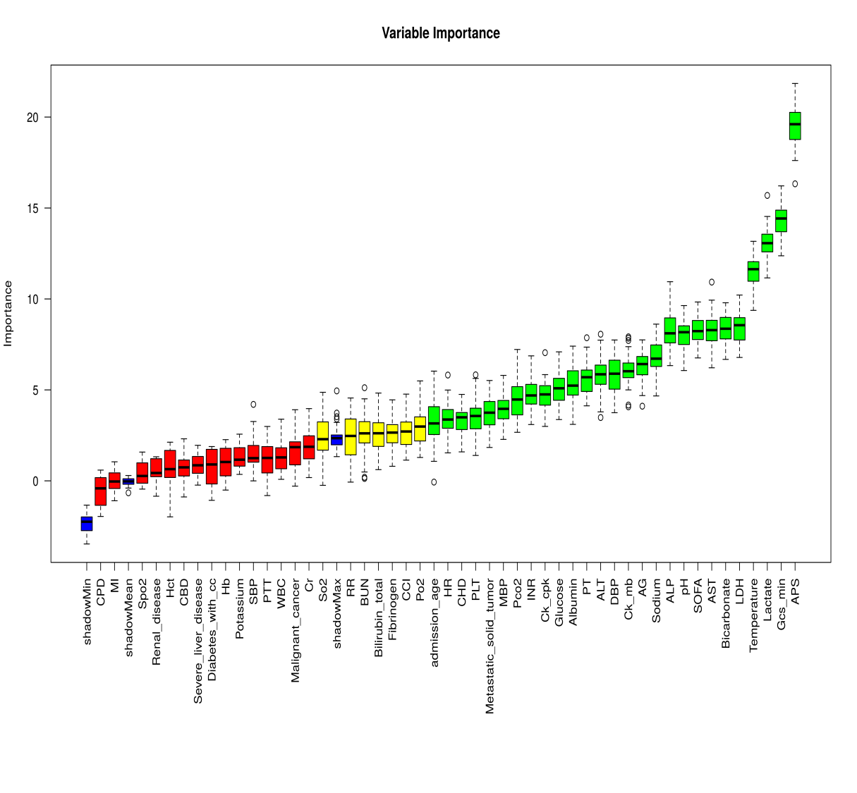
Fig. S3. Flow diagram of variable selection using the Boruta method, classifying predictors as confirmed, rejected, or tentative based on feature importance and stability across methods.
Confirmed Variables (Green, n=27):
SOFA, APS, Admission_age, CHF, Metastatic_solid_tumor, Lactate, pH, PCO₂, PLT, Albumin, AG, Bicarbonate, Sodium, INR, PT, ALT, ALP, AST,
Ck-CPK, Ck-MB, LDH, HR, DBP, MBP, Temperature, Glucose, Gcs_min.
Rejected Variables (Red, n=15):
MI, CBD, CPD, Diabetes_with_cc, Renal_disease, Malignant_cancer, Severe_liver_disease, Hct, Hb, WBC, Cr, Potassium, PTT, SBP, SpO₂.
Tentative Variables (Yellow, n=7):
CCI, SO₂, PO₂, BUN, Fibrinogen, Bilirubin_total, RR.
Shadow Variables (Blue, n=0).
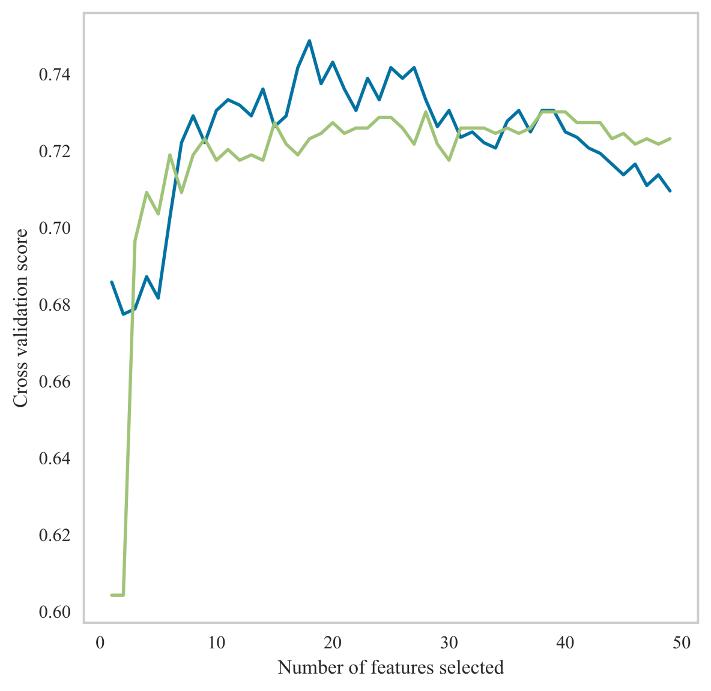
Fig. S4. Support Vector Machine–Recursive Feature Elimination with Cross-Validation (SVM-RFECV) results, retaining 18 key predictors most strongly associated with in-hospital mortality.
18 factors were selected by the SVMREFCV method, including: APSⅢ，Age，CHF，Diabetes_with_cc，Metastatic_solid_tumor，Lactate，pH，Hct，Hb，AG，Bicarbonate，Cr，Sodium，ALT，ALP，AST，Glucose，Gcs_min

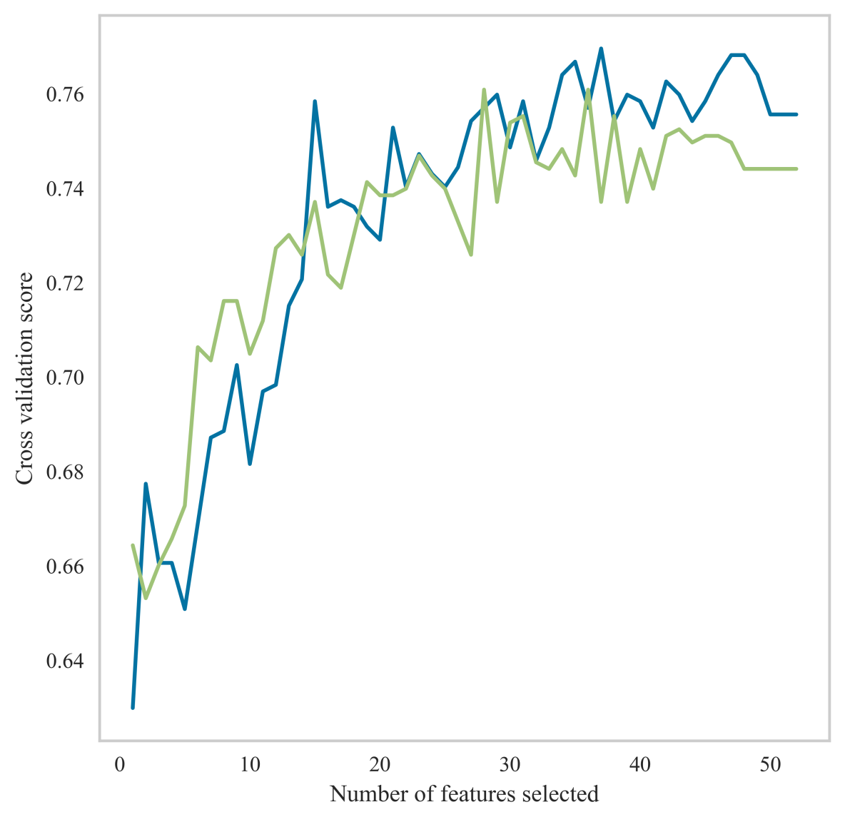
Fig. S5. Recursive Feature Elimination with Cross-Validation (RFECV) results, identifying 28 variables contributing significantly to model discrimination.
28 factors were selected by the REFCV method, including:APSⅢ，SOFA，Age，CHF，CBD，Diabetes_with_cc，Renal_disease，CCI，Lactate，pH，TotalCO₂，PLT，Bicarbonate，Cr，Sodium，PT，ALT，ALP，AST，Bilirubin_total，CK-CPK，CK-MB，LDH，DBP，MBP，Temperature，Glucose，Gcs_min

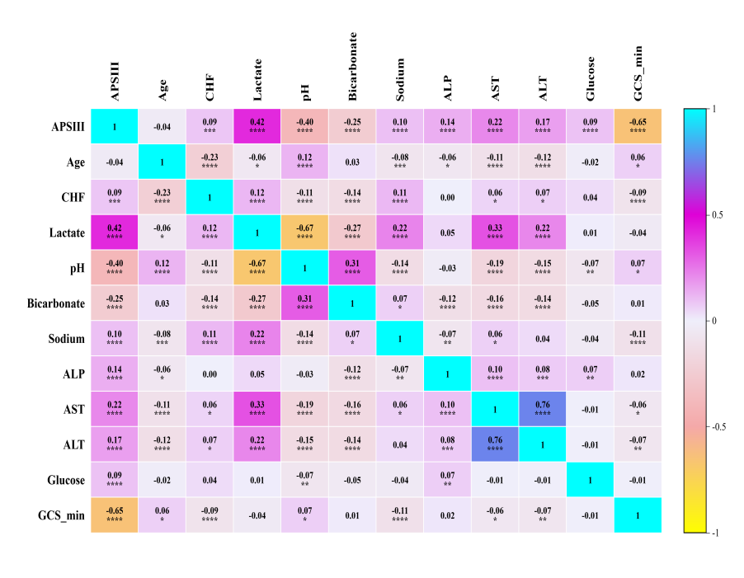
Fig.S6
Fig. S6. Correlation heatmap of candidate predictors, demonstrating covariance structures and highlighting potential collinearity (e.g., sodium vs. chloride, pH vs. bicarbonate).

Table S4. Hyperparameters and selected settings for each algorithm.
Classifier | Model Parameters
XGBoost | objective (optimization function): binary:logistic; colsample_bytree (feature subsampling rate): 1; learning_rate (learning rate): 0.1; max_depth (maximum tree depth): 4; min_child_weight (min instance weight sum for child node): 2; n_estimators (number of base learners): 20; reg_lambda (L2 regularization coefficient): 0.5; subsample (row subsampling rate): 1
Logistic | C (regularization factor): 0.1; l1_ratio (ElasticNet mixing parameter): None; max_iter (number of iterations): 50; penalty (regularization type): l2; solver (algorithm): lbfgs; tol (convergence tolerance): 1e-06
LGBM | boosting_type (algorithm type): dart; learning_rate: 0.001; max_depth (maximum tree depth): 1; n_estimators (number of trees): 5; num_leaves (maximum leaves): 100
AdaBoost | learning_rate: 0.3; n_estimators (number of weak learners): 50
RandomForest | criterion (splitting criterion): gini; max_depth (maximum tree depth): None; max_features (max features for splitting): sqrt; min_impurity_decrease (minimum impurity decrease for split): 0.0; min_samples_leaf (min samples at leaf node): 1; min_samples_split (min samples for internal node split): 2; n_estimators (number of trees): 100
DecisionTree | criterion (splitting criterion): entropy; max_depth (maximum tree depth): 20; min_samples_leaf (min samples at leaf node): 1; min_samples_split (min samples for internal node split): 50
MLP | activation (nonlinearity): logistic; alpha (L2 regularization): 0.0001; batch_size: auto; hidden_layer_sizes (width): (30, 30); learning_rate (schedule): constant; learning_rate_init (initial LR): 0.001; max_iter: 20; solver: adam; tol (convergence tolerance): 0.0001
GNB | priors (prior probabilities): None; var_smoothing (variance smoothing): 1e-07
KNN | algorithm (nearest neighbor algorithm): auto; leaf_size: 10; n_neighbors (number of neighbors): 2; p (distance metric, p=2 for Euclidean): 2; weights (weighting type): uniform
Note: Parameter names are followed by brief explanations in parentheses; values shown are the selected settings for this study.
Table S5. Multi-model classification — Summary of Training set results.
Model | AUC | Cut-off | Accuracy | Sensitivity | Specificity | PPV | NPV | F1 score | Kappa score
XGBoost | 0.91 | 0.43 | 0.83 | 0.79 | 0.85 | 0.78 | 0.86 | 0.78 | 0.64
LR | 0.8 | 0.38 | 0.73 | 0.72 | 0.73 | 0.64 | 0.8 | 0.68 | 0.44
LGBM | 0.68 | 0.4 | 0.68 | 0.66 | 0.69 | 0.59 | 0.76 | 0.62 | 0.35
Ada | 0.85 | 0.5 | 0.77 | 0.72 | 0.8 | 0.71 | 0.82 | 0.71 | 0.52
DT | 0.89 | 0.42 | 0.79 | 0.82 | 0.78 | 0.71 | 0.87 | 0.76 | 0.58
MLP | 0.77 | 0.38 | 0.70 | 0.76 | 0.66 | 0.59 | 0.81 | 0.67 | 0.40
RF | 1 | 0.59 | 0.98 | 0.95 | 0.99 | 0.99 | 0.97 | 0.97 | 0.95
GNB | 0.78 | 0.16 | 0.72 | 0.71 | 0.73 | 0.63 | 0.79 | 0.67 | 0.43
KNN | 0.91 | 0.50 | 0.81 | 0.97 | 0.71 | 0.69 | 0.97 | 0.80 | 0.64

Table S6. Multi-model classification — Summary of Validation set results.
Model | AUC | Cut-off | Accuracy | Sensitivity | Specificity | PPV | NPV | F1 score | Kappa score
XGBoost | 0.81 | 0.43 | 0.74 | 0.69 | 0.78 | 0.67 | 0.79 | 0.68 | 0.47
LR | 0.80 | 0.38 | 0.72 | 0.71 | 0.72 | 0.63 | 0.79 | 0.66 | 0.42
LGBM | 0.67 | 0.40 | 0.67 | 0.66 | 0.68 | 0.57 | 0.75 | 0.61 | 0.33
Ada | 0.81 | 0.50 | 0.74 | 0.69 | 0.78 | 0.67 | 0.79 | 0.67 | 0.46
DT | 0.76 | 0.42 | 0.69 | 0.71 | 0.67 | 0.59 | 0.78 | 0.64 | 0.37
MLP | 0.77 | 0.38 | 0.69 | 0.74 | 0.66 | 0.58 | 0.79 | 0.65 | 0.38
RF | 0.83 | 0.59 | 0.75 | 0.49 | 0.92 | 0.81 | 0.73 | 0.61 | 0.44
GNB | 0.78 | 0.16 | 0.71 | 0.70 | 0.72 | 0.62 | 0.79 | 0.66 | 0.41
KNN | 0.66 | 0.50 | 0.62 | 0.69 | 0.57 | 0.52 | 0.74 | 0.59 | 0.25

Table S7. Z-value averages for DeLong test across models.
Model | XGBoost | LR | LGBM | Ada | DT | MLP | RF | GNB | KNN
XGBoost | NA | 0.0 | 0.0 | 0.0 | 0.0 | 0.0 | 0.0 | 0.0 | 0.0
LR | 0.0 | NA | 0.0 | 0.0 | 0.0 | 0.0 | 0.0 | 0.0 | 0.0
LGBM | 0.0 | 0.0 | NA | 0.0 | 0.0 | 0.0 | 0.0 | 0.0 | 0.0
Ada | 0.0 | 0.0 | 0.0 | NA | 0.0 | 0.0 | 0.0 | 0.0 | 0.0
DT | 0.0 | 0.0 | 0.0 | 0.0 | NA | 0.0 | 0.0 | 0.0 | 0.0
MLP | 0.0 | 0.0 | 0.0 | 0.0 | 0.0 | NA | 0.0 | 0.0 | 0.0
RF | 0.0 | 0.0 | 0.0 | 0.0 | 0.0 | 0.0 | NA | 0.0 | 0.0
GNB | 0.0 | 0.0 | 0.0 | 0.0 | 0.0 | 0.0 | 0.0 | NA | 0.0
KNN | 0.0 | 0.0 | 0.0 | 0.0 | 0.0 | 0.0 | 0.0 | 0.0 | NA
Table S8. P-value means for DeLong test across models.
Model | XGBoost | LR | LGBM | Ada | DT | MLP | RF | GNB | KNN
XGBoost | NA | 1.0 | 1.0 | 1.0 | 1.0 | 1.0 | 1.0 | 1.0 | 1.0
LR | 1.0 | NA | 1.0 | 1.0 | 1.0 | 1.0 | 1.0 | 1.0 | 1.0
LGBM | 1.0 | 1.0 | NA | 1.0 | 1.0 | 1.0 | 1.0 | 1.0 | 1.0
Ada | 1.0 | 1.0 | 1.0 | NA | 1.0 | 1.0 | 1.0 | 1.0 | 1.0
DT | 1.0 | 1.0 | 1.0 | 1.0 | NA | 1.0 | 1.0 | 1.0 | 1.0
MLP | 1.0 | 1.0 | 1.0 | 1.0 | 1.0 | NA | 1.0 | 1.0 | 1.0
RF | 1.0 | 1.0 | 1.0 | 1.0 | 1.0 | 1.0 | NA | 1.0 | 1.0
GNB | 1.0 | 1.0 | 1.0 | 1.0 | 1.0 | 1.0 | 1.0 | NA | 1.0
KNN | 1.0 | 1.0 | 1.0 | 1.0 | 1.0 | 1.0 | 1.0 | 1.0 | NA

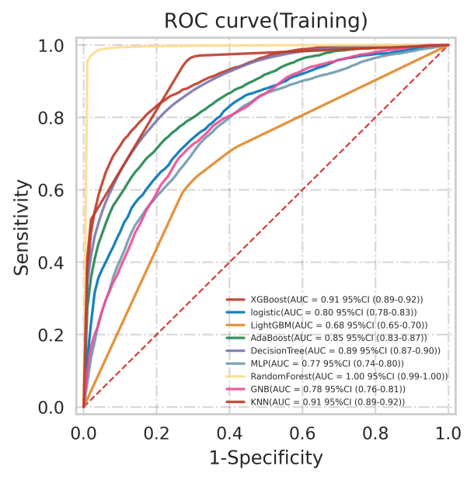
Fig.S7
Fig. S7. Receiver operating characteristic (ROC) curves of nine machine learning models in the training cohort, with Random Forest (RF) achieving the highest AUC.
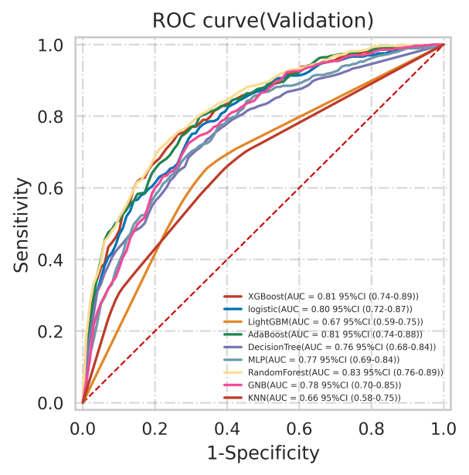
Fig.S8
Fig. S8. ROC curves of nine machine learning models in the validation cohort, showing consistent superiority of the RF model over other algorithms.

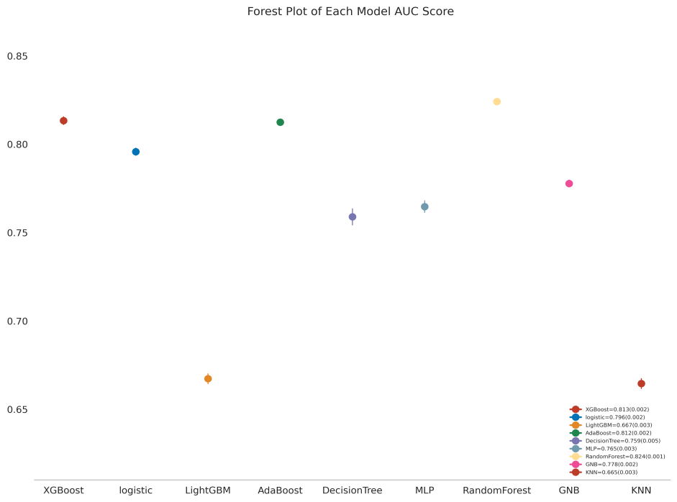
Fig.S9
Fig. S9. Forest plot of AUC distributions for all candidate models, further confirming Random Forest as the best-performing classifier.

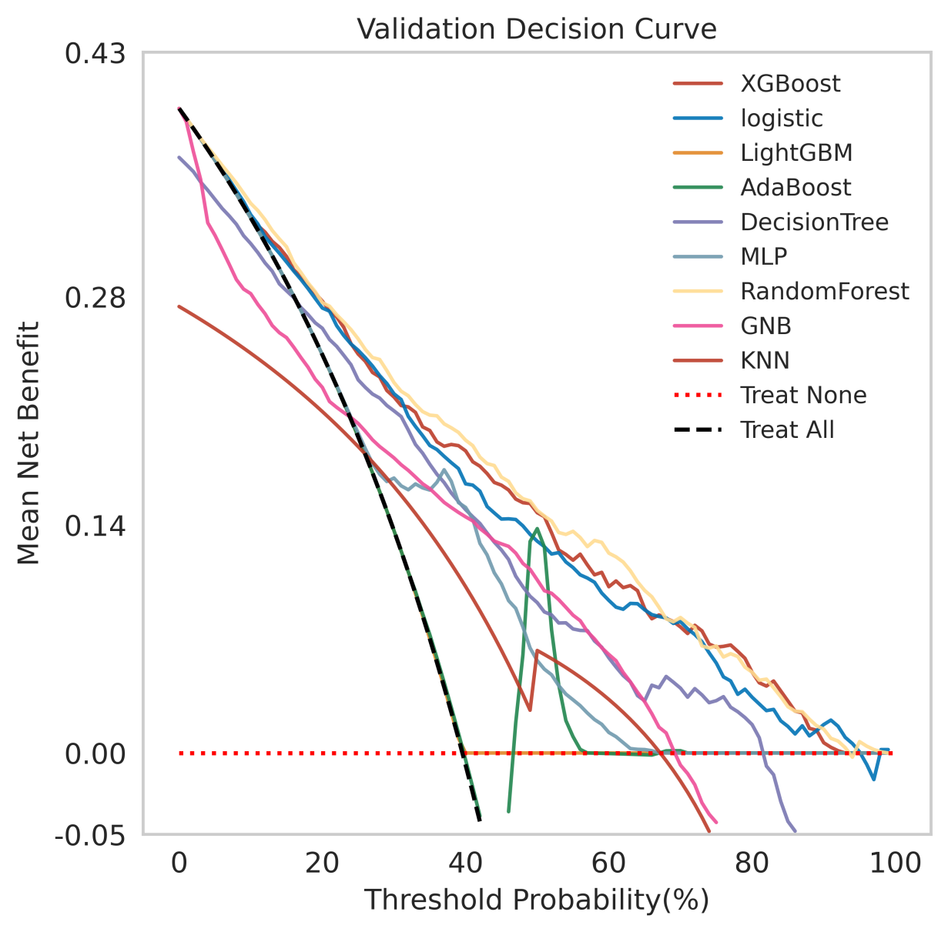
Fig. S10. Decision curve analysis (DCA) of nine models in the validation cohort. RF exhibited the highest net clinical benefit across a broad range of threshold probabilities.

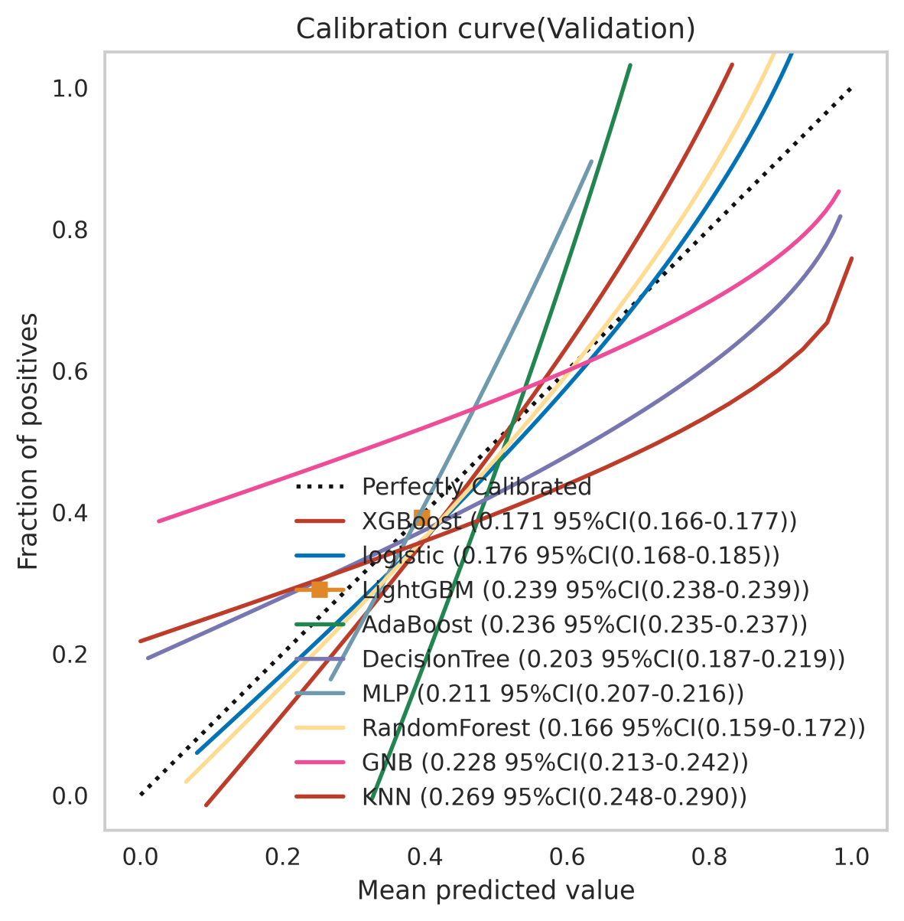
Fig. S11. Calibration curves of machine learning models in the validation cohort. The RF model showed the closest alignment between predicted and observed outcomes, with a calibration error of 0.166 (95% CI: 0.159–0.172).

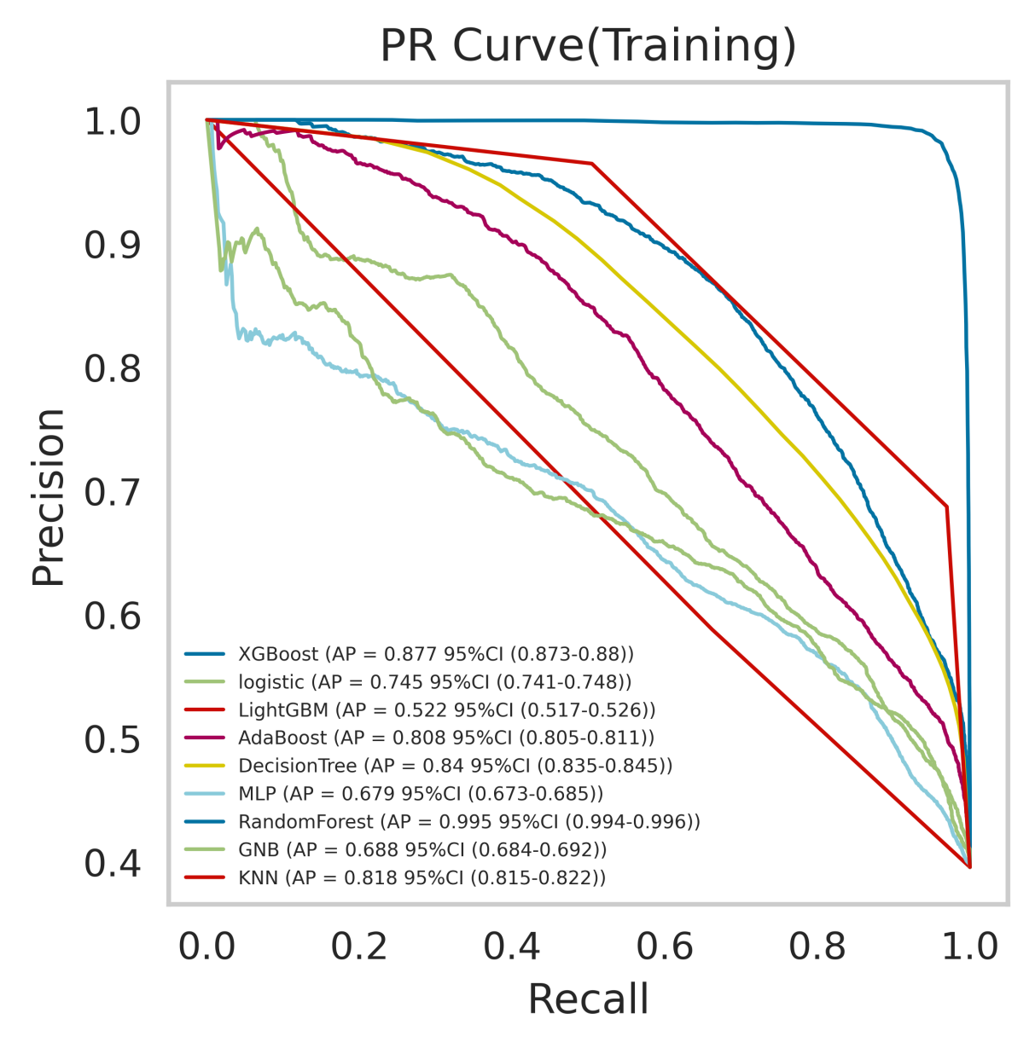
Fig. S12. Precision–recall (PR) curves of nine models in the training cohort, with Random Forest demonstrating the highest average precision (AP = 0.995, 95% CI: 0.994–0.996).

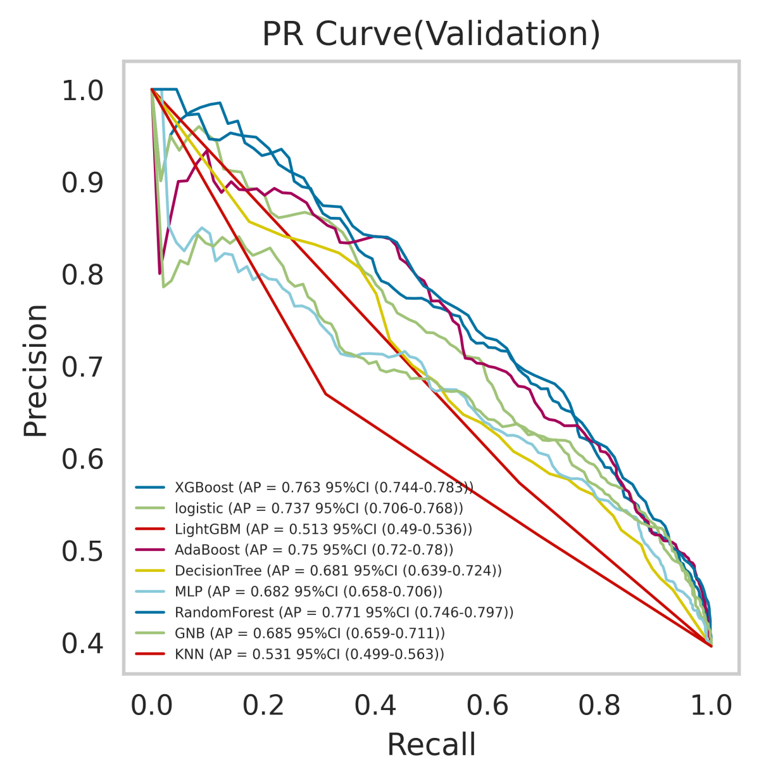
Fig. S13. PR curves of nine models in the validation cohort, where the RF model maintained superior predictive ability (AP = 0.771, 95% CI: 0.746–0.797).

Table S9. Predictive performance of the random forest (RF) model for in-hospital mortality in SCA patients.
Indications | Training(n=1001) | Vaditation(n=215) | Test (n=215)
AUC(95%CI) | 0.87(0.85-0.89) | 0.80(0.78-0.84) | 0.84 (0.79-0.89)
Cut-off(95%CI) | 0.43(0.41-0.45) | 0.58(0.56-0.61) | 0.43
Accuracy(95%CI) | 0.80(0.79-0.80) | 0.74(0.71-0.77) | 0.78
Sensitivity(95%CI) | 0.76(0.73-0.78) | 0.50(0.42-0.57) | 0.72
Specificity(95%CI) | 0.82(0.80-0.85) | 0.91(0.89-0.92) | 0.82
PPV(95%CI) | 0.74(0.72-0.76) | 0.77(0.73-0.81) | 0.72
NPV(95%CI) | 0.84(0.83-0.85) | 0.74(0.71-0.76) | 0.82
F1 score(95%CI) | 0.75(0.74-0.75) | 0.60(0.54-0.66) | 0.72
Kappa Score(95%CI) | 0.58(0.57-0.59) | 0.43(0.35-0.50) | 0.53
Performance metrics include AUC, optimal cut-off value, accuracy, sensitivity, specificity, positive predictive value (PPV), negative predictive value (NPV), F1-score, and kappa coefficient with corresponding 95% confidence intervals (CIs). Results are reported for the training, validation, and independent test cohorts.

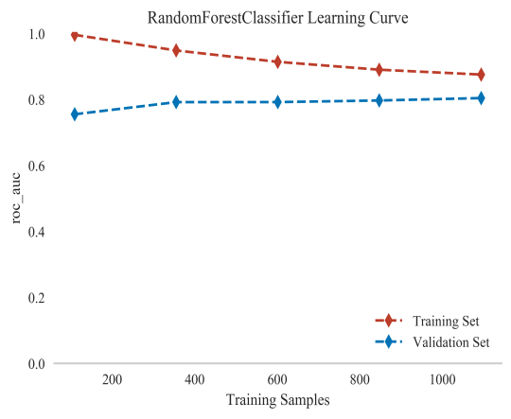
Fig.S14
Fig. S14. Learning curves of the RF model. Training and validation performance converged smoothly with sample size expansion, excluding overfitting.
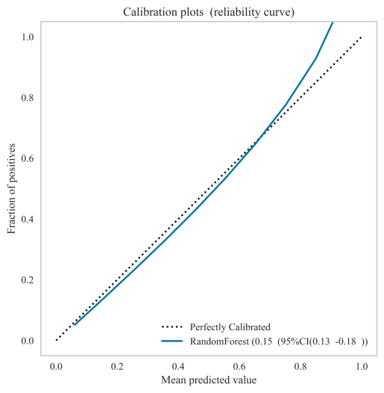
Fig.S15
Fig. S15. Calibration plot of the RF model in the independent test cohort, confirming reliable probability estimation with a Brier score of 0.15 (95% CI: 0.13–0.18).
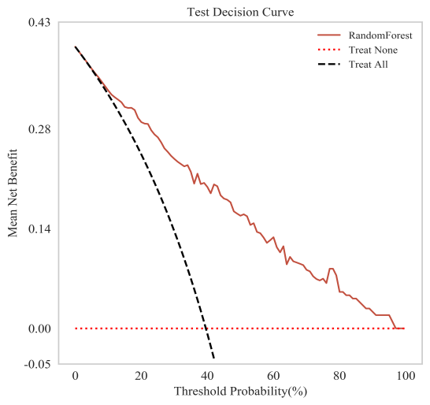
Fig.S16.
Fig. S16. Decision curve analysis (DCA) in the test cohort, showing the RF model provided greater net clinical benefit compared with “Treat All” and “Treat None” strategies.
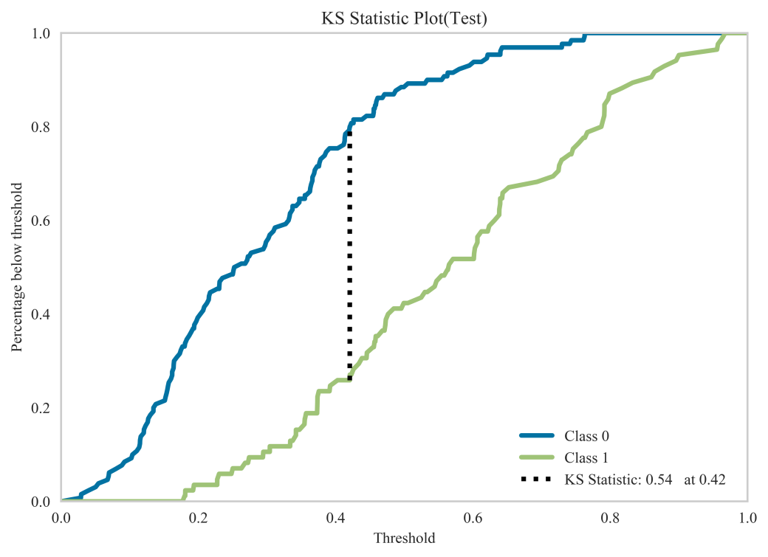
Fig.S17
Fig. S17. Kolmogorov–Smirnov (KS) curve of the RF model in the test cohort. The maximum KS statistic (0.54) was reached at a threshold of 0.42, reflecting strong discrimination between survival and death.

Table S10. Abbreviations of Variables and Methods
Abbreviation | Full Term
MI | Myocardial Infarction
CHF | Congestive Heart Failure
CBD | Cerebrovascular Disease
CPD | Chronic Pulmonary Disease
Diabetes_with_cc | Diabetes with Complications/Comorbidities
Renal_disease | Renal Disease
Malignant_cancer | Malignant Cancer
Severe_liver_disease | Severe Liver Disease
Metastatic_solid_tumor | Metastatic Solid Tumor
APSⅢ | Acute Physiology Score III
SOFA | Sequential Organ Failure Assessment
CCI | Charlson Comorbidity Index
Hct | Hematocrit
Hb | Hemoglobin
PLT | Platelet Count
WBC | White Blood Cell Count
Albumin | Serum Albumin
AG | Anion Gap
Bicarbonate | Serum Bicarbonate
BUN | Blood Urea Nitrogen
Cr | Creatinine
Sodium | Serum Sodium
Potassium | Serum Potassium
Fibrinogen | Plasma Fibrinogen
INR | International Normalized Ratio
PT | Prothrombin Time
PTT | Partial Thromboplastin Time
ALT | Alanine Aminotransferase
ALP | Alkaline Phosphatase
AST | Aspartate Aminotransferase
Amylase | Serum Amylase
Bilirubin_total | Total Bilirubin
CK-CPK | Creatine Phosphokinase
CK-MB | Creatine Kinase-MB Isoenzyme
LDH | Lactate Dehydrogenase
HR | Heart Rate
SBP | Systolic Blood Pressure
DBP | Diastolic Blood Pressure
MBP | Mean Blood Pressure
RR | Respiratory Rate
Temperature | Body Temperature
SPO₂ | Peripheral Oxygen Saturation
SO₂ | Oxygen Saturation (arterial blood gas)
PO₂ | Partial Pressure of Oxygen
PCO₂ | Partial Pressure of Carbon Dioxide
TotalCO₂ | Total Carbon Dioxide
Glucose | Blood Glucose
GCS_min | Glasgow Coma Scale (minimum score)
XGBoost | Extreme Gradient Boosting
LR | Logistic Regression
LGBM | Light Gradient Boosting Machine
Ada | Adaptive Boosting (AdaBoost)
DT | Decision Tree
MLP | Multilayer Perceptron
RF | Random Forest
GNB | Gaussian Naïve Bayes
KNN | K-Nearest Neighbors
ROC | Receiver Operating Characteristic
AUC | Area Under the Curve
PR | Precision–Recall
PPV | Positive Predictive Value
NPV | Negative Predictive Value
F1 | F1 Score (harmonic mean of precision and recall)
DCA | Decision Curve Analysis
CI | Confidence Interval

Acknowledgment
We thank all contributors to the MIMIC-IV database for providing open access to high-quality clinical data. This study was also supported by the Extreme Smart Analysis platform (https://www.xsmartanalysis.com/).

