Quantitative evaluation of encrustations in double-J ureteral stents with micro-computed tomography and semantic segmentation

Shaokai Zheng^{1*}, Pedro Amado¹, Bernhard Kiss², Fabian Stangl², Andreas Haeberlin³, Daniel Sidler⁴, Dominik Obrist¹, Fiona Burkhard², and Francesco Clavica¹

¹ ARTORG Center for Biomedical Engineering Research, University of Bern, 3010 Bern, CH; ² Department of Urology, Inselspital, Bern University Hospital, University of Bern, 3010 Bern, CH; ³ Department of Cardiology, Inselspital, Bern University Hospital, University of Bern, 3010 Bern, CH; ⁴ Department of Nephrology and Hypertension, Inselspital, Bern University Hospital, University of Bern, 3010 Bern, CH. *Email: shaokai.zheng@outlook.com

Supplementary Material S1.

This supplementary material provides full technical notes on the µ-CT (micro–Computed Tomography) and subsequent segmentation. Generally, there are five steps involved in the process, i.e. sample preparation, scanning, image pre-processing, model training and data processing.

Figure S1.1. Illustration of the locations of stent section samples.

In terms of sample preparation, each stent was dried in an oven at 60°C for three hours to remove residual urine and cut into four parts for µ-CT scans, as illustrated in Figure S1.1. Note that, there are radio opaque markers over the length of the stent (referred to as the radio opaque zone, or simply ROZ) to check stent locations in clinical practice. The scanning parameters for the µ-CT scanner (SCANCO Medical AG, Bruettisellen, CH) are listed in Table S1.1, and were kept the same for all scans. Note that the selection of these parameters largely depends on the material and should always be optimized in preliminary scans.
Since the X-ray beam of our µ-CT scanner rotates horizontally, samples need to be placed in a way to have the best possible axisymmetry about the vertical axis. Therefore, the pigtail parts were placed in the sample holder horizontally, while the straight parts were placed vertically, as shown in Figure S1.2. This is important to clarify because the final images from these two parts were different, and therefore required two independent training sessions for the deep learning model.

Parameter | Value
Photon Energy, kVp | 90
Intensity, μA | 200
Integration Time, ms | 200
Frame Averaging, n | 2
Filter (Cupper), mm | 0.1
Voxel Size, μm | 11.4
Field of View, mm | 35.2
Number of slices, n | 310
Table S1.1. Parameters for µ-CT scans.

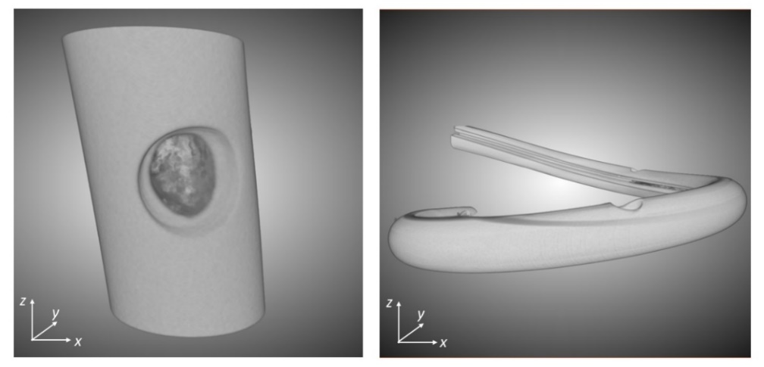
Figure S1.2. Orientations of the straight parts (left) and pigtails (right) in the µ-CT scanner.

To follow, the raw µ-CT images were pre-processed to normalize their intensities and optimize the contract. Subsequently, fifty frames from the straight part images and twenty six images from the pigtail images were labelled (i.e. marked as stent, ROZ, background, and encrustation), as shown in Figure S1.3a-c. The ROZ appears black in the CT images (since they are opaque to the X-ray beam) but does incorporate certain geometries and counts as part of the stent volume. An individual label was therefore designated to separate the ROZ from the background.
These labelled images were used to train the deep-learning segmentation model in the Dragonfly software (Object Research Systems Inc. Quebec, CA), yielding dice coefficients of 0.97 and 0.92 for the straight part and pigtail models, respectively. Examples of test predictions are given in Figure S1.3d-f, where comparisons between ground truth and predictions are visually demonstrated.

Figure S1.3. Sample slices from the ground truth (a-c) and test predictions (d-f). Labels are color coded for stent (blue), ROZ (yellow), encrustations (orange) and background (black).

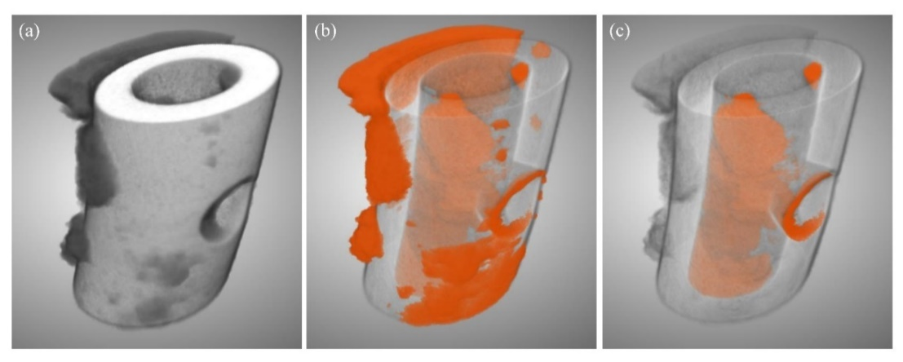
Figure S1.4. Example of (a) the pre-processed 3D image from µ-CT, (b) segmented encrustations (in orange), and (c) luminal encrustations only. The stent is made semi-transparent in (b, c) for better visualization. The section shown is approximately 3.5mm in length, 2mm in outer diameter with 1mm internal diameter. The diameter of the side hole is 1mm.

After the training, all image datasets were segmented using the corresponding model and the luminal encrustations were isolated by excluding encrustations on the external surface. Finally, the volume of each label was extracted, and the volume ratio was calculated for further analyses, as described in the main text.

