Table. 1 Clinical Characteristics in the training, internal test, and external test sets.
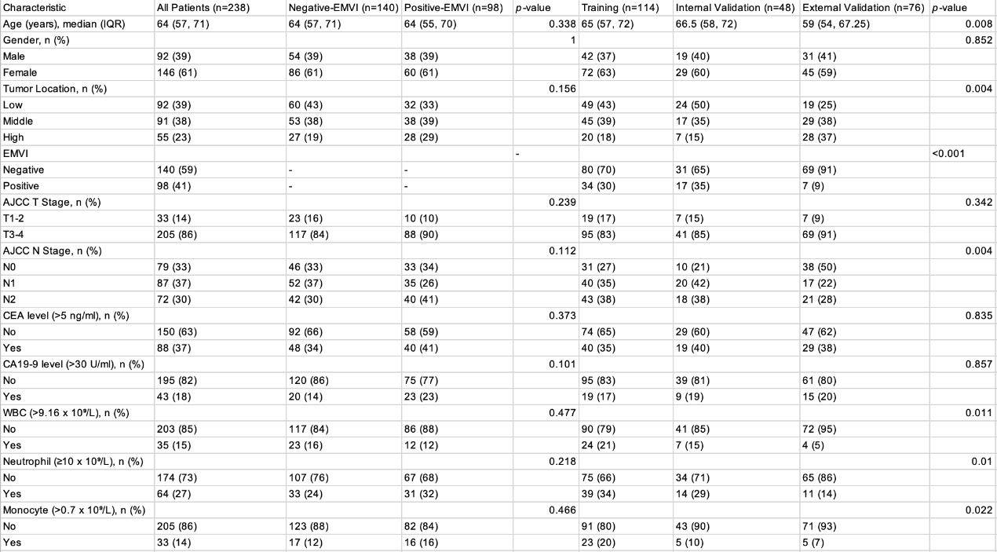

Table. 2 Logistic regression analysis of variables for the association with extramural venous invasion in patients in the training set.
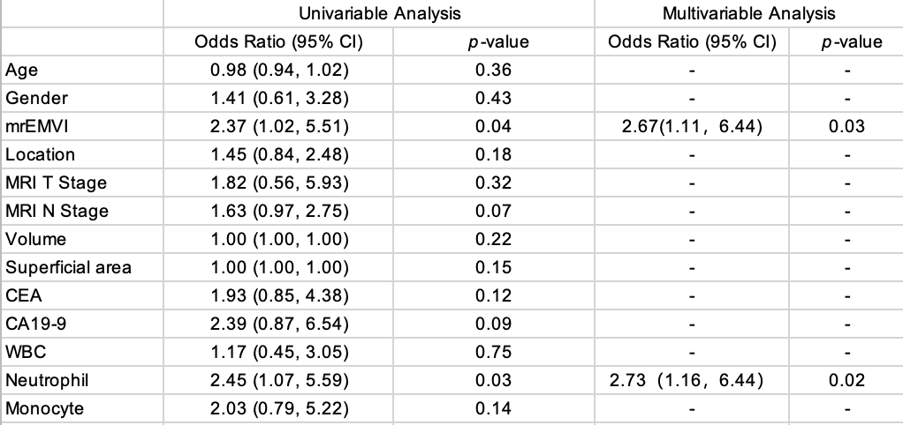
Table. 3 Diagnostic performance of the clinical, radiomics, and combined models in the testing set.
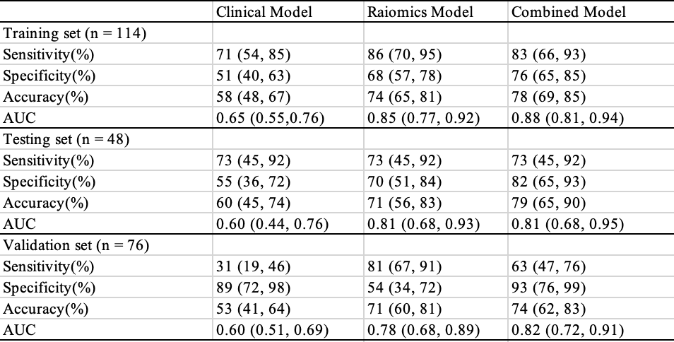

Table. 4 Diagnostic Performance of the Smith 5-point scoring System and the Combined Model in the Training and Validation Cohorts.
