Supporting Information
Topological Anionic Confinement Enables Mild-Synthesis of
2D High-Entropy Molybdates

Bin Chen ¹, Qicheng Zhang ^{1,2,3*}, Honglin Du ⁴, Pengwei Zhao ¹, Weipeng Zhao ¹, Mingjun Cen ¹, Zhuo Chen ¹, Shuya Zhang ¹, Linjie Guan ¹, Yizhe Hu ¹, Tianhao Niu ⁴, Lin Gu ¹, Danyun Xu ^{1,3}, Wenchao Peng ¹, Yang Li ¹, Junliang Sun^{4*} and Xiaobin Fan ^{1,2,3*}

¹ School of Chemical Engineering and Technology, State Key Laboratory of Chemical Engineering, International Joint Laboratory of Low-carbon Chemical Engineering of Ministry of Education, Tianjin University, Tianjin 300072, China.
² Haihe Laboratory of Sustainable Chemical Transformations, Tianjin 300192, China
³ Zhejiang Institute of Tianjin University, Shaoxing, Zhejiang 312300, China.
⁴ College of Chemistry and Molecular Engineering, Peking University, Beijing 100871, China
* Corresponding authors.
E-mail addresses: zhangqicheng@tju.edu.cn; junliang.sun@pku.edu.cn; xiaobinfan@tju.edu.cn.

Materials
All the chemicals used in this work were of analytical grade and used without further purification. Sodium molybdate (Na₂MoO₄), manganous nitrate (Mn(NO₃)₂), ferric nitrate nonahydrate (Fe(NO₃)₃·9H₂O), cobaltous nitrate hexahydrate (Co(NO₃)₂·6H₂O), nickel nitrate hexahydrate (Ni(NO₃)₂·6H₂O), copper nitrate hexahydrate (Cu(NO₃)₂·6H₂O), zinc nitrate hexahydrate (Zn(NO₃)₂·6H₂O), nitric acid (HNO₃) and potassium hydroxide (KOH) were purchased from Aladdin Ltd. Methanol (CH₃OH), ethanol (CH₃CH₂OH) and formic acid (HCOOH) were purchased from Kermel Chemical Reagent Co., Ltd. NafionTM D521 dispersion was purchased from SCI Materials Hub. Deionized water used in all experiments and commercially bottled purified water (Watsons®) exclusively for HPLC mobile phase preparation.
Characterization
Scanning electron microscopy (SEM) images were acquired using a Hitachi Regulus 8100 instrument. Transmission electron microscopy (TEM), high-resolution TEM (HRTEM), and elemental mapping analysis were performed on a JEOL JEM-F200 instrument. X-ray diffraction (XRD) patterns were collected on a Bruker D8 Advance diffractometer with Cu Kα radiation (λ = 1.54178 Å). X-ray photoelectron spectroscopy (XPS) measurements employed a Thermo Fisher K-Alpha+ spectrometer. The spot diameter was 400 μm and the operating pressure was 5×10⁻⁸ Pa. The binding energy was calibrated with C 1s of polluted carbon (284.8 eV is the correction value). Inductively coupled plasma optical emission spectroscopy (ICP-OES) analysis was conducted using an Agilent 5800 instrument, with samples prepared by dissolving catalysts in concentrated HNO₃. Thermogravimetric analysis (TGA) was performed on a TA Instruments Q500 thermobalance under N₂ atmosphere (30−600°C, 10°C/min ramp rate, no equilibration). Raman spectra were collected on a Horiba LabRAM HR Evolution spectrometer (532 nm excitation), calibrated against the Si 520.7 cm⁻¹ peak. X-ray absorption spectroscopy at the metal K-edge was conducted at beamline BL14W1^{[1]} of the Shanghai Synchrotron Radiation Facility (SSRF) using a Si(111) double-crystal monochromator. Measurements employed transmission mode (ionization chambers) or fluorescence mode (Lytle detector) at room temperature, with synchrotron parameters of 3.5 GeV energy and 150−210 mA current. Energy calibration referenced the first inflection point of metal foil.
Electrode preparation
A catalyst ink was prepared by dispersing 10 mg of catalyst and 50 μL NafionTM D521 dispersion in a mixed solvent of 475 μL ethanol and 475 μL deionized water, followed by 30 min sonication to achieve homogeneity. The resulting ink was drop-cast onto 1 × 1.5 cm² nickel foam substrate (1 mm thickness) and dried under ambient conditions. The as-prepared electrode was subsequently employed for methanol oxidation reaction (MOR) studies.

Electrochemical measurements
All electrochemical measurements were performed using a CHI 760E electrochemical workstation (CH Instruments, Shanghai) with a standard three-electrode configuration: the catalyst-modified nickel foam as working electrode, Ag/AgCl (saturated KCl solution) as reference electrode, and graphite rod as counter electrode. The electrolyte consisted of 1.0 M KOH and 1.0 M methanol in deionized water. Prior to testing, electrodes underwent activation via 50 cyclic voltammetry (CV) cycles between 0.15−0.45 V vs. Ag/AgCl at 50 mV s⁻¹ scan rate. All reported potentials were converted to the reversible hydrogen electrode (RHE) scale according to:
E_{RHE}=E_{Ag/AgCl} + 0.0591 × pH + 0.197
Product analysis
Formate concentrations in electrolyte were quantified by high performance liquid chromatography (HPLC; Thermo Scientific UltiMate 3000) with a TC-C18 column (150 × 4.6 mm, 5 μm; Agilent). Separation used 5 mM H₂SO₄ eluent at 0.6 mL/min flow rate, with samples acidified using matching-concentration HCl prior to injection. ¹H NMR spectra were recorded on a Bruker Avance 400 MHz spectrometer using D₂O as solvent and dimethyl sulfoxide (DMSO) as internal standard.

Figure S1. Initial structure model of 5HEMoO that obtained from the initial structure solution with cPEDT data (a), and structure model that after being assigning the right chemistry information and further Rietveld refinement (b).

Figure S2. Thermogravimetric analysis (TGA) from 30-600 °C of 5HEMoO.

Figure S3. Mn (a₁), Fe (b₁), Co(c₁), Ni(d₁) and Cu(e₁) K-edge XANES spectra of 5HEMoO. Mn (a₂), Fe (b₂), Co(c₂), Ni(d₂) and Cu(e₂) non-phase-corrected k2-weighted Fourier-transformed EXAFS spectra of 5HEMoO. R is the interatomic distance, and α is the phase correction.
Figure S4. TEM images of 5HEMoO at 10 min (a) and 30 min (b-b₂). (c) DF-STEM image and corresponding EDS mapping images of 5HEMoO at 10 min. (d) pH results of the crystallization mother liquor with different reaction times and corresponding photo.

Figure S5. Composition and structure analysis of molybdates containing three to six elements. (a) XRD pattern, (b)ICP-OES results, (c) XPS spectra, (d) Mo K-edge XANES spectra, (e) Non-phase-corrected k²-weighted Fourier-transformed EXAFS spectra, (f) Raman patterns of molybdates containing three to six elements. R is the interatomic distance, and α is the phase correction in (e).

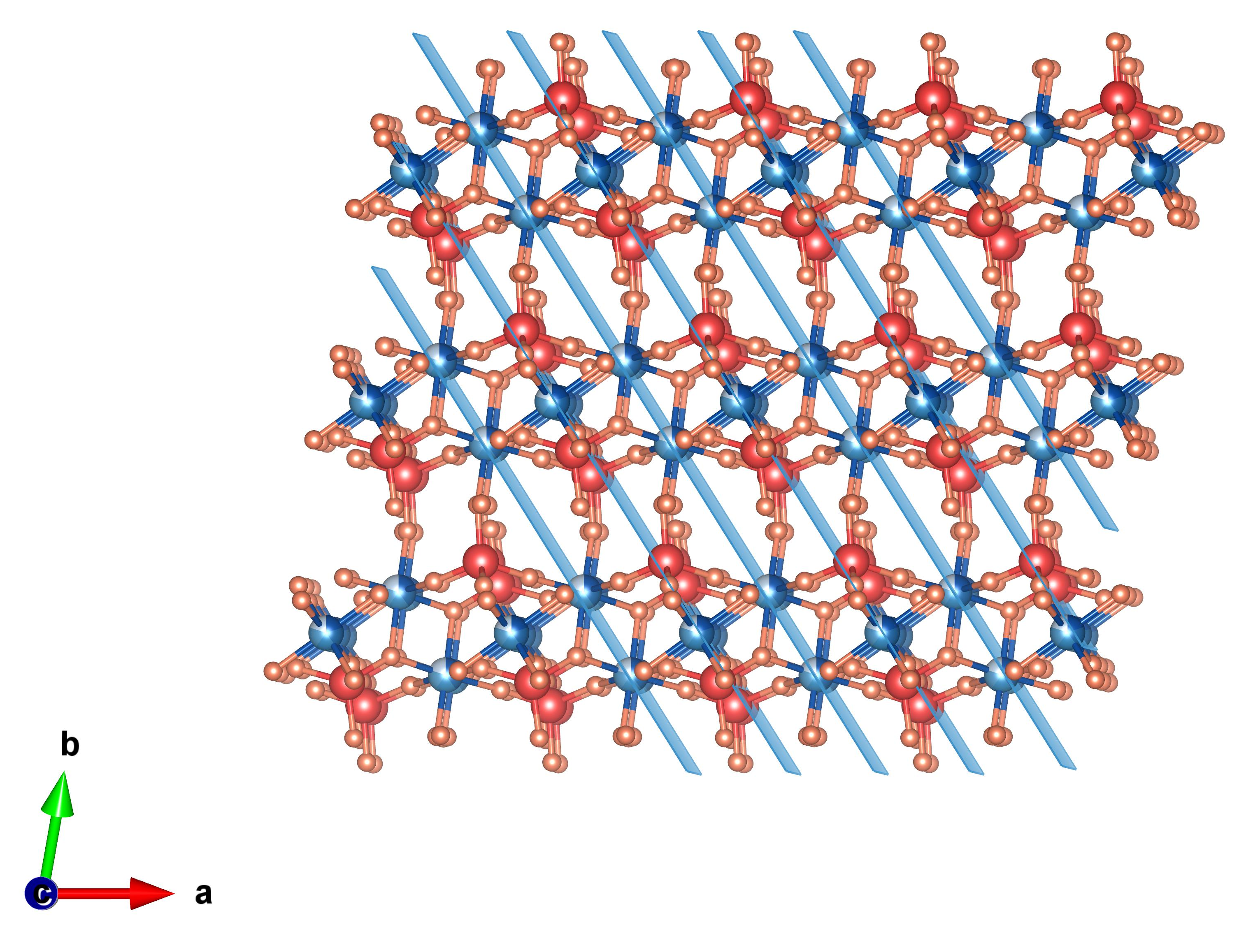
Figure S6. (220) plane in the HEMoO crystal structure.

Figure S7. 1H NMR spectra (400 MHz, D₂O) of the electrolyte after a 1-h test at 100 mA cm⁻² using DMSO as internal standard.

Figure S8. (a) Calibration curve for formic acid quantification via HPLC. (b) Correlation between theoretical and actual formic acid yields versus charge passed.

Figure S9. The conversion of methanol in the MEA cell at different flow rates.

Table S1 Summary of the Rietveld refinement results of 5HEMoO.
Name | 5HEMoO
Chemical formual | M₃(MoO₄)₄·4H₂O (M = Mn, Fe, Co, Ni, Cu)
Crystal system | Triclinic
Unit cell | a = 5.7186(2) Å, b = 7.6594(3) Å, c = 10.4441(3) Å,  α = 70.478(3)°, β = 85.964(2)°, γ = 78.852(3)°
Space group | P–1 (No. 2)
Volume/ Å³ | 423.02
X-ray source | Cu Kα
Wavelength/ Å | 1.5418
2θ | 5−40°
Number of data points | 2742
Refinement method | Rietveld refinement
R_{p} | 7.06%
R_{wp} | 9.28%
R_{exp} | 3.93%
GoF | 2.36

Table S2 Fractional all non-hydrogen atomic coordinates and the unit cell of 5HEMoO from the Rietveld refinement.
5HEMoO |  | Space group: P–1 (No. 2)  a = 5.7186(2) Å, b = 7.6594(3) Å, c = 10.4441(3) Å,  α = 70.478(3)°, β = 85.964(2)°, γ = 78.852(3)°
Name | Atom type | x | y | z
Mo01 | Mo | 0.7542(11) | 0.8100(8) | 0.6722(5)
Mo02 | Mo | 0.1496(12) | 0.2887(10) | 0.7256(5)
M03 | Mn/Fe/Co/Ni/Cu | 0.333(2) | 0.6793(14) | 0.4885(9)
M04 | Mn/Fe/Co/Ni/Cu | 0.000 | 0.500 | 1.000
O05 | O | 0.519(6) | 0.724(5) | 0.634(3)
O06 | O | 0.357(8) | 0.401(6) | 0.606(3)
O07 | O | −0.142(6) | 0.350(5) | 0.663(3)
O08 | O | 1.027(8) | 0.742(5) | 0.594(3)
O09 | O | 0.159(8) | 0.361(7) | 0.872(3)
O10 | O | 0.241(5) | 0.047(5) | 0.764(3)
O11 | O | 0.248(7) | 0.666(5) | 0.958(3)
O12 | O | 1.318(7) | 0.945(6) | 0.370(3)
O13 | O | 0.200(8) | 0.295(6) | 0.150(4)
O14 | O | −0.287(5) | 0.057(4) | 0.960(2)

Table S3 Chemical reagents for 3HEMoO−6HEMoO synthesis.
 | 3HEMoO | 4HEMoO | 5HEMoO | 6HEMoO
Na₂MoO₄ | 3.5 mmol | 4.5 mmol | 5.5 mmol | 6.5 mmol
HNO₃ | 1 mmol | 1 mmol | 1 mmol | 1 mmol
50 wt% Mn(NO₃)₂ solution | 1 mmol | 1 mmol | 1 mmol | 1 mmol
Fe(NO₃)₃·9H₂O | 1 mmol | 1 mmol | 1 mmol | 1 mmol
Co(NO₃)₂·6H₂O | 1 mmol | 1 mmol | 1 mmol | 1 mmol
Ni(NO₃)₂·6H₂O | - | 1 mmol | 1 mmol | 1 mmol
Cu(NO₃)₂·6H₂O | - | - | 1 mmol | 1 mmol
Zn(NO₃)₂·6H₂O | - | - | - | 1 mmol

References
[1] Yu Hai-Sheng et al., Nucl. Sci. Tech. 2015, 26, 050102

