Supplement Figure S1. Haplotyping Control Template (HCT) Sequence. The template sequence of an artificially synthesized 467 base pairs chimeric DNA fragment. It contains the genetic sequences matching the primers and probes targeting the SNPs of interest. The fragments are conjoined in the order of TOMM40 rs2075650, APOE rs429358, and APOC1 rs12721046. The nucleotides in red within the parentheses are the major (in uppercase) and minor (in lowercase) alleles of the SNPs. The // denotes the point of junction where the genes were joined together. A total of eight HCTs for accounting for all SNP variances and haplotype patterns: (1) A-T-G; (2) A-T-a; (3) A-c-G; (4) A-c-a; (5) g-T-G; (6) g-T-a; (7) g-c-G; and (8) g-c-a.

5’-cctctttacaggtggaatcctttgtgagatgttctgctgtgggtctctggagagagctgggggtggtagggaaggaagagatgagagttggtgtggggttgg(A/g)gtggagtgtgacagcgtttctcttctccagagctgtttcccatt//cacggctgtccaaggagctgcaggcggcgcaggcccggctgggcgcggacatggaggacgtg(T/c)gcggccgcctggtgcagtaccgcggcgaggtgcaggccatgctcggccagagcaccgaggagctgcgggt//agtgagccgagatcatgccactgcactccagcctgggcgacaaggcgagactccatgccaaaaaagaaaaaaaactcctggc(G/a)cggtggctcacgccagtaatcccagcactgtgggaggctgagcaggcggatcacgaggtcaggagttcgagactagcctgctcaacataatgaaaccctctctg

Supplement Figure S2. Hypothetical graphical model illustrating optimal 2D-signal distribution from duplexed dPCR reactions. (a) Sample with target SNPs located on the same chromosome (CIS conformation), showing enriched partitions in the (+,+) quadrant. (b) Sample with target SNPs situated on different chromosome (TRANS conformation), depicting enriched partitions in the (+,–) and the (–,+) quadrants.
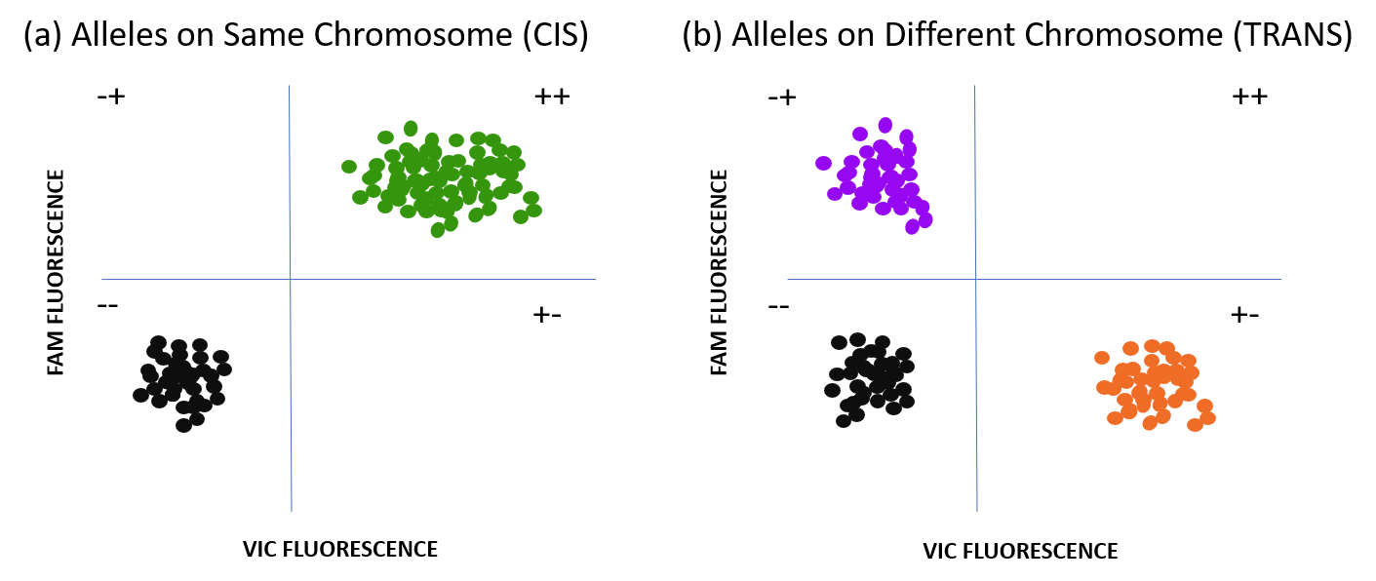

Supplement Figure S3. Fluorescent Plot of Assay with Rain Effect. A graphical depiction of fluorescent signal plots of a DNA sample heterozygous on both APOE and APOC1 SNP sites. (a) The fluorescent plot of the APOE rs429358 c-allele HEX prototype assay. The plot depicted a clear cluster of positive signals at 500 – 1000 RFUs. The HEX signal is detected by VIC channel by Absolute Q dPCR system, therefore labeled as VIC Fluorescence by the software. (b) The fluorescent plot of the APOC1 rs12721046 G-allele ABY prototype assay. The plot depicted a very wide cluster of positive signals at between 0 – 4000 RFUs. The TAMRA signal is detected by ABY channel by Absolute Q dPCR system, therefore labeled as ABY Fluorescence by the software.

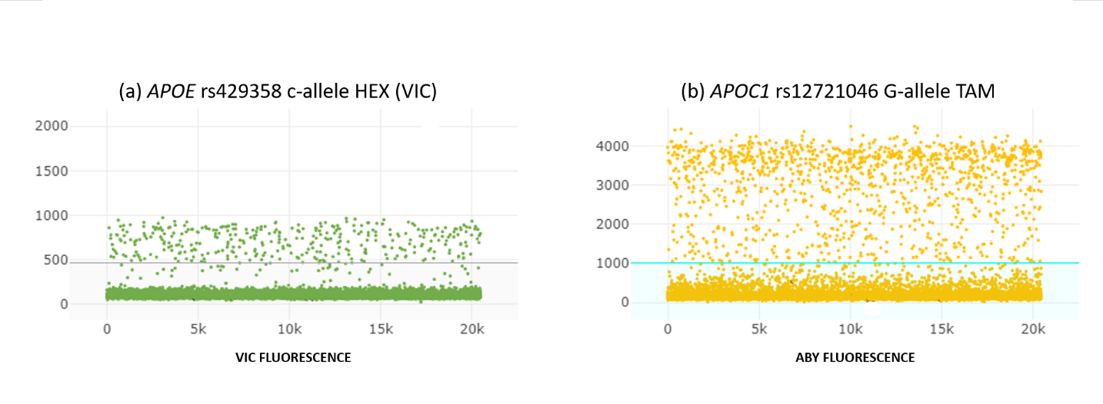

Supplement Figure S4. Fluorescent Plots and 2D-plot of Assay with Non-specific Amplification. A graphical depiction of fluorescent signal plots of a DNA sample heterozygous on both APOE and TOMM40 SNP sites. (a) The fluorescent plot of the APOE rs429358 c-allele HEX prototype assay. The plot depicted a clear cluster of positive signals at 1500 – 2000 RFUs. The HEX signal is detected by VIC channel by Absolute Q dPCR system, therefore labeled as VIC Fluorescence by the software. (b) The fluorescent plot of the TOMM40 rs2075650 g-allele ABY prototype assay. The plot depicted one positive signal cluster at approximately 15,000 RFU, and another false positive cluster at 5,000 RFU. (c) A graphical depiction of double clustering of fluorescent signals in the (+,–) and (–,–) quadrants due to false positive fluorescent signals.

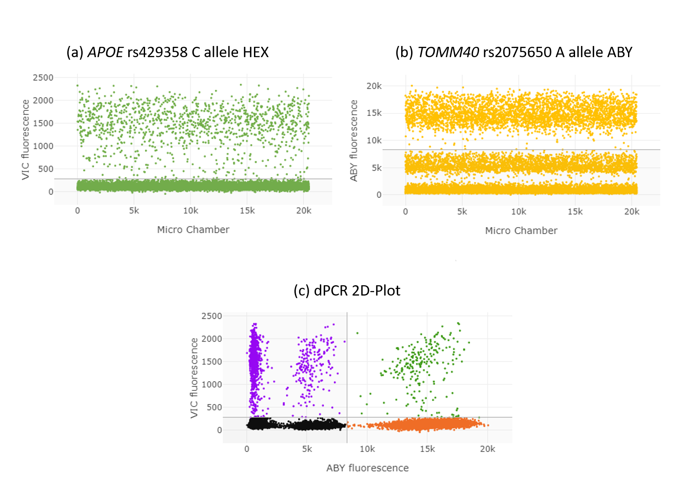

Supplement Table S1. dPCR Primers and Probes.
Gene | SNP Target |  | Primer | Sequence | Comment
TOMM40 | rs2075650 g-allele |  | Ch19_50087415_F | 5’-GGG GGT GGT AGG GAA GGA AGA G-3’ | Forward
 |  |  | Ch19_50087521_R | 5’-CTT GAC ACC CTC CAT CTG AAT G-3’ | Reverse
 |  |  | TOMM40_rs207-G_SUN | /5SUN/AA ACG CTG T/ZEN/C ACA CTC CAC CCC AA/3IABkFQ/ | Long Probe
APOE | rs429358 c-allele |  | Taq_429358_F2 | 5’-GGG CGC GGA CAT GGA G-3’ | Forward
 |  |  | Taq_429358_R2 | 5’-CCT CGC CGC GGT ACT GCA C-3’ | Reverse
 |  |  | APOE_rs429R-C_FAM | /56-FAM/CG GCC GCG CAC GT/3MGBEc/ | MGB Probe
APOC1 | rs12721046 g-allele |  | Ch19_50113051_F | 5’-ACA AGG CGA GAC TCC ATG C-3’ | Forward
 |  |  | Ch19_50113138_R | TGC TCA GCC TCC CAC AGT | Reverse
 |  |  | APOC1_rs127-G_TAM | /56-TAMN/CTC CTG G+C+G +CGG TGG/3IABkFQ/ | Probe (Affinity Plus)

Supplement Table S2. mdPCR Partition Raw Data. (a) Raw TOMM40 – APOE partition numbers extracted from three separate mdPCR experiments. The (+,–) represents APOE rs429358 SNP partitions, the (–,+) represents TOMM40 rs20725650 SNP partitions, the (+,+) represents partitions with both APOE and TOMM40 SNPs, and (–,–) represents empty partitions. (b) Raw APOE – APOC1 partition numbers extracted from three separate mdPCR experiments. The (+,–) represents APOE rs429358 SNP partitions, the (–,+) represents APOC1 rs12721046 SNP partitions, the (+,+) represents partitions with both APOE and APOC1 SNPs, and (–,–) represents empty partitions.
(a) APOE and TOMM40 mdPCR Result
SampleID | +- | -+ | ++ | -- |  | +- | -+ | ++ | -- |  | +- | -+ | ++ | --
AD1 | 425 | 3943 | 91 | 16021 |  | 576 | 7773 | 410 | 11721 |  | 533 | 4562 | 164 | 15221
AD5 | 480 | 3586 | 90 | 16324 |  | 266 | 1843 | 26 | 18345 |  | 286 | 2420 | 42 | 17732
AD8 | 132 | 1864 | 14 | 18470 |  | 197 | 2678 | 32 | 17573 |  | 193 | 3079 | 40 | 17168
AD10 | 415 | 5556 | 182 | 14327 |  | 433 | 4904 | 130 | 15013 |  | 337 | 3300 | 79 | 16764
AD11 | 685 | 12324 | 1396 | 6075 |  | 734 | 9826 | 786 | 9134 |  | 795 | 8317 | 671 | 10697
AD12 | 487 | 4837 | 168 | 14988 |  | 341 | 2947 | 52 | 17140 |  | 401 | 4961 | 113 | 15005
AD13 | 610 | 7438 | 331 | 12101 |  | 557 | 7712 | 388 | 11823 |  | 612 | 9632 | 635 | 9601
AD14 | 702 | 9902 | 814 | 9062 |  | 949 | 9265 | 1045 | 9221 |  | 774 | 5791 | 324 | 13591
AD15 | 568 | 7238 | 349 | 12325 |  | 273 | 3155 | 55 | 16997 |  | 760 | 8247 | 474 | 10999
AD16 | 862 | 12324 | 2147 | 5147 |  | 883 | 8447 | 650 | 10500 |  | 676 | 13507 | 2476 | 3821
AD18 | 846 | 10735 | 1175 | 7724 |  | 8220 | 9787 | 870 | 9003 |  | 838 | 8280 | 448 | 10914
AD19 | 551 | 6070 | 238 | 13621 |  | 370 | 4342 | 87 | 15681 |  | 578 | 6648 | 285 | 12969
AD20 | 428 | 10107 | 450 | 9495 |  | 214 | 4284 | 71 | 15911 |  | 320 | 4828 | 142 | 15190
AD21 | 90 | 487 | 4 | 19899 |  | 88 | 370 | 2 | 20020 |  | 33 | 145 | 0 | 30302
AD22 | 875 | 8538 | 766 | 10301 |  | 831 | 6974 | 496 | 12179 |  | 1017 | 7086 | 433 | 11944
AD23 | 132 | 1579 | 17 | 18752 |  | 154 | 1669 | 16 | 18641 |  | 228 | 4193 | 78 | 15981
AD25 | 418 | 4325 | 132 | 15605 |  | 721 | 7865 | 489 | 11405 |  | 1234 | 9006 | 1248 | 8992
AD27 | 720 | 7551 | 444 | 11765 |  | 762 | 6709 | 394 | 12615 |  | 749 | 6866 | 436 | 12429
AD28 | 82 | 585 | 1 | 19812 |  | 141 | 780 | 6 | 19553 |  | 44 | 321 | 1 | 20114
AD29 | 21 | 211 | 1 | 20247 |  | 20 | 189 | 0 | 20271 |  | 18 | 117 | 0 | 20345
AD31 | 239 | 3109 | 53 | 17079 |  | 510 | 6718 | 289 | 12963 |  | 1045 | 10012 | 1248 | 8175
AD32 | 527 | 4909 | 180 | 14864 |  | 546 | 4059 | 145 | 15730 |  | 500 | 4123 | 135 | 15722
AD34 | 900 | 10166 | 1243 | 8171 |  | 660 | 5188 | 246 | 14386 |  | 523 | 4236 | 128 | 15593
AD35 | 188 | 4788 | 78 | 15426 |  | 253 | 3554 | 74 | 16599 |  | 355 | 9128 | 310 | 10687
AD36 | 297 | 4729 | 97 | 15357 |  | 168 | 2219 | 21 | 18072 |  | 236 | 1847 | 24 | 18373
AD37 | 377 | 7632 | 270 | 12201 |  | 402 | 6218 | 244 | 13616 |  | 463 | 8531 | 507 | 10979
AD40 | 628 | 7126 | 367 | 12359 |  | 300 | 2796 | 55 | 17329 |  | 388 | 5010 | 142 | 14940
CTRL1 | 104 | 1246 | 12 | 19118 |  | 156 | 2085 | 28 | 18211 |  | 183 | 2476 | 29 | 17792
CTRL2 | 961 | 9216 | 955 | 9348 |  | 481 | 11832 | 729 | 7438 |  | 319 | 2613 | 45 | 17503
CTRL3 | 354 | 4301 | 98 | 15727 |  | 381 | 6030 | 191 | 13878 |  | 432 | 7710 | 270 | 12068
CTRL5 | 627 | 5155 | 209 | 14489 |  | 722 | 6546 | 405 | 12807 |  | 566 | 4594 | 181 | 15139
CTRL6 | 273 | 5180 | 92 | 14935 |  | 376 | 10253 | 466 | 9385 |  | 670 | 10363 | 969 | 8478
CTRL7 | 298 | 2208 | 47 | 17927 |  | 320 | 3008 | 62 | 17090 |  | 560 | 3494 | 138 | 16288
CTRL8 | 285 | 3767 | 57 | 16371 |  | 416 | 4608 | 124 | 15332 |  | 289 | 3530 | 77 | 16584
CTRL9 | 208 | 3173 | 42 | 17057 |  | 154 | 289 | 3 | 20034 |  | 392 | 5082 | 128 | 14878
GMM_CTRL1 | 864 | 3473 | 171 | 15972 |  | 985 | 3630 | 201 | 15664 |  | 1166 | 3649 | 307 | 15358
GMM_CTRL2 | 1130 | 6312 | 700 | 12338 |  | 1187 | 6240 | 563 | 12490 |  | 897 | 5556 | 357 | 13670

(b) APOE and APOC1 mdPCR Result
SampleID | +- | -+ | ++ | -- |  | +- | -+ | ++ | -- |  | +- | -+ | ++ | --
AD1 | 357 | 2580 | 46 | 17497 |  | 301 | 2325 | 54 | 17800 |  | 348 | 2500 | 56 | 17576
AD2 | 58 | 336 | 3 | 20083 |  | 118 | 478 | 4 | 19880 |  | 104 | 451 | 3 | 19922
AD3 | 445 | 2462 | 58 | 17515 |  | 556 | 2500 | 87 | 17337 |  | 475 | 2539 | 55 | 17411
AD5 | 82 | 427 | 2 | 19969 |  | 105 | 449 | 4 | 19922 |  | 91 | 500 | 5 | 19884
AD8 | 125 | 1116 | 11 | 19228 |  | 117 | 1171 | 6 | 19186 |  | 109 | 1054 | 4 | 19313
AD10 | 534 | 2270 | 59 | 17617 |  | 518 | 2245 | 61 | 17656 |  | 534 | 2217 | 62 | 17667
AD11 | 735 | 5076 | 228 | 14441 |  | 797 | 4933 | 273 | 14447 |  | 715 | 4608 | 218 | 14939
AD12 | 228 | 1950 | 27 | 18275 |  | 234 | 2026 | 19 | 18201 |  | 217 | 1771 | 20 | 18472
AD13 | 338 | 4191 | 88 | 15863 |  | 368 | 4107 | 96 | 15909 |  | 361 | 4293 | 101 | 15725
AD14 | 921 | 3248 | 201 | 16610 |  | 948 | 3490 | 212 | 15830 |  | 966 | 3500 | 217 | 15797
AD15 | 439 | 3714 | 95 | 16232 |  | 431 | 3700 | 88 | 16261 |  | 424 | 3404 | 73 | 16579
AD16 | 730 | 6075 | 350 | 13325 |  | 739 | 5619 | 300 | 13822 |  | 688 | 5185 | 255 | 14352
AD18 | 596 | 5932 | 237 | 13715 |  | 505 | 5781 | 204 | 13990 |  | 418 | 5003 | 136 | 14923
AD19 | 518 | 4293 | 133 | 15536 |  | 543 | 5347 | 191 | 14399 |  | 432 | 4607 | 120 | 15321
AD20 | 214 | 13978 | 511 | 5777 |  | 200 | 11715 | 313 | 8252 |  | 193 | 11622 | 306 | 8359
AD21 | 29 | 184 | 0 | 20267 |  | 36 | 197 | 0 | 20247 |  | 21 | 153 | 0 | 20306
AD22 | 716 | 4014 | 167 | 15583 |  | 600 | 2200 | 52 | 17628 |  | 627 | 3373 | 112 | 16368
AD23 | 283 | 1552 | 36 | 18609 |  | 231 | 1417 | 12 | 18820 |  | 248 | 1476 | 17 | 18739
AD24 | 1315 | 4058 | 367 | 14740 |  | 232 | 1327 | 17 | 18904 |  | 317 | 1432 | 19 | 18712
AD25 | 858 | 3257 | 148 | 16217 |  | 439 | 2108 | 62 | 17871 |  | 515 | 2285 | 68 | 17612
AD27 | 403 | 2949 | 76 | 17052 |  | 417 | 3325 | 71 | 16667 |  | 382 | 2724 | 53 | 17321
AD28 | 90 | 300 | 1 | 20089 |  | 73 | 312 | 2 | 20093 |  | 84 | 300 | 0 | 20096
AD29 | 16 | 95 | 0 | 20369 |  | 15 | 121 | 0 | 20344 |  | 16 | 92 | 0 | 20372
AD31 | 330 | 3226 | 56 | 16868 |  | 241 | 1884 | 25 | 18330 |  | 320 | 2682 | 51 | 17427
AD40 | 238 | 1500 | 28 | 18714 |  | 206 | 1855 | 16 | 18403 |  | 215 | 1775 | 16 | 18474
CTRL1 | 257 | 1627 | 24 | 18572 |  | 238 | 1796 | 17 | 18429 |  | 257 | 1669 | 30 | 18524
CTRL2 | 518 | 4099 | 125 | 15738 |  | 285 | 2702 | 38 | 17455 |  | 433 | 4010 | 91 | 15946
CTRL3 | 147 | 2744 | 25 | 17564 |  | 155 | 2729 | 23 | 17573 |  | 146 | 2532 | 16 | 17786
CTRL5 | 450 | 2414 | 64 | 17552 |  | 457 | 2246 | 43 | 17734 |  | 484 | 2140 | 56 | 17800
CTRL7 | 239 | 1192 | 13 | 19036 |  | 197 | 1232 | 9 | 19042 |  | 199 | 1227 | 5 | 19049
CTRL8 | 210 | 3015 | 41 | 17214 |  | 200 | 2846 | 28 | 17406 |  | 205 | 2768 | 38 | 17469
CTRL9 | 159 | 1798 | 18 | 18505 |  | 148 | 1824 | 10 | 18498 |  | 157 | 1774 | 14 | 18535
GMM_CTRL1 | 701 | 1183 | 57 | 18539 |  | 592 | 1195 | 46 | 18647 |  | 730 | 1392 | 57 | 18301
GMM_CTRL2 | 577 | 2005 | 70 | 17828 |  | 846 | 2433 | 129 | 17072 |  | 813 | 2333 | 108 | 17226

Supplement Table S3. GMM Analysis Result (CIS and TRANS Classification). (a) APOE – TOMM40 GMM classification of CIS or TRANS haplotype pattern based on mdPCR partitions. (b) APOE – APOC1 GMM classification of CIS or TRANS haplotype pattern based on mdPCR partitions.
(a) APOE – TOMM40 GMM Analysis Result
SampleID | cis_fraction | trans_fraction | CIS_posterior | GMM_class
AD1 | 0.036 | 0.964 | 0.343 | TRANS
AD5 | 0.017 | 0.983 | 0.098 | TRANS
AD8 | 0.010 | 0.990 | 0.083 | TRANS
AD10 | 0.025 | 0.975 | 0.150 | TRANS
AD11 | 0.080 | 0.920 | 1.000 | CIS
AD12 | 0.023 | 0.977 | 0.130 | TRANS
AD13 | 0.049 | 0.951 | 0.788 | CIS
AD14 | 0.074 | 0.926 | 0.999 | CIS
AD15 | 0.042 | 0.958 | 0.534 | CIS
AD16 | 0.126 | 0.874 | 1.000 | CIS
AD18 | 0.061 | 0.939 | 0.980 | CIS
AD19 | 0.032 | 0.968 | 0.242 | TRANS
AD20 | 0.032 | 0.968 | 0.242 | TRANS
AD21 | 0.005 | 0.995 | 0.084 | TRANS
AD22 | 0.063 | 0.937 | 0.988 | CIS
AD23 | 0.014 | 0.986 | 0.087 | TRANS
AD25 | 0.073 | 0.927 | 0.999 | CIS
AD27 | 0.052 | 0.948 | 0.874 | CIS
AD28 | 0.004 | 0.996 | 0.085 | TRANS
AD29 | 0.002 | 0.998 | 0.090 | TRANS
AD31 | 0.068 | 0.932 | 0.997 | CIS
AD32 | 0.030 | 0.970 | 0.216 | TRANS
AD34 | 0.069 | 0.931 | 0.998 | CIS
AD35 | 0.025 | 0.975 | 0.142 | TRANS
AD36 | 0.015 | 0.985 | 0.089 | TRANS
AD37 | 0.041 | 0.959 | 0.529 | CIS
AD40 | 0.034 | 0.966 | 0.279 | TRANS
CTRL1 | 0.011 | 0.989 | 0.083 | TRANS
CTRL2 | 0.064 | 0.936 | 0.991 | CIS
CTRL3 | 0.028 | 0.972 | 0.183 | TRANS
CTRL5 | 0.042 | 0.958 | 0.544 | CIS
CTRL6 | 0.053 | 0.947 | 0.905 | CIS
CTRL7 | 0.024 | 0.976 | 0.139 | TRANS
CTRL8 | 0.020 | 0.980 | 0.107 | TRANS
CTRL9 | 0.018 | 0.982 | 0.101 | TRANS
GMM_CTRL1 | 0.047 | 0.953 | 0.739 | CIS
GMM_CTRL2 | 0.071 | 0.929 | 0.999 | CIS

(b) APOE – APOC1 GMM Analysis Result
SampleID | cis_fraction | trans_fraction | CIS_posterior | GMM_class
AD1 | 0.018 | 0.982 | 0.484 | TRANS
AD2 | 0.006 | 0.994 | 0.086 | TRANS
AD3 | 0.022 | 0.978 | 0.736 | CIS
AD5 | 0.007 | 0.993 | 0.087 | TRANS
AD8 | 0.006 | 0.994 | 0.080 | TRANS
AD10 | 0.021 | 0.979 | 0.711 | CIS
AD11 | 0.041 | 0.959 | 1.000 | CIS
AD12 | 0.010 | 0.990 | 0.136 | TRANS
AD13 | 0.020 | 0.980 | 0.644 | CIS
AD14 | 0.046 | 0.954 | 1.000 | CIS
AD15 | 0.021 | 0.979 | 0.663 | CIS
AD16 | 0.045 | 0.955 | 1.000 | CIS
AD18 | 0.031 | 0.969 | 0.989 | CIS
AD19 | 0.027 | 0.973 | 0.957 | CIS
AD20 | 0.029 | 0.971 | 0.977 | CIS
AD21 | 0.000 | 1.000 | 0.058 | TRANS
AD22 | 0.028 | 0.972 | 0.965 | CIS
AD23 | 0.012 | 0.988 | 0.189 | TRANS
AD24 | 0.044 | 0.956 | 1.000 | CIS
AD25 | 0.029 | 0.971 | 0.973 | CIS
AD27 | 0.019 | 0.981 | 0.557 | CIS
AD28 | 0.003 | 0.997 | 0.064 | TRANS
AD29 | 0.000 | 1.000 | 0.058 | TRANS
AD31 | 0.015 | 0.985 | 0.291 | TRANS
AD40 | 0.010 | 0.990 | 0.138 | TRANS
CTRL1 | 0.012 | 0.988 | 0.179 | TRANS
CTRL2 | 0.021 | 0.979 | 0.659 | CIS
CTRL3 | 0.008 | 0.992 | 0.097 | TRANS
CTRL5 | 0.020 | 0.980 | 0.577 | CIS
CTRL7 | 0.006 | 0.994 | 0.084 | TRANS
CTRL8 | 0.011 | 0.989 | 0.164 | TRANS
CTRL9 | 0.007 | 0.993 | 0.092 | TRANS
GMM_CTRL1 | 0.027 | 0.973 | 0.947 | CIS
GMM_CTRL2 | 0.033 | 0.967 | 0.996 | CIS

Supplementary Methods

Preparation of gDNA: Restriction Enzymes versus Sonication
While the default dPCR protocol uses restriction enzymes to fragment gDNA, this approach has key limitations. Enzymes cleave only at specific recognition sites, which may be absent in the target region, and can disrupt the full gene sequence by cutting between SNPs of interest. Therefore, using a sonication protocol as an alternative to restriction enzyme digestion offers the researchers more flexibility. The intensity, duration, and cycles of each sonication protocol can be easily adjusted based on the research design. This protocol can also generate larger DNA fragments, allowing for haplotype reconstruction of target SNPs spanning larger genomic regions. A previous study has also suggested that random shearing through sonication can effectively increase the sensitivity of droplet digital PCR (1). This sonication approach improved dPCR’s partition occupancy and signal discrimination, thereby enhancing the assay’s capacity for reliable haplotype phasing in challenging genomic contexts. However, the process of random shearing of gDNA can also cut between the target SNPs, generating DNA fragments that contain only one target SNP. This contributes to the enriched signals and partitions observed in the (+,–) and (–,+) quadrants from dPCR, even in samples that are homozygous for the target haplotype. It also highlights the importance of using machine learning model such as GMM for haplotype classification instead of categorizing with an arbitrary threshold. The GMM-based statistical framework enables unbiased and scalable interpretation of complex multiplex dPCR datasets, thereby enhancing the accuracy and reproducibility of haplotype phasing. Moreover, this approach significantly improves the scalability and robustness of mdPCR analyses when applied to high-throughput experimental platforms.

Addressing Challenges in SNP Assays and Optimizing the Design
The advantage of using TaqMan-based assay is that it is relatively inexpensive to synthesize large batch of primers to test for primers and probes compatibility. In this study, we made multiple attempts to mix and match, and redesign different primer and probe combinations. The assay’s ultra-sensitive detection system can be challenged by fluorescence tag interference and target regions containing SNPs, high GC content, or repetitive sequences.

The reporter dyes VIC and FAM, in combination of Minor Groove Binder (MGB) quencher, are considered the gold standard for TaqMan-based allelic discrimination protocols (2). Other combinations of reporter dyes have rarely been tested together; thus, their compatibility for multiplexing remains unclear. In this study, we systematically evaluated multiple duplex combinations of FAM, VIC, HEX, ABY, TAMRA, ROX, Texas Red, and Cy5 to optimize detection efficiency. Based on our results, we recommend tagging the primer/probe set with lowest amplification efficiency using the reporter dye with highest fluorescent intensity—typically FAM—to compensate for reduced signal output detected by Absolute Q. This strategic pairing enhances overall assay performance and improves the reliability of multiplexed detection. These results underscore the critical importance of instrument-specific spectral optimization when designing multiplexed assays and highlight Absolute Q’s superior performance in accommodating expanded dye sets.

Primer interferences in the duplex design can result in reduced PCR amplification efficiency. The non-specific bindings of the primers and inefficient amplifications of the target sequence within each microwell lead to the emission of wide spectrum of inconsistent fluorescent signals. This resulted in an indistinct threshold between target and background signals. Rather than forming a clear cluster of well-amplified partitions, the one-dimensional fluorescence signal plot displayed a “rain effect”, with signals scattered between the positive and background clusters.

A severe “rain effect” was initially observed from the fluorescence plots of APOE rs429358 and APOC1 rs12721046 prototype assays (See Supplement Figure S3). We addressed this issue by increasing the annealing and extension temperature of the dPCR profile from 60ºC to 70ºC, allowing for more stringent annealing and increasing the specificity of the probes and primers. However, we observed a significant decrease in positive partitioning from the pairing duplex assay (rs429358), suggesting that other primers and probes in the duplex reaction may not withstand higher temperatures, making this approach less ideal. Consequently, we opted for an alternative method by artificially increasing the melting temperature (Tm) and specificity of the probe with Locked Nucleic Acid design (3). Through this design, we were able to decrease the annealing and extension temperature of the dPCR profile from 70ºC to 66ºC; successfully eliminated the “rain effect” while preserving the efficacy of the other assay.

Another big challenge in this study was the occurrence of the false positive partitions in the prototype SNP assays for TOMM40 rs2075650 (See Supplement Figure S4). Instead of single band of positive partitions, we observed double bands of positive partitions for prototype rs2075650 SNP assay in the fluorescent plot (Figure S4a vs. S4b). The band with lower fluorescent signal is likely a representation of non-specific amplification. This results in an extra cluster to appear in the 2D-plot and would heavily skew the result due to inflated (+,–) partitions (Figure S4c). We speculated that the presence of multiple G-nucleotides (four consecutive Gs located 5bp upstream) around the target SNP might complicate probe annealing, potentially resulting in non-specific amplification. It is unknown why non-specific amplification would emit a lower RFU signal, we have consulted ThermoFisher Scientifics Absolute Q troubleshooting team, but was unable to identify the background mechanism of such observation. However, we resolved the double band issue by synthesizing extra-long probe and by increasing the annealing and extension temperature of the dPCR profile from 60ºC to 62ºC.

It is noteworthy that despite the high GC content, the APOE SNP rs429358, which is also enriched in highly repetitive and condensed 5'-C-phosphate-G-3' (CpG) site, amplified successfully without any issues. This suggested that even with high GC contents, it is possible to design a probe that avoids non-specific amplification and amplifies the target SNP properly.

Capabilities of the dPCR Instruments
Three major factors are taken into consideration when testing the two dPCR instruments. First, we evaluated the sensitivity and target detection accuracy by comparing detected partition numbers to actual copy numbers of the synthesized HCTs. Both systems showed 10 – 15% partition discrepancies, but overall demonstrated adequate accurate estimations.

Second, we assessed the variety of fluorescent dyes each system could detect, as this study’s goal was to develop a multiplex protocol for haplotype reconstruction. Absolute Q uses ROX (Red Channel) as quality control channel, can multiplex up to four SNPs. In contrast, QIAcuity employs a specialized internal control channel, supports multiplex up to five SNPs. However, we found that QIAcuity was less effective at detecting fluorescent signals from red and crimson spectra. Although Absolute Q’s signal intensity in the red-end spectrum was also slightly lower, it showed no accuracy issues, making it more favorable for phase haplotyping despite lacking an additional detection channel.

Lastly, we evaluated the cost-effectiveness of both dPCR systems. Compared to Absolute Q’s MAP 16 plate, which can only accommodate for a maximum of 16 samples per run, the QIAcuity nanoplate can handle 24 to 96 samples per run depending on the model of the nanoplate. However, this increased throughput comes at the expense of a lower total number of detectable partitions. A key advantage of the MAP16 plate is its flexibility. only four samples per well need to be run at once, allowing unused wells to be preserved for future experiments. In contrast, QIAcuity nanoplate requires either filling all wells (24 or 96 samples) or sacrificing the entire plate for fewer samples. As a result, we concluded that Absolute Q is more suitable for the exploration, development, and optimization of dPCR phase haplotype protocol.

Supplement References
1. Vitomirov A, Ramirez-Gaona M, Mehta SR, Perez-Santiago J. Random shearing as an alternative to digestion for mitochondrial DNA processing in droplet digital PCR. Mitochondrion. 2017;32:16-8.
2. Latif S, Bauer-Sardina I, Ranade K, Livak KJ, Kwok PY. Fluorescence polarization in homogeneous nucleic acid analysis II: 5'-nuclease assay. Genome Res. 2001;11(3):436-40.
3. Grunweller A, Hartmann RK. Locked nucleic acid oligonucleotides: the next generation of antisense agents? BioDrugs. 2007;21(4):235-43.

