Table S1 Analysis of variance (ANOVA) for the 55 morphological variables of Laelia albida in the Tehuacán Valley.
Variable | Mean | Coefficient  of  variation | Mean Square |  | Variable | Mean | Coefficient  of  variation | Mean Square
Variable | Mean | Coefficient  of  variation | Accessions | Error |  |  |  | Accessions | Error
BASAL REGION |  |  |  |  | BASAL REGION
A1 | 2.010 | 4.185 | 0.134*** | 0.007 | B3 | 0.309 | 8.482 | 0.004*** | 0.000
A2 | 0.440 | 9.913 | 0.027*** | 0.001 | B4 | 0.744 | 6.155 | 0.065*** | 0.002
A3 | 0.341 | 14.472 | 0.024*** | 0.002 | B5 | 0.755 | 5.778 | 0.075*** | 0.001
A4 | 1.380 | 5.367 | 0.268*** | 0.005 | C1 | 0.299 | 7.732 | 0.006*** | 0.000
A5 | 0.344 | 13.584 | 0.019*** | 0.002 | C2 | 1.524 | 4.650 | 0.225*** | 0.005
A6 | 0.428 | 12.419 | 0.024*** | 0.002 | C3 | 0.297 | 8.292 | 0.006*** | 0.000
A7 | 0.741 | 0.216 | 0.061*** | 0.002 | C4 | 0.820 | 4.629 | 0.053*** | 0.001
A8 | 0.758 | 6.121 | 0.076*** | 0.002 | C5 | 0.812 | 5.233 | 0.052*** | 0.001
B1 | 0.313 | 8.473 | 0.005*** | 0.000 | C6 | 0.825 | 5.623 | 0.066*** | 0.002
B2 | 1.538 | 4.175 | 0.195*** | 0.004 | C7 | 0.821 | 7.991 | 0.064*** | 0.004
MIDDLE REGION |  |  |  |  |  | APICAL REGION
D1 | 0.184 | 51.721 | 0.051*** | 0.009 | F4 | 0.643 | 5.973 | 0.045*** | 0.001
D2 | 1.458 | 8.836 | 0.280*** | 0.016 | F5 | 0.683 | 5.801 | 0.022*** | 0.001
D3 | 0.167 | 16.142 | 0.005*** | 0.000 | F6 | 0.696 | 5.962 | 0.026*** | 0.001
D4 | 0.185 | 23.780 | 0.008*** | 0.001 | F7 | 0.645 | 6.187 | 0.054*** | 0.001
D5 | 0.179 | 27.574 | 0.007*** | 0.002 | G1 | 0.282 | 8.793 | 0.014*** | 0.000
D6 | 0.284 | 12.387 | 0.011*** | 0.001 | G2 | 1.079 | 6.709 | 0.071*** | 0.005
E1 | 0.181 | 58.393 | 0.038*** | 0.011 | G3 | 0.279 | 8.041 | 0.015*** | 0.000
E2 | 1.156 | 11.720 | 0.303*** | 0.018 | G4 | 0.687 | 6.164 | 0.023*** | 0.001
E3 | 0.159 | 24.636 | 0.003* | 0.001 | G5 | 0.600 | 7.268 | 0.012*** | 0.001
E4 | 0.162 | 21.472 | 0.009*** | 0.001 | G6 | 0.606 | 7.906 | 0.016*** | 0.002
E5 | 0.177 | 26.194 | 0.008*** | 0.002 | G7 | 0.692 | 5.545 | 0.026*** | 0.001
E6 | 0.144 | 20.613 | 0.005*** | 0.000 | H1 | 0.219 | 21.938 | 0.006* | 0.002
E7 | 0.140 | 24.606 | 0.005*** | 0.001 | H2 | 0.167 | 30.443 | 0.007* | 0.002
E8 | 0.175 | 22.430 | 0.008*** | 0.001 | H3 | 0.602 | 8.040 | 0.014*** | 0.002
E9 | 0.183 | 25.953 | 0.007*** | 0.002 | H4 | 0.416 | 11.740 | 0.011*** | 0.002
F1 | 0.279 | 30.448 | 0.029*** | 0.007 | H5 | 0.421 | 14.096 | 0.012*** | 0.003
F2 | 1.266 | 8.344 | 0.116*** | 0.011 | H6 | 0.595 | 9.124 | 0.013*** | 0.002
F3 | 0.269 | 16.392 | 0.018*** | 0.001
*=P≤0.05,***=P≤0.0001
CV: High CV: Intermediate CV: Low
Table S2. Eigenvalues and cumulative proportion of variance explained by the first three principal components (PCs) for the 55 labellum morphological variables of Laelia albida.

Valores propios | PC1 | PC2 | PC3
Eigenvalue | 25.832 | 5.561 | 3.668
Variance (%) | 46.966 | 10.110 | 6.669
Accumulative variance (%) | 46.966 | 57.077 | 63.746

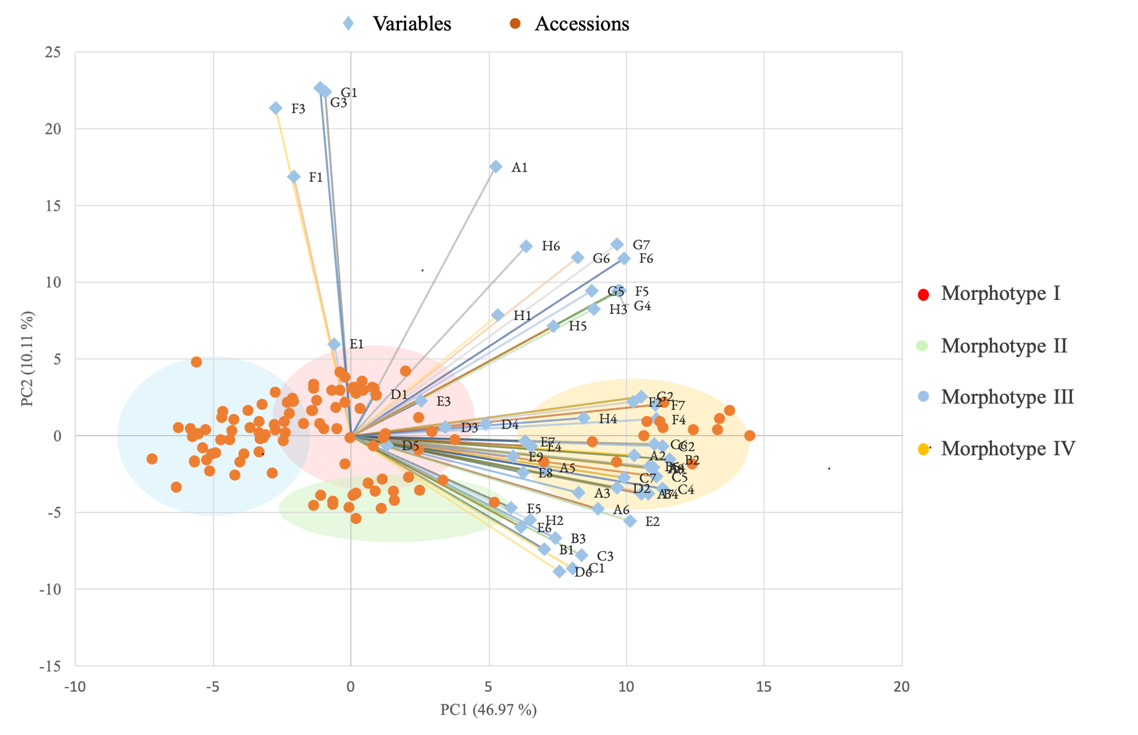
Figure S1 Spatial distribution of morphotypes in Laelia albida populations and the morphological variables with the highest loadings on the principal components (PC). Blue diamonds denote morphological variables, and orange circles denote accessions grouped by morphotype. Each morphotype is delineated with an arbitrary color for visual distinction.

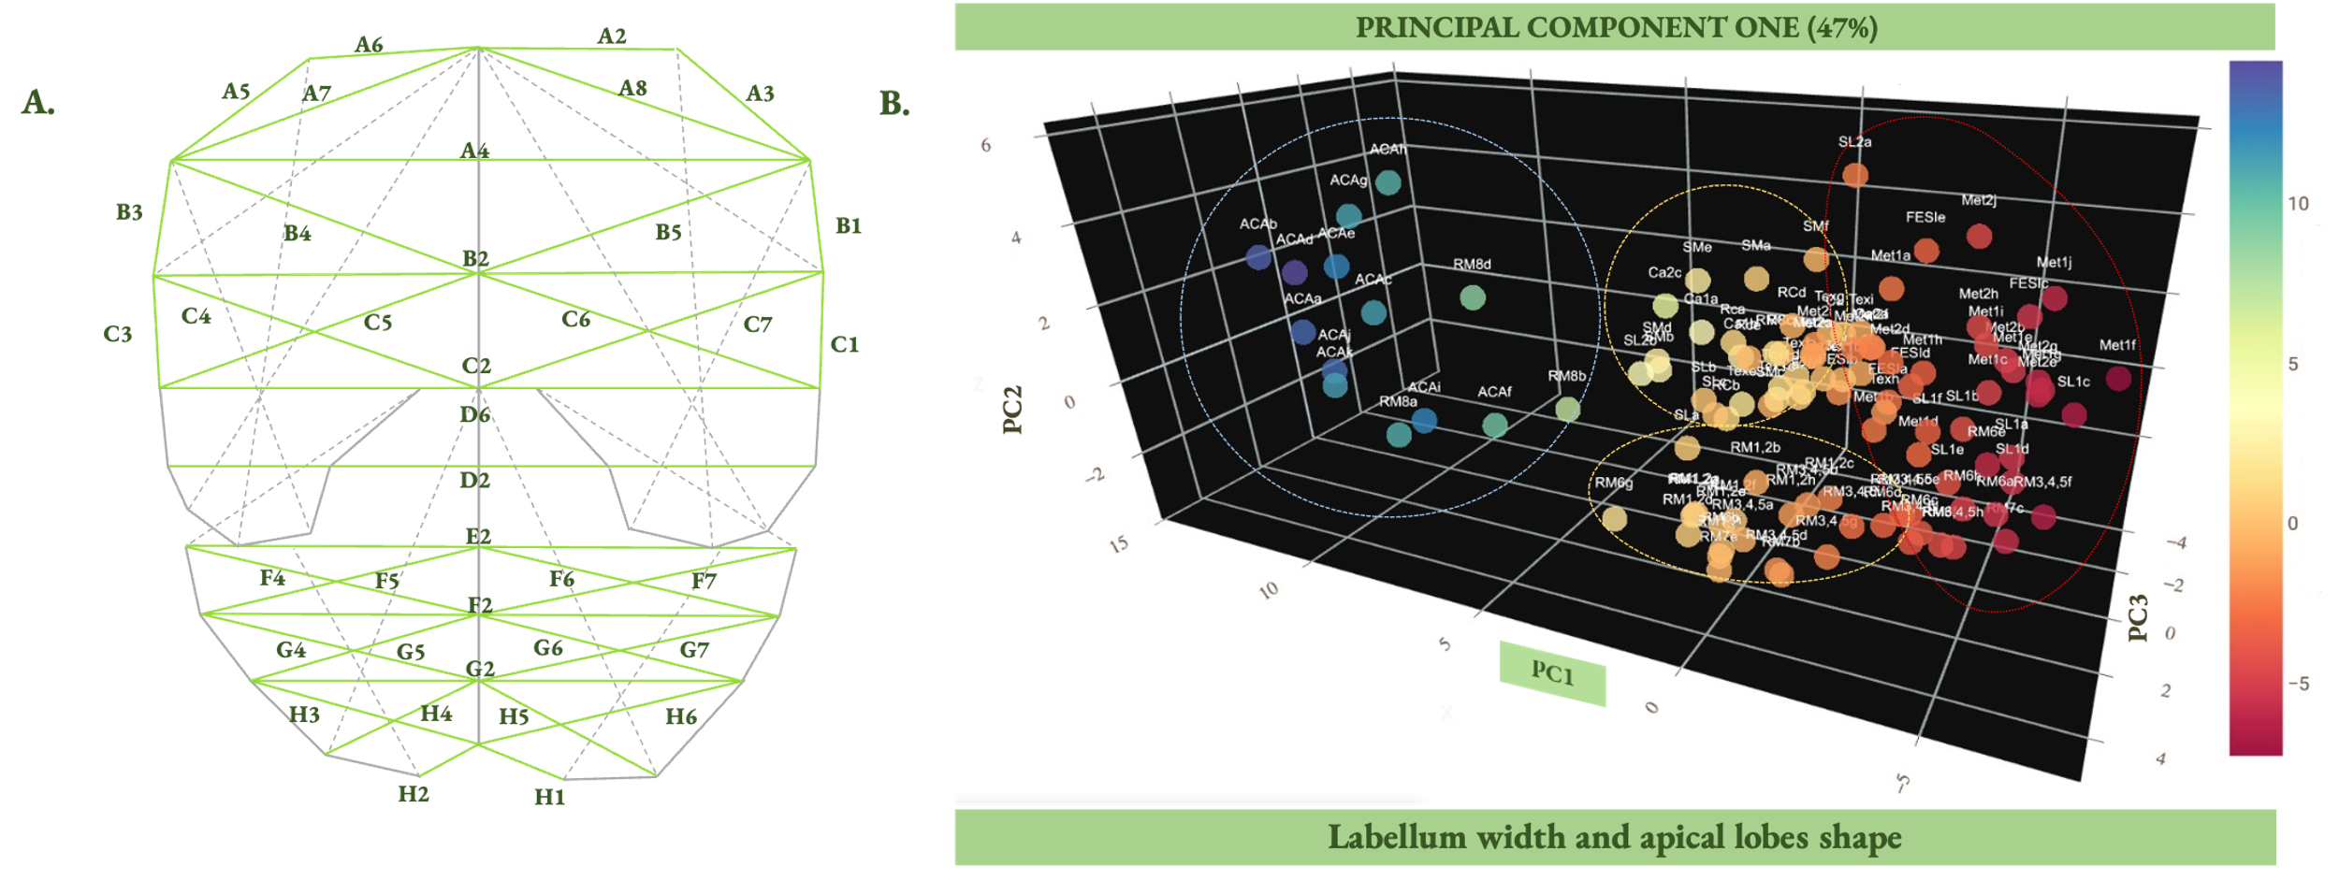
Figure S2 Distribution of the 110 Laelia albida accessions along the first principal component (PC1). (A) Morphological variables of the labellum grouped within PC1. (B) Distribution of accessions according to their PC1 scores. The color bar indicates values, with the highest in the violet spectrum and the lowest in the red spectrum, highlighting three groups ordered according to the color gradient.

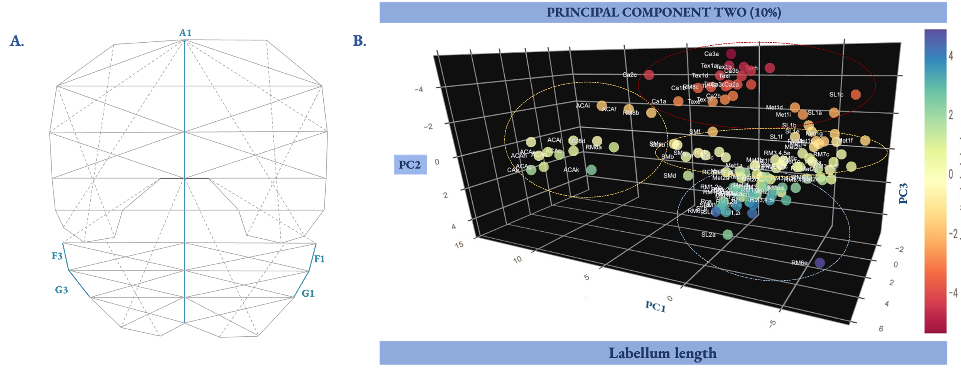
Figure S3 Distribution of the 110 Laelia albida accessions along the second principal component (PC2). (A) Morphological variables of the labellum grouped within PC2. (B) Distribution of accessions according to their PC2 scores. The color bar indicates values, with the highest in the violet spectrum and the lowest in the red spectrum, highlighting three groups ordered according to the color gradient.

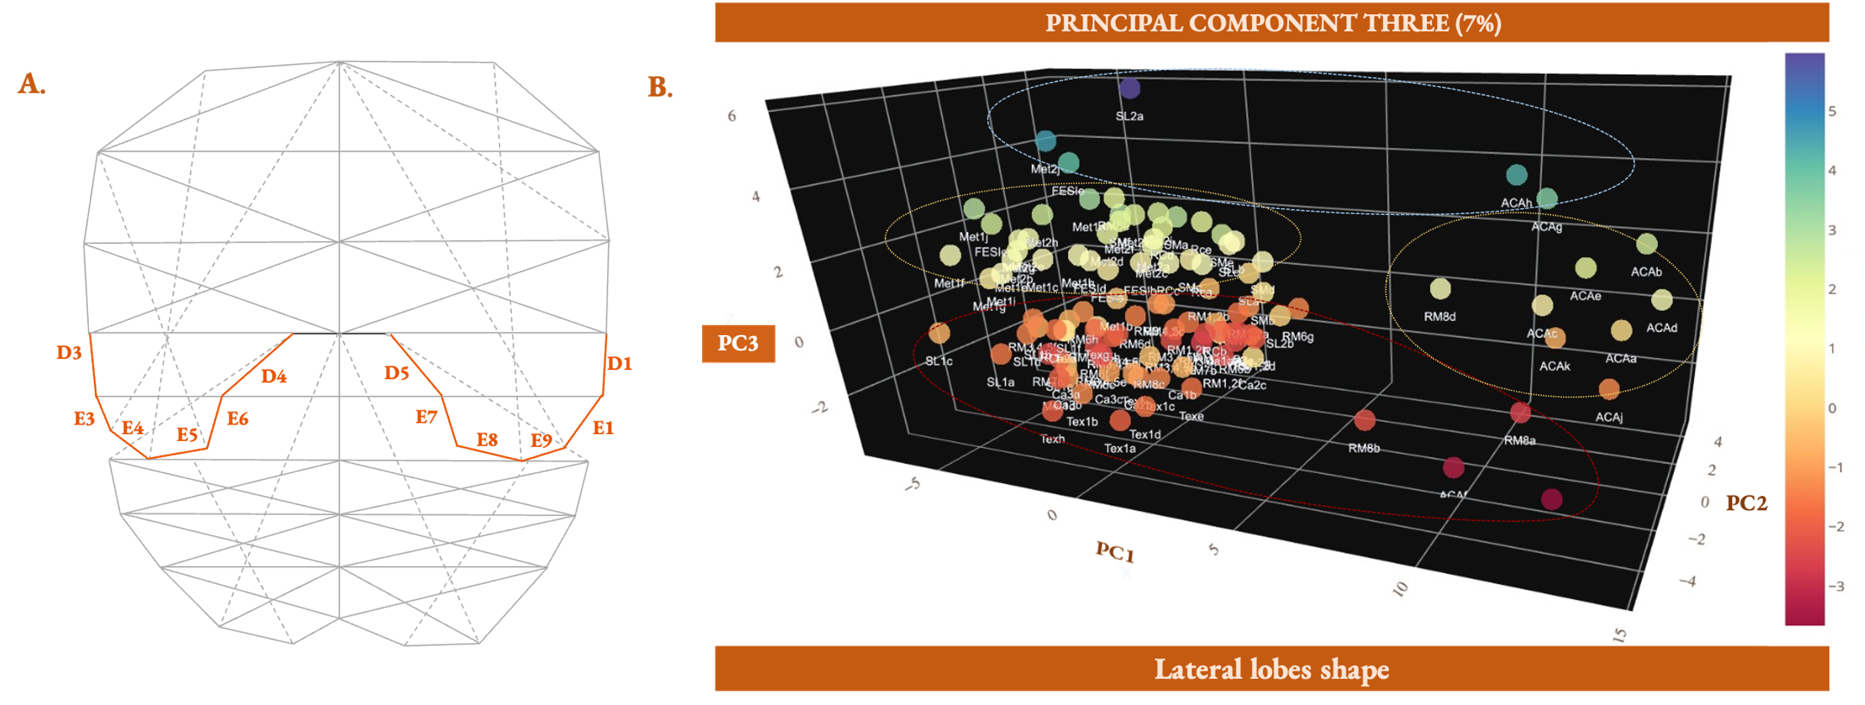
Figure S4 Dispersion of the 110 Laelia albida accessions along the third principal component (PC3). (A) Morphological variables of the labellum grouped within PC3. (B) Distribution of accessions according to their PC3 scores. The color bar indicates values, with the highest in the violet spectrum and the lowest in the red spectrum, highlighting three groups ordered according to the color gradient.

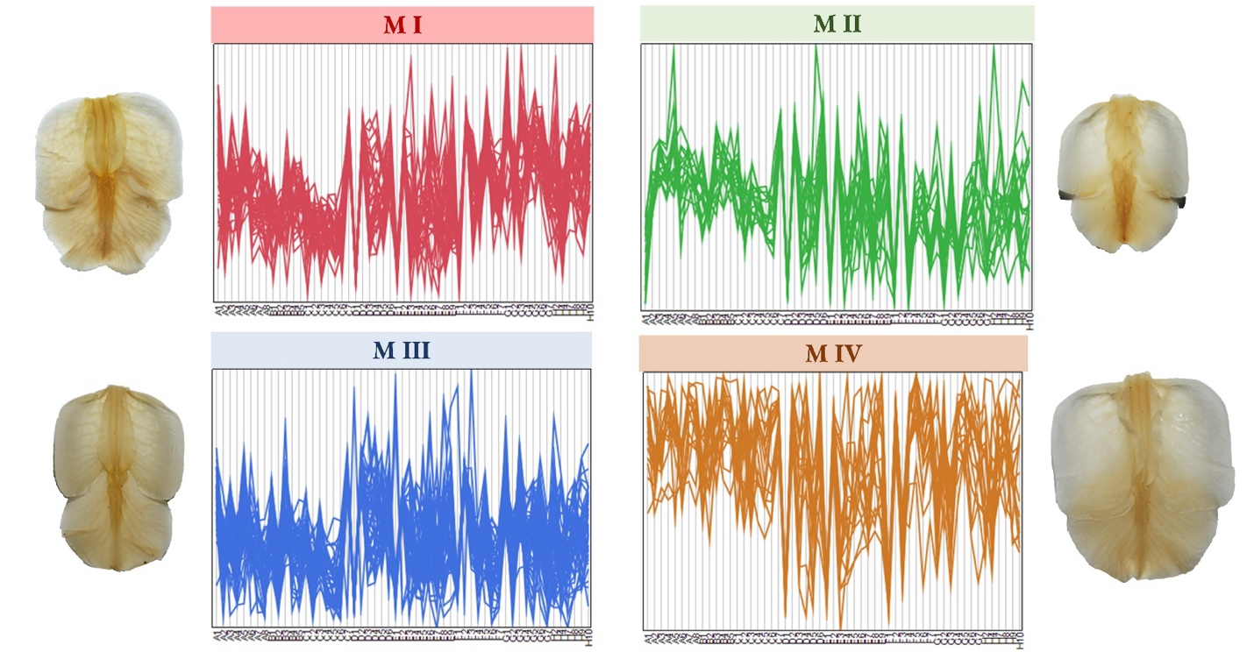
Figure S5 Morphological expression profile of the Laelia albida labellum variables for each morphotype. The number of lines corresponds to the number of accessions included in each morphotype; therefore, Morphotypes I and III present the highest number of lines.

