Table 1 Chemical structures and AChE inhibitory activity of 1,3-dihydroxyxanthone (1) and its derivatives (2a-2r)
Compounds | Chemical Structure | Percentage of  Inhibition at 45 μM (%) | IC₅₀ value (μM)
1 | 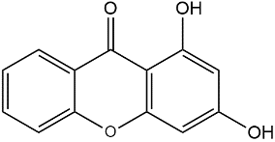 | Not detected | 157.5 ± 7.0^{h}
2a | 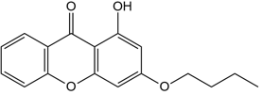 | 54.1 ± 1.2 | 39.3 ± 3.4^{cde}
2b | 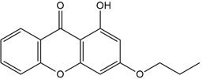 | 51.6 ± 1.3 | 44.2 ± 1.8^{def}
2c | 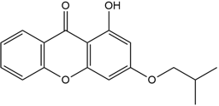 | 46.2 ± 2.6 | 53.0 ± 4.7^{f}
2d | 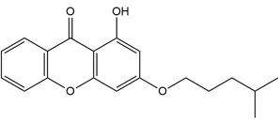 | 50.5 ± 1.0 | 48.0 ± 3.5^{ef}
2e | 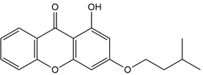 | 52.8 ± 3.1 | 42.8 ± 3.0de
2f | 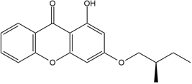 | 49.7 ± 1.3 | 46.2 ± 0.7^{ef}
2g | 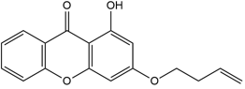 | 71.5 ± 3.3 | 20.8 ± 1.5ª
2h | 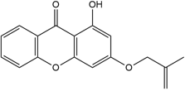 | 51.3 ± 0.9 | 40.9 ± 2.2de
2i | 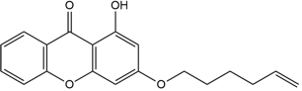 | 62.1 ± 0.6 | 31.2 ± 2.0^{bc}
2j | 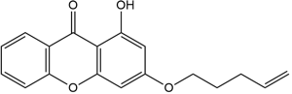 | 72.7 ± 0.4 | 21.5 ± 1.6ª
2k | 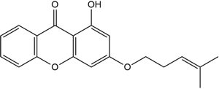 | 57.2 ± 1.1 | 39.6 ± 1.6^{cde}
2l | 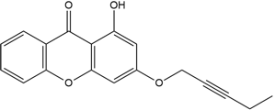 | 40.9 ± 0.9 | 70.4 ± 1.6^{g}
2m | 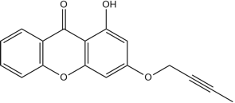 | 46.4 ± 0.9 | 63.7 ± 3.6^{g}
2n | 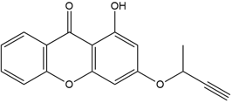 | 44.6 ± 1.6 | 71.2 ± 5.5^{g}
2o | 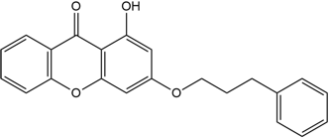 | 64.3 ± 1.1 | 25.0 ± 0.8^{ab}
2p | 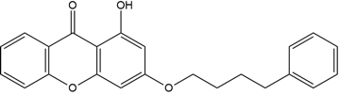 | 70.6 ± 0.4 | 22.2 ± 1.0^{ab}
2q | 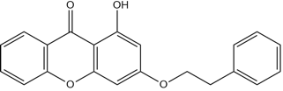 | 56.8 ± 3.3 | 35.1 ± 3.0^{cd}
2r | 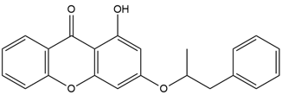 | 52.2 ± 0.9 | 39.9 ± 2.9^{cde}
Tacrine |  | - | 0.9 ± 0.1
All data are expressed as mean ± SD of triplicate experimental runs. Means with different alphabet letters are significantly different (p < 0.05)

