Supplementary Material
Synthesis of 1-Hydroxy-3-O-Substituted Xanthone Derivatives and their Structure-activity Relationship on Acetylcholinesterase Inhibitory Effect
Vincentsia Vienna Vanessa¹, Soek Sin Teh², Kok Wai, Lam³, Siau Hui Mah^{1,4}*,
¹School of Biosciences, Taylor’s University (Lakeside Campus), 1, Jalan Taylor’s, 47500, Subang Jaya, Selangor, Malaysia
²Energy & Environment Unit, Engineering & Processing Division, Malaysian Palm Oil Board, No. 6, Persiaran Institusi, Bandar Baru Bangi, Kajang, 43000, Malaysia
³Drug and Herbal Research Centre, Faculty of Pharmacy, Universiti Kebangsaan Malaysia, Kuala Lumpur, Malaysia.
⁴Centre for Drug Discovery and Molecular Pharmacology, Faculty of Health and Medical Sciences, Taylor’s University (Lakeside Campus), 1, Jalan Taylor’s, 47500, Subang Jaya, Selangor, Malaysia
Corresponding Author: SiauHui.Mah@taylors.edu.my

¹H NMR of 1,3-Dihydroxyxanthone (1)
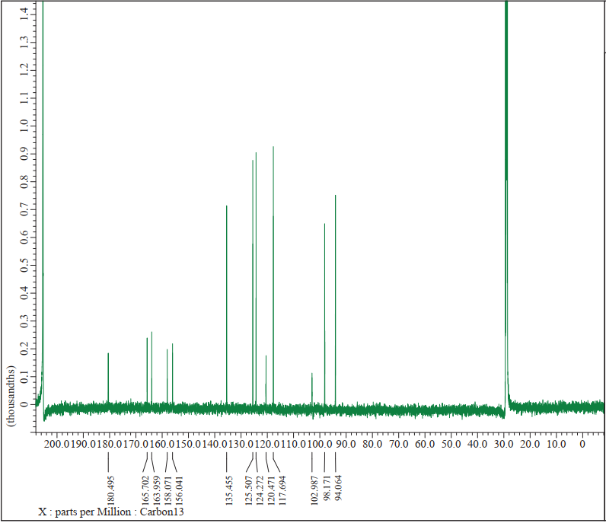

¹H NMR of 1-Hydroxy-3-butoxy-9H-xanthen-9-one (2a)
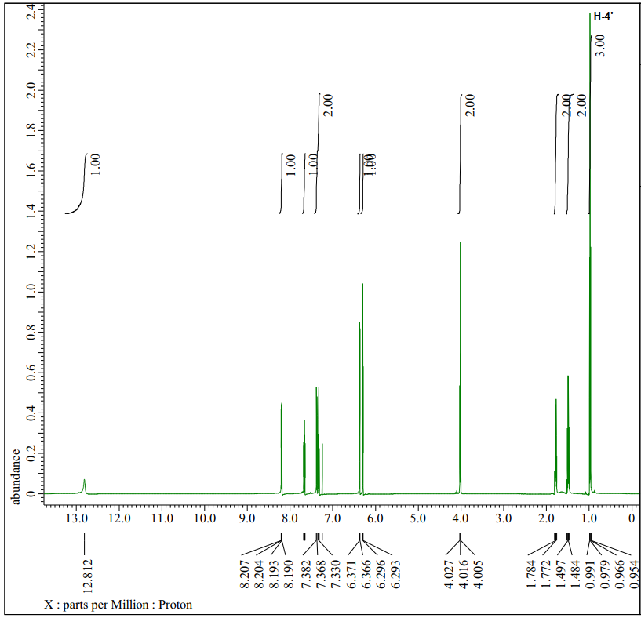

¹H NMR of 1-Hydroxy-3-propoxy-9H-xanthen-9-one (2b)
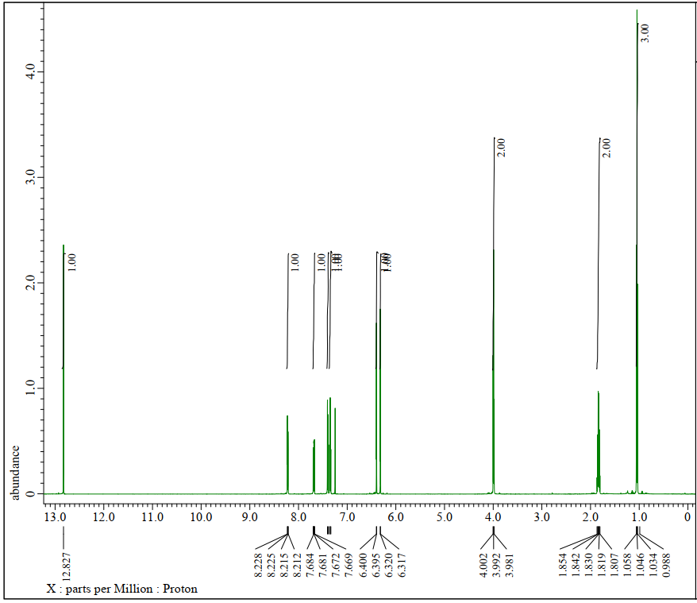

1.4 1-Hydroxy-3-isobutoxy-9H-xanthen-9-one (2c)

¹H NMR of 1-Hydroxy-3-((4-methylpentyl)oxy)-9H-xanthen-9-one (2d)
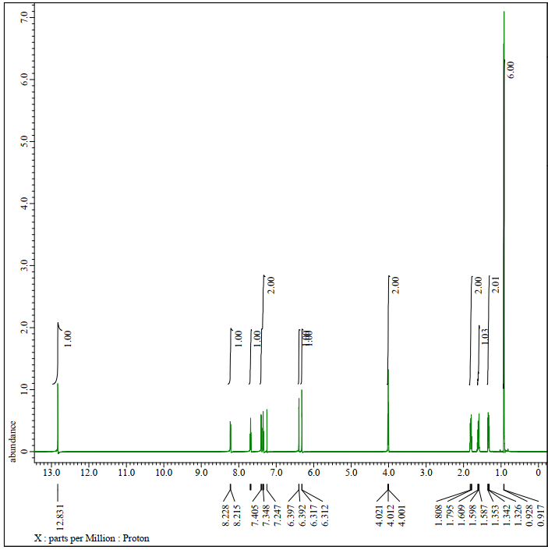

¹H NMR of 1-Hydroxy-3-(isopentyloxy)-9H-xanthen-9-one (2e)
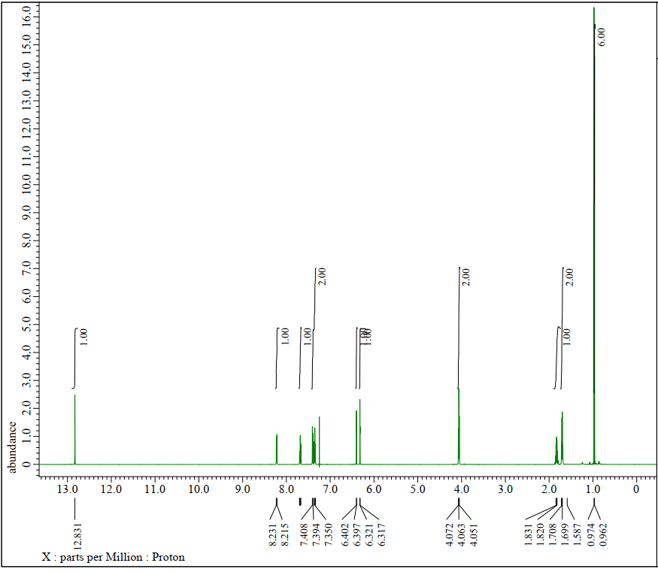

¹H NMR of (R)-(-)-1-Hydroxy-3-(2-methylbutoxy)-9H-xanthen-9-one (2f)
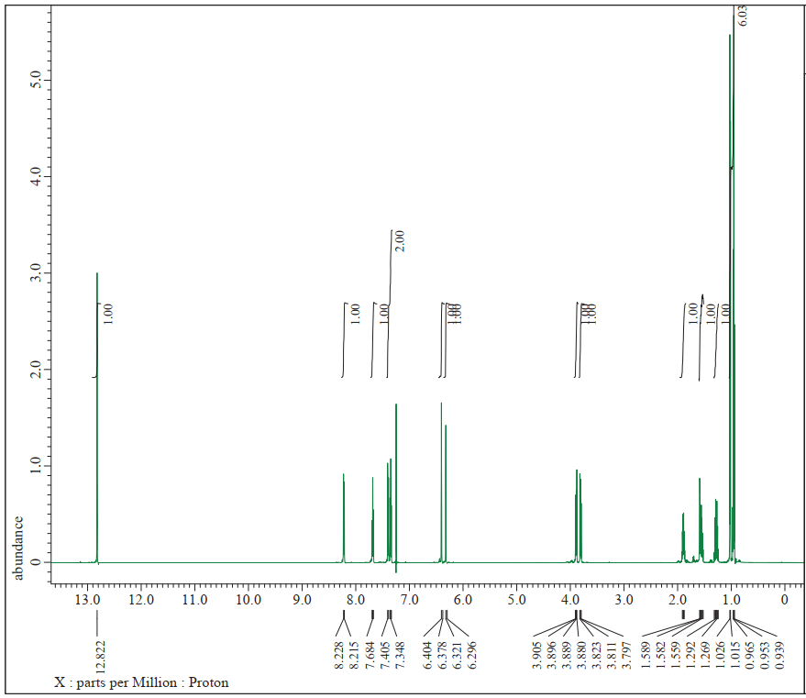

¹H NMR of 1-Hydroxy-3-(but-3-en-1-yloxy)-9H-xanthen-9-one (2g)
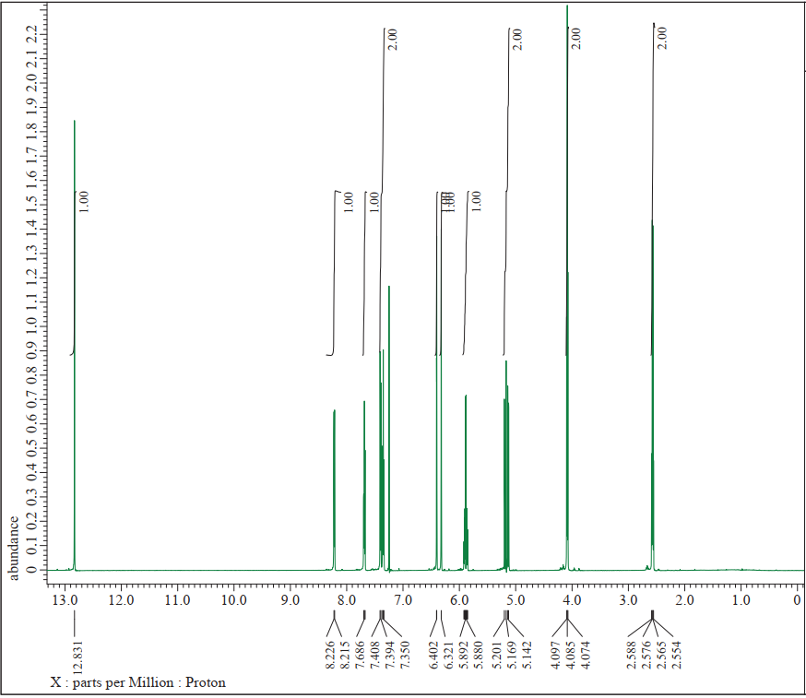

¹H NMR of 1-Hydroxy-3-((2-methylallyl)oxy)-9H-xanthen-9-one (2h)
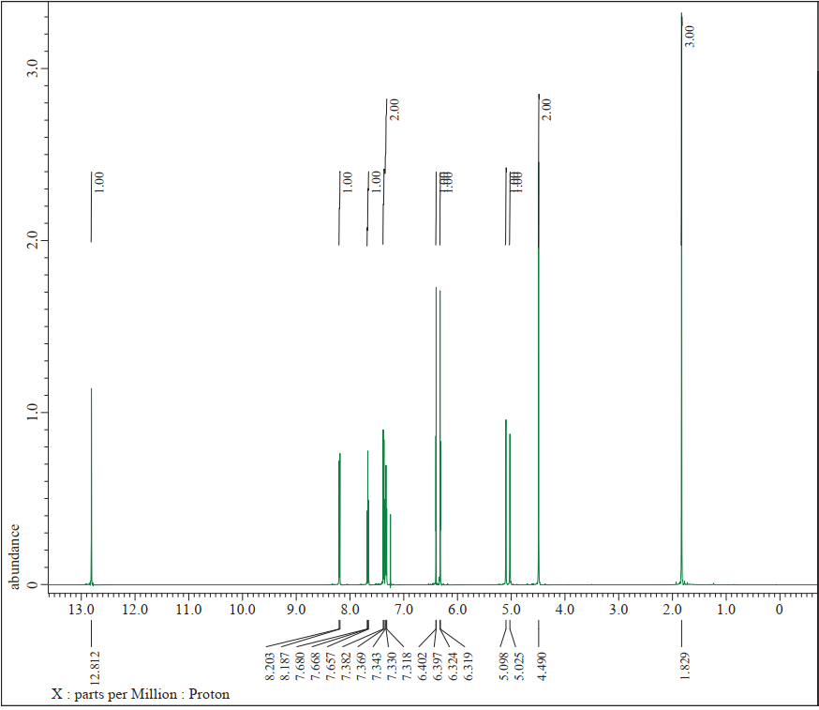

¹H NMR of 1-Hydroxy-3-(hex-5-en-1-yloxy)-9H-xanthen-9-one (2i)
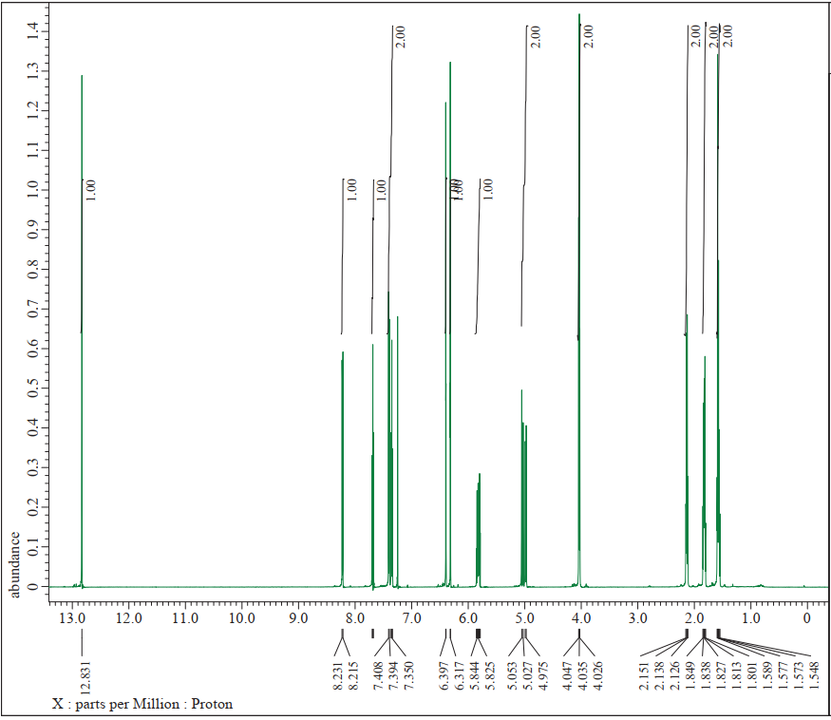

¹H NMR of 1-Hydroxy-3-(pent-4-en-1-yloxy)-9H-xanthen-9-one (2j)
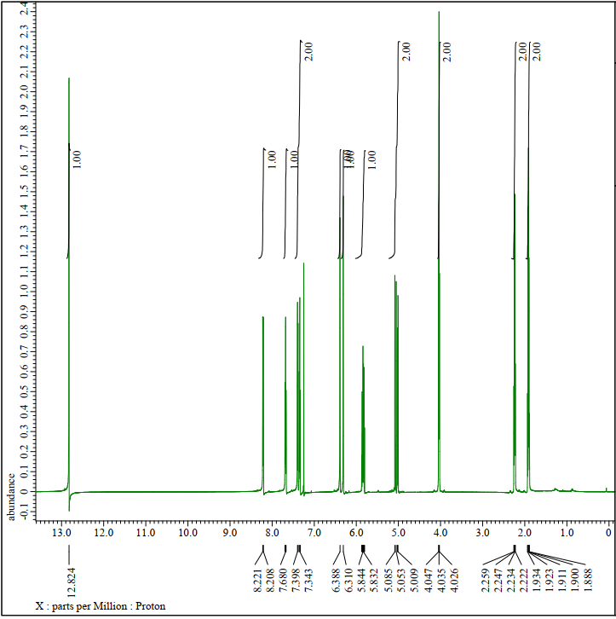

¹H NMR of 1-Hydroxy-3-((4-methylpent-3-en-1-yl)oxy)-9H-xanthen-9-one (2k)
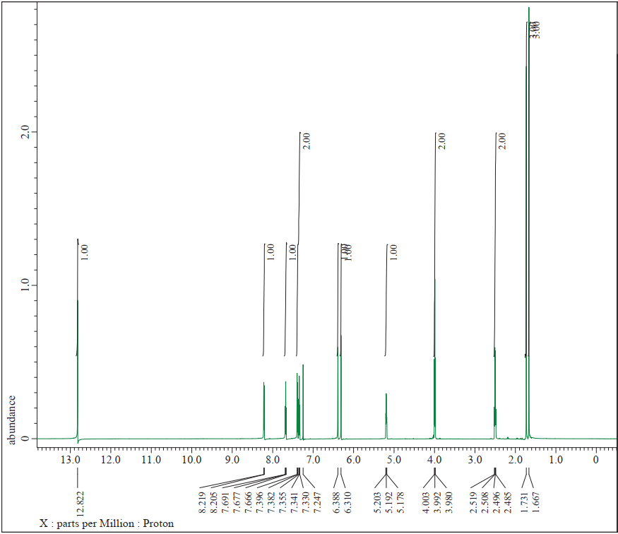

¹H NMR of 1-Hydroxy-3-(pent-2-yn-1-yloxy)-9H-xanthen-9-one (2l)
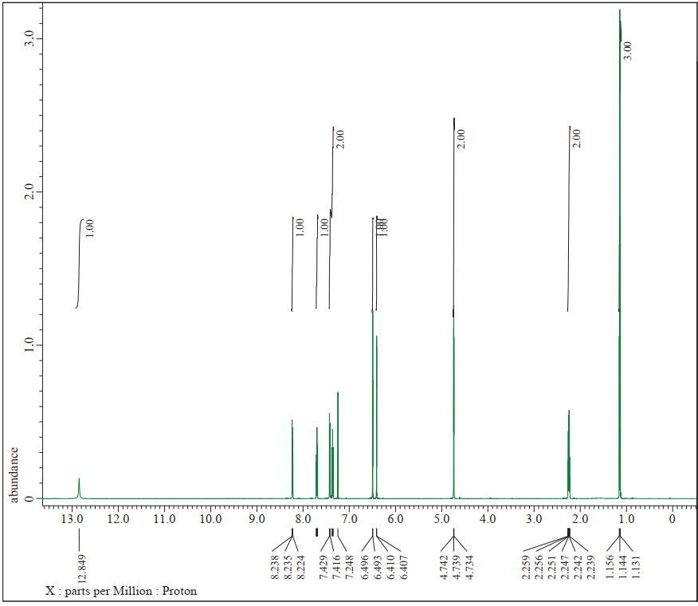

¹H NMR of 1-Hydroxy-3-(but-2-yn-1-yloxy)-9H-xanthen-9-one (2m)
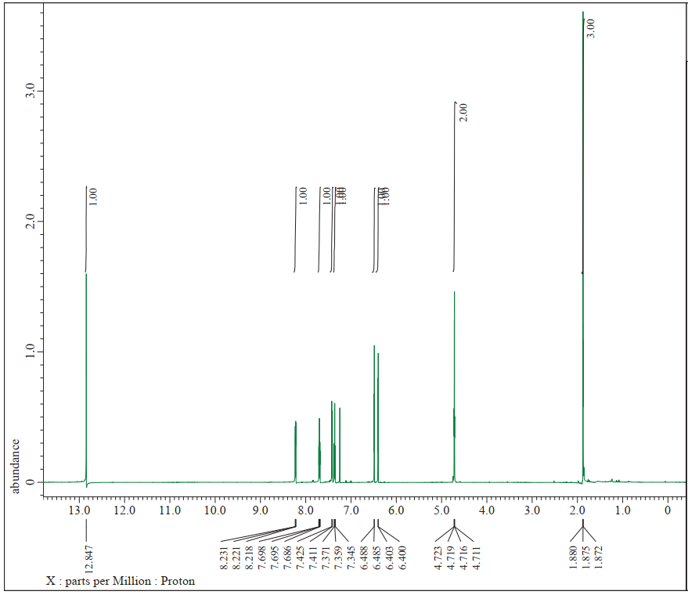

¹H NMR of 1-Hydroxy-3-(but-3-yn-2-yloxy)-9H-xanthen-9-one (2n)
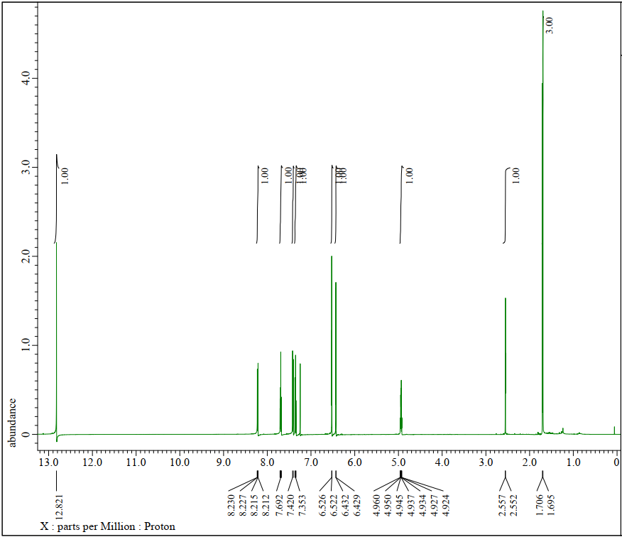

¹H NMR of 1-Hydroxy-3-(3-phenylpropoxy)-9H-xanthen-9-one (2o)
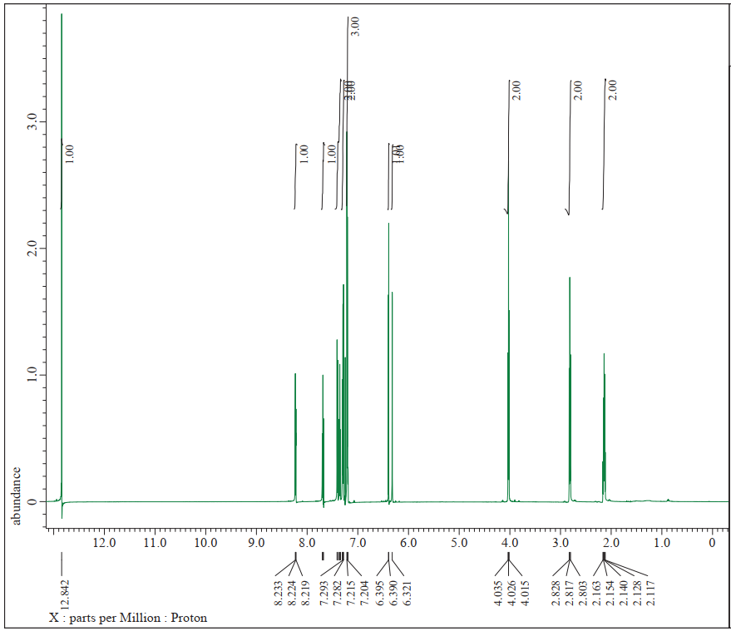

¹H NMR of 1-Hydroxy-3-(4-phenylbutoxy)-9H-xanthen-9-one (2p)
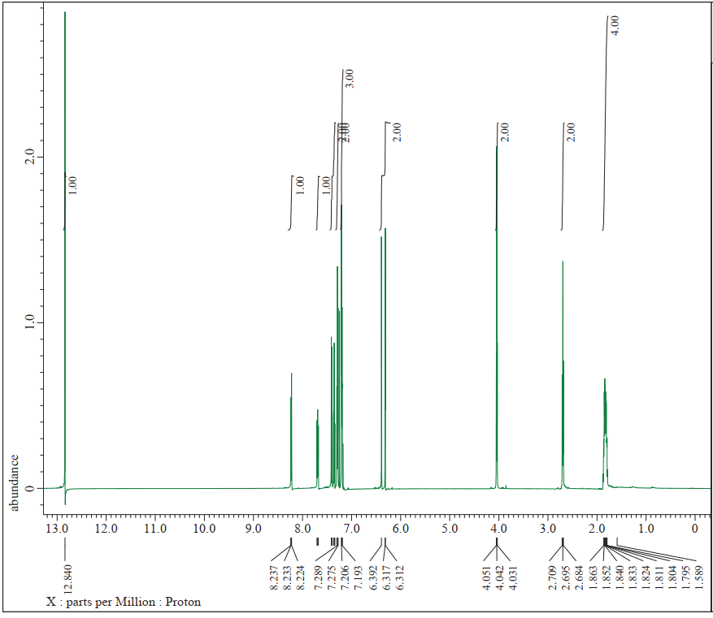

¹H NMR of 1-Hydroxy-3-(phenethoxy)-9H-xanthen-9-one (2q)
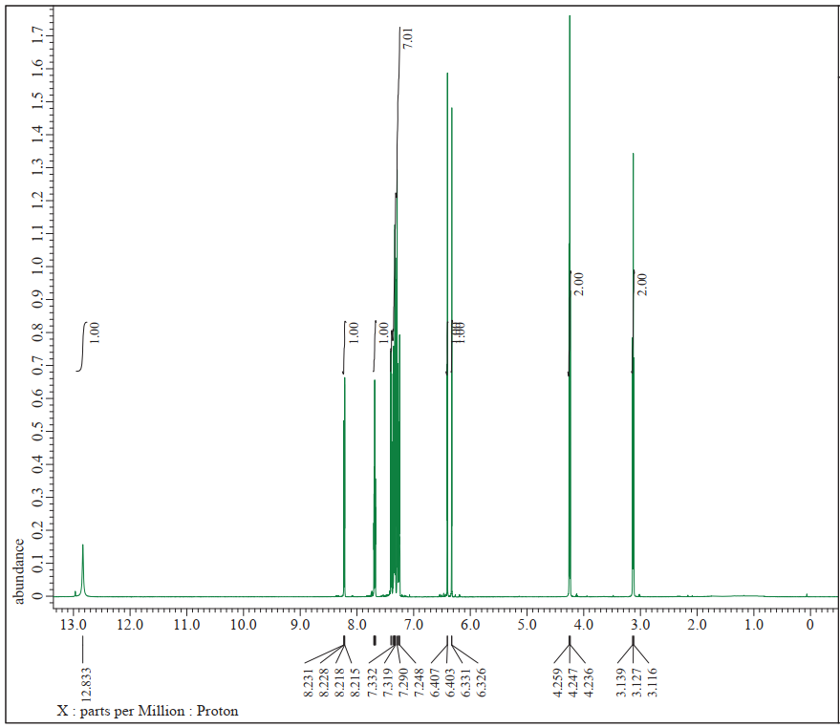

¹H NMR of 1-Hydroxy-3-((1-phenylpropan-2-yl)oxy)-9H-xanthen-9-one (2r)
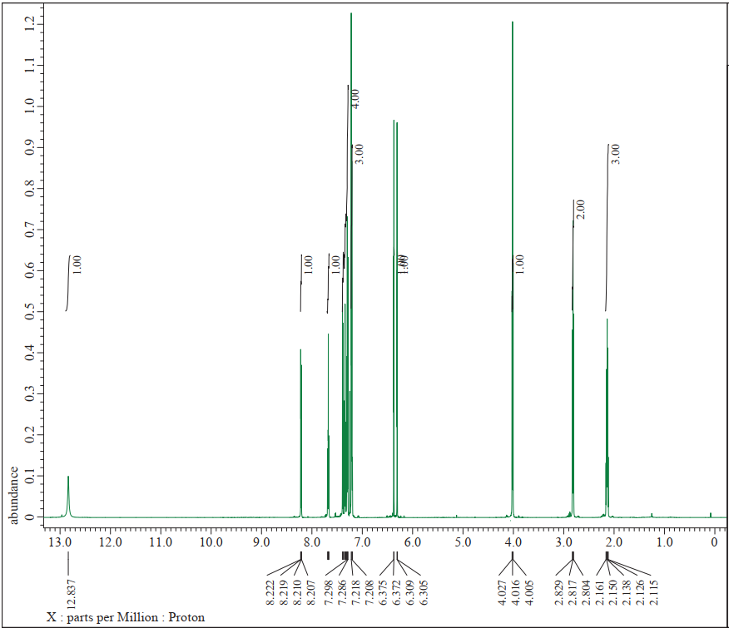

2.0 Percentage of AChE inhibition of the synthesized xanthones
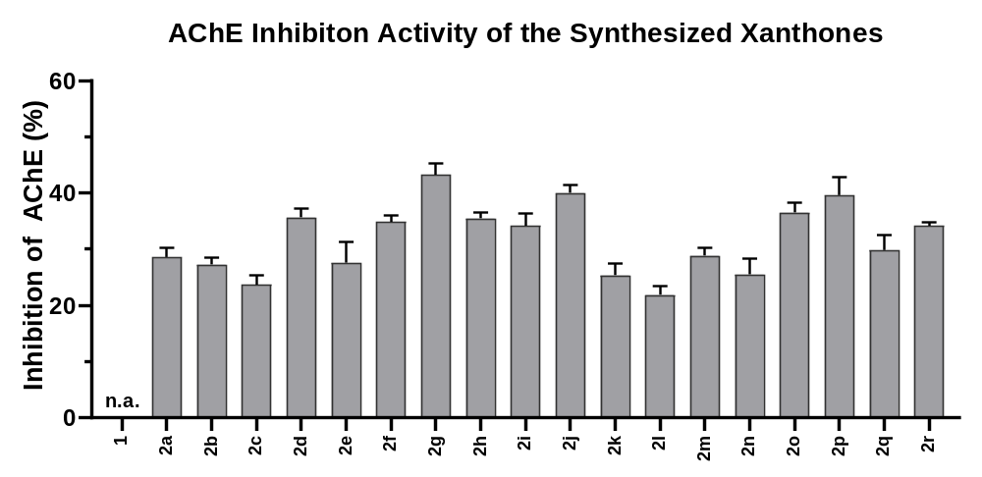
Figure S1. The percentage of AChE inhibition 1,3-dihydroxyxanthone (1) and the four series of derivatives (2a-2r) at the concentration of 15 µM (n.a. = not active).
Values are expressed as means ± SD, error bars indicate standard deviation (n = 3).

3.0 Michaelis-Menten parameters
Table S1. Kinetic parameters of acetylcholinesterase inhibitions by 2g.
Substrate conc. | Velocity of enzyme activity (ΔA min⁻¹) |  |  |  |  |  | V_{max} (ΔA min⁻¹) | K_{m} (mM)
Substrate conc. | 0.5 mM | 0.6 mM | 0.7 mM | 0.8 mM | 0.9 mM |  | V_{max} (ΔA min⁻¹) | K_{m} (mM)
Control | 7.20x10⁻³ ± 2.05x10⁻⁴ | 8.10x10⁻³ ± 1.25x10⁻⁴ | 9.90x10⁻³ ± 4.32x10⁻⁴ | 1.08x10⁻² ± 4.78x10⁻⁴ | 1.20x10⁻² ± 4.92x10⁻⁴ |  | 1.75x10⁻² | 0.72
7.5 µM | 5.80x10⁻³ ± 2.05x10⁻⁴ | 6.50x10⁻³ ± 1.89x10⁻⁴ | 7.2x10⁻³ ± 2.05x10⁻⁴ | 7.90x10⁻³ ± 9.43x10⁻⁵ | 9.10x10⁻³ ± 1.63x10⁻⁴ |  | 1.54x10⁻² | 0.84
10.0 µM | 5.50x10⁻³ ± 2.45x10⁻⁴ | 6.10x10⁻³ ± 9.43x10⁻⁵ | 6.80x10⁻³ ± 1.41x10⁻⁴ | 7.70x10⁻³ ± 1.41x10⁻⁴ | 8.60x10⁻³ ± 1.70x10⁻⁴ |  | 1.50x10⁻² | 0.89
12.5 µM | 4.60x10⁻³ ± 1.63x10⁻⁴ | 5.10x10⁻³ ± 1.25x10⁻⁴ | 6.20x10⁻³ ± 1.63x10⁻⁴ | 7.00x10⁻³ ± 8.16x10⁻⁵ | 7.80x10⁻³ ± 8.16x10⁻⁵ |  | 1.36x10⁻² | 0.99
15.0 µM | 4.10x10⁻³ ± 9.43x10⁻⁵ | 4.40x10⁻³ ± 1.70x10⁻⁴ | 6.00x10⁻³ ± 9.43x10⁻⁵ | 6.80x10⁻³ ± 4.71x10⁻⁵ | 7.40x10⁻³ ± 9.43x10⁻⁵ |  | 1.24x10⁻² | 1.08
All data are presented as mean ± SD of triplicates run in three independent experiments.
Table S2. Kinetic parameters of acetylcholinesterase inhibitions by 2j.
Substrate conc. | Velocity of enzyme activity (ΔA min⁻¹) |  |  |  |  |  | V_{max} (ΔA min⁻¹) | K_{m} (mM)
Substrate conc. | 0.5 mM | 0.6 mM | 0.7 mM | 0.8 mM | 0.9 mM |  | V_{max} (ΔA min⁻¹) | K_{m} (mM)
Control | 7.80x10⁻³ ± 2.49x10⁻⁴ | 9.10x10⁻³ ± 2.49x10⁻⁴ | 1.00x10⁻² ± 4.64x10⁻⁴ | 1.08x10⁻² ± 1.70x10⁻⁴ | 1.12x10⁻² ± 1.70x10⁻⁴ |  | 2.99x10⁻² | 1.37
7.5 µM | 6.40x10⁻³ ± 4.99x10⁻⁴ | 7.40x10⁻³ ± 4.50x10⁻⁴ | 7.90x10⁻³ ± 4.55x10⁻⁴ | 8.60x10⁻³ ± 4.78x10⁻⁴ | 9.70x10⁻³ ± 5.89x10⁻⁴ |  | 2.32x10⁻² | 1.52
10.0 µM | 6.10x10⁻³ ± 4.92x10⁻⁴ | 7.00x10⁻³ ± 4.50.x10⁻⁴ | 7.30x10⁻³ ± 4.92x10⁻⁴ | 8.20x10⁻³ ± 4.11x10⁻⁴ | 9.40x10⁻³ ± 4.11x10⁻⁴ |  | 2.26x10⁻² | 1.56
12.5 µM | 5.40x10⁻³ ± 3.74x10⁻⁴ | 6.20x10⁻³ ± 4.11x10⁻⁴ | 6.60x10⁻³ ± 4.64x10⁻⁴ | 7.40x10⁻³ ± 4.19x10⁻⁴ | 8.30x10⁻³ ± 4.64x10⁻⁴ |  | 2.33x10⁻² | 1.87
15.0 µM | 5.20x10⁻³ ± 2.62x10⁻⁴ | 5.84x10⁻³ ± 4.55x10⁻⁴ | 6.50x10⁻³ ± 4.08x10⁻⁴ | 7.30x10⁻³ ± 3.30x10⁻⁴ | 7.80x10⁻³ ± 4.55x10⁻⁴ |  | 2.51x10⁻² | 2.19
All data are presented as mean ± SD of triplicates run in three independent experiment

