Morin Modulates Key Targets and Pathways Associated with Gastric Cancer: Network Pharmacology, Molecular Docking, Molecular Dynamics, ADMET, and In-Vitro Analysis

Nilesh Naskar¹, Sunil Kumar², Bijo Mathew², Naseer Maliyakkal³, Shweta Shrivastava⁴,Uday Kumar R⁵, Manish Kumar Jeengar^{1,*}
¹ Department of Pharmacology, Amrita School of Pharmacy, Amrita Vishwa Vidyapeetham, AIMS Health Sciences Campus, Kochi, 682041, Kerala, India
² Department of Pharmaceutical Chemistry, Amrita School of Pharmacy, Amrita Vishwa Vidyapeetham, AIMS Health Sciences Campus, Kochi, 682041, Kerala, India
³ Department of Basic Medical Sciences, College of Applied Medical Sciences, Khamis Mushait, King Khalid University, Kingdom of Saudi Arabia
⁴ School of Pharmacy, School of Health and Allied Sciences, ARKA JAIN University, Gamharia, Seraikela Kharsawan- 832108, Jharkhand- India
⁵ Department of Pharmacy Practice, Amrita School of Pharmacy, Amrita Vishwa Vidyapeetham, Kochi, Kerala, India

Supplementary Data

Rank | Gene | PDB ID | Resolution | Mutation | Specified ligand
1 | PIK3R3 | 5ZUT | 2.82 Å | No | Absent
2 | PIK3CA | 8EXL | 1.99 Å | No | Present
3 | PIK3CB | No PDB ID found
4 | PIK3CD | 6PYR | 2.21 Å | No | Present
5 | PIK3R2 | 7RNU | 1.45 Å | No | Absent
6 | PLCG1 | 7NXE | 2.10 Å | No | Present
7 | JAK2 | 4D1S | 1.66 Å | No | Present
8 | IGF1R | 5FXS | 1.90 Å | No | Present
9 | ZAP70 | 1U59 | 2.30 Å | No | Present
10 | ERBB4 | 3BBT | 2.80 Å | No | Present
Table S1 Key characteristics of the selected proteins.

Table S2 Overlapping targets between morin and gastric cancer.
FNTA | PLEKHA4 | DUT | GP1BA | THRB | TREM1 | PDE4B | BCAT2 | HSD17B1
C1R | MTHFD1 | PDE4D | PYGL | UCK2 | BACE1 | PLA2G10 | PCK1 | CBR1
NOS3 | YARS1 | ARSA | PDE3B | ADH1C | RNASE4 | MAN1B1 | SULT2A1 | CBS
NT5M | RNASE3 | PAK6 | NR1H2 | ALDOA | FECH | TGM3 | CD1A | PDE5A
NMNAT1 | MAPKAPK2 | ACADM | FABP6 | SRM | ADK | GSTT2 | NR1I2 | HAGH
NQO2 | GNPDA1 | TPH1 | THRA | SETD7 | ARL5A | GSTA3 | PITPNA | DPEP1
EEA1 | OTC | OAT | RAB9A | MMP16 | ARF4 | HADH | GSTM2 | ZAP70
PPP1CC | PNMT | GCDH | HCK | ESR1 | MAPK14 | PIM1 | EGFR | GSTP1
PPIA | CDK6 | CDK2 | AURKA | GSR | ESR2 | NQO1 | HSPA8 | SRC
MTAP | PDPK1 | DPP4 | MMP8 | SOD2 | PRKACA | FGFR1 | CASP7 | DCK
SHBG | CCNA2 | PPARD | MMP3 | MMP13 | ESRRG | PLK1 | KIF11 | CCNT1
ALDH2 | DAPK1 | ISG20 | GSK3B | ADAM17 | PDHB | AKT1 | REG1A | ABO
RHEB | LCK | C1S | MIF | RHOA | CASP3 | HDAC8 | FABP4 | ITK
EPHB4 | CCL5 | UMPS | CSNK2A1 | NOS2 | ERBB4 | INSR | MET | BIRC7
LYZ | RXRA | IL2 | ARHGAP1 | RAB5A | PARP1 | FHIT | PDK2 | CHIT1
ACE | AKR1C1 | IGF1R | NR1H4 | MMP12 | XIAP | JAK2 | CLK1 | EPHA2
IGF1 | MMP9 | KIT | RAC2 | ABL1 | GALE | PLA2G2A | TK1 | JAK3
PAPSS1 | SULT2B1 | APRT | HPRT1 | TGFB2 | AKT2 | PPARA | GSTA1 | MMP1
HINT1 | VDR | PADI4 | EIF4E | CD209 | FOLH1 | CDC42 | RARA | TRDMT1
HNMT | STAT1 | HMOX1 | CLEC4M | RAF1 | GSTM1 | RND3 | CASP1 | CDK7
RAN | GSTO1 | KAT2B
4 common elements in “PharmMapper” and “Open targets”
62 common elements in “PharmMapper” and “GeneCard”
117 common elements in “PharmMapper”, “GeneCard” and “Open targets”

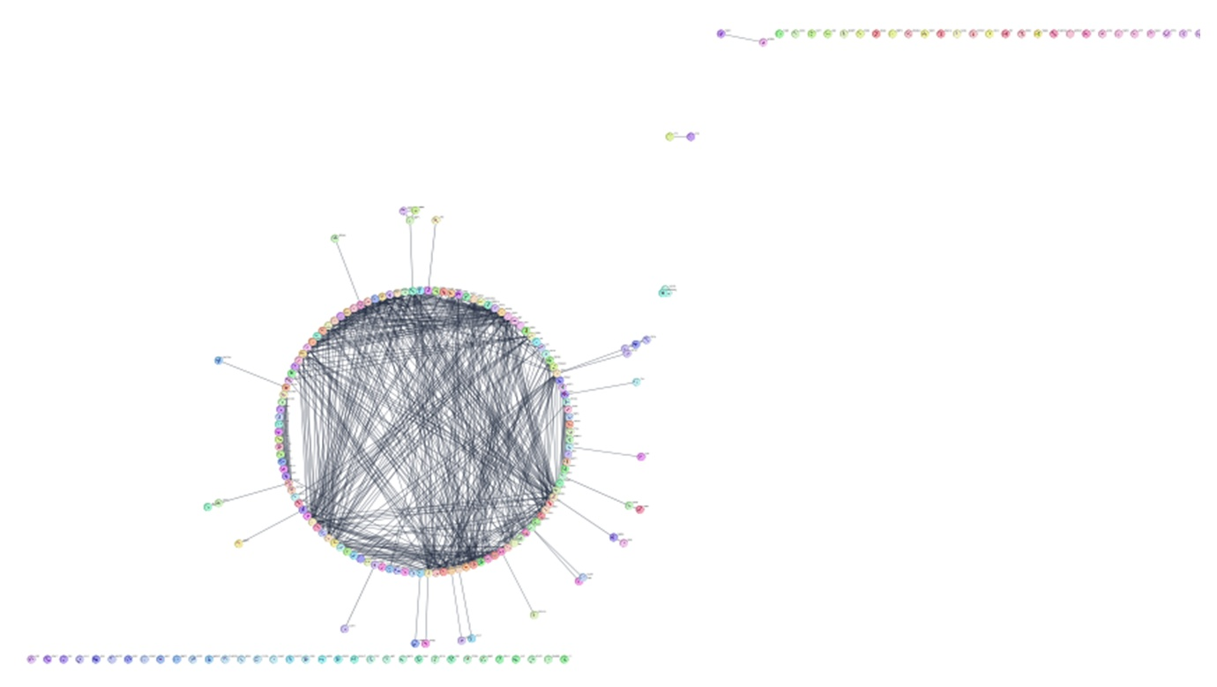

Fig. S1 STRING network

Table S3 PPI network modules of shared morin GC targets.

Sl. No. | Module | Targets | MCODE Score | Nodes | Edges
1 | Cluster 1 | PIK3R3, PDPK1, IGF1R, ZAP70, PIK3CA, RAC2, JAK2, PIK3CB, PIK3CD, ERBB4, JAK3, PLCG1, PIK3R2 | 9.333 | 13 | 56
2 | Cluster 2 | HPRT1, PDE3B, ADK, NT5M, DCK, PDE4B, ENPP1, APRT, PDE4D, ENPP3 | 7.556 | 10 | 34
3 | Cluster 3 | CBR1, SULT2B1, CYP1A1, CYP2E1, AKR1C1, CYP3A4 | 4.8 | 6 | 12
4 | Cluster 4 | PLK1, ESR1, NCOR1, AKT1, BRCA1, ABL1, GSK3B, ESR2, MAPK3, AURKA, HSP90AA1, HSPA8, CASP3, CCNA2, STAT3, JUN, NOS3 | 4.75 | 17 | 38
5 | Cluster 5 | EGFR, AKT2, FGFR1, SHC1, SRC, CDC42, PIK3R1, THRB, ITK, PTPN11, THRA, KIT, RAF1 | 4.54 | 13 | 27
6 | Cluster 6 | MET, INSR, GRB2, CBL | 3.333 | 4 | 5
7 | Cluster 7 | CLEC4M, CD209, RHOA | 3 | 3 | 3
8 | Cluster 8 | MMP3, MMP1, MMP9 | 3 | 3 | 3

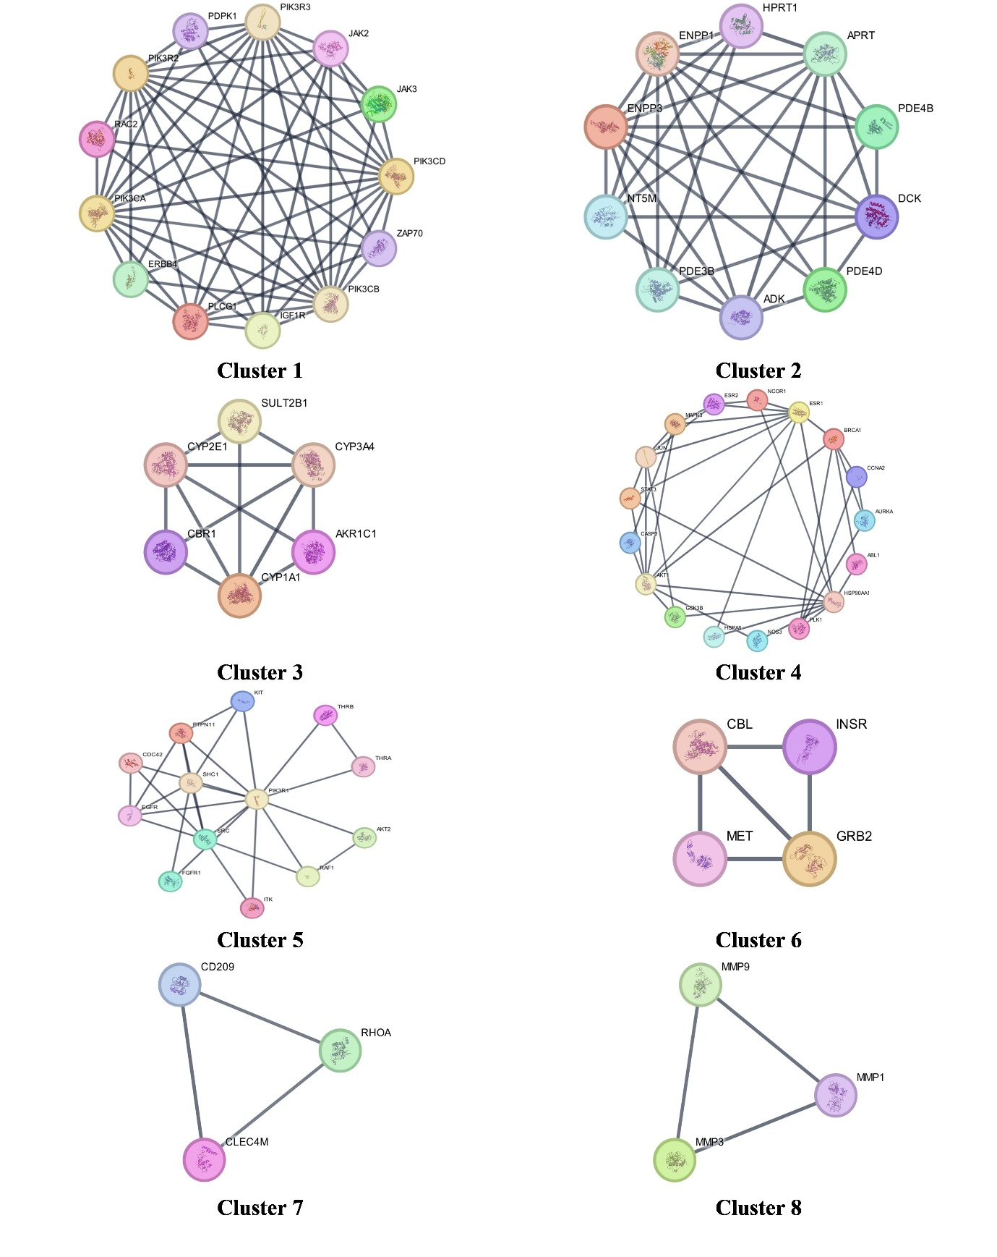
Fig. S2 Clusters generated by MCODE

Table S4 Top 10 genes ranked by degree method in cluster 1.
Rank | Shared name | Shown name | Score
1 | 9606.ENSP00000262741 | PIK3R3 | 12
1 | 9606.ENSP00000263967 | PIK3CA | 12
1 | 9606.ENSP00000501150 | PIK3CB | 12
1 | 9606.ENSP00000366563 | PIK3CD | 12
1 | 9606.ENSP00000222254 | PIK3R2 | 12
6 | 9606.ENSP00000244007 | PLCG1 | 9
7 | 9606.ENSP00000371067 | JAK2 | 8
8 | 9606.ENSP00000497069 | IGF1R | 7
9 | 9606.ENSP00000264972 | ZAP70 | 6
9 | 9606.ENSP00000342235 | ERBB4 | 6

Table S5 Top 10 genes ranked by closeness method in cluster 1.
Rank | Shared name | Shown name | Score
1 | 9606.ENSP00000262741 | PIK3R3 | 12
1 | 9606.ENSP00000263967 | PIK3CA | 12
1 | 9606.ENSP00000501150 | PIK3CB | 12
1 | 9606.ENSP00000366563 | PIK3CD | 12
1 | 9606.ENSP00000222254 | PIK3R2 | 12
6 | 9606.ENSP00000244007 | PLCG1 | 10.5
7 | 9606.ENSP00000371067 | JAK2 | 10
8 | 9606.ENSP00000497069 | IGF1R | 9.5
9 | 9606.ENSP00000264972 | ZAP70 | 9
9 | 9606.ENSP00000342235 | ERBB4 | 9

Table S6 Top 10 genes ranked by betweenness method in cluster 1.

Rank | Shared name | Shown name | Score
1 | 9606.ENSP00000262741 | PIK3R3 | 8.333333333
1 | 9606.ENSP00000263967 | PIK3CA | 8.333333333
1 | 9606.ENSP00000501150 | PIK3CB | 8.333333333
1 | 9606.ENSP00000366563 | PIK3CD | 8.333333333
1 | 9606.ENSP00000222254 | PIK3R2 | 8.333333333
6 | 9606.ENSP00000244007 | PLCG1 | 1.666666667
7 | 9606.ENSP00000371067 | JAK2 | 0.666666667
8 | 9606.ENSP00000344220 | PDPK1 | 0
8 | 9606.ENSP00000497069 | IGF1R | 0
8 | 9606.ENSP00000264972 | ZAP70 | 0

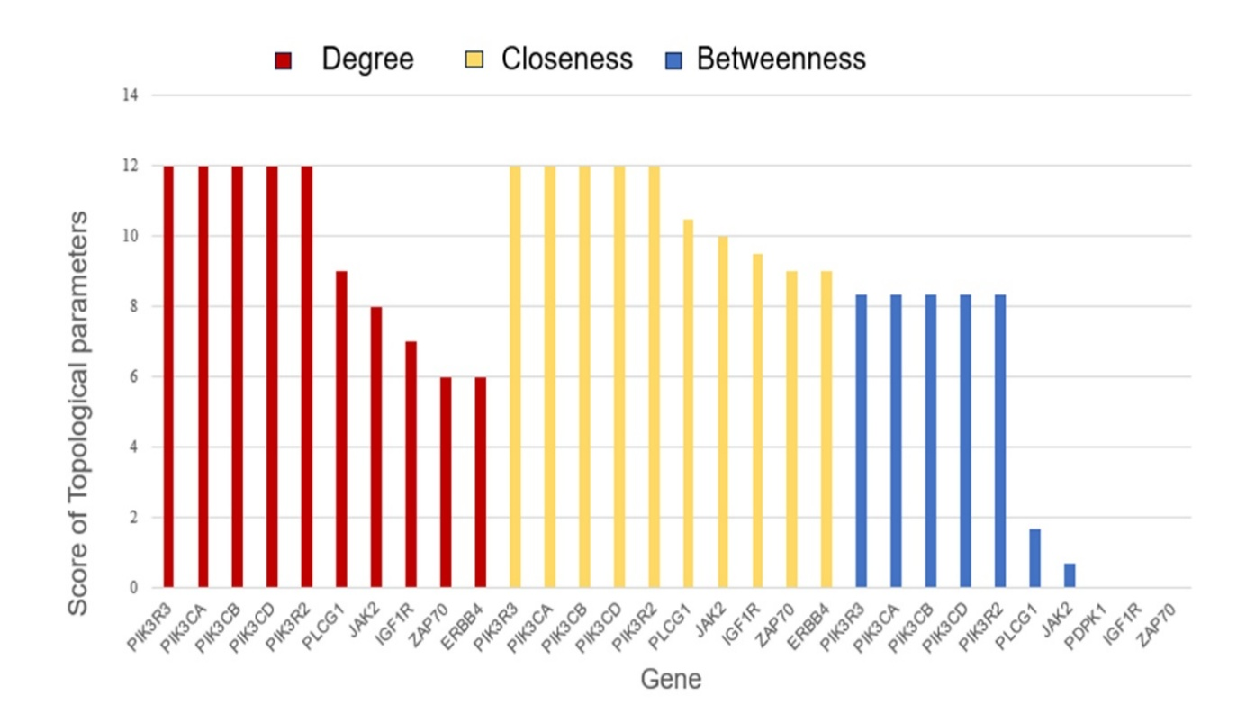
Fig. S3 Genes and their corresponding topological parameters.
Fig. S4 Visualization of morin’s interaction points in the GC pathway (KEGG analysis).
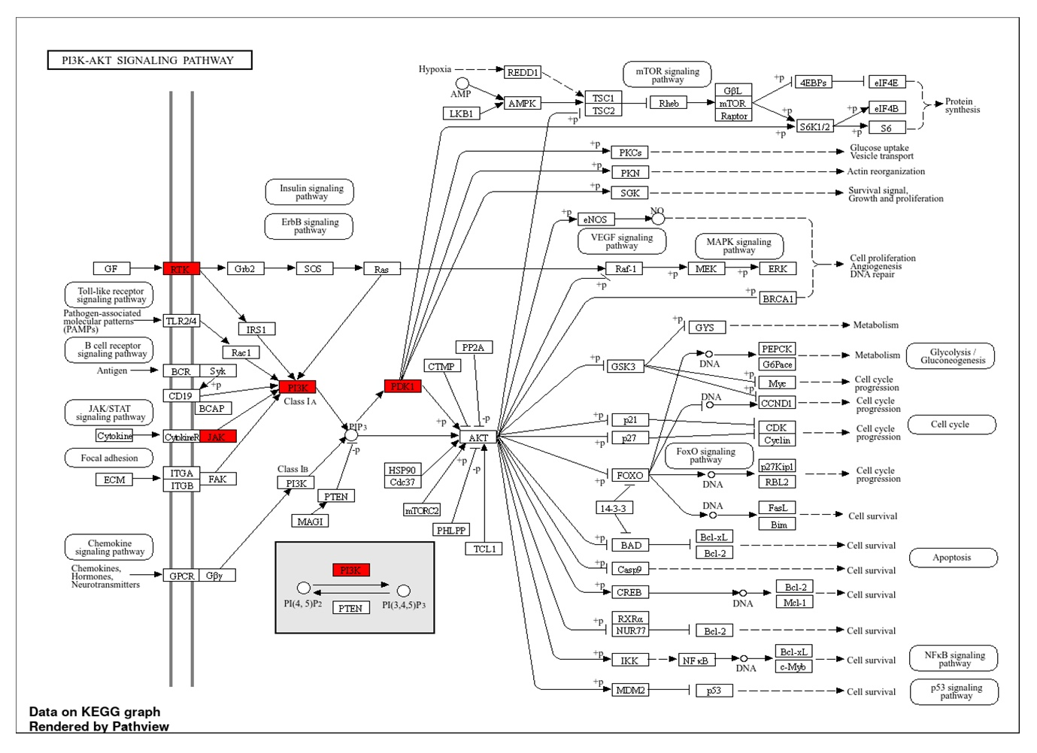Fig. S5 Morin’s targets in the PI3K-AKT pathway based on KEGG analysis.

