Supplementary Section
Potential accelerated biotransformation of petrochemical plastic surfaces by anaerobic digester sludge microorganisms

Apsara Muhandiram ¹, Supun Rathnayaka ¹, Maheshi Somasiri ¹ , Charitha Basnayaka ¹, P. Neelamanie Yapa ¹ and Eustace Y Fernando ^{*1}

¹ Department of Biological Sciences, Faculty of Applied Sciences, Rajarata University of Sri Lanka, Mihintale,
50300
*Corresponding Author
Email for correspondence: eustace6192@as.rjt.ac.lk
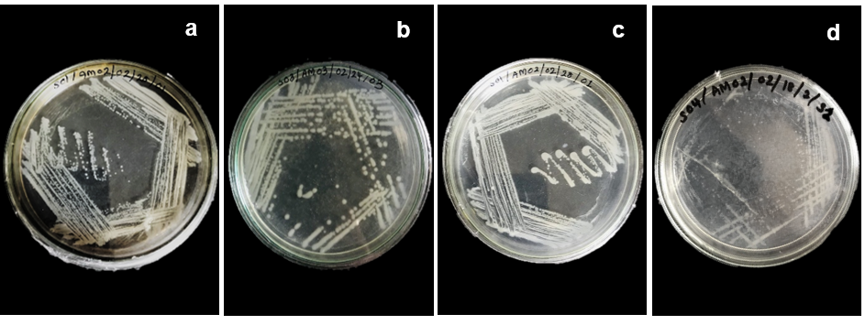
Supplementary figure 01: Microorganisms isolated from the sludge sample 01_01 (a), sample 03_03 (b), sample 04_01 (c) and sample 04_02 (d) showing different colony morphologies on Nutrient agar in anaerobic conditions.
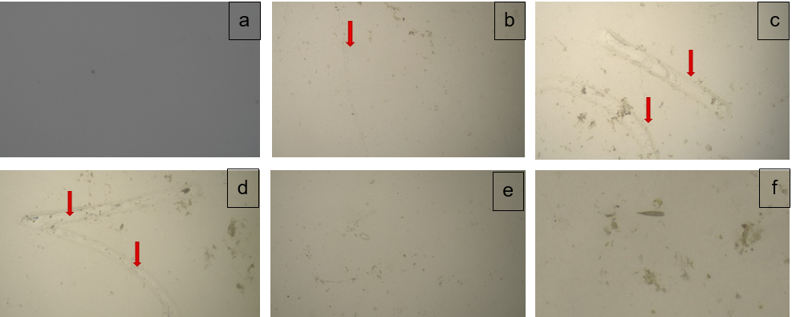
Supplementary figure 02: Surface micrographs of Polypropylene (PP) pieces under phase contrast microscopy (x40) in 0 days (a), 10 days (b), 20 days (c), 30 days (d), 40 days (e) and 50 days (f) showing evidences for surface embrittlement
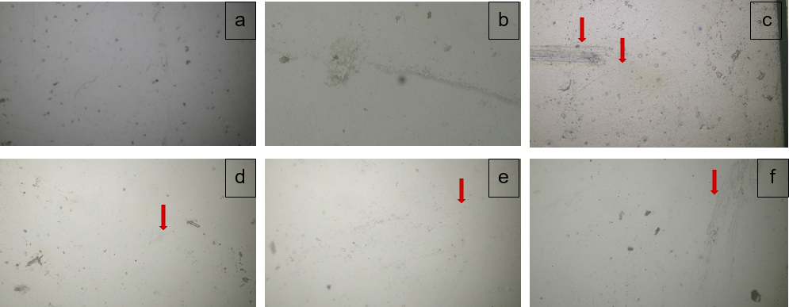
Supplementary figure 3: Surface micrographs of Polyvinyl chloride (PVC) pieces under phase contrast microscopy (x40) in 0 days (a), 10 days (b), 20 days (c), 30 days (d), 40 days (e) and 50 days (f) showing evidences for surface embrittlement

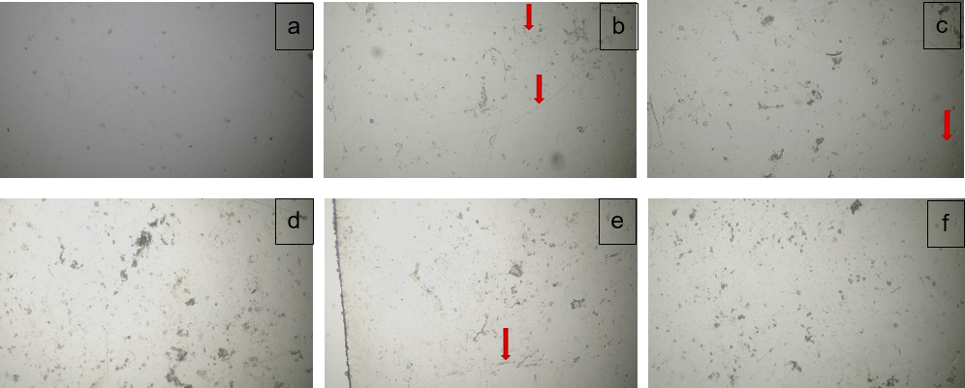
Supplementary figure 4: Surface micrographs of Polyethylene (PE) pieces under phase contrast microscopy (x40) in 0 days (a), 10 days (b), 20 days (c), 30 days (d), 40 days (e) and 50 days (f) showing evidences for surface embrittlement.
Supplementary figure 5: Atomic force microscopy (AFM) surface topography images of PVC surfaces of (A) Day 0, (B) Day 30 (C) Day 50 and (D) the corresponding surface roughness distributions of the same samples

Table 1: Daily and cumulative gas volume data with corresponding substrates and yield coefficients for thirty (30) days’ time period.
Time (Days) | Substrates(g) | Daily volume(mL) | Cumulative volume(mL) | Yield coefficient  Yx/s (methane)
1 | 10 | 1 | 1 | 0.1
2 | 10 | 2 | 3 | 0.2
3 | 10 | 2 | 5 | 0.2
4 | 10 | 1 | 6 | 0.1
5 | 10 | 8 | 14 | 0.8
6 | 10 | 5 | 19 | 0.5
7 | 10 | 10 | 29 | 1
8 | 10 | 10 | 39 | 1
9 | 10 | 11 | 50 | 1.1
10 | 10 | 11 | 61 | 1.1
11 | 10 | 11 | 72 | 1.1
12 | 10 | 9 | 81 | 0.9
13 | 10 | 5 | 86 | 0.5
14 | 10 | 13 | 99 | 1.3
15 | 10 | 13 | 112 | 1.3
16 | 10 | 15 | 127 | 1.5
17 | 10 | 22 | 149 | 2.2
18 | 10 | 23 | 172 | 2.3
19 | 10 | 23 | 195 | 2.3
20 | 10 | 24 | 219 | 2.4
21 | 10 | 26 | 245 | 2.6
22 | 10 | 26 | 271 | 2.6
23 | 10 | 27 | 298 | 2.7
24 | 10 | 29 | 327 | 2.9
25 | 10 | 29 | 356 | 2.9
26 | 10 | 29 | 385 | 2.9
27 | 10 | 31 | 416 | 3.1
28 | 10 | 33 | 449 | 3.3
29 | 10 | 35 | 484 | 3.5
30 | 10 | 38 | 522 | 3.8
Average Volume |  | 17.4±2.09 | 176.4±29.9 | 1.74±0.21

Table 3: Mass loss and mass loss percentage of Polypropylene (PP) samples after wet peroxide oxidation (WPO) process.
Sampling event | Sample name | Initial mass (mg) | Final mass (mg) | Mass loss | Mass loss percentage
10 Days/ Sampling event 01 | PP/S01/R01/01 | 81.9 | 81.8 | 0.1 | 0.12%
 | PP/S01/R02/03 | 81.4 | 81.4 | 0 | 0
 | PP/S01/R03/05 | 81.7 | 81.7 | 0 | 0
20 Days/ Sampling event 02 | PP/S02/R01/07 | 81 | 80.9 | 0.1 | 0.12%
 | PP/S02/R02/08 | 81.1 | 81 | 0.1 | 0.12%
 | PP/S02/R03/11 | 82.1 | 81.8 | 0.3 | 0.37%
30 Days/ Sampling event 03 | PP/S03/R01/13 | 80.9 | 80.9 | 0 | 0
 | PP/S03/R02/15 | 82.6 | 82.6 | 0 | 0
 | PP/S03/R03/17 | 81.5 | 81.5 | 0 | 0
40 Days/ Sampling event 04 | PP/S04/R01/19 | 84.4 | 84.4 | 0 | 0
 | PP/S04/R02/21 | 82.5 | 82.5 | 0 | 0
 | PP/S04/R03/23 | 81.5 | 81.5 | 0 | 0
50 days/ Sampling event 05 | PP/S05/R01/25 | 78 | 78 | 0 | 0
 | PP/S05/R02/27 | 70.9 | 70.9 | 0 | 0
 | PP/S05/R03/30 | 74.9 | 74.9 | 0 | 0
Mean
 |  |  |  | 0.04
Standard deviation |  |  |  | 0.08
Standard error |  |  |  | 0.02
Average Polypropylene mass loss |  |  |  | 0.04±0.02

Table 4: Mass loss and mass loss percentage of Polyvinyl chloride (PVC) samples after wet peroxide oxidation (WPO) process
Sampling event | Sample name | Initial mass (mg) | Final mass (mg) | Mass loss | Mass loss percentage
10 Days/ Sampling event 01 | PVC/S01/R01/01 | 71.6 | 69.1 | 2.5 | 3.49%
 | PVC/S01/R02/03 | 59 | 58 | 1 | 1.69%
 | PVC/S01/R03/05 | 62.5 | 61 | 1.5 | 2.40%
20 Days/ Sampling event 02 | PVC/S02/R01/07 | 63.2 | 62.5 | 0.7 | 1.11%
 | PVC/S02/R02/08 | 65.7 | 65.3 | 0.4 | 0.61%
 | PVC/S02/R03/11 | 68.7 | 67.2 | 1.5 | 2.18%
30 Days/ Sampling event 03 | PVC/S03/R01/13 | 69.2 | 67.7 | 1.5 | 2.17%
 | PVC/S03/R02/15 | 65.8 | 64.7 | 1.1 | 1.67%
 | PVC/S03/R03/17 | 69.8 | 67.9 | 1.9 | 2.72%
40 Days/ Sampling event 04 | PVC/S04/R01/19 | 64.4 | 63.1 | 1.3 | 2.02%
 | PVC/S04/R02/21 | 73 | 72.1 | 0.9 | 1.23%
 | PVC/S04/R03/23 | 63.6 | 62.4 | 1.2 | 1.89%
50 days/ Sampling event 05 | PVC/S05/R01/25 | 70.2 | 70.1 | 0.1 | 0.14%
 | PVC/S05/R02/27 | 75.5 | 75.1 | 0.4 | 0.53%
 | PVC/S05/R03/29 | 70.2 | 69.7 | 0.5 | 0.71%
Mean
 |  |  |  | 1.11
Standard deviation |  |  |  | 0.64
Standard error |  |  |  | 0.16
Average Polyvinylchloride mass loss |  |  |  | 1.11±0.16

Table 5: Mass loss and mass loss percentage of Polyethylene (PE) samples after wet peroxide oxidation (WPO) process.
Sampling event | Sample name | Initial mass (mg) | Final mass (mg) | Mass loss | Mass loss percentage
0 Days | PE/S00/R01/00 | 20 | 20 | 0 | 0
10 Days/ Sampling event 01 | PE/S01/R01/01 | 21.2 | 21 | 0.2 | 0.94%
 | PE/S01/R02/03 | 20.4 | 20.4 | 0 | 0
 | PE/S01/R03/05 | 25.8 | 25.7 | 0.1 | 0.39%
20 Days/ Sampling event 02 | PE/S02/R01/07 | 20.5 | 20.5 | 0 | 0
 | PE/S02/R02/08 | 20.4 | 20.4 | 0 | 0
 | PE/S02/R03/11 | 21.4 | 20.9 | 0.5 | 2.34%
30 Days/ Sampling event 03 | PE/S03/R01/13 | 20.8 | 20.6 | 0.2 | 0.96%
 | PE/S03/R02/15 | 21.4 | 21 | 0.4 | 1.87%
 | PE/S03/R03/17 | 20.7 | 20 | 0.7 | 3.38%
40 Days/ Sampling event 04 | PE/S04/R01/19 | 20.4 | 20.4 | 0 | 0
 | PE/S04/R02/21 | 20.4 | 20.4 | 0 | 0
 | PE/S04/R03/23 | 21.3 | 21.3 | 0 | 0
50 days/ Sampling event 05 | PE/S05/R01/25 | 21.3 | 21.3 | 0 | 0
 | PE/S05/R02/27 | 21.1 | 21 | 0.1 | 0.47%
 | PE/S05/R03/29 | 21.8 | 21.8 | 0 | 0
Mean
 |  |  |  | 0.15
Standard deviation |  |  |  | 0.22
Standard error |  |  |  | 0.06
Average Polyethylene mass loss |  |  |  | 0.15±0.06

