Supplementary Materials

Tracing back the origin of cell-cell communication: Hydra vulgaris releases extracellular vesicles delivering regulators of head and foot regeneration

Maria Moros^{1,2#,} Eugenio Fergola^{2#}, Valentina Marchesano², Margherita Mutarelli², Giuseppina Tommasini², Beata Miedziak^{2,$}, Giuliana Palumbo², Alfredo Ambrosone^{2,&}, Angela Tino², Claudia Tortiglione^{2*}

1 Instituto de Nanociencia y Materiales de Aragón(INMA), Zaragoza, Spain
2 Istituto di Scienze Applicate e Sistemi Intelligenti “E.Caianiello”, Pozzuoli, Italy

Present address
& Department of Pharmacy, Biomedical division, University of Salerno, Italy
$ University of Rzeszów, Faculty od Biotechnology, Rzeszów, Poland

* Corresponding author: claudia.tortiglione@cnr.it

Supplementary information includes:
Fig. S1. Morphological characterization of Hydra EV
Fig. S2. in vivo and in vitro assembly of AuNP on Hydra EV
Fig. S3. Uptake of Hydra EV into Hydra tissue
Fig. S4. EV protein identification by MALDI-TOF/TOF
Fig. S5. Subclustering EV transcripts into single cell type
Fig. S6. Influence of EV on Hydra head regeneration
Supplementary file 1. Full list of transcripts detected in the alignment against the NCBI Hydra vulgaris reference transcriptome (assembly Hydra_RP_1.0)
Supplementary file 2. Full list of transcripts detected in the alignment against the single cell RNAseq reference transcriptome (assembly GHHG01.1)

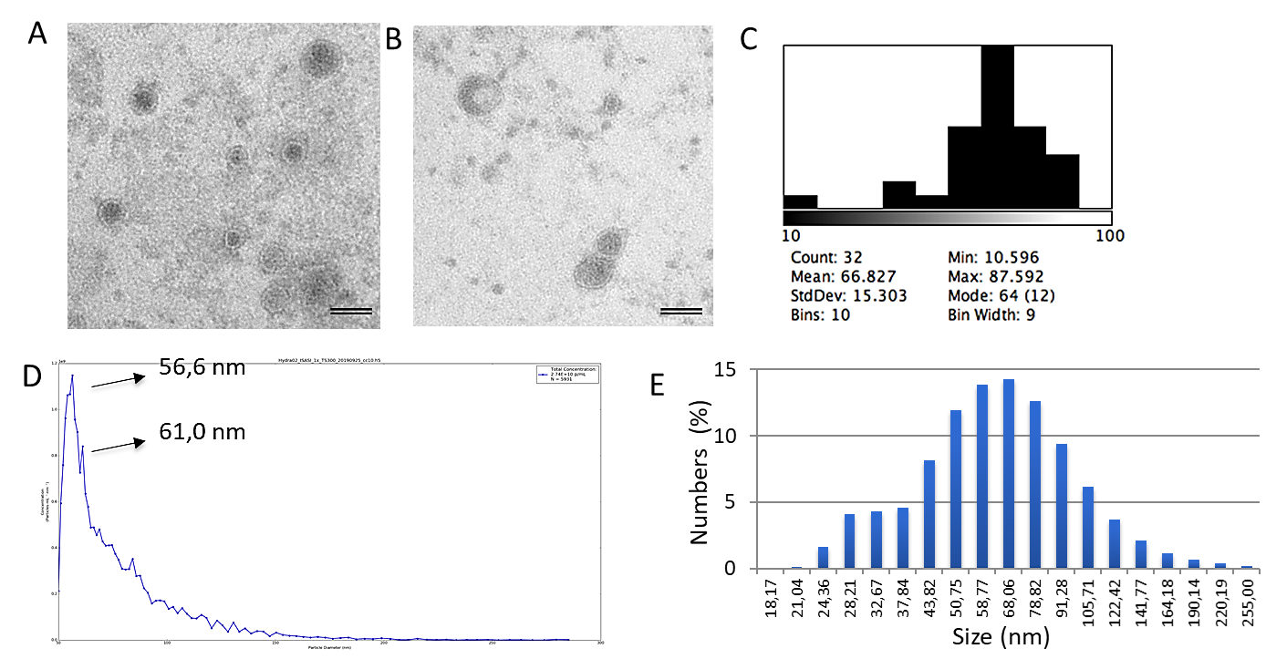

Fig. S1. Morphological characterization of Hydra EV.
A-B) TEM images show the double membrane limiting electron dense core of the EV. Scale bars 50 nm. C) Size distribution of vesicles identified by TEM D) MRPS measurements showing the distribution of the EV size, presenting two major peaks at 56,6 and 61 nm (using a TS-300 cartridge). E) Dynamic light scattering analysis shows an average size of Hydra EV peaking at 68 nm.

Fig. S2. in vivo and in vitro assembly of AuNP on Hydra EV
A) TEM image (TEM, T20 200KeV; FEI) of positively charged AuNPs used in this study shows the high monodispersity of the gold core of AuNP-N3 of an average size of 14 nm. B-C) Polyps were incubated with 25 nM AuNP, then extensively washed and processed 48 h later for TEM. AuNPs appear attached to nanosized vesicles outside the cell membrane, within the glycocalyx. D-E) Hydra EVs were purified from a standard preparation procedure (250 polyps in 10mL of medium) and incubated 4 h with AuNPs, before processing for TEM. AuNP coat the EV surface, forming rosette structures. Scale bars, 100 nm in A, B, C and 50 nm in D-E

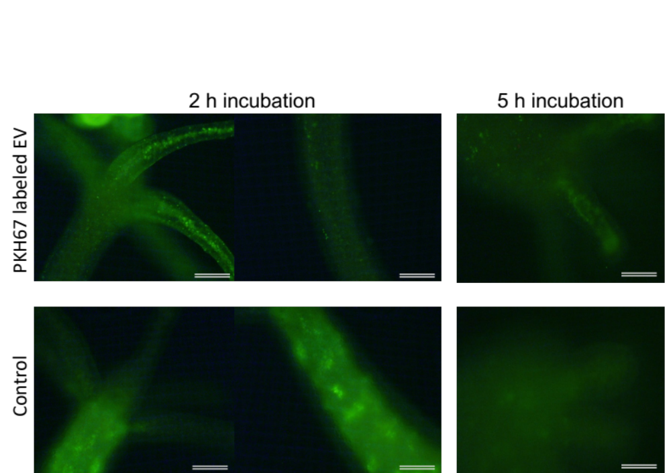
Fig. S3. Uptake of Hydra EV into Hydra tissue
Living Hydra were treated with freshly EVs labelled with PKH67 derived from a standard EV preparation (250 polyp into 10 ml of medium). 2 h post incubation, labelled EVs are internalized in the animal tissues as shown in the upper part of the figure where a green, fluorescent granular signal is detectable both in the tentacles (left) and the body column (right). On the contrary, polyps treated with a negative control solution (PKH67 in Hydra medium) show a diffuse green fluorescent pattern due to the free dye internalization. After 5 h of incubation, the granular fluorescence signal in treated polyps became diffuse and faint, probably indicating the processing of EVs inside the cells. Scale bars, 200 µm.

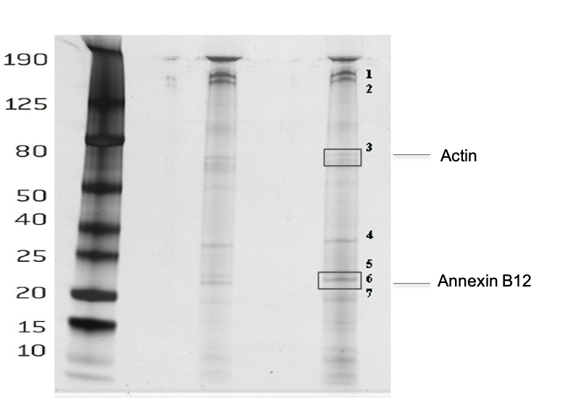

Fig S4. EV protein identification by MALDI-TOF/TOF
Proteins extracted from EVs were run in a 7.5% SDS-PAGE gel. After silver staining, 7 bands were excised from the gel and processed for MALDI-TOF/TOF analysis. The framed area 3 corresponds to actin, while from frame 6 Annexin B12 was identified. 2 biological replicas were performed.

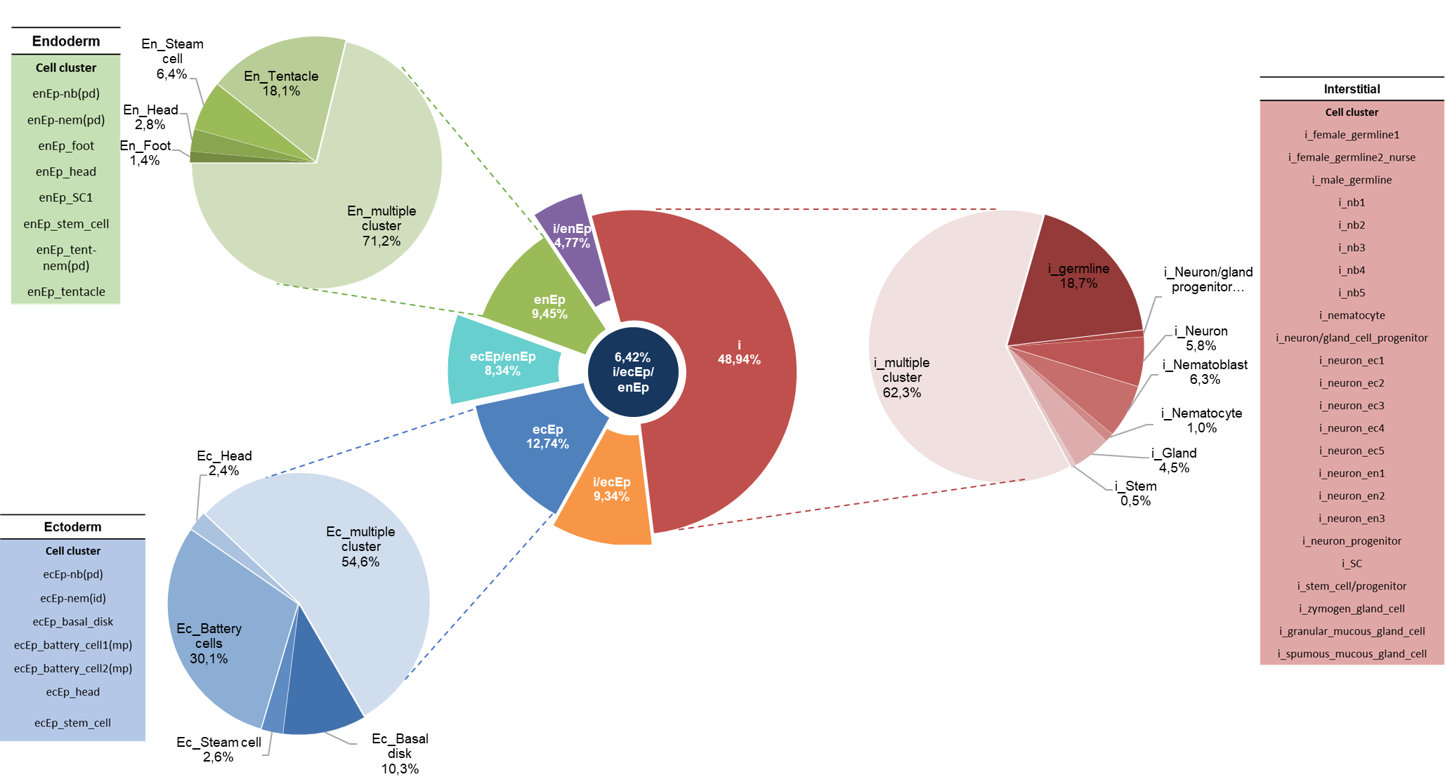

Fig.S5. Subclustering EV transcripts into single cell types
Hydra EV-associated genes were clustered according to ectodermal, endodermal and interstitial cell lineages using a recently-published scRNA-seq atlas (Siebert, Farrell et al. 2019) and expressed as percentages. EV transcripts common to the three lineages are shown in dark blue, while those unique of the interstitial cell lineage (in red) represent the major portion. The amount of ectodermal and endodermal transcripts (in blue and green, respectively) are similar, to those shared between two lineages (interstitial and ectodermal, in orange; ectodermal and endodermal, in azure; interstitial and endodermal in violet).
For each cell lineage EV transcripts matching multiple cell cluster represent the wider portion, while a minority match with single cell clusters, listed beside each distribution.

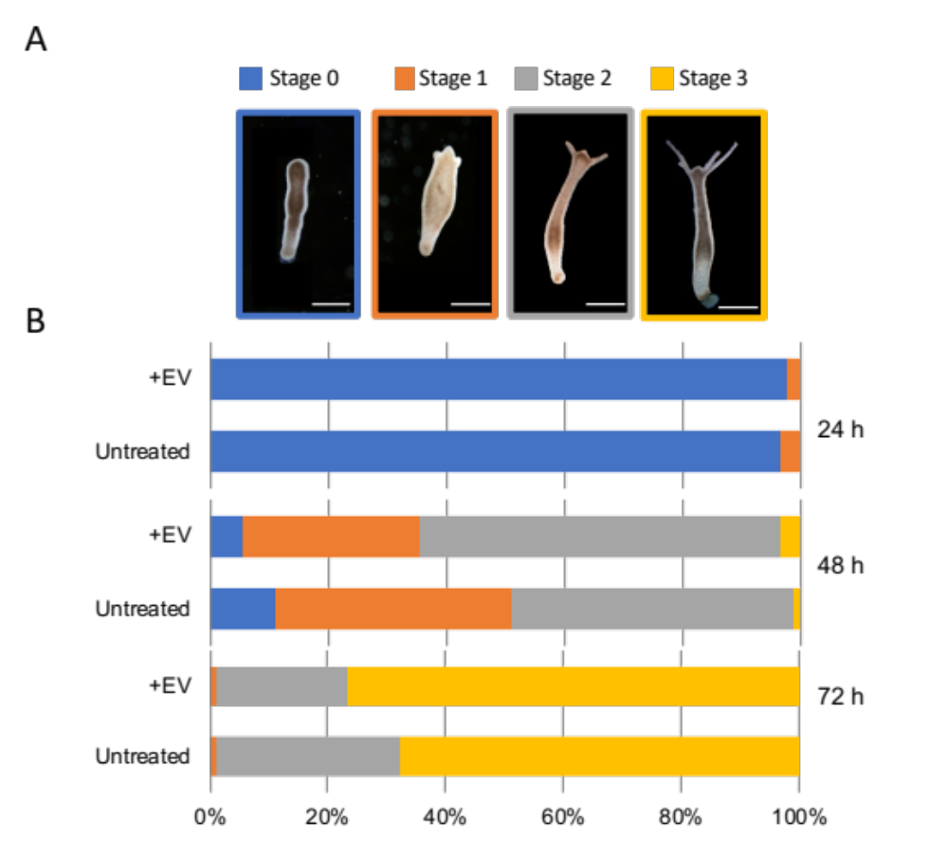

Fig. S6. Influence of EV on Hydra head regeneration.
Groups of 30 animals were bisected at subhypostomal level and allowed to regenerate in presence of EV, or in normal medium (untreated). A) At 24 h, 48 h and 72 h p.a. animals were inspected for viability and regeneration stage: stage 0 indicates wound closure; stage 1 indicates the presence of tentacle buds; stage 2 indicates new emerging tentacles, stage 3 indicates growth tentacles. B) Histograms report the distribution of developmental stages at 24 h, 48 h and 72 h p.a. The bar color corresponds to the regenerative stages shown in A. Animals treated with EV present more advanced stages than untreated animals. Data are means of three independent experiments (n=90). Statistical analysis performed at 48 h p.a. shows Chi squared =12.099 with 3 degrees of freedom. The two-tailed **P value= 0.0071. At 72 h Chi squared equals 3.335 with 2 degrees of freedom. The two-tailed P value equals 0.1887 (not significant).

Accession No. | Protein Name | Putative Function | Matched Peaks | Matched Peptides | Mascot Score | Exocarta
CDG70628 | Actin, cytoplasmic 1, partial | Cytoskeleton component | 18 | 16 | 235 | Yes
XP_002161913 | Tubulin beta chain | Cytoskeleton component | 10 | 8 | 169 | Yes
XP_002156816 | Uncharacterized protein LOC100207118 | Thrombospondin type-1 domain | 5 | 5 | 130 | ---
XP_012558692 | Fibrillin-1 | Microfibril assembly | 11 | 10 | 125 | Yes
XP_002166874 | Fibrillin-2 isoform X1 | Microfibril assembly | 9 | 7 | 107 | Yes
NP_001296699 | Annexin B12 | Calcium-dependent membrane binding | 7 | 4 | 100 | No
XP_002159321 | Syntenin-1-like isoform X2 | Biogenesis of exosomes | 9 | 8 | 99 | Yes
NP_001296663 | Elongation factor EF1-alpha | Translation elongation factor | 11 | 10 | 89 | Yes
XP_004212135 | Protocadherin Fat 4, partial | Cell-cell adhesion | 7 | 7 | 89 | Yes
XP_002159997 | Mucin-5AC, partial | Glycocalix constituent | 5 | 4 | 86 | Yes
XP_012559193 | Neurogenic locus notch homolog protein 1, partial | Notch signalling | 9 | 7 | 86 | Yes
XP_004205459 | Histone H4 | Nucleosome assembly | 8 | 7 | 83 | Yes
XP_002154154 | Latent-transforming growth factor beta-binding protein 4-like | Extracellular matrix constituent | 12 | 12 | 80 | Yes
XP_012556685 | Zinc finger MYM-type protein 1 | Transcriptional repressor | 9 | 9 | 79 | Yes
CDG71416 | Heat shock cognate 71 kDa protein | Molecular chaperon | 8 | 8 | 73 | Yes
ABC25030 | Heat shock protein 70 | Stress-induced molecular chaperon | 9 | 9 | 73 | Yes
XP_004212674 | Protocadherin Fat 1, partial | Cell-cell adhesion | 17 | 17 | 71 | Yes
XP_012558915 | Uncharacterized protein LOC100197130 | Chitin binding domain | 2 | 2 | 71 | ---
XP_012554603 | Uncharacterized protein LOC100208285 | CUB extracellular domain | 11 | 11 | 69 | ---
XP_002166847 | Uncharacterized protein LOC100198427, partial | -------------------------- | 2 | 2 | 67 | ----
XP_004209567 | Histone H1-delta | Nucleosome assembly | 5 | 5 | 63 | Yes
XP_012553809 | Annexin A4-like | Calcium-dependent membrane binding | 14 | 13 | 61 | Yes
AAW82079 | Thypedin | Foot formation stimulator | 5 | 5 | 57 | No
XP_002163070 | Ubiquitin-40S ribosomal protein S27a | Vesicle cargo sorting | 3 | 2 | 57 | No
XP_002165348 | CD151 antigen | Exosome marker | 5 | 5 | 56 | Yes
AAN87350 | 14-3-3 protein B | Growth adaptation to food supply | 2 | 2 | 54 | No
CAJ33888 | Putative serine protease inhibitor | Protective function against excessive autophagy | 5 | 5 | 54 | No
XP_002156827 | Ras-like GTP-binding protein RHO | Signal transduction | 2 | 2 | 52 | Yes
XP_012562569 | Uncharacterized protein LOC100200012 | Von Willebrand factor type A (vWA) domain | 5 | 5 | 51 | ---
XP_004211099 | Usherin-like, partial | Integral component of membrane | 2 | 2 | 47 | No
CDG70601 | 40S ribosomal protein S3a, partial | Ribosome assembly | 6 | 6 | 46 | Yes
XP_012564127 | Uncharacterized protein LOC101234629 | Calcium-binding EGF-like domain | 9 | 7 | 44 | ---
XP_012565905 | Uncharacterized protein LOC105849991, partial | ---------------------------- | 4 | 3 | 44 | ---
CDG71497 | ATP synthase subunit beta, mitochondrial, partial | Cellular respiration | 10 | 10 | 44 | Yes
XP_002162060 | Programmed cell death 6-interacting protein | Multivesicular body biogenesis | 10 | 9 | 43 | Yes
XP_002155023 | Polyubiquitin-B | Vesicle cargo sorting | 11 | 7 | 43 | Yes
XP_012566106 | Uncharacterized protein LOC100203042, partial | Thrombospondin type 1 domain | 3 | 2 | 42 | ---
XP_012554672 | cAMP-dependent protein kinase type II regulatory subunit-like isoform X2 | cAMP-mediated signalling pathway | 5 | 4 | 42 | Yes
XP_004208264 | Uncharacterized serine-rich protein C215.13-like | ------------------------------ | 2 | 2 | 41 | ---
XP_012564784 | Von Willebrand factor D and EGF domain-containing protein-like, partial | Cell surface receptor signaling pathway | 6 | 6 | 41 | No
XP_004208788 | Tubulin alpha-1D chain | Cytoskeleton component | 5 | 4 | 41 | Yes
XP_002158871 | Flagellar calcium-binding protein-like | Calcium ion binding | 4 | 3 | 40 | No
CDG71487 | Protein disulfide-isomerase | ------------------------------ | 5 | 4 | 40 | Yes
XP_012553917 | Malate dehydrogenase, cytoplasmic-like | Krebs cycle | 3 | 3 | 38 | Yes
AAQ13347 | Ribosomal protein L10 | Ribosome pathway | 3 | 2 | 36 | Yes
XP_004209147 | Cell division control protein 42 homolog | small GTPase mediated signal transduction | 2 | 2 | 36 | No
XP_012557607 | Uncharacterized protein LOC100208299 | Chromosome segregation protein SMC | 6 | 6 | 34 | --
XP_002162887 | ADP-ribosylation factor 1-like 2 | Retrograde transport, endosome to Golgi | 2 | 2 | 34 | Yes
AEW90237 | Voltage-gated sodium channel Nav2.1, partial | Neuronal signaling in Hydra | 15 | 15 | 34 | No
XP_012560741 | Uncharacterized protein LOC105846485, partial | NOD-like receptor signaling pathway | 7 | 6 | 32 | --
XP_012562547 | Mitotic spindle assembly checkpoint protein MAD1-like | Mitotic spindle assembly checkpoint signaling | 11 | 11 | 32 | No
XP_004207315 | Uncharacterized protein LOC101240603 | Reverse transcriptase domain | 3 | 2 | 32 | ---

Table S1. List of 52 proteins identified in EV vesicles by LC-ESI-MS/MS analysis, mascot score >32, matched peptide >2

TARGET GENE | C_{t} MEAN
Hsp70 | 24.86 ± 1.85
Hsp70 (NTC) | 37.60 ± 1.96
β-cat | 27.07 ± 0.27
β-cat (NTC) | 38.51 ± 2.11
Wnt3 | 30.22 ± 0.75
Wnt3 (NTC)  Actin  Actin (NTC) | 38.19 ± 2.12  25.60 ± 0.5  37.43 ± 2.05

Table S2 RT-PCR validation using presence/absence analysis
Ct mean ± SD were obtained from two independent biological experiments performed in triplicate. NTC= no template control

Gene | Accession No | Forward Primer | Reverse Primer
Wnt3 | NM_001287363 | 5’-CAACAAGGCTGGACGAGAGG-3’ | 5’-CTGAAATGGGGCTGTGAACG-3’
β-catenin | U38624 | 5’-TGCACCTTCTTCACGCTCAATAG-3’ | 5’-GGCGCTCTTCACATTTTAGC-3'
Actin | XM_002154426 | 5’- AAGCTCTTCCCTCGAAGAATC-3’ | 5’- CCAAAATAGATCCTCCGATCC-3’
Hsp70 | NM_001309695 | 5’-CGACGTATTCAGACAATCAAC-3’ | 5’-CAATTTGAGGAACACCTCTTG-3’
Ef1α | NM_001309734.1 | 5’-CCAGGAGACAATGTCGGTTT-3’ | 5’-GCTTCAATGGCAGGATCATT-3’

Table S3. Primer sequences used for RT-PCR analysis

Cell Cluster | Gene ID | Gene ID (NCBI) | Gene name | Homology (OrthoDB)
Ec_basal_disk | t11369aep | 100199560 | TCTP | TPT1 [Homo sapiens] NP_001273201.1
Ec_basal_disk | t16171aep | 105845407 | Uncharacterized | galaxin-like isoform X2 [Danio rerio] XP_005163007.1
Ec_basal_disk | t9810aep | 105847572 | Flocculation protein FLO11-like | IFT140 [Homo sapiens] XP_016879399.1
Ec_basal_disk | t11479aep | 100207237 | Uncharacterized | C-type lectin-like
Ec_basal_disk | t13256aep | 105844822 | rhamnose-binding lectin-like | EVA1C [Homo sapiens] NP_478067.2
Ec_battery_cell2(mp) | t11116aep | 100202036 | actin, non-muscle 6.2-like | POTEI [Homo sapiens] XP_016860221.1
Ec_battery_cell2(mp) | t34888aep | 105846558 | lipopolysaccharide-induced tumor necrosis factor-alpha factor homolog | CDIP1 [Homo sapiens] NP_037531.2
Ec_battery_cell2(mp) | t4993aep | 100215092 | inositol-tetrakisphosphate 1-kinase-like | ITPK1 [Homo sapiens] NP_055031.2
Ec_battery_cell2(mp) | t30709aep | 105845211 | protein PFC0760c-like | /
Ec_battery_cell2(mp) | t35aep | 100202307 | ADP-ribosylation factor 6 | ARL4C [Homo sapiens] NP_001269360.1
Ec_head | t24379aep | / | / | /
Ec_head | t4117aep | / | / | /
Ec_head | t33641aep | 100213910 | ATP synthase F(0) complex subunit B1, mitochondrial-like | ATP5F1 [Homo sapiens] NP_001679.2
Ec_head | t19284aep | 100209701 | ATP synthase subunit gamma, mitochondrial-like | ATP5F1C [Homo sapiens] NP_001001973.1
Ec_head | t16848aep | 100207790 | mitochondrial-processing peptidase subunit beta-like | UQCRC1 [Homo sapiens] NP_003356.2
Ec_stem_cell | t19380aep | / | / | /
Ec_stem_cell | t22090aep | / | putative leucine-rich repeat-containing protein DDB_G0290503 | /
Ec_stem_cell | t26296aep | 100209179 | cold shock domain-containing protein E1-like | CSDE1 [Homo sapiens] NP_001229820.1
Ec_stem_cell | t13120aep | 100204386 | mitochondrial import receptor subunit TOM70-like | TOMM70 [Homo sapiens] NP_055635.3
Ec_stem_cell | t7502aep | 100211597 | prostaglandin E synthase 2-like | PTGES2 [Homo sapiens] NP_079348.1
EnEp-nem(pd) | t38379aep | 100200982 | electron transfer flavoprotein subunit beta-like | ETFB [Homo sapiens] NP_001014763.1
En_foot | t27064aep | 101240735 | Uncharacterized | POGK [Homo sapiens] XP_016857403.1
En_foot | t31094aep | 100215335 | forkhead box protein D2-like | fkh-10 [Caenorhabditis elegans] NP_492676.2
En_foot | t9657aep | 101238486 | neuropeptide Y receptor-like | CG13995 [Drosophila melanogaster] NP_608986.1
En_foot | t10383aep | 100215397 | glycylpeptide N-tetradecanoyltransferase 2-like | NMT1 [Homo sapiens] NP_066565.1
En_head | t16838aep
En_head | t20529aep | 100199243 | protein RER1-like | RER1 [Homo sapiens] NP_008964.3
En_head | t16864aep | / | Cytosolic 10-formyltetrahydrofolate dehydrogenase [Exaiptasia pallida] | /
En_head | t1100aep | 101236386 | ras-specific guanine nucleotide-releasing factor RalGPS2-like | RALGPS2 [Homo sapiens] NP_689876.3
En_head | t34763aep | 100205238 | Uncharacterized | protein naked cuticle homolog 2-like [Propithecus coquereli] XP_012520768.1
En_SC1 | t20542aep | 101235897 | hsp90aa1 | HSP90AA1 [Homo sapiens] NP_001017963.2
En_stem_cell | t1207aep |  | galaxin-2-like [Lingula anatina] | /
En_stem_cell | t6483aep | 100204864 | mitochondrial import inner membrane translocase subunit Tim17-A-like | TIMM17B [Homo sapiens] NP_001161419.1
En_stem_cell | t11367aep | 100211497 | cytochrome c oxidase subunit 4 isoform 2, mitochondrial-like | COX4I1 [Homo sapiens] XP_024305924.1
En_SC1 | t22130aep | 100203295 | stress-induced-phosphoprotein 1-like | STIP1 [Homo sapiens] NP_001269581.1
enEp_tent-nem(pd) | t33887aep | / | / | /
enEp_tentacle | t29036aep | / | / | /
enEp_tent-nem(pd) | t5837aep | / | / | /
enEp_tentacle | t327aep | 100201881 | cytoplasmic protein NCK2-like | NCK2 [Homo sapiens] XP_016860592.1
enEp_tentacle | t29023aep | 100206535 | serine/threonine-protein kinase dst1-like | STK17A [Homo sapiens] NP_004751.2
i_female germline2_nurse | t32296aep | 100203304 | hsp70 | HSPA8 [Homo sapiens] NP_006588.1
i_female germline2_nurse | t12608aep | 100204298 | fumarate hydratase, mitochondrial-like | FH [Homo sapiens] NP_000134.2
i_female germline1 | t12818aep | 100211523 | ELAV-like protein 3 | ELAVL3 [Homo sapiens] XP_024307178.1
i_female germline1 | t9539aep | 100209541 | very-long-chain enoyl-CoA reductase-like | TECR [Homo sapiens] XP_024307558.1
i_female germline1 | t24294aep | 100208612 | Uncharacterized | /
i_male germline | t4609aep | 100214281 | NADH dehydrogenase [ubiquinone] 1 alpha subcomplex subunit 6-like | NDUFA6 [Homo sapiens] NP_002481.3
i_male germline | t36963aep | 100215790 | peptidyl-prolyl cis-trans isomerase D-like | PPID [Homo sapiens] NP_005029.1
i_male germline | t29886aep |  | Protein Asterix [Exaiptasia pallida] | /
i_male germline | t14411aep | 100208062 | 26S protease regulatory subunit 7 | PSMC1 [Homo sapiens] NP_002793.2
i_male germline | t7735aep | 101240495 | uncharacterized protein C10orf35 homolog | FAM241B [Homo sapiens] XP_005269663.1
i_zymogen gland cell | t8678aep | 100192274 | dickkopf-like protein Dlp-2 | DKK1 [Homo sapiens] NP_036374.1
i_spumous mucous | t12601aep | 105850171 | Uncharacterized | macrophage mannose receptor 1-like [Hydra vulgaris] XP_012565955.1
i_zymogen gland cell | t2549aep | 100208683 | Uncharacterized | /
i_zymogen gland cell | t18337aep | 100208251 | chymotrypsin-like elastase family member 3B | CELA3A [Homo sapiens] NP_005738.4
i_spumous mucous | t16833aep | 101236854 | probable inactive serine/threonine-protein kinase DDB_G0274613 | galaxin-like [Octopus bimaculoides] XP_014775667.1
i_nb3 | t28759aep | 105843076 | protein hunchback-like | /
i_nb3 | t31474aep |  | / | /
i_nb3 | t6076aep | 101235787 | zonadhesin-like | IGFBP2 [Homo sapiens] NP_000588.3
i_nb2 | t36424aep |  | universal stress protein A-like protein | /
i_nb1 | t9542aep | 100208570 | coiled-coil domain-containing protein 47-like | coiled-coil domain-containing protein 47 [Nematostella vectensis] XP_001635664.1
i_nematocyte | t20281aep | 100201793 | probable Bax inhibitor 1 | TMBIM6 [Homo sapiens] NP_001092046.1
i_nematocyte | t26342aep | 100211366 | charged multivesicular body protein 4c-like | CHMP4C [Homo sapiens] NP_689497.1
i_nematocyte | t12987aep | 100199474 | protein FAM49B-like | FAM49A [Homo sapiens] NP_110424.1
i_nematocyte | t49aep |  | predicted protein [Nematostella vectensis] >gi|156226719|gb|EDO47527.1 | /
i_nematocyte | t14606aep | 100204791 | feline leukemia virus subgroup C receptor-related protein 1-like | FLVCR2 [Homo sapiens] NP_060261.2
i_neuron progenitor | t1704aep | 100212336 | 14-3-3 protein gamma-like | YWHAG [Homo sapiens] NP_036611.2
i_neuron ec | t605aep |  | /
i_neuron ec | t16657aep | 100213338 | pol-RFamide neuropeptides-like | /
i_neuron ec | t12724aep |  | Gs protein alpha subunit [Tripedalia cystophora] | /
i_neuron ec | t11848aep | 100211830 | ubiquilin-1-like | UBQLN1 [Homo sapiens] NP_038466.2
i_neuron/gland progentior | t33270aep | 100209415 | probable serine/threonine-protein kinase DDB_G0268642 | EIF2AK4 [Homo sapiens] NP_001013725.2
i_neuron/gland progentior | t15889aep | 100203250 | ATPase inhibitor A, mitochondrial-like | bromodomain-containing protein DDB_G0280777-like [Octopus bimaculoides] XP_014776060.1
i_neuron/gland progentior | t3951aep | 100211845 | histidine--tRNA ligase, cytoplasmic-like | HARS [Homo sapiens] NP_002100.2
i_neuron/gland progentior | t4973aep | 100207258 | mediator of RNA polymerase II transcription subunit 22-like | MED22 [Homo sapiens] NP_598395.1
i_neuron/gland progentior | t12704aep | 100210427 | 26S protease regulatory subunit 6A-B-like | PSMC [Homo sapiens] XP_016873515.1

Table S4. List of EV transcripts subclustered according to unique cell type expression
The 5 top genes in each cell cluster are shown

Gene ID | Gene ID (NCBI) | Gene name | Lineage | Cell type | Anatomical region | Homology (OrthoDB)
t30823aep | / | / | Ectoderm | Ec_basal_disk, Ec_battery_cell, Ec_head, Ec_stem_cell | Head, Body, Foot | /
t1568aep | 100197360 | branched-chain-amino-acid aminotransferase, cytosolic-like | Interstitial | i_nb, i_SC, i_stem cell/progenitor | Body | BCAT2 [Homo sapiens] NP_001181.2
t8317aep | / | / | Ectoderm | Ec_basal_disk, Ec_battery_cell, Ec_head, Ec_stem cell | Head, Body, Foot | /
t273aep | 105847469 | Uncharacterized | Endoderm, Interstitial | En_tentacle, i_male germline | Tentacle, Body | AF4/FMR2 family member 4-like [Octopus bimaculoides] XP_014773896.1
t1932aep | 100205747 | eukaryotic translation initiation factor 4E-binding protein 3-like | Interstitial | i_female germline, i_SC, i_stem_cell/progenitor | Body | EIF4EBP1 [Homo sapiens] NP_004086.1
t35773aep | 100205436 | soma ferritin-like | Ectoderm, Endoderm, Interstitial | Ec_battery cell, Ec_head, Ec_stem cell, En_tent-nem(pd), i_nematocyte, i_neuron_ec | Head, Body | FTH1 [Homo sapiens] NP_002023.2
t8678aep | 100192274 | Dickkopf 1/2/4-A | Interstitial | i_zimogen gland cell | Body | DKK1 [Homo sapiens] NP_036374.1
t29320aep | / | / | Ectoderm | Ec_battery cell, Ec_head, Ec_stem cell | Head, Body | /
t11116aep | 100202036 | actin, non-muscle 6.2-like | Ectoderm | Ec_battery_cell2(mp) | Tentacle | POTEI [Homo sapiens] XP_016860221.1
t15818aep | 101240323 | neuroblast differentiation-associated protein AHNAK | Ectoderm, Endoderm | Ec_basal disk, Ec_battery_cell, Ec_head, Ec_stem_cell, En_tent-nem(pd) | Head, Body, Foot | AHNAK [Homo sapiens] NP_001333375.1

Table S5. List of top ten EV transcripts matching the scRNA-seq atlas

