Supplementary materials
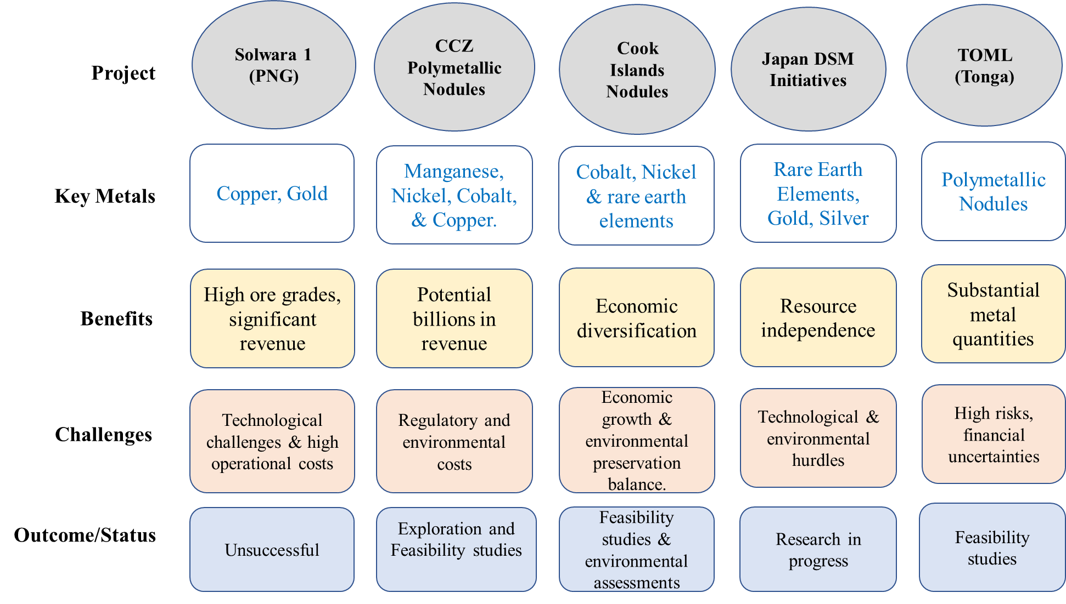

Extended Data Figure 1: Examples of real-world economic analyses related to deep-sea mining. Shows different potential project, the metals targeted, expected benefits, the challenges faced and the current status/outcomes of the projects.

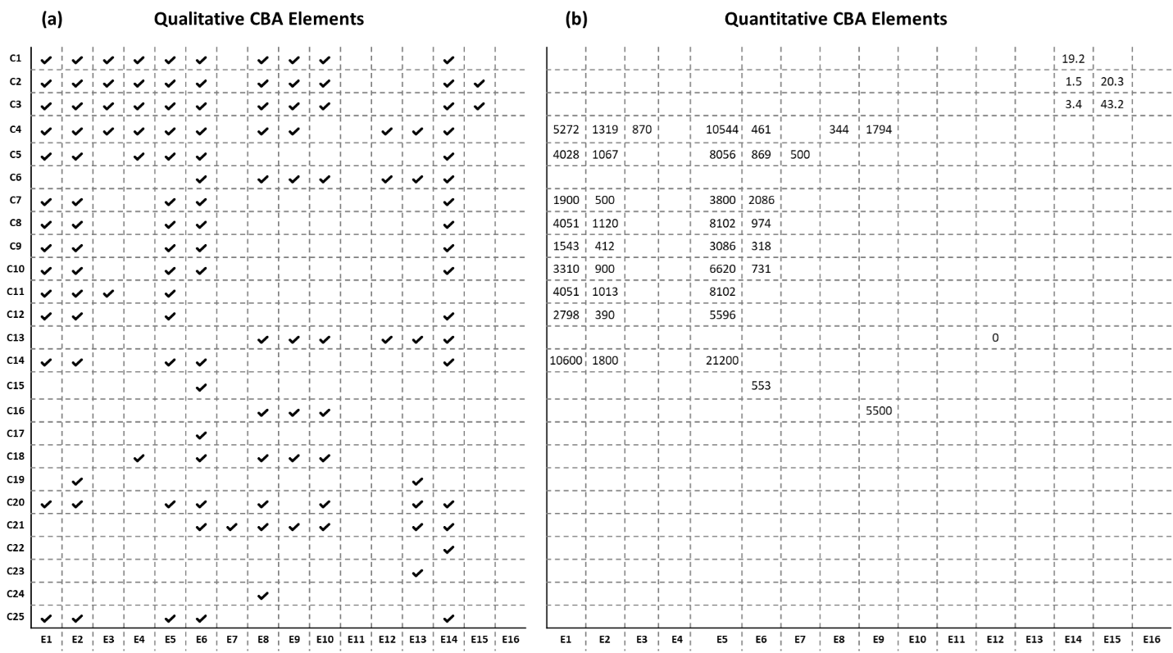
Extended Data Figure 2: CBA qualitative and quantitative representation of data from literature. Side-by-side visualization of Cost-Benefit Analysis (CBA) elements across 25 deep-sea mining case studies. (a) presents the qualitative assessment, where bold checkmarks (✓) indicate the inclusion of a specific CBA element (E1–E16) in each case study (C1–C25). (b) shows quantitative data (in billion USD/3 million tonnes, except for revenue, which is in USD/tonne), with bold numerical entries representing monetary or unit-based estimates where available. Empty cells denote missing data. This comparative view highlights coverage patterns and identifies gaps in the evaluation of environmental, social, and economic impacts of deep-sea mining. Total # of cells: 400; Cells with data qualitative and quantitative: 32% and 11%, respectively. CBA Elements (E): E1: Exploration & extraction cost; E2: Operational costs; E3: Annual maintenance cost; E4: Compliance cost; E5: Environmental remediation and restoration; E6: Revenue from extracted minerals; E7: Salvage value; E8: Loss of biodiversity; E9: Disruption of deep-sea ecological functions; E10: Chemical leakage and contamination; E11: Reduction greenhouse gases; E12: Impact on Indigenous or traditional knowledge; E13: Distribution of mining benefits and burdens; E14: Employment/income/capacity building; E15: Contribution to GDP; E16: Degradation of non-use and existence values. Case Studies (C): C1: SPC Technical Report 2016 (PNG); C2: SPC Technical Report 2016 (Marshall Islands); C3: SPC Technical Report 2016 (Cooks islands); C4: Planet tracker 2024; C5: Kirchaim et al. 2019 (MIT Model); C6: Wakefield & Myers 2016; C7: Sharma 2011; C8: Kirchaim et al. 2019 (African Group); C9: Kirchaim et al. 2019 (BMWi); C10: Kirchaim et al. 2019 (China Model); C11: Van Nijen et al. 2018; C12: Wilde 2023; C13: Binney & Fleming 2016; C14: AMC 2021; C15: Thaler 2024; C16: Amon et al. 2023; C17: Lapteva 2022; C18: EASAC 2023; C19: DSCC 2020; C20: Lof et al. 2022; C21: Levin et al. 2020; C22: OEWG 2022; C23: Groch 2023; C24: Donaldson 2023; C25: German study 2016.
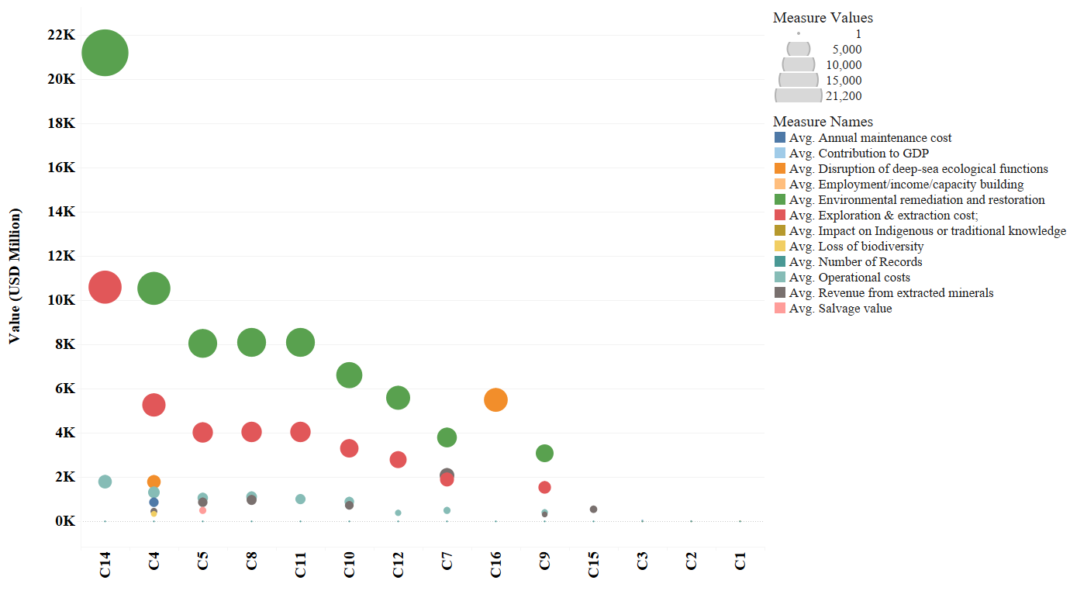
Extended Data Figure 3: Quantitative estimates of cost-benefit analysis elements in deep-sea mining. The y-axis represents the reported estimates in USD million, while the x-axis lists the case studies analyzed. The bubble sizes indicate the magnitude of the values, and different colors represent the various cost-benefit elements.

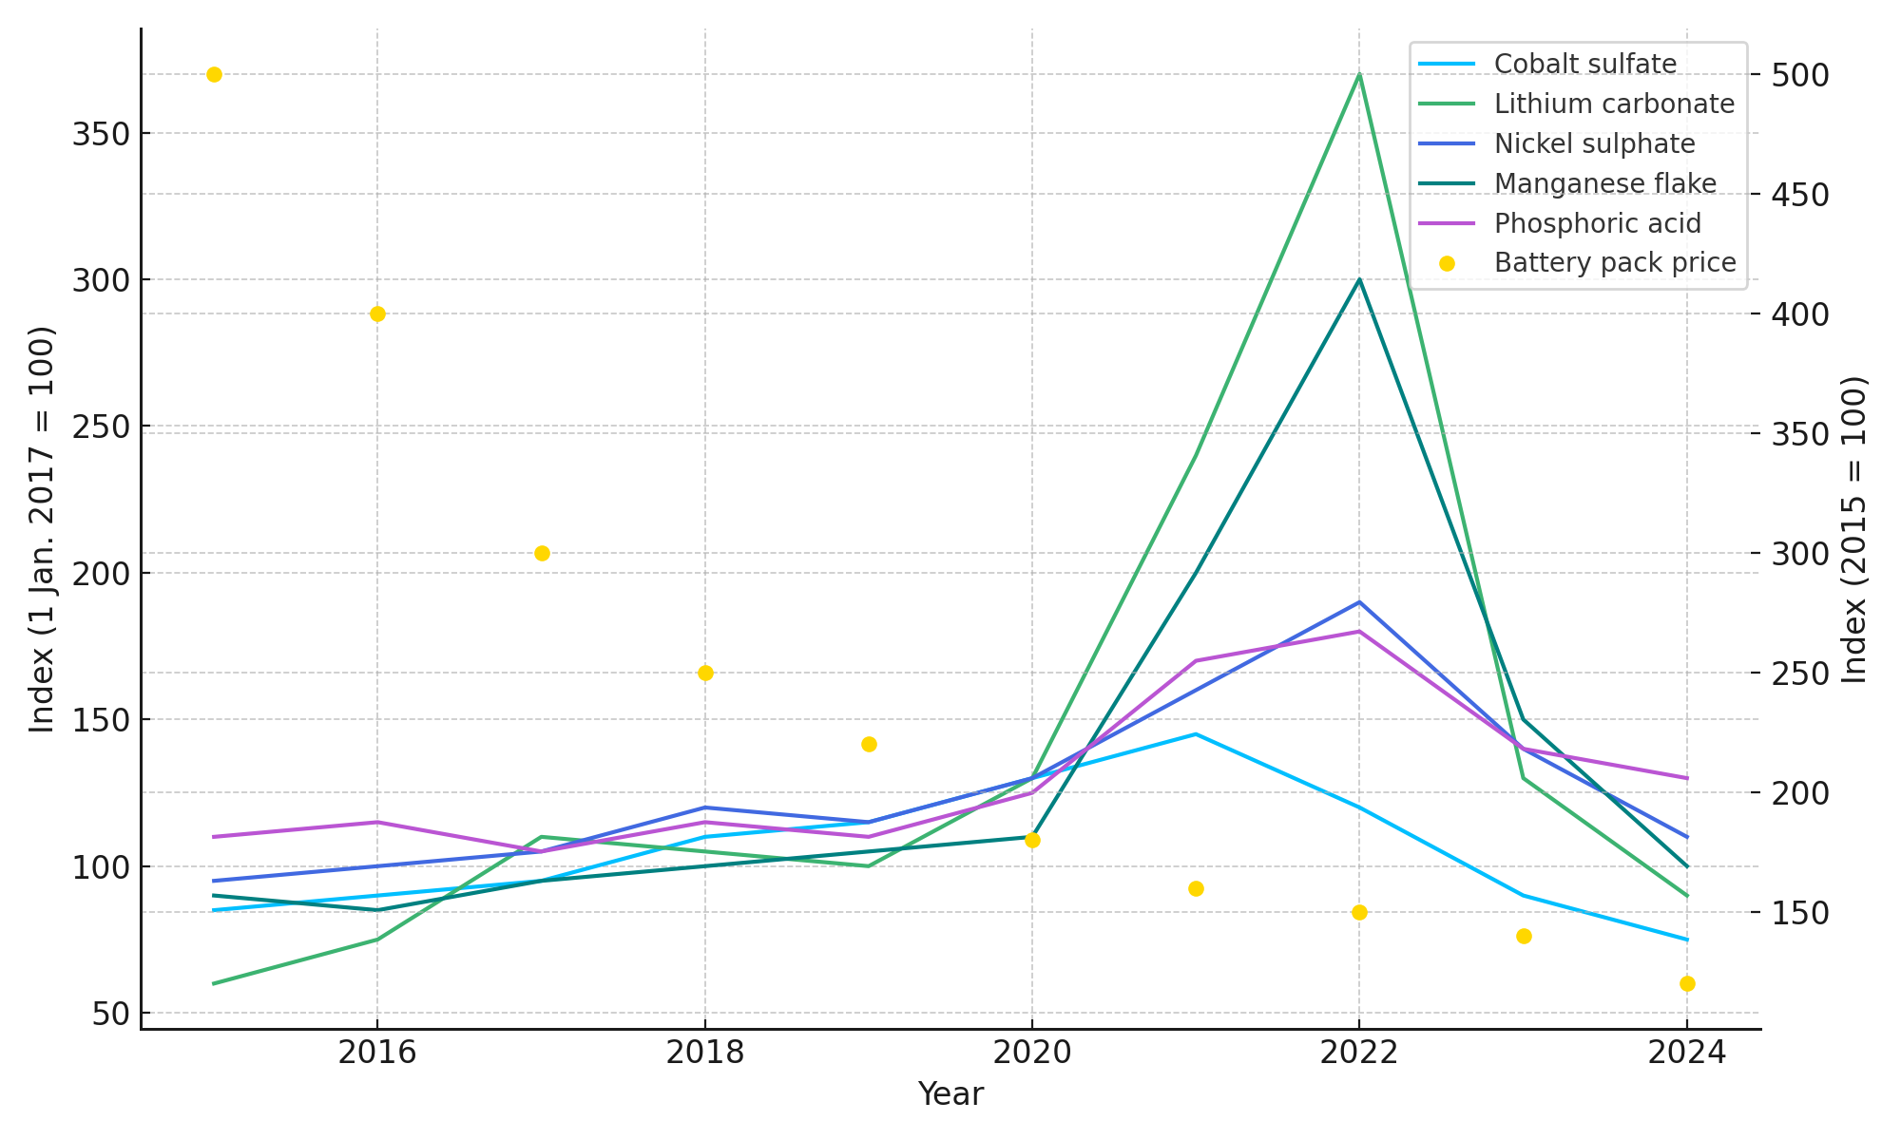
Material | % Change (Peak to 2024)
Battery pack price | -76.0%
Lithium carbonate | -75.68%
Manganese flake | -66.67%
Cobalt sulfate | -48.28%
Nickel sulphate | -42.11%
Phosphoric acid | -27.78%
Extended Data Figure 4. (a) Redrawn battery metal and pack price index chart reported in Global EV Outlook 2024. This chart illustrates the indexed prices (2015–2024) for selected battery metals and lithium-ion battery packs; and (b) presents the percentage change from the peak price to the most recent price (2024) for selected battery metals and lithium-ion battery packs, based on indexed data (2015–2024).

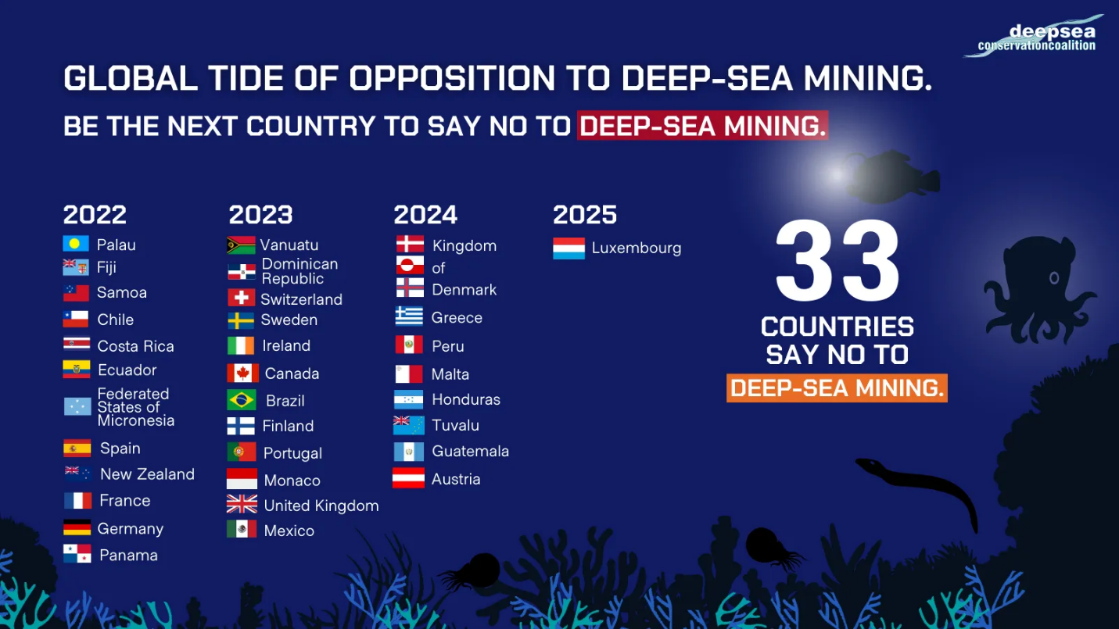

Extended Data Figure 5: Global opposition to deep-sea mining (2022–2025).
A total of 33 countries have formally expressed their opposition to deep-sea mining by calling for a moratorium, precautionary pause, or ban, as visualized in this infographic compiled by the Deep Sea Conservation Coalition. (Source: Governments and Parliamentarians - Deep Sea Conservation Coalition).

Extended Data Table 1: List of papers reviewed to extract CBA Information on Deep-Sea Mining
Case study code | CBA elements
C1: SPC Technical Report 2016 (PNG)¹⁶ | E1: Exploration & extraction cost  E2: Operational costs  E3: Annual maintenance cost  E4: Compliance cost  E5: Environmental remediation and restoration  E6: Revenue from extracted minerals  E8: Loss of biodiversity  E9: Disruption of deep-sea ecological functions  E10: Chemical leakage and contamination  E13: Employment/income/capacity building
C2: SPC Technical Report 2016 (Marshall Islands) ¹⁶ | E1: Exploration & extraction cost  E2: Operational costs  E3: Annual maintenance cost  E4: Compliance cost  E5: Environmental remediation and restoration  E6: Revenue from extracted minerals  E8: Loss of biodiversity  E9: Disruption of deep-sea ecological functions  E10: Chemical leakage and contamination  E13: Employment/income/capacity building  E14: Contribution to GDP
C3: SPC Technical Report 2016 (Cooks islands) ¹⁶ | E1: Exploration & extraction cost  E2: Operational costs  E3: Annual maintenance cost  E4: Compliance cost  E5: Environmental remediation and restoration  E6: Revenue from extracted minerals  E8: Loss of biodiversity  E9: Disruption of deep-sea ecological functions  E10: Chemical leakage and contamination  E13: Employment/income/capacity building  E14: Contribution to GDP
C4: Planet tracker 2024¹⁷ | E1: Exploration & extraction cost  E2: Operational costs  E3: Annual maintenance cost  E4: Compliance cost  E5: Environmental remediation and restoration  E6: Revenue from extracted minerals  E8: Loss of biodiversity  E9: Disruption of deep-sea ecological functions  E11: Impact on Indigenous or traditional knowledge  E12: Distribution of mining benefits and burdens  E13: Employment/income/capacity building
C5 (MIT Model) ¹⁸ | E1: Exploration & extraction cost  E2: Operational costs  E4: Compliance cost  E5: Environmental remediation and restoration  E6: Revenue from extracted minerals  E13: Employment/income/capacity building
C6: Wakefield & Myers 2016¹⁹ | E6: Revenue from extracted minerals  E8: Loss of biodiversity  E9: Disruption of deep-sea ecological  E10: Chemical leakage and contamination  E11: Impact on Indigenous or traditional knowledge  E12: Distribution of mining benefits and burdens  E13: Employment/income/capacity building
C7: Sharma 2011²⁰ | E1: Exploration & extraction cost  E2: Operational costs  E5: Environmental remediation and restoration  E6: Revenue from extracted minerals  E13: Employment/income/capacity building
C8: Kirchaim et al. 2019 (African Group) | E1: Exploration & extraction cost  E2: Operational costs  E5: Environmental remediation and restoration  E6: Revenue from extracted minerals  E13: Employment/income/capacity building
C9: Kirchaim et al. 2019 (BMWi) | E1: Exploration & extraction cost  E2: Operational costs  E5: Environmental remediation and restoration  E6: Revenue from extracted minerals  E13: Employment/income/capacity building
C10: Kirchaim et al. 2019 (China Model) | E1: Exploration & extraction cost  E2: Operational costs  E5: Environmental remediation and restoration  E6: Revenue from extracted minerals  E13: Employment/income/capacity building
C11: Van Nijen et al. 2018 | E1: Exploration & extraction cost  E2: Operational costs  E3: Annual maintenance cost  E5: Environmental remediation and restoration
C12: Wilde 2023 | E1: Exploration & extraction cost  E2: Operational costs  E5: Environmental remediation and restoration  E13: Employment/income/capacity building
C13: Binney & Fleming 2016 | E8: Loss of biodiversity  E9: Disruption of deep-sea ecological functions  E10: Chemical leakage and contamination  E11: Impact on Indigenous or traditional knowledge  E12: Distribution of mining benefits and burdens  E13: Employment/income/capacity building
C14: AMC 2021 | E1: Exploration & extraction cost  E2: Operational costs  E5: Environmental remediation and restoration  E6: Revenue from extracted minerals  E13: Employment/income/capacity building
C15: Thaler 2024 | E6: Revenue from extracted minerals
C16: Amon et al. 2023 | E8: Loss of biodiversity  E9: Disruption of deep-sea ecological functions  E10: Chemical leakage and contamination
C17: ISA 2022 | E6: Revenue from extracted minerals
C18: EASAC 2023 | E4: Compliance cost  E6: Revenue from extracted minerals  E8: Loss of biodiversity  E9: Disruption of deep-sea ecological functions  E10: Chemical leakage and contamination
C19: DSCC 2020 | E2: Operational costs  E12: Distribution of mining benefits and burdens
C20: Lof et al. 2022 | E1: Exploration & extraction cost  E2: Operational costs  E5: Environmental remediation and restoration  E6: Revenue from extracted minerals  E8: Loss of biodiversity  E10: Chemical leakage and contamination  E12: Distribution of mining benefits and burdens  E13: Employment/income/capacity building
C21: Levin et al. 2020 | E6: Revenue from extracted minerals  E7: Salvage value  E8: Loss of biodiversity  E9: Disruption of deep-sea ecological functions  E10: Chemical leakage and contamination  E12: Distribution of mining benefits and burdens  E13: Employment/income/capacity building
C22: OEWG 2022 | E13: Employment/income/capacity building
C23: Groch 2023 | E12: Distribution of mining benefits and burdens
C24: Donaldson 2023 | E8: Loss of biodiversity
C25: German study 2016 | E1: Exploration & extraction cost  E2: Operational costs  E4: Compliance cost  E5: Environmental remediation and restoration  E13: Employment/income/capacity building
Extended Data Table 2: Flow of discounted net costs over time from deep-sea mining operations – Mean (Conventional discounting) in USD Billion.

Year | Direct financial  Net financial | Environmental  Net costs | Social  Net social | Option & existence  Net costs
0 | -12515 | 1631 | -662 | 1252
1 | 1878 | 1553 | -630 | 1192
2 | 1789 | 1479 | -600 | 1136
3 | 1703 | 1409 | -572 | 1081
4 | 1622 | 1342 | -545 | 1030
5 | 1545 | 1278 | -519 | 981
6 | 1471 | 1217 | -494 | 934
7 | 1401 | 1159 | -470 | 890
8 | 1335 | 1104 | -448 | 847
9 | 1271 | 1051 | -427 | 807
10 | 1211 | 1001 | -406 | 769
11 | 1153 | 953 | -387 | 732
12 | 1098 | 908 | -369 | 697
13 | 1046 | 865 | -351 | 664
14 | 996 | 824 | -334 | 632
15 | 948 | 784 | -318 | 602
16 | 903 | 747 | -303 | 574
17 | 860 | 711 | -289 | 546
18 | 819 | 678 | -275 | 520
19 | 780 | 645 | -262 | 495
20 | 743 | 615 | -249 | 472
21 | 708 | 585 | -238 | 449
22 | 674 | 557 | -226 | 428
23 | 642 | 531 | -216 | 408
24 | -1976 | 506 | -205 | 388
25 | 0 | 1631 | -662 | 1252
26 | 0 | 1553 | -630 | 1192
27 | 0 | 1479 | -600 | 1136
28 | 0 | 1409 | -572 | 1081
29 | 0 | 1342 | -545 | 1030
30 | 0 | 1278 | -519 | 981
31 | 0 | 1217 | -494 | 934
32 | 0 | 1159 | -470 | 890
33 | 0 | 1104 | -448 | 847
34 | 0 | 1051 | -427 | 807
35 | 0 | 1001 | -406 | 769
36 | 0 | 953 | -387 | 732
37 | 0 | 908 | -369 | 697
38 | 0 | 865 | -351 | 664
39 | 0 | 824 | -334 | 632
40 | 0 | 784 | -318 | 602
41 | 0 | 747 | -303 | 574
42 | 0 | 711 | -289 | 546
43 | 0 | 678 | -275 | 520
44 | 0 | 645 | -262 | 495
45 | 0 | 615 | -249 | 472
46 | 0 | 585 | -238 | 449
47 | 0 | 557 | -226 | 428
48 | 0 | 531 | -216 | 408
49 | 0 | 506 | -205 | 388
Total | 12107 | 48263 | -19592 | 37053

Extended Data Table 3: Flow of discounted net costs over time from deep-sea mining operations – Mean (Intergenerational discounting) in USD Billion.

Year | Direct financial  (Net financial) | Environmental  (Net costs) | Social  (Net social) | Option & existence  (Net costs)
0 | -12515 | 1631 | -662 | 1252
1 | 1878 | 1553 | -630 | 1192
2 | 1789 | 1479 | -600 | 1136
3 | 1703 | 1409 | -572 | 1081
4 | 1622 | 1342 | -545 | 1030
5 | 1545 | 1278 | -519 | 981
6 | 1471 | 1217 | -494 | 934
7 | 1401 | 1159 | -470 | 890
8 | 1335 | 1104 | -448 | 847
9 | 1271 | 1051 | -427 | 807
10 | 1211 | 1001 | -406 | 769
11 | 1153 | 953 | -387 | 732
12 | 1098 | 908 | -369 | 697
13 | 1046 | 865 | -351 | 664
14 | 996 | 824 | -334 | 632
15 | 948 | 784 | -318 | 602
16 | 903 | 747 | -303 | 574
17 | 860 | 711 | -289 | 546
18 | 819 | 678 | -275 | 520
19 | 780 | 645 | -262 | 495
20 | 743 | 615 | -249 | 472
21 | 708 | 585 | -238 | 449
22 | 674 | 557 | -226 | 428
23 | 642 | 531 | -216 | 408
24 | -1976 | 506 | -205 | 388
25 | 0 | 482 | -195 | 370
26 | 0 | 459 | -186 | 352
27 | 0 | 437 | -177 | 335
28 | 0 | 416 | -169 | 319
29 | 0 | 396 | -161 | 304
30 | 0 | 377 | -153 | 290
31 | 0 | 359 | -146 | 276
32 | 0 | 342 | -139 | 263
33 | 0 | 326 | -132 | 250
34 | 0 | 310 | -126 | 238
35 | 0 | 296 | -120 | 227
36 | 0 | 282 | -114 | 216
37 | 0 | 268 | -109 | 206
38 | 0 | 255 | -104 | 196
39 | 0 | 243 | -99 | 187
40 | 0 | 232 | -94 | 178
41 | 0 | 221 | -90 | 169
42 | 0 | 210 | -85 | 161
43 | 0 | 200 | -81 | 154
44 | 0 | 191 | -77 | 146
45 | 0 | 181 | -74 | 139
46 | 0 | 173 | -70 | 133
47 | 0 | 165 | -67 | 126
48 | 0 | 157 | -64 | 120
49 | 0 | 149 | -61 | 115
Total | 12107 | 31257 | -12689 | 23997

Extended Data Table 4: Cost Benefit Analysis element estimates.

Elements of costs and benefits | 1-Stdv <mean | Mean | 1-Stdv>mean
Exploration and extraction technology (million USD opening year) | 1,497 | 4,173 | 6,848
Annual maintenance (million USD) | 870 | 870 | 870
Operational costs (million USD/year) | 484 | 947 | 1,410
Compliance with regulations (million USD/year)* | 152 | 152 | 152
Decommissioning and restoration obligations (million USD end of life) | 2,993 | 8,345 | 13,697
Revenue from extracted 3 million tonnes of minerals (million USD/year) | 1,742 | 1,972 | 2,202
Salvage value (million USD end of life) | 500 | 500 | 500
Loss of biodiversity (million USD/year) | 344 | 344 | 344
Disruption of deep-sea ecological functions (million USD/year) | 1,794 | 3,647 | 6,268
Chemical leakage and contamination (million USD one time)* | 650 | 650 | 650
Reduction greenhouse gases (million USD/year) | (1,157) | (1,157) | (1,157)
Impact on Indigenous knowledge (million USD/year)* | 573 | 573 | 573
Distribution of mining benefits and burdens (million USD/year)* | 97 | 97 | 97
Employment income (million USD/year) | 0 | 8 | 18
Contribution to GDP (million USD/year) | 0 | 20 | 43
Degradation of option and existence values (million USD/year)* | 1,252 | 1,252 | 1,252
*Cost Benefit Analysis element without quantitative data and therefore estimated.

Supplementary materials

Extended Data Figure 1: Examples of real-world economic analyses related to deep-sea mining. Shows different potential project, the metals targeted, expected benefits, the challenges faced and the current status/outcomes of the projects.

Extended Data Figure 2: CBA qualitative and quantitative representation of data from literature. Side-by-side visualization of Cost-Benefit Analysis (CBA) elements across 25 deep-sea mining case studies. (a) presents the qualitative assessment, where bold checkmarks (✓) indicate the inclusion of a specific CBA element (E1–E16) in each case study (C1–C25). (b) shows quantitative data (in billion USD/3 million tonnes, except for revenue, which is in USD/tonne), with bold numerical entries representing monetary or unit-based estimates where available. Empty cells denote missing data. This comparative view highlights coverage patterns and identifies gaps in the evaluation of environmental, social, and economic impacts of deep-sea mining. Total # of cells: 400; Cells with data qualitative and quantitative: 32% and 11%, respectively. CBA Elements (E): E1: Exploration & extraction cost; E2: Operational costs; E3: Annual maintenance cost; E4: Compliance cost; E5: Environmental remediation and restoration; E6: Revenue from extracted minerals; E7: Salvage value; E8: Loss of biodiversity; E9: Disruption of deep-sea ecological functions; E10: Chemical leakage and contamination; E11: Reduction greenhouse gases; E12: Impact on Indigenous or traditional knowledge; E13: Distribution of mining benefits and burdens; E14: Employment/income/capacity building; E15: Contribution to GDP; E16: Degradation of non-use and existence values. Case Studies (C): C1: SPC Technical Report 2016 (PNG); C2: SPC Technical Report 2016 (Marshall Islands); C3: SPC Technical Report 2016 (Cooks islands); C4: Planet tracker 2024; C5: Kirchaim et al. 2019 (MIT Model); C6: Wakefield & Myers 2016; C7: Sharma 2011; C8: Kirchaim et al. 2019 (African Group); C9: Kirchaim et al. 2019 (BMWi); C10: Kirchaim et al. 2019 (China Model); C11: Van Nijen et al. 2018; C12: Wilde 2023; C13: Binney & Fleming 2016; C14: AMC 2021; C15: Thaler 2024; C16: Amon et al. 2023; C17: Lapteva 2022; C18: EASAC 2023; C19: DSCC 2020; C20: Lof et al. 2022; C21: Levin et al. 2020; C22: OEWG 2022; C23: Groch 2023; C24: Donaldson 2023; C25: German study 2016.
Extended Data Figure 3: Quantitative estimates of cost-benefit analysis elements in deep-sea mining. The y-axis represents the reported estimates in USD million, while the x-axis lists the case studies analyzed. The bubble sizes indicate the magnitude of the values, and different colors represent the various cost-benefit elements.

Material | % Change (Peak to 2024)
Battery pack price | -76.0%
Lithium carbonate | -75.68%
Manganese flake | -66.67%
Cobalt sulfate | -48.28%
Nickel sulphate | -42.11%
Phosphoric acid | -27.78%
Extended Data Figure 4. (a) Redrawn battery metal and pack price index chart reported in Global EV Outlook 2024. This chart illustrates the indexed prices (2015–2024) for selected battery metals and lithium-ion battery packs; and (b) presents the percentage change from the peak price to the most recent price (2024) for selected battery metals and lithium-ion battery packs, based on indexed data (2015–2024).

Extended Data Figure 5: Global opposition to deep-sea mining (2022–2025).
A total of 33 countries have formally expressed their opposition to deep-sea mining by calling for a moratorium, precautionary pause, or ban, as visualized in this infographic compiled by the Deep Sea Conservation Coalition. (Source: Governments and Parliamentarians - Deep Sea Conservation Coalition).

Extended Data Table 1: List of papers reviewed to extract CBA Information on Deep-Sea Mining
Case study code | CBA elements
C1: SPC Technical Report 2016 (PNG)¹⁶ | E1: Exploration & extraction cost  E2: Operational costs  E3: Annual maintenance cost  E4: Compliance cost  E5: Environmental remediation and restoration  E6: Revenue from extracted minerals  E8: Loss of biodiversity  E9: Disruption of deep-sea ecological functions  E10: Chemical leakage and contamination  E13: Employment/income/capacity building
C2: SPC Technical Report 2016 (Marshall Islands) ¹⁶ | E1: Exploration & extraction cost  E2: Operational costs  E3: Annual maintenance cost  E4: Compliance cost  E5: Environmental remediation and restoration  E6: Revenue from extracted minerals  E8: Loss of biodiversity  E9: Disruption of deep-sea ecological functions  E10: Chemical leakage and contamination  E13: Employment/income/capacity building  E14: Contribution to GDP
C3: SPC Technical Report 2016 (Cooks islands) ¹⁶ | E1: Exploration & extraction cost  E2: Operational costs  E3: Annual maintenance cost  E4: Compliance cost  E5: Environmental remediation and restoration  E6: Revenue from extracted minerals  E8: Loss of biodiversity  E9: Disruption of deep-sea ecological functions  E10: Chemical leakage and contamination  E13: Employment/income/capacity building  E14: Contribution to GDP
C4: Planet tracker 2024¹⁷ | E1: Exploration & extraction cost  E2: Operational costs  E3: Annual maintenance cost  E4: Compliance cost  E5: Environmental remediation and restoration  E6: Revenue from extracted minerals  E8: Loss of biodiversity  E9: Disruption of deep-sea ecological functions  E11: Impact on Indigenous or traditional knowledge  E12: Distribution of mining benefits and burdens  E13: Employment/income/capacity building
C5 (MIT Model) ¹⁸ | E1: Exploration & extraction cost  E2: Operational costs  E4: Compliance cost  E5: Environmental remediation and restoration  E6: Revenue from extracted minerals  E13: Employment/income/capacity building
C6: Wakefield & Myers 2016¹⁹ | E6: Revenue from extracted minerals  E8: Loss of biodiversity  E9: Disruption of deep-sea ecological  E10: Chemical leakage and contamination  E11: Impact on Indigenous or traditional knowledge  E12: Distribution of mining benefits and burdens  E13: Employment/income/capacity building
C7: Sharma 2011²⁰ | E1: Exploration & extraction cost  E2: Operational costs  E5: Environmental remediation and restoration  E6: Revenue from extracted minerals  E13: Employment/income/capacity building
C8: Kirchaim et al. 2019 (African Group) | E1: Exploration & extraction cost  E2: Operational costs  E5: Environmental remediation and restoration  E6: Revenue from extracted minerals  E13: Employment/income/capacity building
C9: Kirchaim et al. 2019 (BMWi) | E1: Exploration & extraction cost  E2: Operational costs  E5: Environmental remediation and restoration  E6: Revenue from extracted minerals  E13: Employment/income/capacity building
C10: Kirchaim et al. 2019 (China Model) | E1: Exploration & extraction cost  E2: Operational costs  E5: Environmental remediation and restoration  E6: Revenue from extracted minerals  E13: Employment/income/capacity building
C11: Van Nijen et al. 2018 | E1: Exploration & extraction cost  E2: Operational costs  E3: Annual maintenance cost  E5: Environmental remediation and restoration
C12: Wilde 2023 | E1: Exploration & extraction cost  E2: Operational costs  E5: Environmental remediation and restoration  E13: Employment/income/capacity building
C13: Binney & Fleming 2016 | E8: Loss of biodiversity  E9: Disruption of deep-sea ecological functions  E10: Chemical leakage and contamination  E11: Impact on Indigenous or traditional knowledge  E12: Distribution of mining benefits and burdens  E13: Employment/income/capacity building
C14: AMC 2021 | E1: Exploration & extraction cost  E2: Operational costs  E5: Environmental remediation and restoration  E6: Revenue from extracted minerals  E13: Employment/income/capacity building
C15: Thaler 2024 | E6: Revenue from extracted minerals
C16: Amon et al. 2023 | E8: Loss of biodiversity  E9: Disruption of deep-sea ecological functions  E10: Chemical leakage and contamination
C17: ISA 2022 | E6: Revenue from extracted minerals
C18: EASAC 2023 | E4: Compliance cost  E6: Revenue from extracted minerals  E8: Loss of biodiversity  E9: Disruption of deep-sea ecological functions  E10: Chemical leakage and contamination
C19: DSCC 2020 | E2: Operational costs  E12: Distribution of mining benefits and burdens
C20: Lof et al. 2022 | E1: Exploration & extraction cost  E2: Operational costs  E5: Environmental remediation and restoration  E6: Revenue from extracted minerals  E8: Loss of biodiversity  E10: Chemical leakage and contamination  E12: Distribution of mining benefits and burdens  E13: Employment/income/capacity building
C21: Levin et al. 2020 | E6: Revenue from extracted minerals  E7: Salvage value  E8: Loss of biodiversity  E9: Disruption of deep-sea ecological functions  E10: Chemical leakage and contamination  E12: Distribution of mining benefits and burdens  E13: Employment/income/capacity building
C22: OEWG 2022 | E13: Employment/income/capacity building
C23: Groch 2023 | E12: Distribution of mining benefits and burdens
C24: Donaldson 2023 | E8: Loss of biodiversity
C25: German study 2016 | E1: Exploration & extraction cost  E2: Operational costs  E4: Compliance cost  E5: Environmental remediation and restoration  E13: Employment/income/capacity building
Extended Data Table 2: Flow of discounted net costs over time from deep-sea mining operations – Mean (Conventional discounting) in USD Billion.

Year | Direct financial  Net financial | Environmental  Net costs | Social  Net social | Option & existence  Net costs
0 | -12515 | 1631 | -662 | 1252
1 | 1878 | 1553 | -630 | 1192
2 | 1789 | 1479 | -600 | 1136
3 | 1703 | 1409 | -572 | 1081
4 | 1622 | 1342 | -545 | 1030
5 | 1545 | 1278 | -519 | 981
6 | 1471 | 1217 | -494 | 934
7 | 1401 | 1159 | -470 | 890
8 | 1335 | 1104 | -448 | 847
9 | 1271 | 1051 | -427 | 807
10 | 1211 | 1001 | -406 | 769
11 | 1153 | 953 | -387 | 732
12 | 1098 | 908 | -369 | 697
13 | 1046 | 865 | -351 | 664
14 | 996 | 824 | -334 | 632
15 | 948 | 784 | -318 | 602
16 | 903 | 747 | -303 | 574
17 | 860 | 711 | -289 | 546
18 | 819 | 678 | -275 | 520
19 | 780 | 645 | -262 | 495
20 | 743 | 615 | -249 | 472
21 | 708 | 585 | -238 | 449
22 | 674 | 557 | -226 | 428
23 | 642 | 531 | -216 | 408
24 | -1976 | 506 | -205 | 388
25 | 0 | 1631 | -662 | 1252
26 | 0 | 1553 | -630 | 1192
27 | 0 | 1479 | -600 | 1136
28 | 0 | 1409 | -572 | 1081
29 | 0 | 1342 | -545 | 1030
30 | 0 | 1278 | -519 | 981
31 | 0 | 1217 | -494 | 934
32 | 0 | 1159 | -470 | 890
33 | 0 | 1104 | -448 | 847
34 | 0 | 1051 | -427 | 807
35 | 0 | 1001 | -406 | 769
36 | 0 | 953 | -387 | 732
37 | 0 | 908 | -369 | 697
38 | 0 | 865 | -351 | 664
39 | 0 | 824 | -334 | 632
40 | 0 | 784 | -318 | 602
41 | 0 | 747 | -303 | 574
42 | 0 | 711 | -289 | 546
43 | 0 | 678 | -275 | 520
44 | 0 | 645 | -262 | 495
45 | 0 | 615 | -249 | 472
46 | 0 | 585 | -238 | 449
47 | 0 | 557 | -226 | 428
48 | 0 | 531 | -216 | 408
49 | 0 | 506 | -205 | 388
Total | 12107 | 48263 | -19592 | 37053

Extended Data Table 3: Flow of discounted net costs over time from deep-sea mining operations – Mean (Intergenerational discounting) in USD Billion.

Year | Direct financial  (Net financial) | Environmental  (Net costs) | Social  (Net social) | Option & existence  (Net costs)
0 | -12515 | 1631 | -662 | 1252
1 | 1878 | 1553 | -630 | 1192
2 | 1789 | 1479 | -600 | 1136
3 | 1703 | 1409 | -572 | 1081
4 | 1622 | 1342 | -545 | 1030
5 | 1545 | 1278 | -519 | 981
6 | 1471 | 1217 | -494 | 934
7 | 1401 | 1159 | -470 | 890
8 | 1335 | 1104 | -448 | 847
9 | 1271 | 1051 | -427 | 807
10 | 1211 | 1001 | -406 | 769
11 | 1153 | 953 | -387 | 732
12 | 1098 | 908 | -369 | 697
13 | 1046 | 865 | -351 | 664
14 | 996 | 824 | -334 | 632
15 | 948 | 784 | -318 | 602
16 | 903 | 747 | -303 | 574
17 | 860 | 711 | -289 | 546
18 | 819 | 678 | -275 | 520
19 | 780 | 645 | -262 | 495
20 | 743 | 615 | -249 | 472
21 | 708 | 585 | -238 | 449
22 | 674 | 557 | -226 | 428
23 | 642 | 531 | -216 | 408
24 | -1976 | 506 | -205 | 388
25 | 0 | 482 | -195 | 370
26 | 0 | 459 | -186 | 352
27 | 0 | 437 | -177 | 335
28 | 0 | 416 | -169 | 319
29 | 0 | 396 | -161 | 304
30 | 0 | 377 | -153 | 290
31 | 0 | 359 | -146 | 276
32 | 0 | 342 | -139 | 263
33 | 0 | 326 | -132 | 250
34 | 0 | 310 | -126 | 238
35 | 0 | 296 | -120 | 227
36 | 0 | 282 | -114 | 216
37 | 0 | 268 | -109 | 206
38 | 0 | 255 | -104 | 196
39 | 0 | 243 | -99 | 187
40 | 0 | 232 | -94 | 178
41 | 0 | 221 | -90 | 169
42 | 0 | 210 | -85 | 161
43 | 0 | 200 | -81 | 154
44 | 0 | 191 | -77 | 146
45 | 0 | 181 | -74 | 139
46 | 0 | 173 | -70 | 133
47 | 0 | 165 | -67 | 126
48 | 0 | 157 | -64 | 120
49 | 0 | 149 | -61 | 115
Total | 12107 | 31257 | -12689 | 23997

Extended Data Table 4: Cost Benefit Analysis element estimates.

Elements of costs and benefits | 1-Stdv <mean | Mean | 1-Stdv>mean
Exploration and extraction technology (million USD opening year) | 1,497 | 4,173 | 6,848
Annual maintenance (million USD) | 870 | 870 | 870
Operational costs (million USD/year) | 484 | 947 | 1,410
Compliance with regulations (million USD/year)* | 152 | 152 | 152
Decommissioning and restoration obligations (million USD end of life) | 2,993 | 8,345 | 13,697
Revenue from extracted 3 million tonnes of minerals (million USD/year) | 1,742 | 1,972 | 2,202
Salvage value (million USD end of life) | 500 | 500 | 500
Loss of biodiversity (million USD/year) | 344 | 344 | 344
Disruption of deep-sea ecological functions (million USD/year) | 1,794 | 3,647 | 6,268
Chemical leakage and contamination (million USD one time)* | 650 | 650 | 650
Reduction greenhouse gases (million USD/year) | (1,157) | (1,157) | (1,157)
Impact on Indigenous knowledge (million USD/year)* | 573 | 573 | 573
Distribution of mining benefits and burdens (million USD/year)* | 97 | 97 | 97
Employment income (million USD/year) | 0 | 8 | 18
Contribution to GDP (million USD/year) | 0 | 20 | 43
Degradation of option and existence values (million USD/year)* | 1,252 | 1,252 | 1,252
*Cost Benefit Analysis element without quantitative data and therefore estimated.

