Table 1. Optimization of benzylamine N-methylationª
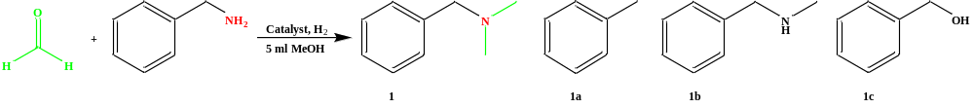
Entry | Catalyst | Temperature (°C) | Time (h) | H₂  Pressure  (bar) | Yield of 1 (%)
1 | Pd@N/C-2 | 90 | 12 | 20 | >99
2 | Pd@N/C-2 | 80 | 6 | 20 | >99
3 | Pd@N/C-2 | 70 | 6 | 20 | >99
4 | Pd@N/C-2 | 60 | 6 | 20 | >99
5 | Pd@N/C-2 | 50 | 6 | 20 | 81
6 | Pd@N/C-2 | 40 | 6 | 20 | 62
7 | Pd@N/C-2 | 60 | 4 | 20 | 88
8 | Pd@N/C-2 | 60 | 2 | 20 | 57
9 | Pd@N/C-2 | 70 | 4 | 20 | >99
10 | Pd@N/C-2 | 70 | 2 | 20 | >99
11 | Pd@N/C-2 | 70 | 1 | 20 | 82
12 | Pd@N/C-2 | 70 | 2 | 15 | 92
13 | Pd@N/C-2 | 70 | 2 | 10 | 91
14 | Pd@N/C-9 | 70 | 2 | 20 | 39
15 | Purchase Pd/NC | 70 | 2 | 20 | 56
16 | Pd/C | 70 | 8 | 25 | 95
17 | Rh/C | 70 | 8 | 25 | 74
ª Reaction conditions: 10 mg catalyst, 0.5 mmol benzylamine, 3 mmol formaldehyde (37% aq), 5 mL methanol. Yields were determined by GC using 1, 3, 5-trimethoxybenzenen as an internal standard.

Scheme 1. Synthesis of tertiary amines via Pd@N/C-2 catalyzed N-methylation of primary amines
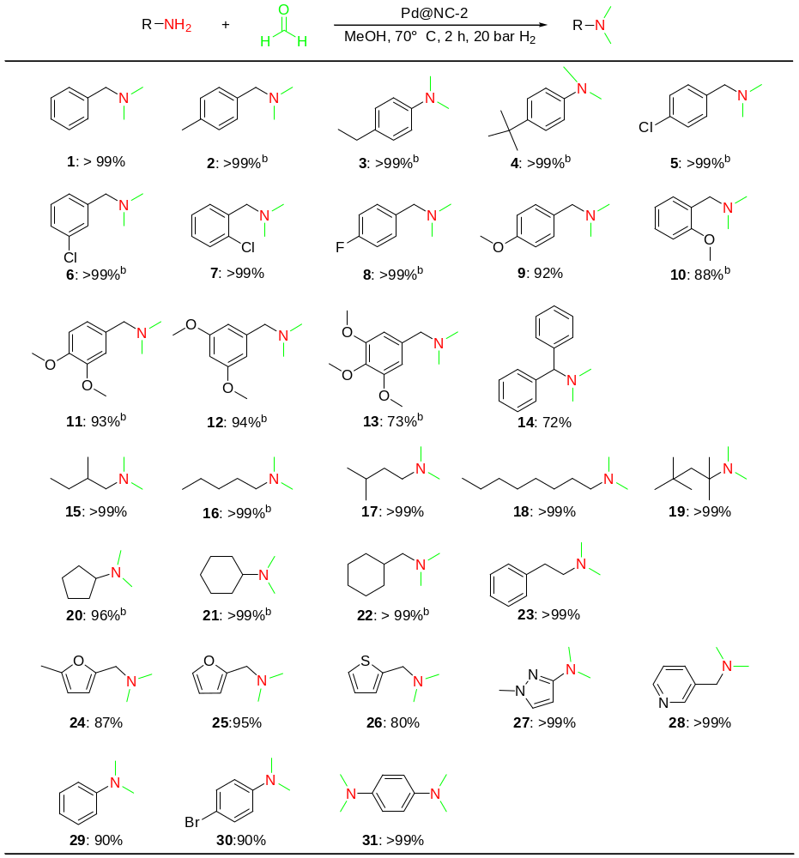
Reaction conditions: ª10 mg catalyst, 0.5 mmol amine, 3 mmol formaldehyde (37% aq), 5 ml methanol, 20 bar H₂, 70 ℃, 2 h; ^{b}10 mg catalyst, 0.5 mmol amine, 3 mmol formaldehyde (37% aq), 5 ml methanol, 20 bar H₂, 80 ℃, 4 h. Yields and conversion were determined by GC based on amine. The types of products were determined by GCMS.

Scheme 2. Synthesis of tertiary amines via Pd@N/C-2 catalyzed N-methylation of secondary amines
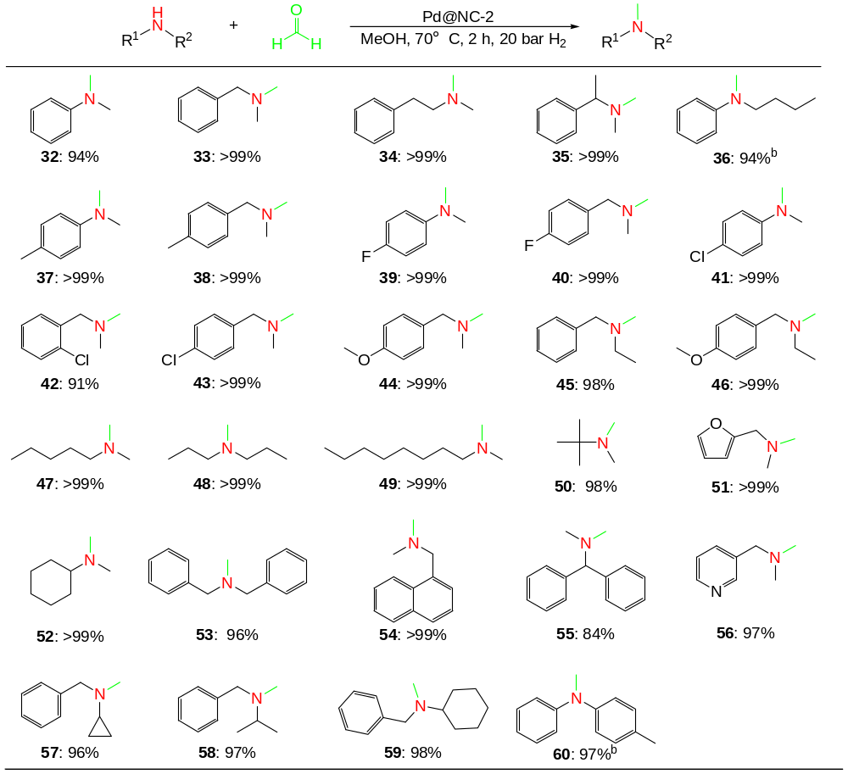
Reaction conditions: ª10 mg catalyst, 0.5 mmol secondary amine, 3 mmol formaldehyde (37% aq), 5 ml methanol, 20 bar H₂, 70 ℃, 2 h; ^{b}10 mg catalyst, 0.5 mmol amine, 3 mmol formaldehyde (37% aq), 5 ml methanol, 20 bar H₂, 80 ℃, 4 h. Yields and conversion were determined by GC based on amine. The types of products were determined by GCMS.

Scheme 3. Synthesis of tertiary amine via Pd@N/C-2 catalyzed N-methylation of amines and functional aldehydes.
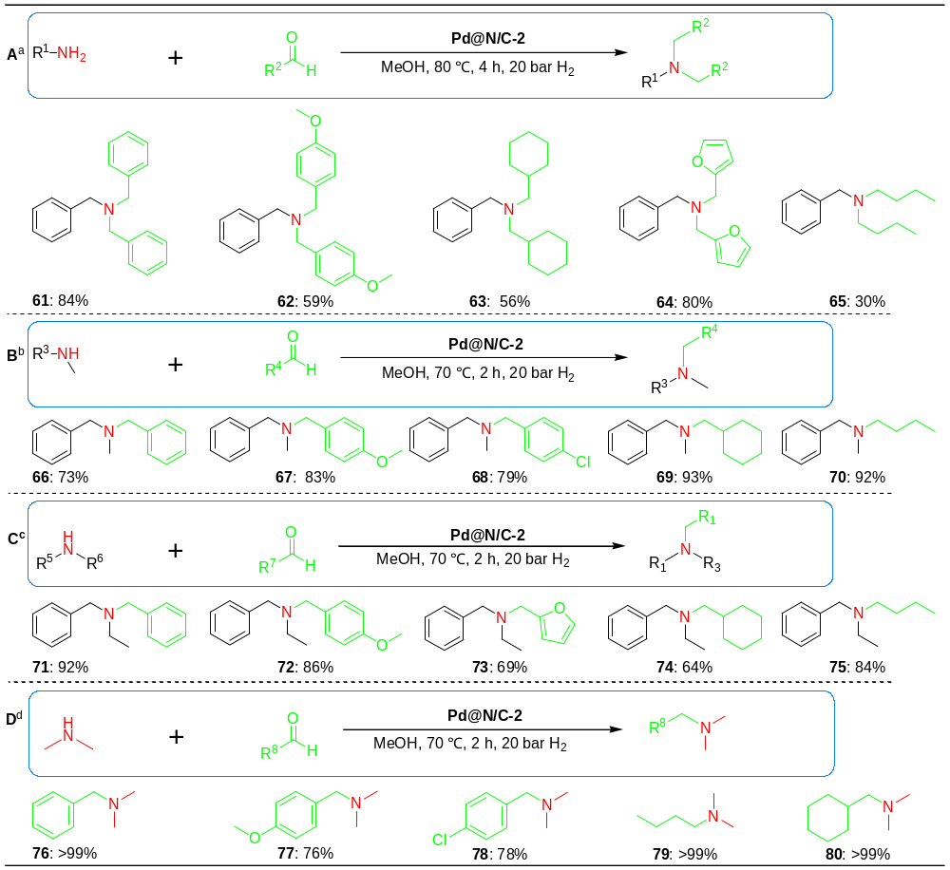
Reaction conditions: ª10 mg Pd@N/C-2 catalyst, 0.5 mmol primary amine, 3 mmol aldehyde, 5 mL methanol, 20 bar H₂, 80 ℃, 4 h; ^{b,c}10 mg Pd@N/C-2 catalyst, 0.5 mmol secondary amine, 3 mmol aldehyde, 5 mL methanol, 20 bar H₂, 70 ℃, 2 h; ^{d}10 mg Pd@N/C-2 catalyst, 0.5 mmol aldehyde, 0.5 ml dimethylamine solution (2 M in methanol), 4.5 mL methanol, 20 bar H₂, 70 ℃, 2 h; ^{a,b,c}Yields and conversion were determined by GC based on amine; ^{d}Yields and conversion were determined by GC based on aldehyde. The types of products were determined by GCMS and ¹H NMR.

Scheme 4. Gram-scale synthesis, catalyst stability and recycling test, and cascade flow synthesis of amines.
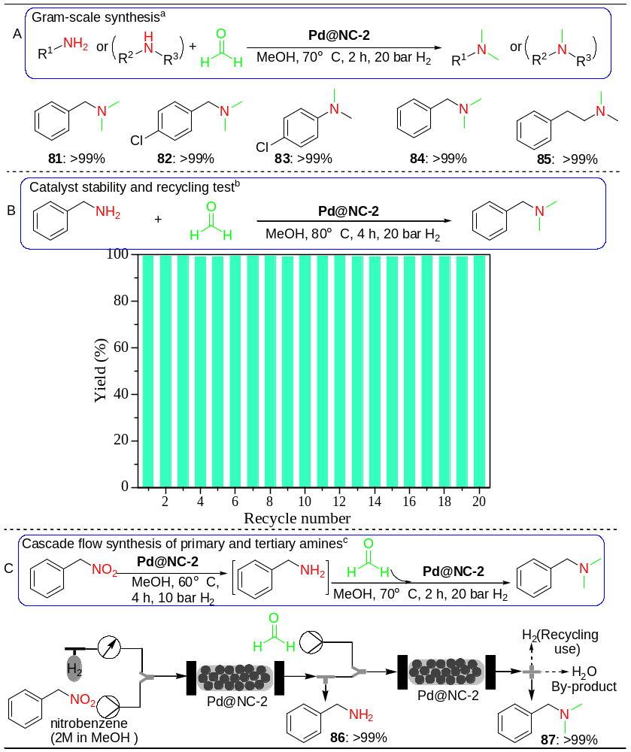
ªReaction conditions: 200 mg Pd@N/C-2 catalyst, 10 mmol amine, 60 mmol formaldehyde (37% aq), 100 mL methanol, 20 bar H₂, 80 ℃, 4 h. Yields and conversion were determined by GC based on amine. The types of products were determined by GCMS and ¹H NMR. ^{b}Reaction conditions: 10 mg Pd@N/C-2 catalyst, 0.5 mmol benzylamine, 3 mmol formaldehyde (37% aq), 5 mL methanol, 20 bar H₂, 80 ℃, 4 h. Yields and conversion were determined by GC using 1,3,5-trimethoxybenzenen as an internal standard based on amine. The types of products were determined by GCMS and ¹H NMR. ^{c}Reaction conditions: 10 mg Pd@N/C-2 catalyst, 0.5 mmol nitrobenzene, 3 mmol formaldehyde (37% aq), 10 bar H₂, 60 ℃, 4 h and 20 bar H₂, 70 ℃, 2 h. Yields and conversion were determined by GC using 1,3,5-trimethoxybenzenen as an internal standard based on amine. The types of products were determined by GCMS and ¹H NMR.

