Supplemental materials

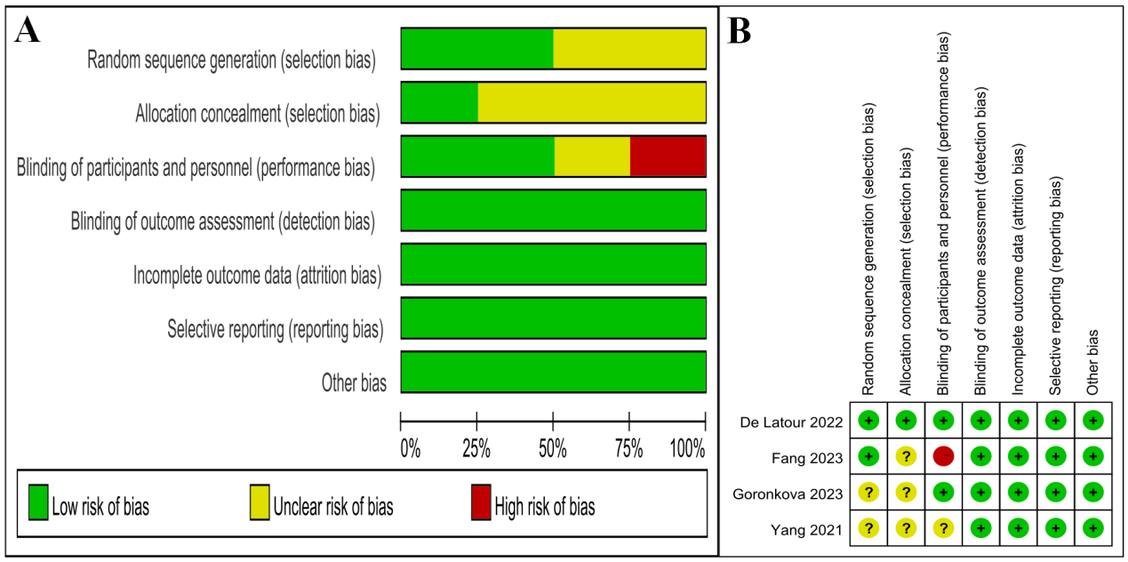
Supplemental Figure 1. Quality assessment of RCTs included in this meta-analysis. A: Risk of bias graph: Judgments about each risk of bias item presented as percentages across all included studies. B: Risk of bias summary: Judgments about each risk of bias item for each included study.

