Supplementary Figure Legends
Supplementary Forest Plot:
Supplementary Figure 1.1. Forest plot of 12-Month Tumor Recurrence Rates: Laser vs. Non-Laser Subgroups
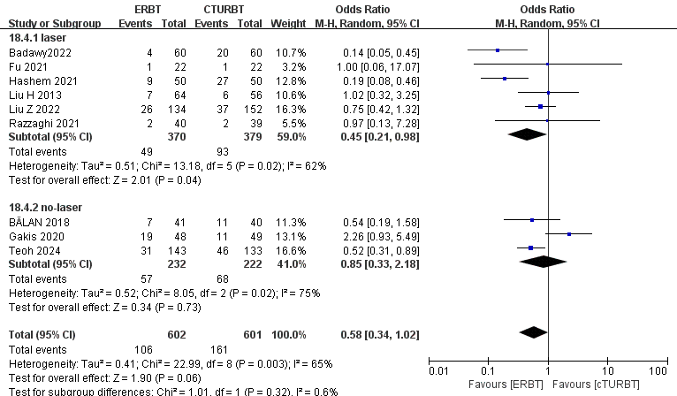
Supplementary Figure 1.2. Forest plot of 24-Month Tumor Recurrence Rates: Laser vs. Non-Laser Subgroups
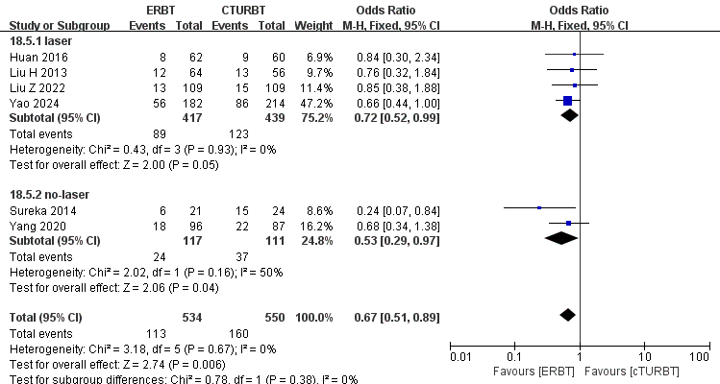
Supplementary Figure 1.3. Forest plot of 36-Month Tumor Recurrence Rates: Laser vs. Non-Laser Subgroups
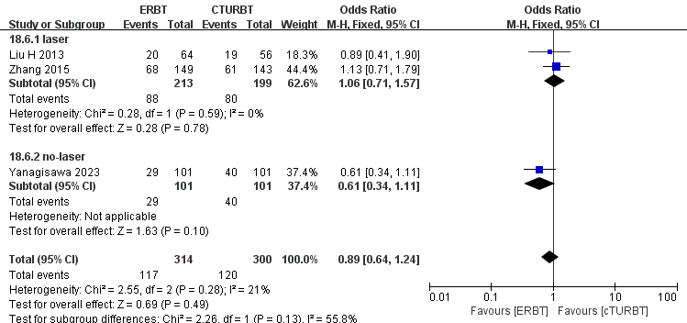
Supplementary Figure 2.1. Forest plot of 12-Month Tumor Progression Rates: Laser vs. Non-Laser Subgroups
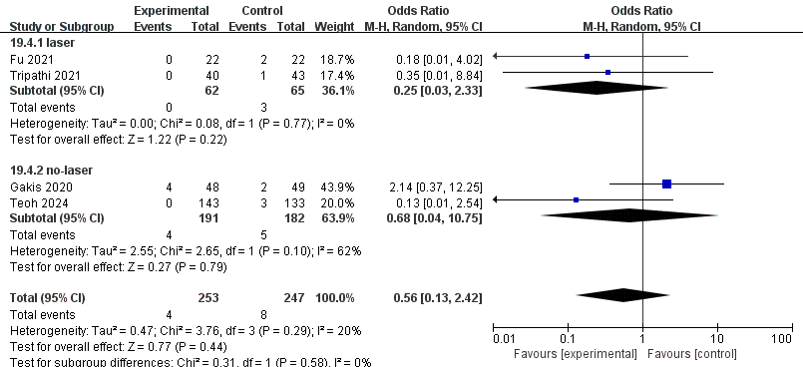
Supplementary Figure 2.2. Forest plot of 24-Month Tumor Progression Rates: Laser vs. Non-Laser Subgroups
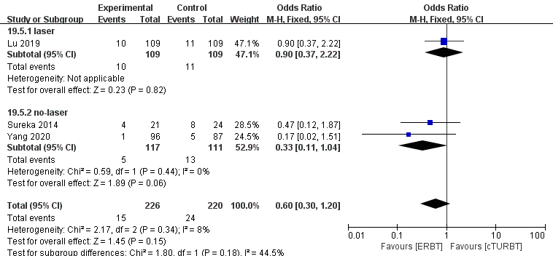
Supplementary Figure 3.1. Forest plot of Detrusor Muscle Presence: Laser vs. Non-Laser Subgroups
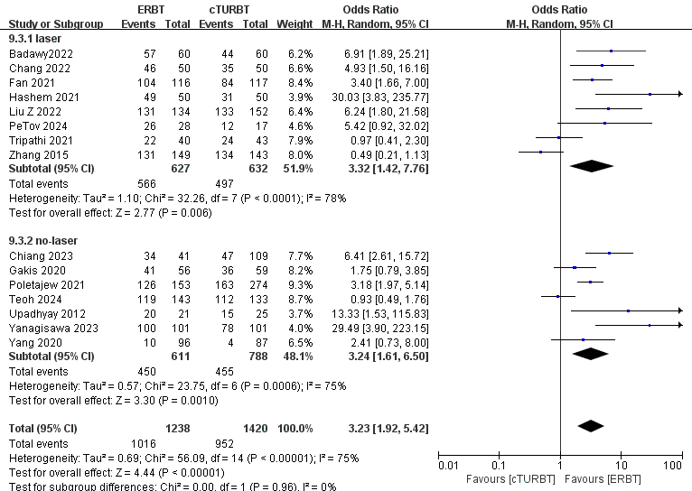
Supplementary Figure 3.2. Forest plot of Detrusor Muscle Presence by Tumor Size Subgroups (＜3 cm vs. >3 cm)
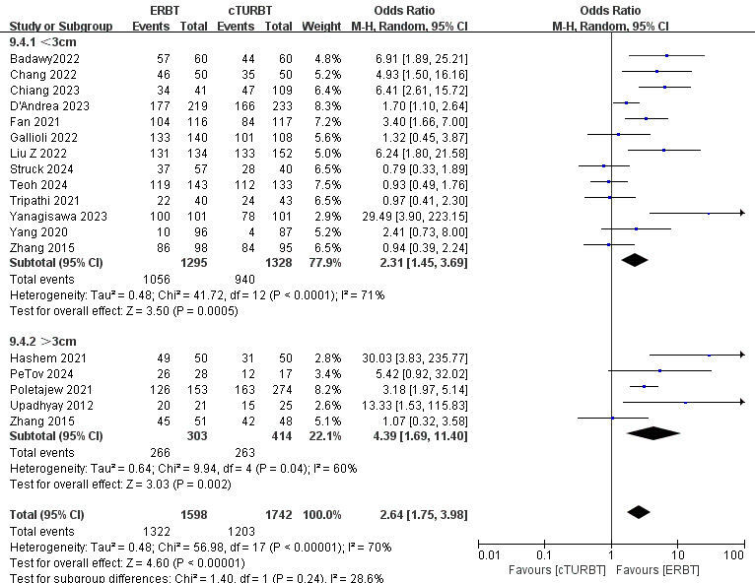
Supplementary Figure 4.1. Forest plot of Residual Tumor: Laser vs. Non-Laser Subgroups
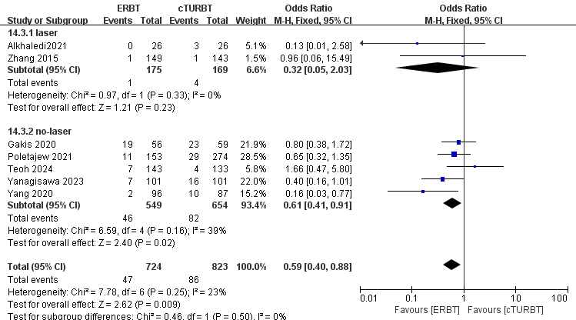
Supplementary Figure 4.2. Forest plot of Residual Tumor by Tumor Size Subgroups (＜3 cm vs. >3 cm)
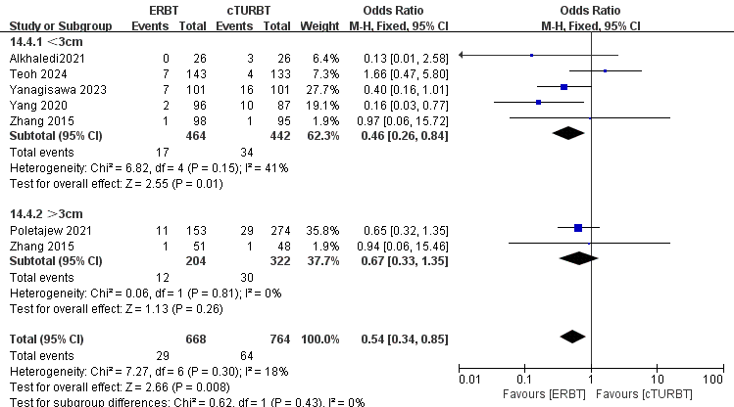
Supplementary Figure 5.1. Forest plot of Bladder Perforation: Laser vs. Non-Laser Subgroups
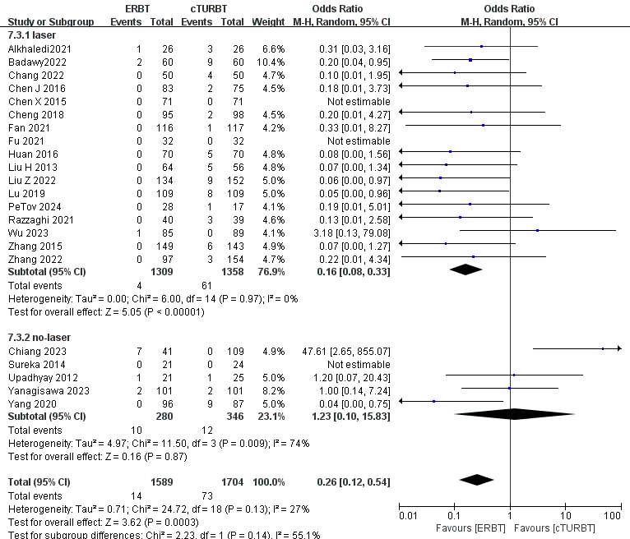
Supplementary Figure 5.2. Forest plot of Bladder Perforation by Tumor Size Subgroups (＜3 cm vs. >3 cm)
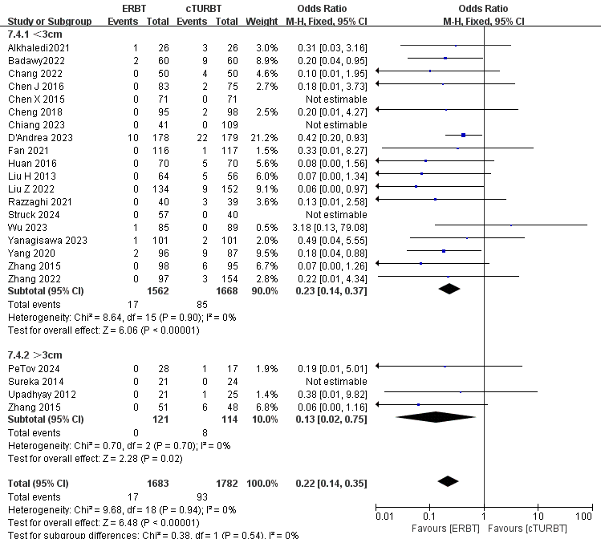
Supplementary Figure 6.1. Forest plot of Obturator Nerve Reflex: Laser vs. Non-Laser Subgroups
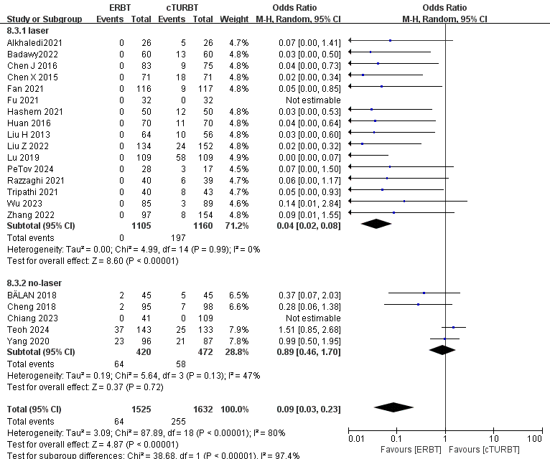
Supplementary Figure 6.2. Forest plot of Obturator Nerve Reflex by Tumor Size Subgroups (＜3 cm vs. >3 cm)
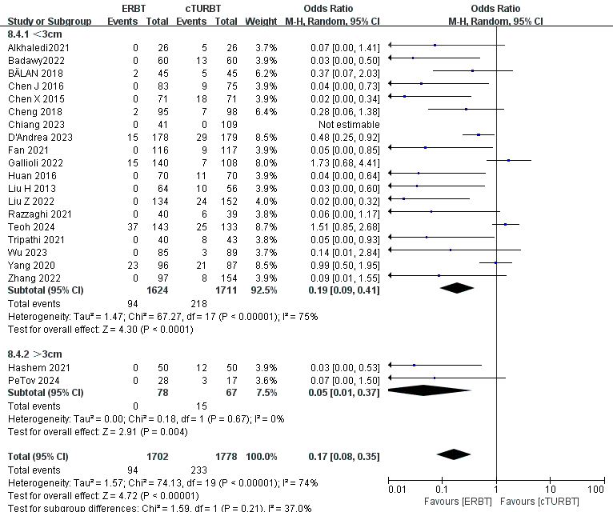
Supplementary Figure 7.1. Forest plot of Re-TURBT: Laser vs. Non-Laser Subgroups
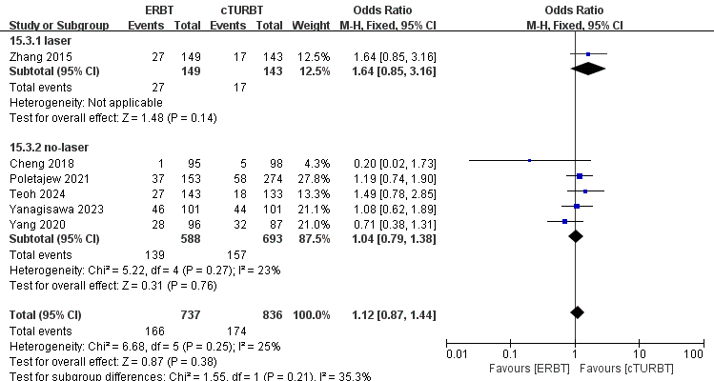
Supplementary Figure 7.2. Forest plot of Re-TURBT by Tumor Size Subgroups (＜3 cm vs. >3 cm)
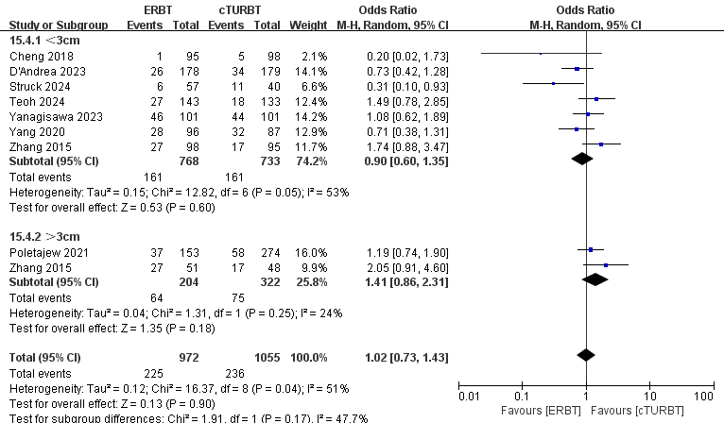
Supplementary Figure 8.1. Forest plot of Catheterization Duration: Laser vs. Non-Laser Subgroups
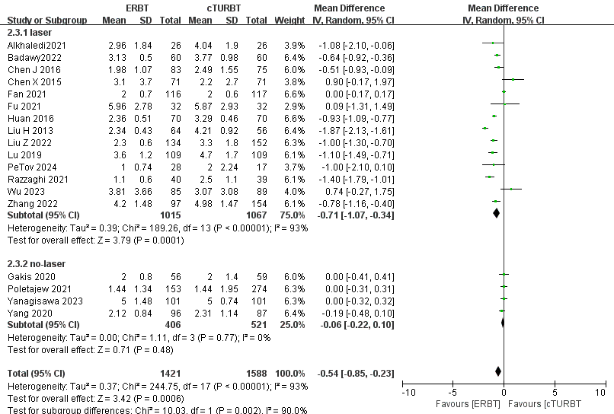
Supplementary Figure 8.2. Forest plot of Catheterization Duration by Tumor Size Subgroups (＜3 cm vs. >3 cm)
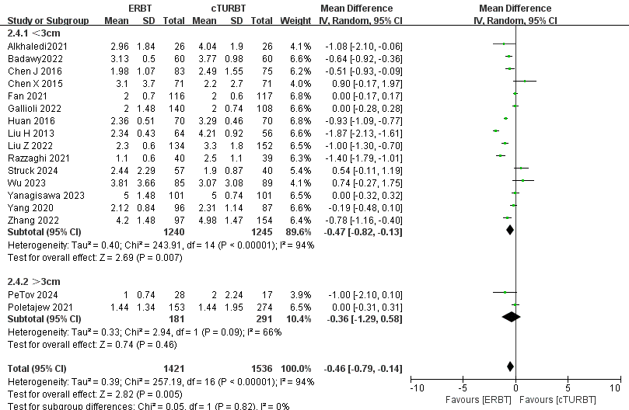
Supplementary Figure 9.1. Forest plot of Hospital Stay: Laser vs. Non-Laser Subgroups
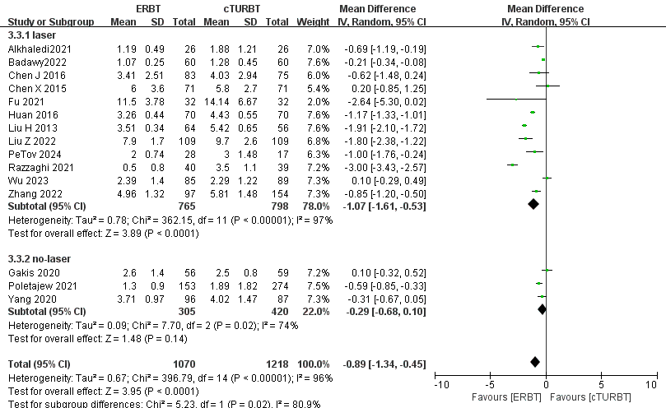
Supplementary Figure 9.2. Forest plot of Hospital Stay by Tumor Size Subgroups (＜3 cm vs. >3 cm)
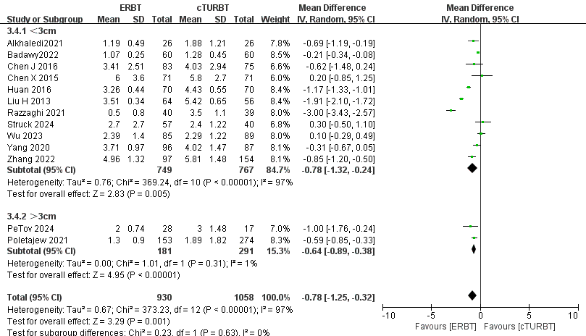
Supplementary Figure 10.1. Forest plot of Total Operative Time: Laser vs. Non-Laser Subgroups
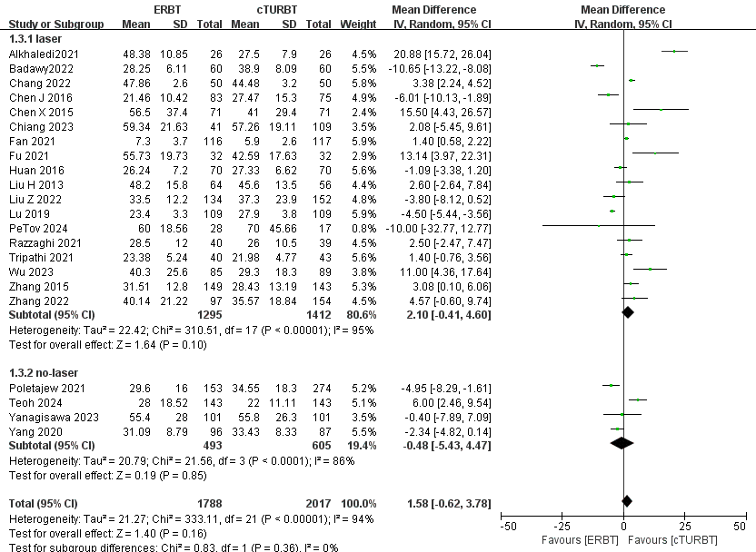
Supplementary Figure 10.2. Forest plot of Total Operative Time by Tumor Size Subgroups (＜3 cm vs. >3 cm)
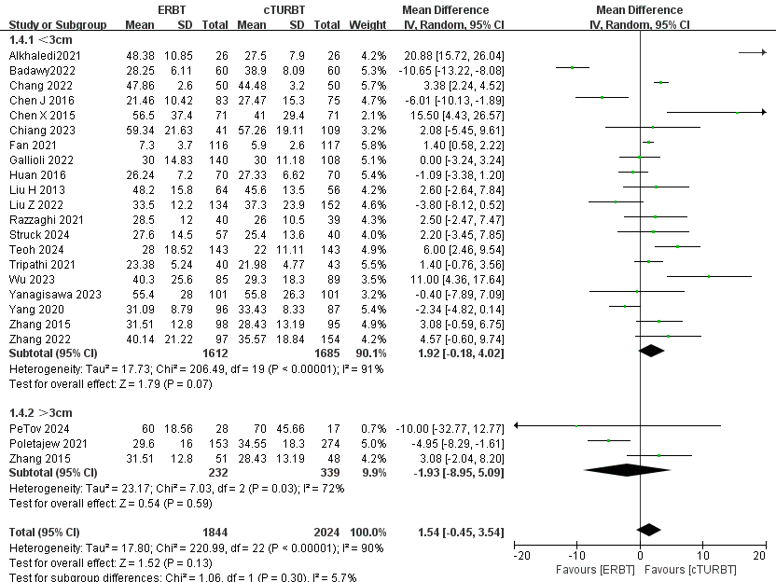

Supplementary Funnel Plot:
Supplementary Figure 11. Funnel Plot of Obturator Nerve Reflex.
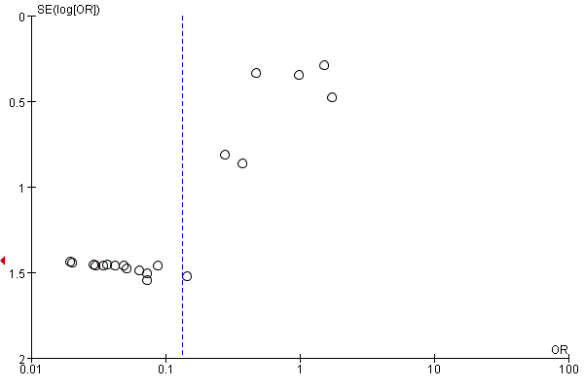
Supplementary Figure 12. Funnel Plot of Bladder Perforation.
