Additional information
Supplementary Information is available for this paper.
Correspondence and requests for materials should be addressed to Anise N. Happi.
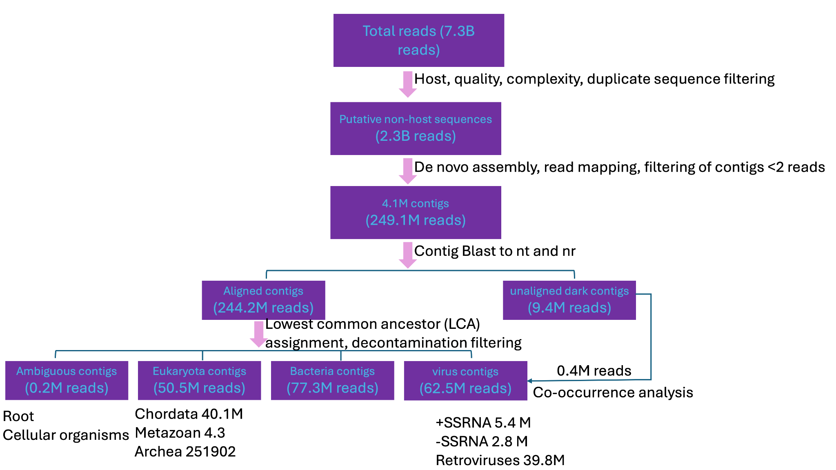
Extended Data Fig. 1 | Metagenomic processing and taxonomic assignment workflow. We analysed 7.3 billion raw reads from 240 mammalian species. After removal of host-derived, low-quality and low-complexity sequences, 2.3 billion high-quality reads (31.5% of input) remained. De novo assembly of 249.1 million reads (≈10.8% of filtered) yielded 4.1 million contigs. Contigs were aligned to NCBI databases and assigned by a lowest-common-ancestor (LCA) approach. Of the assembled reads, 244.2 million mapped to contigs with significant BLAST hits, whereas 27.3 million (10.9%) were unassigned or ambiguous, including 491,160 with no detectable homology (“dark matter”) and 201,297 with conflicting matches. Among eukaryotic assignments (56.3 million reads), 40.8 million mapped to Chordata—likely residual host signal due to database incompleteness or divergence—leaving 203.3 million non-host reads for final classification across Eukaryota, Bacteria, and Viruses. Viral calls prioritised complete/near-complete RNA viral genomes and curated RNA-dependent RNA polymerase (RdRp) contigs, supported by co-occurring contigs (~0.4 million reads) linked to each RdRp. Overall, ~11% of filtered reads assembled into analysable contigs; the flowchart annotates each decision point and read count.
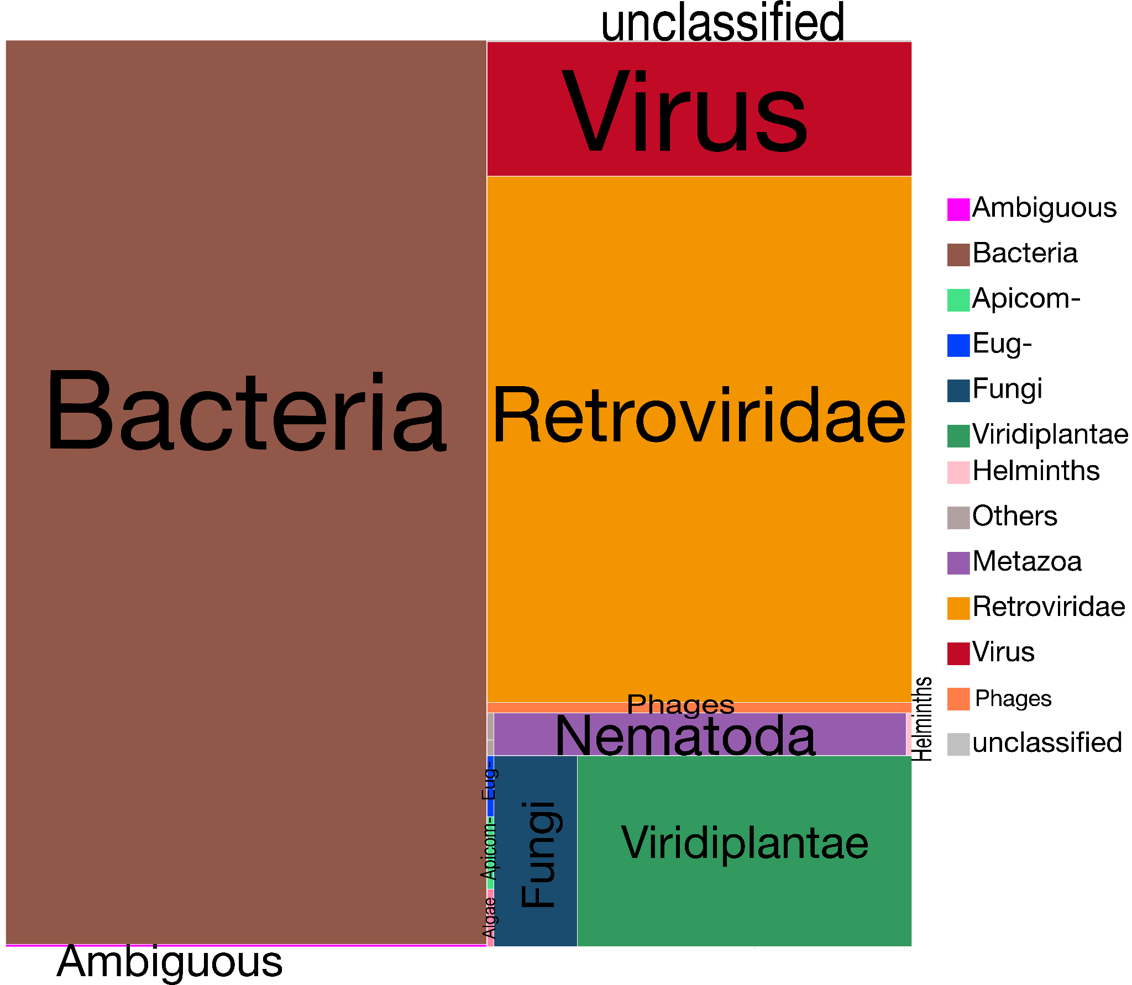
Extended Data Fig. 2 | High-resolution of the 240 microbiota
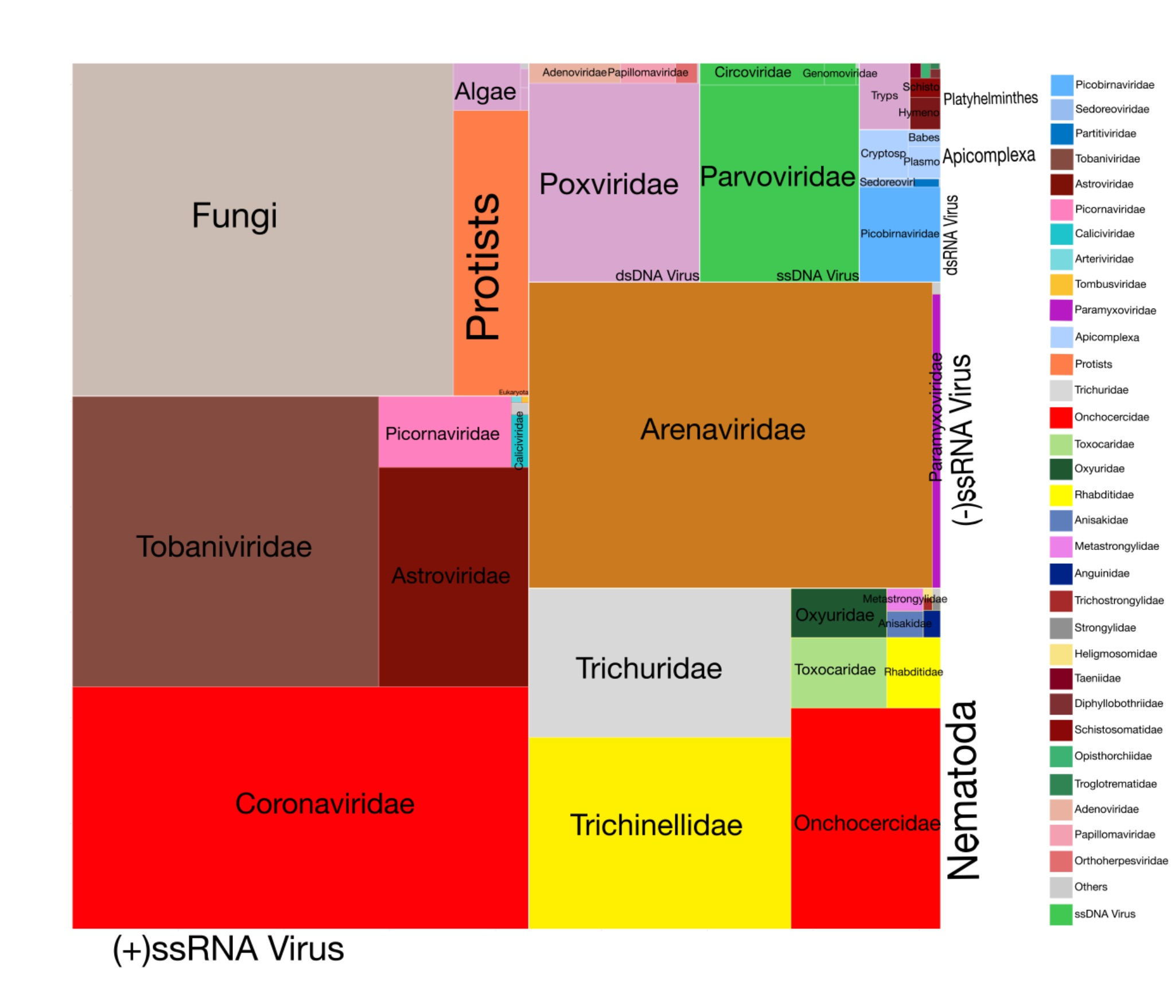
Extended Data Fig. 3 | High-resolution breakdown of the animal’s viruses, eukaryotes. Due to inherent uncertainties in classifying prokaryotic and eukaryotic taxa, cellular organisms are conservatively assigned to the lowest plausible taxonomic rank. Viral lineages are distinctly partitioned, with colour-coding reflecting each taxa as per legend.
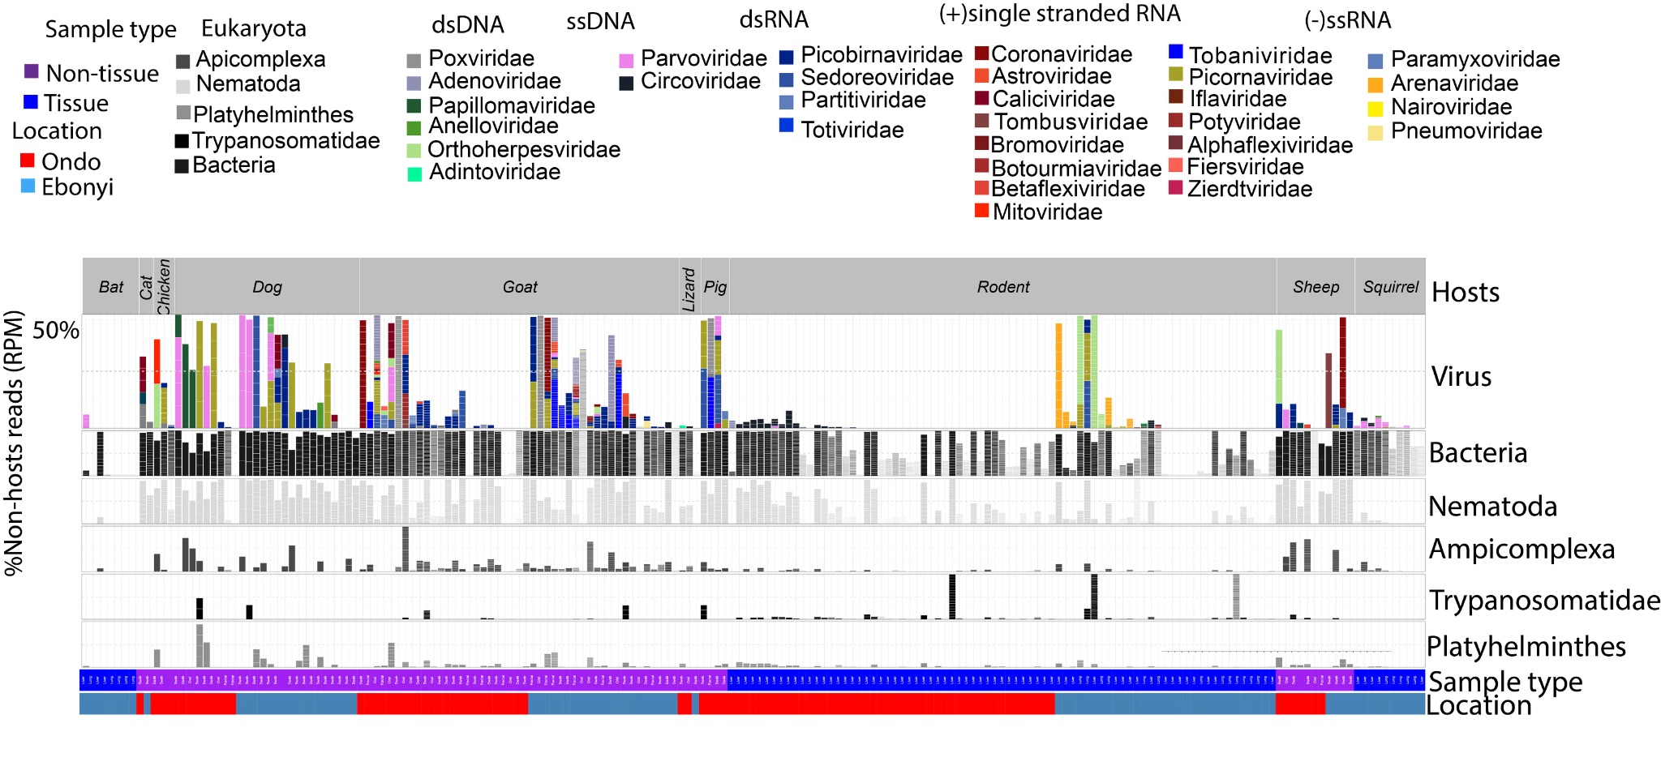
Extended Data Fig. 4 | Sequencing of individual animals reveals diverse microbiota across different hosts, sample types, and geographic locations. The bar plots show proportions of non-host reads from individual animals, emphasising those supported by more than 1RPM (Reads per Million) of non-host reads linked to assembled contigs identified as viruses (top panel), bacteria (middle panel), and select eukaryotic microbes (bottom panel). Virus species are indicated by different colours as detailed in the legend at the top of the figure. The bottom panel employs grey bars to denote samples containing taxa from Trypanosomatidae, Apicomplexa, Nematoda, and Platyhelminthes respectively. Samples are organized by host species (top labels), collection site (Ebonyi represented in steel blue, Ondo in red, indicated at the bottom), and sample type (Tissue samples in blue, purple for Non-tissue sample).
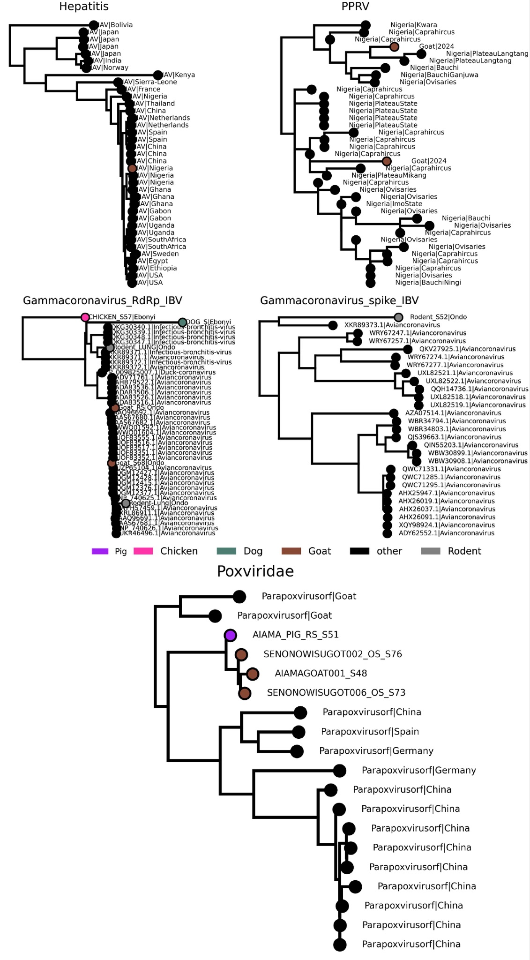
Extended Data Fig. 5 | maximum likelihood phylogeny of selected viruses inferred with nucleotide sequences.
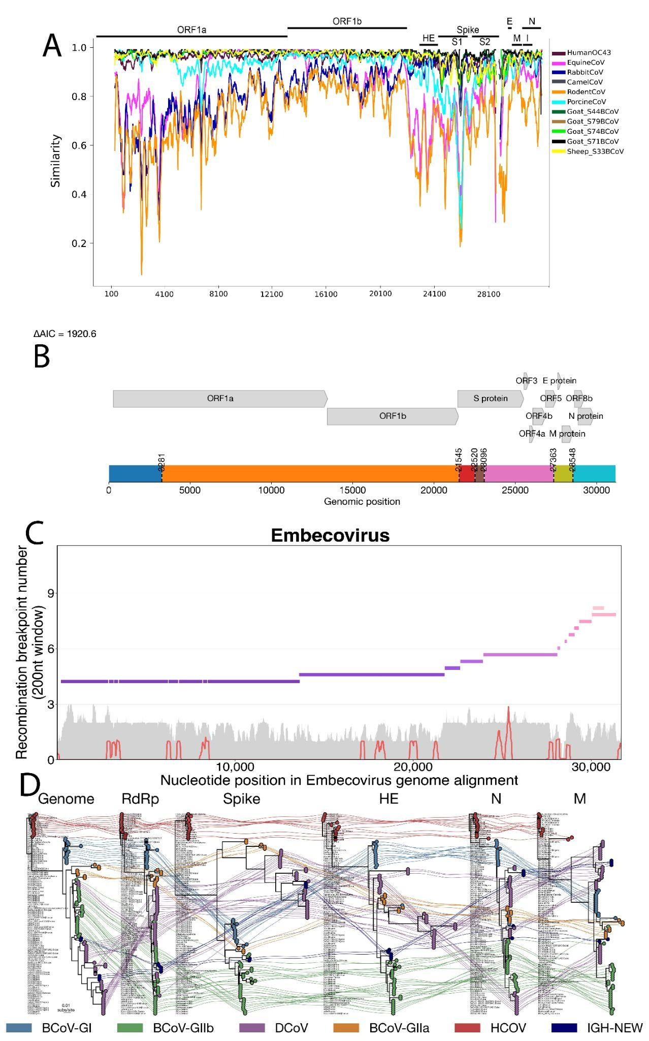
Extended Data Fig. 6 | Phylogenetic and recombination analyses of betacoronavirus genomes. a, Similarity plot generated using RDP4 software identifying recombination hotspots across betacoronavirus genomes. Distinct virus lineages are color-coded for clarity. b, Genome schematic indicating breakpoint positions detected by GARD analysis. c, Sliding-window analysis of recombination breakpoint density across the Embecovirus genome alignment. The x-axis represents nucleotide positions, while the y-axis depicts the cumulative number of recombination breakpoints identified in each genomic region. d, Tanglegram illustrating the phylogenetic congruence and incongruence between the full genome tree and the gene-specific trees (Genome, RDRP, Spike, HE, N, and M).

