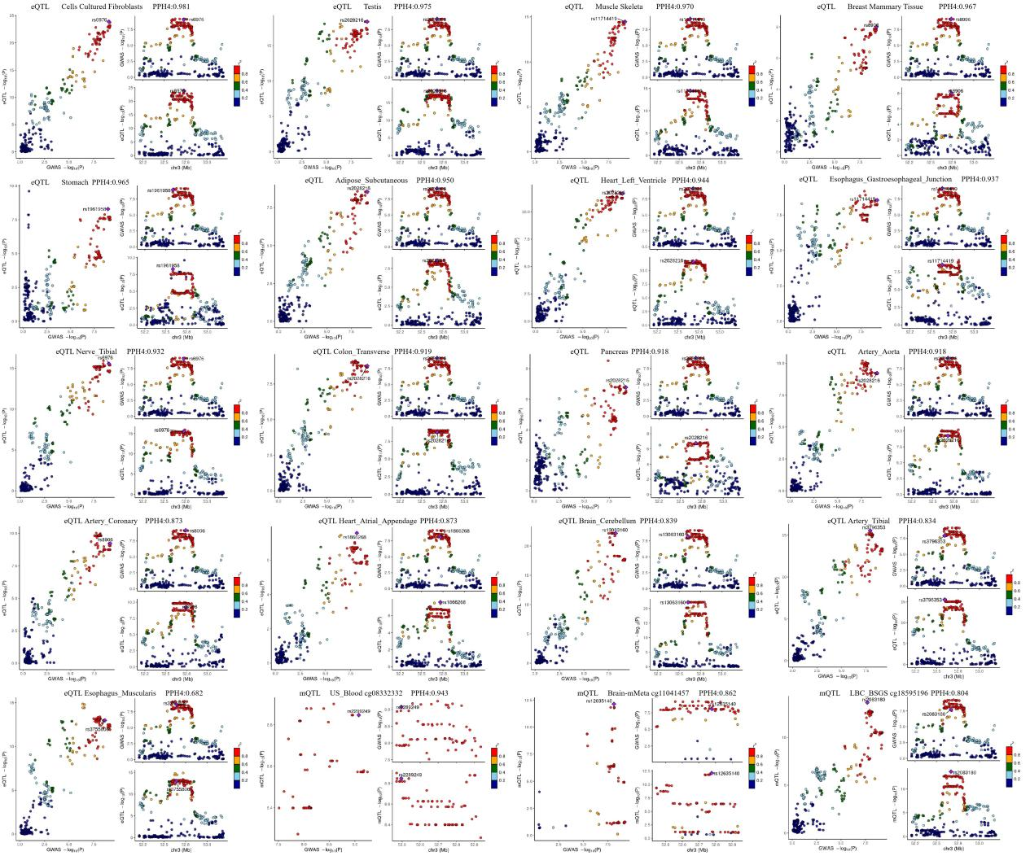Supplementary Figure S1. Colocalization plots for OA risk and GNL3 molecular QTLs. Representative LocusCompare plots visualizing the colocalization between GWAS signals for osteoarthritis (P01779) and GNL3 molecular QTLs in various tissues. Each panel represents one tissue or dataset. In each plot, the x-axis shows the signed -log10 p-value for SNPs from the GWAS, and the y-axis shows the signed -log10 p-value for SNPs from the corresponding QTL study. The sign (+/-) indicates the direction of the effect allele. Each point represents a single SNP, colored by its linkage disequilibrium (LD, r²) with the lead GWAS SNP (purple diamond). The high correlation of p-values for SNPs that are in high LD (indicated by red/orange points) and the high posterior probability of a shared variant (PP.H4) provide strong visual evidence for colocalization, suggesting that the same underlying causal variant drives both the OA risk and the molecular QTL.
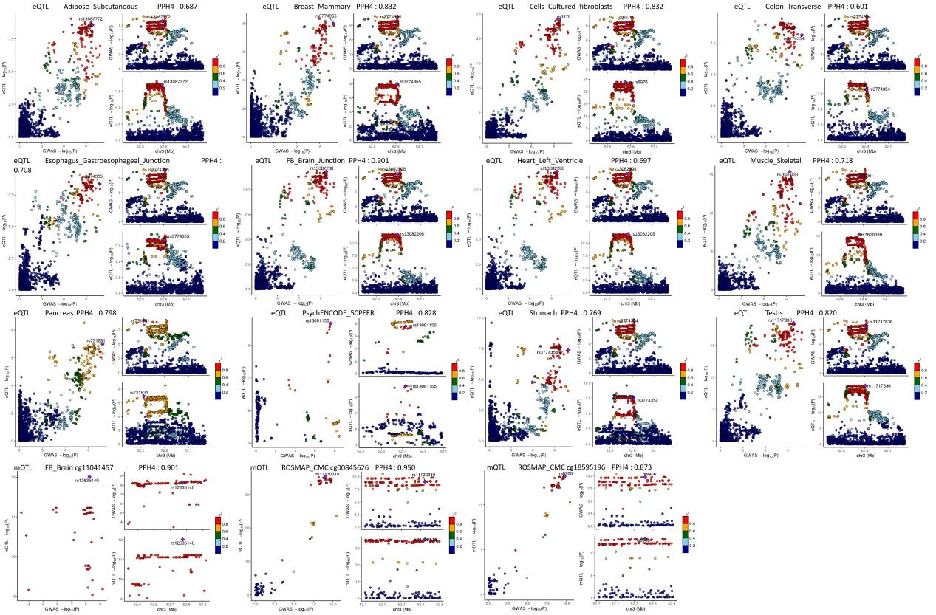Supplementary Figure S2. Colocalization plots for OA risk (Tachmazidou et al., 2019) and GNL3 molecular QTLs. Representative LocusCompare plots visualizing the colocalization between GWAS signals for osteoarthritis of the hip or knee (GWAS ID: P02059; Tachmazidou et al., 2019) and GNL3 molecular QTLs in various tissues. Each panel represents one tissue or dataset. In each plot, the x-axis shows the signed -log10 p-value for SNPs from the GWAS, and the y-axis shows the signed -log10 p-value for SNPs from the corresponding QTL study. The sign (+/-) indicates the direction of the effect allele. Each point represents a single SNP, colored by its linkage disequilibrium (LD, r²) with the lead GWAS SNP (purple diamond). The high correlation of p-values for SNPs in high LD (indicated by red/orange points) provides strong visual evidence for colocalization, supporting the conclusion that the same causal variant drives both the OA risk signal in this specific cohort and the molecular QTL.
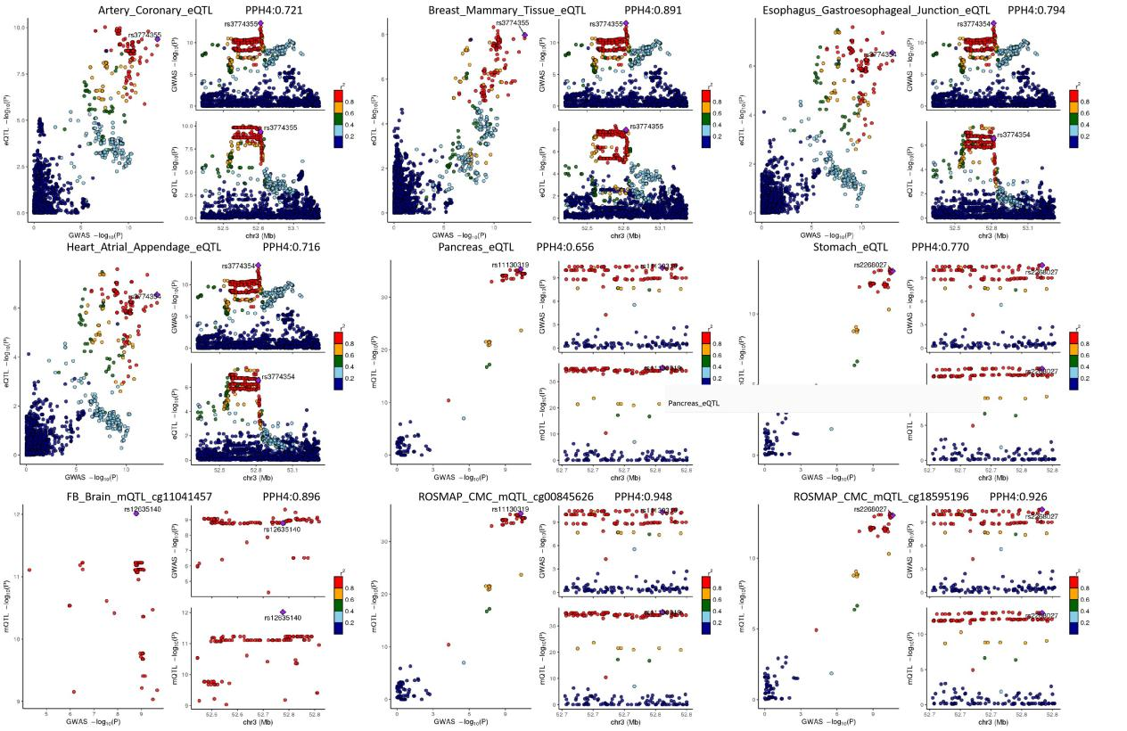Supplementary Figure S3. Colocalization plots for Hip Osteoarthritis risk (Tachmazidou et al., 2019) and GNL3 molecular QTLs. Representative LocusCompare plots visualizing the colocalization between GWAS signals for hip osteoarthritis (GWAS ID: P02060; Tachmazidou et al., 2019) and GNL3 molecular QTLs in various tissues. Each panel represents one tissue or dataset. In each plot, the x-axis shows the signed -log10 p-value for SNPs from the GWAS, and the y-axis shows the signed -log10 p-value for SNPs from the corresponding QTL study. The sign (+/-) indicates the direction of the effect allele. Each point represents a single SNP, colored by its linkage disequilibrium (LD, r²) with the lead GWAS SNP (purple diamond). The high correlation of p-values for SNPs in high LD (indicated by red/orange points) provides strong visual evidence for colocalization, supporting the conclusion that the same causal variant drives both the hip OA risk signal in this specific cohort and the molecular QTL.
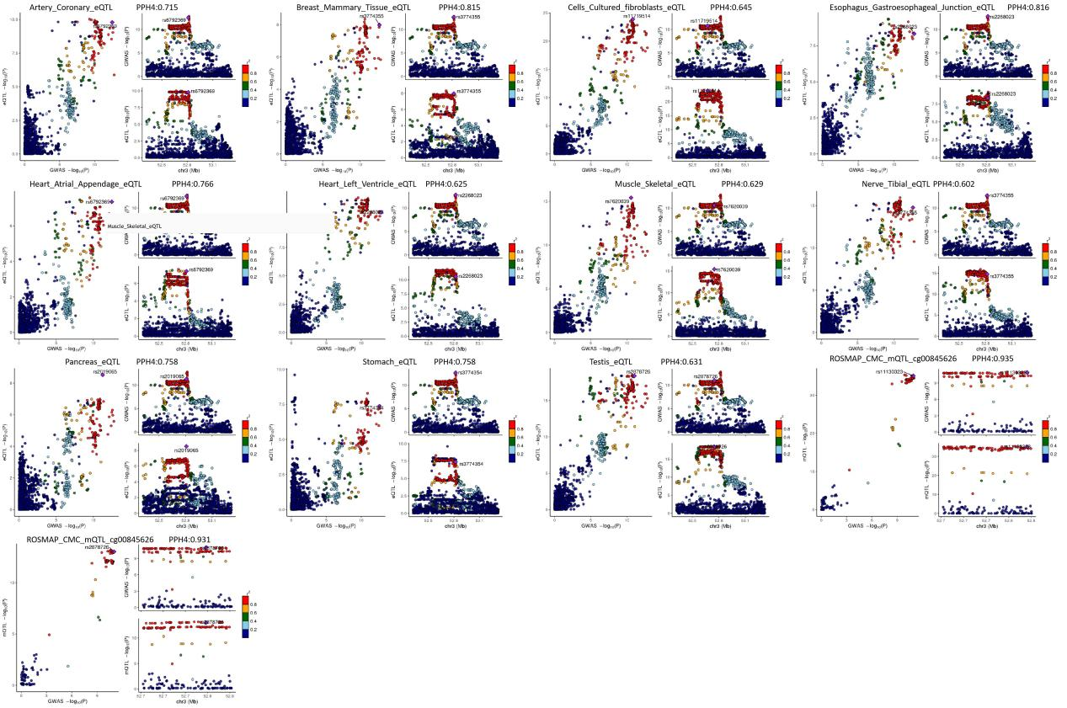Supplementary Figure S4. Colocalization plots for Hip Osteoarthritis risk (Boer et al., 2021) and GNL3 molecular QTLs. Representative LocusCompare plots visualizing the colocalization between GWAS signals for hip osteoarthritis (GWAS ID: P02070; Boer et al., 2021) and GNL3 molecular QTLs in various tissues. Each panel represents one tissue or dataset. In each plot, the x-axis shows the signed -log10 p-value for SNPs from the GWAS, and the y-axis shows the signed -log10 p-value for SNPs from the corresponding QTL study. The sign (+/-) indicates the direction of the effect allele. Each point represents a single SNP, colored by its linkage disequilibrium (LD, r²) with the lead GWAS SNP (purple diamond). The high correlation of p-values for SNPs in high LD (indicated by red/orange points) provides strong visual evidence for colocalization, supporting the conclusion that the same causal variant drives both the hip OA risk signal in this specific cohort and the molecular QTL.
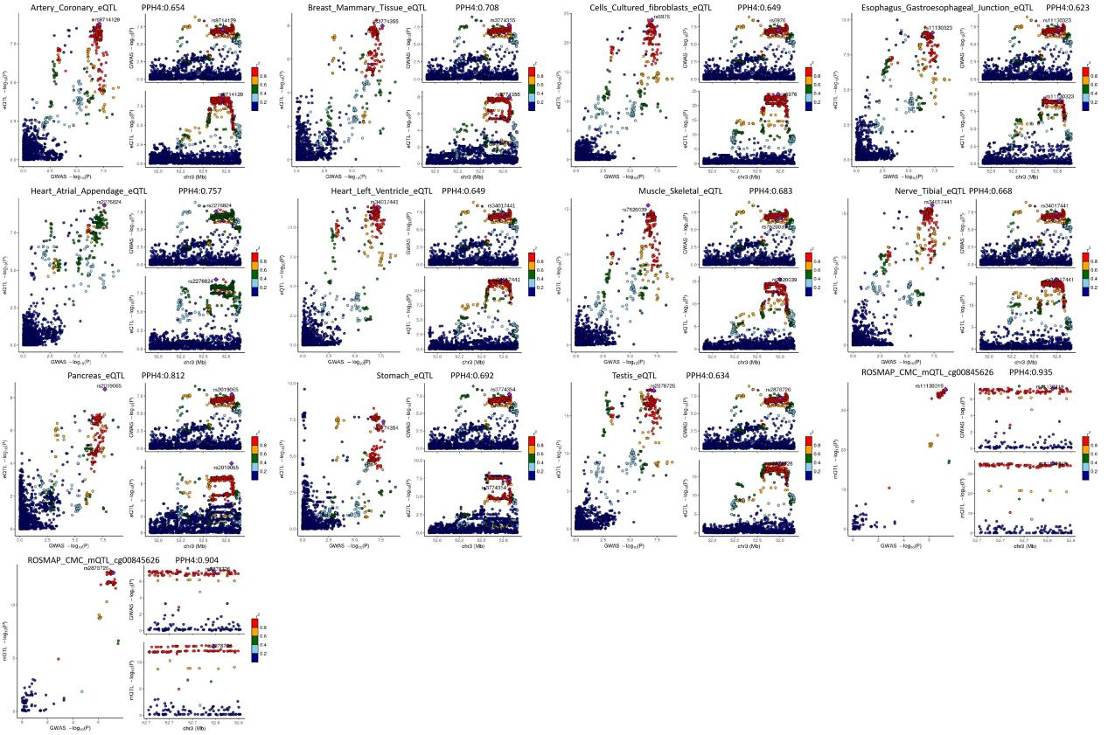Supplementary Figure S5. Colocalization plots for Knee and/or Hip Osteoarthritis risk (Boer et al., 2021) and GNL3 molecular QTLs. Representative LocusCompare plots visualizing the colocalization between GWAS signals for knee and/or hip osteoarthritis (GWAS ID: P02071; Boer et al., 2021) and GNL3 molecular QTLs in various tissues. Each panel represents one tissue or dataset. In each plot, the x-axis shows the signed -log10 p-value for SNPs from the GWAS, and the y-axis shows the signed -log10 p-value for SNPs from the corresponding QTL study. The sign (+/-) indicates the direction of the effect allele. Each point represents a single SNP, colored by its linkage disequilibrium (LD, r²) with the lead GWAS SNP (purple diamond). The high correlation of p-values for SNPs in high LD (indicated by red/orange points) provides strong visual evidence for colocalization, supporting the conclusion that the same causal variant drives both the OA risk signal in this specific cohort and the molecular QTL.
Supplementary Figure S6. Genomic location of the 17 CpG methylation probes analyzed at the GNL3 locus. Schematic diagram illustrating the genomic architecture of the human GNL3 locus on chromosome 3. The top panel displays various known transcripts of GNL3, including protein-coding (e.g., ENST00000479230.5), retained intron, and lncRNA isoforms. Exons are shown as taller blocks, introns as lines, and the coding sequence (CDS) and untranslated regions (UTR) are indicated by color. The bottom panel shows the precise genomic position of the 17 CpG methylation probes (labeled with cg identifiers) analyzed in this study. The diagram highlights that these probes are clustered within key regulatory regions, including the gene promoter, the 5' UTR, and the first exon, and are situated within or adjacent to a CpG island (indicated by the color legend for Island, Shore, and Shelf).

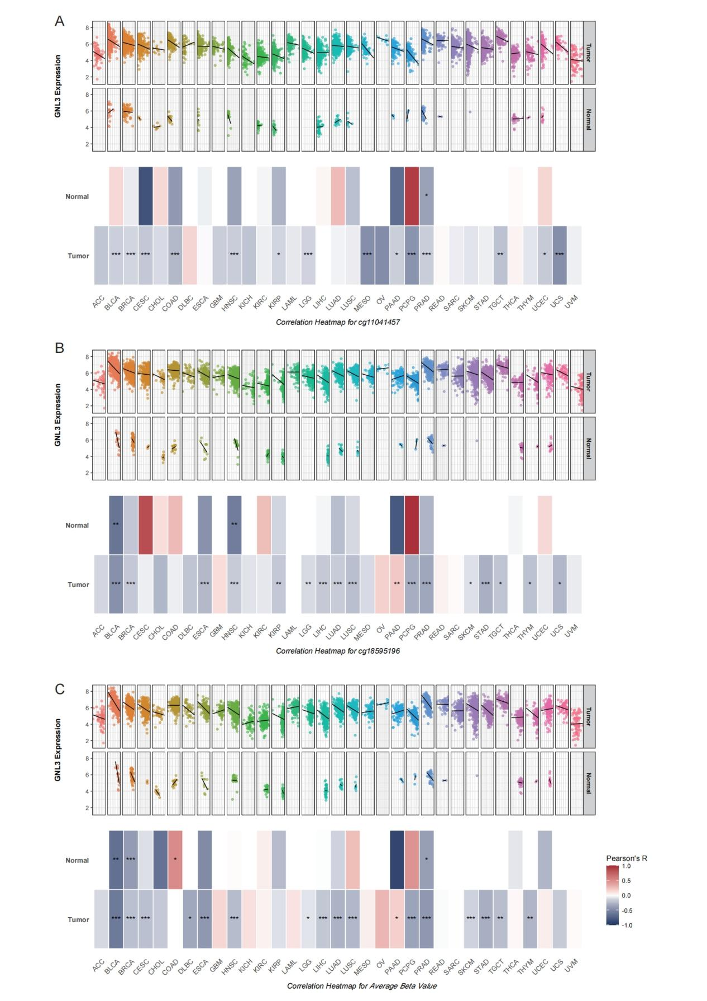Supplementary Figure S7. Detailed pan-cancer correlation analysis between GNL3 expression and DNA methylation. This figure provides a detailed visualization of the Pearson correlation between GNL3 mRNA expression and DNA methylation levels across multiple cancer types from The Cancer Genome Atlas (TCGA), analyzed separately for primary tumor and adjacent normal tissues. The analysis is shown for two key individual CpG sites and their average value. For each panel, the top scatter plots show the relationship between GNL3 expression (y-axis) and methylation Beta-values (x-axis) for each cancer type, with a regression line indicating the trend. The bottom heatmaps summarize the correlation coefficients (Pearson's R) and statistical significance (*p < 0.05, **p < 0.01, ***p < 0.001) for each cancer type.
(A) Correlation analysis for the CpG site cg11041457.
(B) Correlation analysis for the CpG site cg18595196.
(C) Correlation analysis using the average methylation Beta-value across 17 probes located in the GNL3 promoter region.

